Supplementary Information

Extensive phenotypic characterisation of a human TDP-43^{Q331K} transgenic mouse model of amyotrophic lateral sclerosis (ALS)
Jodie A. Watkins, James J. P. Alix, Pamela J. Shaw, Richard J. Mead

Supplementary Movie 1 -TDP43^{Q331K} tremor. This video shows the typical continuous resting tremor in a 6 month old TDP-43^{Q331K} female mouse. This phenotype develops from 10-14 weeks of age onwards.
Supplementary Movie 2-TDP43^{Q331K} gait. This video shows the obvious waddling or “swimming” gait in a 6 month old female mouse. This gait abnormality develops from approximately 27 weeks of age and can be quantified using gait analysis (see figure 2F and G)
Supplementary Movie 3-TDP43^{WT} gait. This video shows the normal gait observed in a TDP-43WT transgenic mouse at 6 months of age.

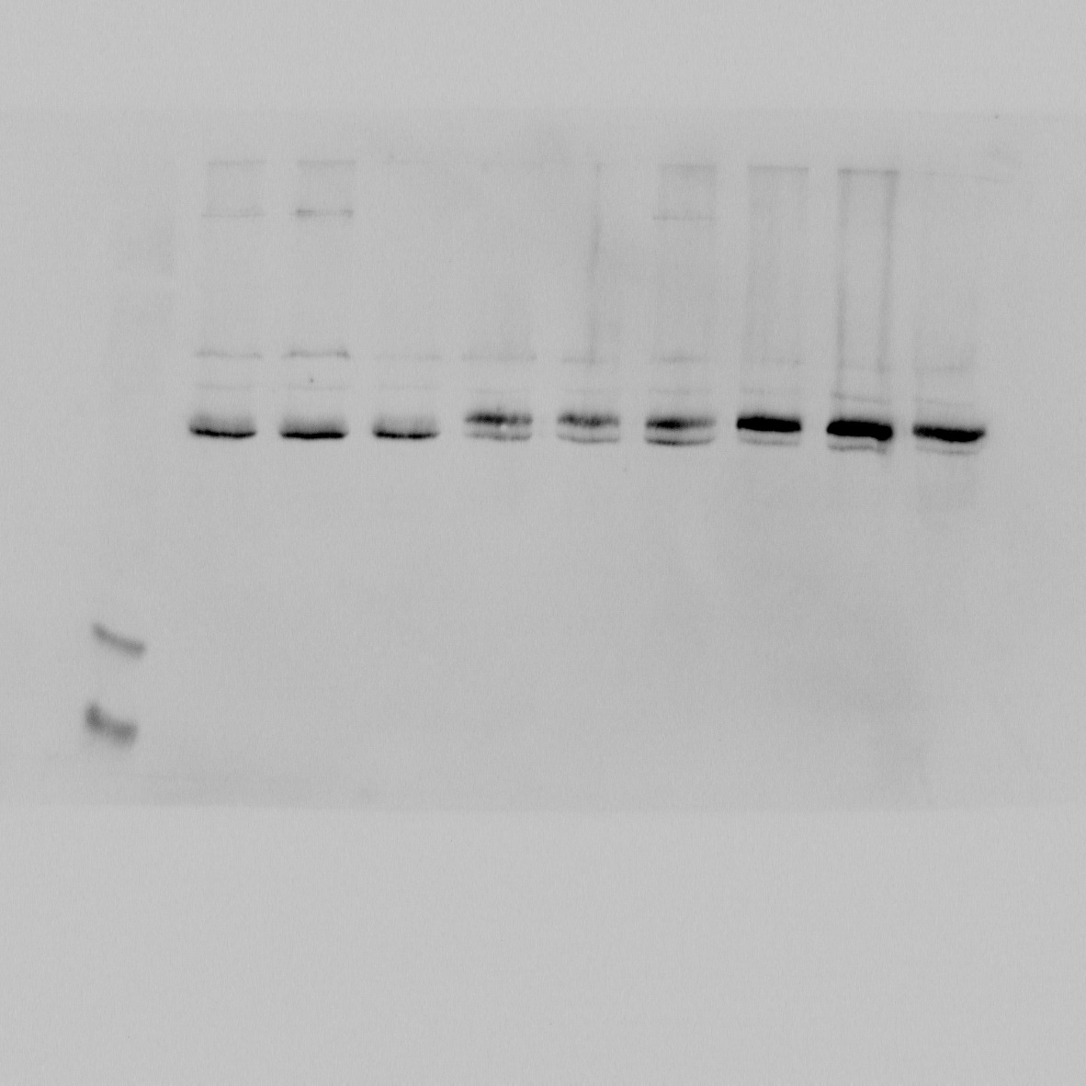
Supplementary Figure 1
Image showing the original captured image of the western blot in Figure 4d, TDP-43

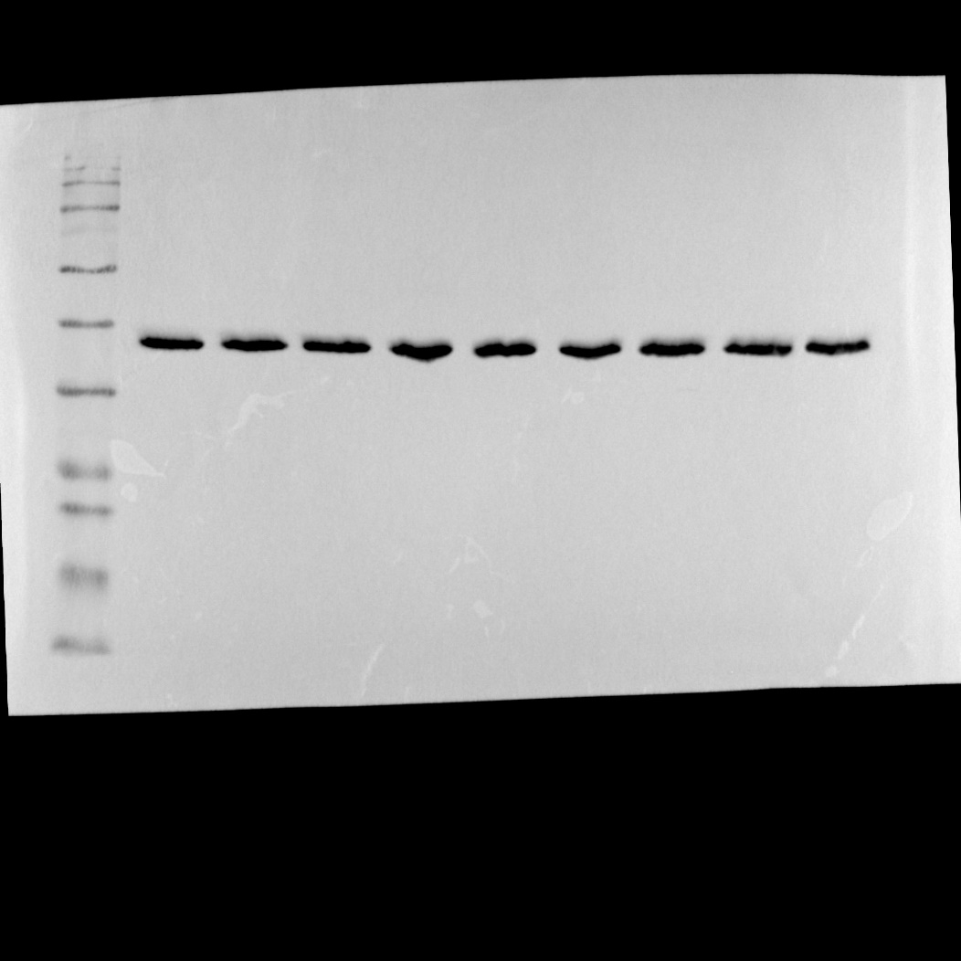

Supplementary Figure 2
Image showing the original captured image of the western blot in Figure 4d, beta-actin

