Supplementary Information
A panel of DNA methylation biomarkers for detection and improving diagnostic efficiency of lung cancer
Bing Wei^{a,b†}, Fengxin Wu^{d†}, Wenqun Xing^{c}, Haibo Sun^{c}, Chi Yan^{a,b}, Chengzhi Zhao^{a,b}, Dongqing Wang^{a,b}, Xiaobing Chen^{c}, Yanli Chen^{d}, Mingming Li^{d}, Jie Ma^{a,b}*
ªDepartment of Molecular Pathology, Affiliated Cancer Hospital of Zhengzhou University, Henan Cancer Hospital, Zhengzhou, Henan, China
^{b}Henan Key Laboratory of Molecular Pathology, Zhengzhou, Henan, China
^{c}Department of Thoracic Surgery, Affiliated Cancer Hospital of Zhengzhou University, Henan Cancer Hospital, Zhengzhou, Henan, China
^{d}Excellen Medical Technology Co., Ltd., Beijing, China
†These authors contributed equally to this work.
* Correspondence:
Jie Ma, Department of Molecular Pathology, Affiliated Cancer Hospital of Zhengzhou University, Henan Cancer Hospital, No 127, Dongming Road, Zhengzhou, Henan 450008, China
Fax: +86-0371-65587686
Tel: +86-0371-65587686
E-mails: majie_fzbl@163.com

SHOX2
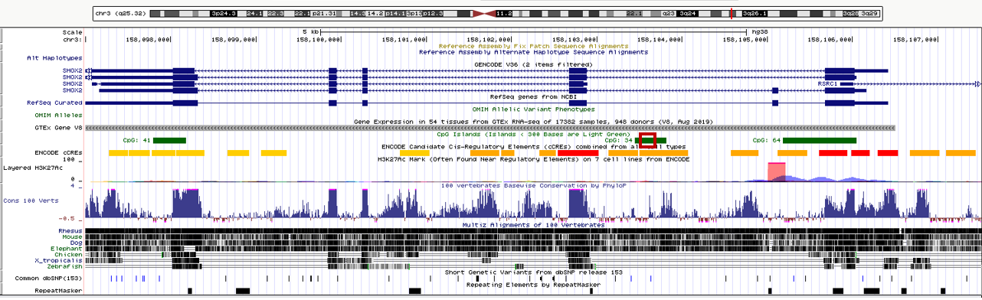

RASSF1A
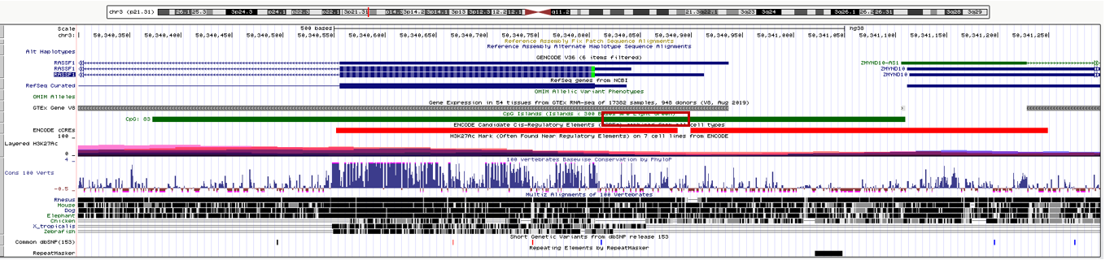

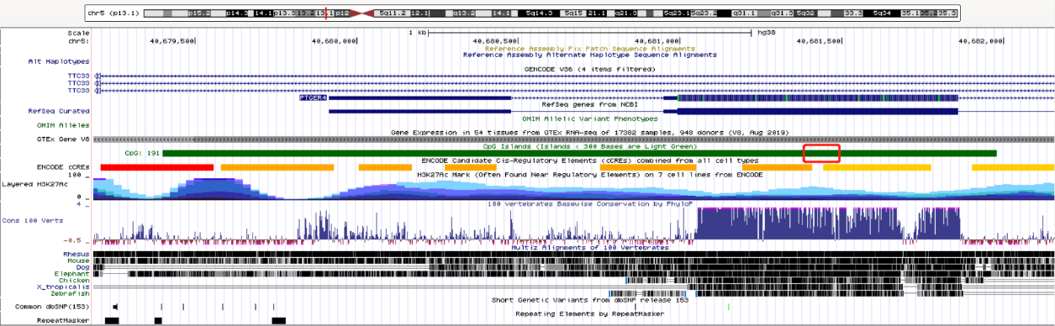
PTGER4

Supplementary Figure S1: Genomic organization of the SHOX2, RASSF1A, and PTGER4 genes and regions targeted for methylation analyses. The qPCR target regions within the genome SHOX2: chromosome 3:158,103,514-158,103,606, RASSF1A: chromosome 3:50,340,809-50,340,892, and PTGER4: chromosome 5:40,681,382-40,681,493 indicated by red boxes. All information was taken from human genome assembly GRCh38/hg38 (http://genome.ucsc.edu).

Supplementary Table S1. The primer and the fluorescent probe sequences used in this study.
Gene | Forward primer (5´-3´) | Probe (5´-3´) | Reverse primer (5´-3´)
SHOX2 | GTTCGTGCGATTTCGGTC | FAM- CAACCAAATAATCTCCGTCCCGC-BHQ1 | TCGCTACCCCTAAACTCGA
RASSF1A | GCGTTGAAGTCGGGGTTCG | JOE-CGCTAACAAACGCGAACCGA-BHQ1 | CCGATTAAACCCGTACTTC
PTGER4 | TGGGTATTGTAGTCGCGAGTTATC | Texas Red-CAATCTATACGTCCAACGTACTCTTTTACGCGCTA -BHQ2 | CTACGTAAACAAACGATTAACG
ACTB | GTGATGGAGGAGGTTTAGTAAGT | CY5-ACCACCACCCAACACACAATAACAAACACA-BHQ2 | CCAATAAAACCTACTCCTCCCTT

Supplementary Methods
Analytical Sensitivity- Limit of Detection
The analytical sensitivity of the assay was evaluated at four laboratories according to CLSI EP12 and EP17 guidance documents. All sites utilized the test kit manufactured under final manufacturing conditions. Seven levels of technical samples were tested with CpGenome Universal Methylated DNA diluted at concentrations of 0, 8, 16, 24, 30, 40, and 50 pg/ml. The estimated Limit of Detection (LoD) was determined to be 26.83 pg/mL (95% CI 23.86-32.05 pg/mL) using probit analysis.

