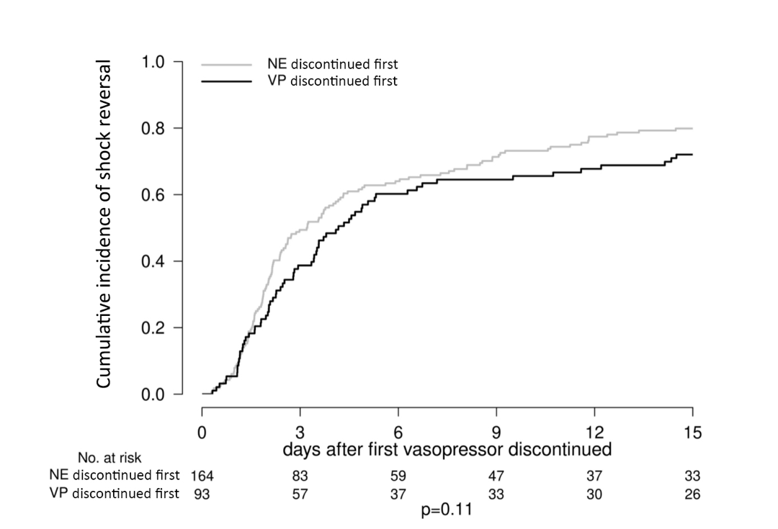

Additional Figure 6. Cumulative incidence of shock reversal following first vasopressor discontinuation among cardiogenic shock only patients

