Supplementary Information

Article Title: 3D printing fluorescent material with tunable optical properties
Authors: Alberto J. Ruiz^{1,2}, Sadhya Garg¹, Samuel Streeter¹, Mia K. Giallorenzi¹, Ethan P.M. LaRochelle², Kimberley S. Samkoe¹, Brian W. Pogue^{1,2}

¹Thayer School of Engineering at Dartmouth, Hanover NH 03755
²QUEL Imaging LLC, White River Junction VT 05001

Supplementary Fig. 1 Manufacturing steps and respective considerations for the presented 3D printing methodology. Pre-dispersed solutions of the fluorophores, absorbers, and scatterers are integrated into the resin to generate 3D printed fluorescent structures with tuned optical absorption and reduced scattering properties.

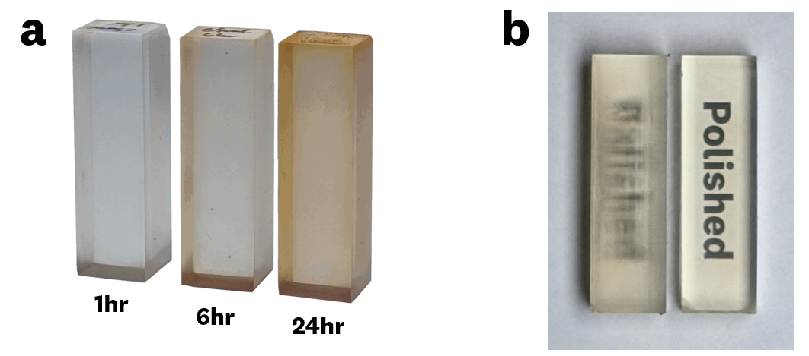
Supplementary Fig. 2 3DP cuvettes used for optical characterization a Visualization of “yellowing” associated with increased post-curing time on 3DP solid cuvettes (eSun clear resin). b Polished and unpolished 3DP cuvettes. Polishing enables spectral measurements of the printed material.

Supplementary Fig. 3 Spectral shifts of IR-125 laser dye in three commercially available resins. a normalized absorbance spectra b normalized fluorescence emission spectra. Optical measurements were performed on 3DP cuvettes with an IR-125 dye concentration of 1000nM.

Supplementary Fig. 4 Spectral comparison of IR-125 doped uncured resin and 3D printed material using three commercially available resins. a,b eSun Standard Clear resin. c,d 3DM Tough resin. e,f , NextGen 3Dresyn TD90. Optical measurements were performed on 3DP cuvettes with an IR-125 dye concentration of 1000nM.

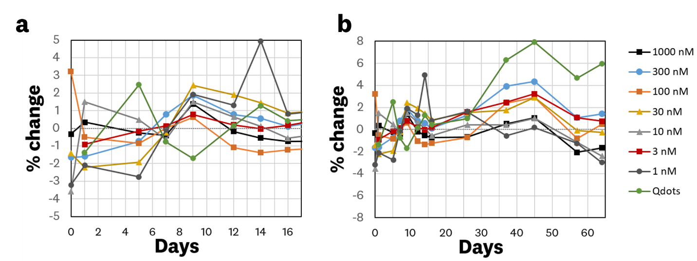
Supplementary Fig. 5 Photostability measurements performed over two months on IR-125 and quantum dot doped 3DP material. a First 16 days of measurements b 64 days of photostability measurements. The measured standard deviation for the each timepoint is 1-2%; error bars are omitted for visual clarity.

