Supplementary data

Detection of Borrelia burgdorferi antigens in tissues and plasma during early infection in a mouse model

Victoria Dolange¹, Stéphanie Simon¹ and Nathalie Morel¹

Supplementary Figure S1
Standard curve of qPCR using serial dilutions of B. afzelii BO23 strain DNA.

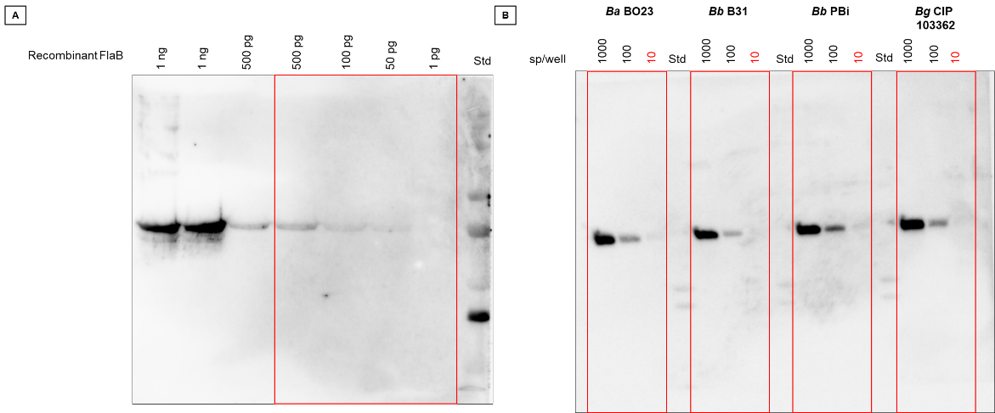
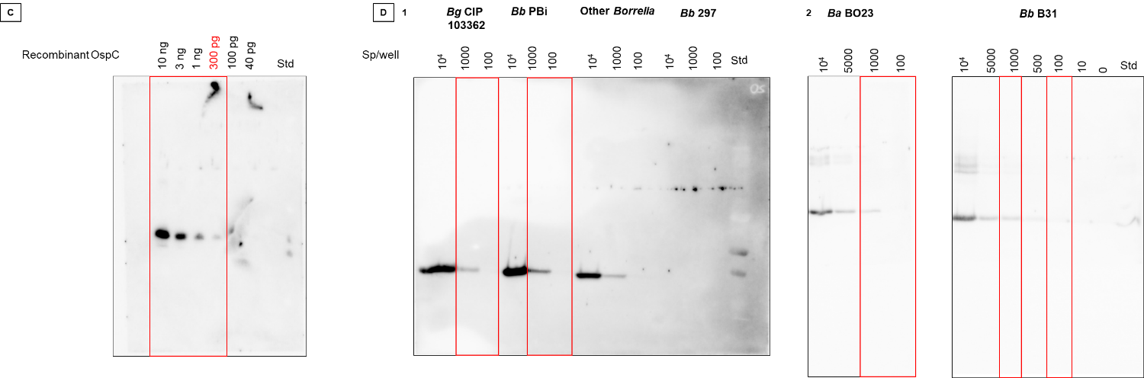
Supplementary Figure S2
Original, uncropped images of western blot membranes shown in Figure 1. [A] Exposure: Auto optimal 395.082 s [B] Exposure: Auto optimal 28.999s [C] Exposure: Auto optimal 7.523 s [D] 1.Exposure: Auto optimal 64.465 s 2.Exposure: Auto optimal 24.333s. Red boxes represent the regions used in the main figures. The standards correspond to the Chemidoc chemiluminescence image, for a better visibility of the markers, the images were also captured by colorimetry.

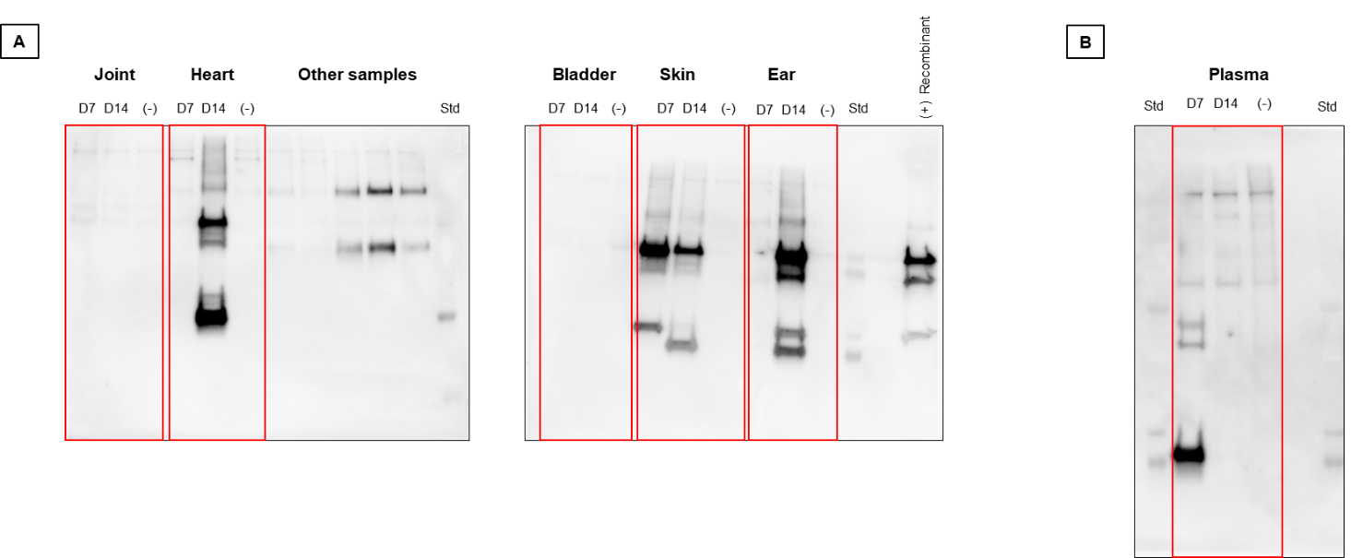
Supplementary Figure S3
Original, uncropped images of western blot membranes shown in Figure 5. [A] Exposure: Auto optimal 33.629 s [B] Exposure: Auto optimal 53.752 s. Red boxes represent the regions used in the main figures. The standards correspond to the Chemidoc chemiluminescence image, for a better visibility of the markers, the images were also captured by colorimetry.

