Title: Genomic Landscape of Gliosarcoma: Distinguishing Features and Targetable Alterations

Short title: Genomic Landscape of Gliosarcoma

Authors Mark M. Zaki, BS, BA¹; Eleanor Woodward, BS¹; Leila Mashouf, BS¹; Saksham Gupta, MD¹; Ian F. Dunn, MD²; Patrick Wen, MD³; Brian V. Nahed, MD, MSc³; Wenya Linda Bi, MD, PhD¹

¹Center for Skull Base and Pituitary Surgery, Department of Neurosurgery, Brigham and Women’s Hospital, Harvard Medical School, Boston, MA
²Department of Neurosurgery, University of Oklahoma Health Sciences Center, Oklahoma City, OK
³Center for NeuroOncology, Dana-Farber Cancer Institute, Harvard Medical School, Boston, MA
⁴Department of Neurosurgery, Massachusetts General Hospital, Harvard Medical School, Boston, MA

Conflict of interests: none for all authors

Disclosures: none for all authors

Funding: none for all authors

Post-Publication Corresponding Author:
Wenya Linda Bi, MD, PhD
Center for Skull Base and Pituitary Surgery
Department of Neurosurgery
Brigham and Women’s Hospital
60 Fenwood Road
Boston, MA 02115
Phone : 617-525-8319
Fax : 617-713-3050
E-mail : wbi@bwh.harvard.edu

Supplementary Figure 1.
- Glioblastoma Comut Plot
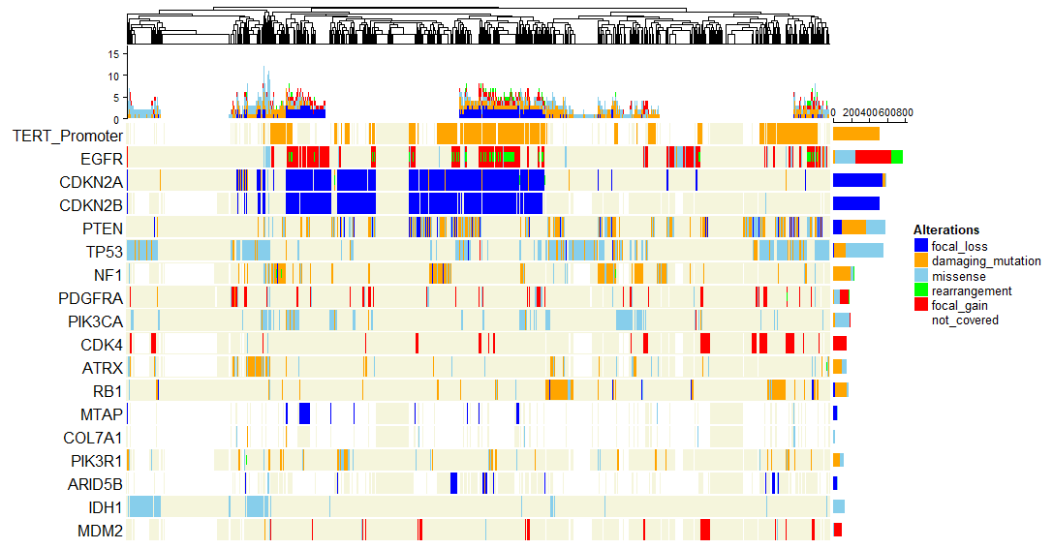

- Soft Tissue Sarcoma Comut Plot
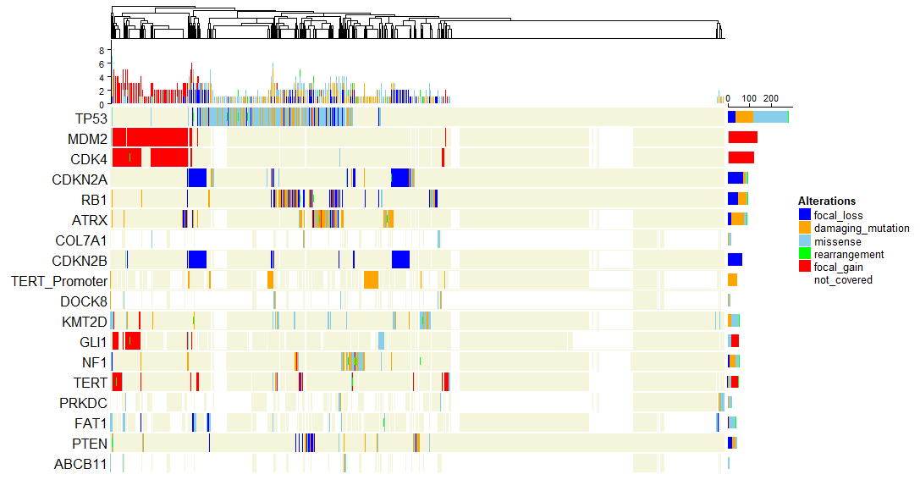

Supplementary Table 1. Contributing GENIE Institutions
Institution | Panel | No. of Genes Assayed | No. of Cases
MSK | MSK-IMPACT341 | 341 | 4
MSK | MSK-IMPACT410 | 410 | 4
MSK | MSK-IMPACT468 | 468 | 4
MDA | MDA-46-V1 | 46 | 2
MDA | MDA-50-V1 | 50 | 5
JHU | JHU-50GP-V2 | 40 | 3
DFCI | DFCI-ONCOPANEL-1 | 275 | 1
DFCI | DFCI-ONCOPANEL-2 | 300 | 4
DFCI | DFCI-ONCOPANEL-3 | 447 | 1
DFCI | GRCC-MOSC4 | 82 | 2

Supplementary Table 2. Total Alterations per Sample
Sample | Total  No. of Alterations | No. of Mutations | No. of Copy Number Alterations (CNAs) (All) |  | No. of CNAs (High-level only) |  | No. of Structural Variants | Sequencing Assay
 |  |  | + | - | + | -
GENIE-DFCI-002987-63 | 39 | 2 | 18 | 19 | 0 | 0 | 0 | DFCI-ONCOPANEL-1
GENIE-DFCI-007570-4277 | 110 | 4 | 17 | 89 | 0 | 0 | 0 | DFCI-ONCOPANEL-2
GENIE-DFCI-008626-7049 | 101 | 5 | 8 | 88 | 2 | 1 | 0 | DFCI-ONCOPANEL-2
GENIE-DFCI-010523-10381 | 139 | 6 | 130 | 3 | 2 | 1 | 0 | DFCI-ONCOPANEL-2
GENIE-DFCI-037378-73845 | 132 | 29 | 86 | 17 | 0 | 0 | 0 | DFCI-ONCOPANEL-2
GENIE-DFCI-037074-88660 | 88 | 10 | 22 | 56 | 0 | 5 | 0 | DFCI-ONCOPANEL-3
GENIE-GRCC-z221npmm-sample-a | 5 | 5 | 0 | 0 | 0 | 0 | 0 | GRCC-MOSC4
GENIE-GRCC-e2ddkv4y-sample-a | 0 | 0 | 0 | 0 | 0 | 0 | 0 | GRCC-MOSC4
GENIE-JHU-01841-02250 | 2 | 2 | 0 | 0 | 0 | 0 | 0 | JHU-50GP-V2
GENIE-JHU-03996-04667 | 1 | 1 | 0 | 0 | 0 | 0 | 0 | JHU-50GP-V2
GENIE-JHU-04154-04848 | 1 | 1 | 0 | 0 | 0 | 0 | 0 | JHU-50GP-V2
GENIE-MDA-2285-4440 | 2 | 2 | 0 | 0 | 0 | 0 | 0 | MDA-46-V1
GENIE-MDA-2287-4442 | 1 | 1 | 0 | 0 | 0 | 0 | 0 | MDA-46-V1
GENIE-MDA-3132-5662 | 1 | 1 | 0 | 0 | 0 | 0 | 0 | MDA-50-V1
GENIE-MDA-4953-15967 | 2 | 2 | 0 | 0 | 0 | 0 | 0 | MDA-50-V1
GENIE-MDA-5743-16652 | 1 | 1 | 0 | 0 | 0 | 0 | 0 | MDA-50-V1
GENIE-MDA-5984-16909 | 1 | 1 | 0 | 0 | 0 | 0 | 0 | MDA-50-V1
GENIE-MDA-6678-17919 | 2 | 2 | 0 | 0 | 0 | 0 | 0 | MDA-50-V1
GENIE-MSK-P-0000653-T01-IM3 | 8 | 8 | 0 | 0 | 0 | 0 | 0 | MSK-IMPACT341
GENIE-MSK-P-0001049-T01-IM3 | 2 | 2 | 0 | 0 | 2 | 1 | 0 | MSK-IMPACT341
GENIE-MSK-P-0001053-T01-IM3 | 6 | 6 | 0 | 0 | 0 | 0 | 0 | MSK-IMPACT341
GENIE-MSK-P-0002138-T01-IM3 | 8 | 7 | 0 | 1 | 1 | 0 | 0 | MSK-IMPACT341
GENIE-MSK-P-0006848-T01-IM5 | 6 | 6 | 0 | 0 | 0 | 0 | 0 | MSK-IMPACT410
GENIE-MSK-P-0008380-T01-IM5 | 3 | 3 | 0 | 0 | 0 | 1 | 0 | MSK-IMPACT410
GENIE-MSK-P-0009649-T01-IM5 | 6 | 6 | 0 | 0 | 0 | 3 | 0 | MSK-IMPACT410
GENIE-MSK-P-0011026-T01-IM5 | 4 | 4 | 0 | 0 | 2 | 2 | 0 | MSK-IMPACT410
GENIE-MSK-P-0015347-T01-IM6 | 6 | 6 | 0 | 0 | 0 | 2 | 0 | MSK-IMPACT468
GENIE-MSK-P-0016784-T01-IM6 | 2 | 2 | 0 | 0 | 0 | 0 | 0 | MSK-IMPACT468
GENIE-MSK-P-0021478-T01-IM6 | 5 | 4 | 0 | 0 | 0 | 2 | 1 | MSK-IMPACT468
GENIE-MSK-P-0021832-T01-IM6 | 6 | 6 | 0 | 0 | 0 | 1 | 0 | MSK-IMPACT468

Supplementary Table 3. Comparison of Gliosarcoma alterations frequencies with GBM and Soft Tissue Sarcoma (STS)
Gene | Alteration Type | Gliosarcoma samples altered (n) | Samples Assayed (n) | Gliosarcoma Alteration Frequency (%) | GBM Alteration Frequency (%) | STS Alteration Frequency (%) | Gliosarcoma vs. GBM p-value | Gliosarcoma vs. STS p-value | Gliosarcoma vs. GBM q-value (FDR corr.) | Gliosarcoma vs. STS q-value (FDR corr.) | Gliosarcoma frequency closer to GBM than STS?
TERT Promoter* | mut | 12 | 13 | 92.3% | 71.7% | 6.6% | 1.25E-01 | 3.43E-13 | 2.99E-01 | 6.35E-12 | TRUE
TP53 | mut | 18 | 30 | 60.0% | 35.0% | 22.3% | 6.41E-03 | 1.34E-05 | 1.40E-01 | 1.65E-04 | TRUE
PTEN | mut | 15 | 30 | 50.0% | 32.9% | 2.4% | 7.58E-02 | 2.26E-15 | 2.54E-01 | 8.37E-14 | TRUE
NF1 | mut | 7 | 20 | 35.0% | 18.2% | 5.0% | 7.56E-02 | 5.34E-05 | 2.54E-01 | 3.95E-04 | TRUE
CDKN2A | cna | 5 | 18 | 27.8% | 46.8% | 7.7% | 1.52E-01 | 1.13E-02 | 3.20E-01 | 3.48E-02 | FALSE
CDKN2B | cna | 5 | 18 | 27.8% | 44.2% | 7.3% | 2.31E-01 | 8.98E-03 | 4.07E-01 | 3.02E-02 | FALSE
STAG2 | mut | 4 | 18 | 22.2% | 5.3% | 0.7% | 1.51E-02 | 1.85E-05 | 1.40E-01 | 1.71E-04 | TRUE
RB1 | mut | 6 | 30 | 20.0% | 10.7% | 4.5% | 1.29E-01 | 2.60E-03 | 2.99E-01 | 1.20E-02 | TRUE
PTEN | cna | 3 | 18 | 16.7% | 8.2% | 2.2% | 1.85E-01 | 8.25E-03 | 3.42E-01 | 3.02E-02 | TRUE
ARID2 | mut | 2 | 18 | 11.1% | 3.0% | 2.0% | 1.09E-01 | 5.75E-02 | 2.88E-01 | 1.18E-01 | TRUE
CBL | mut | 2 | 18 | 11.1% | 2.0% | 1.0% | 5.59E-02 | 1.68E-02 | 2.54E-01 | 4.59E-02 | TRUE
MSH6 | mut | 2 | 18 | 11.1% | 2.5% | 1.4% | 8.10E-02 | 3.07E-02 | 2.54E-01 | 7.10E-02 | TRUE
SUZ12 | mut | 2 | 18 | 11.1% | 0.9% | 1.0% | 1.37E-02 | 1.74E-02 | 1.40E-01 | 4.59E-02 | TRUE
SOX2 | cna | 2 | 18 | 11.1% | 3.9% | 0.1% | 1.57E-01 | 1.03E-03 | 3.20E-01 | 6.35E-03 | TRUE
BRAF | mut | 3 | 30 | 10.0% | 3.5% | 1.2% | 8.93E-02 | 8.67E-03 | 2.54E-01 | 3.02E-02 | TRUE
PTPN11 | mut | 3 | 30 | 10.0% | 5.9% | 0.7% | 4.18E-01 | 2.08E-03 | 6.73E-01 | 1.10E-02 | TRUE
APC | mut | 2 | 30 | 6.7% | 2.3% | 3.3% | 1.64E-01 | 2.67E-01 | 3.20E-01 | 4.49E-01 | TRUE
EGFR | mut | 2 | 30 | 6.7% | 21.7% | 1.2% | 4.42E-02 | 6.34E-02 | 2.54E-01 | 1.24E-01 | FALSE
FBXW7 | mut | 2 | 30 | 6.7% | 1.1% | 1.2% | 4.98E-02 | 5.59E-02 | 2.54E-01 | 1.18E-01 | TRUE
CREBBP | mut | 1 | 18 | 5.6% | 4.3% | 3.1% | 5.52E-01 | 4.41E-01 | 8.52E-01 | 7.10E-01 | TRUE
CREBBP | cna | 1 | 18 | 5.6% | 0.2% | 0.0% | 4.49E-02 | 1.92E-02 | 2.54E-01 | 4.73E-02 | TRUE
EGFR | cna | 1 | 18 | 5.6% | 33.9% | 0.3% | 1.01E-02 | 7.46E-02 | 1.40E-01 | 1.38E-01 | FALSE
NF1 | cna | 1 | 18 | 5.6% | 0.4% | 0.9% | 8.79E-02 | 1.61E-01 | 2.54E-01 | 2.83E-01 | TRUE
RB1 | cna | 1 | 18 | 5.6% | 1.5% | 5.2% | 2.42E-01 | 1.00E+00 | 4.07E-01 | 1.00E+00 | FALSE
CDKN2A | mut | 1 | 30 | 3.3% | 3.0% | 2.1% | 6.08E-01 | 4.83E-01 | 9.00E-01 | 7.45E-01 | TRUE
CDKN2B | mut | 0 | 18 | 0.0% | 0.4% | 0.1% | 1.00E+00 | 1.00E+00 | 1.00E+00 | 1.00E+00 | FALSE
SOX2 | mut | 0 | 18 | 0.0% | 0.3% | 0.6% | 1.00E+00 | 1.00E+00 | 1.00E+00 | 1.00E+00 | TRUE
APC | cna | 0 | 18 | 0.0% | 0.0% | 0.1% | 1.00E+00 | 1.00E+00 | 1.00E+00 | 1.00E+00 | FALSE
ARID2 | cna | 0 | 18 | 0.0% | 0.4% | 0.1% | 1.00E+00 | 1.00E+00 | 1.00E+00 | 1.00E+00 | FALSE
BRAF | cna | 0 | 18 | 0.0% | 0.5% | 0.0% | 1.00E+00 | 1.00E+00 | 1.00E+00 | 1.00E+00 | FALSE
CBL | cna | 0 | 18 | 0.0% | 0.0% | 0.4% | 1.00E+00 | 1.00E+00 | 1.00E+00 | 1.00E+00 | FALSE
FBXW7 | cna | 0 | 18 | 0.0% | 0.1% | 0.3% | 1.00E+00 | 1.00E+00 | 1.00E+00 | 1.00E+00 | TRUE
MSH6 | cna | 0 | 18 | 0.0% | 0.1% | 0.0% | 1.00E+00 | 1.00E+00 | 1.00E+00 | 1.00E+00 | FALSE
PTPN11 | cna | 0 | 18 | 0.0% | 0.1% | 0.4% | 1.00E+00 | 1.00E+00 | 1.00E+00 | 1.00E+00 | TRUE
STAG2 | cna | 0 | 18 | 0.0% | 0.3% | 0.1% | 1.00E+00 | 1.00E+00 | 1.00E+00 | 1.00E+00 | FALSE
SUZ12 | cna | 0 | 18 | 0.0% | 0.1% | 0.5% | 1.00E+00 | 1.00E+00 | 1.00E+00 | 1.00E+00 | TRUE
TP53 | cna | 0 | 18 | 0.0% | 1.0% | 4.1% | 1.00E+00 | 1.00E+00 | 1.00E+00 | 1.00E+00 | TRUE
Abbreviations: mutation (mut); copy number alteration (cna).
*TERT Promoter region not specifically annotated for CNAs
Yellow highlight indicates p < .05
Red highlight indicates “false”

Supplementary Table 4. Mutation and CNA frequency in genes altered in greater than 5% of samples in GBM and Soft Tissue Sarcoma (STS).
GBM
Gene | No. of samples mutated | No. of samples assayed (mutations) | Mutation Frequency (%) | No. of samples with CNA | No. of samples assayed (CNA) | CNA Frequency (%) | Total Combined Alteration Frequency (%)
TERT Promoter | 521 | 727 | 71.7% | NA | NA | 0.0% | 71.7%
EGFR | 241 | 1449 | 16.6% | 396 | 1168 | 33.9% | 50.5%
CDKN2A | 40 | 1449 | 2.8% | 547 | 1168 | 46.8% | 49.6%
CDKN2B | 5 | 1181 | 0.4% | 516 | 1168 | 44.2% | 44.6%
PTEN | 477 | 1449 | 32.9% | 96 | 1168 | 8.2% | 41.1%
TP53 | 507 | 1449 | 35.0% | 12 | 1168 | 1.0% | 36.0%
NF1 | 212 | 1196 | 17.7% | 5 | 1168 | 0.4% | 18.2%
PDGFRA | 74 | 1436 | 5.2% | 98 | 1168 | 8.4% | 13.5%
PIK3CA | 184 | 1449 | 12.7% | 9 | 1168 | 0.8% | 13.5%
CDK4 | 5 | 1181 | 0.4% | 149 | 1168 | 12.8% | 13.2%
ATRX | 142 | 1181 | 12.0% | 3 | 1168 | 0.3% | 12.3%
RB1 | 153 | 1449 | 10.6% | 17 | 1168 | 1.5% | 12.0%
MTAP | 5 | 176 | 2.8% | 49 | 592 | 8.3% | 11.1%
COL7A1 | 19 | 176 | 10.8% | 0 | 592 | 0.0% | 10.8%
PIK3R1 | 115 | 1196 | 9.6% | 1 | 1168 | 0.1% | 9.7%
ARID5B | 9 | 551 | 1.6% | 42 | 551 | 7.6% | 9.3%
IDH1 | 134 | 1449 | 9.2% | 0 | 1168 | 0.0% | 9.2%
MDM2 | 10 | 1181 | 0.8% | 89 | 1168 | 7.6% | 8.5%
PIK3C2B | 17 | 617 | 2.8% | 32 | 617 | 5.2% | 7.9%
KIT | 28 | 1449 | 1.9% | 65 | 1168 | 5.6% | 7.5%
PRKDC | 47 | 630 | 7.5% | 0 | 617 | 0.0% | 7.5%
SETD2 | 81 | 1181 | 6.9% | 1 | 1168 | 0.1% | 6.9%
KDR | 36 | 1449 | 2.5% | 50 | 1168 | 4.3% | 6.8%
GLI1 | 25 | 1103 | 2.3% | 52 | 1168 | 4.5% | 6.7%
FANCM | 13 | 201 | 6.5% | 0 | 592 | 0.0% | 6.5%
KMT2D | 73 | 1181 | 6.2% | 2 | 1143 | 0.2% | 6.4%
USP28 | 11 | 176 | 6.3% | 0 | 592 | 0.0% | 6.3%
MDM4 | 9 | 1181 | 0.8% | 64 | 1168 | 5.5% | 6.2%
PTPN11 | 85 | 1449 | 5.9% | 1 | 1168 | 0.1% | 6.0%
TEK | 5 | 243 | 2.1% | 21 | 551 | 3.8% | 5.9%
STAG2 | 63 | 1179 | 5.3% | 3 | 1143 | 0.3% | 5.6%
CDKN2C | 21 | 1170 | 1.8% | 42 | 1168 | 3.6% | 5.4%
FAT1 | 34 | 750 | 4.5% | 7 | 1168 | 0.6% | 5.1%
KAT6B | 9 | 178 | 5.1% | 0 | 592 | 0.0% | 5.1%
STS
Gene | No. of samples mutated | No. of samples assayed (mutations) | Mutation Frequency (%) | No. of samples with CNA | No. of samples assayed (CNA) | CNA Frequency (%) | Total Combined Alteration Frequency (%)
TP53 | 229 | 1042 | 22.0% | 38 | 921 | 4.1% | 26.1%
MDM2 | 3 | 933 | 0.3% | 134 | 921 | 14.5% | 14.9%
CDK4 | 4 | 933 | 0.4% | 118 | 921 | 12.8% | 13.2%
CDKN2A | 21 | 1042 | 2.0% | 71 | 921 | 7.7% | 9.7%
RB1 | 46 | 1042 | 4.4% | 48 | 921 | 5.2% | 9.6%
ATRX | 69 | 933 | 7.4% | 19 | 921 | 2.1% | 9.5%
COL7A1 | 14 | 160 | 8.8% | 0 | 406 | 0.0% | 8.8%
CDKN2B | 1 | 933 | 0.1% | 67 | 921 | 7.3% | 7.4%
TERT Promoter | 44 | 671 | 6.6% | 0 | 0 | 0.0% | 6.6%
DOCK8 | 10 | 160 | 6.3% | 1 | 406 | 0.2% | 6.5%
KMT2D | 49 | 933 | 5.3% | 3 | 917 | 0.3% | 5.6%
GLI1 | 16 | 859 | 1.9% | 34 | 921 | 3.7% | 5.6%
NF1 | 43 | 939 | 4.6% | 8 | 921 | 0.9% | 5.4%
TERT | 15 | 917 | 1.6% | 34 | 917 | 3.7% | 5.3%

