Supplementary Annex:
Association of Maternal History of Neonatal Death with Subsequent Neonatal Death across 56 Low- and Middle-Income Countries

Appendix Table 1. Countries and survey years involved in the study
Country | Survey year | Income class
Afghanistan | 2015 | L
Angola | 2015-16 | UM
Bangladesh | 2014 | LM
Benin | 2017-18 | L
Burkina Faso | 2010 | L
Burundi | 2016-17 | L
Cambodia | 2014 | L
Cameroon | 2018 | LM
Chad | 2014-15 | L
Colombia | 2015 | UM
Comoros | 2012 | L
Congo, Rep. | 2011-12 | LM
Cote d'Ivoire | 2011-12 | LM
Congo, Dem. Rep. | 2013-14 | L
Dominican Republic | 2013 | UM
Egypt, Arab Rep. | 2014 | LM
Ethiopia | 2016 | L
Gabon | 2012 | UM
Gambia, The | 2013 | L
Ghana | 2014 | LM
Guatemala | 2014-15 | LM
Guinea | 2018 | L
Haiti | 2016-17 | L
Honduras | 2011-12 | LM
India | 2015-16 | LM
Indonesia | 2017 | LM
Jordan | 2017-18 | UM
Kenya | 2014 | LM
Kyrgyz Republic | 2012 | L
Lesotho | 2014 | LM
Liberia | 2013 | L
Malawi | 2015-16 | L
Maldives | 2016-17 | UM
Mali | 2018 | L
Mozambique | 2011 | L
Myanmar | 2015-16 | LM
Namibia | 2013 | UM
Nepal | 2016 | L
Niger | 2012 | L
Nigeria | 2018 | LM
Pakistan | 2017-18 | LM
Papua New Guinea | 2016-18 | LM
Peru | 2012 | UM
Philippines | 2017 | LM
Rwanda | 2014-15 | L
Senegal | 2018 | LM
Sierra Leone | 2013 | L
South Africa | 2016 | UM
Tajikistan | 2017 | L
Tanzania | 2015-16 | L
Timor-Leste | 2016 | LM
Togo | 2013-14 | L
Uganda | 2016 | L
Yemen | 2013 | LM
Zambia | 2018 | LM
Zimbabwe | 2015 | L
Note:
“L” represents “low-income countries”; “LM” represents “lower-middle-income countries”; “UM” represents “upper-middle-income countries”.

Appendix Table 2. The attenuation effect between unadjusted (UOR) and partially adjusted odds ratios (PAOR) for neonatal mortality by maternal history of neonatal death, pooled sample
Covariates | PAOR (95% CI) | Change (%)
Wealth, quintile
Poorest | 3.23(3.00, 3.47) | 1.0%
Poorer | 3.25(3.02, 3.49) | 0.1%
Middle | 3.25(3.03, 3.50) | -0.1%
Richer | 3.24(3.02, 3.49) | 0.2%
Richest | 3.22(3.00, 3.47) | 1.2%
Place of residence, urban | 3.23(3.00, 3.47) | 0.9%
Maternal education, y
0 | 3.14(2.92, 3.38) | 4.8%
<5 | 3.25(3.02, 3.50) | -0.1%
5-7 | 3.25(3.02, 3.50) | 0.0%
8-9 | 3.24(3.02, 3.49) | 0.3%
10-11 | 3.22(2.99, 3.46) | 1.4%
≥12 | 3.20(2.98, 3.44) | 2.2%
Sex of child, male | 3.26(3.04, 3.51) | -0.7%
Birth weight
Not weighted | 3.05(2.83, 3.28) | 9.0%
Low
Mother's recall | 3.24(3.01, 3.48) | 0.5%
Written card | 3.25(3.03, 3.50) | -0.2%
Within reference range or higher
Mother's recall | 3.20(2.97, 3.44) | 2.4%
Written card | 3.11(2.89, 3.35) | 6.1%
Birth size
Within reference range or higher | 3.22(2.99, 3.46) | 1.6%
Small | 3.23(3.01, 3.48) | 0.8%
Very small | 3.18(2.95, 3.42) | 3.3%
Antenatal care visits, No.
0 | 3.18(2.96, 3.43) | 2.9%
1-4 | 3.26(3.03, 3.51) | -0.6%
5-7 | 3.24(3.01, 3.48) | 0.5%
8-9 | 3.22(2.99, 3.46) | 1.5%
≥10 | 3.23(3.00, 3.47) | 1.0%
Delivered with skilled birth attendant | 3.23(3.00, 3.48) | 0.9%
Institutional delivery | 3.19(2.97, 3.44) | 2.5%
Full tetanus protection | 3.25(3.02, 3.50) | 0.0%
Maternal age at birth, y
<18 | 3.25(3.03, 3.50) | -0.2%
18-34 | 3.11(2.89, 3.34) | 6.3%
≥35 | 3.10(2.89, 3.34) | 6.5%
Birth interval, mo
<18 | 3.04(2.82, 3.27) | 9.6%
18-59 | 3.24(3.02, 3.49) | 0.5%
≥59 | 3.25(3.02, 3.49) | 0.2%
Improved sanitation | 3.12(2.90, 3.37) | 5.7%
Improved water | 3.27(3.04, 3.52) | -1.0%
Breastfeeding initiation <1 hour of birth | 2.78(2.47, 3.13) | 20.9%
Number of household members
<6 | 3.32(3.09, 3.57) | -3.3%
6-10 | 3.29(3.06, 3.54) | -1.8%
≥10 | 3.26(3.03, 3.51) | -0.5%

Note:
- “Change” is the degree to which the odds ratios were attenuated after adjustment that was calculated according to the formula $\frac{UOR-PAOR}{UOR-1}*100$

Appendix Table 3. Unadjusted (UOR) and fully adjusted odds ratios (FAOR) for neonatal mortality by maternal history of neonatal death
Country | UOR | FAOR | Change
Afghanistan | 2.6(1.6, 4.2) | 2.2(1.2, 4.0) | 26.5%
Angola | 5.2(3.0, 8.9) | 5.1(2.9, 9.1) | 1.7%
Bangladesh | 1.2(0.5, 3.2) | 1.1(0.4, 3.1) | 52.7%
Benin | 2.7(1.7, 4.2) | 2.3(1.4, 3.7) | 24.5%
Burkina Faso | 3.2(2.0, 5.2) | 2.7(1.6, 4.4) | 23.7%
Burundi | 2.2(1.0, 4.9) | 1.7(0.9, 3.1) | 42.5%
Cambodia | 6.2(2.4, 15.8) | 3.2(1.2, 8.8) | 57.2%
Cameroon | 2.9(1.8, 4.9) | 2.3(1.3, 3.9) | 32.0%
Chad | 2.4(1.6, 3.6) | 2.2(1.5, 3.3) | 11.6%
Colombia | 4.5(1.5, 13.5) | 3.9(1.3, 11.9) | 17.6%
Comoros | 6.9(2.7, 17.9) | 2.2(1.9, 3.4) | 80.0%
Congo, Dem. Rep. | 2.5(1.4, 4.4) | 2.0(1.1, 3.7) | 30.5%
Congo, Rep. | 1.1(0.3, 4.7) | 1.4(0.4, 5.0) | -344.5%
Cote d'Ivoire | 2.4(1.3, 4.2) | 2.4(1.4, 4.2) | 0.5%
Dominican Republic | 0.3(0.0, 2.1) | 0.4(0.0, 4.0) | 12.9%
Egypt, Arab Rep. | 6.2(3.3, 11.6) | 11.7(4.5, 39.7) | -106.5%
Ethiopia | 2.4(1.3, 4.8) | 2.3(1.1, 4.6) | 6.7%
Gabon | 4.0(1.2, 12.9) | 2.1(0.4, 10.6) | 64.7%
Gambia, The | 4.0(1.9, 8.3) | 4.3(2.0, 9.4) | -11.2%
Ghana | 4.9(2.1, 11.2) | 5.1(2.0, 13.2) | -5.2%
Guatemala | 2.8(1.3, 6.2) | 2.2(0.9, 5.2) | 32.5%
Guinea | 3.9(2.4, 6.1) | 3.2(2.0, 5.2) | 23.0%
Haiti | 4.2(1.9, 9.2) | 3.8(1.6, 9.3) | 11.9%
Honduras | 2.5(1.2, 5.5) | 1.6(0.7, 3.4) | 61.6%
India | 3.5(3.1, 4.0) | 2.5(2.2, 2.9) | 39.0%
Indonesia | 5.3(3.1, 9.0) | 4.1(2.3, 7.6) | 26.9%
Jordan | 13.2(4.4, 39.0) | 10.7(3.5, 32.9) | 20.5%
Kenya | 1.9(1.1, 3.1) | 1.6(0.9, 2.7) | 36.3%
Kyrgyz Republic | 2.0(0.4, 9.6) | 0.7(0.0, 12.7) | 128.1%
Lesotho | 2.4(1.0, 5.8) | 1.9(0.7, 5.3) | 37.5%
Liberia | 2.3(1.1, 4.8) | 2.7(1.2, 6.1) | -32.4%
Malawi | 3.9(2.3, 6.6) | 3.6(2.0, 6.2) | 11.7%
Maldives | 5.8(1.4, 24.6) | 5.3(0.6, 30.4) | 10.7%
Mali | 2.6(1.5, 4.4) | 2.2(1.2, 3.8) | 27.1%
Mozambique | 2.6(1.5, 4.4) | 2.6(1.4, 4.6) | 0.8%
Myanmar | 2.6(1.1, 6.0) | 1.7(0.7, 4.3) | 54.2%
Namibia | 3.3(1.3, 8.7) | 3.6(1.2, 10.8) | -13.1%
Nepal | 3.4(1.4, 8.0) | 3.9(1.4, 10.6) | -21.4%
Niger | 4.1(2.5, 6.9) | 3.8(2.2, 6.6) | 8.3%
Nigeria | 2.5(1.9, 3.2) | 2.3(1.8, 3.1) | 10.4%
Pakistan | 2.0(1.0, 4.0) | 2.0(1.0, 4.0) | 0.1%
Papua New Guinea | 2.1(1.0, 4.6) | 1.8(0.8, 4.1) | 29.4%
Peru | 2.4(0.9, 6.5) | 2.6(0.7, 9.0) | -12.6%
Philippines | 6.4(2.4, 17.0) | 6.2(2.6, 15.0) | 3.2%
Rwanda | 4.7(2.5, 9.0) | 3.5(1.7, 7.2) | 32.2%
Senegal | 2.0(0.8, 4.8) | 1.4(0.5, 4.2) | 56.6%
Sierra Leone | 2.2(1.4, 3.5) | 2.2(1.4, 3.7) | -3.3%
South Africa | 7.5(2.7, 21.1) | 16.1(3.6, 42.0) | -131.6%
Tajikistan | 6.1(2.2, 17.4) | 6.0(2.1, 16.8) | 2.6%
Tanzania | 3.4(1.8, 6.5) | 2.7(1.5, 4.7) | 30.4%
Timor-Leste | 4.2(2.0, 9.1) | 2.7(1.3, 5.8) | 45.4%
Togo | 4.3(2.3, 7.9) | 3.0(1.4, 6.5) | 38.6%
Uganda | 2.9(1.8, 4.6) | 2.5(1.5, 4.0) | 23.6%
Yemen, Rep. | 3.4(2.1, 5.6) | 2.8(1.7, 4.6) | 26.2%
Zambia | 3.2(1.6, 6.2) | 2.6(1.2, 5.5) | 27.0%
Zimbabwe | 2.8(1.2, 6.5) | 2.5(0.9, 6.6) | 18.8%

Note:
- We marked the insignificant associations in red
- “Change” is the degree to which the odds ratios were attenuated after adjustment that was calculated according to the formula $\frac{UOR-FAOR}{UOR-1}*100$

Appendix Figure 1. Unadjusted (UOR) and fully adjusted odds ratio (FAOR) for period of occurrence of mortality stratified by maternal history of neonatal death
- UOR
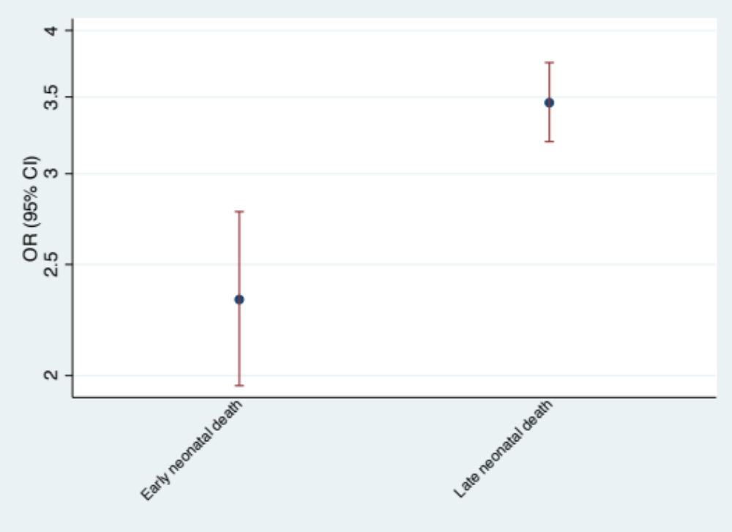
3.46 (3.20, 3.75)
2.33 (1.96, 2.78)

- FAOR
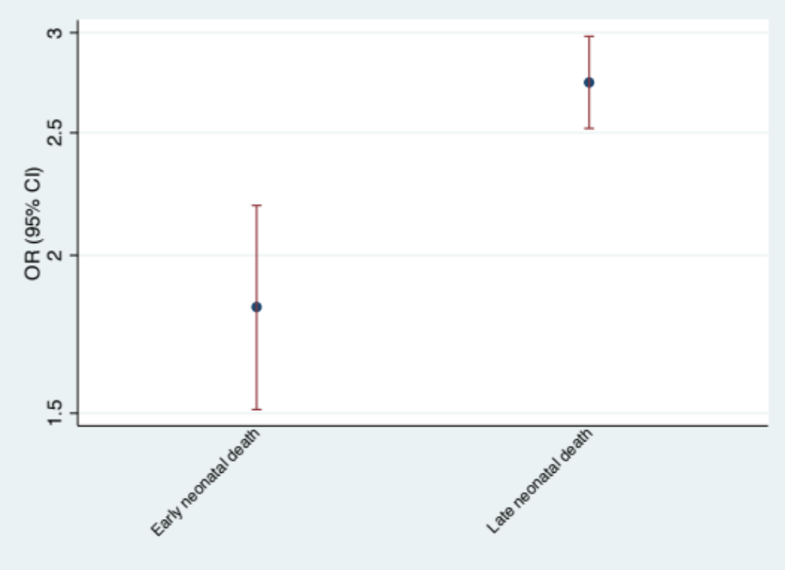
2.74 (2.52, 2.98)
1.82 (1.51, 2.19)
Note: The two ORs in both unadjusted and adjusted models were significant different from each other with p<0.001

Appendix Figure 2. Unadjusted (UOR) and fully adjusted odds ratios (FAOR) for neonatal mortality stratified by maternal history of one neonatal death or more than one neonatal deaths
- UOR
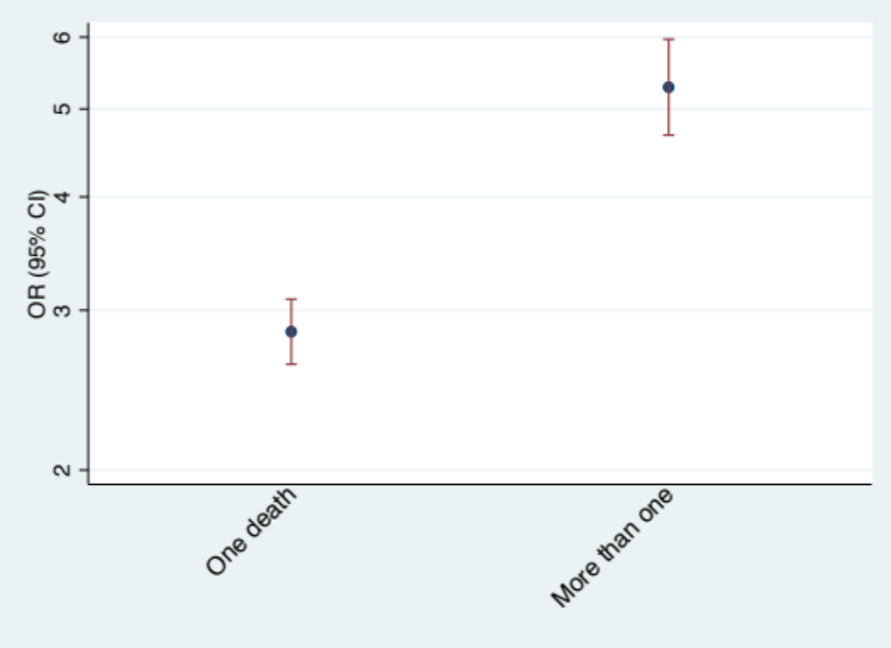
2.84 (2.62, 3.09)
5.28 (4.68, 5.97)

- FAOR
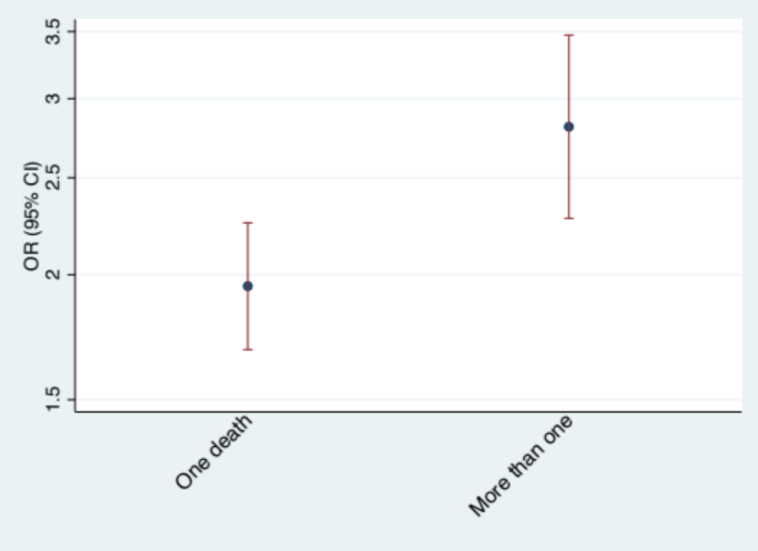
2.81 (2.28, 3.47)
1.94 (1.68, 2.25)

Note: The two ORs in both unadjusted and adjusted models were significant different from each other with p<0.001
Appendix Table 4. Fully adjusted odds ratio for period of occurrence of mortality stratified by maternal history of neonatal death by country
Country | Early neonatal death | Late neonatal death | Difference
Country | Early neonatal death | Late neonatal death | P value | Direction
Afghanistan | 2.69(1.47, 4.92) | 1.11(0.42, 2.94) | 0.000 | +
Angola | 5.52(3.01, 10.11) | 2.02(0.37, 11.03) | 0.000 | +
Bangladesh | 1.17(0.27, 5.15) | 0.89(0.16, 5.00) | 0.133 | Insignificant
Benin | 2.37(1.43, 3.94) | 1.15(0.27, 4.92) | 0.000 | +
Burkina Faso | 2.61(1.43, 4.78) | 2.66(1.19, 5.91) | 0.087 | Insignificant
Burundi | 1.56(0.72, 3.36) | 1.75(0.66, 4.65) | 0.077 | Insignificant
Cambodia | 3.14(0.88, 11.19) | 3.47(0.90, 13.34) | 0.054 | Insignificant
Cameroon | 2.24(1.19, 4.22) | 2.84(0.76, 10.56) | 0.000 | -
Chad | 2.69(1.72, 4.20) | 1.17(0.49, 2.79) | 0.000 | +
Colombia | 6.58(1.95, 22.21) | 0.69(0.07, 7.10) | 0.108 | Insignificant
Congo, Dem. Rep. | 2.04(1.07, 3.90) | 2.01(0.49, 8.21) | 0.054 | Insignificant
Cote d'Ivoire | 2.94(1.62, 5.34) | 0.74(0.18, 3.04) | 0.000 | +
Egypt, Arab Rep. | 4.54(1.81, 11.41) | 8.23(2.74, 24.71) | 0.311 | Insignificant
Ethiopia | 2.96(1.44, 6.06) | 0.07(0.01, 0.50) | 0.000 | +
Gabon | 1.86(0.23, 14.97) | 4.09(0.66, 25.28) | 0.463 | Insignificant
Gambia, The | 4.63(2.11, 10.16) | 0.65(0.11, 4.03) | 0.000 | +
Guatemala | 2.35(0.86, 6.42) | 2.21(0.56, 8.66) | 0.001 | +
Guinea | 3.58(2.14, 5.97) | 1.21(0.13, 11.32) | 0.000 | +
Haiti | 5.05(1.61, 15.85) | 2.18(0.62, 7.63) | 0.000 | +
India | 2.65(2.31, 3.04) | 1.81(1.30, 2.53) | 0.000 | +
Indonesia | 4.11(2.21, 7.63) | 3.14(0.48, 20.67) | 0.000 | +
Kenya | 1.84(1.02, 3.29) | 0.58(0.12, 2.77) | 0.000 | +
Lesotho | 2.12(0.62, 7.28) | 0.88(0.05, 15.32) | 0.007 | +
Liberia | 3.42(1.40, 8.34) | 1.94(0.24, 15.78) | 0.000 | +
Malawi | 4.22(2.35, 7.60) | 0.80(0.19, 3.32) | 0.000 | +
Mali | 2.66(1.49, 4.76) | 0.49(0.08, 3.06) | 0.000 | +
Mozambique | 2.50(1.37, 4.55) | 3.19(0.51, 19.83) | 0.000 | -
Nepal | 2.75(0.90, 8.37) | 20.95(3.24, 135.51) | 0.052 | Insignificant
Niger | 3.32(1.74, 6.33) | 6.90(2.72, 17.50) | 0.001 | -
Nigeria | 2.37(1.74, 3.24) | 2.14(1.09, 4.19) | 0.000 | +
Pakistan | 2.36(1.20, 4.63) | 0.81(0.11, 5.75) | 0.000 | +
Papua New Guinea | 2.33(0.99, 5.48) | 0.14(0.01, 1.45) | 0.000 | +
Philippines | 6.05(2.25, 16.24) | 6.77(1.67, 27.49) | 0.009 | -
Rwanda | 4.90(2.32, 10.37) | 0.32(0.05, 1.98) | 0.000 | +
Senegal | 1.54(0.50, 4.73) | 1.75(0.14, 22.14) | 0.009 | -
Sierra Leone | 2.09(1.21, 3.61) | 3.40(1.21, 9.58) | 0.000 | -
Tajikistan | 6.99(2.59, 18.89) | 13.80(1.63, 117.21) | 0.194 | Insignificant
Timor-Leste | 3.00(1.39, 6.47) | 1.56(0.00, 598.66) | 0.001 | +
Uganda | 2.46(1.42, 4.24) | 2.26(0.94, 5.40) | 0.000 | +
Yemen, Rep. | 3.19(1.78, 5.74) | 1.73(0.65, 4.59) | 0.000 | +
Zambia | 3.33(1.46, 7.58) | 0.81(0.19, 3.42) | 0.001 | +
Zimbabwe | 0.92(0.20, 4.24) | 10.25(2.75, 38.19) | 0.013 | -

Note:
We excluded the countries with the number of early neonatal deaths or the number of late neonatal deaths less than 20.
“+” means the OR for early neonatal death is larger than that for late neonatal death;
“-” means the OR for early neonatal death is smaller than that for late neonatal death.

Appendix Table 5. Fully adjusted odds ratio for neonatal mortality stratified by maternal history of one neonatal death or more than one neonatal deaths by country
Country | History of more than one neonatal death | History of one neonatal death | Difference
Country | History of more than one neonatal death | History of one neonatal death | P value | Direction
Afghanistan | 2.9(1.4, 6.0) | 2.1(1.0, 4.1) | 0.455 | Insignificant
Angola | 5.1(1.8, 14.7) | 5.2(2.7, 10.1) | 0.980 | Insignificant
Bangladesh | 7.9(1.5, 40.5) | 0.5(0.1, 1.8) | 0.008 | +
Benin | 3.0(1.3, 7.3) | 2.1(1.2, 3.7) | 0.468 | Insignificant
Burkina Faso | 3.5(1.6, 7.7) | 2.5(1.4, 4.4) | 0.463 | Insignificant
Burundi | 2.1(0.6, 7.6) | 1.6(0.8, 3.2) | 0.695 | Insignificant
Cambodia | 3.7(0.8, 17.7) | 2.9(0.9, 9.0) | 0.785 | Insignificant
Cameroon | 2.5(1.0, 6.4) | 2.2(1.1, 4.4) | 0.835 | Insignificant
Chad | 2.3(1.2, 4.5) | 2.2(1.4, 3.5) | 0.921 | Insignificant
Comoros | 18.7(3.6, 98.2) | 5.7(1.6, 20.7) | 0.234 | Insignificant
Congo, Rep. | 1.6(0.2, 10.1) | 1.4(0.3, 5.8) | 0.935 | Insignificant
Cote d'Ivoire | 2.3(0.9, 5.7) | 2.4(1.2, 4.8) | 0.955 | Insignificant
Congo, Dem. Rep. | 2.6(0.9, 7.2) | 1.9(1.0, 3.4) | 0.546 | Insignificant
Egypt, Arab Rep. | 22.8(7.2, 72.5) | 3.2(1.5, 6.8) | 0.006 | +
Ethiopia | 4.0(1.0, 16.3) | 2.2(1.1, 4.7) | 0.413 | Insignificant
Gabon | 1.9(0.1, 55.0) | 2.2(0.4, 12.7) | 0.948 | Insignificant
Gambia, The | 10.5(2.9, 38.2) | 2.6(1.0, 6.8) | 0.063 | Insignificant
Ghana | 12.3(3.2, 47.2) | 3.8(1.3, 11.5) | 0.119 | Insignificant
Guatemala | 1.7(0.5, 5.5) | 2.3(0.9, 5.8) | 0.648 | Insignificant
Guinea | 4.3(1.8, 10.4) | 2.9(1.7, 5.1) | 0.447 | Insignificant
Haiti | 12.5(4.1, 38.2) | 2.2(0.8, 6.4) | 0.018 | +
Honduras | 4.1(0.5, 32.0) | 1.3(0.6, 3.0) | 0.317 | Insignificant
India | 4.0(3.2, 5.0) | 2.2(1.9, 2.6) | 0.000 | +
Indonesia | 2.1(0.3, 14.0) | 4.8(2.6, 8.8) | 0.406 | Insignificant
Jordan | 52.8(4.5, 618.2) | 6.5(2.0, 21.5) | 0.119 | Insignificant
Kenya | 5.8(2.5, 13.0) | 0.8(0.4, 1.5) | 0.000 | +
Liberia | 1.6(0.4, 6.7) | 3.1(1.3, 7.5) | 0.426 | Insignificant
Malawi | 5.8(2.1, 15.6) | 3.1(1.7, 5.6) | 0.282 | Insignificant
Mali | 4.2(1.9, 9.2) | 1.6(0.8, 3.2) | 0.036 | +
Mozambique | 4.0(1.5, 10.3) | 2.2(1.1, 4.2) | 0.261 | Insignificant
Myanmar | 2.0(0.4, 9.7) | 1.6(0.6, 4.5) | 0.838 | Insignificant
Namibia | 9.7(1.8, 51.6) | 2.9(0.8, 10.8) | 0.256 | Insignificant
Nepal | 15.2(3.0, 76.3) | 2.5(0.7, 9.0) | 0.043 | +
Niger | 1.8(0.6, 5.6) | 4.8(2.7, 8.2) | 0.095 | Insignificant
Nigeria | 2.8(1.8, 4.4) | 2.2(1.6, 3.1) | 0.382 | Insignificant
Pakistan | 3.4(1.4, 8.7) | 1.7(0.7, 4.0) | 0.240 | Insignificant
Papua New Guinea | 1.5(0.2, 12.7) | 1.7(0.7, 4.3) | 0.918 | Insignificant
Peru | 3.5(0.3, 41.1) | 2.3(0.6, 9.3) | 0.768 | Insignificant
Philippines | 4.3(0.5, 34.9) | 6.8(2.7, 17.0) | 0.688 | Insignificant
Rwanda | 3.0(1.1, 8.4) | 3.6(1.6, 8.2) | 0.757 | Insignificant
Senegal | 3.0(0.6, 15.7) | 1.1(0.3, 3.9) | 0.288 | Insignificant
Sierra Leone | 2.7(1.2, 5.8) | 2.1(1.2, 3.7) | 0.594 | Insignificant
South Africa | 44.3(8.9, 221.7) | 7.6(2.6, 22.4) | 0.050 | +
Tajikistan | 6.8(0.3, 174.6) | 5.8(2.0, 17.0) | 0.927 | Insignificant
Tanzania | 4.1(1.3, 13.4) | 2.4(1.3, 4.4) | 0.384 | Insignificant
Timor-Leste | 5.5(1.1, 26.6) | 2.1(0.9, 4.7) | 0.251 | Insignificant
Togo | 9.1(3.2, 26.2) | 1.9(0.8, 4.4) | 0.005 | +
Uganda | 4.6(2.0, 10.6) | 2.0(1.2, 3.4) | 0.070 | Insignificant
Zambia | 2.7(0.9, 8.0) | 2.5(1.1, 6.0) | 0.942 | Insignificant
Zimbabwe | 1.9(0.2, 19.0) | 2.6(0.9, 7.3) | 0.809 | Insignificant
Note:
We excluded the countries with the number of one previous neonatal death or the number of more than one previous neonatal deaths less than 20.
“+” means the association between history of more than one neonatal deaths and subsequent neonatal mortality is larger than the association between history of one neonatal death and subsequent neonatal mortality

