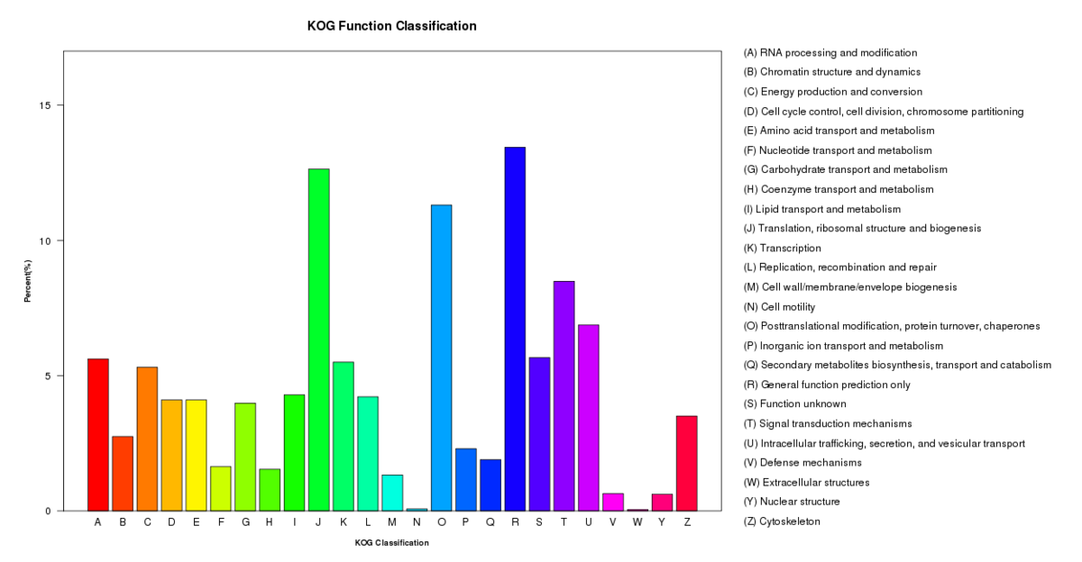
Supplementary Fig. S1. Eukarotic orthologous groups (KOG) classification of P. polysora unigenes. A total of 4,218 unigenes were clustered into 25 orthologous groups.

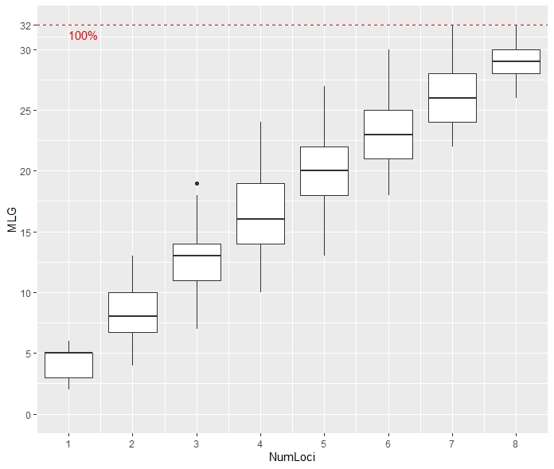
Supplementary Fig. S2. Genotype accumulation curve. For each boxplot, the loci were randomly sampled 1,000 times.

