Different Theta Connectivity Patterns Underlie Pleasantness Evoked by Familiar and Unfamiliar Music: Supplementary Materials
Alberto Ara^{1,2}
Josep Marco-Pallarés^{1,2}

¹Department of Cognition, Development and Educational Psychology, Institute of Neurosciences, University of Barcelona, Spain
²Cognition and Brain Plasticity Unit, Bellvitge Biomedical Research Institute, L'Hospitalet de Llobregat, Spain
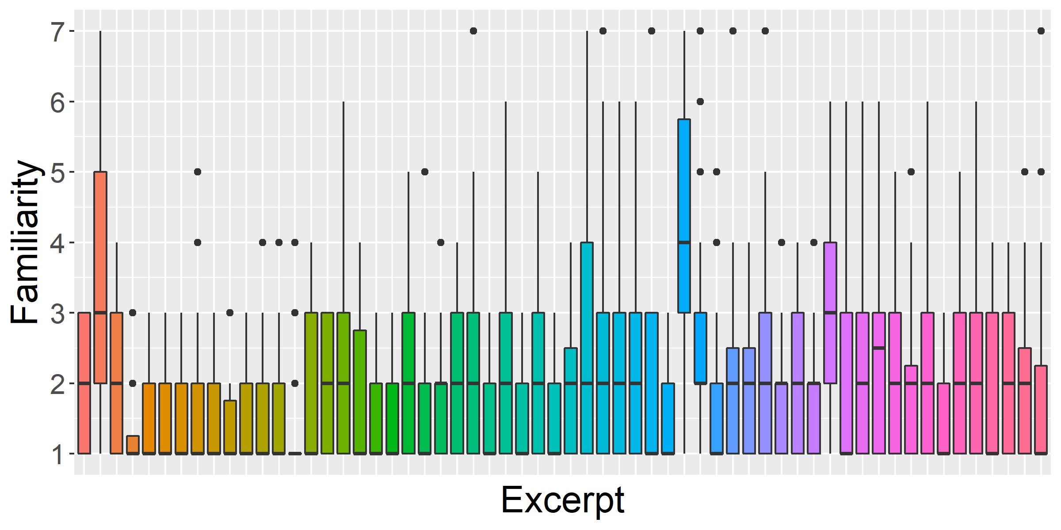
Fig S1. Distribution of familiarity ratings per excerpt the first time they were listened to (exposure session). Plot generated in R [53] with package ggplot2 [54].

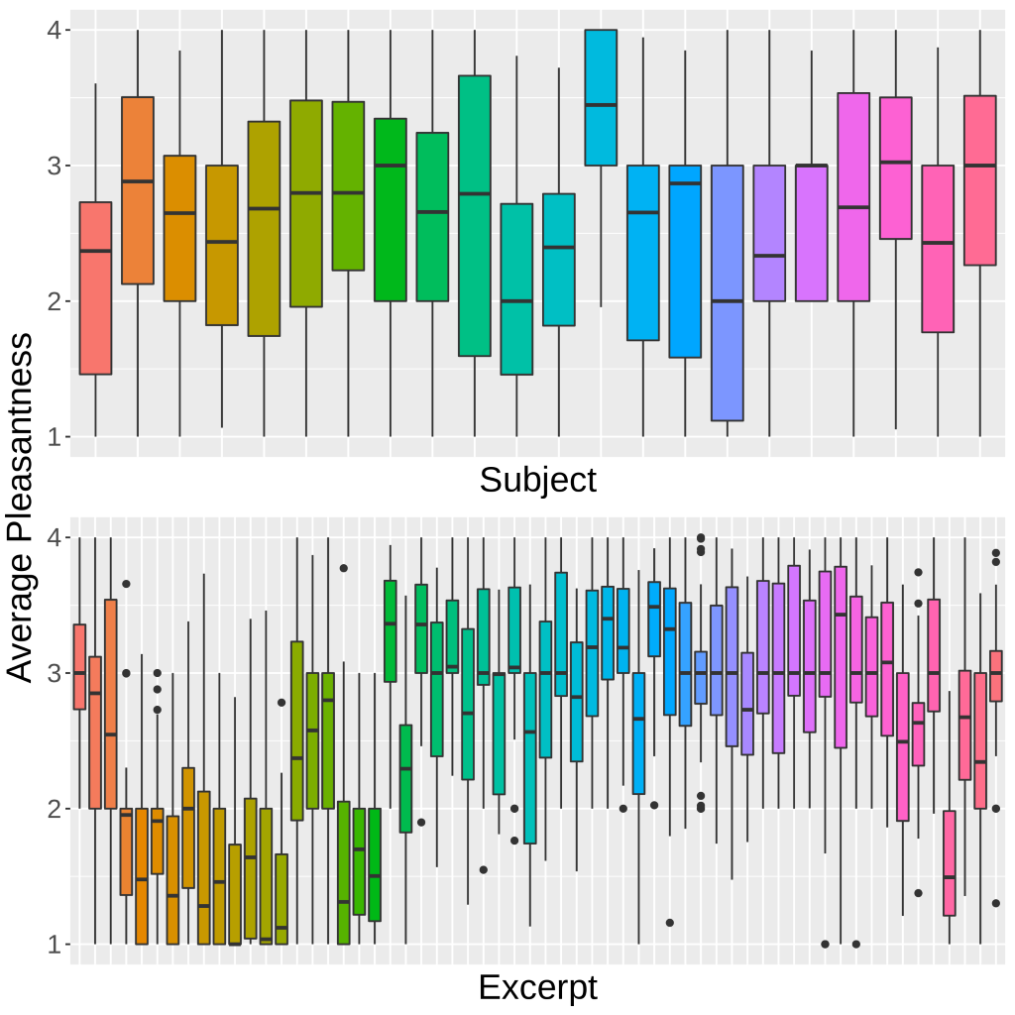
Fig S2. Distribution of time-weighted self-reported pleasantness per subject (top) and excerpt (bottom). Plot generated in R [53] with package ggplot2 [54].

 | A) most liked ≠ least liked  (new music) | B) most liked ≠ least liked  (old music)
p < 0.05 | 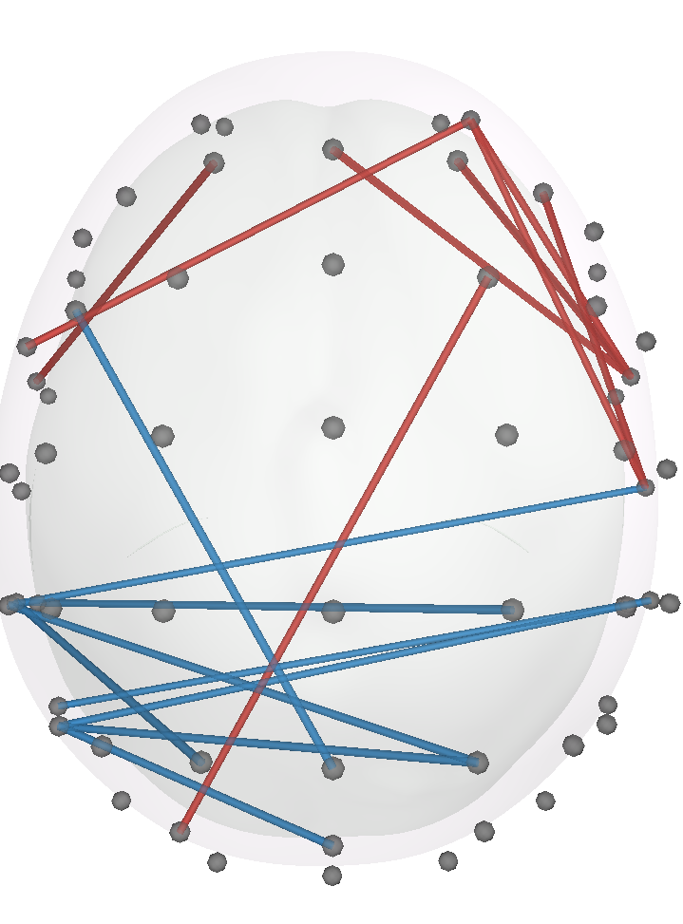 | 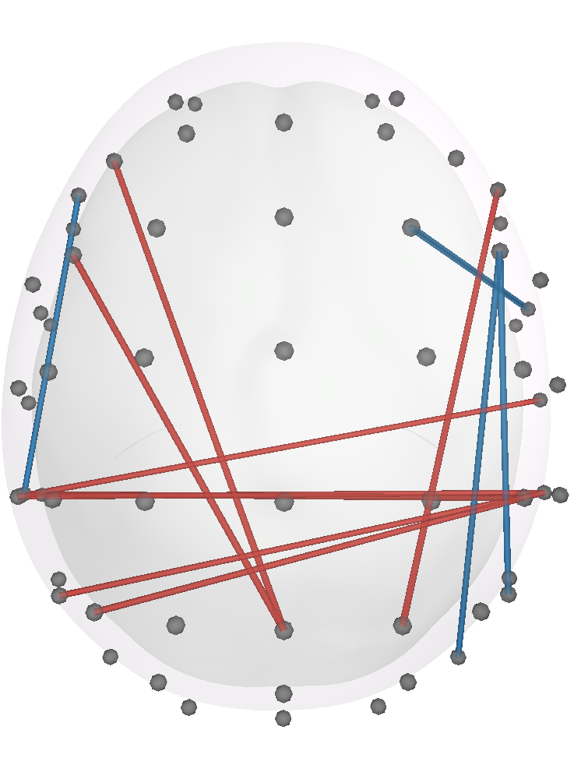
p < 0.01 | 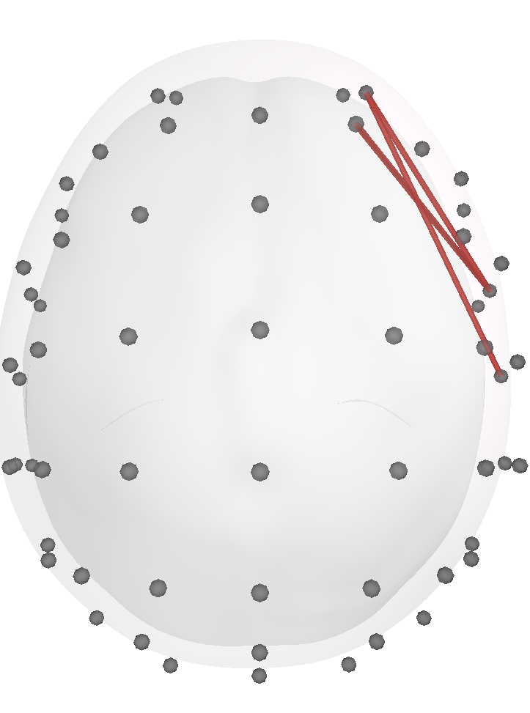 | 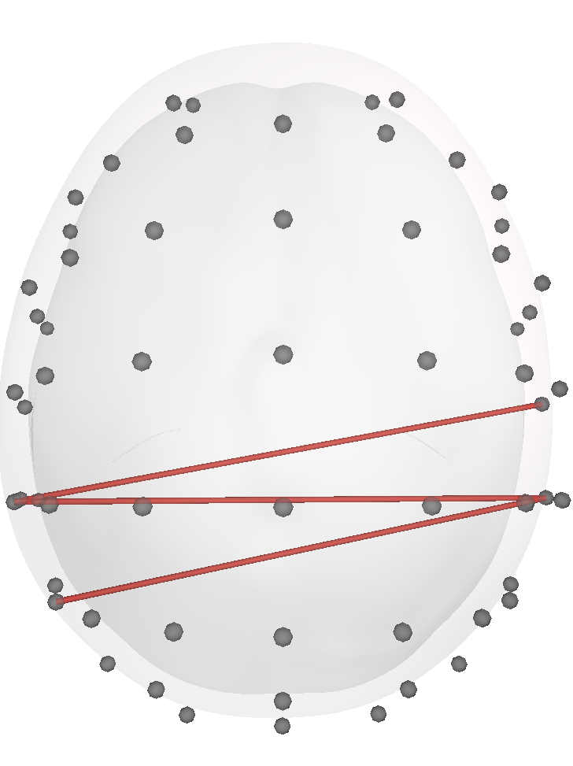
p < 0.005 | 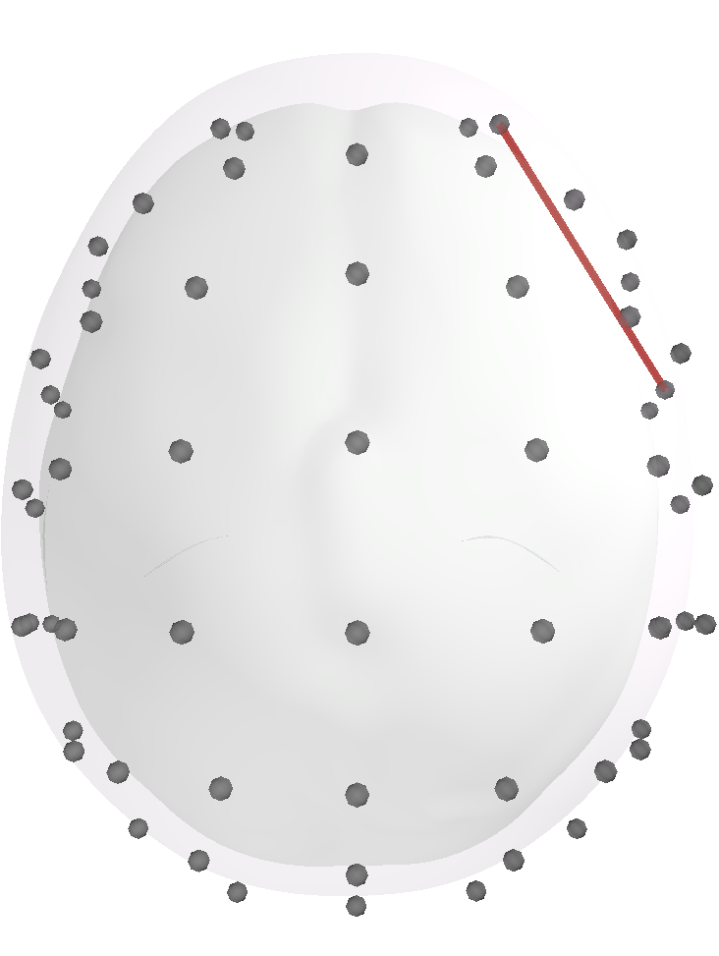 | 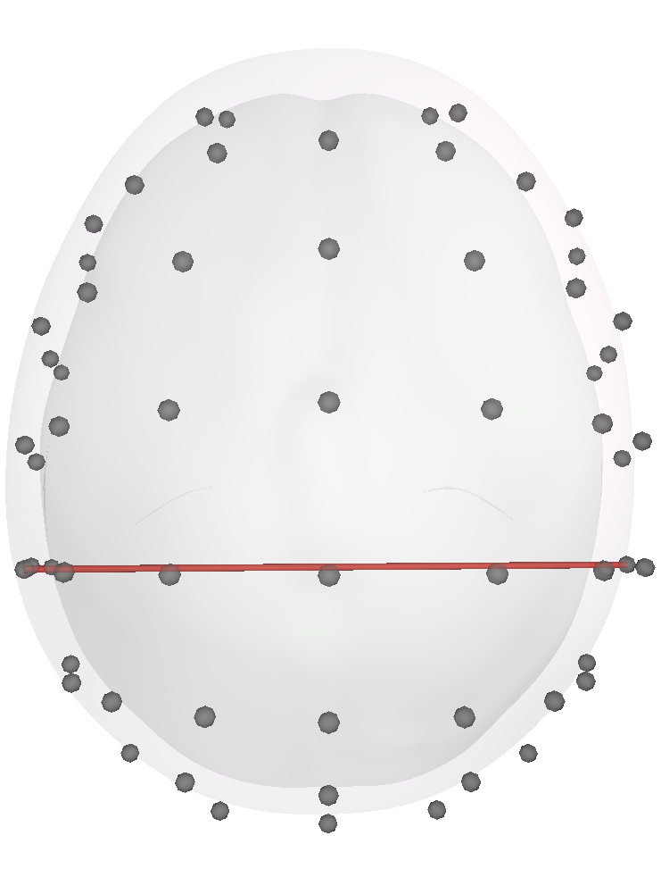
p < 0.001
Fig S3. Significant connections in theta under the frequentist framework with different alpha levels for A) effects of liking for novel music and B) effects liking for familiar music. Red lines indicate positive relationships and blue lines negative relationships. No connection survived family-wise error or false discovery rate corrections. Models were implemented with R package glmmTMB.

Artist | Track | Passage(s)
Anjulie | Boom | Verse, Chorus
Atari Teenagers | New Blood | Intro, Verse
Atari Teenagers | Street Grime | Intro, Verse
Basshunter | All I ever wanted | Pre-chorus, Chorus
Baz Corden | Hearts and Rainbows | Verse, Chorus
Blinding | The Island | Beat
Dub Trees | Buffalo | Beat, Beat
Caro Emerald | Just One Dance | Verse, Chorus
Cashmere Cat | Mirror Maru | Beat, Break, Beat
Comforce | Semantic Field | Beat
Conrad Schnitzer | Wurm | Beat
Daft Punk | The Game Has Changed | Beat
Dua Lipa | Blow Your Mind (Instrumental) | Pre-chorus, Chorus
Errors | A Rumor in Africa | Intro, Verse
Finally Awake | Gone Away | Verse, Chorus
Florence + The machine | Dog days are over (instrumental) | Verse, Chorus
James Arthur | Coming Home for Summer | Verse, Chorus
James Welsh | Nowt | Intro, Beat
JRY ft. Rooty | Pray | Pre-chorus, Chorus
Kaskade ft. Martina of Dragonette | Fire your new shoes | Verse, Chorus
Klingande | Jubel (original mix) | Beat
KSHRM | Kashmir (original mix) | Break, Beat
Linkin Park | Heavy (instrumental) | Verse, Chorus
Linkin Park | Battle Symphony (instrumental) | Pre-chorus, Chorus
Marina & the Diamonds | Hollywood (instrumental) | Verse, Pre-chorus, Chorus
Martin Solveig & GTA | Intoxicated (instrumental) | Intro, Beat
Martin Solveig ft. Sam White | +1 | Verse, Beat, Verse
Maybeshewill | Opening | Solo
Metric | Combat Baby (instrumental) | Verse, Chorus
Metric | Speed the collapse | Verse, Chorus
Table S1. List of songs used in the experiment and the corresponding passages used in the excerpts. Songs labeled as instrumental are instrumental versions of songs originally written with lyrics.

Artist | Track | Passage(s)
Moguai ft. Cheat Codes | Hold On | Verse, Beat
Mumdance | Shook | Verse
Mumdance | Take time | Verse
Nine Inch Nails | 8 ghosts I | Beat
Nine Inch Nails 1 | 14 ghosts II | Beat
Núria Graham | Unknown | Verse, Chorus
Paloma Faith | Black & Blue | Verse, Chorus
Paloma Faith | Only Love Can Hurt Like This (instrumental) | Verse
Passenger | Bullets | Chorus
Quarta 330 | Digital lotus flower | Intro, Beat
Richard Devine | Pallete | Beat
Richard Devine | Reneanalogueseq | Beat
Robin Bengtsson | Constellation Prize | Pre-chorus, Chorus
Robin Dtjiernberg | Rain (Didrick remix) | Pre-chorus, Beat
Roco | Dealer | Verse, Chorus
S-Type | Billboard (Lido Remix) | Break, Beat, Break
Scooter | Maria (I like it loud) | Beat
Scooter | My gabber | Break, Beat, Break
Sia | Alive (instrumental) | Verse, Pre-Chorus, Chorus
Special D | Come with me | Pre-chorus, Chorus
Special D | You | Verse, Break, Beat
Stargate ft. Pink & Sia | Waterfall (instrumental) | Verse, Chorus
Stephen Marley | Hey Baby (instrumental) | Verse
Subshock Evangelos | All Right | Break, Beat
The Mad Trist | Pay the Piper | Verse, Chorus
TNGHT | Goooo | Intro, Beat, Break, Beat
Triana Park | Iron Blue | Pre-chorus, Chorus
Ulver | Darling, didn’t we kill you? | Beat, Outro
Venetian Snares | Öngyilkos Vasárnap | Beat
ZAYN | Fool For You (instrumental) | Verse, Break, Chorus
Table S1 (continuation)

