SUPPLEMENTS

Figure 1: ROC analysis utilized for cut-off definition regarding daily mean highest PaCO2.
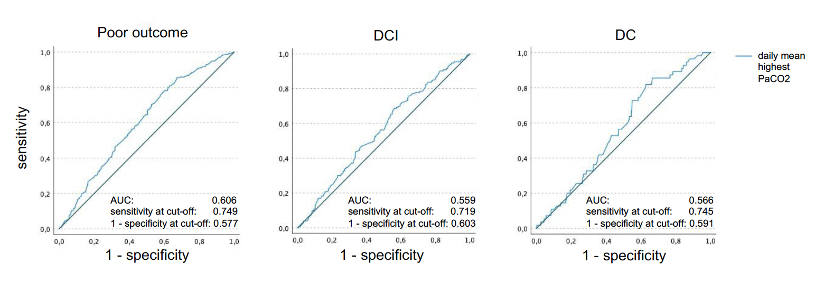

Figure 2: ROC analysis utilized for cut-off definition regarding daily mean lowest PaCO2.
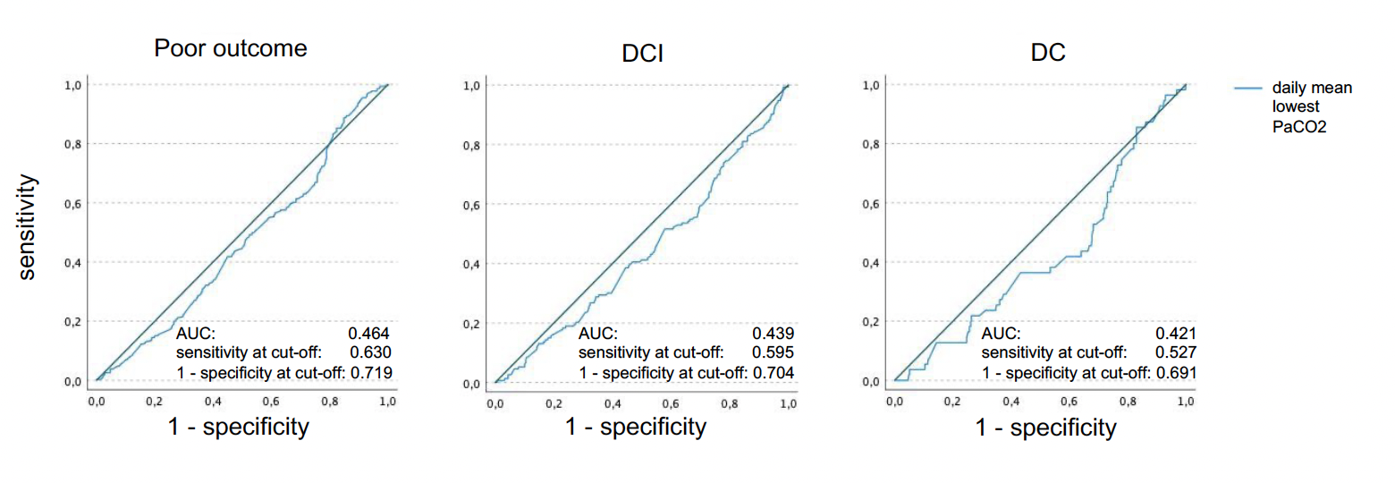

Parameter |  | %/mean±SD
Female sex |  | 66.7%
Age (years) |  | 54.57±13.66
WFNS 4/5 |  | 47.4%
Fisher 3/4 * |  | 91.2%
Acute Hydrocephalus |  | 78.2%
Treatment clipping |  | 41.2%
Aneurysm location
 | MCA | 24.0%
 | ICA | 10.7%
 | pACA | 35.1%
 | dACA | 3.3%
 | Posterior circulation | 26.9%
Pulmonary complications
 | Pneumonia † | 23.7%
 | Prolonged MV‡ | 52.6%
Ventilation/Blood gas
 | Time of MV (days) ‡ | 8.1 ± 6.0
 | Mean daily highest PaCO2(mmHg) | 39.50 ± 3.98
 | Mean daily highest PaCO2(mmHg) | 31.79 ± 4.66
Infarction
 | Early# | 30.9%
 | DCI# | 24.2%
Vasospasm |  | 22.7%
DC
 | DC before conservative treatment | 22.9%
 | DC due to refractory ICP increase | 11.3%
Conservative ICP Therapy Level 1** |  | 46.3%
Conservative ICP Therapy Level 2** |  | 3.0%
Poor Outcome at 6-month follow-up *** |  | 49.5%
In hospital mortality |  | 14.2%
Optimal PaCO2 (30-38 mmHg) |  | 17.2%
* Data missing for 43 patients
† Data missing for 29 patients
‡ Data missing for 4 patients
# Data missing for 1 patient
** Data missing for 3 patients
***Data missing for 5 patients
Table 1: Overview of baseline characteristics of the study cohort.

Parameter | Mean lowest PaCO2 <30mmHg | Optimal PaCO2 (30-38mmHg) | Mean highest PaCO2 >38mmHg
Number of patients (n)* | 190 | 109 | 401
Age (years/mean±SD) | 53.16±12.85 | 52.74±14.00 | 55.51±13.72
Prolonged MV(%) | 54.5% | 26.6% | 61.5%
DCI (%) | 30.7% | 11.9% | 27.5%
Poor outcome (%) | 56.7% | 23.9% | 56.0%
DC due to refractory ICP increase (%) | 16.8% | 3.3% | 13.7%
ICU > 10 days (%) | 49.7% | 22.9% | 55.2%
Mean lowest PaCO2 (mmHg/mean±SD) | 28.24±1.49 | 31.54±1.48 | -
Mean highest PaCO2 (mmHg/mean±SD) | - | 36.33±1.38 | 41.70±3.01
*67 patients exceeded the cut-offs in both groups (mean daily lowest and mean highest PaCO2 )
Table 2: Overview over distribution of patients exceeding the mean daily cut-offs volumes for mean lowest and mean highest PaCO2 in comparison with the optimal PaCO2 group regarding endpoints, prolonged MV and absolute PaCO2 values.

Parameter | p | aOR | 95% CI
Total time of MV (completely controlled and supported) (days) | 0.003 | 0.86 | 0.78 - 0.95
Total time of completely controlled MV (days) | 0.672 | 0.91 | 0.91 - 1.15

Table 3.: Multivariate analysis of influence of mechanical ventilation mode on the occurrence of “optimal PaCO2” values.

