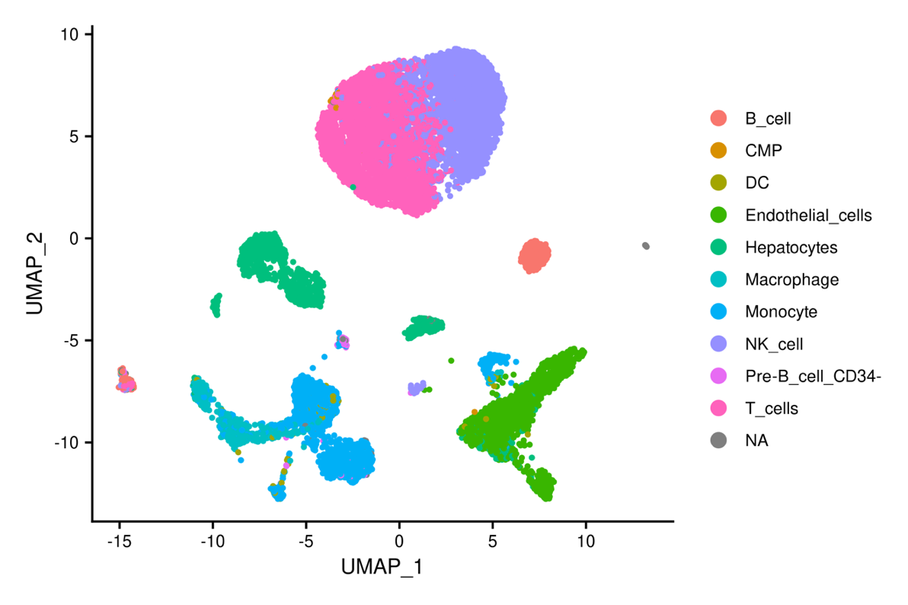
Supplementary Fig. 1. Automated cell type annotation by SingleR. UMAP embedding of all cells profiled in this study colored by automatically generated reference-based annotations from Human Primary Cell Atlas.

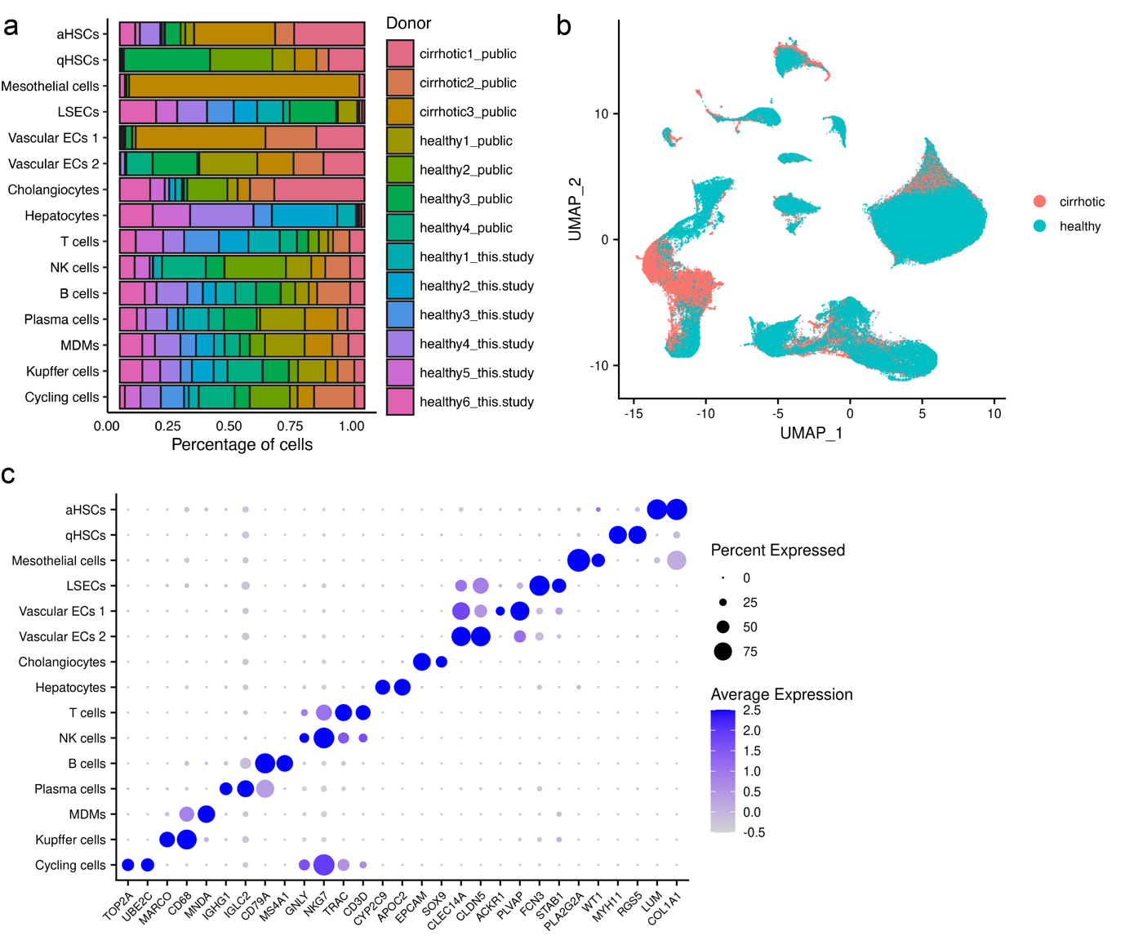
Supplementary Fig. 2. Analysis of integrated human liver scRNA-seq data. (A) Barplot representing the relative contribution of cells from each donor for each cell type. q/a HSCs, quiescent/activated hepatic stellate cells; LSECs, liver sinusoidal endothelial cells; Vascular ECs, vascular endothelial cells; MDMs, monocyte-derived macrophages; NK cells, natural killer cells. (B) UMAP visualization of single cells. Each point depicts a single cell, colored according to disease stage. (C) Dotplot displaying select differentially expressed genes for each cell type identified. Size of the dot represents proportion of the cell population that expresses each gene. Color indicates level of expression.

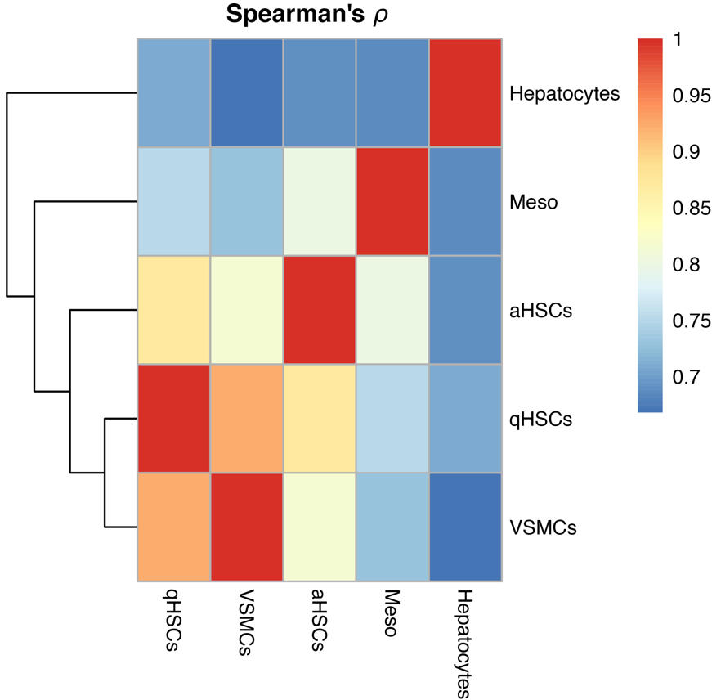
Supplementary Fig. 3. Correlations of gene-expression levels between cell types. The heatmap of the pairwise Spearman’s correlation coefficient (ρ) is based on genes with their expression averaged across cells for each cell type. It represents the degree of similarity of gene-expression profiles between cell types. Meso, mesothelial cells; q/a HSCs, quiescent/activated hepatic stellate cells; VSMCs, vascular smooth muscle cells.

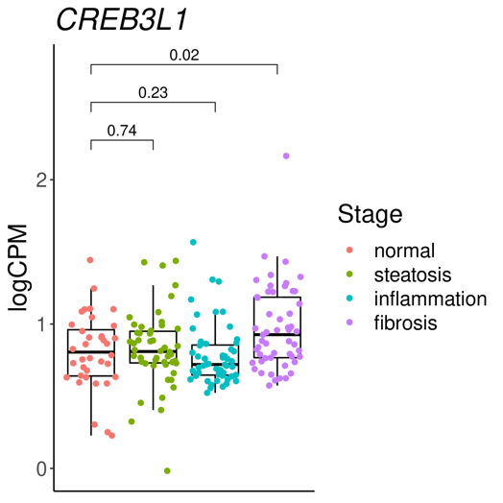
Supplementary Fig. 4. Expression of CREB3L1 across the nonalcoholic fatty liver disease spectrum. RNA-seq data of the 191 liver samples (normal, 36; steatosis, 50; inflammation, 52; fibrosis, 53) obtained from Gerhard et al. (2018) were reanalyzed. Mann–Whitney U tests (two-sided) were performed for statistical pairwise comparisons. logCPM, log-transformed Counts per Million.

