Soil bacterial community as impacted by addition of rice straw and biochar
Zhiqiang Tang^{1,2}, Liying Zhang², Na He², Diankai Gong², Hong Gao², Zuobin Ma², Liang Fu², Mingzhu Zhao², Hui Wang², Changhua Wang², Wenjing Zheng², Wenzhong Zhang^{1*}
Affiliation: ¹ Shenyang Agricultural University, Shenyang, China.
² Liaoning Rice Research Institute, Shenyang, China.

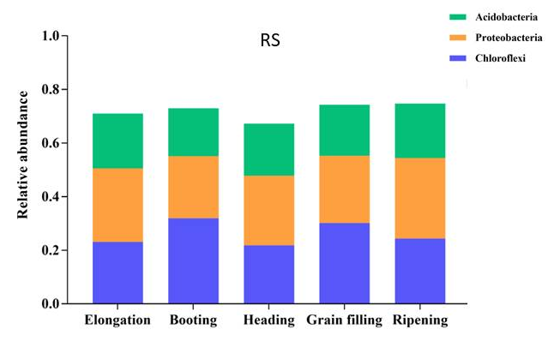

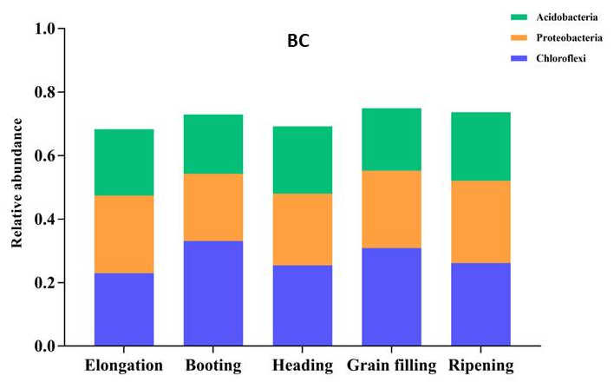
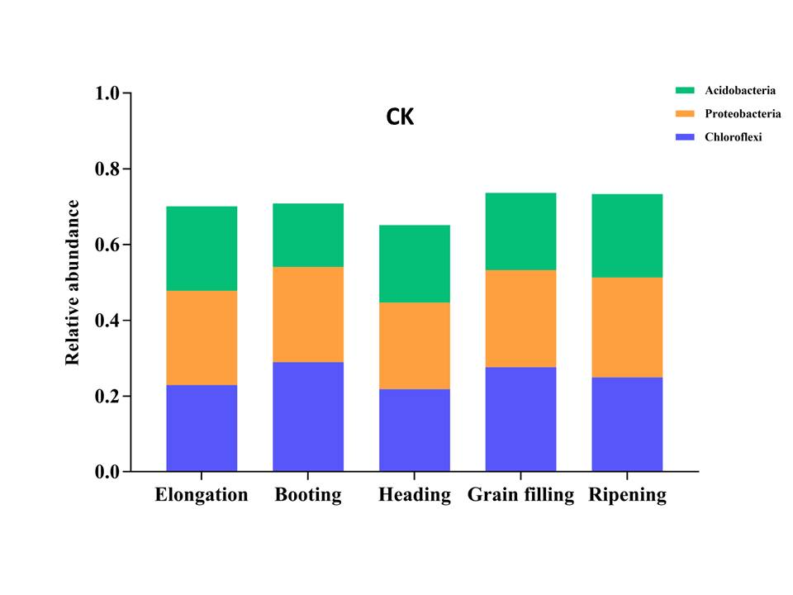

Figure S1. The relative abundance of the phylum Chloroflexi, Proteobacteria and Acidobacteria in the rhizosphere at all growth stages. Treatments: RS = Rice straw applied at 9000 kg ha⁻¹; BC = Biochar applied at 3150 kg ha⁻¹; CK = Soil without straw/biochar application.

