Supplementary materials
Phosphorus availability and leaching losses in annual and perennial cropping systems in an upper US Midwest landscape

Mir Zaman Hussain^{1,2,*}, Stephen K. Hamilton^{1,2,3,4}, G. Philip Robertson^{1,2,5} and Bruno Basso^{1,2,6}

¹ W.K. Kellogg Biological Station, Michigan State University, Hickory Corners, MI 49060, USA

² Great Lakes Bioenergy Research Center, Michigan State University, East Lansing, MI 48824, USA

³ Department of Integrative Biology, Michigan State University, East Lansing, MI 48824, USA

⁴ Cary Institute of Ecosystem Studies, Millbrook, NY 12545, USA

⁵ Department of Plant, Soil, and Microbial Sciences, Michigan State University, East Lansing, MI 48824, USA

⁶ Department of Earth and Environmental Sciences, Michigan State University, East Lansing, MI 48824, USA

*Corresponding author (mirzamanhussain@gmail.com)

Table S1 Plant species composition in the restored prairie cropping system
 | Species | Taxa
1 | Elymus canadensis | Grass
2 | Sorghastrum nutans (L.) Nash ex Small | Grass
3 | Schizacyrium scoparium (Michx.) Nash | Grass
4 | Andropogon gerardii | Grass
5 | Desmodium canadense | Forb
6 | Lespedeza capitate | Forb
7 | Baptisia lacteal var. lacteal | Forb
8 | Rudbeckia hirta L. | Forb
9 | Anemone canadensis L. | Forb
10 | Asclepias tuberosa L. | Forb
11 | Monarda fistulosa L. | Forb
12 | Silphium perfoliatum L. | Forb
13 | Ratibida pinnata (Vent.) Barnh. | Forb
14 | Solidago rigida L. | Forb
15 | Solidago speciose L. | Forb
16 | Aster novae-angliae L. | Forb
17 | Koeleria cristata | Grass
18 | Panicum virgatum var. Southlow | Grass

Table S2. Description of lakes, streams and wells in SW Michigan from where water was sampled for TDP concentrations. The wells, streams and some lakes were sampled on multiple dates.
Sampling sites | Coordinates (latitude, longitude) | Township/County
Crooked Lake | N42.491600°, W85.429100° |  | Delton/Barry
Douglas Lake | N42.356270°, W85.367126° |  | Augusta/Kalamazoo
Duck Lake | N42.408419°, W85.381941° |  | Ross/Kalamazoo
Eagle Lake | N42.322815°, W85.323590° |  | Charleston/Kalamazoo
Fair Lake | N42.489358°, W85.330371° |  | Hickory Corners/Barry
Gilkey Lake | N42.481601°, W85.360072° |  | Delton/Barry
Gull Lake | N42.402564°, W85.416145° |  | Ross/Kalamazoo/Barry
Little long Lake | N42.422894°, W85.443878° |  | Prairieville/Barry
Miller Lake | N42.403309°, W85.433563° |  | Richland/Kalamazoo
Mud Lake | N42.481412°, W85.390568° |  | Delton/Barry
Pleasant Lake | N42.491216°, W85.385134° |  | Delton/Barry
Stony Lake | N42.377773°, W85.345235° |  | Ross/Barry
Three Lakes | N42.351981°, W85.431972° |  | Richland/Kalamazoo
Whitford Lawler Lake | N42.310440°, W85.356943° |  | Charleston/Kalamazoo
Windmill Pond, KBS | N42.403601°, W85.400413° |  | Ross/Barry
Wintergreen Lake | N42.397844°, W85.384502° |  | Ross/Barry
Augusta Creek | N42.361439°, W85.354208° |  | Augusta/Kalamazoo
Gull Creek | N42.301287°, W85.399527° |  | Galesburg/Kalamazoo
Kalamazoo River | N42.676690°, W86.215310° |  | Multiple
Prairieville Creek | N42.427616°, W85.430082° |  | Prairieville/Barry
Stony Creek | N42.360425°, W85.310606° |  | Ross/Kalamazoo/Barry
KBS wells | N42.409646°, W85.392782° |  | Ross/Kalamazoo

Figure S1. Experimental layout of GLBRC Biofuel Cropping System Experiment (BCSE) showing the distribution of treatments, and position of soil water samplers (suction lysimeters) in the plots.

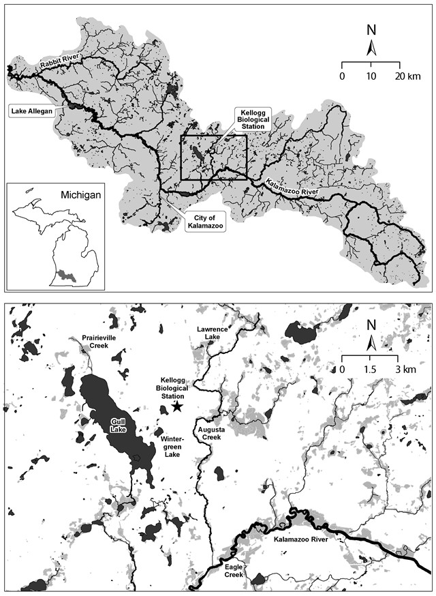
Figure S2. Location of the study area within the Kalamazoo River watershed (using ArcGIS software) in southwestern Michigan (Top panel); enlargement of the inset from top panel showing the area in the vicinity of the cropping systems where streams, lakes, and residential water supply wells were sampled (Bottom panel) for comparison with leachate concentrations (only selected water bodies are labeled).

