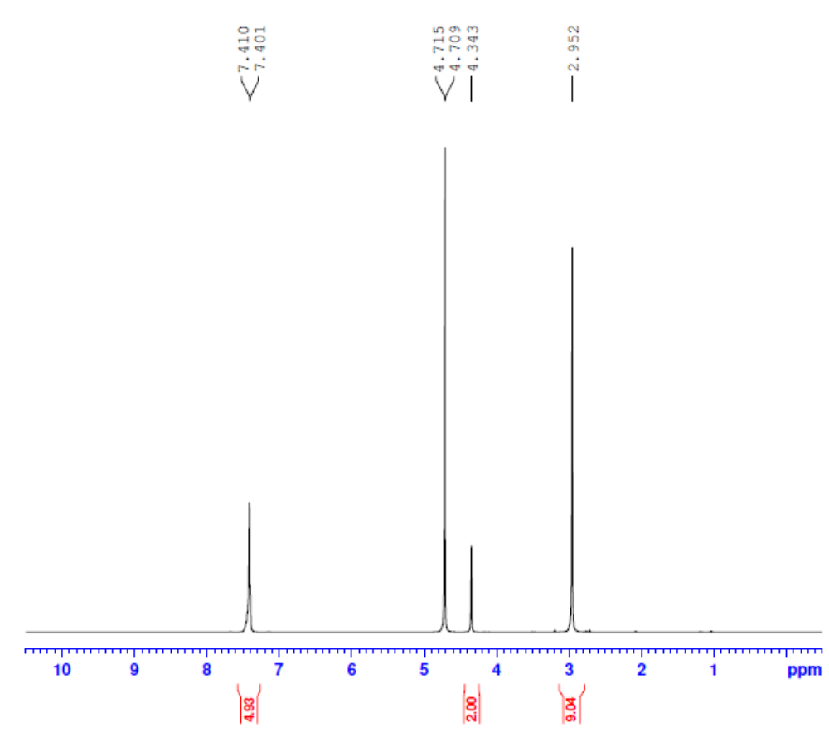
Fig S1: H¹ NMR graph of SDES formed with Triton X 100 as HBD and Choline chloride as HBA (TX:CCL)

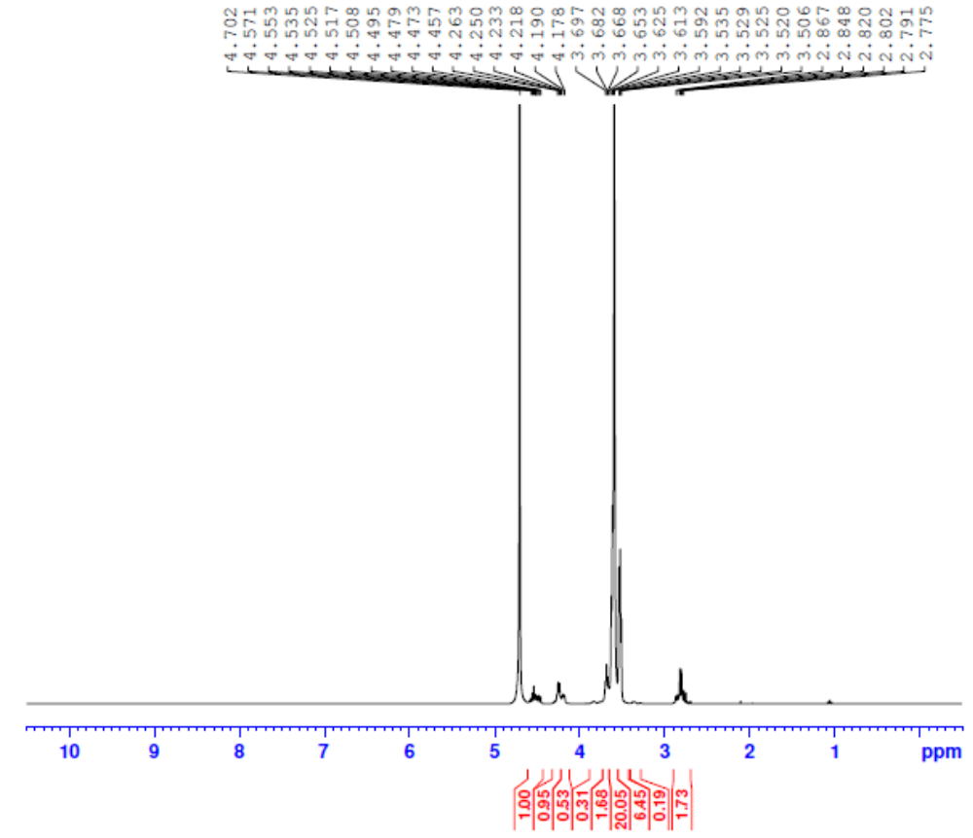
Fig S2: H¹ NMR graph of SDES formed with Triton X 100 as HBD and Tetrabutyl ammonium chloride as HBA (TX:TBAC)
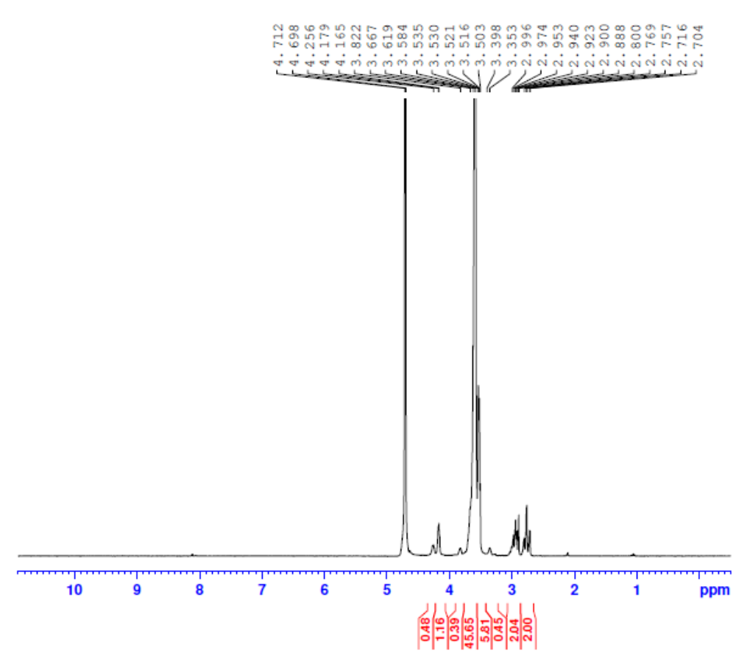
Fig S3: H¹ NMR graph of SDES formed with Triton X 100 as HBD and Tetrabutyl ammonium bromide as HBA (TX:TBAB)

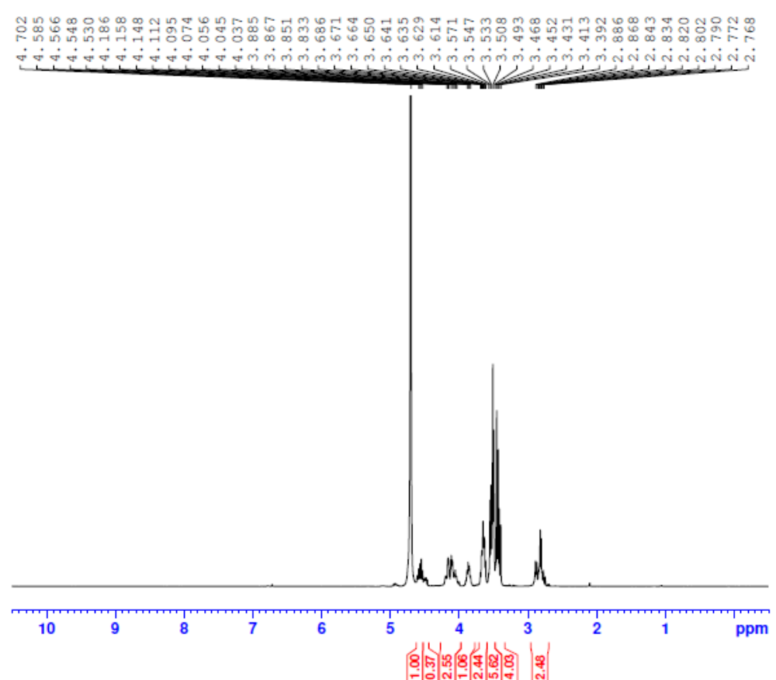
Fig S4: H¹ NMR graph of SDES formed with Tween 80 as HBD and choline chloride as HBA (TW:CCL)
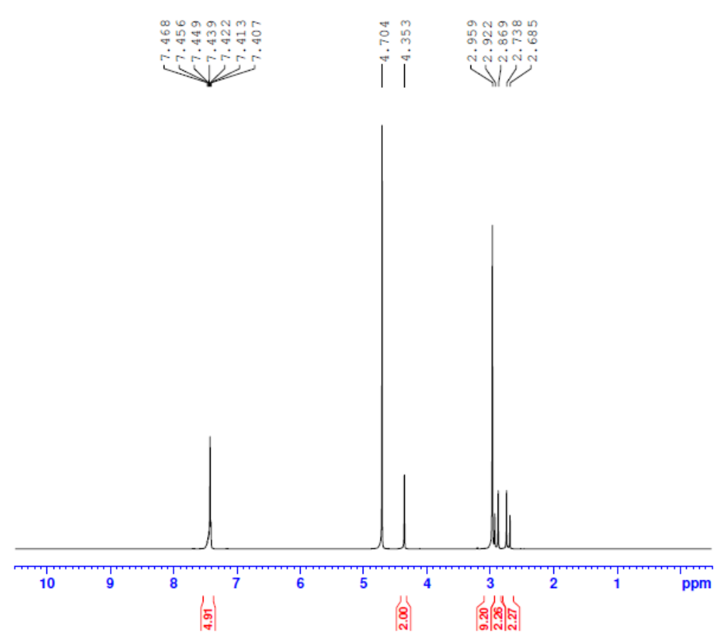
Fig S5: H¹ NMR graph of SDES formed with Tween 80 as HBD and Tetra butyl ammonium chloride as HBA (TW:TBAC)

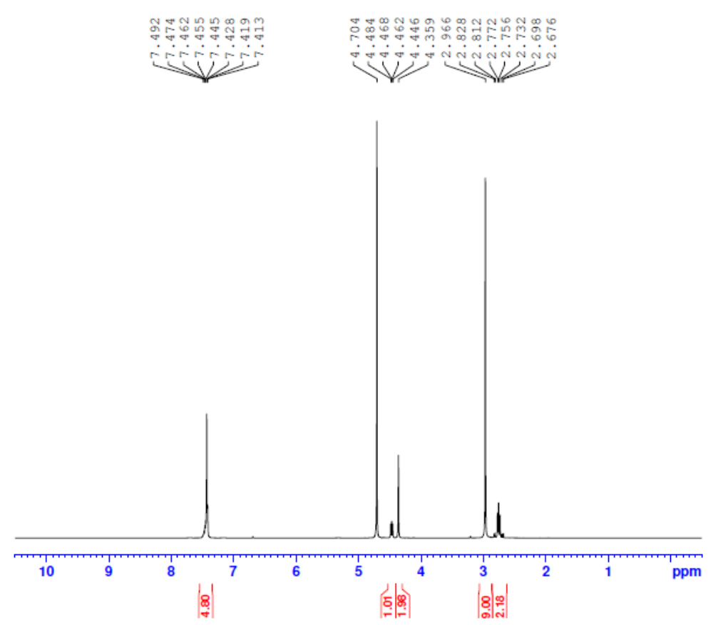
Fig S6: H¹ NMR graph of SDES formed with Tween 80 as HBD and Tetra butyl ammonium bromide as HBA (TW:TBAC)

