Title :
Serum-free cultures of C2C12 cells show different muscle phenotypes which can be estimated by metabolic profiling

Full name of authors :
Mi Jang¹, Jana Scheffold¹, Lisa Marie Røst¹, Hyejeong Cheon², Per Bruheim¹.

Affiliation of authors:
^{1.} Department of Biotechnology and Food Science, Norwegian University of Science and Technology, Hogskoleringen 1, 7491 Trondheim, Norway.
^{2.} PoreLab, Department of Physics, Norwegian University of Science and Technology, Hogskoleringen 1, 7491 Trondheim, Norway.

Corresponding author : Per Bruheim
Address: Department of Biotechnology and Food Science, Norwegian University of Science and Technology, Hogskoleringen 1, 7491 Trondheim, Norway.
e-mail : per.bruheim@ntnu.no

Supplementary table 1. List of metabolite abbreviations
Class | Abbreviation | Full name
Glycolysis | G6P | Glucose-6-phosphate
Glycolysis | F6P | Fructose-6-phosphate
Glycolysis | F1,6BP | Fructose 1,6-biphosphate
Glycolysis | 2/3-PG | 2-/3-Phopho-D.glycerate
Glycolysis | PEP | Phosphoenolpyruvic acid
Glycolysis | Pyr | Pyruvic acid
Lac | Lac | Lactate
PPP | 6PG | 6-Phospho-D-Gluconate
PPP | PRPP | Phosphoribosyl pyrophosphate
PPP | R5P | D-Ribose-5-phosphate
PPP | S7P | D-Sedoheptulose-7-phosphate
Other sugar phosphates | F1P | Fructose-1-phosphate
Other sugar phosphates | G1P | Glucose-1-phosphate
Other sugar phosphates | GAL1P | Galactose-1-phosphate
Other sugar phosphates | GL3P | Glycerol-3-phosphate
Other sugar phosphates | M6P | mannose-6-phosphate
Other sugar phosphates | UDP-GlcNAc | Uridine diphosphate N-acetylglucosamine
TCA cycle | Cit | Citrate
TCA cycle | Icit | Isocitrate
TCA cycle | aKG | α-ketoglutarate
TCA cycle | Suc | Succinate
TCA cycle | Fum | Fumarate
TCA cycle | IA | Itaconic acid
TCA cycle | Mal | Malate
Nucleoside phosphates | AMP | Adenosine monophosphate
Nucleoside phosphates | ADP | Adenosine diphosphate
Nucleoside phosphates | ATP | Adenosine triphosphate
Nucleoside phosphates | CMP | Cytidine monophosphate
Nucleoside phosphates | CDP | Cytidine diphosphate
Nucleoside phosphates | CTP | Cytidine triphosphate
Nucleoside phosphates | GMP | Guanosine monophosphate
Nucleoside phosphates | GDP | Guanosine diphosphate
Nucleoside phosphates | GTP | Guanosine triphosphate
Nucleoside phosphates | IMP | Inosine monophosphate
Nucleoside phosphates | UMP | Uridine monophosphate
Nucleoside phosphates | UDP | Uridine diphosphate
Nucleoside phosphates | UTP | Uridine triphosphate
Deoxy nucleoside phosphates | dADP | Deoxyadenosine diphosphate
Deoxy nucleoside phosphates | dATP | Deoxyadenosine triphosphate
Deoxy nucleoside phosphates | dCTP | Deoxycytidine triphosphate
Deoxy nucleoside phosphates | dTDP | Deoxythymidine diphosphate
Deoxy nucleoside phosphates | dTTP | Deoxythymidine triphosphate
Deoxy nucleoside phosphates | dUMP | Deoxyuridine monophosphate
Amino acids | Ala | Alanine
Amino acids | Arg | Arginine
Amino acids | Asn | Asparagine
Amino acids | Asp | Aspartate
Amino acids | Cys | Cysteine
Amino acids | Gln | Glutamine
Amino acids | Glu | Glutamate
Amino acids | Gly | Glycine
Amino acids | His | Histidine
Amino acids | Ile | Isoleucine
Amino acids | Leu | Leucine
Amino acids | Lys | Lysine
Amino acids | Met | Methionine
Amino acids | Phe | Phenylalanine
Amino acids | Pro | Proline
Amino acids | Ser | Serine
Amino acids | Thr | Threonine
Amino acids | Trp | Tryptophan
Amino acids | Tyr | Tyrosine
Amino acids | Val | Valine

Supplementary figure 1. Heat map of normalized intracellular metabolites (Auto scale) pools in myoblasts (day 1) cultured in 3 different medium conditions (Serum vs. B27 vs. AIM-V). The graph was illustrated using Metaboanalyst 5.0.
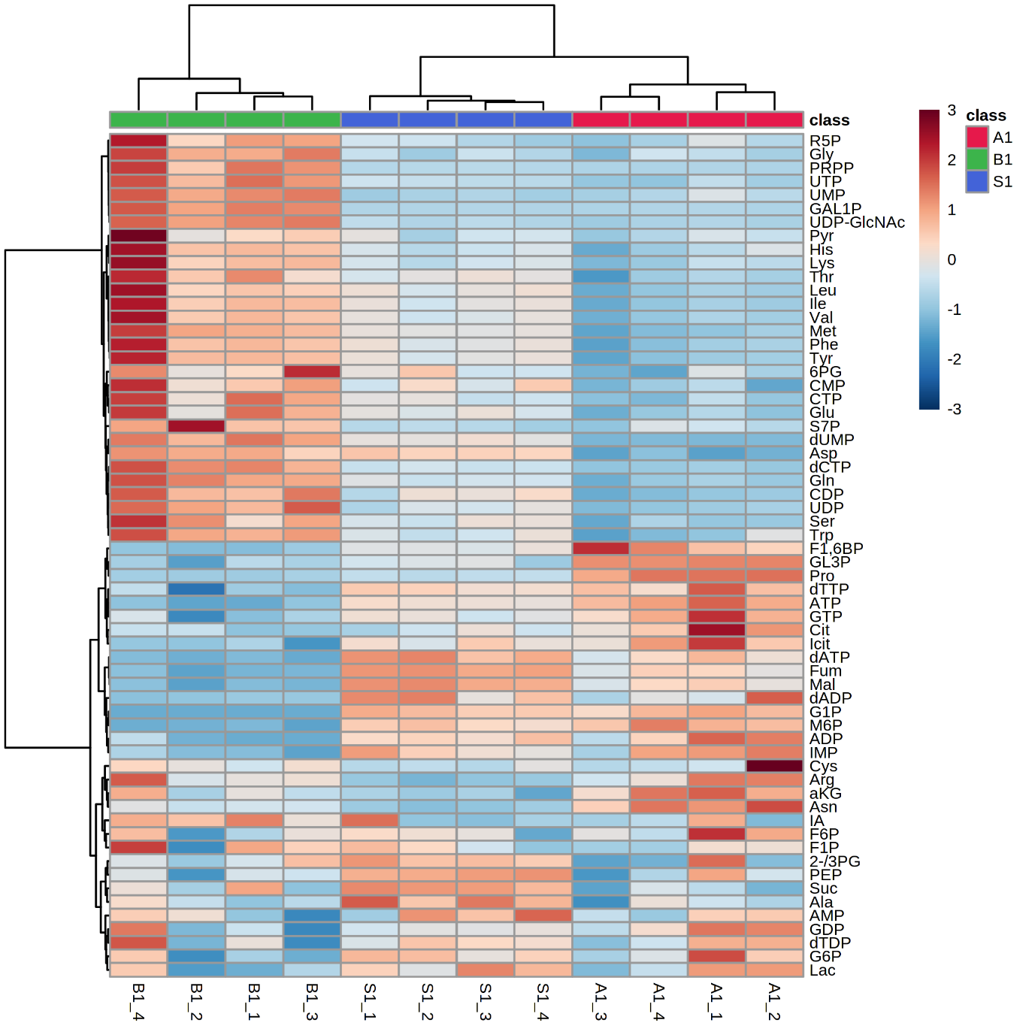

Supplementary figure 2. Heat map of normalized intracellular metabolites (Auto scale) pools in myotubes (day 7) cultured in 3 different medium conditions (Serum vs. B27 vs. AIM-V). The graph was illustrated using Metaboanalyst 5.0.

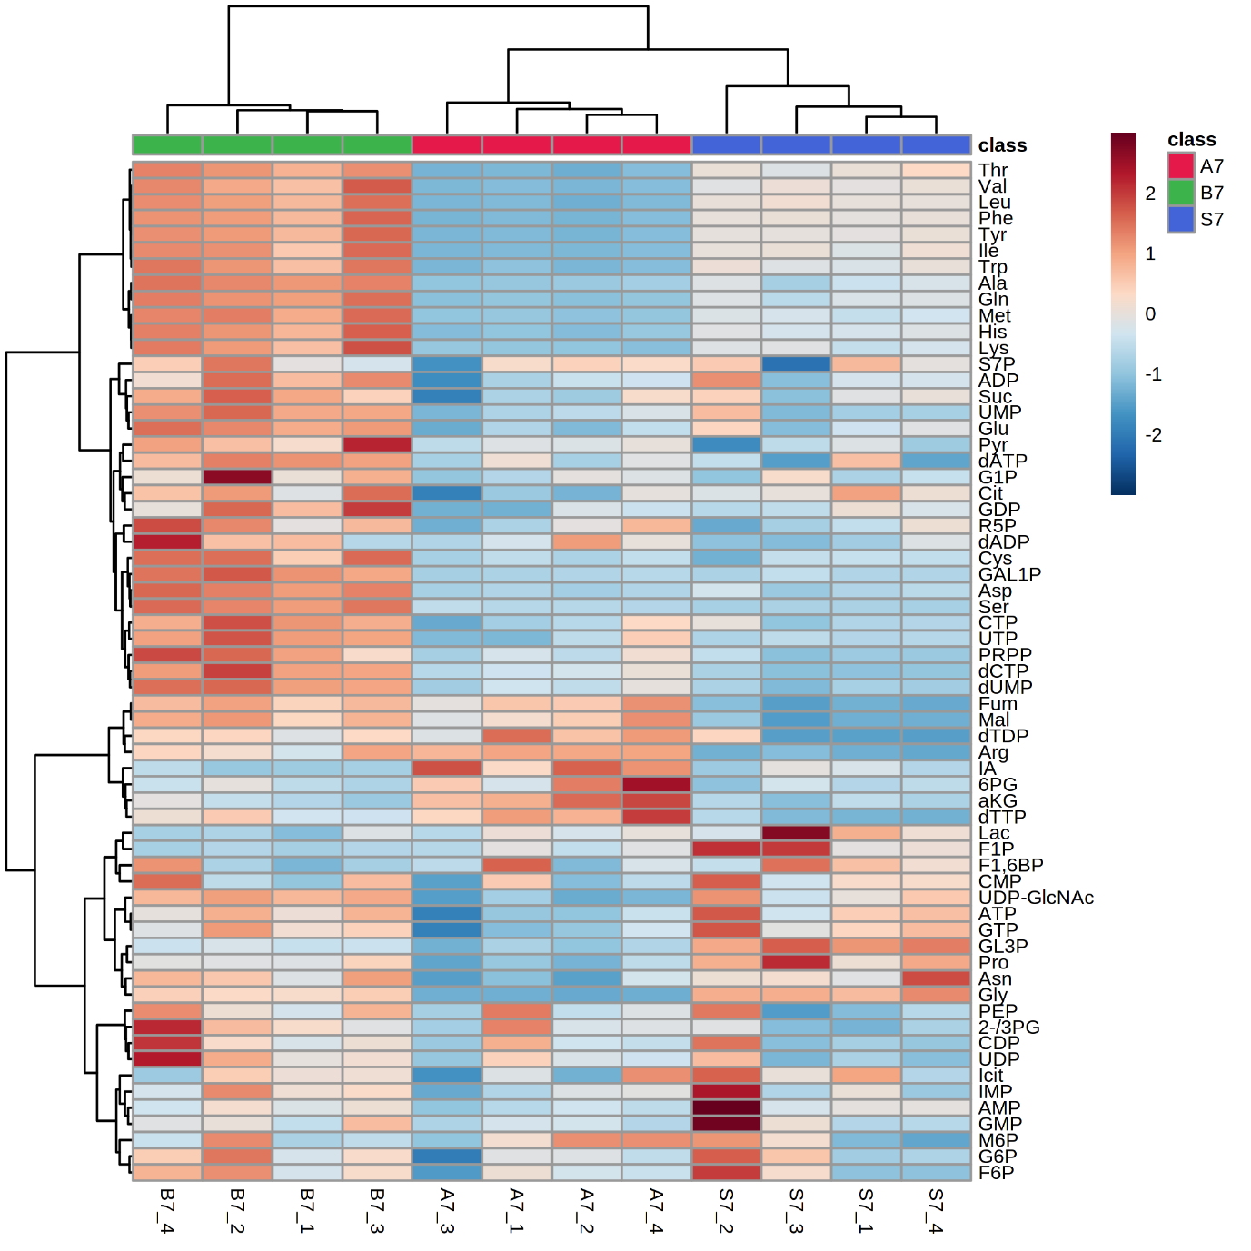

Supplementary figure 3. Average of Adenyl Energy charge in myoblasts (day 1) and myotubes (day 7) in DMEM, Serum, B27, AIM-V. (n) =4. Data presented as average ± standard deviation (SD).

Supplementary figure 4. Video analysis of myotubes twitching (A) Scheme of the process step of video analysis to present the muscle fiber contraction. (B) The visualized muscle cells beating signal for 20 seconds in Serum, B27, and AIM-V culture at day 7. The red box shows the magnified images from indicating a location for 1.5 seconds. A red arrow indicates time to single muscle twitching movement. (C) Contour maps of myotube twitching. All experiments were performed 3 times and representative results are presented.

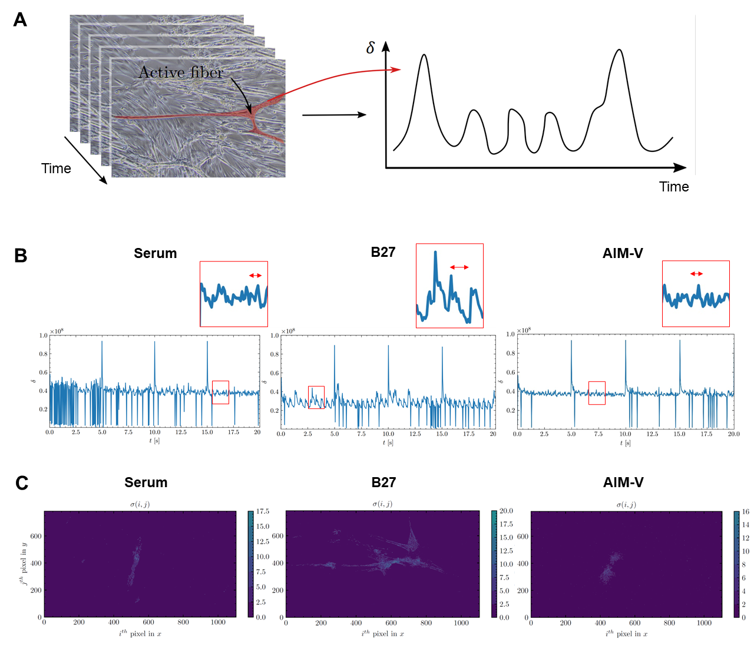

Supplementary table 2. The sum of the glycolytic metabolism-related metabolites (G6P, F6P, F1,6BP, 2/3-PG, PEP, Pyr, and Lac) and Oxidative metabolism-related metabolites (Cit, Icit, aKG, Suc, Fum, IA, and Mal). The ratio of sum of glycolytic to Oxidative-related metabolites. Data presented as average ± standard deviation (SD). *p<0.05, **p<0.01 vs. Serum
 | Serum | B27 | AIM-V
Sum of Glycolytic- related metabolites (M) | 0.0189±0.0077 | 0.0088±0.0024 (P=0.06, vs.Serum) | 0.0119±0.0019
Sum of Oxidative-related metabolites (M) | 0.0013±0.0001 | 0.0019±0.0001** | 0.0019±0.0003*
Ratio of  Oxidative/Glycolytic | 0.084±0.031 | 0.239±0.05* | 0.16±0.018

Supplementary table 3. The composition and concentrations of DMEM medium.
Component | g/L
Inorganic Salts
CaCl₂ | 0.2
Fe(NO₃)₃ • 9H2O | 0.0001
MgSO₄ | 0.0976
KCl | 0.4
NaHCO₃ | 3.7
NaCl | 6.4
NaH₂PO₄ | 0.109
Amino Acids
L-Arginine • HCl | 0.084
L-Cystine • 2HCl | 0.0626
L-Glutamine | 0.584
Glycine | 0.03
L-Histidine • HCl • H₂O | 0.042
L-Isoleucine | 0.105
L-leucine | 0.105
L-Lysine • HCl | 0.146
L-Methionine | 0.03
L-Phenylalanine | 0.066
L-Serine | 0.042
L-Threonine | 0.095
L-Tryptophan | 0.016
L-Tyrosine • 2Na • 2H₂O | 0.10379
L-Valine | 0.094
Vitamins
Choline Chloride | 0.004
Folic Acid | 0.004
myo-Inositol | 0.0072
Niacinamide | 0.004
D-Pantothenic Acid • ½Ca | 0.004
Pyridoxine • HCl | 0.004
Riboflavin | 0.0004
Thiamine • HCl | 0.004
Other
D-Glucose | 4.5
Phenol Red • Na | 0.0159
Pyruvic Acid • Na | 0.11

Supplementary table 4. Amino acid profiles on day 1 (Myoblast) and day 7 (Myotube). The ratio of Serum versus B27, Serum versus AIM-V, and B27 versus AIM-V cultures. Data presented as average ± standard deviation (SD). *p<0.05. AA indicates amino acids.
 | Myoblast (Day 1) |  |  | Myotube (Day 7)
Name of AA | Serum/  B27 | Serum/  AIM-V | B27/  AIM-V | Serum/  B27 | Serum/  AIM-V | B27/  AIM-V
Sum of AA | 0.737398 | 1.219981 | 1.654441 | 0.746095* | 2.25001* | 3.015715*
Ala | 1.214782* | 1.255867* | 1.03382 | 0.512225* | 1.434698* | 2.800914*
Arg | 0.516064 | 0.478402* | 0.927022 | 0.504432* | 0.422794* | 0.838159
Asn | 0.671063* | 0.381435* | 0.568405* | 0.994121 | 1.286288 | 1.293895*
Asp | 0.89644 | 2.04648* | 2.282897* | 0.288781* | 1.186267 | 4.107846*
Cys | 0.603306 | 0.472413 | 0.783042 | 0.470445* | 0.976586 | 2.075879*
Gln | 0.639259* | 1.32238* | 2.068614* | 0.489528* | 2.021878* | 4.13026*
Glu | 0.81156* | 1.202704 | 1.481967* | 0.64921* | 1.284669 | 1.978819*
Gly | 0.703219* | 1.024809 | 1.457311* | 1.254449* | 5.801957* | 4.625105*
His | 0.648041* | 1.167033 | 1.800863* | 0.616711* | 1.570327* | 2.546292*
Ile | 0.656791* | 1.700426 | 2.588989* | 0.645983* | 2.235268* | 3.460259*
Leu | 0.694562 | 1.718571 | 2.474322* | 0.672597* | 2.309502* | 3.43371*
Lys | 0.523521* | 1.356475 | 2.591062* | 0.578441* | 1.587699* | 2.744789*
Met | 0.683677* | 1.6859* | 2.46593* | 0.505887* | 1.731814* | 3.423324*
Phe | 0.700297* | 1.586557 | 2.265549* | 0.660369* | 2.157116* | 3.266529*
Pro | 1.852728 | 0.263025* | 0.141966* | 1.262562 | 1.766896* | 1.399453*
Ser | 0.782753* | 1.230689 | 1.572258* | 0.10049* | 0.598868 | 5.959457*
Thr | 0.721604* | 1.435767 | 1.989687* | 0.681692* | 2.294734* | 3.36623*
Trp | 0.62686* | 1.404222 | 2.240088* | 0.632579* | 1.997269* | 3.157342*
Tyr | 0.68162* | 1.638371* | 2.403642* | 0.645859* | 2.158255* | 3.34168*
Val | 0.628297* | 1.604662 | 2.553987* | 0.646823* | 2.134218* | 3.29954*

Supplementary material and methods

Muscle contraction signal analysis
The pulse of muscle contraction signals was processed by analyzing a set of frame images extracted from a video based on previous publications with slightly modified equation^{1,2}. A 784×1104 matrix at k^{th} frame image is extracted from a sample video when k is from 1 to 600. The playtime of each sample video was 20 seconds and FPS (Frame Per Second) was set to 30 ($20×30=600$ frames). The 784×1104 matrix is from a frame image with 784 pixels in height and 1104 pixels in width. Here, an index that shows the degree of activation at each frame, $δ_{k}$, is described as:
$$δ_{k}=\sum_{i}^{m}{\sum_{j}^{n}{\sqrt{{{(M_{k+1}[i,j]-M}_{k}[i,j])}^{2}} where k∈\{1,2, ...,N-1\}, m=784, n=1104. }}$$
where i and j denote the row index and the column index, respectively, and N=600, the total number of the frames.
We further showed muscle movements as a contour map by introducing the standard deviation of $δ$[i, j], [i, j]. Here, [i, j] stands for the position of a single-pixel such as i^{th} pixel in the x-direction and j^{th} pixel in the y-direction. $δ_{k}[$i, j], 𝛿[i, j] at the kth frame matrix, is rewritten as:

$δ_{k}[i,j]=\sqrt{{{(M_{k+1}[i,j]-M}_{k}[i,j])}^{2}} where k∈\{1,2, ...,N-1\}, i∈\{1,2, ...,784\}, j∈\{1,2, ...,1104\}$,
therefore,
$$δ_{k}=\sum_{i}^{m}{\sum_{j}^{n}{δ_{k}[i,j]. }}$$
The standard deviation of [i, j] for totally N frame matrices is described as:
$$σ[i,j]=\sqrt{\sum_{k}^{N}{\frac{{\left(δ_{k}[i,j]-δ_{avg}[i,j]\right)}^{2}}{N} }}$$
where $δ_{avg}$[i, j] is the average of N number of $δ[i, j]$. Therefore, [i, j] indicates the degree of active movement where the muscle contraction and expansion are active.
References
1. Maddah, M. et al. A Non-invasive Platform for Functional Characterization of Stem-Cell-Derived Cardiomyocytes with Applications in Cardiotoxicity Testing. Stem Cell Reports 4, 621–631 (2015).
2. Polina Golland, N. H. C. B. J. H. and R. H. eds. LNCS 8674 - Medical Image Computing and Computer-Assisted Intervention – MICCAI 2014. Proceedings, Part I Medical Image Computing and Computer-Assisted Intervention-MICCAI (2014).

Supplementary video 1. Twitching of C2C12 myotubes cultured in AIM-V.
Supplementary video 2. Twitching of C2C12 myotubes cultured in B27.
Supplementary video 3. Twitching of C2C12 myotubes cultured in Serum.

