The significance of ErbB2/3 in the conversion of induced pluripotent stem cells into cancer stem cells

Ghmkin Hassan^{1,2}, Maram H. Zahra¹, Akimasa Seno^{1,3}, Masaharu Seno^{1*}

- Department of Biotechnology and Drug Discovery, Graduate School of Interdisciplinary Science and Engineering in Health Systems, Okayama University, Okayama 700-8530, Japan.
- Department of Genomic Oncology and Oral Medicine, Graduate School of Biomedical and Health Science, Hiroshima University, Hiroshima 734-8553, Japan.
- The Laboratory of Natural Food and Medicine, Co., Ltd., Okayama 700-8530, Japan

Corresponding:
Prof. Masaharu Seno,
Professor of Nano-Biotechnology, Department of Biotechnology and Drug Discovery
Graduate School of Interdisciplinary Science and Engineering in Health Systems, Okayama University
Office: 3.1.1 Tsushima-Naka, Kita, Okayama 700-8530, Japan.
Voice/Fax: +81-86-251-8216
E-mail: mseno@okayama-u.ac.jp

Supplementary Table 1. Transcript count number for genes of ErbB receptor family, their ligands and genes related to JAK-STAT, focal adhesion pathways.
Transcript | Count number
 | miPSCs | miPS-PK8cm | miPS-PK8cmP
Erbb2 | 155 | 432 | 248
Erbb3 | 78 | 318 | 355
Erbb4 | 0 | 0 | 0
Egfr | 12 | 59 | 77
Nrg1 | 15 | 22 | 36
Nrg2 | 14 | 228 | 115
Nrg3 | 0 | 0 | 0
Jak1 | 361 | 1029.762 | 839.12073
Ccl2 | 0 | 112 | 1
Il17d | 126 | 398.5962 | 197.35665
Cxcl1 | 2 | 17.78859 | 19.788589
Cxcl12 | 8 | 34.2595 | 2.3663867
Ccl7 | 1 | 28.98881 | 0
Itga3 | 847 | 1573.302 | 1851.461
Itga5 | 767 | 1894.155 | 1344.1076
Itga6 | 1106 | 3719.792 | 3346.5441
Itgav | 150 | 405.8434 | 322.30187
Itgb3 | 25 | 363.019 | 404.17885
Itgb4 | 112 | 339.3009 | 367.26322
Itgb5 | 473 | 1405.298 | 1050.2024
Ptk2 | 447 | 666.7427 | 603.42861
Src | 546 | 1712.316 | 1188.8727

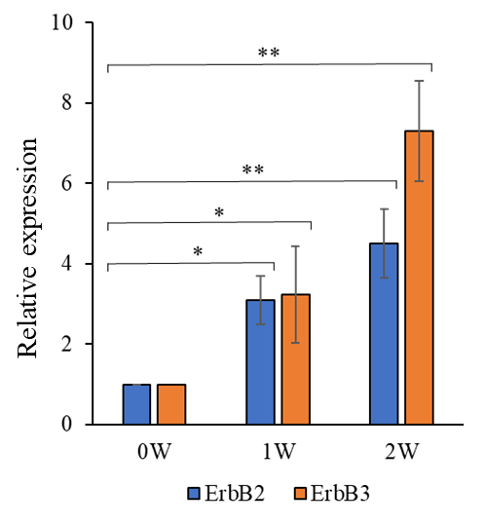
Supplementary Figure 1. Relative expression levels of ErbB2 and ErbB3 genes in week 0,1 and 2 of culturing miPSCs in CM assessed by RT-qPCR. Data were obtained from three different experiments. *, p < 0.05; **, p < 0.001. 0W, week 0; 1W, after one week of conversion; 2W, after two weeks of conversion.

Supplementary Table 2. Primer used in the study
Gene | Accession Number | Forward primer | Reverse primer
ErbB2 | NM_001003817.1 | CGAGTGTCAGCCTCAAAACA | TCCGGGTACTTCCAGATAGG
ErbB3 | NM_010153.2 | ATGCGCCCATTTTCGTGATG | CTGGTCCCTTACACCCTTGG
Actb | NM_007393.5 | AAATCTGGCACCACACCTTC | GGGGTGTTGAAGGTCTCAAA

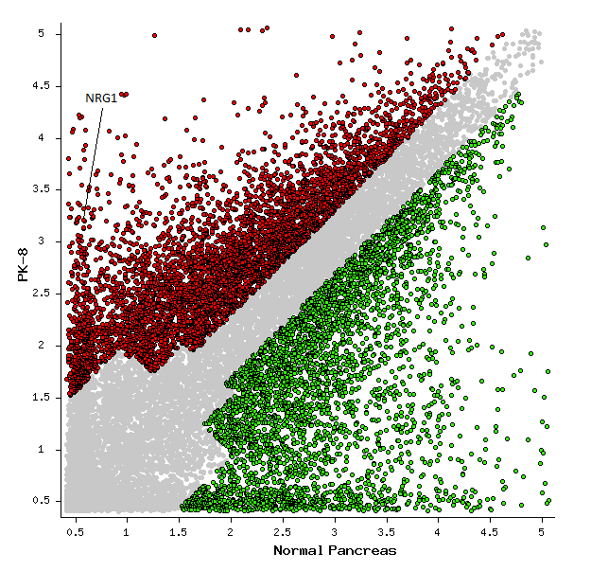
Supplementary Figure 2. Representative image for scatter plot of over- and down-expressed genes in PK8 cells compared with normal pancreas. Microarray data was obtained from GEO database. PK8 from GSE141247 dataset and normal pancreas from GSE71729 dataset. Red dots represent significant over-expressed genes in PK8 cells, and green dots are significant down-expressed genes. Significance criteria were false discovery rate (FDR) ≤ 0,0001 and fold change ≥ 2.

