Interactions between human milk oligosaccharides, microbiota and immune factors in milk of women with and without mastitis
Irma Castro¹, Cristina García-Carral^{1,2}, Annalee Furst³, Sadaf Khwajazada³, Janneiry García³, Rebeca Arroyo¹, Lorena Ruiz⁴, Juan M. Rodríguez¹, Lars Bode^{3,*}, Leónides Fernández^{5,*}
¹Departament of Nutrition and Food Science, Complutense University of Madrid, Madrid, Spain
²Probisearch S.L., Tres Cantos, Spain
³Department of Pediatrics and Larsson-Rosenquist Foundation Mother-Milk-Infant Center of Research Excellence, University of California San Diego, La Jolla, California, USA
⁴IPLA-CSIC, Department of Microbiology and Biochemistry of Dairy Products, Institute of Dairy Products of Asturias, Villaviciosa, Spain
⁵Department of Galenic Pharmacy and Food Technology, Complutense University of Madrid, Madrid, Spain
Correspondence and requests for materials should be addressed to L.B. (email: lbode@helath.ucsd.edu) or L.F. (email: leonides@vet.ucm.es).

Supplementary Table 1. Concentration (nmol/mL) of grouped HMOs in milk samples according to the Secretor status and breast health status (HW, healthy women; MW, mastitis cases) in women.
HMO | NON-SECRETOR |  |  | SECRETOR
HMO | HW (n = 10) | MW (n = 11) | p-value¹ |  | HW (n = 31) | MW (n = 62) | p-value¹
HMO | Median (IQR) or | Median (IQR) or |  |  | Median (IQR) or | Median (IQR) or | p-value¹
HMO | mean [95% CI] | mean [95% CI] |  |  | mean [95% CI] | mean [95% CI] | p-value¹
HMO-bound sialic acid² | 1445.02 [454.63] | 1814.97 [530.32] | 0.261 |  | 1494.50 (1092.00-1821.95) | 2209.05 (1508.55-2927.97) | *0.000
HMO-bound fucose acid³ | 11953.85 (9840.57-13970.92) | 11236.40 (9084.85-11751.40) | 0.387 |  | 15179.80[898.38] | 14959.79 [577.08] | 0.912
Small HMOs⁴ | 6582.75 [1762.07] | 6101.08 [1471.87] | 0.774 |  | 9782.40 [578.31] | 9971.63 [541.59] | 0.665
Type 1 HMOs⁵ | 5199.25 [1348.77] | 4299.32 [1296.04] | 0.212 |  | 3864.42 [467.61] | 3703.35 [373.18] | 0.851
Type 2 HMOs⁶ | 182.95 (154.32-283.57) | 254.40 (195.70-401.90) | 0.314 |  | 398.90 (335.65-528.30) | 653.65 (416.85-934.15) | *0.000
α-1,2⁷ | 223.49 [61.03] | 242.16 [69.77] | 0.693 |  | 7178.72 [874.60] | 8072.34 [785.43] | 0.655
α-1,3⁸ | 5725.79 [1666.11] | 4978.54 [1348.48] | 0.636 |  | 2218.20 (1530.40-3201.40) | 1726.30 (1288.82-2786.97) | 0.313
α-2,6⁹ | 468.65 (279.52-671.65) | 905.50 (716.85-1160.05) | 0.116 |  | 416.00 (280.30-638.70) | 1010.00 (585.32-1269.26) | *0.000
Evenness | 0.21 [0.04] | 0.21 [0.04] | 0.324 |  | 0.25 (0.20-0.30) | 0.23 (0.19-0.30) | 0.750
Diversity | 4.15 [0.96] | 4.03 [0.89] | 0.324 |  | 4.75 (3.75-5.70) | 4.40 (3.55-5.72) | 0.750
Total HMOs | 15183.95 (12131.33-15836.43) | 13948.00 (10163.20-12470.15) | 0.114 |  | 16039.70 (14288.35-18290.85) | 17283.75 (14594.78-18473.79) | 0.534
¹Wilcoxon rank sum test or ANOVA tests (depending on the distribution of the data) were used to determine differences in HMOs concentration between samples from mastitis-suffering or healthy women from Secretor or non-Secretor status. FDR-adjusted p-values.
*Statistically significant difference, p < 0.05.
²Calculated as the sum of all sialic acid moieties bound to each HMO.
³Calculated as the sum of all fucose moieties bound to each HMO.
⁴Calculated as 2'FL + 3FL + 3'SL + 6'SL.
⁵Calculated as LNT + LNFP I + LNFP II + LSTb + DSLNT.
⁶Calculated as LNnT + LNFP III + LSTc.
⁷Calculated as LNFP I + 2’FL
⁸Calculated as LNFP III + 3FL.
⁹Calculated as LSTc + 6'SL.

Supplementary Table 2. Microbiological counts (expressed as log₁₀ CFU/mL) using culture-dependent analysis of milk samples from healthy women (HW, n = 37) and women with mastitis (MW; n = 69) according to their Secretor status.
 | HW |  |  |  |  |  |  | MW
Microorganism | Non-Secretor (n = 9) |  | Secretor (n = 28) |  |  |  | Non-Secretor (n = 11) |  |  | Secretor (n = 58)
 | n (%)¹ | Median (IQR)² | n (%) | Median (IQR) | p-value³ | p-value⁴ |  | n (%) | Median (IQR) |  | n (%) | Median (IQR) |  | p-value³ |  | p-value⁴
Firmicutes
Staphylococcus epidermidis | 9 (100) | 2.86 (2.58-3.38) | 26 (93) | 2.10 (1.60-2.71) | 1.000 | 0.063 |  | 8 (73) | 5.05 (4.79-5.26) |  | 51 (88) | 5.00 (4.52-5.33) |  | 0.975 |  | 1.000
Staphylococcus aureus | 2 (22) | 1.65 (1.44-1.80) | 1 (4) | 1.30 | 0.890 | 1.000 |  | 8 (73) | 4.68 (3.38-5.08) |  | 31 (53) | 4.88 (4.10-5.30) |  | 0.975 |  | 1.000
Other staphylococci⁵ | 1 (11) | 2.30 | 4 (14) | 2.60 (1.89-2.92) | 1.000 | 1.000 |  | 3 (27) | 2.65 (2.57-3.60) |  | 5 (9) | 4.65 (3.70-4.70) |  | 0.545 |  | 0.786
Streptococcus mitis/oralis | 4 (44) | 1.70 (1.40-2.09) | 5 (18) | 2.46 (1.00-2.90) | 0.890 | 1.000 |  | 4 (36) | 4.65 (4.14-4.94) |  | 15 (26) | 3.70 (3.33-5.09) |  | 0.975 |  | 1.000
Streptococcus salivarius | 1 (11) | 2.60 | 3 (11) | 1.84 (1.60-1.93) | 1.000 | 1.000 |  | 4 (36) | 4.51 (4.06-4.70) |  | 14 (26) | 4.14 (3.70-4.62) |  | 0.975 |  | 1.000
Other streptococci⁶ | 4 (44) | 1.81 (1.63-2.10) | 9 (32) | 1.95 (1.30-2.08) | 1.000 | 1.000 |  | 1 (9) | 4.30 |  | 11 (19) | 4.00 (3.70-4.70) |  | 0.975 |  | 1.000
Enterococcus spp. | 1 (11) | 3.83 | 1 (4) | 1.00 | 0.990 | 1.000 |  | 2 (18) | 4.73 (4.48-4.88) |  | 1 (2) | 4.18 |  | 0.480 |  | 1.000
Other Firmicutes⁷ | 3 (33) | 2.50 (2.41-3.06) | 4 (14) | 2.04 (1.44-3.27) | 0.990 | 1.000 |  | 3 (27) | 4.40 (4.35-4.51) |  | 3 (5) | 3.78 (3.63-3.90) |  | 0.480 |  | 0.786
Proteobacteria⁸ | 3 (33) | 3.60 (3.31-3.73) | 0 (0) | - | 1.000 | - |  | 0 (0) | - |  | 5 (9) | 2.60 (2.54-5.10) |  | 0.975 |  | -
Actinobacteria
Rothia.mucilaginosa | 1 (11) | 1.78 | 3 (11) | 1.78 (1.54-1.84) | 1.000 | 1.000 |  | 2 (18) | 3.72 (3.46-3.88) |  | 7 (12) | 3.78 (3.46-4.97) |  | 0.975 |  | 1.000
Corynebacterium spp. | 3 (33) | 1.00 (1.00-1.18) | 2 (7) | 1.18 (1.10-1.24) | 0.890 | 1.000 |  | 1 (9) | 3.40 |  | 8 (14) | 3.70 (3.62-4.19) |  | 1.000 |  | 1.000
Other Actinobacteria⁹ | 2 (22) | 2.10 (1.86-2.25) | 7 (25) | 2.60 (1.30-3.10) | 1.000 | 1.000 |  | 0 (0) | - |  | 0 (0) | - |  | 1.000 |  | -
Yeast | 1 (11) | 2.30 | 1 (4) | 1.00 | 0.990 | 1.000 |  | 0 (0) | - |  | 4 (7) | 3.14 (2.85-4.15) |  | 0.975 |  | -
Not identified | 6 (67) | 2.86 (2.38-3.15) | 14 (50) | 2.35 (2.01-2.59) | 0.990 | 0.933 |  | 0 (0) | - |  | 0 (0) | - |  | 1.000 |  | -
Total CFU | 9 (100) | 3.10 (2.96-3.69) | 28 (100) | 2.38 (1.67-3.04) | 1.000 | 0.063 |  | 11 (100) | 5.34 (5.03-5.47) |  | 58 (100) | 5.31 (5.04-5.54) |  | 1.000 |  | 1.000
¹n (%): number (percentage) of samples in which the microorganism was detected (relative frequency of detection).
²All data expressed as median (IQR) log₁₀ CFU/mL (only samples where bacterial growth was detected).
³Fisher tests were used to determine a possible association between the Secretor or non-Secretor status and woman health (HW and MW groups) in those women in which the microorganism or group was isolated. FDR-adjusted p-values.*Statistically significant difference, p < 0.05.
⁴Wilcoxon rank sum tests were used to determine if there were differences in microbiological counts according to Secretor status in HW and MW groups. FDR-adjusted p-values.
⁵Other staphylococcal species that were identified include S. hominis, S. lugdunensis, S. pasteuri and S. warneri.
⁶Other streptococcal species that were identified include S. anginosus, S. gordonii, S. parasanguinis, S. pneumoniae and S. vestibularis.
⁷Other Firmicutes includes Bacillus, Lactococcus, former Lactobacillus and Weisella.
⁸Proteobacteria includes Brevundimonas, Enterobacteriaceae, Moraxella, Rhizobium and Stenotrophomonas.
⁹Other Actinobacteria includes Actinomyces, Bifidobacterium, Cutibacterium, Kocuria and Propionibacterium.
IQR: interquartile range; CFU: colony-forming units.

Supplementary Table 3. Frequency and concentration of immune factors in milk samples according to the breast health status (HW, healthy women; MW, mastitis cases) and secretory status.
 | HW |  |  |  |  |  |  |  |  | MW
 | Non-Secretor (n=10) |  | Secretor (n=31) |  |  |  |  |  |  | Non-Secretor (n=8) |  |  | Secretor (n=46)
 | n (%)¹ | Median (IQR)² | n (%) | Median (IQR) | p-value³ |  | p-value⁴ |  | n (%) |  | Median (IQR) | n (%) |  | Median (IQR) | p-value³ |  | p-value⁴
Innate immunity
IL1β (ng/L) | 9 (90) | 0.40 (0.30-1.50) | 14 (45) | 1.35 (0.62-6.72) | 0.225 |  | 0.479 |  | 7 (87) |  | 3.21 (1.37-16.10) | 44 (96) |  | 8.24 (1.17-23.67) | 1.000 |  | 1.000
IL6 (ng/L) | 7 (70) | 12.70 (8.35-18.05) | 10 (32) | 13.15 (7.77-18.05) | 0.373 |  | 1.000 |  | 6 (75) |  | 13.12 (4.51-31.10) | 36 (78) |  | 10.26 (2.10-37.43) | 1.000 |  | 1.000
IL12(p70) (ng/L) | 1 (10) | 0.10 | 5 (16) | 0.90 (0.20-0.90) | 1.000 |  | 0.479 |  | 2 (25) |  | 4.62 (3.56-5.69) | 6 (13) |  | 1.42 (0.76-3.52) | 1.000 |  | 1.000
IFNγ (ng/L) | 0 (0) | - | 1 (3) | 4.70 | 1.000 |  | - |  | 8 (100) |  | 79.44 (21.17-295.30) | 44 (96) |  | 54.43 (11.22-259.90) | 1.000 |  | 1.000
TNFα (ng/L) | 4 (40) | 3.45 (2.52-4.75) | 14 (45) | 3.10 (2.02-4.52) | 1.000 |  | 0.886 |  | 8 (100) |  | 35.24 (16.53-95.36) | 46 (100) |  | 29.02 (12.34-67.72) | 1.000 |  | 1.000
Acquired immunity
IL2 (ng/L) | 0 (0) | - | 0 (0) | - | 1.000 |  | - |  | 4 (50) |  | 15.46 (11.63-19.40) | 34 (74) |  | 5.95 (0.98-17.51) | 1.000 |  | 1.000
IL4 (ng/L) | 1 (10) | 0.70 | 0 (0) | - | 0.878 |  | - |  | 3 (37) |  | 1.01 (0.85-1.31) | 25 (54) |  | 0.55 (0.26-1.32) | 1.000 |  | 1.000
IL10 (ng/L) | 8 (80) | 3.75 (2.70-4.15) | 24 (77) | 3.15 (1.60-4.40) | 1.000 |  | 0.886 |  | 0 (0) |  | - | 6 (13) |  | 3.51 (3.29-4.40) | 1.000 |  | -
IL13 (ng/L) | 8 (80) | 4.20 (3.20-7.60) | 25 (81) | 2.40 (1.30-2.90) | 1.000 |  | 0.266 |  | 1 (12) |  | 0.22 | 9 (19) |  | 0.76 (0.76-1.24) | 1.000 |  | 1.000
IL17 (ng/L) | 0 (0) | - | 2 (6) | 4.30 (3.20-5.40) | 1.000 |  | - |  | 5 (62) |  | 21.42 (7.86-31.70) | 26 (56) |  | 17.67 (9.89-52.57) | 1.000 |  | 1.000
Chemokines
IL8 (ng/L) | 10 (100) | 128.55 (95.47-184.25) | 31 (100) | 43.60 (22.40-152.85) | 1.000 |  | 0.343 |  | 8 (100) |  | 199.70 (172.50-1321.00) | 46 (100) |  | 275.70 (98.84-1818.00) | 1.000 |  | 1.000
MCP1 (ng/L) | 10 (100) | 181.85 (136.77-313.50) | 22 (71) | 144.15 (51.67-265.80) | 0.373 |  | 0.470 |  | 8 (100) |  | 511.00 (315.90-1646.00) | 45 (98) |  | 375.70 (70.77-985.40) | 1.000 |  | 1.000
MIP1β (ng/L) | 10 (100) | 46.25 (36.37-103.47) | 29 (93) | 28.50 (14.60-55.00) | 1.000 |  | 0.327 |  | 8 (100) |  | 31.68 (12.17-156.30) | 46 (100) |  | 25.35 (9.75-161.30) | 1.000 |  | 1.000
Hematopoyetic factors
IL5 (ng/L) | 1 (10) | 2.80 | 2 (6) | 1.70 (1.25-2.15) | 1.000 |  | 0.887 |  | 3 (37) |  | 21.32 (16.18-38.56) | 12 (26) |  | 37.33 (19.74-67.32) | 1.000 |  | 1.000
IL7 (ng/L) | 10 (100) | 57.70 (42.40-87.57) | 28 (90) | 32.85 (25.45-51.30) | 1.000 |  | 0.226 |  | 4 (50) |  | 21.71 (13.62-57.67) | 16 (35) |  | 22.42 (11.47-62.17) | 1.000 |  | 1.000
GCSF (ng/L) | 10 (100) | 40.50 (18.42-71.77) | 19 (61) | 16.70 (4.90-38.30) | 0.225 |  | 0.410 |  | 7 (87) |  | 176.50 (67.13-683.80) | 44 (96) |  | 213.90 (47.61-692.00) | 1.000 |  | 1.000
GMCSF (ng/L) | 1 (10) | 12.90 | 2 (6) | 12.10 (6.25-17.95) | 1.000 |  | 1.000 |  | 4 (50) |  | 1.54 (1.25-1.75) | 15 (33) |  | 4.88 (2.03-5.23) | 1.000 |  | 1.000
TGFβ2 (µg/L) | 10 (100) | 2.55 (1.65-4.45) | 31 (100) | 1.80 (1.10-3.25) | 1.000 |  | 0.410 |  | 8 (100) |  | 4.33 (1.20-6.53) | 46 (100) |  | 1.31 (0.38-4.86) | 1.000 |  | 1.000
¹n (%): number (percentage) of samples in which the immunological compound was detected (relative frequency of detection).
²Data expressed as median and interquartile range (IQR).
³Fisher tests were used to determine a possible association between the Secretor status and the immunological compound detected. FDR-adjusted p-values.
⁴Wilcoxon rank sum tests were used to determine differences in the concentration detected of each immunological compound according to Secretor status. FDR-adjusted p-values.
GCSF, granulocyte colony-stimulating factor; GMCSF, granulocyte-macrophage colony-stimulating factor; INFγ, interferon-γ; IL, interleukin; MCP1, macrophage-monocyte chemoattractant protein-1; MIP1β, macrophage inflammatoryprotein-1β; TGFβ2, transforming growth factor-β2; TNFα, tumor necrosis factor-α.

Supplementary Table 4. Microbiological counts (expressed as log₁₀ CFU/mL) determined using culture-dependent analysis of milk samples from acute mastitis (AM; n = 29) and subacute mastitis (SAM; n = 40) cases.
Microorganism | AM (n = 29) |  | SAM (n = 40)
Microorganism | n (%) | Median (IQR) |  | n (%) | Median (IQR) |  | p-value³ |  | p-value⁴
Firmicutes
Staphylococcus epidermidis | 21 (72) | 4.70 (4.00-5.00) |  | 38 (95) | 5.14 (4.87-5.40) |  | 0.091 |  | 0.156
Staphylococcus aureus | 29 (100) | 5.18 (4.78-5.30) |  | 10 (25) | 3.06 (2.80-3.42) |  | *0.000 |  | *0.000
Other staphylococci | 4 (14) | 2.93 (2.61-4.45) |  | 4 (10) | 4.42 (3.84-4.66) |  | 0.974 |  | 0.743
Streptococcus mitis/oralis | 10 (34) | 4.63 (3.47-5.05) |  | 9 (22) | 4.18 (3.48-4.98) |  | 0.772 |  | 0.945
Streptococcus salivarius | 6 (21) | 4.18 (4.12-4.61) |  | 12 (30) | 4.00 (3.57-4.70) |  | 0.772 |  | 0.743
Other streptococci | 6 (21) | 4.18 (3.80-4.63) |  | 6 (15) | 4.38 (3.75-4.68) |  | 0.974 |  | 0.944
Enterococcus spp. | 1 (3) | 3.81 |  | 2 (5) | 4.76 (4.56-4.90) |  | 0.722 |  | 0.910
Other Firmicutes | 3 (10) | 4.40 (4.14-4.51) |  | 3 (7) | 4.00 (3.90-4.18) |  | 1.000 |  | 0.910
Proteobacteria | 1 (3) | 1.70 |  | 4 (10) | 4.80 (2.59-5.10) |  | 0.722 |  | 0.743
Rothia mucilaginosa | 2 (7) | 5.37 (5.31-5.43) |  | 7 (17) | 3.48 (3.21-3.90) |  | 0.722 |  | 0.195
Corynebacterium spp. | 4 (14) | 4.44 (3.60-5.00) |  | 6 (15) | 3.70 (3.49-4.10) |  | 1.000 |  | 0.910
Yeast | 1 (3) | 2.87 |  | 3 (7) | 3.30 (3.10-4.41) |  | 0.974 |  | 1.000
Total CFU | 29 (100) | 5.35 (5.21-5.54) |  | 40 (100) | 5.24 (5.00-5.43) |  | 1.000 |  | 0.195
¹ n (%): number (percentage) of samples in which the microorganism was detected (relative frequency of detection).
² All data expressed as median (IQR) log10 CFU/mL (only samples where bacterial growth was detected).
³ Fisher tests or χ2 tests (in italics) were used to determine a possible association between the type of mastitis and individual microorganisms or group of microorganisms isolated from milk samples. FDR-adjusted p-values. *Statistically significant difference, p < 0.05.
⁴ Wilcoxon rank sum tests were used to determine if there were differences in microbiological counts according to Secretor status in AM and SAM cases. FDR-adjusted p-values. *Statistically significant difference, p < 0.05.
⁵ Other staphylococcal species that were identified include S. hominis, S. lugdunensis, S. pasteuri and S. warneri.
⁶ Other streptococcal species that were identified include S. anginosus, S. gordonii, S. parasanguinis, S. pneumoniae and S. vestibularis.
⁷ Other Firmicutes includes Bacillus, Lactococcus, former Lactobacillus and Weisella.
⁸ Proteobacteria includes Brevundimonas, Enterobacteriaceae, Moraxella, Rhizobium and Stenotrophomonas.
IQR: interquartile range; CFU: colony-forming units.

Supplementary Table 5. Concentration (nmol/mL) of individual HMOs in milk samples according to mastitis type: acute (AM) or subacute (SAM) mastitis.
HMO | AM (n = 29) | SAM (n = 40) | p-value¹
HMO | Median (IQR) or  mean [95% CI] | Median (IQR) or  mean [95% CI] | p-value¹
Fucosylated
2'FL | 5924.50 (3902.60-8340.70) | 5921.10 (3313.80-7521.62) | 0.793
3FL | 1460.40 (1097.75-2941.90) | 2358.00 (1483.12-3644.75) | 0.060
DFLac | 297.90 (235.50-399.60) | 351.15 (247.12-498.65) | 0.317
LNFP I | 1633.70 (630.70-2135.25) | 965.25 (416.27-1510.60) | 0.317
LNFP II | 798.90 (532.20-1443.20) | 781.60 (542.15-1166.67) | 0.806
LNFP III | 24.90 (16.90-39.40) | 14.15 (7.95-24.07) | *0.042
DFLNT | 1120.72 [222.32] | 987.35 [177.29] | 0.800
FLNH | 208.40 (152.30-292.30) | 173.75 (91.87-288.85) | 0.325
DFLNH | 88.30 (41.50-161.70) | 124.00 (57.07-206.62) | 0.325
Sialylated
3'SL | 314.80 (225.20-401.90) | 331.15 (251.15-444.22) | 0.542
6'SL | 800.15 (649.80-934.50) | 618.15 (346.35-823.22) | 0.187
LSTb | 74.80 (48.10-91.30) | 54.20 (39.95-92.70) | 0.334
LSTc | 284.30 (199.50-382.50) | 162.10 (56.40-249.72) | 0.057
DSLNT | 212.50 (107.90-258.60) | 90.45 (28.67-167.05) | *0.032
FDSLNH | 166.75 [31.50] | 134.05 [31.17] | 0.326
DSLNH | 69.10 (47.50-97.70) | 57.45 (31.80-96.32) | 0.472
Neutral
LNnT | 427.30 (320.80-536.90) | 230.00 (161.42-353.80) | *0.000
LNT | 1510.10 (1235.30-2159.35) | 986.90 (565.45-1436.55) | *0.000
LNH | 55.50 (33.30-112.25) | 58.00 (34.47-95.02) | 0.966
¹Wilcoxon rank sum test or ANOVA tests (depending on the distribution of the data) were used to determine differences in HMOs concentration between samples from AM or SAM cases. FDR-adjusted p-values. *Statistically significant difference, p < 0.05.
CI, confidence interval; IQR. Interquartile range. DFLac, difucosyllactose; DFLNH, difucosyllacto-N-hexaose; DFLNT, difucosyllacto-N-tetrose; DSLNH, diasilyllacto-N-hexaose; DSLNT, diasilyllacto-N-tetraose; FDSLNH, fucodisialyllacto-N-hexaose; FLNH, fucosyllacto-N-hexaose; HMO, human milk oligosaccharide; LNFP, lacto-N-fucopentaose; LNH, lacto-N-hexaose; LNnT, lacto-N-neotetraose; LNT, lacto-N-tetraose; LSTb, sialyl-lacto-N-tetraose b; LSTc, sialyl-lacto-N-tetraose c; 2’FL, 2’-fucosyllactose; 3FL, 3-fucosyllactose; 3’SL, 3’-sialyllactose; 6’SL, 6’-sialyllactose.
Supplementary Table 6. Concentration (nmol/mL) of grouped HMOs in milk samples according to mastitis type: acute (AM) or subacute (SAM) mastitis.
HMO | AM (n = 29) | SAM (n = 40) | p-value¹
HMO | Median (IQR)  or mean [95% CI] | Median (IQR)  or mean [95% CI] | p-value¹
HMO-bound fucose acid² | 15146.85 (12164.10-16000.60) | 14379.75 (11790.13-16667.88) | 0.957
HMO-bound sialic acid³ | 2409.92 [336.68] | 2034.44 [332.44] | 0.212
Small HMOs⁴ | 9003.99 [954.95] | 9608.76 [806.10] | 0.390
Type 1 HMOs⁵ | 4588.3 [469.97] | 3419.25 [447.15] | *0.000
Type 2 HMOs⁶ | 748.60 (520.70-940.30) | 417.30 (269.55-671.00) | *0.005
α-1,2⁷ | 8038.90 (5273.80-9768.05) | 6998.10 (3959.25-9010.00) | 0.558
α-1,3⁸ | 1508.30 (1161.15-2992.00) | 2372.75 (1530.40-3652.50) | 0.073
α-2,6⁹ | 1015.10 (751.35-1243.25) | 864.65 (364.22-1473.10) | 0.588
Evenness | 0.25 (0.17-0.31) | 0.23 (0.18-0.26) | 0.390
Diversity | 4.81 (3.31-5.92) | 4.36 (3.51-5.00) | 0.390
Total HMOs | 17239.40 (14559.20-18433.80) | 16284.25 (13510.93-18320.40) | 0.390
¹Wilcoxon rank sum test or ANOVA tests (depending on the distribution of the data) were used to determine differences in HMOs concentration between samples from AM or SAM cases. FDR-adjusted p-values.
*Statistically significant difference, p < 0.05.
²Calculated as the sum of all fucose moieties bound to each HMO.
³Calculated as the sum of all sialic acid moieties bound to each HMO.
⁴Calculated as 2'FL + 3FL + 3'SL + 6'SL.
⁵Calculated as LNT + LNFP I + LNFP II + LSTb + DSLNT.
⁶Calculated as LNnT + LNFP III + LSTc.
⁷Calculated as LNFP I + 2’FL
⁸Calculated as LNFP III + 3FL.
⁹Calculated as LSTc + 6'SL.

Supplementary Table 7. Frequency and concentration of immune factors detected in milk samples from acute mastitis (AM; n = 19) and subacute mastitis (SAM; n= 35) cases.
Compound |  | AM (n = 19) |  | SAM (n = 35) | p-value² | p-value³
Compound | n (%)¹ | Median (IQR) | n (%) | Median (IQR) | p-value² | p-value³
Innate immunity
IL1β (ng/L) | 19 (100) | 15.51 (3.51-33.60) | 32 (91) | 4.23 (1.01-11.51) | 0.779 | 0.382
IL6 (ng/L) | 17 (89) | 12.76 (4.43-48.23) | 25 (71) | 8.44 (1.08-23.16) | 0.779 | 0.404
IL12(p70) (ng/L) | 2 (11) | 1.62 (1.19-2.06) | 6 (17) | 3.04 (1.09-6.07) | 1.000 | 0.644
IFNγ (ng/L) | 19 (100) | 84.09 (13.47-220.99) | 33 (94) | 48.23 (10.59-427.18) | 0.977 | 0.747
TNFα (ng/L) | 19 (100) | 42.04 (24.93-67.45) | 35 (100) | 21.39 (10.57-94.68) | 1.000 | 0.404
Acquired immunity
IL2 (ng/L) | 18 (95) | 5.95 (1.30-9.56) | 20 (57) | 14.27 (0.98-35.33) | 0.072 | 0.382
IL4 (ng/L) | 10 (53) | 0.48 (0.26-0.67) | 18 (51) | 1.04 (0.28-2.39) | 1.000 | 0.382
IL10 (ng/L) | 0 (0) | - | 6 (17) | 3.51 (3.29-4.40) | 0.480 | -
IL13 (ng/L) | 1 (5) | 0.04 | 9 (25) | 0.76 (0.76-1.24) | 0.480 | 0.404
IL17 (ng/L) | 13 (68) | 17.04 (11.89-19.55) | 18 (51) | 31.11 (8.2-63.56) | 0.779 | 0.404
Chemokines
IL8 (ng/L) | 19 (100) | 351.30 (208.98-2140.61) | 35 (100) | 195.12 (90.78-1406.96) | 1.000 | 0.382
MCP1 (ng/L) | 19 (100) | 537.96 (201.35-1080.37) | 35 (100) | 376.36 (58.33-728.20) | 1.000 | 0.443
MIP1β (ng/L) | 19 (100) | 65.59 (19.41-162.03) | 35 (100) | 16.80 (9.55-145.50) | 1.000 | 0.404
Hematopoyetic factors
IL5 (ng/L) | 5 (26) | 11.03 (8.28-21.32) | 10 (29) | 49.13 (34.43-75.25) | 1.000 | 0.238
IL7 (ng/L) | 6 (32) | 16.74 (8.61-23.32) | 14 (40) | 25.40 (15.54-137.52) | 0.977 | 0.403
GCSF (ng/L) | 19 (100) | 425.25 (74.01-696.52) | 32 (91) | 117.38 (41.85-688.67) | 0.779 | 0.443
GMCSF (ng/L) | 7 (37) | 1.20 (0.43-3.44) | 12 (34) | 4.61 (2.67-5.10) | 0.954 | 0.382
TGFβ₂ (µg/L) | 19 (100) | 1.88 (0.90-5.57) | 35 (100) | 1.09 (0.32-6.53) | 1.000 | 0.544
¹n (%): number (percentage) of samples in which the immunological compound was detected (relative frequency of detection).
²χ2 or Fisher tests (in italics) were used to determine a possible association between the AM and SAM cases and the immunological compound detected. FDR-adjusted p-values.
³Wilcoxon rank sum tests were used to determine differences in the concentration detected of each immunological compound between samples from AM and SAM cases. FDR-adjusted p-values.
GCSF, granulocyte colony-stimulating factor; GMCSF, granulocyte-macrophage colony-stimulating factor; INFγ, interferon-γ; IL, interleukin; MCP1, macrophage-monocyte chemoattractant protein-1; MIP1β, macrophage inflammatory protein-1β; TGFβ2, transforming growth factor-β2; TNFα, tumor necrosis factor-α.
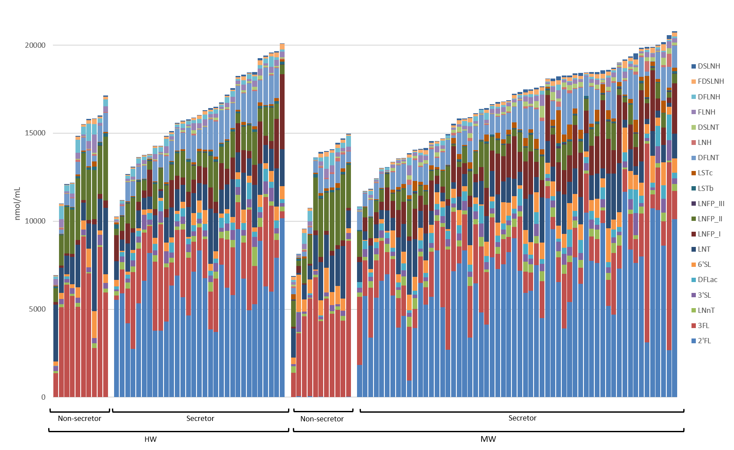
Supplementary Figure 1. Absolute HMOs concentration (nmol/mL) and HMO profile in 110 samples from all participant women in the study according to health status (HW, healthy women; MW, mastitis women) and secretory status. Each vertical line represents an individual sample and the concentration of the different HMOs are coded by the colors shown in the legend.
DFLac, difucosyllactose; DFLNH, difucosyllacto-N-hexaose; DFLNT, difucosyllacto-N-tetrose; DSLNH, diasilyllacto-N-hexaose; DSLNT, diasilyllacto-N-tetraose; FDSLNH, fucodisialyllacto-N-hexaose; FLNH, fucosyllacto-N-hexaose; HMO, human milk oligosaccharide; LNFP, lacto-N-fucopentaose; LNH, lacto-N-hexaose; LNnT, lacto-N-neotetraose; LNT, lacto-N-tetraose; LSTb, sialyl-lacto-N-tetraose b; LSTc, sialyl-lacto-N-tetraose c; 2’FL, 2’-fucosyllactose; 3FL, 3-fucosyllactose; 3’SL, 3’-sialyllactose; 6’SL, 6’-sialyllactose.

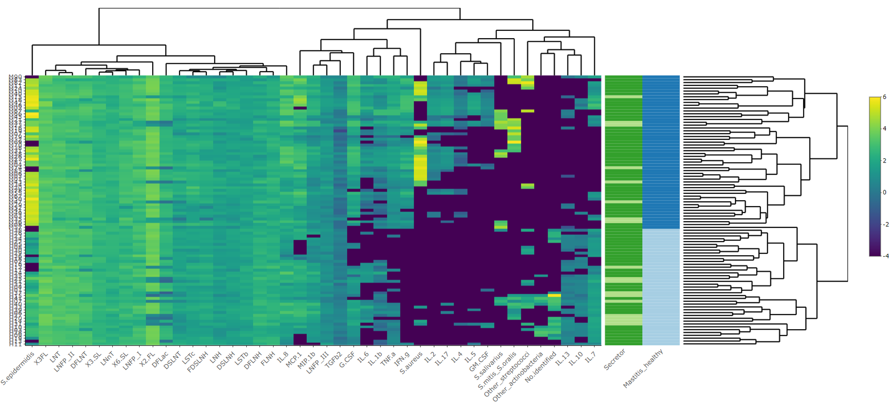Supplementary Figure 2. Heatmap showing log₁₀-transformed HMO and immunological concentrations and microbiological counts (x axis) in milk samples (y axis; each row represents one milk sample). Samples from women with mastitis (MW group) are color coded in dark blue, and samples from healthy women (HW group) in light blue (Mastitis_Healthy column). Samples from women characterized as Secretors are color coded in dark green and non-Secretors in light green (Secretor column). The concentration of individual or grouped HMOs, immunological compounds and bacterial species within each sample is indicated by the color of the scale ranging from yellow (high concentration) to dark blue (low concentration) as indicated in the scale shown at the right. Upper dendrogram linkages are based on similarities among HMO and immunological compound concentrations and microbial counts; right side dendrogram linkages are based on similarities among the profile of the samples. The heatmap was generated using the heatmaply package [1] (v. 1.2.1) available for R (http://cran.r-project.org/package=heatmaply).
DFLac, difucosyllactose; DFLNH, difucosyllacto-N-hexaose; DFLNT, difucosyllacto-N-tetraose; DSLNH, diasilyllacto-N-hexaose; DSLNT, diasilyllacto-N-tetraose; FDSLNH, fucodisialyllacto-N-hexaose; FLNH, fucosyllacto-N-hexaose; LNFP, lacto-N-fucopentaose; LNH, lacto-N-hexaose; LNnT, lacto-N-neotetraose; LNT, lacto-N-tetraose; LSTb, sialyl-lacto-N-tetraose b; LSTc, sialyl-lacto-N-tetraose c; 2’FL, 2’-fucosyllactose; 3FL, 3-fucosyllactose; 3’SL, 3’-sialyllactose; 6’SL, 6’-sialyllactose. Other streptococcal species that were identified include S. anginosus, S. gordonii, S. parasanguinis, S. pneumoniae and S. vestibularis. Other Actinobacteria includes Actinomyces, Bifidobacterium, Cutibacterium, Kocuria and Propionibacterium. GCSF, granulocyte colony-stimulating factor; GM.CSF, granulocyte-macrophage colony-stimulating factor; INF.g, interferon γ; IL, interleukin; MCP.1, macrophage-monocyte chemoattractant protein 1; MIP.1b, macrophage inflammatoryprotein 1β; TGFb, transforming growth factor-β₂; TNF.a, tumor necrosis factor α.
[1] Galili, T., O'Callaghan, A., Sidi, J. & Sievert, C. heatmaply: an R package for creating interactive cluster heatmaps for online publishing. Bioinformatics, 34, 1600-1602; 10.1093/bioinformatics/btx657 (2018).

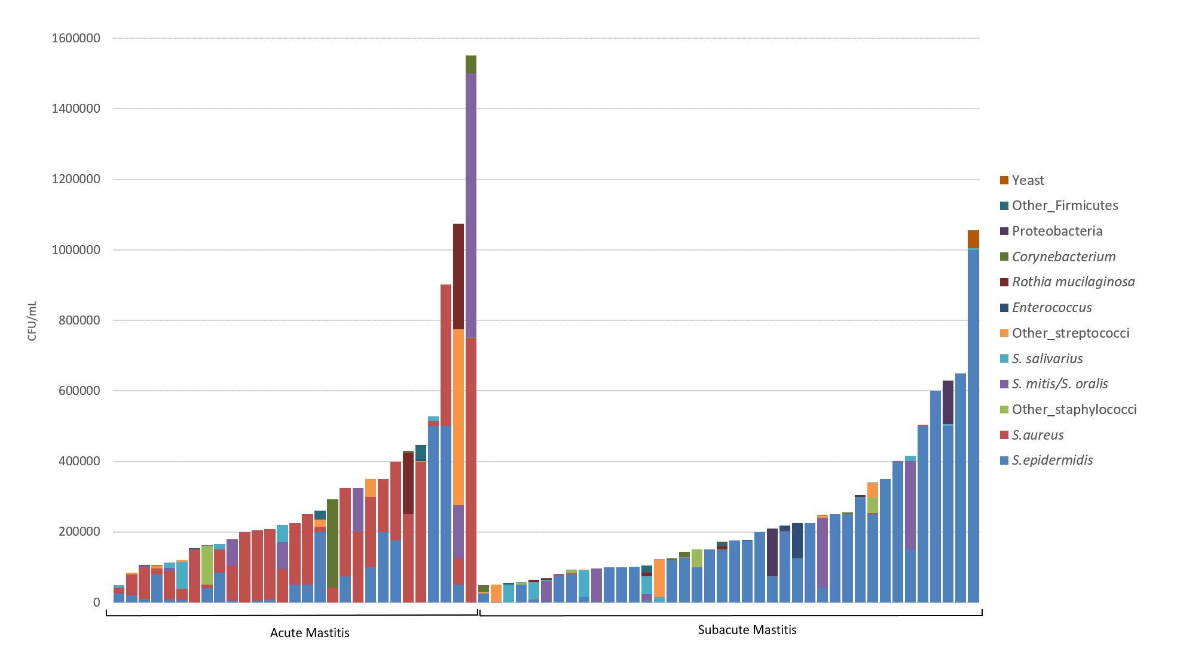
Supplementary Figure 3. Microbial profile of samples from acute (AM; n = 29) and subacute mastitis (SAM; n = 40) cases. Each vertical line represents an individual sample and the concentrations (CFU/mL) of individual or grouped microorganism are coded by the colors shown in the legend. Other staphylococcal species that were identified include S. hominis, S. lugdunensis, S. pasteuri and S. warneri. Other streptococcal species that were identified include S. anginosus, S. gordonii, S. parasanguinis, S. pneumoniae and S. vestibularis. Other Firmicutes includes Bacillus, Lactococcus, former Lactobacillus and Weisella. Proteobacteria includes Brevundimonas, Enterobacteriaceae, Moraxella, Rhizobium and Stenotrophomonas.

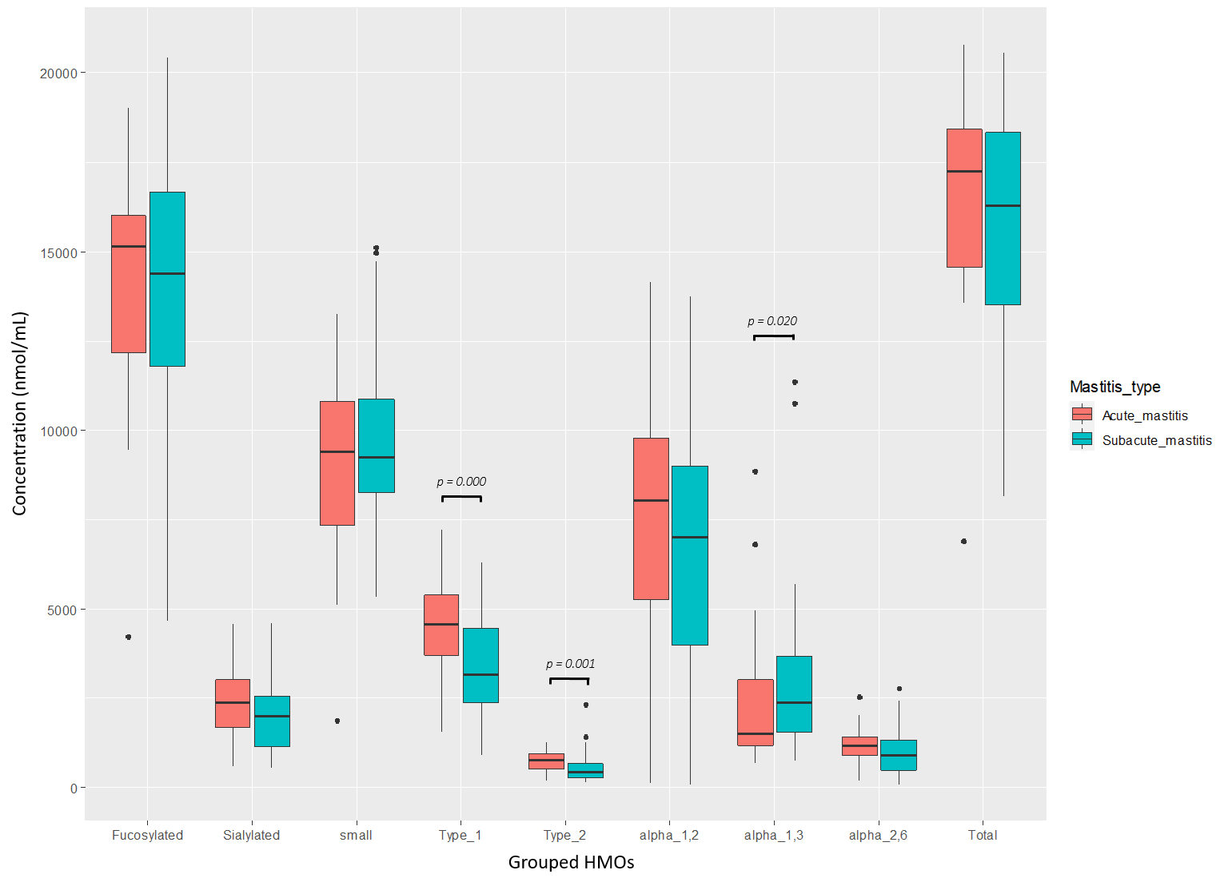
Supplementary Figure 4. Box-plots showing the concentrations (nmol/mL) of grouped HMOs. The boxes represent the values of the interquartile ranges, with the median represented as a line. Outliers are represented as dots. Samples colored in red belong to acute mastitis (AM) and in green to subacute m (SAM) cases.
Fucosylated HMOs are calculated as the sum of all sialic acid moieties bound to each HMO; Sialylated HMOs are calculated as the sum of all fucose moieties bound to each HMO; Small HMOs are calculated as 2'FL + 3FL + 3'SL + 6'SL; Type 1 HMOs are calculated as LNT + LNFP I + LNFP II + LSTb + DSLNT; Type 2 HMOs are calculated as LNnT + LNFP III + LSTc; α-1,2 HMOs are calculated as LNFP I + 2’FL; α-1,3 are calculated as LNFP III + 3FL; α-2,6 are alculated as LSTc + 6'SL.

Supplementary Figure 5. Receiver operating characteristic (ROC) curve for IL8 concentration in milk used to predict mastitis. The closer the area under the curve (AUC) is to 1.0, the better the IL8 concentration predicts mastitis. Diagnostic accuracy was categorized as failed (ROC AUC ≤ 0.6), poor (0.6 < ROC AUC ≤ 0.7), fair (0.7 < ROC AUC ≤ 0.8), good (0.8 < ROC AUC ≤ 0.9) or excellent (0.9 < ROC AUC ≤ 1.0).

