SUPPLEMENTARY INFORMATION

GLUT3 inhibitor discovery through in silico ligand screening and in vivo validation in eukaryotic expression systems

Cristina V. Iancu^{1,#}, Giovanni Bocci^{2,#}, Mohd Ishtikhar ^{1,#}, Moumita Khamrai¹, Mislav Oreb³, Tudor I. Oprea^{2,4,5,6*}, and Jun-yong Choe^{1,7,8*}

¹ East Carolina Diabetes and Obesity Institute, East Carolina University, Greenville, NC 27834, USA.
² Translational Informatics Division, Department of Internal Medicine, The University of New Mexico School of Medicine, Albuquerque, NM 87131, USA.
³ Institute of Molecular Biosciences, Faculty of Biological Sciences, Goethe University Frankfurt, Frankfurt am Main, Germany.
⁴ UNM Comprehensive Cancer Center, The University of New Mexico, Albuquerque, NM 87131, USA.
⁵ Department of Rheumatology and Inflammation Research, Institute of Medicine, Sahlgrenska Academy at University of Gothenburg, Gothenburg, Sweden.
⁶ Novo Nordisk Foundation Center for Protein Research, Faculty of Health and Medical Sciences, University of Copenhagen, Copenhagen, Denmark.
⁷ Department of Chemistry, East Carolina Diabetes and Obesity Institute, East Carolina University, Greenville, NC 27834, USA.
⁸ Department of Biochemistry and Molecular Biology, Rosalind Franklin University, North Chicago, IL 60064 USA.

# Contributed equally
* Corresponding authors: Tudor Oprea, toprea@salud.unm.edu
Jun-yong Choe, choej18@ecu.edu

Supplementary Figure S1
Supplementary Figure S2
Supplementary Figure S3
Supplementary Figure S4
Supplementary Figure S5
Supplementary Figure S6
Supplementary Figure S7
Supplementary Figure S8
Supplementary Figure S9
Supplementary Figure S10
Supplementary Table S1
Supplementary Table S2

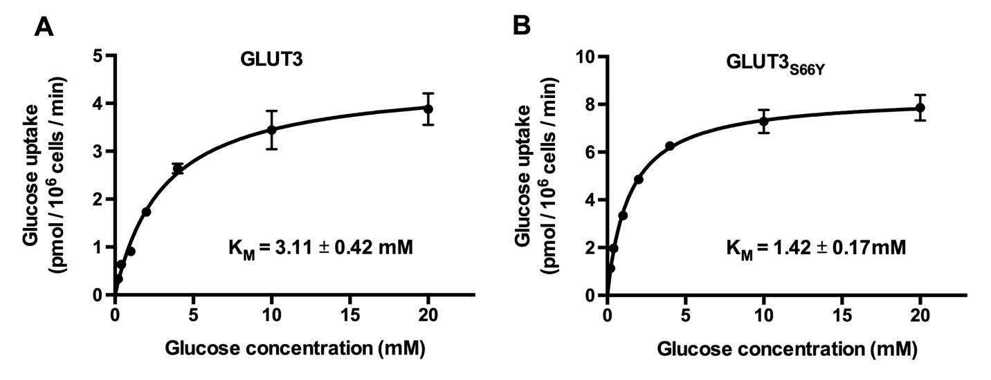

Supplementary Figure S1. Michaelis-Menten curves for glucose transport in GLUT3 yeast systems. Glucose transport activity of GLUT3 wild-type (A) or S66Y mutant (B) expressed in hexose transporter-deficient (hxt⁰) EBY.S7 yeast cells¹ at different glucose concentrations. Transport activity was initiated by the addition of C¹⁴-glucose to the yeast cells in PBS buffer. After 10 mins, transport activity was stopped, and the radioactivity accumulated in cells was measured. See Materials and Methods for details. Error bars represent standard deviation of three independent measurements. Graphs and data analysis for K_{M} calculation were generated with GraphPad (www.graphpad.com).

Supplementary Figure S2. Effect of top-ranked ligand candidates from TBVS on GLUT3 transport activity. The tested compounds (listed in Supplementary Table S1) are identified by the ChemNavigator Structure ID. Relative transport activity of GLUT3 expressed in EBY.S7 yeast cells in the presence of 100 µM compound concentration, at 3 mM glucose concentration (i.e., glucose K_{M} concentration, see Supplementary Figure S1A). More details are in Materials and Methods. Error bars represent the standard deviation from three independent measurements.

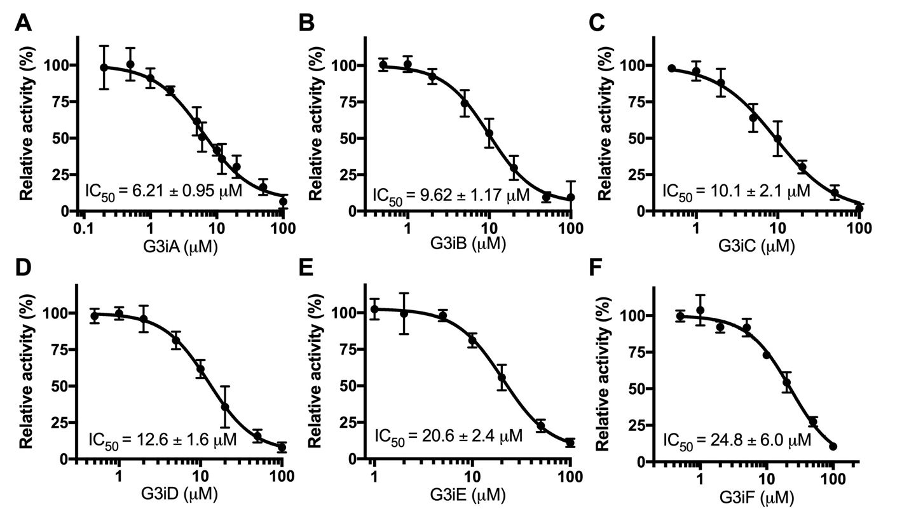

Supplementary Figure S3. Dose response curves for G3iA-G3iF inhibition of GLUT3_{S66Y}. The relative glucose transport activity of GLUT3_{S66Y} in EBY.S7 hxt⁰ yeast cells was assayed at 1.5 mM glucose concentration to match the glucose K_{M} (Supplementary Figure S1B). Error bars represent standard deviations from at least three independent measurements. Graphs, data analysis, and IC₅₀ values were generated with GraphPad (www.graphpad.com).

Supplementary Figure S4. Inhibition mode of G3iA, G3iC, and G3iE in GLUT3. (A-C) Dixon plots² for GLUT3_{S66Y} inhibition by G3iA, G3iC, and G3iE, respectively. The glucose transport activity of GLUT3_{S66Y} in EBY.S7 hxt⁰ yeast cells was assayed at 0.75, 1.50, and 3.00 mM glucose concentrations, with different inhibitor concentrations. The radioisotope assay is described in Materials and Methods. Data analysis and the graphs were generated with GraphPad Prism (https://www.graphpad.com). All inhibitors showed competitive inhibition with glucose, with K_{i,G3iA} = 3.49 ± 0.47 µM (A), K_{i,G3iC} = 5.83 ± 0.30 µM (B) and K_{i,G3iE} = 12.3 ± 0.9 µM (C). Error bars represent standard deviations from at least three independent measurements.

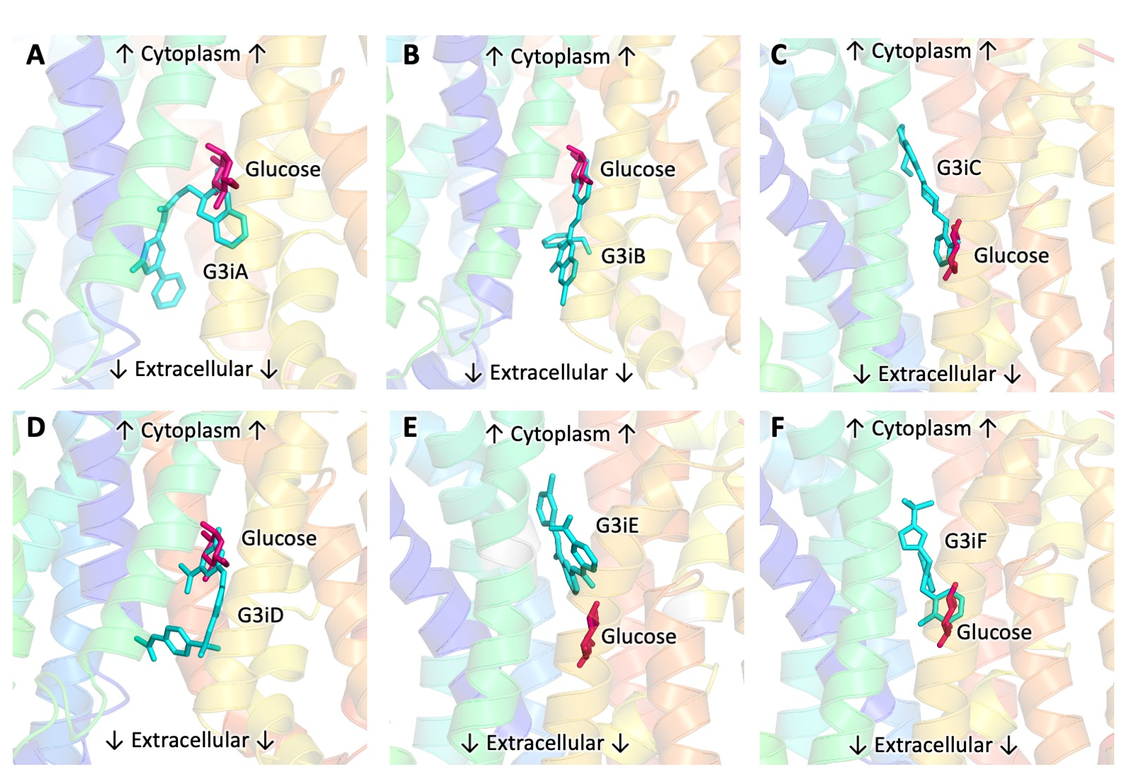
Supplementary Figure S5. Predicted docking sites of GLUT3 inhibitors relative to the glucose binding site in the GLUT3 models. Close-up of the glucose binding site in the outward-facing (A, B, D) and inward-facing (C, E, F) GLUT3 models, showing the predicted docking sites from TBVS for G3iA (A), G3iB (B), G3iC (C), G3iD (D), G3iE (E) and G3iF (F). The structural models for the inward-facing (A, B, D) and outward-facing (C, E, F) conformations of GLUT3 were generated as described in the Material and Methods. GLUT3 inhibitors (cyan), and glucose modeled in its active site (red) are shown as stick models. Glucose modeling was based on the glucosyl moiety of nonyl beta-D-glucopyranoside from PDB ID 4PYP (C, E, F) and alpha-D-glucopyranose-(1-4)-alpha-D-glucopyranose from PDB ID 4ZWC (A, B, D). Figures were generated with Pymol (https://www.pymol.org).

Supplementary Figure S6. Dose response curves for GLUT3 inhibitors on the transport activities of GLUT1, GLUT2, and GLUT4 in hxt⁰ yeast cells. Dose response curves for GLUT3 inhibitors in GLUT1 (top row), GLUT2 (middle row), and GLUT4 (bottom row). Substrate conditions for relative transport activity matched the corresponding substrate K_{M}: 15 mM glucose for GLUT2, and 5 mM glucose for GLUT1 and GLUT4. Glucose transport activity of functional GLUTs (GLUT1³, GLUT2_{∆loopS_Q455R}¹, and GLUT4³) expressed in hxt⁰ yeast cells (EBY.S7 cells for GLUT1 and GLUT2_{∆loopS_Q455R}, and SDY.022 cells for GLUT4) was measured as C¹⁴-glucose uptake in whole cells (see Materials and Methods for details). Error bars represent standard deviations from at least three independent measurements. Graphs, data analysis, and IC₅₀ values were generated with GraphPad (www.graphpad.com).

Supplementary Figure S7. G3iD inhibition in GLUT4. (A) Dixon plot² for GLUT4 inhibition by G3iD. The glucose transport activity of GLUT4 in SDY.022 hxt⁰ yeast cells was assayed at 2.5, 5, and 10 mM glucose concentrations, in the presence of 0, 4, and 8 µM G3iD concentration. The radioisotope assay is described in Materials and Methods. Data analysis and the graph were generated with GraphPad Prism (https://www.graphpad.com). G3iD was competitive with glucose, with K_{i,G3iD} = 2.65 ± 0.24 µM. Error bars represent standard deviations from at least three independent measurements. (B) Close-up of the glucose binding site in the outward-facing model of GLUT4, showing the predicted docking site for G3iD. Glucose (cyan), G3iD (pink), and protein residues interacting with the inhibitor (grey) are shown as stick models. The structural model for GLUT4 was based on the GLUT1 crystal structure PDB ID 4PYP and generated as described in the Material and Methods. The figure was generated with Pymol (https://www.pymol.org).

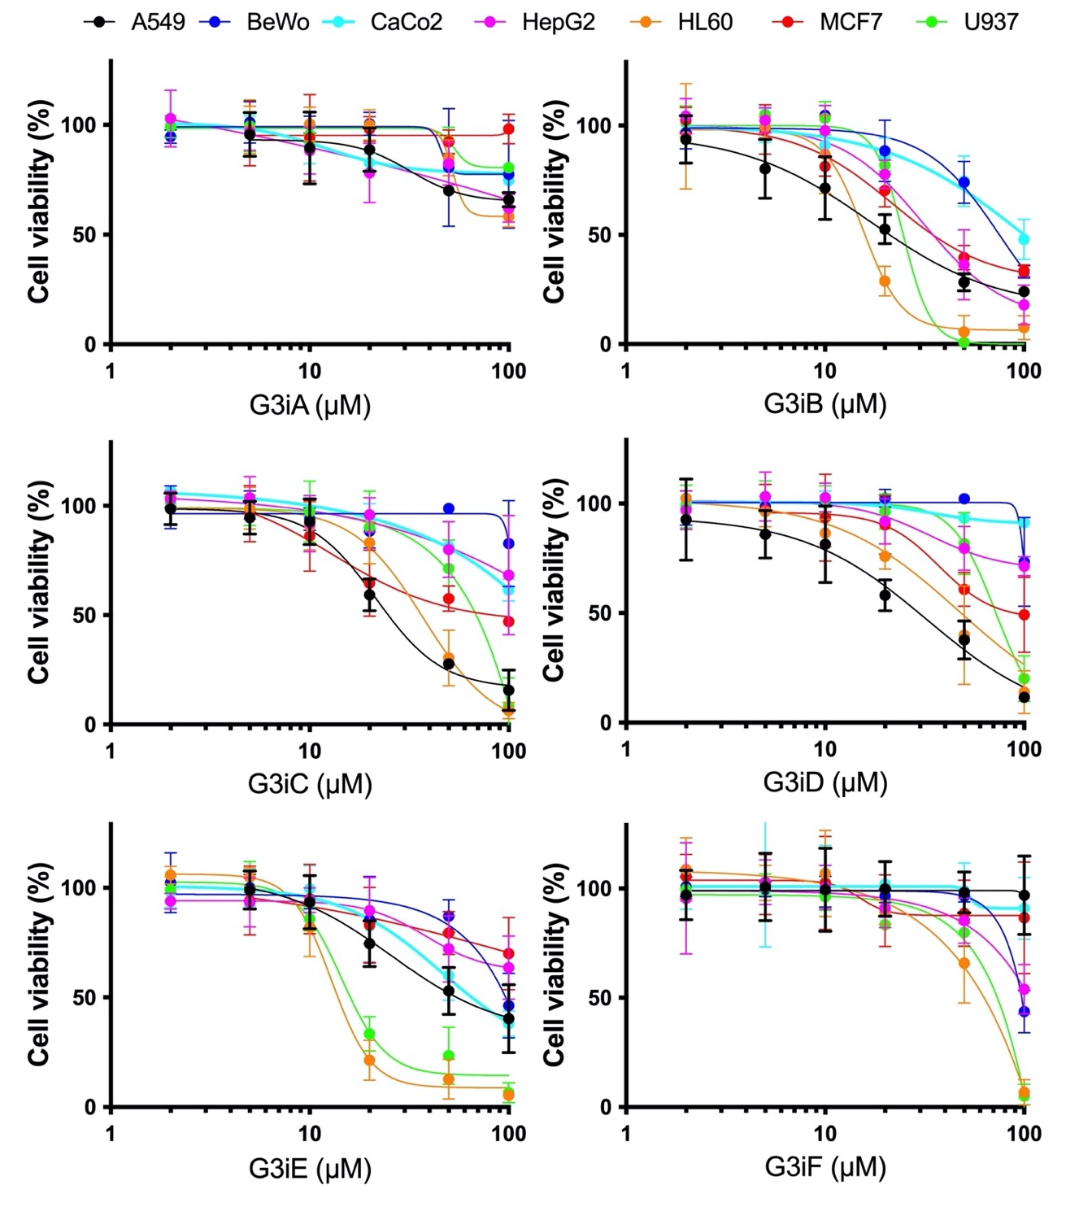

Supplementary Figure S8. Effect of GLUT3 inhibitors on the viability of various cancer cell lines. Cell viability was determined by MTT assay in A549 (lung cancer), BeWo (choriocarcinoma), Caco-2 (colon cancer), HepG2 (liver cancer), HL-60 (leukemia), MCF7 (breast cancer), and U937 (histiocytic lymphoma) cell lines. GLUT3 inhibitors at concentrations of 2, 5, 10, 20, 50, and 100 µM were incubated with cells in 96-well plates for 48 hours before the addition of the MTT reagent.

A. G3iA B. G3iB

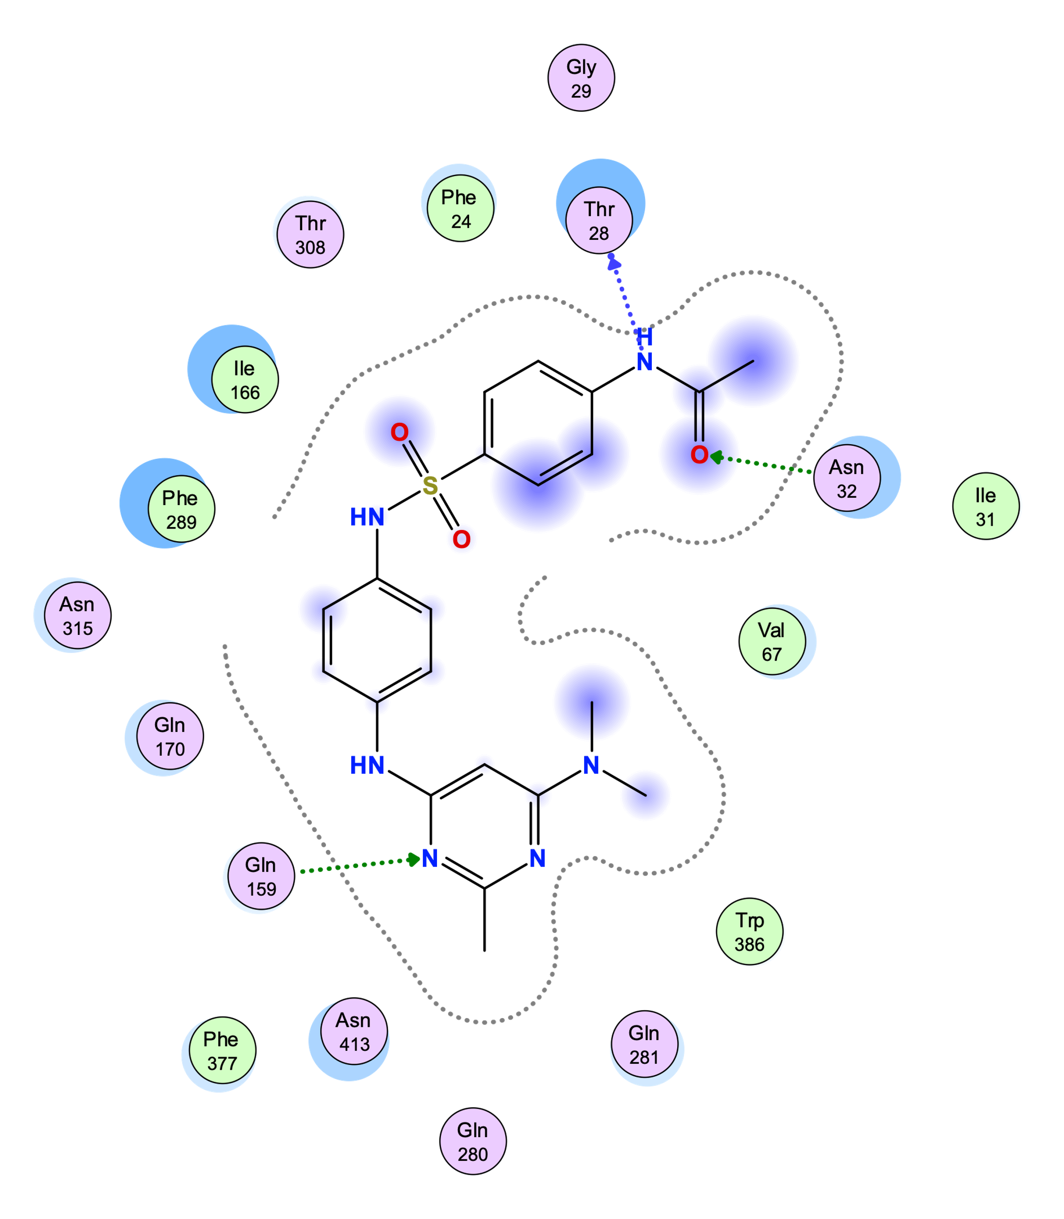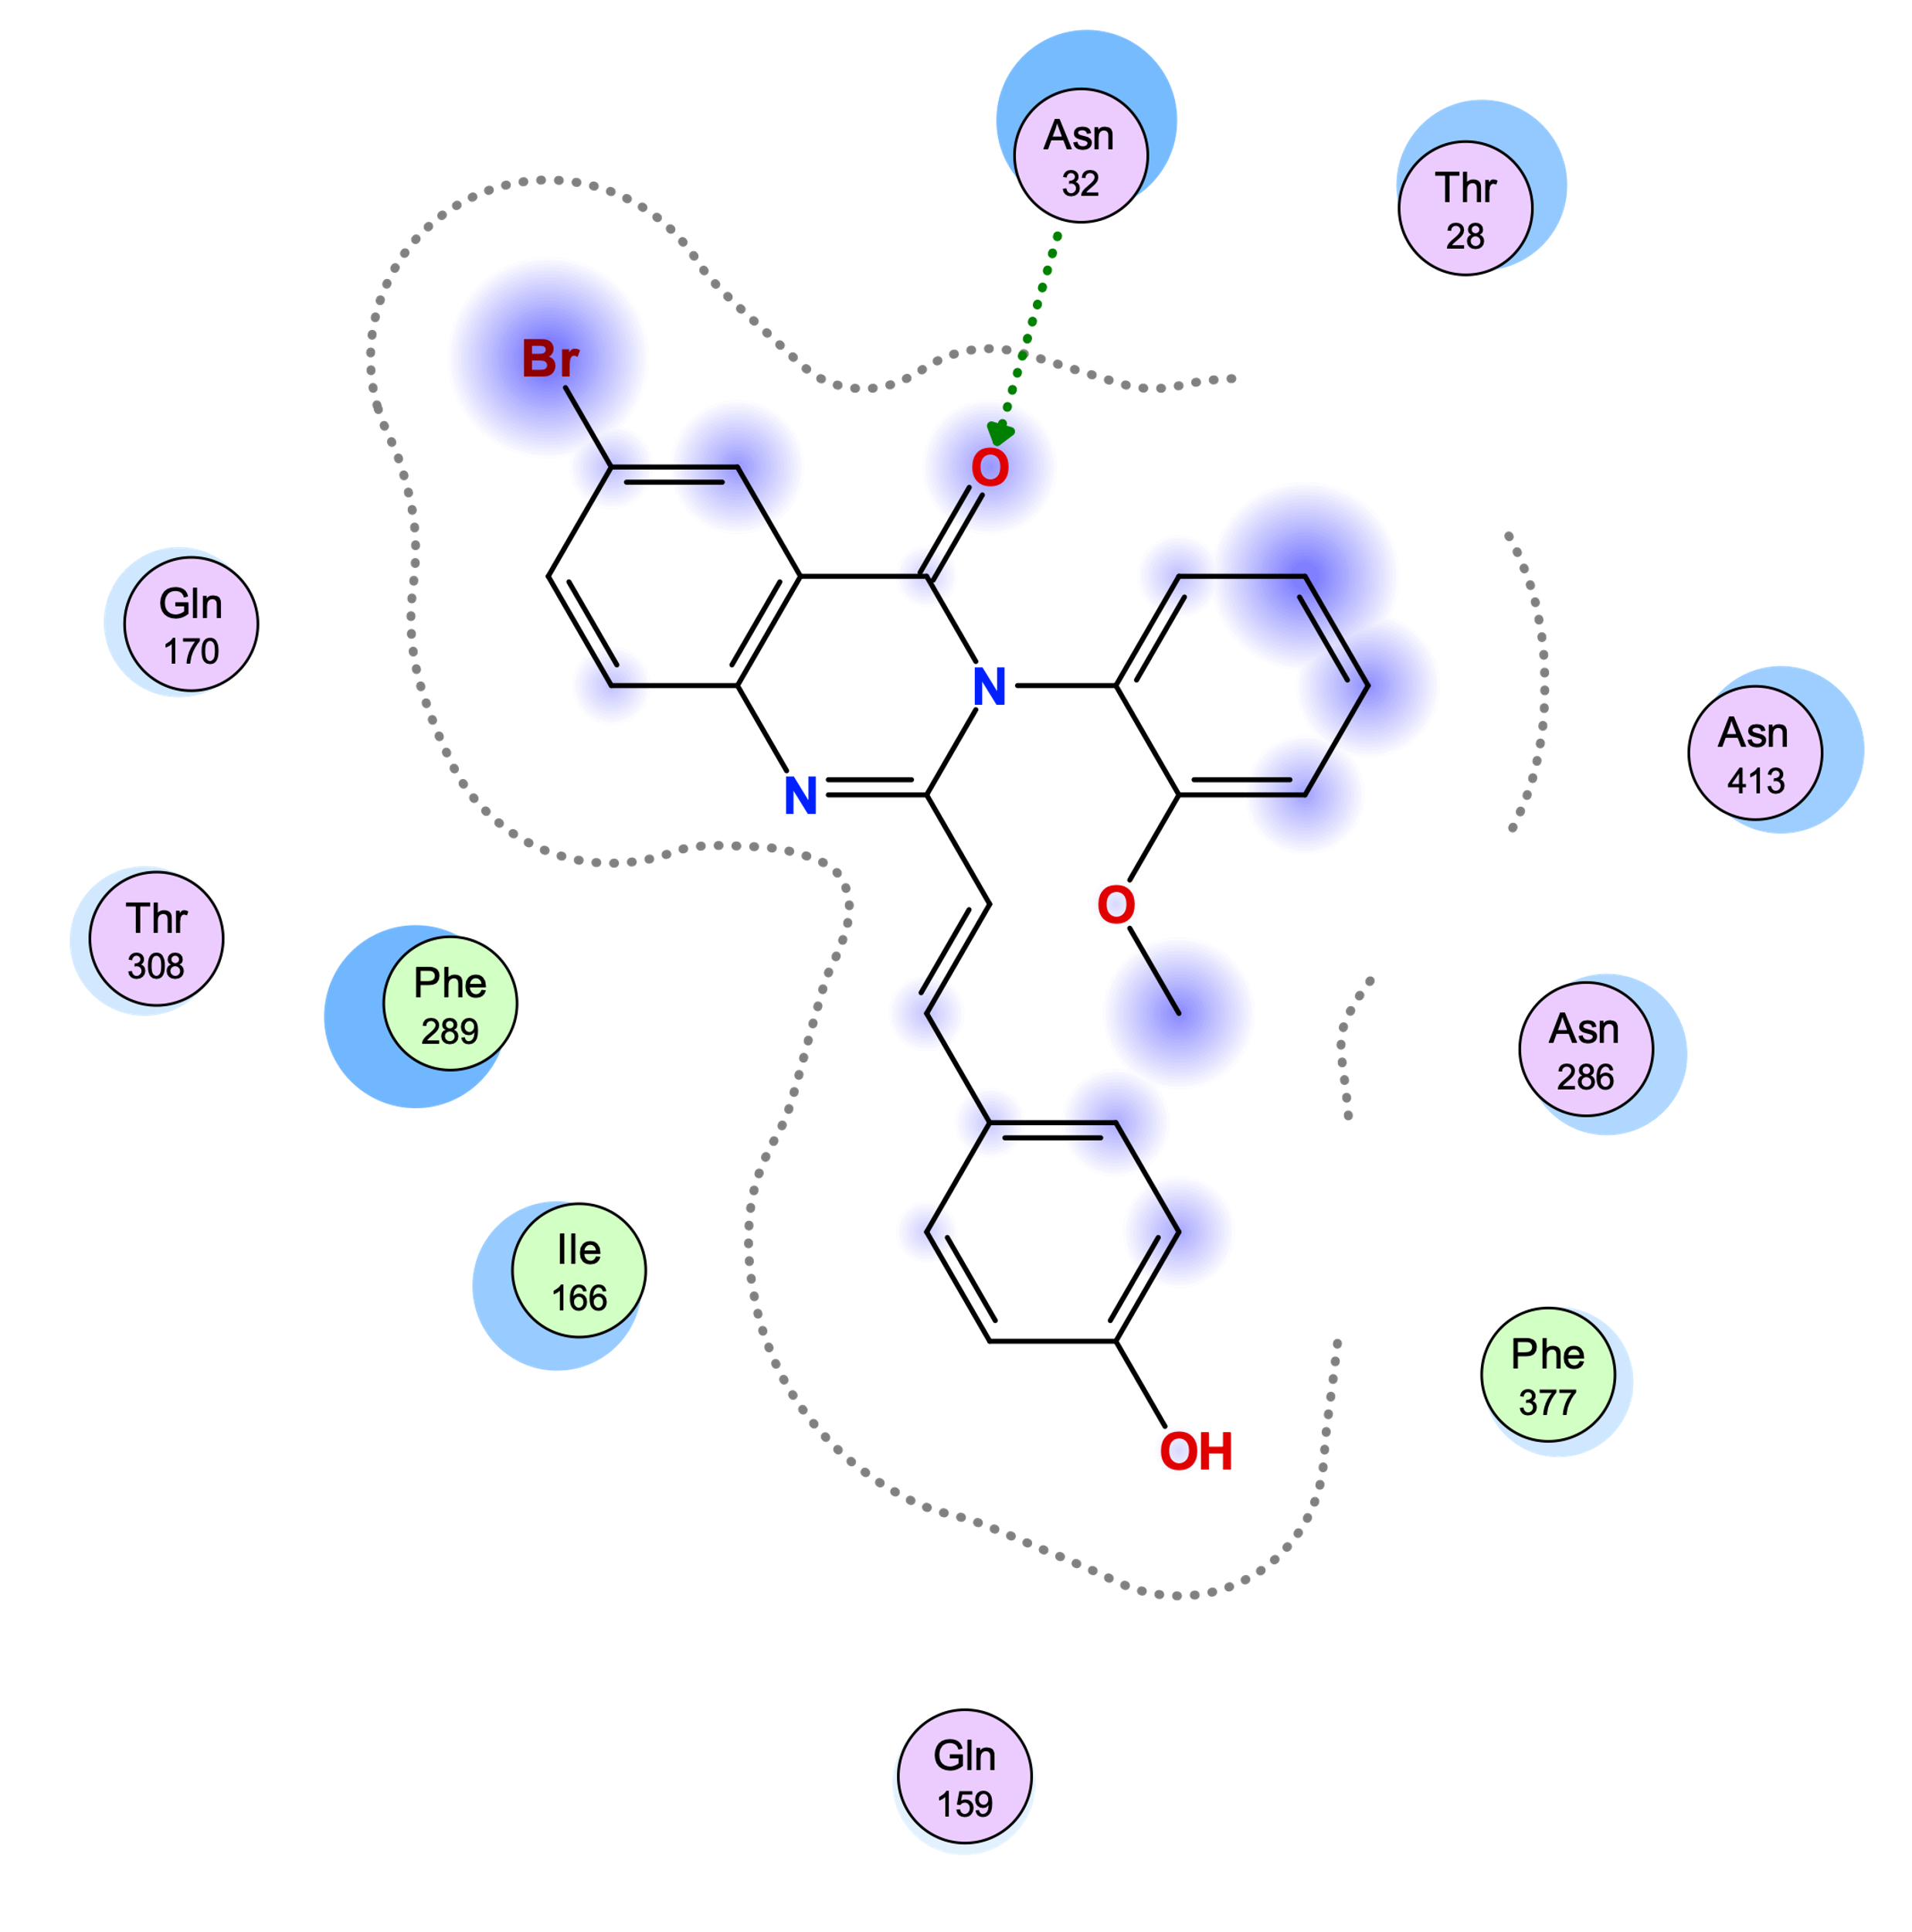

C. G3iC D. G3iD

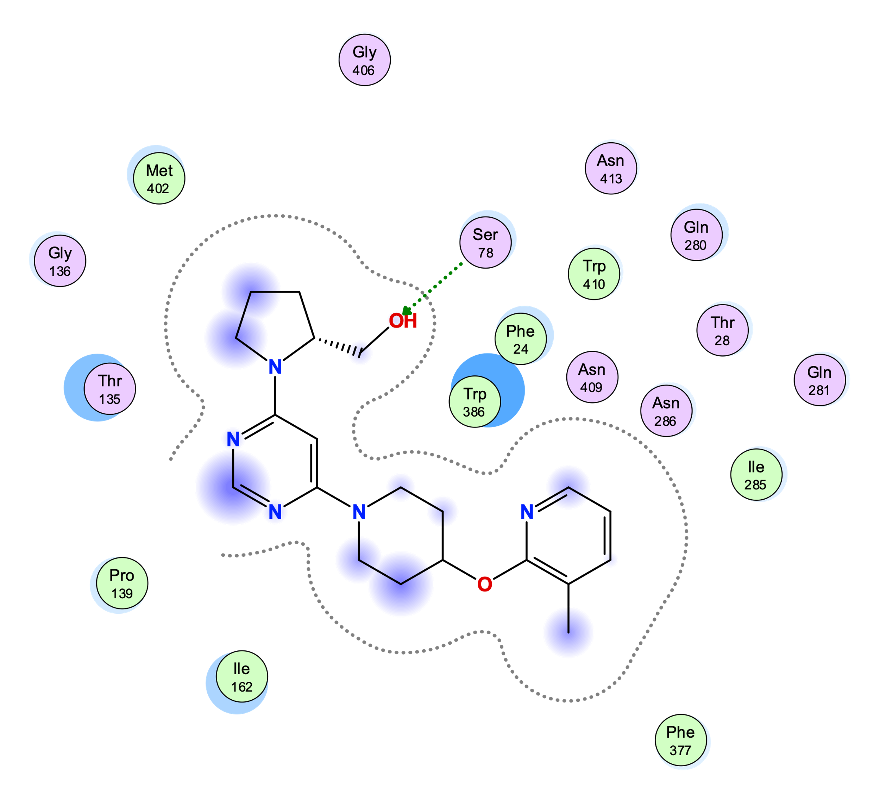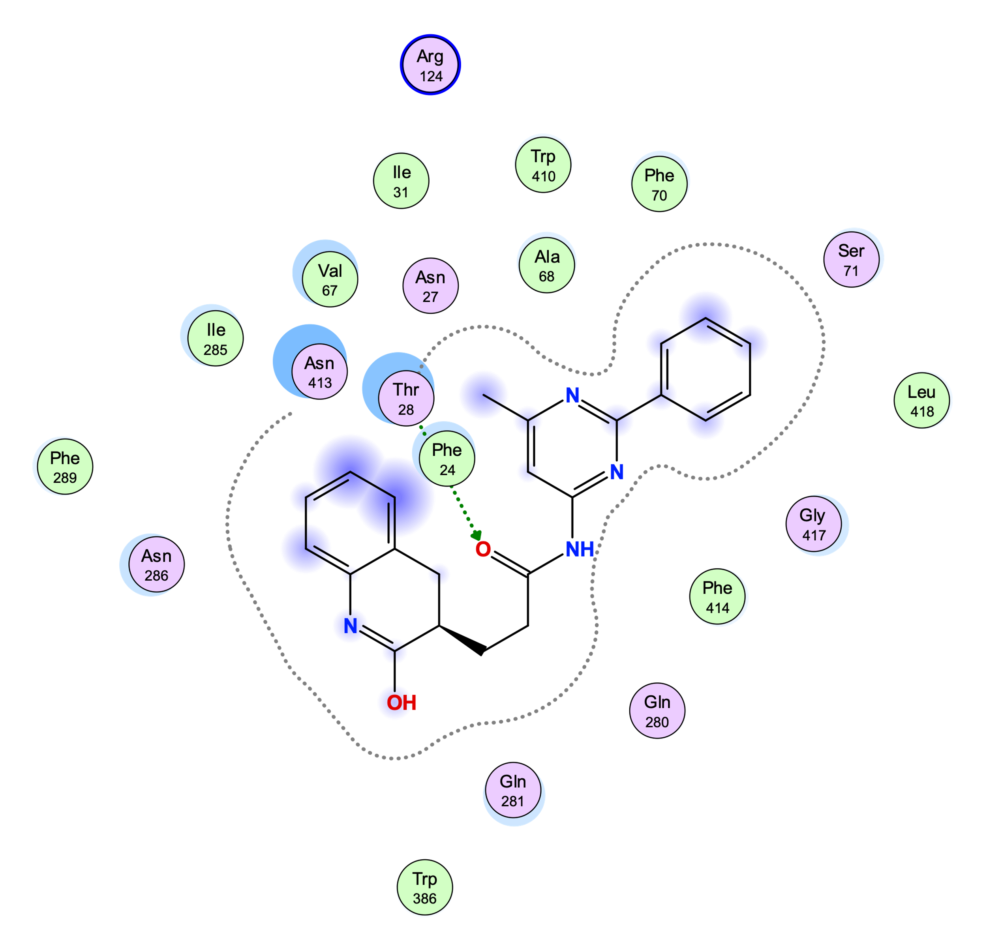

E. G3iE F. G3iF

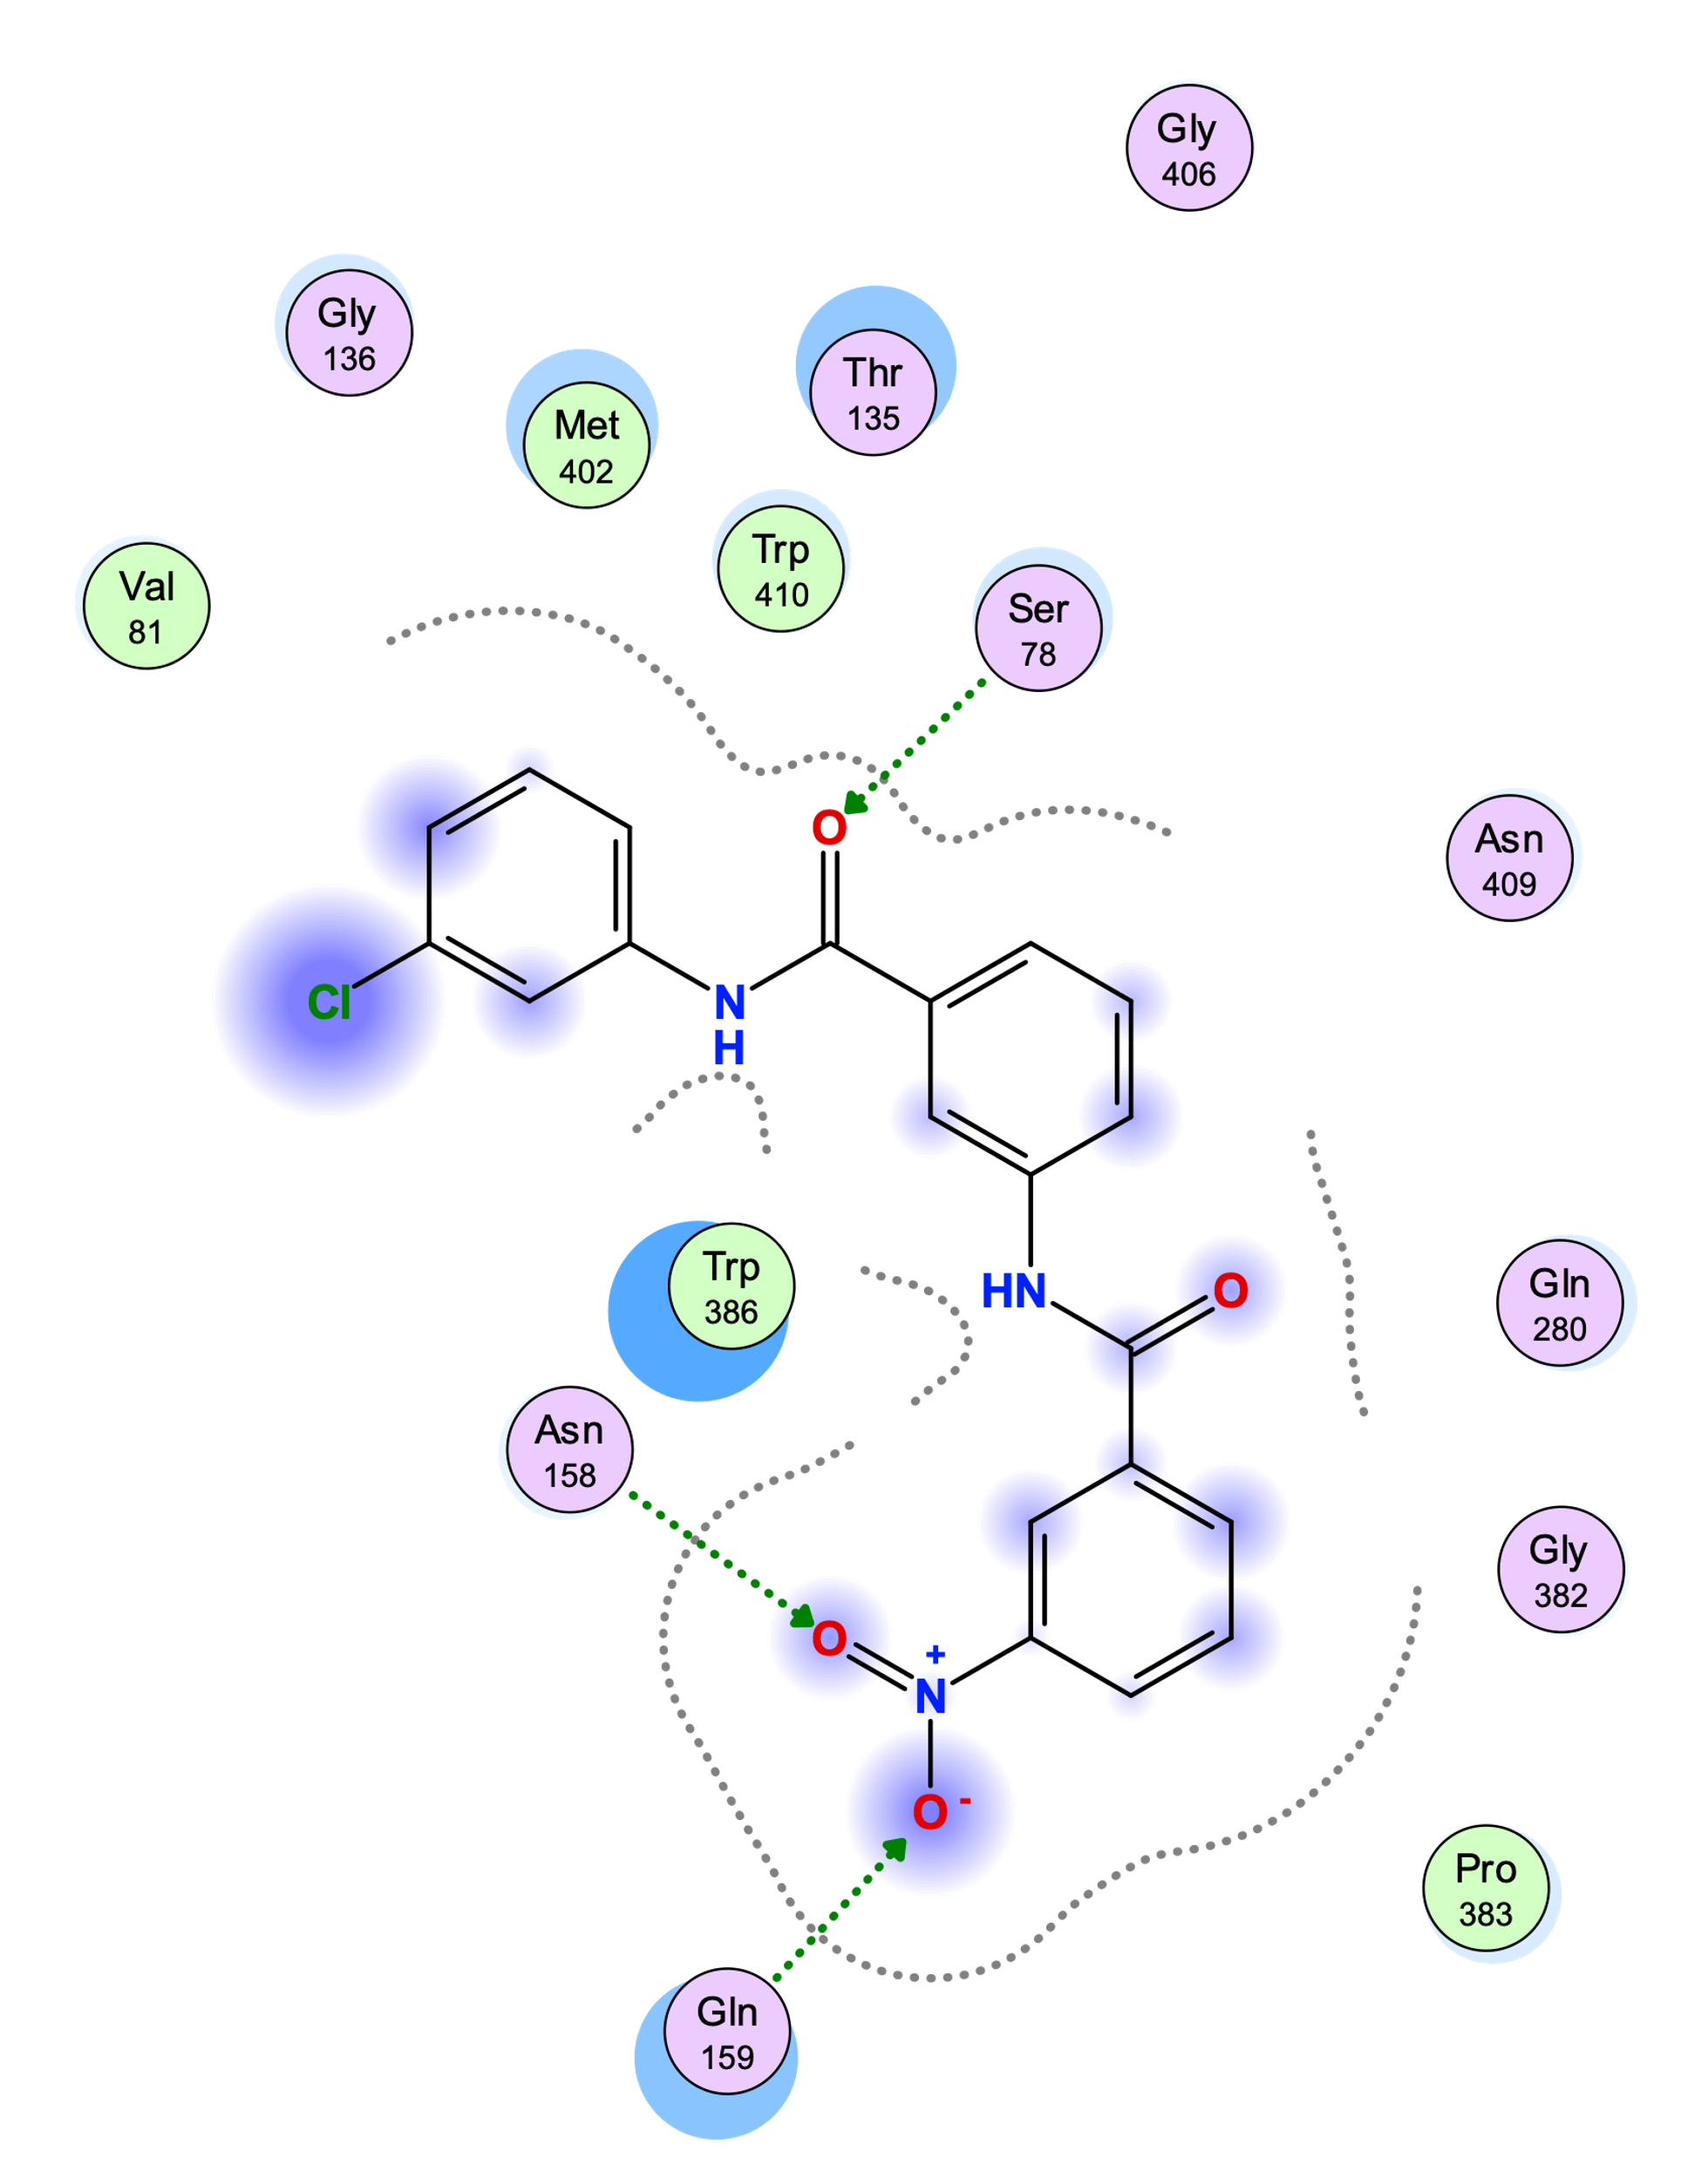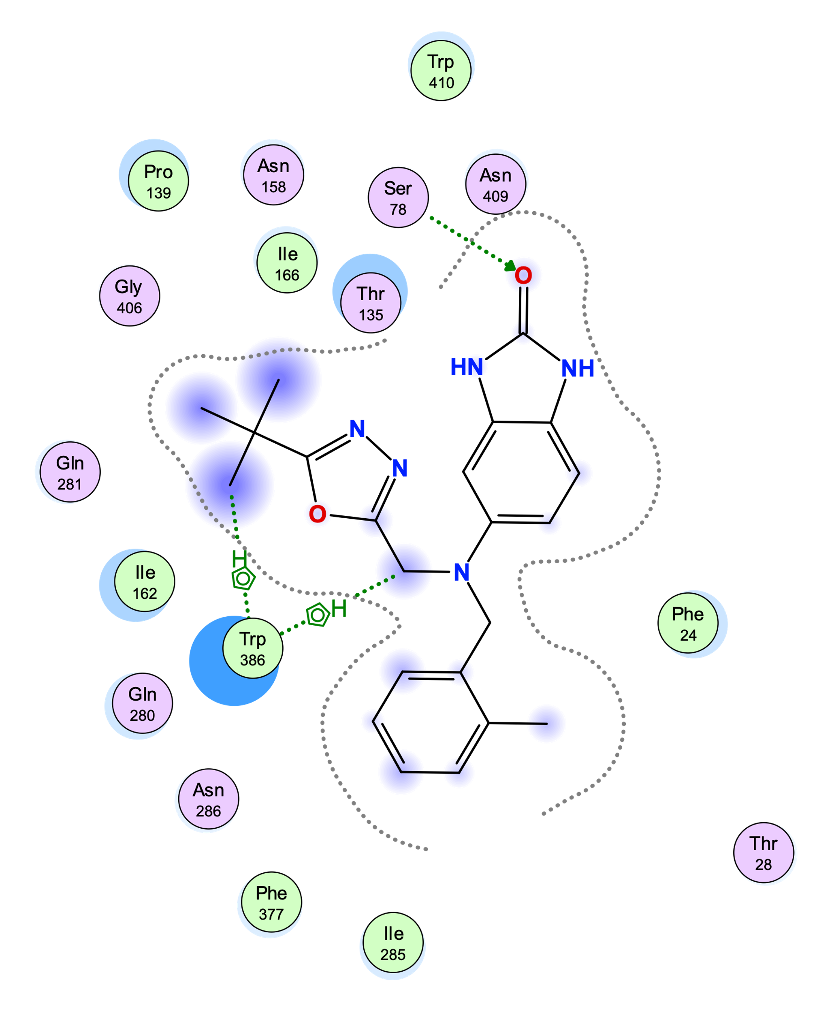

G. Legend

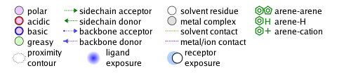

Supplementary Figure S9. Protein-ligand interactions for docked GLUT3 inhibitors to the outward-facing conformation GLUT3 model (A, B, D) and inward-facing conformation GLUT3 model (C, E, F). The ligand-protein interaction diagrams for G3iA (A), G3iB (B), G3iC (C), G3iD (D), G3iE (E), and G3iF (F), were generated in MOE (https://www.chemcomp.com) with the program “Ligand Interactions”. (G) Legend for the type of residues and ligand-protein interactions in (A-F).

Supplementary Figure S10. Docking of G3iD and G3iF to GLUT3 and GLUT4 models. The homology models for GLUT3 and GLUT4 were generated in MOE using as templates the crystal structure of GLUT1 (PDB ID 4PYP) for the inward-facing conformations, and the GLUT3 crystal structure (PDB ID 5C65) for the outward-facing. Views from the extracellular side of the transporter showing G3iD docked to the outward-facing conformation of GLUT3 (A) or GLUT4 (B). Views from the cytoplasmic side of G3iF docked to the inward-facing conformation of GLUT3 (C) and GLUT4 (D). The transmembrane helices are denoted as H1-12, and their color code is as in Figure 4G. Helices H1-H6 belong to the N-half of the transporter, helices H7-H12 belong to the C-half of the transporter. The figures were generated with Pymol (https://www.pymol.org).

Supplementary Table S1. Top-scored ligand candidates from target-based virtual screening that were purchased and tested for GLUT3 transport inhibition. The ChemNavigator structure identifier (Structure_ID), commercial information (Supplier and Catalog #), chemical name, SMILES code, and molecular formula (MF) are indicated for each compound (except for some unavailable chemicals’ names). Identified GLUT3 inhibitors (G3iA-G3iF) are in red font.

CHEMICAL |  |  |  | SUPPLIER
Structure_ID | Name | SMILES | MF | Name | Catalog #
282359772 | 1-(1,3-benzoxazol-2-yl)-N-[2-(3-chlorophenyl)-2-hydroxyethyl]-4-piperidinecarboxamide | Clc1cc(ccc1)C(O)CNC(=O)C2CCN(CC2)c3nc4c([o]3)cccc4 | C21H22O3N3Cl1 | Enamine | Z384626092
410456137 | 1-(2-(3,5-dimethyl-1H-1,2,4-triazol-1-yl)phenyl)-3-((3-hydroxycyclohexyl)methyl)urea | [n]3(nc(nc3C)C)c1c(cccc1)NC(=O)NCC2CC(CCC2)O | C18H25O2N5 | Enamine | Z1531376630
926266993 |  | [n]21ncnc2CCC(C1)NC(=O)NCc3cc(c(cc3)c4ccccc4)C | C21H23O1N5 | Enamine | Z1752450232
369122635 | 2-(4-{[6-(cyclopropylmethoxy)-3-pyridinyl]carbonyl}-1-piperazinyl)cyclopentanol | N2(CCN(CC2)C(=O)c3cnc(cc3)OCC4CC4)C1C(CCC1)O | C19H27O3N3 | Enamine | Z1143005635
124031033 | 3-{[3-(2-oxo-1,2,3,4-tetrahydro-3-quinolinyl)propanoyl]amino}-4-(1-pyrrolidinyl)benzamide | N4(CCCC4)c1c(cc(cc1)C(=O)N)NC(=O)CCC2Cc3c(cccc3)NC2=O | C23H26O3N4 | Enamine | Z238859824
155978154 | 4-(1-pyrrolidinyl)-3-{[3-(1H-1,2,4-triazol-1-yl)propanoyl]amino}benzamide | [n]3(ncnc3)CCC(=O)Nc1c(ccc(c1)C(=O)N)N2CCCC2 | C16H20O2N6 | Enamine | Z228177696
410464285 | (2-hydroxy-3-methylphenyl)(4-(1-(2-hydroxyethyl)-1H-pyrazol-5-yl)piperidin-1-yl)methanone | [n]1(nccc1C2CCN(CC2)C(=O)c3c(c(ccc3)C)O)CCO | C18H23O3N3 | Enamine | Z1591483015
465742018 | G3iD | N1c2c(cccc2)CC(C1=O)CCC(=O)Nc3nc(nc(c3)C)c4ccccc4 | C23H22O2N4 | Enamine | Z1981613202
34299577 | 2-[4-(2-hydroxyphenyl)-1-piperazinyl]-N-(2-oxo-2,3-dihydro-1H-benzimidazol-5-yl)acetamide | N3(CCN(CC3)c4c(cccc4)O)CC(=O)Nc1cc2nc([nH]c2cc1)O | C19H21O3N5 | Enamine | Z46201483
113904437 | 4-[3-(2,4-dichlorophenoxy)-2-hydroxypropyl]-3,4-dihydro-2(1H)-quinoxalinone | Clc1c(ccc(c1)Cl)OCC(O)CN2CC(=O)Nc3c2cccc3 | C17H16O3N2Cl2 | Enamine | Z229097516
412955061 | 1-(3-((1H-1,2,4-triazol-1-yl)methyl)phenyl)-3-((1S,4R)-4-(hydroxymethyl)cyclopent-2-en-1-yl)urea | [n]3(ncnc3)Cc1cc(ccc1)NC(=O)N[C@H]2C[C@H](C=C2)CO | C16H19O2N5 | Enamine | Z1330787097
333459537 | 2-methoxy-5-[({[2-(1-piperidinyl)-3-pyridinyl]methyl}amino)methyl]phenol | N3(CCCCC3)c1ncccc1CNCc2cc(c(cc2)OC)O | C19H25O2N3 | Enamine | Z873292682
371572692 | 2-(3-hydroxyphenyl)-N-[(2-hydroxy-4-quinolinyl)methyl]acetamide | N(Cc2c3c(nc(c2)O)cccc3)C(=O)Cc1cc(ccc1)O | C18H16O3N2 | Enamine | Z1333667077
189540667 | 4-({[4-(1H-benzimidazol-2-yl)butanoyl]amino}methyl)benzamide | [nH]1c2c(nc1CCCC(=O)NCc3ccc(cc3)C(=O)N)cccc2 | C19H20O2N4 | Enamine | Z371372046
162288663 | methyl 4-{[({2-[(2-hydroxypropyl)amino]-1H-benzimidazol-1-yl}acetyl)amino]methyl}benzoate | [n]2(c3c(nc2NCC(O)C)cccc3)CC(=O)NCc1ccc(cc1)C(=O)OC | C21H24O4N4 | Enamine | Z25766652
430420324 | (3-((((7-bromobenzo[d][1,3]dioxol-5-yl)methyl)amino)methyl)phenyl)methanol | Brc1c2c(cc(c1)CNCc3cc(ccc3)CO)OCO2 | C16H16O3N1Br1 | Enamine | Z1135297588
136993869 | 2,2'-((2-chloro-4-nitrophenyl)azanediyl)bis(ethan-1-ol) | Clc1c(ccc(c1)[N+](=O)[O-])N(CCO)CCO | C10H13O4N2Cl1 | Enamine | Z1270083791
30850154 | (2E)-3-chloro-2-propenyl (2E)-3-(4-nitrophenyl)-2-propenoate | Cl\C=C\COC(=O)\C=C\c1ccc(cc1)[N+](=O)[O-] | C12H10O4N1Cl1 | Enamine | Z54849349
206911061 | N-(2-hydroxy-1-methylethyl)-N'-{[2-(4-morpholinyl)-4-pyridinyl]methyl}urea | N2(CCOCC2)c1nccc(c1)CNC(=O)NC(CO)C | C14H22O3N4 | Enamine | Z435975470
424013283 |  | [n]1(nc(nc1)c2cc(ccc2)NC(=O)NC(CO)c3ccccc3)C | C18H19O2N5 | Enamine | Z1723017494
173439436 | 1-(3-bromophenyl)-2-(4-(2-hydroxyethyl)piperazin-1-yl)ethan-1-ol | Brc1cc(ccc1)C(O)CN2CCN(CC2)CCO | C14H21O2N2Br1 | Enamine | Z320990446
371568915 | N-[3-(4-hydroxyphenyl)propyl]-4-(5-methyl-4H-1,2,4-triazol-3-yl)benzamide | [nH]1c(nnc1c2ccc(cc2)C(=O)NCCCc3ccc(cc3)O)C | C19H20O2N4 | Enamine | Z1315201787
198058947 | N-[4-(2-furoylamino)phenyl]-4-(4-hydroxyphenyl)-1-piperazinecarboxamide | N2(CCN(CC2)C(=O)Nc3ccc(cc3)NC(=O)c4[o]ccc4)c1ccc(cc1)O | C22H22O4N4 | Enamine | Z412776212
122198003 | 1-{3-fluoro-4-[4-(3-nitroimidazo[1,2-a]pyridin-2-yl)-1-piperazinyl]phenyl}ethanone | Fc1c(ccc(c1)C(=O)C)N2CCN(CC2)c3nc4[n](c3[N+](=O)[O-])C=CC=C4 | C19H18O3N5F1 | Enamine | Z128084750
947357175 |  | [S](=O)(=O)(N(C3CCc4c3cccc4)CCO)c1cc2c(cc1)CCNC2=O | C20H22O4N2S1 | Enamine | Z1497048087
39076149 | 4-{[4-(2-hydroxyphenyl)-1-piperazinyl]acetyl}-3,4-dihydro-2(1H)-quinoxalinone | N3(CCN(CC3)c4c(cccc4)O)CC(=O)N1CC(=O)Nc2c1cccc2 | C20H22O3N4 | Enamine | Z46200573
36104902 | 6-methyl-4-(3-methylphenyl)-N-(3-nitrophenyl)-2-oxo-1,2,3,4-tetrahydro-5-pyrimidinecarboxamide | [N+](=O)([O-])c1cc(ccc1)NC(=O)C2=C(NC(=O)NC2c3cc(ccc3)C)C | C19H18O4N4 | Enamine | Z47753201
122437324 | 2-methyl-4-oxo-4-[(2-oxo-2,3-dihydro-1H-benzimidazol-5-yl)amino]-2-phenylbutanoic acid | [nH]1c2c(nc1O)ccc(c2)NC(=O)CC(C)(c3ccccc3)C(=O)O | C18H17O4N3 | Enamine | Z169888110
388055917 |  | N(CCO)C(=O)c1cnc(cc1)Oc2ccccc2 | C14H14O3N2 | Enamine | Z450399074
465736254 |  | Clc1c(ccc(c1)NC(=O)[C@@H]3N(C[C@H](C3)O)C(=O)C)N2CCNC(=O)C2 | C17H21O4N4Cl1 | Enamine | Z1873287556
278495859 | 4-(6,7-dihydrothieno[3,2-c]pyridin-5(4H)-yl)-N-(4-hydroxybenzyl)-4-oxobutanamide | [s]1c2c(cc1)CN(CC2)C(=O)CCC(=O)NCc3ccc(cc3)O | C18H20O3N2S1 | Enamine | Z739437480
174641336 | N~1~-[1-(2-amino-2-oxoethyl)-4-piperidinyl]isophthalamide | N1(CCC(CC1)NC(=O)c2cc(ccc2)C(=O)N)CC(=O)N | C15H20O3N4 | Enamine | Z332853654
150770940 | (4-hydroxyphenyl)[1-(5,6,7,8-tetrahydro-4H-cyclohepta[b]thien-2-ylcarbonyl)-4-piperidinyl]methanone | [s]1c2c(cc1C(=O)N3CCC(CC3)C(=O)c4ccc(cc4)O)CCCCC2 | C22H25O3N1S1 | Enamine | Z234514874
456343845 |  | Cl.N3(CC(CC3)C(=O)O)C(=O)c1cc(ccc1)N2CCCNC2=O | C16H20O4N3Cl1 | Enamine | Z1528724129
32809290 | 4-(hydroxymethyl)-N-(2-methoxyphenyl)benzamide | N(c2c(cccc2)OC)C(=O)c1ccc(cc1)CO | C15H15O3N1 | Enamine | Z31519348
284936943 | N-(3-cyanophenyl)-N'-[2-hydroxy-3-(3-methylphenoxy)propyl]urea | N(CC(O)COc2cc(ccc2)C)C(=O)Nc1cc(ccc1)C#N | C18H19O3N3 | Enamine | Z820031172
432512029 |  | N4(CCOCC4)c1ncc(cn1)c2[nH]c3c(n2)ccc(c3)CC | C17H19O1N5 | Enamine | Z1527390066
465725654 |  | [N+](=O)([O-])c1cc(c(cc1)N)C(=O)N2CCC(CC2)(O)c3ccccc3 | C18H19O4N3 | Enamine | Z1817344290
53227621 | 2-{ethyl[(4-oxo-3,4-dihydro-2-quinazolinyl)methyl]amino}-N-[3-(1-pyrrolidinylsulfonyl)phenyl]acetamide | [S](=O)(=O)(N4CCCC4)c1cc(ccc1)NC(=O)CN(CC)C=C2Nc3c(cccc3)C(=O)N2 | C23H27O4N5S1 | Enamine | Z46301884
190039201 | methyl 3-{[3-({[(3-pyridinylmethyl)amino]carbonyl}amino)phenyl]ethynyl}benzoate | N(Cc3cnccc3)C(=O)Nc1cc(ccc1)C#Cc2cc(ccc2)C(=O)OC | C23H19O3N3 | Enamine | Z434308094
123821031 | 3-{3-[4-(4-hydroxyphenyl)-1-piperidinyl]-3-oxopropyl}-1,3-benzoxazol-2(3H)-one | N3(CCC(CC3)c4ccc(cc4)O)C(=O)CCN1c2c(cccc2)OC1=O | C21H22O4N2 | Enamine | Z237328884
947361171 |  | Fc1cc(cc(c1)CNc2c3c(ccc2)C(CCO3)O)O | C16H16O3N1F1 | Enamine | Z1715775511
45402844 | (1-{[4-amino-6-(2-ethylanilino)-1,3,5-triazin-2-yl]methyl}-1H-benzimidazol-2-yl)methanol | [n]3(c4c(nc3CO)cccc4)Cc1nc(nc(n1)N)Nc2c(cccc2)CC | C20H21O1N7 | Enamine | Z25755761
278569614 | 1-{2-[(4-nitrobenzyl)amino]phenyl}-4-piperidinol | [N+](=O)([O-])c1ccc(cc1)CNc2c(cccc2)N3CCC(CC3)O | C18H21O3N3 | Enamine | Z739800258
448919804 |  | Fc1ccc(cc1)c2[n](c(cc2)C(=O)Nc3cc(c(cc3)OC)CO)C | C20H19O3N2F1 | Enamine | Z1543192888
465720342 |  | N(C3C(c4c(cccc4)C3)O)C(=O)c1cc2c(c(c1)O)cccc2 | C20H17O3N1 | Enamine | Z1942335324
175238827 | N-[2-(1H-benzimidazol-2-yl)ethyl]-N'-[(2-methoxy-4-pyridinyl)methyl]urea | [nH]1c2c(nc1CCNC(=O)NCc3cc(ncc3)OC)cccc2 | C17H19O2N5 | Enamine | Z336588692
175950001 | N-(7,8,9,10-tetrahydro-6H-azepino[1,2-a]benzimidazol-3-yl)-1H-1,2,3-benzotriazole-5-carboxamide | [n]21c3c(nc2CCCCC1)cc(cc3)NC(=O)c4cc5nn[nH]c5cc4 | C19H18O1N6 | Enamine | Z243910642
29464398 | N4,N4'-(propane-1,3-diyl)bis(6-chloropyrimidine-2,4-diamine) | Clc1nc(nc(c1)NCCCNc2nc(nc(c2)Cl)N)N | C11H14N8Cl2 | Enamine | Z357940020
491703340 |  | [n]3(ncnc3)CC1CCN(CC1)C(=O)NCc2ccc(cc2)C(O)C | C18H25O2N5 | Enamine | Z1752308908
33350888 | N-{3-[(3,4-dihydro-2H-pyrrol-5-ylamino)sulfonyl]phenyl}-2-(1H-indol-3-yl)acetamide | [S](=O)(=O)(NC4=CCCN4)c1cc(ccc1)NC(=O)Cc2c3c([nH]c2)cccc3 | C20H20O3N4S1 | Enamine | Z27434489
295759661 | 4-{[3,5-dimethyl-4-(2-pyridinylmethoxy)benzyl]amino}cyclohexanol hydrochloride | Cl.N(C3CCC(CC3)O)Cc1cc(c(c(c1)C)OCc2ncccc2)C | C21H29O2N2Cl1 | Enamine | Z1101435909
728120205 |  | N4(CCCC4)c1c(cc(cc1)C(=O)N)NC(=O)c2cc(ncc2)OC3CCC3 | C21H24O3N4 | Enamine | Z1536578664
456174158 |  | N1c2c(cccc2)CC(C1=O)CCC(=O)NCc3cc(ccc3)C(=O)O | C20H20O4N2 | Enamine | Z1444935188
155430915 | 4-({3-[[3-([1,1'-biphenyl]-4-yloxy)-2-hydroxypropyl](ethyl)amino]propanoyl}amino)benzamide | N(CC(O)COc2ccc(cc2)c3ccccc3)(CCC(=O)Nc1ccc(cc1)C(=O)N)CC | C27H31O4N3 | Enamine | Z295847238
121552236 | 1-{2-[4-(4-nitrophenyl)-1-piperazinyl]-2-oxoethyl}-4-piperidinol | [N+](=O)([O-])c1ccc(cc1)N2CCN(CC2)C(=O)CN3CCC(CC3)O | C17H24O4N4 | Enamine | Z46457462
52971360 | (2E)-3-[1-(1,3-benzodioxol-5-yl)-2,5-dimethyl-1H-pyrrol-3-yl]-2-propenoic acid | [n]3(c(c(cc3C)\C=C\C(=O)O)C)c1cc2c(cc1)OCO2 | C16H15O4N1 | Enamine | Z2312400221
491725655 |  | N1C(CC(C1)O)C(=O)NCCOc2cc3c(cc2)NC(=O)CC3 | C16H21O4N3 | Enamine | Z2242893425
32246862 | 2-[4-(1H-indol-3-ylmethyl)-2,5-dioxo-1-imidazolidinyl]-N-(5-methyl-3-isoxazolyl)acetamide | N1C(C(=O)N(C1=O)CC(=O)Nc4n[o]c(c4)C)Cc2c3c([nH]c2)cccc3 | C18H17O4N5 | Enamine | Z16202326
386800439 | N-(2,6-dimethyl-3-nitrophenyl)-N'-[(1S,4R)-4-(hydroxymethyl)-2-cyclopenten-1-yl]urea | [N+](=O)([O-])c1c(c(c(cc1)C)NC(=O)N[C@H]2C[C@H](C=C2)CO)C | C15H19O4N3 | Enamine | Z1383385779
947346539 |  | Fc1c(ccc(c1)F)C4(CCC4)NC(=O)CCC2Cc3c(cccc3)NC2=O | C22H22O2N2F2 | Enamine | Z1542411934
369138690 | 4-(hydroxymethyl)-N-[3-methyl-4-(2,2,2-trifluoroethoxy)phenyl]-1-piperidinecarboxamide | FC(F)(F)COc1c(cc(cc1)NC(=O)N2CCC(CC2)CO)C | C16H21O3N2F3 | Enamine | Z1244046115
67340514 | 2-[3-(hydroxymethyl)-1-piperidinyl]-5-nitrobenzonitrile | [N+](=O)([O-])c1cc(c(cc1)N2CC(CCC2)CO)C#N | C13H15O3N3 | Enamine | Z31255411
58732066 | 2-(3-oxo-1-piperazinyl)-N-(2-phenoxyethyl)acetamide | N2(CCNC(=O)C2)CC(=O)NCCOc1ccccc1 | C14H19O3N3 | Enamine | Z89087324
580384511 |  | FC1(CN(CCC1C(=O)O)C(=O)OCC2c3c(cccc3)c4c2cccc4)F | C21H19O4N1F2 | Enamine | Z2471178201
188541593 | {3-[(2-nitrobenzyl)amino]phenyl}methanol | [N+](=O)([O-])c1c(cccc1)CNc2cc(ccc2)CO | C14H14O3N2 | Enamine | Z160002836
87818200 | 1-[(6-bromo-1,3-benzodioxol-5-yl)methyl]-5-nitroindoline | Brc1cc2c(cc1CN3CCc4c3ccc(c4)[N+](=O)[O-])OCO2 | C16H13O4N2Br1 | Enamine | Z185280080
282349277 | N-(2-butyl-1H-benzimidazol-5-yl)-3-(2-oxo-1,2,3,4-tetrahydro-3-quinolinyl)propanamide | [nH]1c2c(nc1CCCC)cc(cc2)NC(=O)CCC3Cc4c(cccc4)NC3=O | C23H26O2N4 | Enamine | Z826612728
277255523 | N-[5-(benzoylamino)-2-methylphenyl]-1H-1,2,3-benzotriazole-5-carboxamide | [nH]1nnc2c1ccc(c2)C(=O)Nc3c(ccc(c3)NC(=O)c4ccccc4)C | C21H17O2N5 | Enamine | Z654145204
388174352 | N'-[2-(cyclopentylsulfanyl)phenyl]-N-methyl-N-[2-(4H-1,2,4-triazol-4-yl)ethyl]urea | S(C3CCCC3)c1c(cccc1)NC(=O)N(CC[n]2cnnc2)C | C17H23O1N5S1 | Enamine | Z1409914073
424009541 |  | [S](=O)(=O)(N3CCCC3)c1c[n](c(c1)C(=O)NC2(CC(CC(C2)C)(C)C)CO)C | C20H33O4N3S1 | Enamine | Z1680942458
448923652 |  | Brc1ccc(cc1)C(=O)Nc2cc(ncc2)C(=O)N3CCC(CC3)O | C18H18O3N3Br1 | Enamine | Z1713545237
408609426 | N-(3-(3-cyclopropylureido)benzyl)-2-hydroxy-5,6,7,8-tetrahydroquinoline-3-carboxamide | N(C4CC4)C(=O)Nc1cc(ccc1)CNC(=O)c2c(nc3c(c2)CCCC3)O | C21H24O3N4 | Enamine | Z1167666509
276786968 | 1-{4-[(1,3-benzoxazol-2-ylamino)methyl]-2-fluorophenyl}-4-piperidinol | Fc1c(ccc(c1)CNc3nc4c([o]3)cccc4)N2CCC(CC2)O | C19H20O2N3F1 | Enamine | Z646292228
638632865 |  | [N+](=O)([O-])c1cc(c(cc1)NC2CCc3[n](c(nc3C2)C)CCO)C#N | C17H19O3N5 | Enamine | Z2582964010
414736700 |  | N([C@H](CO)c2ccccc2)C(=O)NC1CCC(CC1)CN(C)C | C18H29O2N3 | Enamine | Z1618940273
272168810 | 3-methyl-N-[2-methyl-1-({[3-oxo-3-(2-pyridinylamino)propyl]amino}carbonyl)propyl]benzamide | N(C(C(C)C)C(=O)NCCC(=O)Nc2ncccc2)C(=O)c1cc(ccc1)C | C21H26O3N4 | Enamine | Z649192748
209807597 | N-[3-chloro-4-(3-oxo-1-piperazinyl)phenyl]-N'-[2-(diethylamino)-2-(3-thienyl)ethyl]urea | [s]1cc(cc1)C(N(CC)CC)CNC(=O)Nc2cc(c(cc2)N3CCNC(=O)C3)Cl | C21H28O2N5Cl1S1 | Enamine | Z436056318
388183984 | 2-{[(ethylamino)carbonyl]amino}-N-[4-(1H-1,2,4-triazol-1-ylmethyl)phenyl]hexanamide | [n]2(ncnc2)Cc1ccc(cc1)NC(=O)C(NC(=O)NCC)CCCC | C18H26O2N6 | Enamine | Z1465580521
424007555 |  | Brc1c(cc(cc1)NC(=O)N(C(C)C)CCO)[N+](=O)[O-] | C12H16O4N3Br1 | Enamine | Z1671631391
330917358 | 2-[(6-fluoro-2-oxo-1,2,3,4-tetrahydro-7-quinolinyl)amino]-N-[4-(1-pyrrolidinylcarbonyl)benzyl]acetamide | Fc1cc2c(cc1NCC(=O)NCc3ccc(cc3)C(=O)N4CCCC4)NC(=O)CC2 | C23H25O3N4F1 | Enamine | Z368764614
280402933 | (4-hydroxyphenyl)(1-{[1-(2-thienylmethyl)-1H-pyrrol-2-yl]carbonyl}-4-piperidinyl)methanone | [s]1c(ccc1)C[n]2c(ccc2)C(=O)N3CCC(CC3)C(=O)c4ccc(cc4)O | C22H22O3N2S1 | Enamine | Z756736706
271093842 | 3-(2-pyrimidinylamino)-N-(tetrahydro-3-furanylmethyl)benzamide | N(CC3COCC3)C(=O)c1cc(ccc1)Nc2ncccn2 | C16H18O2N4 | Enamine | Z384358202
1060952972 | G3iC | N4(C(CCC4)CO)c1ncnc(c1)N2CCC(CC2)Oc3ncccc3C | C20H27O2N5 | Enamine | Z2179783453
397005639 | 3-((7-aminopyrido[2,3-d]pyrimidin-4-yl)amino)-1-phenylpropan-1-ol | N(CCC(O)c3ccccc3)c1ncnc2nc(ccc21)N | C16H17O1N5 | Enamine | Z1537163093
277243498 | methyl 4-{[(2-quinolinylcarbonyl)amino]methyl}phenylcarbamate | N(Cc3ccc(cc3)NC(=O)OC)C(=O)c1nc2c(cc1)cccc2 | C19H17O3N3 | Enamine | Z653909414
288624885 | N~1~-[2-(2-chlorophenyl)ethyl]-1,4-piperidinedicarboxamide | Clc1c(cccc1)CCNC(=O)N2CCC(CC2)C(=O)N | C15H20O2N3Cl1 | Enamine | Z900786504
394352523 | 1-(4-isopropylphenyl)-4-((1-(4-(pyrimidin-5-yl)phenyl)ethyl)amino)cyclohexan-1-ol | N(C3CCC(CC3)(O)c4ccc(cc4)C(C)C)C(C)c1ccc(cc1)c2cncnc2 | C27H33O1N3 | Enamine | Z1566395319
423926351 |  | [N+](=O)([O-])c1c(cc(cc1)N2CC(CCC2)Cc3[n](ccn3)C)C#N | C17H19O2N5 | Enamine | Z1696212670
331004788 | (2E)-7-(2-chlorophenyl)-2-(3-hydroxypropylidene)-N-(2-methoxyphenyl)-5-methyl-1,2,3,7-tetrahydro[1,2,4]triazolo[1,5-a]pyrimidine-6-carboxamide | Clc1c(cccc1)C2N3NC(=CCCO)NC3=NC(=C2C(=O)Nc4c(cccc4)OC)C | C23H24O3N5Cl1 | Enamine | Z1203159345
273214676 | 1-(2-methyl-3-furoyl)-4-(3-nitrophenyl)piperazine | [N+](=O)([O-])c1cc(ccc1)N2CCN(CC2)C(=O)c3c([o]cc3)C | C16H17O4N3 | Enamine | Z435259602
402233903 |  | N1(C(CN(CC1)C(=O)Cc2ccc(cc2)NC(=O)OC(C)(C)C)CC)CC(O)C | C22H35O4N3 | Enamine | Z1274936224
269375914 | 4-chloro-N-(4-hydroxybenzyl)-2-(2-oxopyrrolidin-1-yl)benzamide | Clc1cc(c(cc1)C(=O)NCc3ccc(cc3)O)N2CCCC2=O | C18H17O3N2Cl1 | Enamine | Z296528678
276786988 | 1-(4-{[(4,6-dimethyl-2-pyrimidinyl)amino]methyl}-2-fluorophenyl)-4-piperidinol | Fc1c(ccc(c1)CNc3nc(cc(n3)C)C)N2CCC(CC2)O | C18H23O1N4F1 | Enamine | Z646292356
282383188 | 1-[3-(5-phenyl-1H-pyrazol-1-yl)benzoyl]-4-piperidinecarboxamide | [n]3(nccc3c4ccccc4)c1cc(ccc1)C(=O)N2CCC(CC2)C(=O)N | C22H22O2N4 | Enamine | Z827939870
286299979 | 2-hydroxy-N-[2-hydroxy-3-(1-phenylethoxy)propyl]nicotinamide | N(CC(O)COC(C)c2ccccc2)C(=O)c1c(nccc1)O | C17H20O4N2 | Enamine | Z845218592
394757917 |  | N(CCc3ccc(cc3)O)C(=O)Nc1cc(ccc1)c2nc(c[o]2)C | C19H19O3N3 | Enamine | Z1508524368
428022475 |  | [N+](=O)([O-])c1cc(ccc1)C(Nc2cc(ccc2)N3CCCNC3=O)C | C18H20O3N4 | Enamine | Z1612880154
333516445 | N-(2-hydroxyethyl)-2-[4-(8-quinolinylmethoxy)phenyl]acetamide | N(CCO)C(=O)Cc1ccc(cc1)OCc2c3ncccc3ccc2 | C20H20O3N2 | Enamine | Z1171346571
95595555 | 4-({[4-(3,4-difluorophenyl)-4-methyl-2,5-dioxo-1-imidazolidinyl]acetyl}amino)benzamide | Fc1c(ccc(c1)C2(NC(=O)N(C2=O)CC(=O)Nc3ccc(cc3)C(=O)N)C)F | C19H16O4N4F2 | Enamine | Z134712924
506137548 |  | N3([C@@H](C[C@@H](C3)O)CO)C(=O)NCC1CN(CC1)c2c(cccc2)OC | C18H27O4N3 | Enamine | Z1734333849
947527696 |  | [n]4(ncnc4)Cc1c(cccc1)NC(=O)N[C@H]2[C@@H](C2(C)C)c3ccccc3 | C21H23O1N5 | Enamine | Z2708871873
284337275 | 1,1'-(cyclohexane-1,4-diyl)bis(3-(pyridin-4-yl)urea) | N(C2CCC(CC2)NC(=O)Nc3ccncc3)C(=O)Nc1ccncc1 | C18H22O2N6 | Enamine | Z813059112
213142131 | N-[4-(3-oxo-1-piperazinyl)phenyl]-3-(1-pyrrolidinyl)-1-piperidinecarboxamide | N4(CCCC4)C1CN(CCC1)C(=O)Nc2ccc(cc2)N3CCNC(=O)C3 | C20H29O2N5 | Enamine | Z595295632
408599956 | 4-(4-chlorophenyl)-2-(4-(4-nitrophenyl)piperazin-1-yl)quinazoline | Clc1ccc(cc1)c2nc(nc5c2cccc5)N3CCN(CC3)c4ccc(cc4)[N+](=O)[O-] | C24H20O2N5Cl1 | Enamine | Z1664285856
428057735 |  | N2(C(CC(C2)CNC(=O)c3cc(cc(c3)O)O)C)Cc1ccccc1 | C20H24O3N2 | Enamine | Z1740429081
333481095 | 4-acetyl-3-ethyl-5-methyl-N-{2-[(6-methyl-3-pyridazinyl)amino]ethyl}-1H-pyrrole-2-carboxamide | [nH]1c(c(c(c1C(=O)NCCNc2nnc(cc2)C)CC)C(=O)C)C | C17H23O2N5 | Enamine | Z1121641814
240683209 | N-[3-(aminocarbonyl)-4-chlorophenyl]-2-fluoro-5-nitrobenzamide | Fc1c(cc(cc1)[N+](=O)[O-])C(=O)Nc2cc(c(cc2)Cl)C(=O)N | C14H9O4N3Cl1F1 | Enamine | Z424992678
1069651915 |  | N2(CCc3ncncc3C2)Cc1ccc(cc1)CO | C15H17O1N3 | Enamine | Z2843516784
507485676 |  | [nH]1nc(nc1C)C2CN(CCC2)C(=O)Nc3ccc(cc3)C(=O)N | C16H20O2N6 | Enamine | Z1419911327
298899136 | N-[1-(imidazo[1,2-a]pyridin-2-ylmethyl)-1H-pyrazol-4-yl]-N'-(3-methoxyphenyl)urea | [n]21c(nc(c2)C[n]3ncc(c3)NC(=O)Nc4cc(ccc4)OC)C=CC=C1 | C19H18O2N6 | Enamine | Z994299660
284722394 | N-[3-fluoro-4-(4-hydroxy-1-piperidinyl)benzyl]-6-hydroxynicotinamide | Fc1c(ccc(c1)CNC(=O)c3cnc(cc3)O)N2CCC(CC2)O | C18H20O3N3F1 | Enamine | Z815988602
408596148 | N-(1-(1-benzylpyrrolidin-3-yl)ethyl)-3-nitrobenzamide | [N+](=O)([O-])c1cc(ccc1)C(=O)NC(C2CN(CC2)Cc3ccccc3)C | C20H23O3N3 | Enamine | Z1618949256
388001469 | 3-(5-(2,4-dichlorophenyl)oxazol-2-yl)-N-(3-hydroxypropyl)propanamide | Clc1c(ccc(c1)Cl)c2[o]c(nc2)CCC(=O)NCCCO | C15H16O3N2Cl2 | Enamine | Z352458508
465692628 |  | N1c2c(cc(cc2)C(NC(=O)c3c(cncc3)CC)C)CCC1=O | C19H21O2N3 | Enamine | Z1551792463
240667409 | 3-(2-oxo-1,2,3,4-tetrahydro-3-quinolinyl)-N-(1H-pyrazol-4-yl)propanamide | [nH]1ncc(c1)NC(=O)CCC2Cc3c(cccc3)NC2=O | C15H16O2N4 | Enamine | Z372503644
432496363 |  | N4(CCC(CC4)O)c1c(cc(cc1)NCc2cnc3[n](ncc3c2)C(C)C)C#N | C22H26O1N6 | Enamine | Z1271998224
412961845 |  | Fc1c(cc(cc1)C(=O)N2CCC(CC2)c3[n](ncc3)CCO)OC | C18H22O3N3F1 | Enamine | Z1591484614
308380336 | 2-cyclohexyl-N-[4-(3-oxo-1-piperazinyl)benzyl]acetamide | N3(CCNC(=O)C3)c1ccc(cc1)CNC(=O)CC2CCCCC2 | C19H27O2N3 | Enamine | Z397497278
320958248 | 1-(2-chloro-4-nitrophenyl)-4-(2-pyrimidinyl)-1,4-diazepane | Clc1c(ccc(c1)[N+](=O)[O-])N2CCN(CCC2)c3ncccn3 | C15H16O2N5Cl1 | Enamine | Z1127122513
410449444 |  | [N+](=O)([O-])c1ccc(cc1)CCNC(=O)N[C@H]2C[C@H](C=C2)CO | C15H19O4N3 | Enamine | Z1330702078
432498038 | G3iF | [nH]1c2c(nc1O)ccc(c2)N(Cc4nnc([o]4)C(C)(C)C)Cc3c(cccc3)C | C22H25O2N5 | Enamine | Z1299589939
465671178 |  | Sc1[n]2c(nn1)C=CC(=C2)C(=O)NCC(C(CO)(C)C)c3ccccc3 | C19H22O2N4S1 | Enamine | Z2027666882
245475409 | 4-hydroxy-N-(2-methyl-1H-indol-5-yl)-2-sulfanyl-7-quinazolinecarboxamide | Sc1nc2c(c(n1)O)ccc(c2)C(=O)Nc3cc4c([nH]c(c4)C)cc3 | C18H14O2N4S1 | Enamine | Z423600666
448210849 |  | [n]2(nc(c(c2)CNc3ccc(cc3)C(=O)N4CCC(CC4)O)C(C)(C)C)c1ccccc1 | C26H32O2N4 | Enamine | Z1908529062
513061099 |  | [nH]1nc(nc1CCNC(=O)CNC(=O)c2ccc(cc2)C(C)(C)C)N | C17H24O2N6 | Enamine | Z2233492400
276787001 | 1-{2-fluoro-4-[(7H-purin-6-ylamino)methyl]phenyl}-4-piperidinol | Fc1c(ccc(c1)CNc3ncnc4nc[nH]c43)N2CCC(CC2)O | C17H19O1N6F1 | Enamine | Z646292484
388696493 |  | Fc1c(c(cc(c1)F)c3ccccc3)NC(=O)NCCc2[nH]cnn2 | C17H15O1N5F2 | Enamine | Z1430922631
414755516 | 5-(4-(cyclobutanecarbonyl)piperazin-1-yl)-2-nitrobenzonitrile | [N+](=O)([O-])c1c(cc(cc1)N2CCN(CC2)C(=O)C3CCC3)C#N | C16H18O3N4 | Enamine | Z1696152378
448204474 |  | [n]21c(ncc2CNc3cc(ccc3)CO)NC(=C)C=C1C | C16H18O1N4 | Enamine | Z1832181984
371575179 | N-{3-[(3,5-dimethyl-1H-1,2,4-triazol-1-yl)methyl]phenyl}-N'-(4-hydroxy-1-phenylbutyl)urea | [n]3(nc(nc3C)C)Cc1cc(ccc1)NC(=O)NC(CCCO)c2ccccc2 | C22H27O2N5 | Enamine | Z1352781421
245437584 | 2-hydroxy-N-[4-(3-oxo-1-piperazinyl)phenyl]nicotinamide | N3(CCNC(=O)C3)c1ccc(cc1)NC(=O)c2c(nccc2)O | C16H16O3N4 | Enamine | Z381681324
947507947 |  | Brc1nc(cc(c1)C(=O)N[C@@H]2CC[C@@H](CC2)CO)N | C13H18O2N3Br1 | Enamine | Z2732692877
414752960 | 1-(2-(((1-(p-tolyl)-3-(1H-1,2,4-triazol-1-yl)propyl)amino)methyl)benzyl)piperidin-4-ol | [n]4(ncnc4)CCC(NCc2c(cccc2)CN3CCC(CC3)O)c1ccc(cc1)C | C25H33O1N5 | Enamine | Z1682975805
28500875 | (2E)-3-[3-nitro-4-(1-pyrrolidinyl)phenyl]-2-propenoic acid | [N+](=O)([O-])c1c(ccc(c1)\C=C\C(=O)O)N2CCCC2 | C13H14O4N2 | Key Organics / BIONET | AS-9174
27089271 | 4'-nitro[1,1'-biphenyl]-4-carboxylic acid | [N+](=O)([O-])c1ccc(cc1)c2ccc(cc2)C(=O)O | C13H9O4N1 | Key Organics / BIONET | 3X-0716
34714838 | N-(2-hydroxy-1,1-dimethylethyl)-3-{[(4-methylphenyl)sulfonyl]amino}benzamide | [S](=O)(=O)(Nc2cc(ccc2)C(=O)NC(CO)(C)C)c1ccc(cc1)C | C18H22O4N2S1 | ChemBridge Corporation | 7645593
48620803 | 3-(5-hydroxy-1H-indol-3-yl)-2-(2-(5-hydroxy-4,7-dimethyl-2-oxo-2H-chromen-3-yl)acetamido)propanoic acid | [nH]1c2c(c(c1)CC(NC(=O)CC3=C(c4c(cc(cc4O)C)OC3=O)C)C(=O)O)cc(cc2)O | C24H22O7N2 | InterBioScreen Ltd. | STOCK1N-55719
458459101 | N-(3-([1,2,4]triazolo[4,3-a]pyridin-3-yl)propyl)-4-(4-oxo-3,4-dihydroquinazolin-2-yl)butanamide | [n]21c(nnc2CCCNC(=O)CCC=C3Nc4c(cccc4)C(=O)N3)C=CC=C1 | C21H22O2N6 | InterBioScreen Ltd. | STOCK7S-53456
128071563 | 1-(3-(2-(4-oxo-3,4-dihydrophthalazin-1-yl)acetamido)propanoyl)piperidine-4-carboxamide | N3(CCC(CC3)C(=O)N)C(=O)CCNC(=O)C=C1NNC(=O)c2c1cccc2 | C19H23O4N5 | InterBioScreen Ltd. | STOCK6S-44863
458459477 | (S)-1'-ethyl-N-(1-hydroxy-3-phenylpropan-2-yl)-3',5'-dimethyl-1H,1'H-[3,4'-bipyrazole]-5-carboxamide | [n]1(nc(c(c1C)c2n[nH]c(c2)C(=O)N[C@H](CO)Cc3ccccc3)C)CC | C20H25O2N5 | InterBioScreen Ltd. | STOCK7S-54016
432301229 | 2-((S)-1-(2-(1H-indol-3-yl)ethyl)-2,5-dioxoimidazolidin-4-yl)-N-((S)-1-hydroxy-3-phenylpropan-2-yl)acetamide | N1[C@H](C(=O)N(C1=O)CCc3c4c([nH]c3)cccc4)CC(=O)N[C@H](CO)Cc2ccccc2 | C24H26O4N4 | InterBioScreen Ltd. | STOCK1N-85686
432303415 | N-((2S,3R)-1-hydroxy-3-methylpentan-2-yl)-5-oxo-1-phenethylpyrrolidine-3-carboxamide | N2(CC(CC2=O)C(=O)N[C@@H]([C@@H](CC)C)CO)CCc1ccccc1 | C19H28O3N2 | InterBioScreen Ltd. | STOCK7S-48046
363695433 | N-(3-fluoro-4-methylphenyl)-2-[(8-fluoro-5H-pyrimido[5,4-b]indol-4-yl)thio]acetamide | [S](=O)(=O)(N4CCCC4)c1cc2c(cc1)N(C(=O)CCC2)CC(=O)N3CCCCC3 | C21H29O4N3S1 | ChemDiv, Inc | L707-0212
117441101 | 3-[3-(3-fluorobenzyl)-2-oxotetrahydropyrimidin-1(2H)-yl]-N-[3-(1-hydroxyethyl)phenyl]benzamide | Fc1cc(ccc1)CN2CCCN(C2=O)c3cc(ccc3)C(=O)Nc4cc(ccc4)C(O)C | C26H26O3N3F1 | ChemDiv, Inc | J077-1129
70012770 | N~1~-cyclopropyl-N~1~-[2-(dimethylamino)-5-({[4-(trifluoromethyl)anilino]carbonyl}amino)benzyl]-4-fluorobenzamide | FC(F)(F)c1ccc(cc1)NC(=O)Nc2cc(c(cc2)N(C)C)CN(C4CC4)C(=O)c3ccc(cc3)F | C27H26O2N4F4 | ChemDiv, Inc | V025-7631
119042738 | N-(2-methylphenyl)-N'-{4-[2-(1-phenyl-1H-1,3-benzimidazol-2-yl)ethyl]phenyl}urea | [n]2(c3c(nc2CCc4ccc(cc4)NC(=O)Nc5c(cccc5)C)cccc3)c1ccccc1 | C29H26O1N4 | ChemDiv, Inc | L365-3556
234373176 | 4-[4-[(2-chlorobenzoyl)amino]-2-(morpholinocarbonyl)phenyl]-N~1~-(3-methylphenyl)tetrahydro-1(2H)-pyrazinecarboxamide | Clc1c(cccc1)C(=O)Nc2cc(c(cc2)N4CCN(CC4)C(=O)Nc5cc(ccc5)C)C(=O)N3CCOCC3 | C30H32O4N5Cl1 | ChemDiv, Inc | V005-6703
306910544 | N~3~-(cyclopropylmethyl)-N~1~-[4-({[(4-methylphenyl)amino]carbonyl}amino)phenyl]piperidine-1,3-dicarboxamide | N3(CC(CCC3)C(=O)NCC4CC4)C(=O)Nc1ccc(cc1)NC(=O)Nc2ccc(cc2)C | C25H31O3N5 | ChemDiv, Inc | M667-1035
117515708 | N-(2-chlorophenyl)-3-{5-methyl-2-[(4-methylbenzyl)amino]-7-oxo-4,7-dihydro[1,2,4]triazolo[1,5-a]pyrimidin-6-yl}propanamide | Clc1c(cccc1)NC(=O)CCC2=C(Nc3[n](nc(n3)NCc4ccc(cc4)C)C2=O)C | C23H23O2N6Cl1 | ChemDiv, Inc | D481-0126
111440870 | N-{3-[benzyl(methyl)amino]propyl}-5-[(diethylamino)sulfonyl]-1-methyl-1H-indole-2-carboxamide | [S](=O)(=O)(N(CC)CC)c1cc2c([n](c(c2)C(=O)NCCCN(Cc3ccccc3)C)C)cc1 | C25H34O3N4S1 | ChemDiv, Inc | G732-0231
117514269 | N-(4-{[(4-{[6-(dimethylamino)-2-methylpyrimidin-4-yl]amino}phenyl)amino]sulfonyl}phenyl)acetamide (G3iA) | [S](=O)(=O)(Nc2ccc(cc2)Nc3nc(nc(c3)N(C)C)C)c1ccc(cc1)NC(=O)C | C21H24O3N6S1 | ChemDiv, Inc | D430-1191
234332233 | N-(2,3-dichlorophenyl)-N'-{3-[(4-methylpiperidino)carbonyl]-4-piperidinophenyl}urea | Clc1c(cccc1NC(=O)Nc2cc(c(cc2)N4CCCCC4)C(=O)N3CCC(CC3)C)Cl | C25H30O2N4Cl2 | ChemDiv, Inc | V014-2647
90324129 | 1-[(6-chloro-1,3-benzodioxol-5-yl)methyl]-4-(3-chloro-4-fluorophenyl)-1H-indol-5-yl N,N-diethylcarbamate | Fc1c(cc(cc1)c2c3c([n](cc3)Cc4cc5c(cc4Cl)OCO5)ccc2OC(=O)N(CC)CC)Cl | C27H23O4N2Cl2F1 | ChemDiv, Inc | V008-9620
117418266 | N-(3-methylphenyl)-N'-{2-[5-(piperidin-1-ylcarbonyl)-1H-1,2,3-benzotriazol-1-yl]ethyl}urea | N4(CCCCC4)C(=O)c1cc2nn[n](c2cc1)CCNC(=O)Nc3cc(ccc3)C | C22H26O2N6 | ChemDiv, Inc | G373-3493
339171808 | 2-(4-oxo-3,4-dihydro-1-phthalazinyl)-N-[4-(1H-1,2,4-triazol-1-ylmethyl)phenyl]acetamide | [n]4(ncnc4)Cc1ccc(cc1)NC(=O)C=C2NNC(=O)c3c2cccc3 | C19H16O2N6 | ChemDiv, Inc | Y043-3098
120984885 | N-(2-hydroxypropyl)-N'-{4-[4-({[(2-hydroxypropyl)(methyl)amino]carbonyl}amino)benzyl]phenyl}-N-methylurea | N(CC(O)C)(C)C(=O)Nc1ccc(cc1)Cc2ccc(cc2)NC(=O)N(CC(O)C)C | C23H32O4N4 | Labotest | LT03506200
947226997 |  | Clc1ccc(cc1)C2(CCN(CC2)C(=O)CCCC(=O)N3CCNC(=O)C3)O | C20H26O4N3Cl1 | Pharmeks LTD. | PHAR367090
61813241 | N-(2,2,6,6-tetramethyl-4-piperidinyl)-2-(3,4,9-trimethyl-7-oxo-7H-furo[2,3-f]chromen-8-yl)acetamide | N1C(CC(CC1(C)C)NC(=O)CC2=C(c3c4[o]cc(c4c(cc3OC2=O)C)C)C)(C)C | C25H32O4N2 | Pharmeks LTD. | PHAR200874
457515381 |  | [n]1(c2c(cc1)cc(cc2)NC(=O)CCCc3nc4c(c(n3)O)cccc4)C | C21H20O2N4 | Vitas-M Laboratory, Ltd. | STL422662
128086241 | N-(2-hydroxyethyl)-Nalpha-{[4-(1H-indol-2-ylcarbonyl)piperazin-1-yl]carbonyl}-L-phenylalaninamide | N2(CCN(CC2)C(=O)c3[nH]c4c(c3)cccc4)C(=O)N[C@@H](Cc1ccccc1)C(=O)NCCO | C25H29O4N5 | Vitas-M Laboratory, Ltd. | STK618830
113782447 | trans-N-[(2S)-1-{[2-(dimethylamino)ethyl]amino}-1-oxopropan-2-yl]-4-{[(phenylsulfonyl)amino]methyl}cyclohexanecarboxamide | [S](=O)(=O)(NC[C@@H]2CC[C@H](CC2)C(=O)N[C@@H](C)C(=O)NCCN(C)C)c1ccccc1 | C21H34O4N4S1 | Vitas-M Laboratory, Ltd. | STK626627
28875055 | 4,4'-oxybis(N-(3-iodophenyl)benzamide) | Ic1cc(ccc1)NC(=O)c2ccc(cc2)Oc3ccc(cc3)C(=O)Nc4cc(ccc4)I | C26H18O3N2I2 | Vitas-M Laboratory, Ltd. | STK058635
28412375 | 4-(2-chloro-5-nitrophenyl)-6,7-dimethyl-3,4-dihydroquinolin-2(1H)-one | Clc1c(cc(cc1)[N+](=O)[O-])C2CC(=O)Nc3c2cc(c(c3)C)C | C17H15O3N2Cl1 | Vitas-M Laboratory, Ltd. | STK003156
53080361 | N-(2,4-dimethylphenyl)-6-({4-[(2E)-3-phenylprop-2-en-1-yl]piperazin-1-yl}methyl)-1,3,5-triazine-2,4-diamine | N3(CCN(CC3)C\C=C\c4ccccc4)Cc1nc(nc(n1)N)Nc2c(cc(cc2)C)C | C25H31N7 | Vitas-M Laboratory, Ltd. | STK203554
90161350 | 1-(4-methoxybenzyl)-3-(4-methyl-6-oxo-1,6-dihydropyrimidin-2-yl)guanidine | N(Cc2ccc(cc2)OC)C(=N)Nc1nc(cc(n1)C)O | C14H17O2N5 | Vitas-M Laboratory, Ltd. | STK263579
27577368 | 4-(2-chloro-4-nitrophenyl)-2-methyl-1-(phenylsulfonyl)piperazine | [S](=O)(=O)(N2C(CN(CC2)c3c(cc(cc3)[N+](=O)[O-])Cl)C)c1ccccc1 | C17H18O4N3Cl1S1 | Vitas-M Laboratory, Ltd. | STK148711
34652698 | N-(4-(benzyloxy)phenyl)-2-(2-(4-chlorophenylamino)-2-oxoethoxy)acetamide | Clc1ccc(cc1)NC(=O)COCC(=O)Nc2ccc(cc2)OCc3ccccc3 | C23H21O4N2Cl1 | Vitas-M Laboratory, Ltd. | STK250299
458459064 |  | [n]1(c2c(nc1C)cc(cc2)N3C=C4C(=NNC4=O)C(=C3)C(=O)OC)CCO | C18H17O4N5 | Vitas-M Laboratory, Ltd. | STL493652
258703945 | 3-({2-[4-(2-hydroxyethyl)-1-piperazinyl]-4-quinazolinyl}amino)-1-propanol | N1(CCN(CC1)c2nc3c(c(n2)NCCCO)cccc3)CCO | C17H25O2N5 | Vitas-M Laboratory, Ltd. | STL156365
29353698 | 3-{[6-bromo-4-(2-chlorophenyl)quinazolin-2-yl]amino}propan-1-ol | Brc1cc2c(nc(nc2c3c(cccc3)Cl)NCCCO)cc1 | C17H15O1N3Cl1Br1 | Vitas-M Laboratory, Ltd. | STK842849
65080771 | 3-(5-chloro-2-hydroxy-4-methylphenyl)-5-(2-hydroxyethyl)-4-[4-(propan-2-yl)phenyl]-4,5-dihydropyrrolo[3,4-c]pyrazol-6(2H)-one | Clc1c(cc(c(c1)c2[nH]nc3c2C(N(C3=O)CCO)c4ccc(cc4)C(C)C)O)C | C23H24O3N3Cl1 | Vitas-M Laboratory, Ltd. | STK588049
38991555 | 6-bromo-2-[(E)-2-(4-hydroxyphenyl)ethenyl]-3-(2-methoxyphenyl)quinazolin-4(3H)-one (G3iB) | Brc1cc2c(cc1)N=C(N(C2=O)c4c(cccc4)OC)\C=C\c3ccc(cc3)O | C23H17O3N2Br1 | Vitas-M Laboratory, Ltd. | STL250579
119562983 | 1-(7-chloro-2,3-dimethyl-1H-indol-1-yl)-3-[4-(2-hydroxyethyl)-1-piperazinyl]-2-propanol | Clc1c2[n](c(c(c2ccc1)C)C)CC(O)CN3CCN(CC3)CCO | C19H28O2N3Cl1 | Vitas-M Laboratory, Ltd. | STK944943
29553391 | 4-[(diphenylacetyl)oxy]benzoic acid | O(c3ccc(cc3)C(=O)O)C(=O)C(c2ccccc2)c1ccccc1 | C21H16O4 | Vitas-M Laboratory, Ltd. | STK545575
26879615 | 3-(4-nitrobenzyl)-1,3-benzoxazol-2(3H)-one | [N+](=O)([O-])c1ccc(cc1)CN2c3c(cccc3)OC2=O | C14H10O4N2 | Vitas-M Laboratory, Ltd. | STK735423
37495013 | 2-[4-(8-nitroquinolin-4-yl)piperazin-1-yl]ethanol | [N+](=O)([O-])c1c2nccc(c2ccc1)N3CCN(CC3)CCO | C15H18O3N4 | Vitas-M Laboratory, Ltd. | STK198623
29350280 | 6-methyl-2-[4-(4-nitrophenyl)piperazin-1-yl]-4-phenylquinazoline | [N+](=O)([O-])c1ccc(cc1)N2CCN(CC2)c3nc4c(c(n3)c5ccccc5)cc(cc4)C | C25H23O2N5 | Vitas-M Laboratory, Ltd. | STK841545
31275424 | methyl (2E)-3-(4-nitrophenyl)-2-phenylprop-2-enoate | [N+](=O)([O-])c1ccc(cc1)\C=C(/c2ccccc2)\C(=O)OC | C16H13O4N1 | Vitas-M Laboratory, Ltd. | STK663970
27221431 | 2,2'-(9-methyl-9H-carbazole-3,6-diyl)diacetic acid | [n]1(c2c(c3c1ccc(c3)CC(=O)O)cc(cc2)CC(=O)O)C | C17H15O4N1 | Vitas-M Laboratory, Ltd. | STK530424
30005010 | N-benzyl-1-(3-ethoxy-4-hydroxybenzyl)-N-(2-hydroxyethyl)-4-piperidinecarboxamide | N2(CCC(CC2)C(=O)N(CCO)Cc3ccccc3)Cc1cc(c(cc1)O)OCC | C24H32O4N2 | Vitas-M Laboratory, Ltd. | STK025085
61578219 | N-{2-[1-(3-chlorobenzyl)-1H-benzimidazol-2-yl]ethyl}-4-hydroxypentanamide | Clc1cc(ccc1)C[n]2c3c(nc2CCNC(=O)CCC(O)C)cccc3 | C21H24O2N3Cl1 | Vitas-M Laboratory, Ltd. | STK739223
374589698 | N-(2-hydroxyethyl)-4-(2-pyrimidinylamino)benzamide | N(CCO)C(=O)c1ccc(cc1)Nc2ncccn2 | C13H14O2N4 | Vitas-M Laboratory, Ltd. | STL317561
28736975 | 1-(1,4-dioxaspiro[4.5]dec-2-ylmethyl)-1-[4-(methoxycarbonyl)benzyl]pyrrolidinium | [N+]4(CCCC4)(CC2OC3(OC2)CCCCC3)Cc1ccc(cc1)C(=O)OC | C22H32O4N1 | Vitas-M Laboratory, Ltd. | STK010398
62284998 | 1-({4-amino-6-[(4-ethylphenyl)amino]-1,3,5-triazin-2-yl}methyl)piperidine-4-carboxamide | N3(CCC(CC3)C(=O)N)Cc1nc(nc(n1)N)Nc2ccc(cc2)CC | C18H25O1N7 | Vitas-M Laboratory, Ltd. | STK231489
113775287 | 2-{(1E)-5-fluoro-2-methyl-1-[4-(methylsulfinyl)benzylidene]-1H-inden-3-yl}-N-(3-hydroxyphenyl)acetamide | Fc1cc2c(cc1)\C(=C\c4ccc(cc4)[S](=O)C)\C(=C2CC(=O)Nc3cc(ccc3)O)C | C26H22O3N1S1F1 | Vitas-M Laboratory, Ltd. | STL008997
38209864 | 1-(4-methoxy-2-nitrophenyl)-4-(2-methylbenzoyl)piperazine | [N+](=O)([O-])c1c(ccc(c1)OC)N2CCN(CC2)C(=O)c3c(cccc3)C | C19H21O4N3 | Vitas-M Laboratory, Ltd. | STK206470
37459199 | N-[1-(2,6-dichlorobenzyl)-1H-pyrazol-3-yl]-N'-[2-(4-nitro-1H-pyrazol-1-yl)ethyl]thiourea | S=C(NCC[n]3ncc(c3)[N+](=O)[O-])Nc1n[n](cc1)Cc2c(cccc2Cl)Cl | C16H15O2N7Cl2S1 | Vitas-M Laboratory, Ltd. | STK311594
68523562 | N-{3-[(2-chlorobenzyl)amino]-3-oxopropyl}-3-hydroxyquinoxaline-1(2H)-carboxamide | Clc1c(cccc1)CNC(=O)CCNC(=O)N2CC(=O)Nc3c2cccc3 | C19H19O3N4Cl1 | Vitas-M Laboratory, Ltd. | STK613090
29648851 | N-{3-[(3-chloroanilino)carbonyl]phenyl}-3-nitrobenzamide (G3iE) | Clc1cc(ccc1)NC(=O)c2cc(ccc2)NC(=O)c3cc(ccc3)[N+](=O)[O-] | C20H14O4N3Cl1 | Vitas-M Laboratory, Ltd. | STL069587
40573444 | {4-[4-nitro-2-(trifluoromethyl)phenyl]piperazin-1-yl}(thiophen-2-yl)methanone | FC(F)(F)c1c(ccc(c1)[N+](=O)[O-])N2CCN(CC2)C(=O)c3[s]ccc3 | C16H14O3N3S1F3 | Vitas-M Laboratory, Ltd. | STK205979
30169635 | 2-(4-{3-[4-(2-methylquinolin-4-yl)piperazin-1-yl]-4-nitrophenyl}piperazin-1-yl)ethanol | [N+](=O)([O-])c1c(cc(cc1)N5CCN(CC5)CCO)N2CCN(CC2)c3c4c(nc(c3)C)cccc4 | C26H32O3N6 | Vitas-M Laboratory, Ltd. | STK150205
40921726 | (2,5-dichlorophenyl)[4-(4-methoxy-2-nitrophenyl)piperazin-1-yl]methanone | Clc1c(cc(cc1)Cl)C(=O)N2CCN(CC2)c3c(cc(cc3)OC)[N+](=O)[O-] | C18H17O4N3Cl2 | Vitas-M Laboratory, Ltd. | STK172629

Supplementary Table S2. IC₅₀ values for GLUT3 inhibitors in wild-type and S66Y GLUT3. Dose response curves are in Figure 2 for wild-type GLUT3 and Supplementary Figure S3 for GLUT3_{S66Y}.

 | IC₅₀ (µM)
 | G3iA | G3iB | G3iC | G3iD | G3iE | G3iF
GLUT3 | 7.01 ± 1.02 | 12.2 ± 4.0 | 12.5 ±4.4 | 19.3 ± 4.7 | 23.6 ± 1.9 | 38.4 ± 11.8
GLUT3_{S66Y} | 6.21 ± 0.95 | 9.62 ± 1.17 | 10.1 ± 2.1 | 12.6 ± 1.6 | 20.6 ± 2.4 | 24.8 ± 6.0

REFERENCES

1. Schmidl, S., Tamayo Rojas, S. A., Iancu, C. V., Choe, J.-Y. & Oreb, M. Functional Expression of the Human Glucose Transporters GLUT2 and GLUT3 in Yeast Offers Novel Screening Systems for GLUT-Targeting Drugs. Front Mol Biosci 7, 598419 (2021).
2. Dixon, M. The determination of enzyme inhibitor constants. Biochem J 55, 170–171 (1953).
3. Wieczorke, R., Dlugai, S., Krampe, S. & Boles, E. Characterisation of mammalian GLUT glucose transporters in a heterologous yeast expression system. Cell. Physiol. Biochem. 13, 123–134 (2003).

