This supplementary file has 4 supplementary figures and 3 supplementary tables.

Supplementary Figures

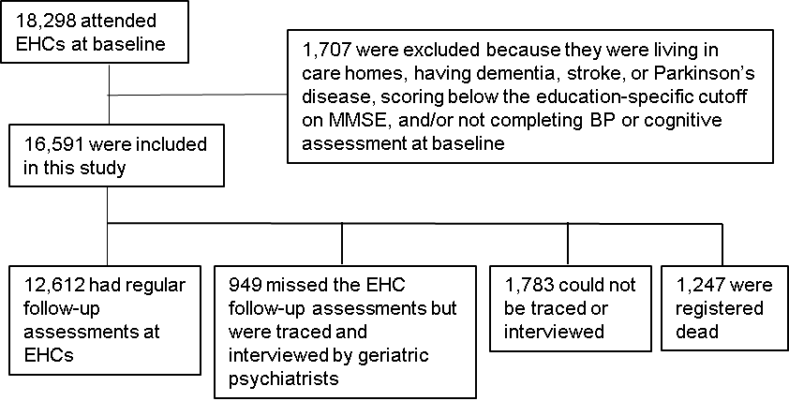

Supplementary Figure 1. Flow chart of the participants in this study.

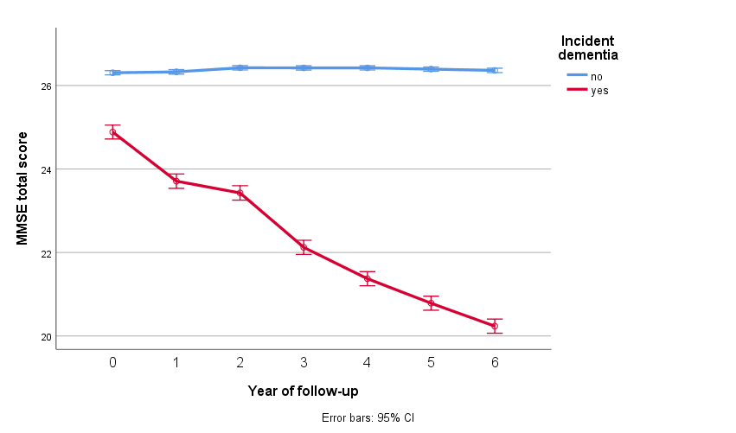

Supplementary Figure 2. Differences in trajectories of MMSE total score between participants with and without incident dementia.

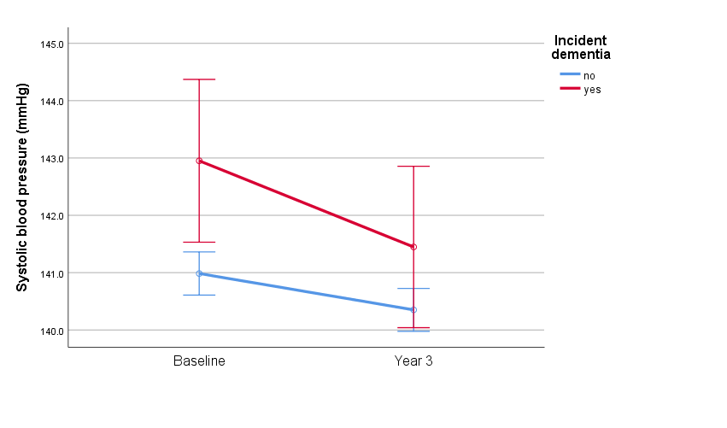
Supplementary Figure 3. Differences in changes of systolic blood pressure from baseline to Year 3 between participants with and without incident dementia from Years 4 to 6.

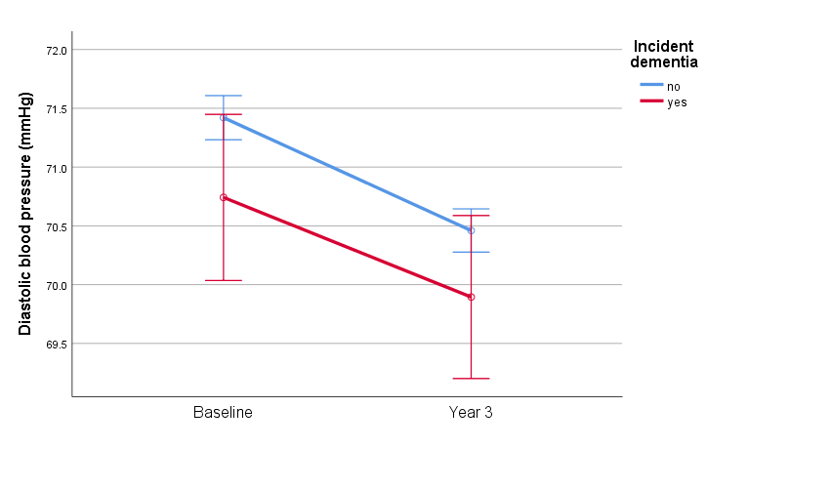
Supplementary Figure 4. Differences in changes of diastolic blood pressure from baseline to Year 3 between participants with and without incident dementia from Years 4 to 6.

Supplementary Tables

Supplementary Table 1. Comparison of persistent hypertension or hypotension from baseline to Year 3 between participants with and without incident dementia at Years 4 to 6. Comparison was made with reference to stable SBP or DBP defined as 100–140mmHg or 60–90mmHg, respectively,† or to stable SBP or DBP defined as 100–130mmHg or 60–80mmHg, respectively.‡ Values are n (%) as determined by the χ² test.

Longitudinal BP | Number of participants | Incident Dementia |  | P value
Longitudinal BP | Number of participants | No | Yes | P value
Persistent SBP≥140mmHg† | 4149 | 3842 (33.8) | 307 (38.3) | 0.01
Persistent DBP≥90mmHg† | 91 | 84 (0.7) | 7 (0.9) | 0.67
Persistent SBP≥130mmHg‡ | 7119 | 6618 (58.2) | 501 (62.5) | 0.02
Persistent DBP≥80mmHg‡ | 1095 | 1023 (9.0) | 72 (9.0) | 0.99
Persistent SBP<100mmHg† | 33 | 32 (0.3) | 1 (0.1) | 0.41
Persistent DBP<60mmHg† | 583 | 537 (4.7) | 46 (5.7) | 0.19

Supplementary Table 2. Comparison of variability of systolic and diastolic blood pressure (SBP and DBP, respectively) measured from baseline to Year 3 between participants with and without incident dementia at Years 4 to 6. Values are mean ± standard deviation for continuous variables as determined by the independent t-test. CV: coefficient of variation; SD: standard deviation.

BP variability | Incident Dementia |  | P value
BP variability | No | Yes | P value
SBP mean, mmHg | 140.2 ± 16.7 | 141.9 ± 17.5 | 0.004
SBP CV | 8.7 ± 5.3 | 9.4 ± 6.0 | <0.05
SBP adjusted SD | 10.9 ± 6.9 | 11.6 ± 7.7 | 0.01
DBP mean, mmHg | 70.9 ± 8.3 | 70.3 ± 8.8 | 0.05
DBP CV | 8.5 ± 5.1 | 9.1 ± 6.1 | 0.005
DBP adjusted SD | 5.3 ± 3.2 | 5.5 ± 3.7 | 0.1

Supplementary Table 3. Comparison of loss of longitudinal blood pressure (BP) increase over the first 3 years between participants with and without incident dementia at Years 4 to 6. Values are n (%) as determined by the χ² test.

 | Number of participants | Incident Dementia |  | P value
 | Number of participants | No | Yes | P value
SBP increased by <10mmHg | 8825 (53.2) | 8216 (72.2) | 609 (75.9) | 0.02
SBP increased by <10% | 9389 (56.6) | 8745 (76.9) | 644 (80.3) | 0.03
DBP increased by <10mmHg | 10720 (64.6) | 10010 (88.0) | 710 (88.5) | 0.66
DBP increased by <10% | 9724 (58.6) | 9067 (79.7) | 657 (81.9) | 0.13

