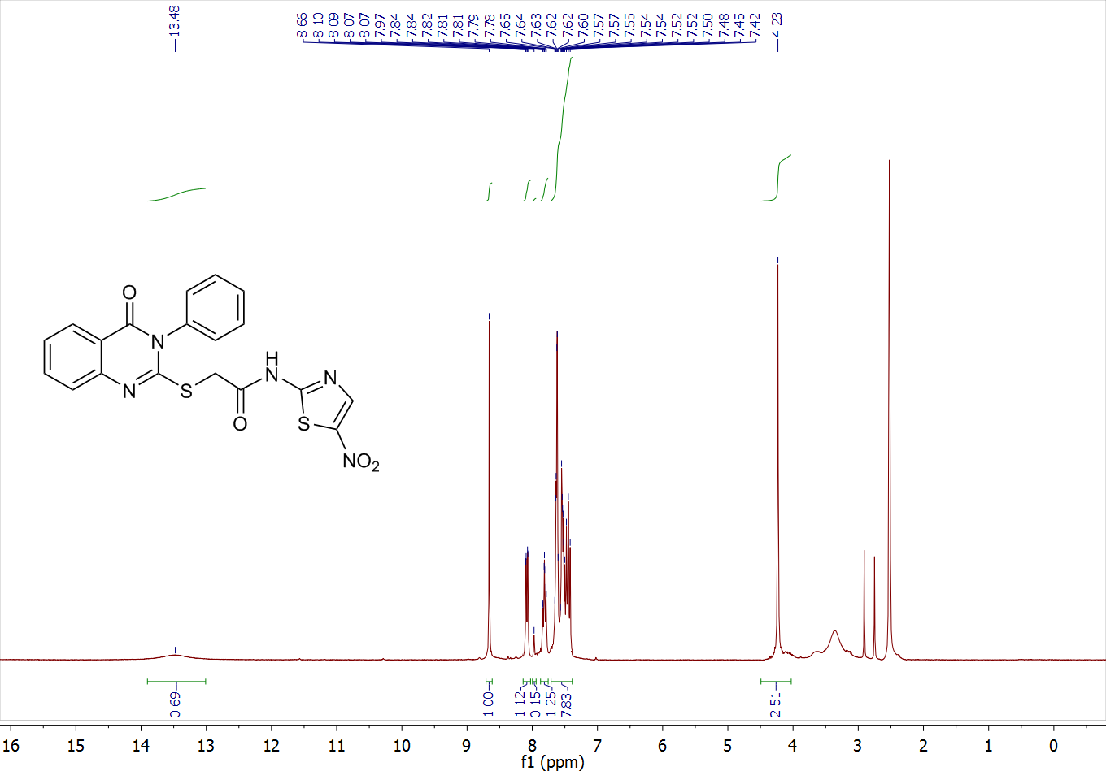
N-(5-nitrothiazol-2-yl)-2-((4-oxo-3-phenyl-3,4-dihydroquinazolin-2-yl)thio)acetamide (8a)

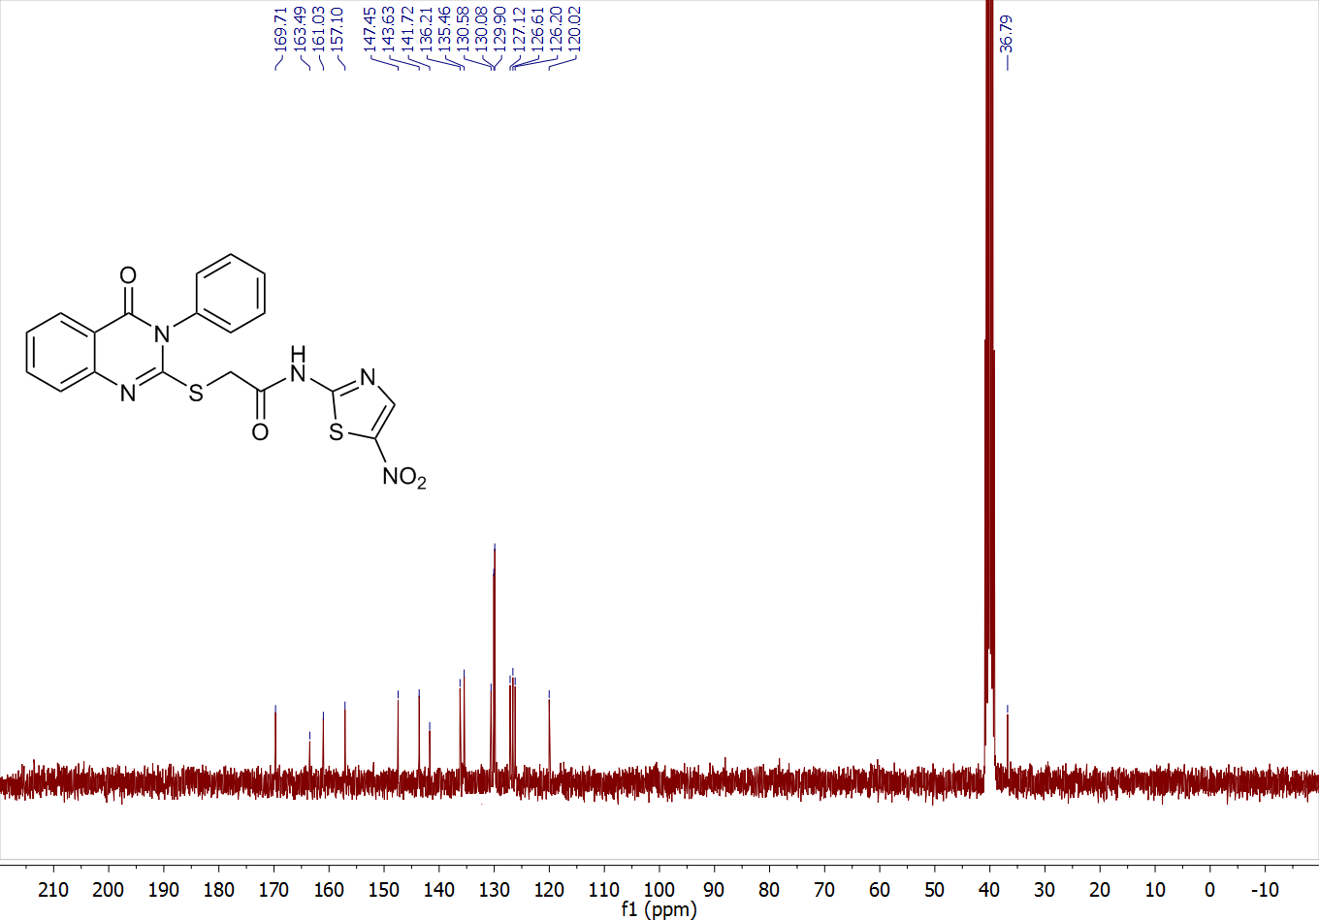
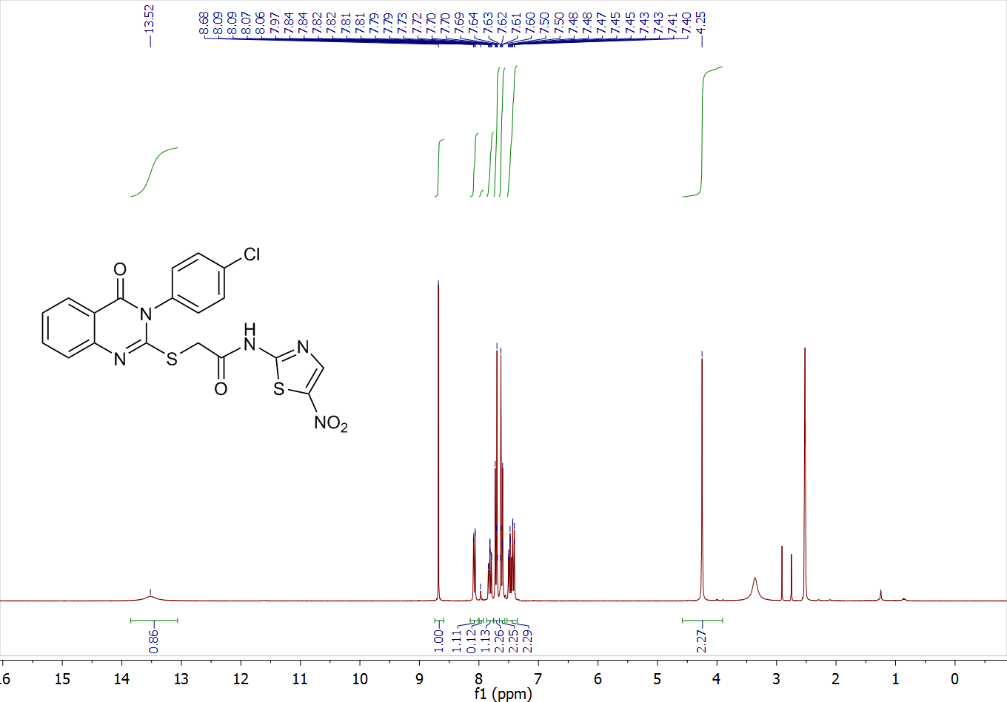

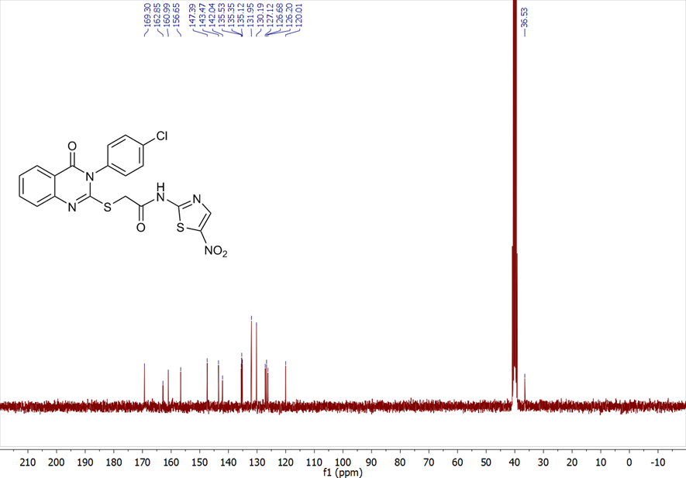

2-((3-(4-bromophenyl)-4-oxo-3,4-dihydroquinazolin-2-yl)thio)-N-(5-nitrothiazol-2-yl)acetamide (8c)
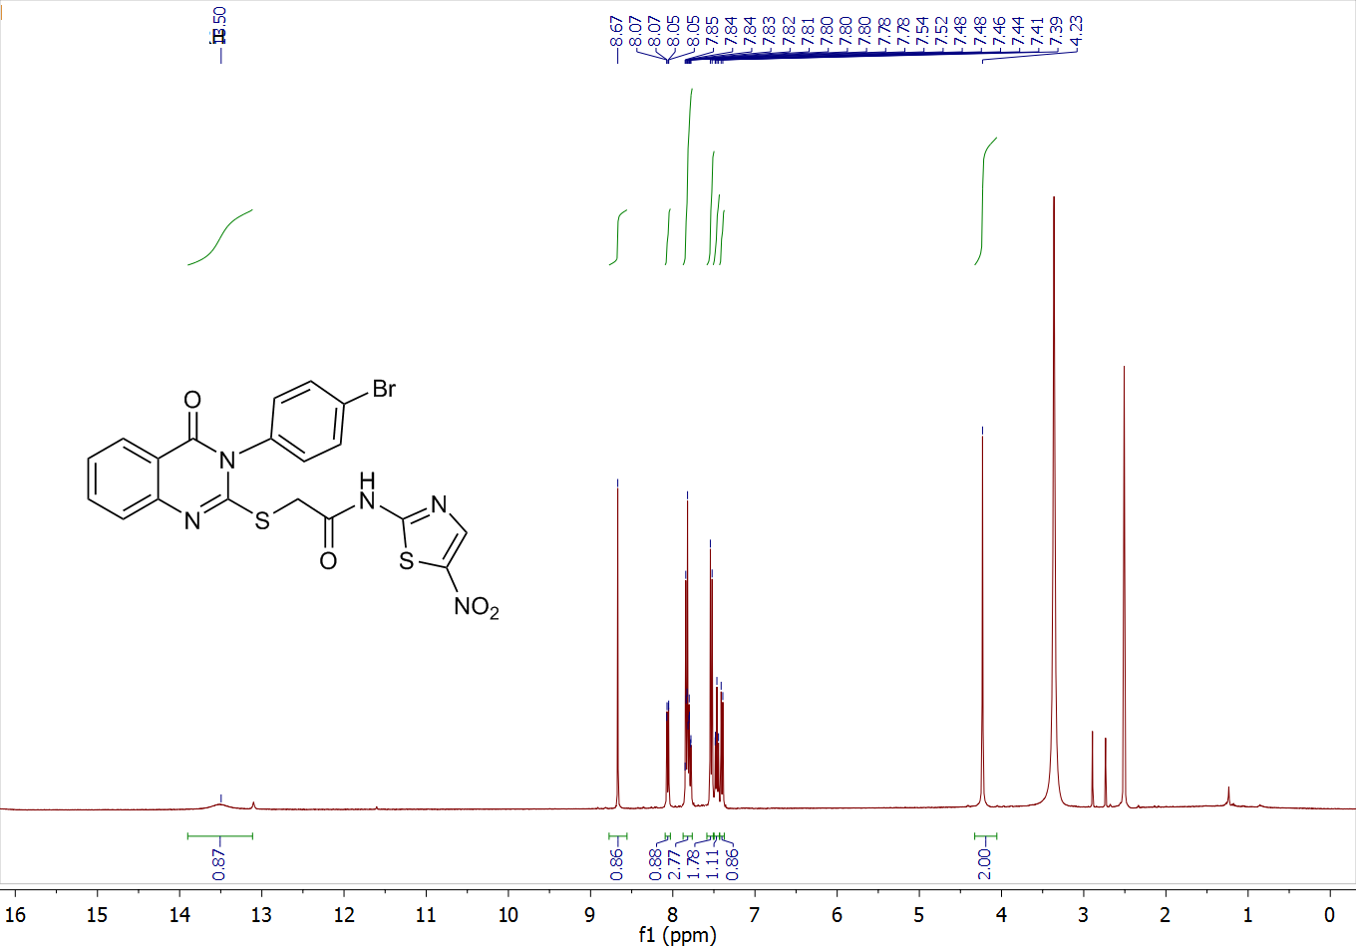
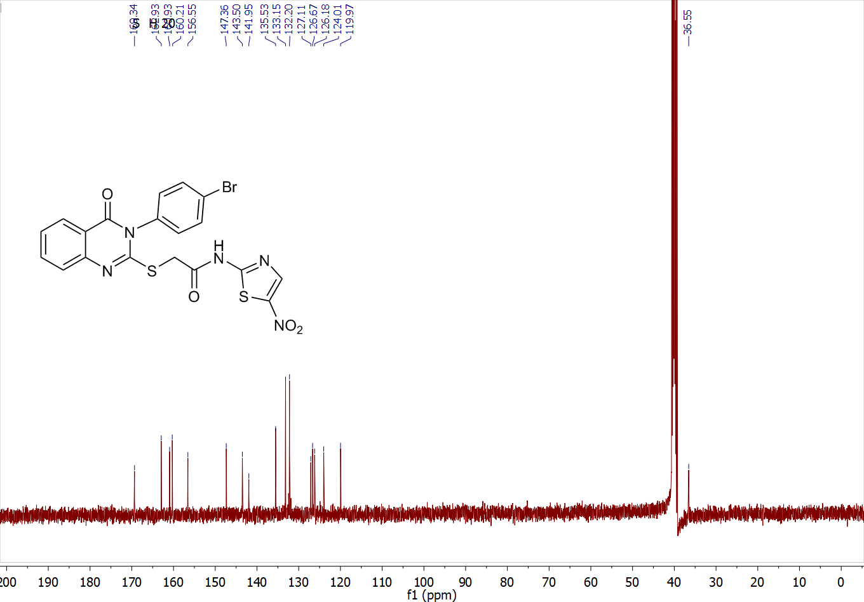
2-((3-(4-methoxyphenyl)-4-oxo-3,4-dihydroquinazolin-2-yl)thio)-N-(5-nitrothiazol-2-yl)acetamide (8d)
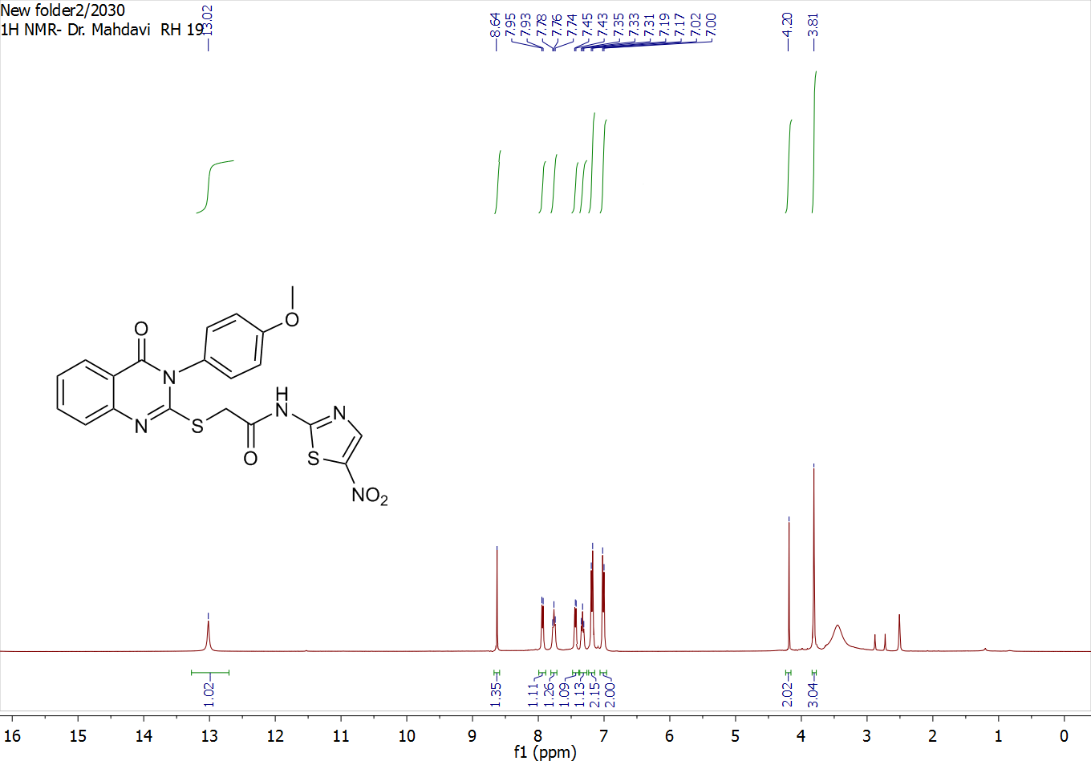
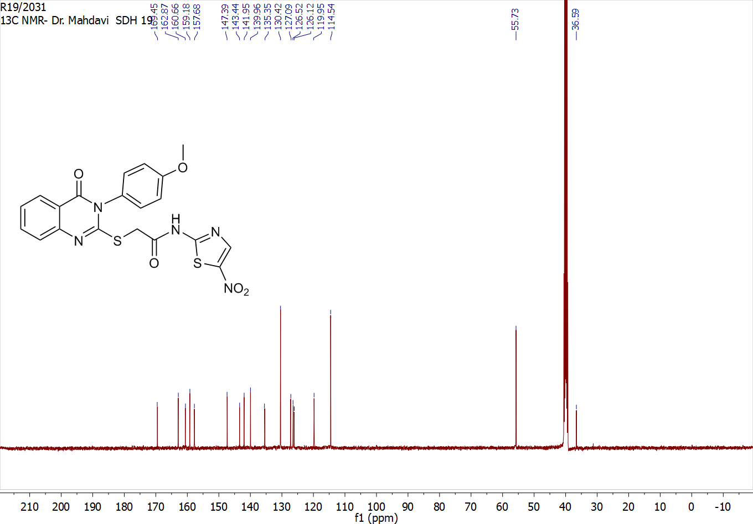
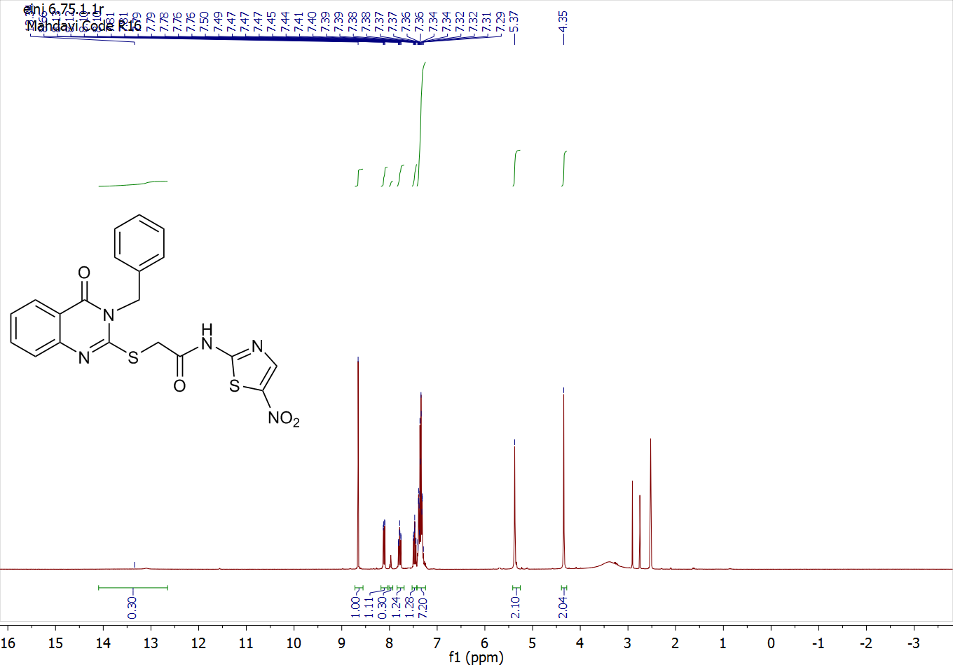
2-((3-benzyl-4-oxo-3,4-dihydroquinazolin-2-yl)thio)-N-(5-nitrothiazol-2-yl)acetamide (8e)

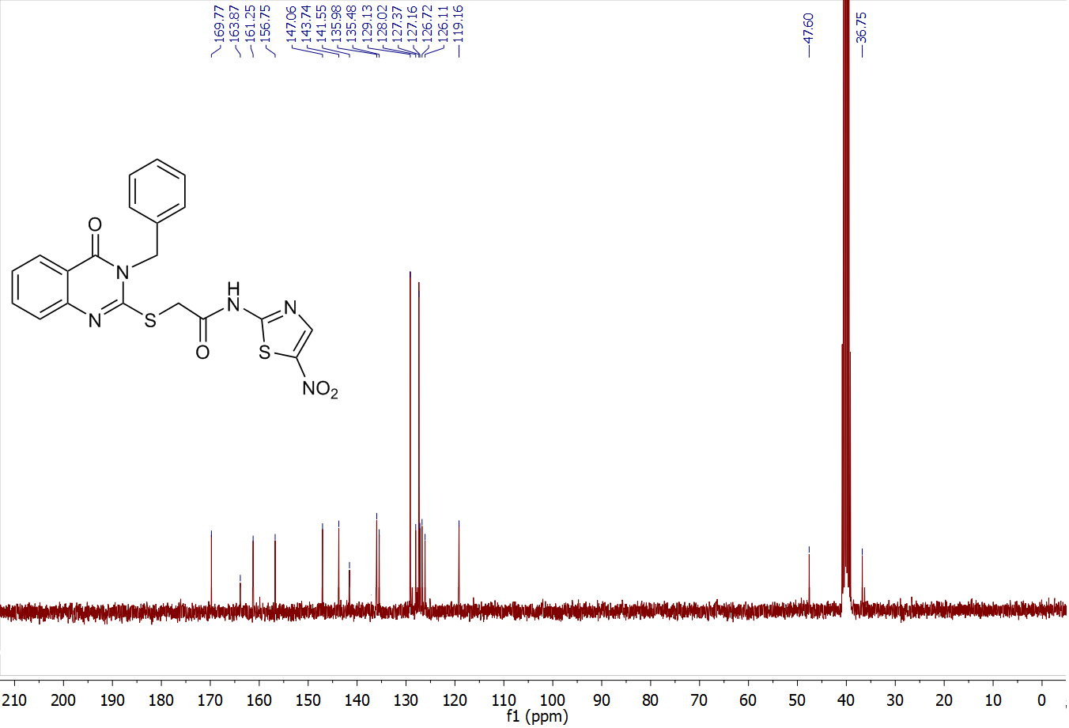

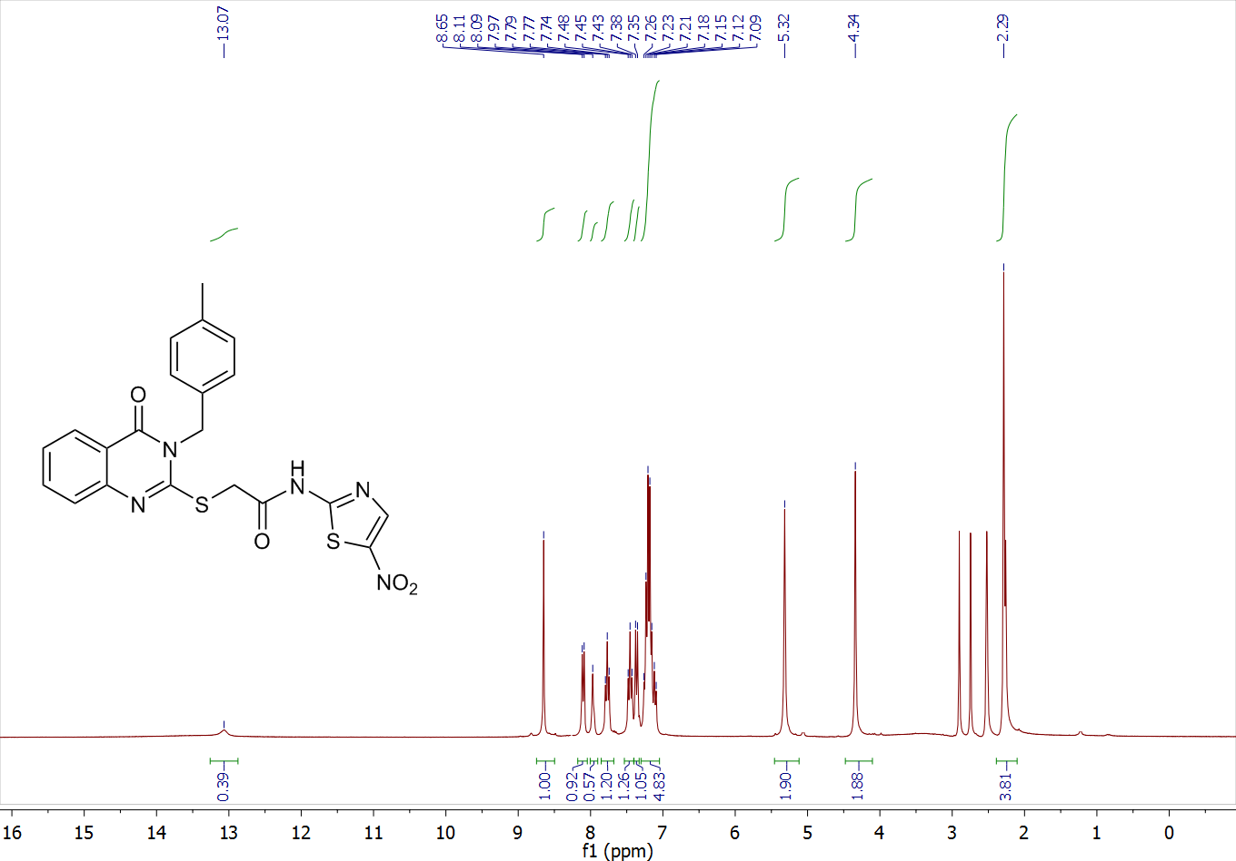
2-((3-(4-methylbenzyl)-4-oxo-3,4-dihydroquinazolin-2-yl)thio)-N-(5-nitrothiazol-2-yl)acetamide (8f)

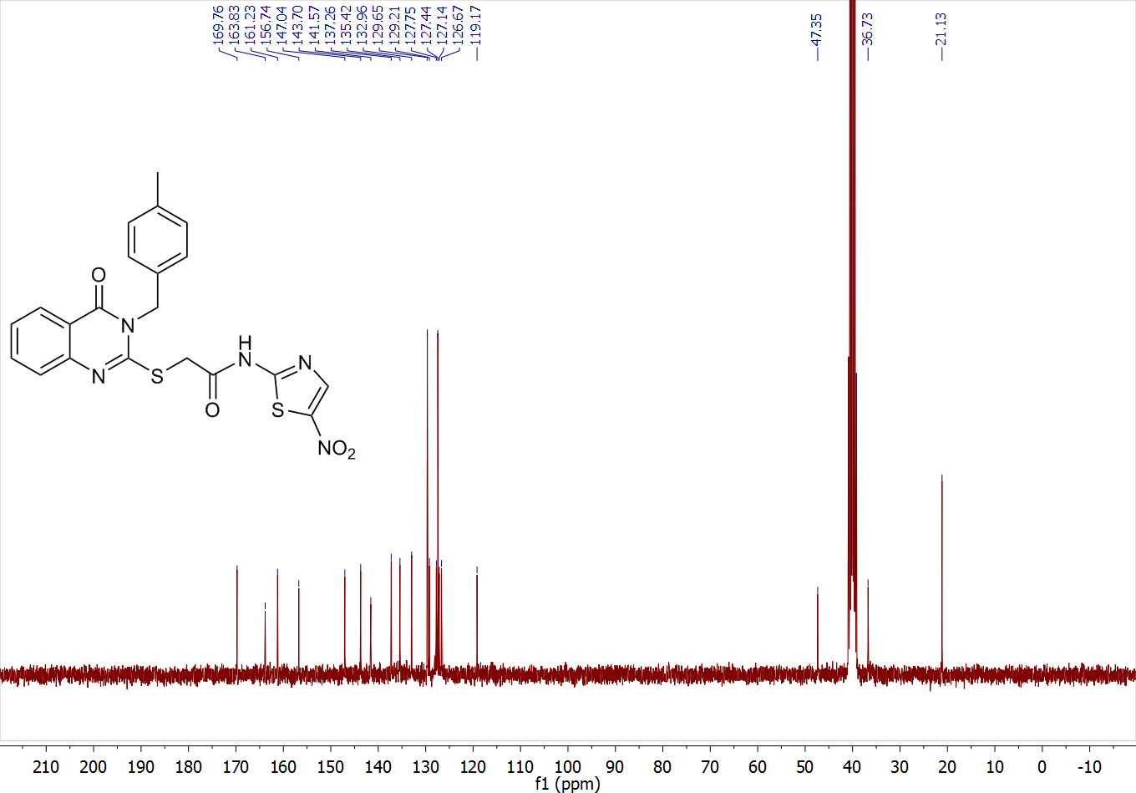

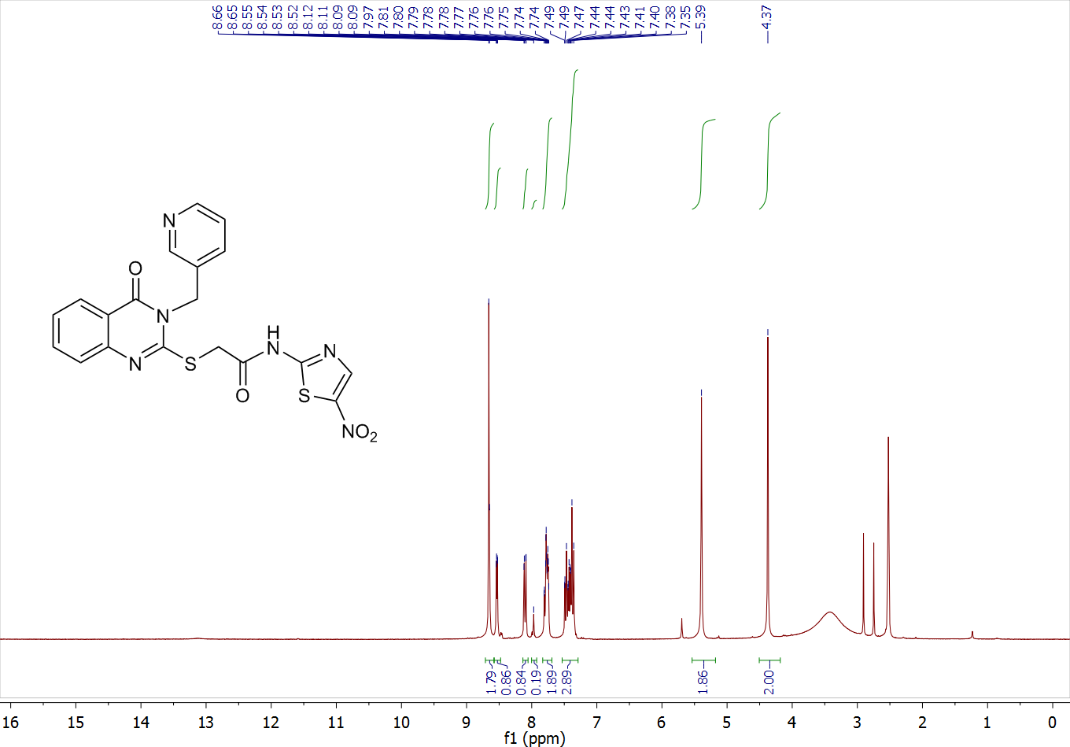
N-(5-nitrothiazol-2-yl)-2-((4-oxo-3-(pyridin-3-ylmethyl)-3,4-dihydroquinazolin-2-yl)thio)acetamide (8g)

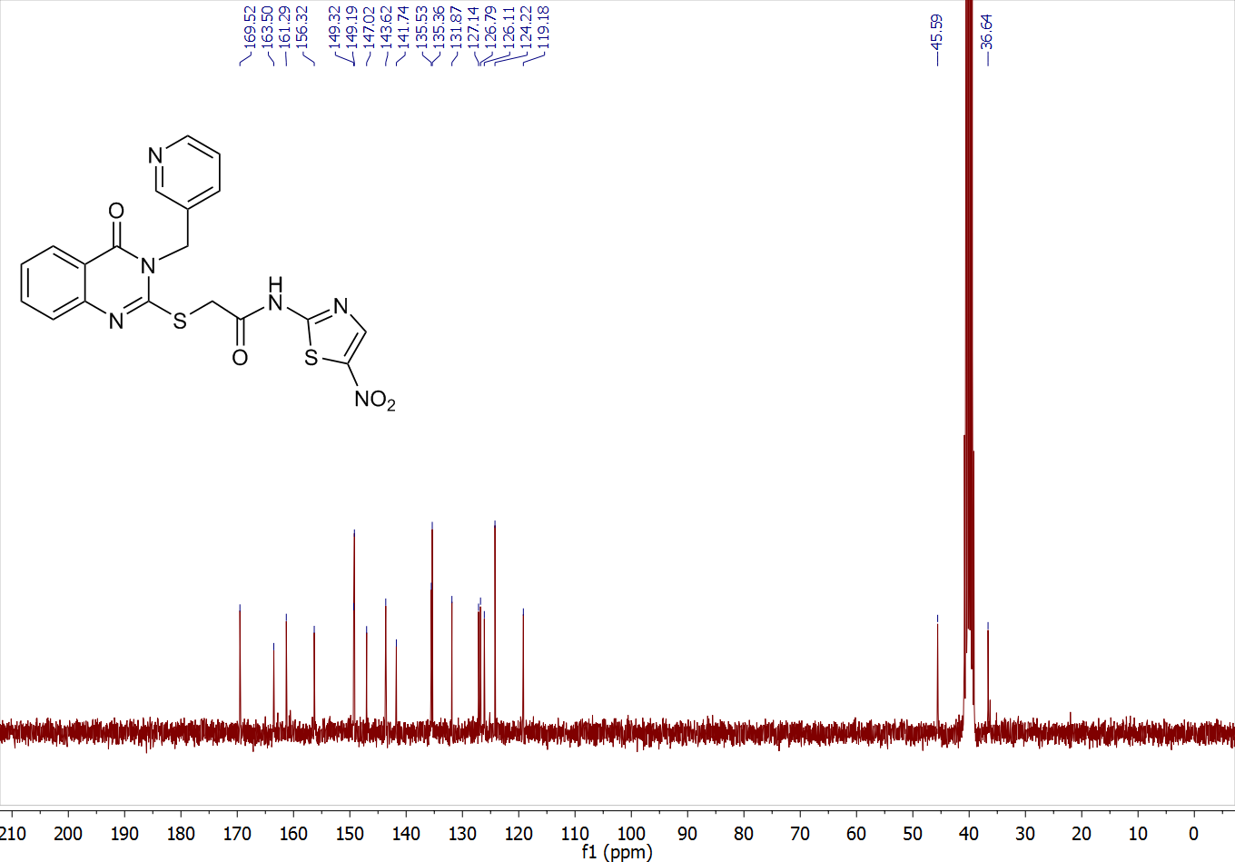

N-(5-nitrothiazol-2-yl)-2-((4-oxo-3-phenethyl-3,4-dihydroquinazolin-2-yl)thio)acetamide (8h)
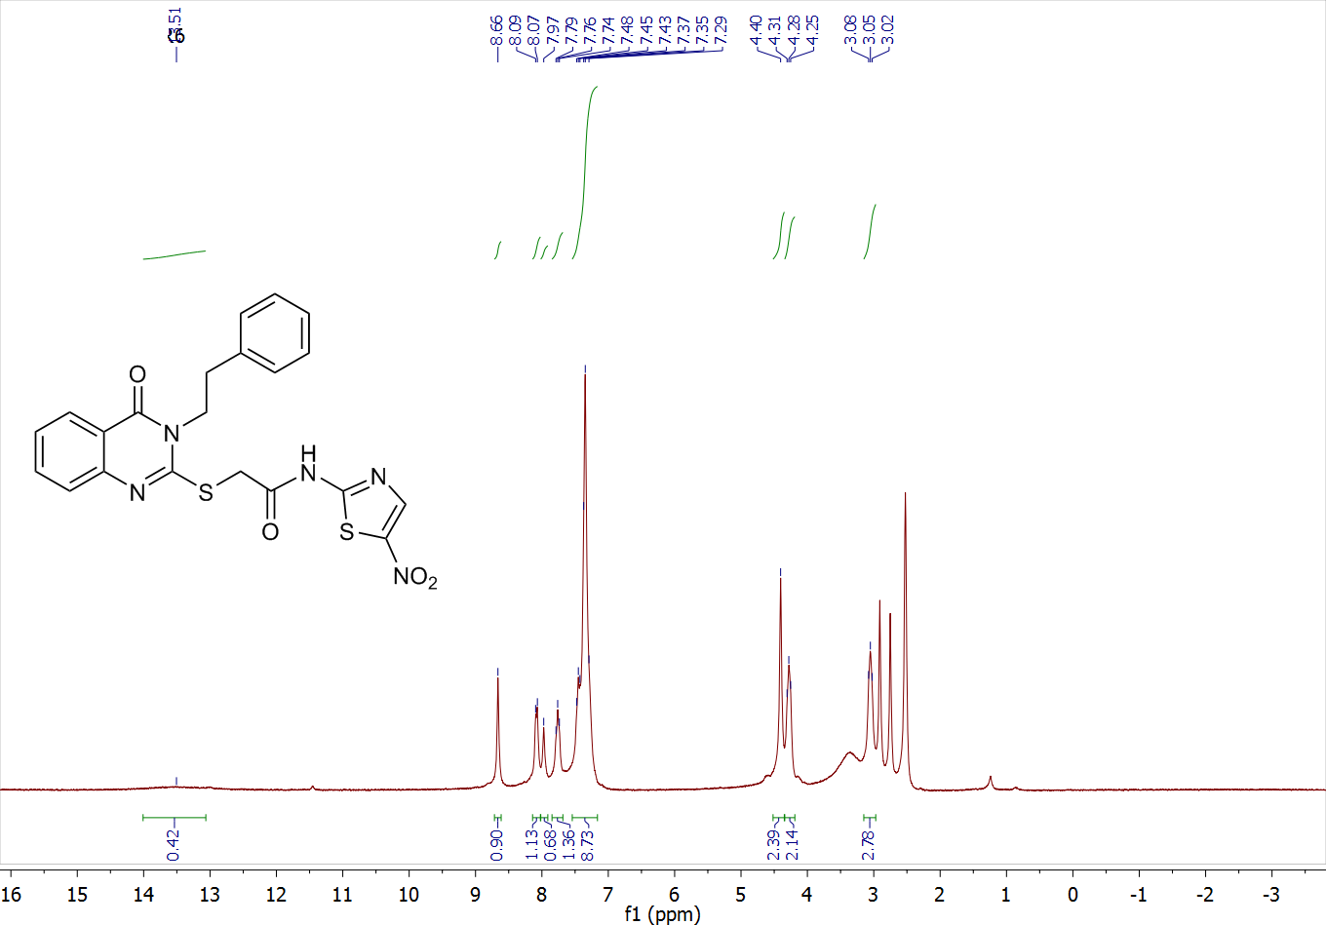

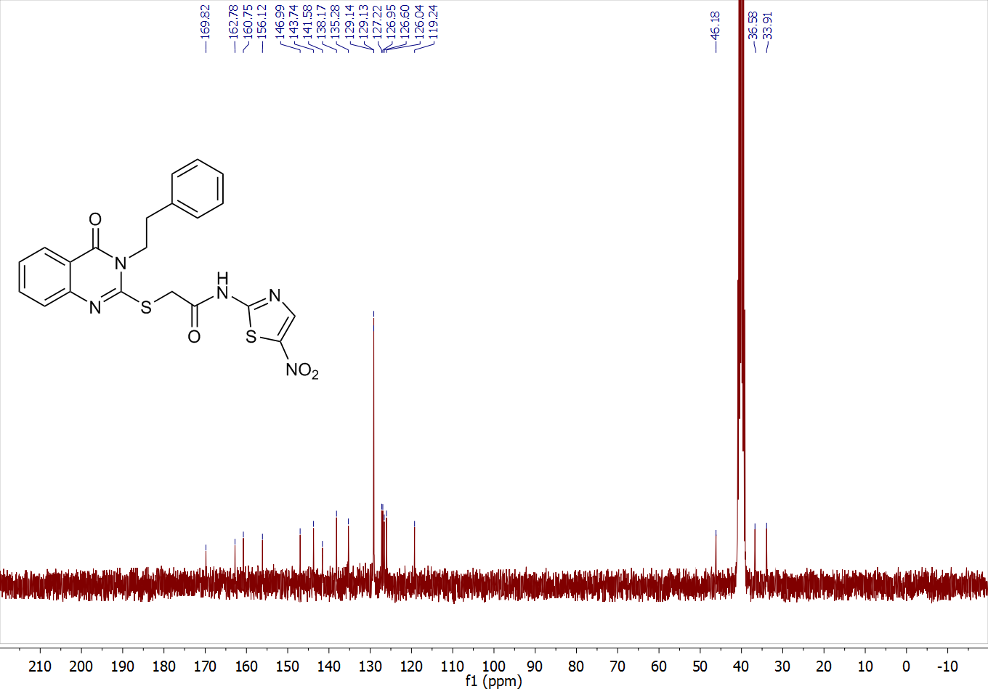

N-(5-nitrothiazol-2-yl)-2-((4-oxo-3-propyl-3,4-dihydroquinazolin-2-yl)thio)acetamide (8i)
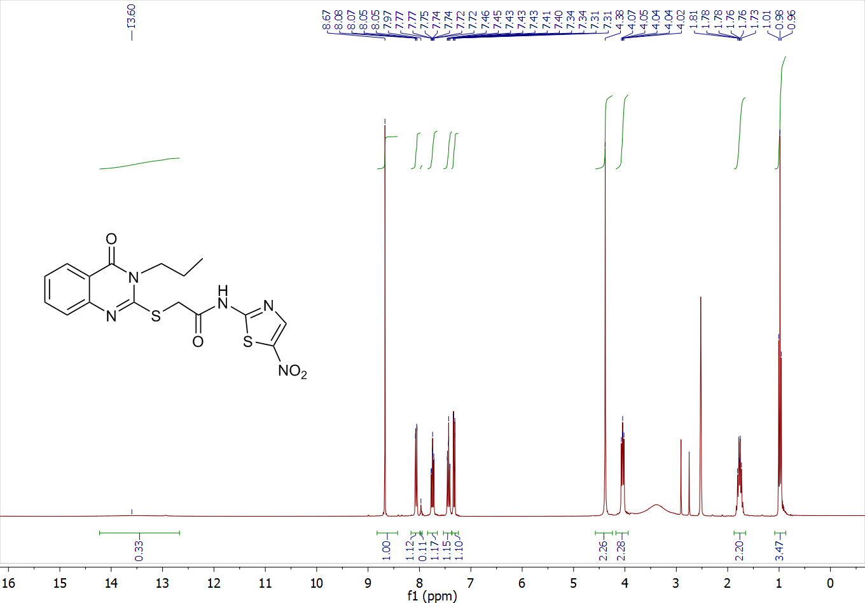

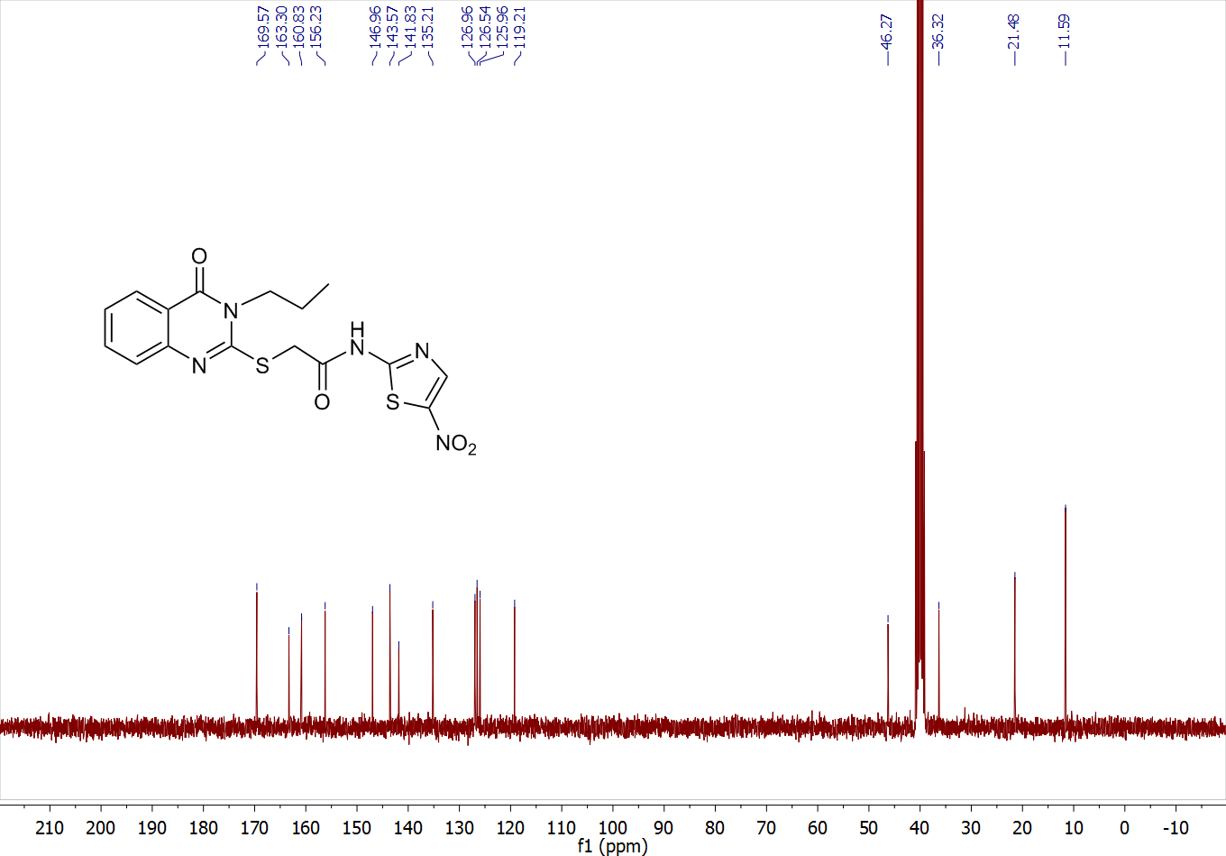

2-((3-isopropyl-4-oxo-3,4-dihydroquinazolin-2-yl)thio)-N-(5-nitrothiazol-2-yl)acetamide (8j)
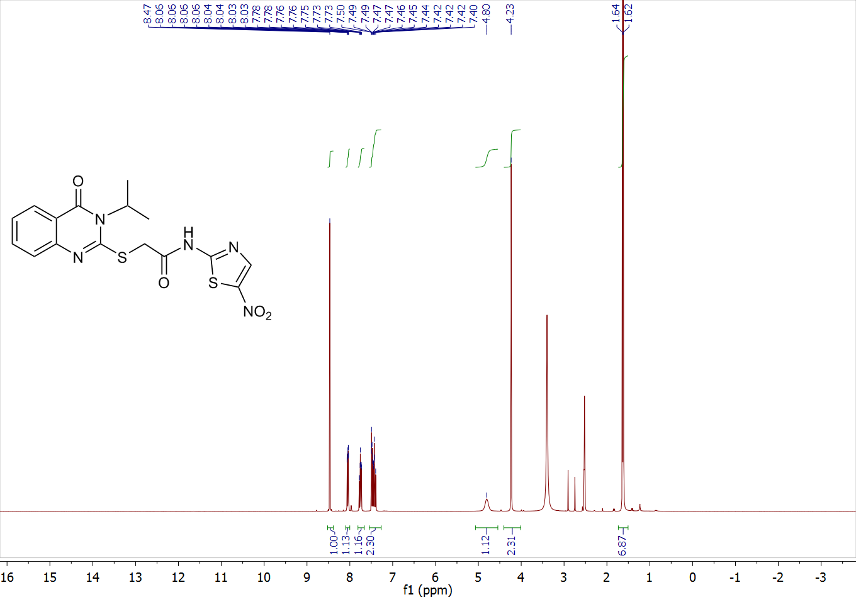

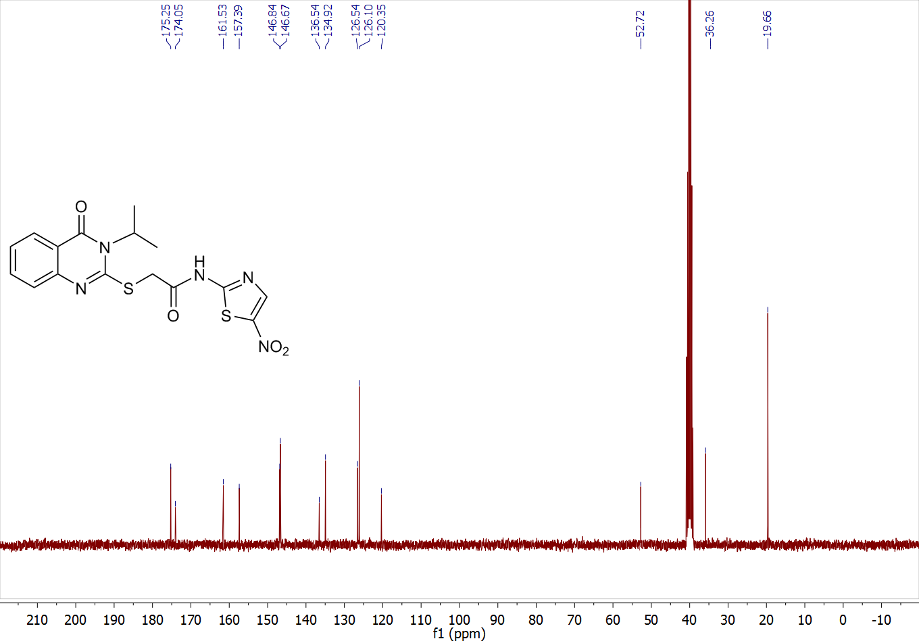

2-((3-butyl-4-oxo-3,4-dihydroquinazolin-2-yl)thio)-N-(5-nitrothiazol-2-yl)acetamide (8k)
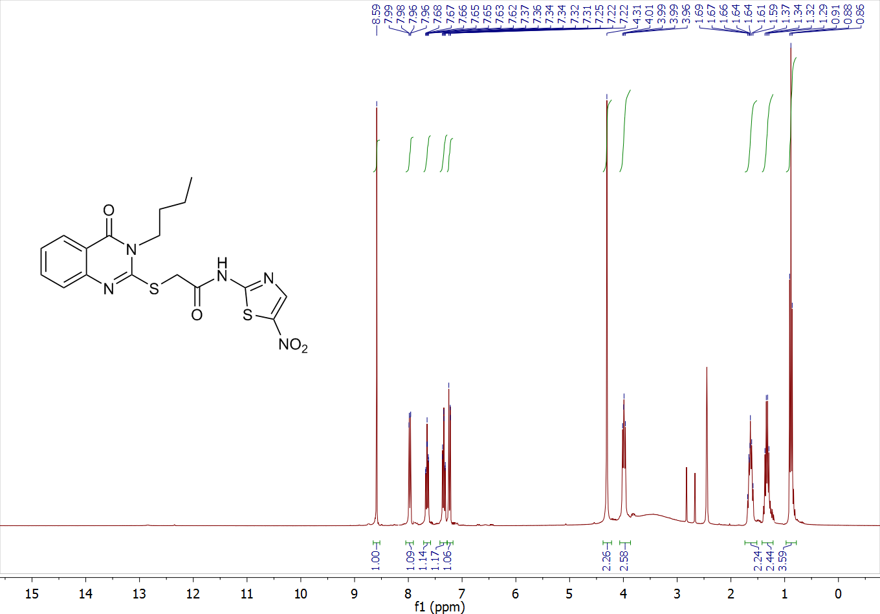

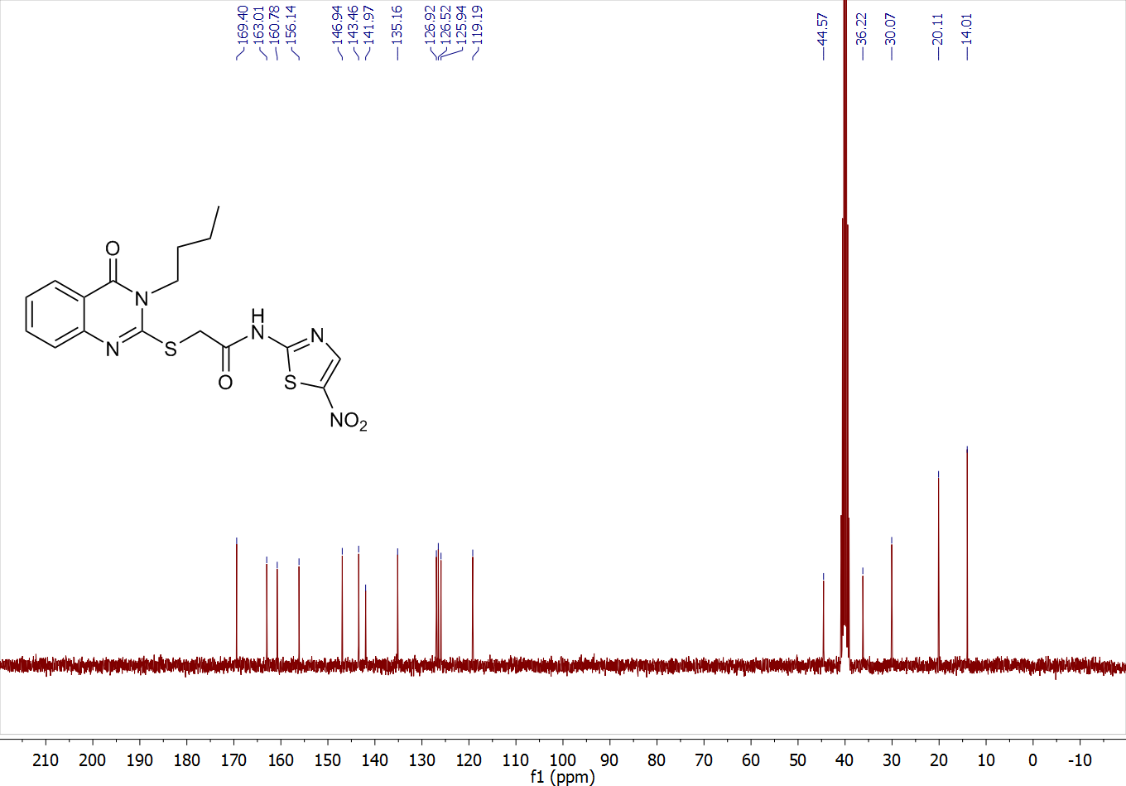

2-((3-isobutyl-4-oxo-3,4-dihydroquinazolin-2-yl)thio)-N-(5-nitrothiazol-2-yl)acetamide (8l)
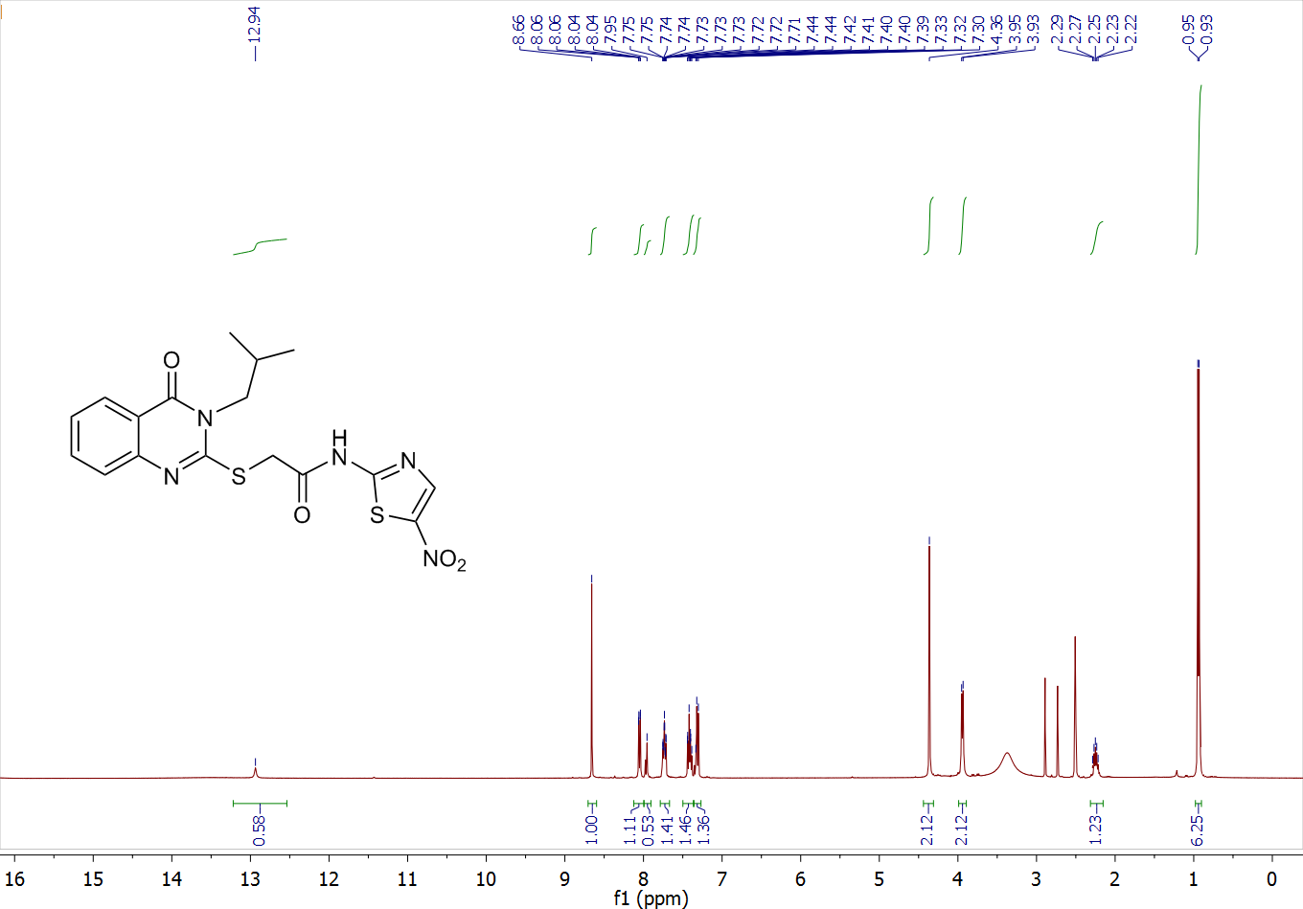
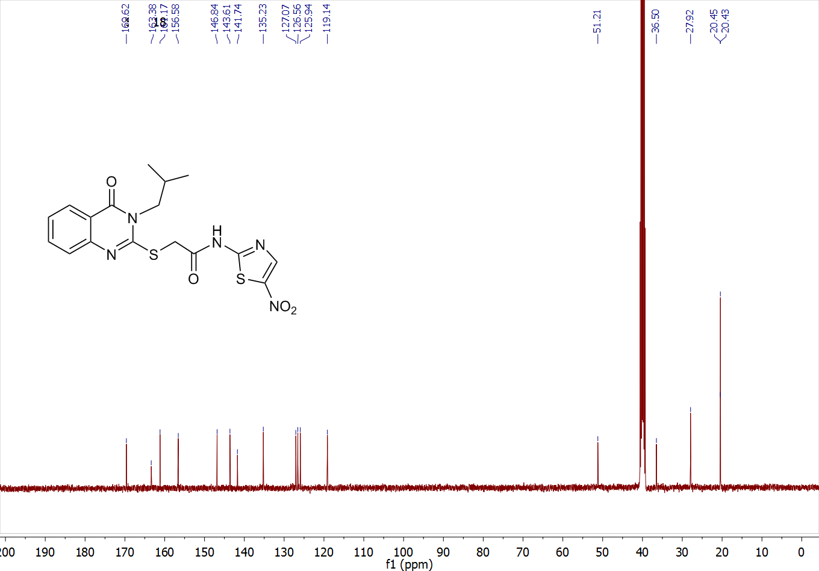
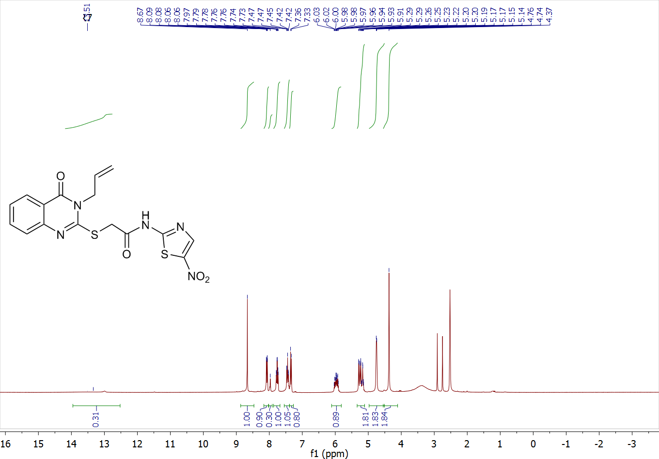
2-((3-allyl-4-oxo-3,4-dihydroquinazolin-2-yl)thio)-N-(5-nitrothiazol-2-yl)acetamide (8m)

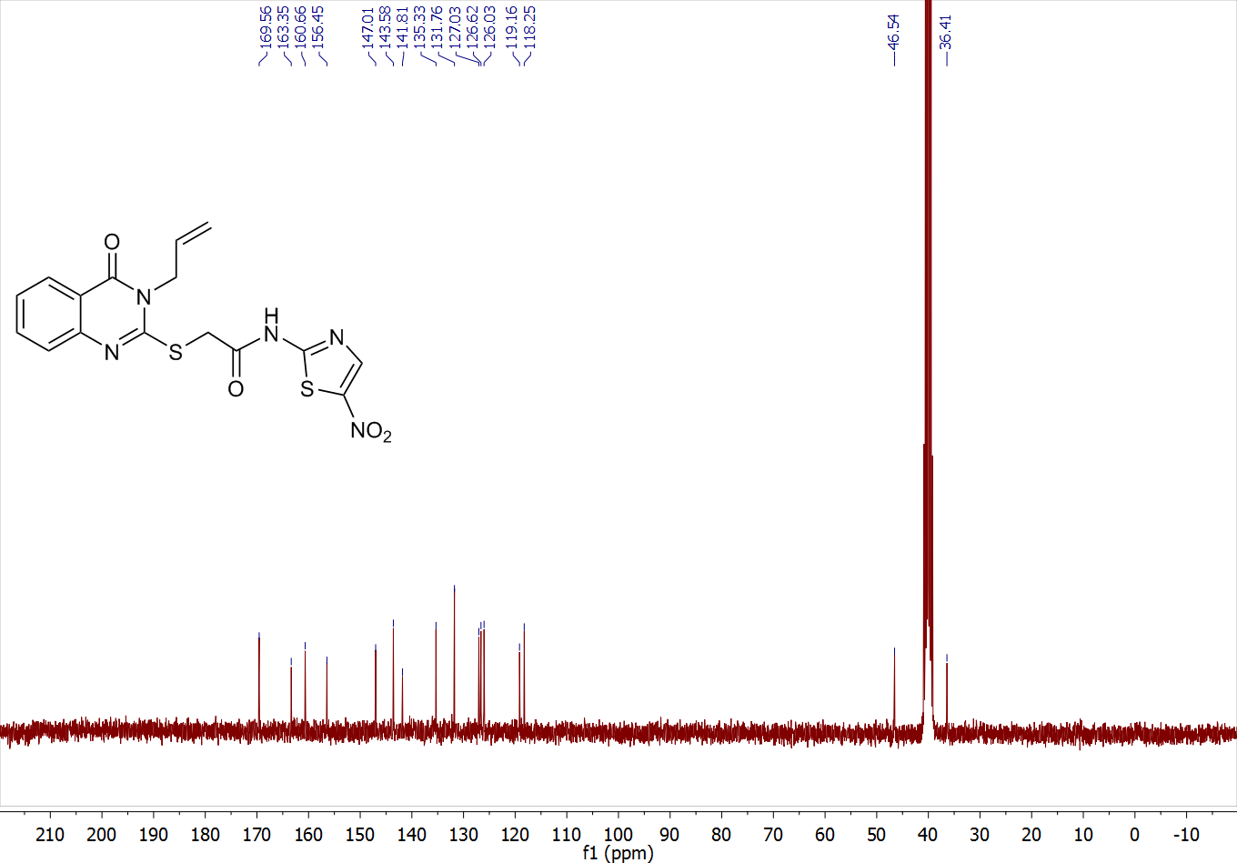

2-((3-cyclopentyl-4-oxo-3,4-dihydroquinazolin-2-yl)thio)-N-(5-nitrothiazol-2-yl)acetamide (8n)
