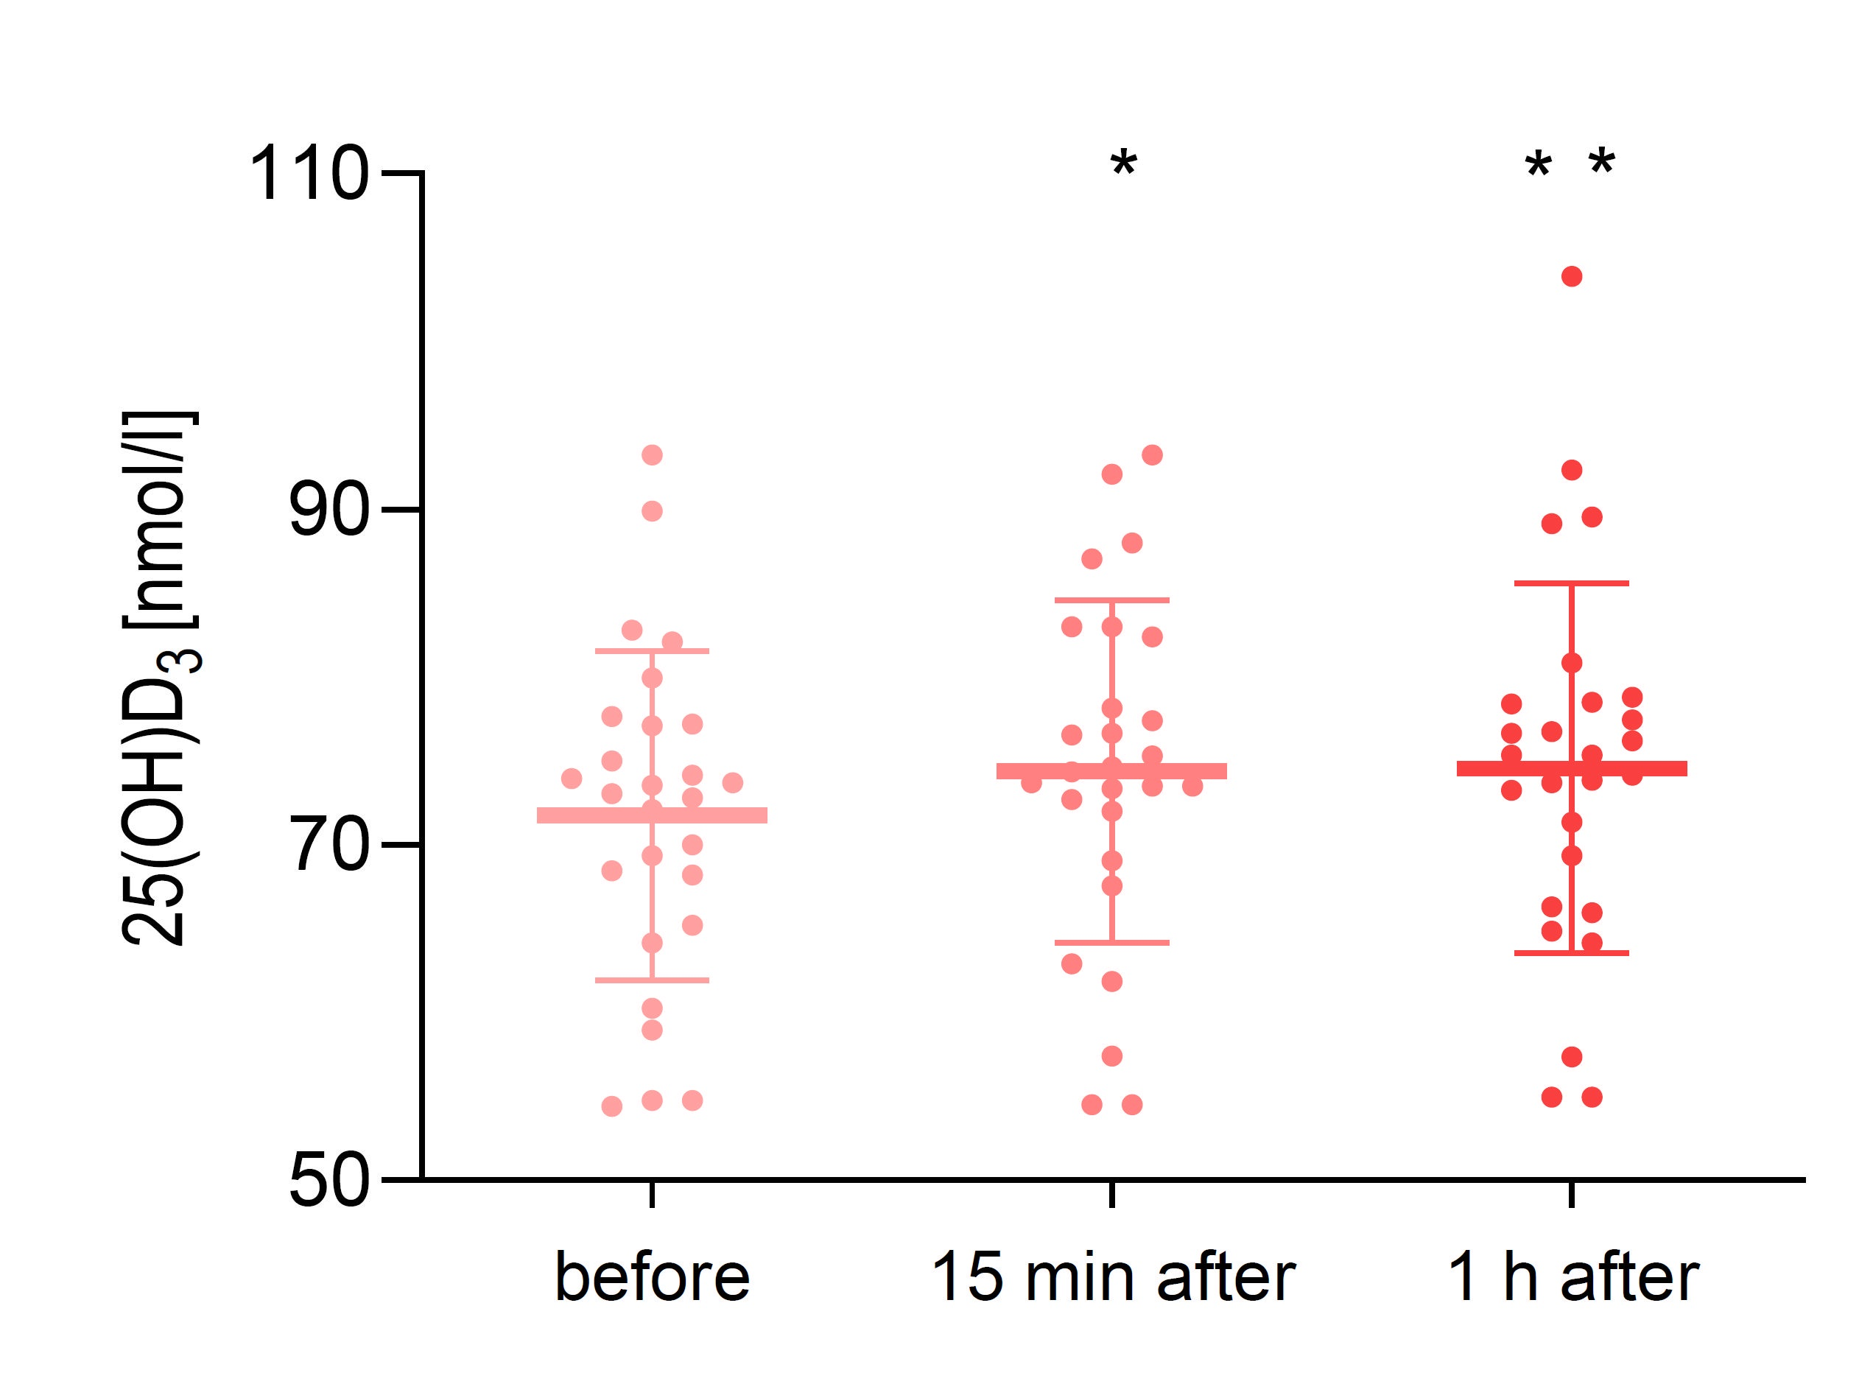
Figure S1. The concentration of 25(OH)D₃ before, 15 minutes after and 1 hour after a single bout of exercise (both VO₂max and WAnT tests) in boys n=26 (10-14 y). Results were expressed as mean±SEM. *p=0.016– difference between indicated result/mean and the results before, **p=0.011 – difference between indicated result/mean the results before, LSD post hoc test after repeated measures ANOVA.

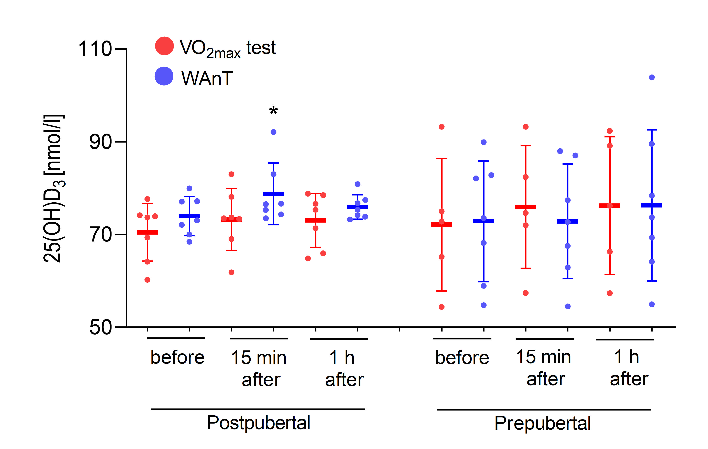
Figure S2. The concentration of 25(OH)D3 before, 15 minutes after and 1 hour after a single bout of exercise in pubertal (n= 7 for VO₂max test, and n= 7 for WAnT test) and prepubertal (n= 5 for VO₂max test, and n=7 for WAnT test) boys according to two types of exercise (VO₂max and WAnT tests). *p=0.032 – difference between indicated result/mean and the results before in the same group and test, LSD post hoc test after repeated measures ANOVA.

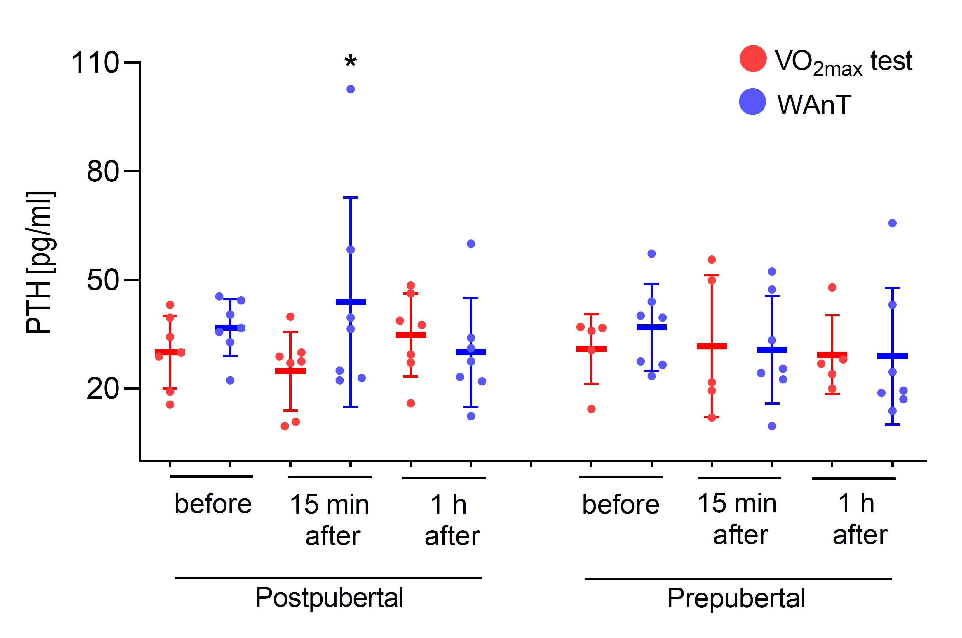
Figure S3. The PTH concentration before, 15 minutes after and 1 hour after a single bout of exercise in pubertal (n= 7 for VO₂max test, and n= 7 for WAnT test) and prepubertal (n= 5 for VO₂max test, and n=7 for WAnT test) boys according to two types of exercise (VO₂max and WAnT tests). *p=0.024 – difference between indicated result/mean and the results 1 hour after in the same group and test, LSD post hoc test after repeated measures ANOVA.

