Supplementary Figure S1
A heatmap illustrating the top 100 most significant differentially expressed genes in diarrhoea-susceptible and diarrhoea-resistant groups.

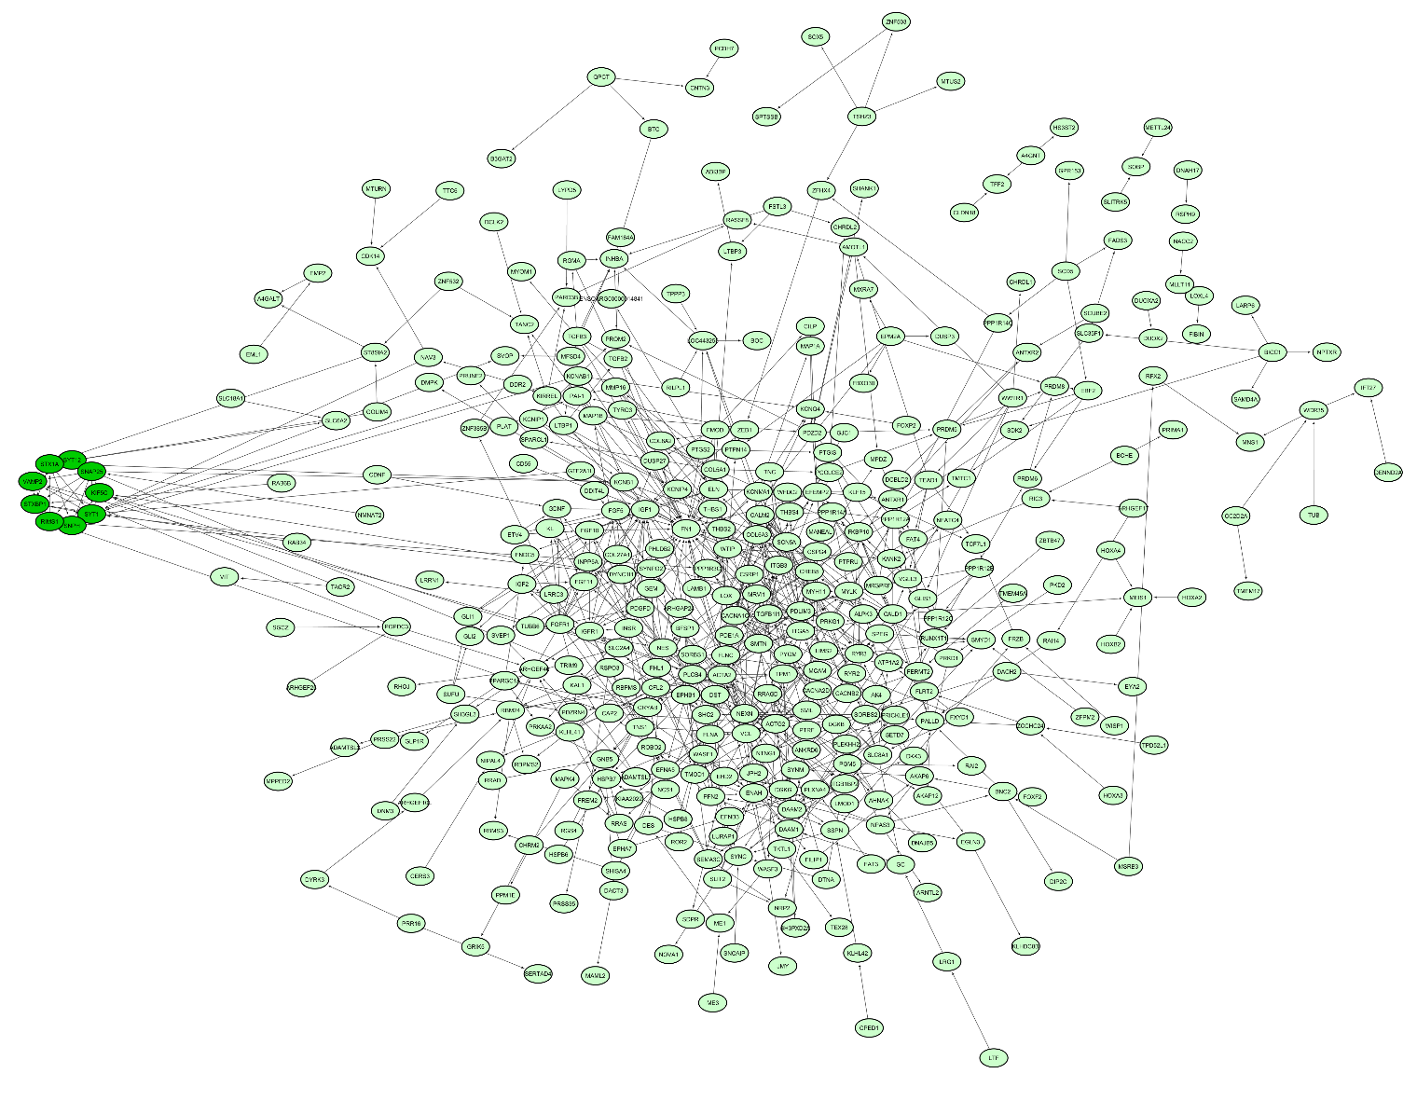
Supplementary Figure S2
Protein-protein interaction (PPI) networks associated with up-regulated DEGs derived from STRING with subnetworks (SN) generated using the Cytoscape ClusterONE plugin. Only one significant SN was associated shown in dark green node (SN1).

