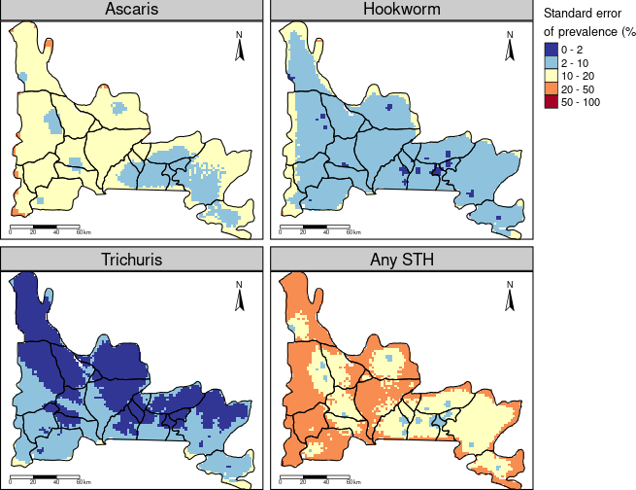Supplementary Figure S1: Map showing the standard error of the predicted risk of soil transmitted helminth infections in Ogun State. This figure was created by the authors in R programming software (R version 4.1.2, Vienna, Austria). Available at https://www.R-project.org/.

