A framework to predict the applicability of Oncotype DX, MammaPrint, and E2F4 gene signatures for improving breast cancer prognostic prediction
Kevin Yao¹, Chun-Yip Tong², Chao Cheng^{2,3,4*}

1. Department of Electrical and Computer Engineering, Texas A&M University, College Station, TX
2. Department of Medicine, Baylor College of Medicine, Houston, TX 77030, USA
3. Dan L Duncan Comprehensive Cancer Center, Baylor College of Medicine, Houston, TX 77030, USA
4. Institute for Clinical and Transcriptional Research, Baylor College of Medicine, Houston, TX 77030, USA

*Corresponding author
Email: chao.cheng@bcm.edu

Supplementary materials
Supplementary Figure S1. (A-C) ROC curves showing the AUC of Oncotype DX, MammaPrint, and E2F4 scores respectively used as univariate predictors of response to neoadjuvant chemotherapy. Generally, incorporating clinical variables in the random forest model increases the performance metric of the model.

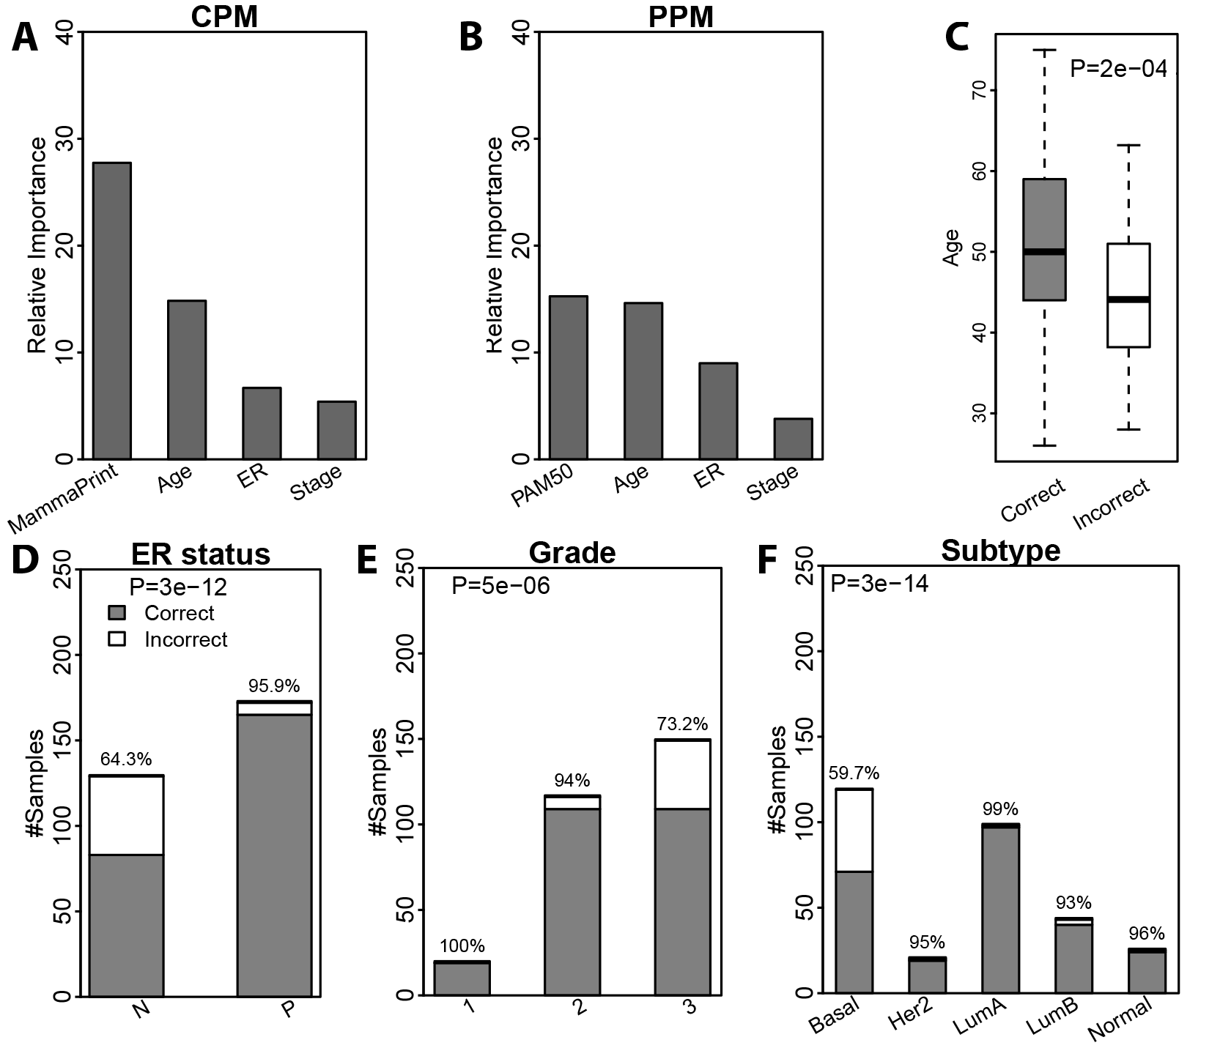
Supplementary Figure S2. Association of predictions based on the MammaPrint assay with clinical variables. (A, B) Relative importance of predictors in the CPM and PPM, respectively. (C) Older patients are more likely to be predicted correctly. (D) ER positive patients are more likely to be predicted correctly. (E) Patients with lower grade are more likely to be predicted correctly. (F) Association of molecular subtypes with prediction accuracy.

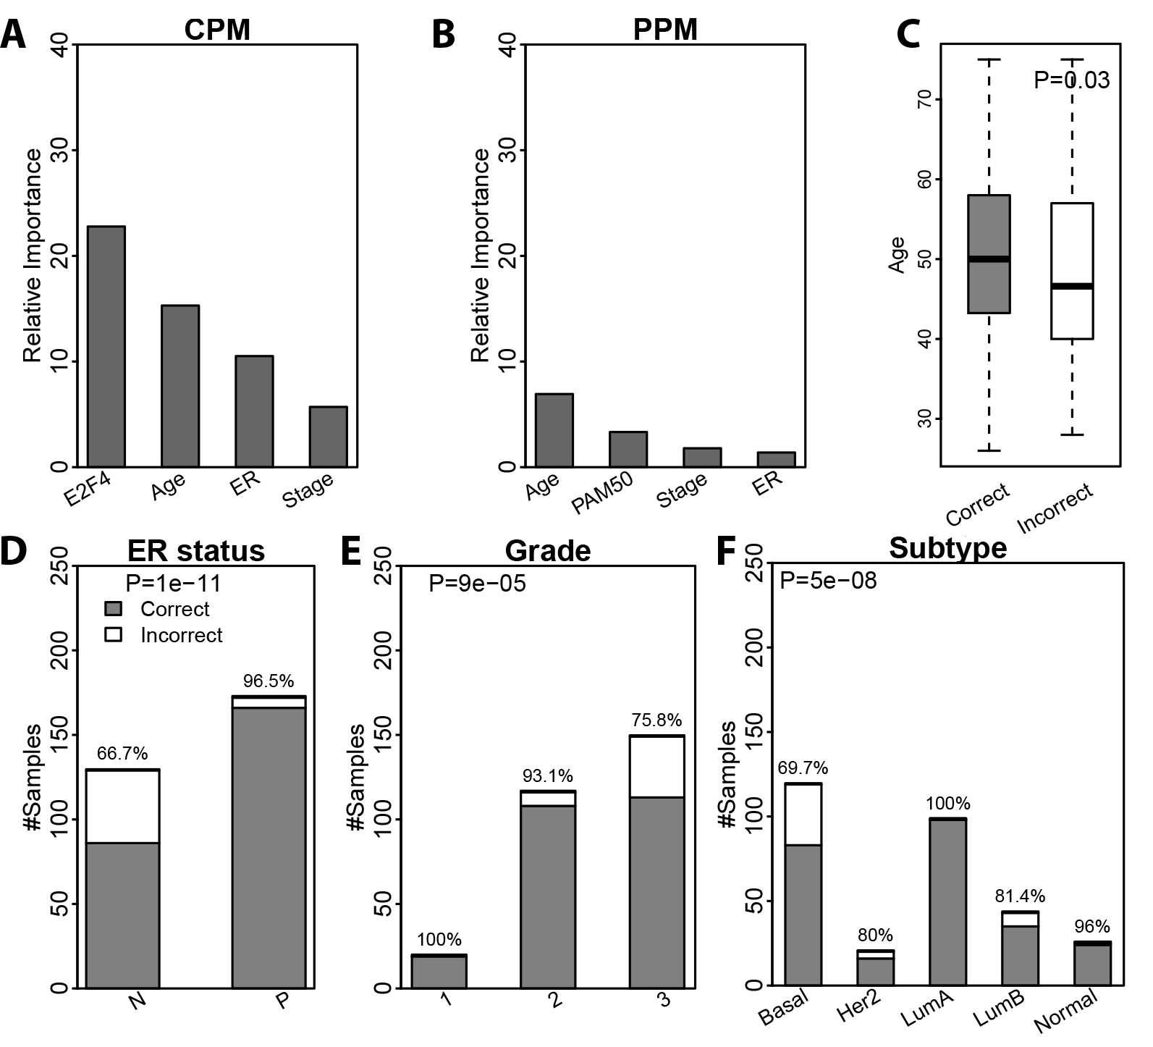
Supplementary Figure S3. Association of predictions based on the E2F4 assay with clinical variables. (A, B) Relative importance of predictors in the CPM and PPM, respectively. (C) Older patients are more likely to be predicted correctly. (D) ER positive patients are more likely to be predicted correctly. (E) Patients with lower grade are more likely to be predicted correctly. (F) Association of molecular subtypes with prediction accuracy.

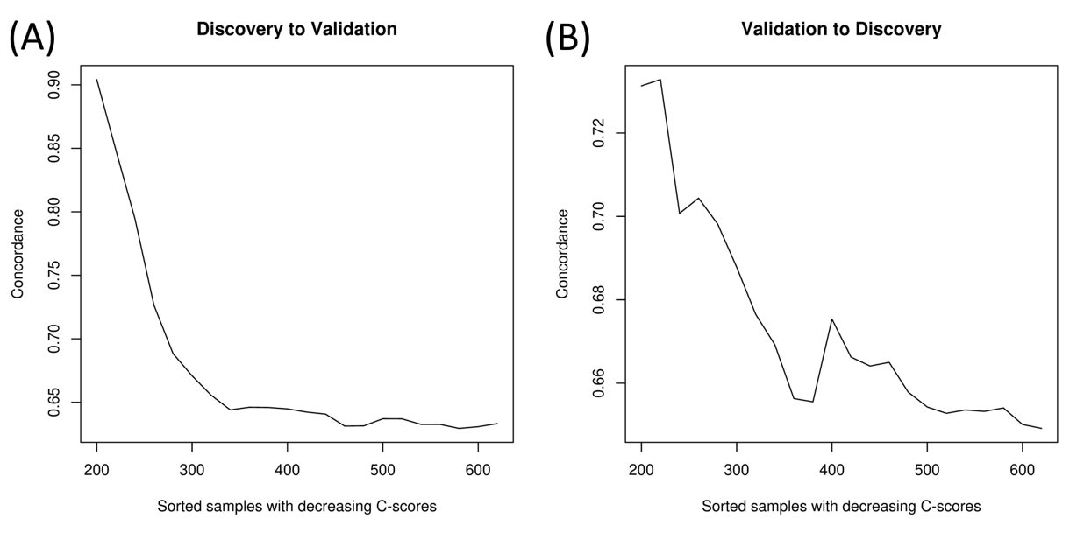
Supplementary Figure S4. Concordance of a CPM that utilizes random survival forest instead of Cox proportional hazards as the predictor of survival. (A) Application of the CPM/PPMs trained from the discovery data to patients in the validation cohort, and (B) vice versa. Patients are sorted in the decreasing order of their confidence scores, and the average concordance in the top N patients was calculated from N=1 to all patients. The curve was smoothed by averaging values within a sliding window of size 200.

Gene | Weight
BIRC5 | 0.182904
NUF2 | 0.21915
SGOL1 | 0.137376
CDCA3 | 0.136733
KIF20A | 0.175755
NUSAP1 | 0.160178
OIP5 | 0.170259
KIF23 | 0.171274
PRC1 | 0.159252
BUB1 | 0.226243
CDCA8 | 0.165218
UBE2T | 0.17157
CEP55 | 0.234161
NCAPH | 0.140164
KIF15 | 0.179671
FOXM1 | 0.170847
EXO1 | 0.16773
CENPA | 0.196286
AURKB | 0.11828
GTSE1 | 0.12707
CDCA5 | 0.178454
C15orf42 | 0.169853
BLM | 0.145058
ASPM | 0.173875
RAD51 | 0.168714
NDC80 | 0.17913
DEPDC1B | 0.196929
NEIL3 | 0.185208
STIL | 0.141571
RAD54L | 0.129884
CENPF | 0.198774
PLK1 | 0.099492
KIF2C | 0.192363
BUB1B | 0.176422
Supp. Table S1. Gene list with weights for the E2F4 gene signature.

Gene signature | Genes
Oncotype DX | Ki67, STK15, BIRC5, CCNB1, MYBL2, MMP11, CTSL2, GRB7, HER2, ER, PGR, BCL2, SCUBE2, GSTM1, BAG1, CD68, ACTB, GAPDH, GUS, RPLPO, TFRC
MammaPrint | BBC3, EGLN1, TGFB3, ESM1, IGFBP5, FGF18, SCUBE2, TGFB3, WISP1, FLT1, HRASLS, STK32B, RASSF7, DCK, MELK, EXT1, GNAZ, EBF4, MTDH, PITRM1, QSCN6L1, CCNE2, ECT2, CENPA, LIN9, KNTC2, MCM6, NUSAP1, ORC6L, TSPYL5, RUNDC1, PRC1, RFC4, RECQL5, CDCA7, DTL, COL4A2, GPR180, MMP9, GPR126, RTN4RL1, DIAPH3, CDC42BPA, PALM2, ALDH4A1, AYTL2, OXCT1, PECI, GMPS, GSTM3, SLC2A3, FLT1, FGF18, COL4A2, GPR180, EGLN1, MMP9, LOC100288906, C9orf30, ZNF533, C16orf61, SERF1A, C20orf46, LOC730018, LOC100131053, AA555029_RC, LGP2, NMU, UCHL5, JHDM1D, AP2B1, MS4 A7, RAB6B
E2F4 | BIRC5, NUF2, SGOL1, CDCA3, KIF20A, NUSAP1, OIP5, KIF23, PRC1, BUB1, CDCA8, UBE2T, CEP55, NCAPH, KIF15, FOXM1, EXO1, CENPA, AURKB, GTSE1, CDCA5, C15orf42, BLM, ASPM, RAD51, NDC80, DEPDC1B, NEIL3, STIL, RAD54L, CENPF, PLK1, KIF2C, BUB1B
Prosigna PAM50 | UBE2T, BIRC5, NUF2, CDC6, CCNB1, TYMS, MYBL2, CEP55, MELK, NDC80, RRM2, UBE2C, CENPF, PTTG1, EXO1, ORC6L, ANLN, CCNE1, CDC20, MKI67, KIF2C, ACTR3B, MYC, EGFR, KRT5, PHGDH, CDH3, MIA, KRT17, FOXC1, SFRP1, KRT14, ESR1, SLC39A6, BAG1, MAPT, PGR, CXXC5, MLPH, BCL2, MDM2, NAT1, FOXA1, BLVRA, MMP11, GPR160, FGFR4, GRB7, TMEM45B, ERBB2
Supplementary Table S2. Gene lists of the Oncotype DX, MammaPrint, E2F4, and Prosigna PAM50 gene signatures. There are a few genes shared between Oncotype DX/MammaPrint/E2F4: one shared gene between Oncotype DX and MammaPrint (SCUBE2), one shared between Oncotype DX and E2F4 (BIRC5), and three shared between MammaPrint and E2F4 (CENPA, NUSAP1, and PRC1).

