*Supplementary data
Supplementary (1) UV.vis Extract of different algal species and assay cytotoxicity

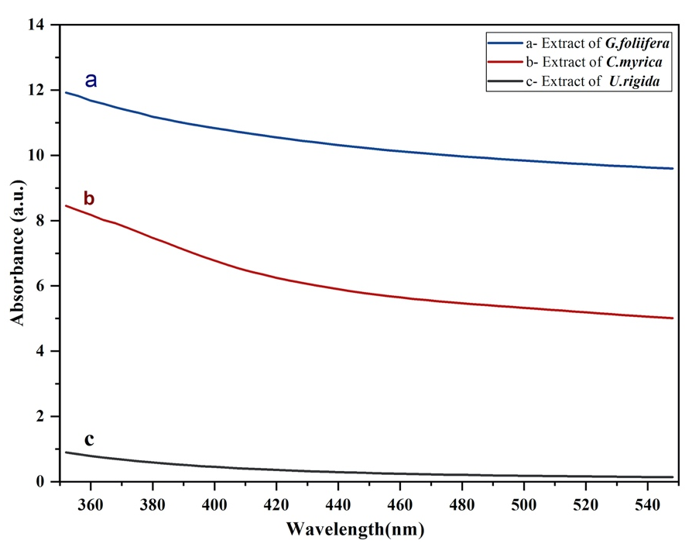

Figure. UV-vis spectra of the different marine algal extracts: (a) U. rigida, (b) C. myrica and (c) G. foliifera.

Supplementary (2)
- Video summarized and reveal cytotoxicity assay of algae-mediated AgNPs against Artemia salina nauplii :

https://streamable.com/lkadsd
