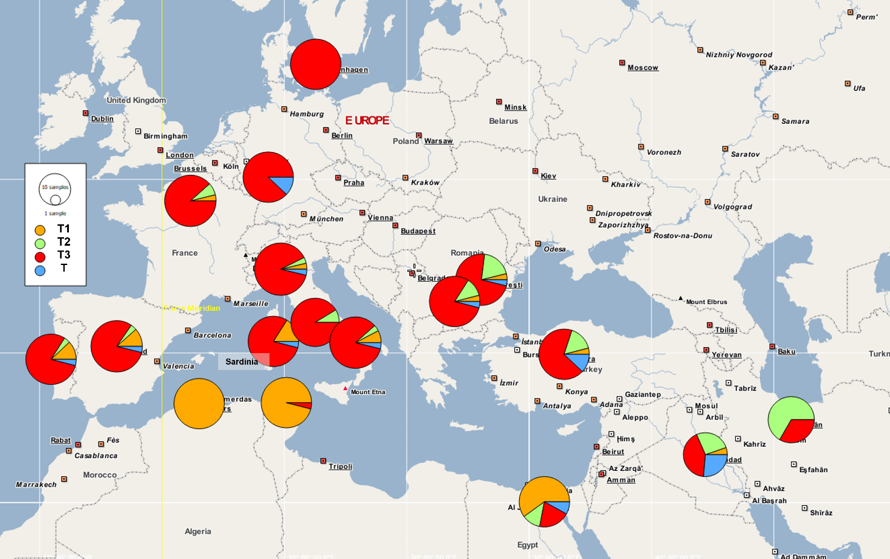
Supplementary Figure S1. Distribution of the major taurine haplogroups in Europe, North Africa and the Middle East. Haplogroup T included T, T1’2’3 and T5. Haplogroup frequencies were displayed with the POPART v.1.7 software [56] (http://popart.otago.ac.nz/index.shtml).

“Mitochondrial DNA diversity of the Sardinian local cattle stock”
Authors: Petretto, E., Dettori, M.L., Pazzola, M., Manca, F. Amills, M., Vacca, G.M.

