Supplementary information

Development of transgenic Daphnia magna for visualizing homology-directed repair of DNA

Rizky Mutiara Fatimah^{1,2}, Nikko Adhitama¹, Yasuhiko Kato¹, Hajime Watanabe¹*
¹ Department of Biotechnology, Graduate School of Engineering, Osaka University, Suita, Osaka, Japan
² Biotechnology Global Human Resource Development Program, Division of Advanced Science and Biotechnology, Department of Biotechnology, Graduate School of Engineering, Osaka University, Suita, Osaka, Japan.

*Corresponding author:
Email: watanabe@bio.eng.osaka-u.ac.jp

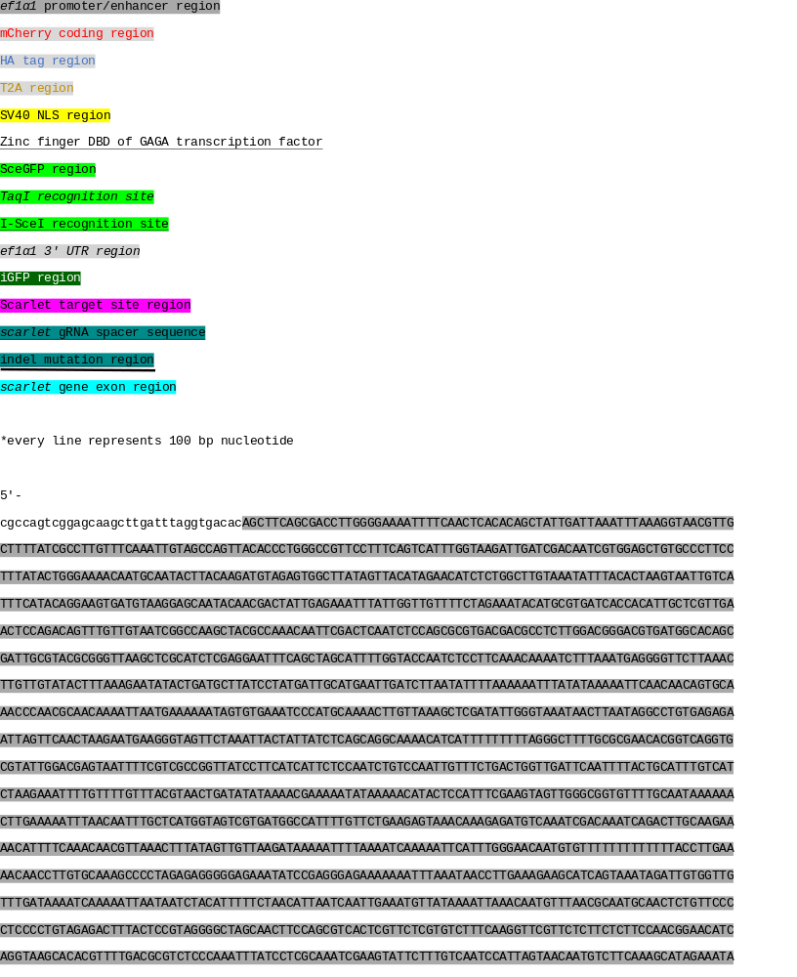
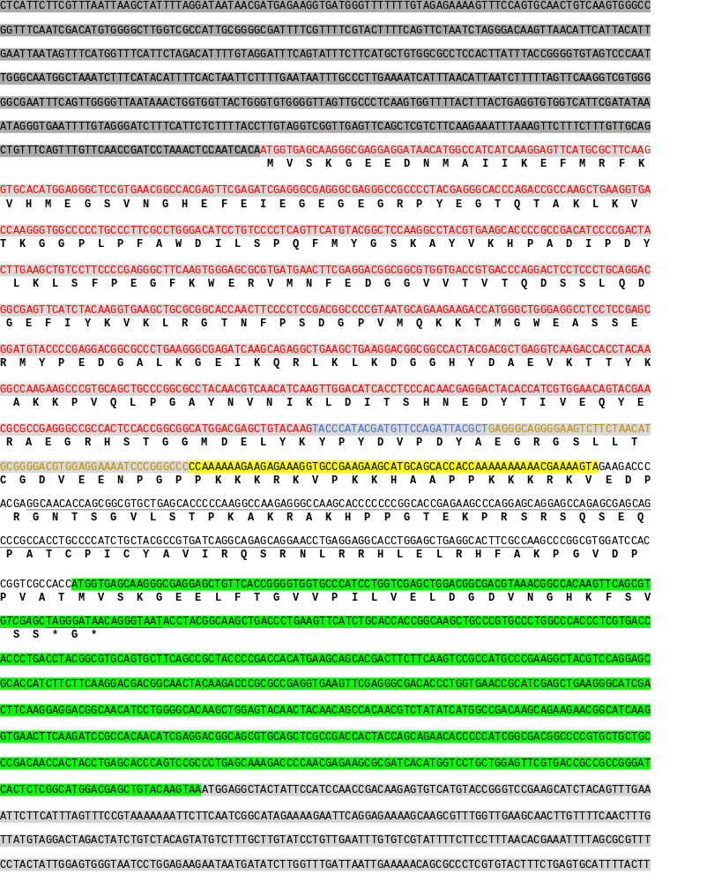

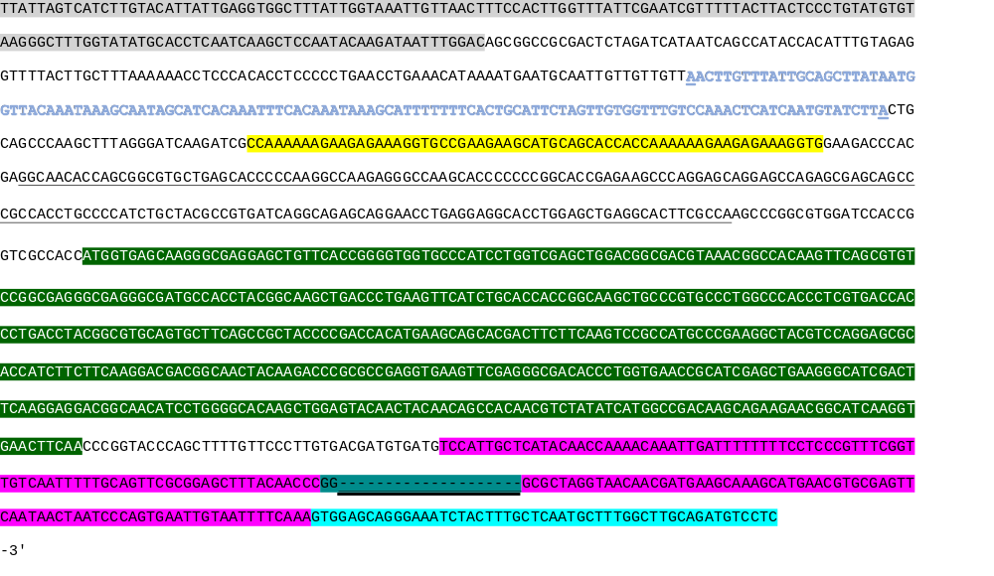
Supplementary Figure S1. The full sequence of integrated DR-GFP reporter in the genome.

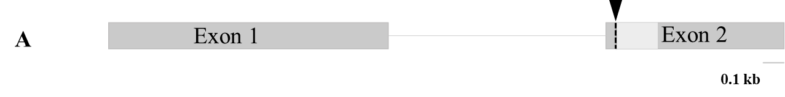

Supplementary Figure S2. Distal-less (Dll) gRNA location. Illustration of exon 1 and 2 of Dll gene in D. magna. gRNA target (dash line) is located upstream of the homeodomain region (light grey box) of Dll gene.

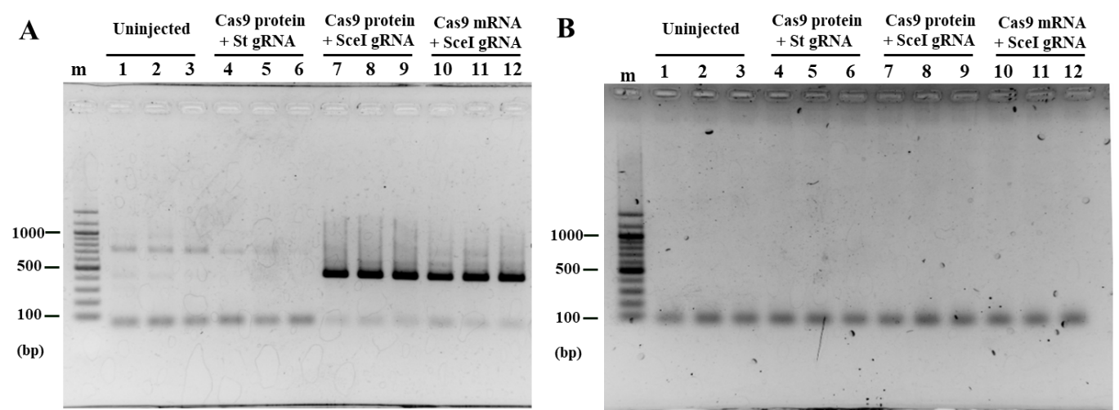
Figure S3. Gel electrophoresis of the qPCR result. (A) The first lane is the marker (m). Repaired SceGFP PCR product which was expected to be 449 bp was only observed in the Cas9 protein (lane 8-10) and mRNA (lane 10-12) co-injection with SceI gRNA. (B) The DNA marker was put in the first lane. All of the samples (lane 2-13) showed a band that was expected to be 67 bp that indicated the PCR product of L32 as an endogenous gene for control of cDNA template.

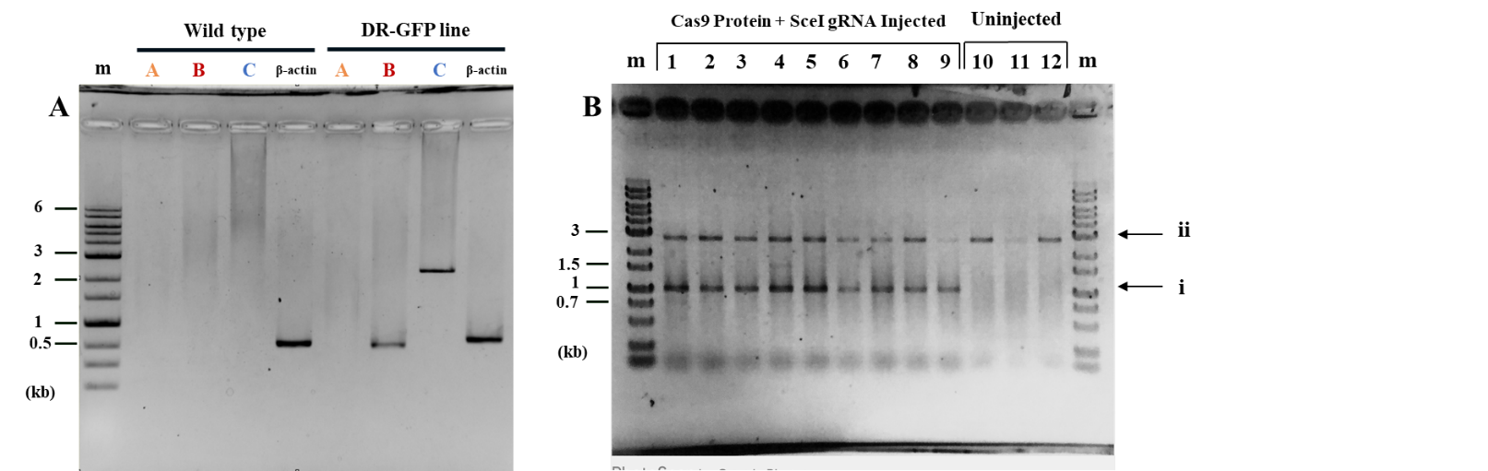
Figure S4. The full length of gels in Figure 3 and Figure 5 (A) PCR result for DR-GFP genotyping was visualized by gel electrophoresis. The first lane is the marker (m), followed by fragments A, B, C, and β-actin (beta-actin) for both wild type and DR-GFP line Daphnia. In the sample using DR-GFP line Daphnia, all fragments except the 5′ junctions, Fragment A, were amplified (lane 6-9). In the wildtype sample only the β-actin band was amplified (line 5). (B) PCR result for genotyping after DSB introduction was shown in the gel electrophoresis. The most left lane indicated the DNA marker (m) followed by amplified genome fragments (lanes 1-9) from Cas9 Protein and SceI gRNA injected embryos. Uninjected DR-GFP (lane 10-12) was used as the negative control. The primer set amplified the repaired SceGFP region with the length 1,048 bp (i). The reverse primer was also attached to the iGFP region, which resulted in a 2,843 bp length PCR product (ii)

Supplementary Table S1. Summary of Dll gRNA and Cas9 protein injection
(co-injected with St gRNA*)
Injected (16h) |  | 38
Hatch |  | 50% (19/38)
Developed (48h) |  | 68.4% (13/19)
White-eye |  | 84.6% (11/13)
Truncated antennae | Strong | 61.5% (8/13)
Truncated antennae | Medium | 15.4% (3/13)
Truncated antennae | Mild | 23.1% (2/13)
*To confirm the functionality of the Cas9 protein, the Dll gRNA was also co-injected together with St gRNA.

