Integrative analyses of genomic and metabolomic data reveal genetic mechanisms associated with carcass merit traits in beef cattle
Jiyuan Li¹, Yining Wang^{1,2}, Robert Mukiibi³, Brian Karisa⁴, Graham S. Plastow¹*, Changxi Li^{1,2}*
¹Department of Agriculture, Food & Nutritional Science, University of Alberta, Edmonton, Alberta, Canada, T6G 2P5, ²Lacombe Research and Development Centre, Agriculture and Agri-food Canada, Lacombe, Alberta, Canada, T4L 1W1, ³The Roslin Institute and Royal (Dick) School of Veterinary Studies, University of Edinburgh, Edinburgh, Scotland, UK, EH25 9RG, ⁴Ministry of Agriculture and Forestry, Edmonton, Alberta, Canada, T6N 1E4

Correspondence and requests for materials should be addressed to Changxi Li (changxi.li@agr.gc.ca ) or Graham Plastow (plastow@ualberta.ca)

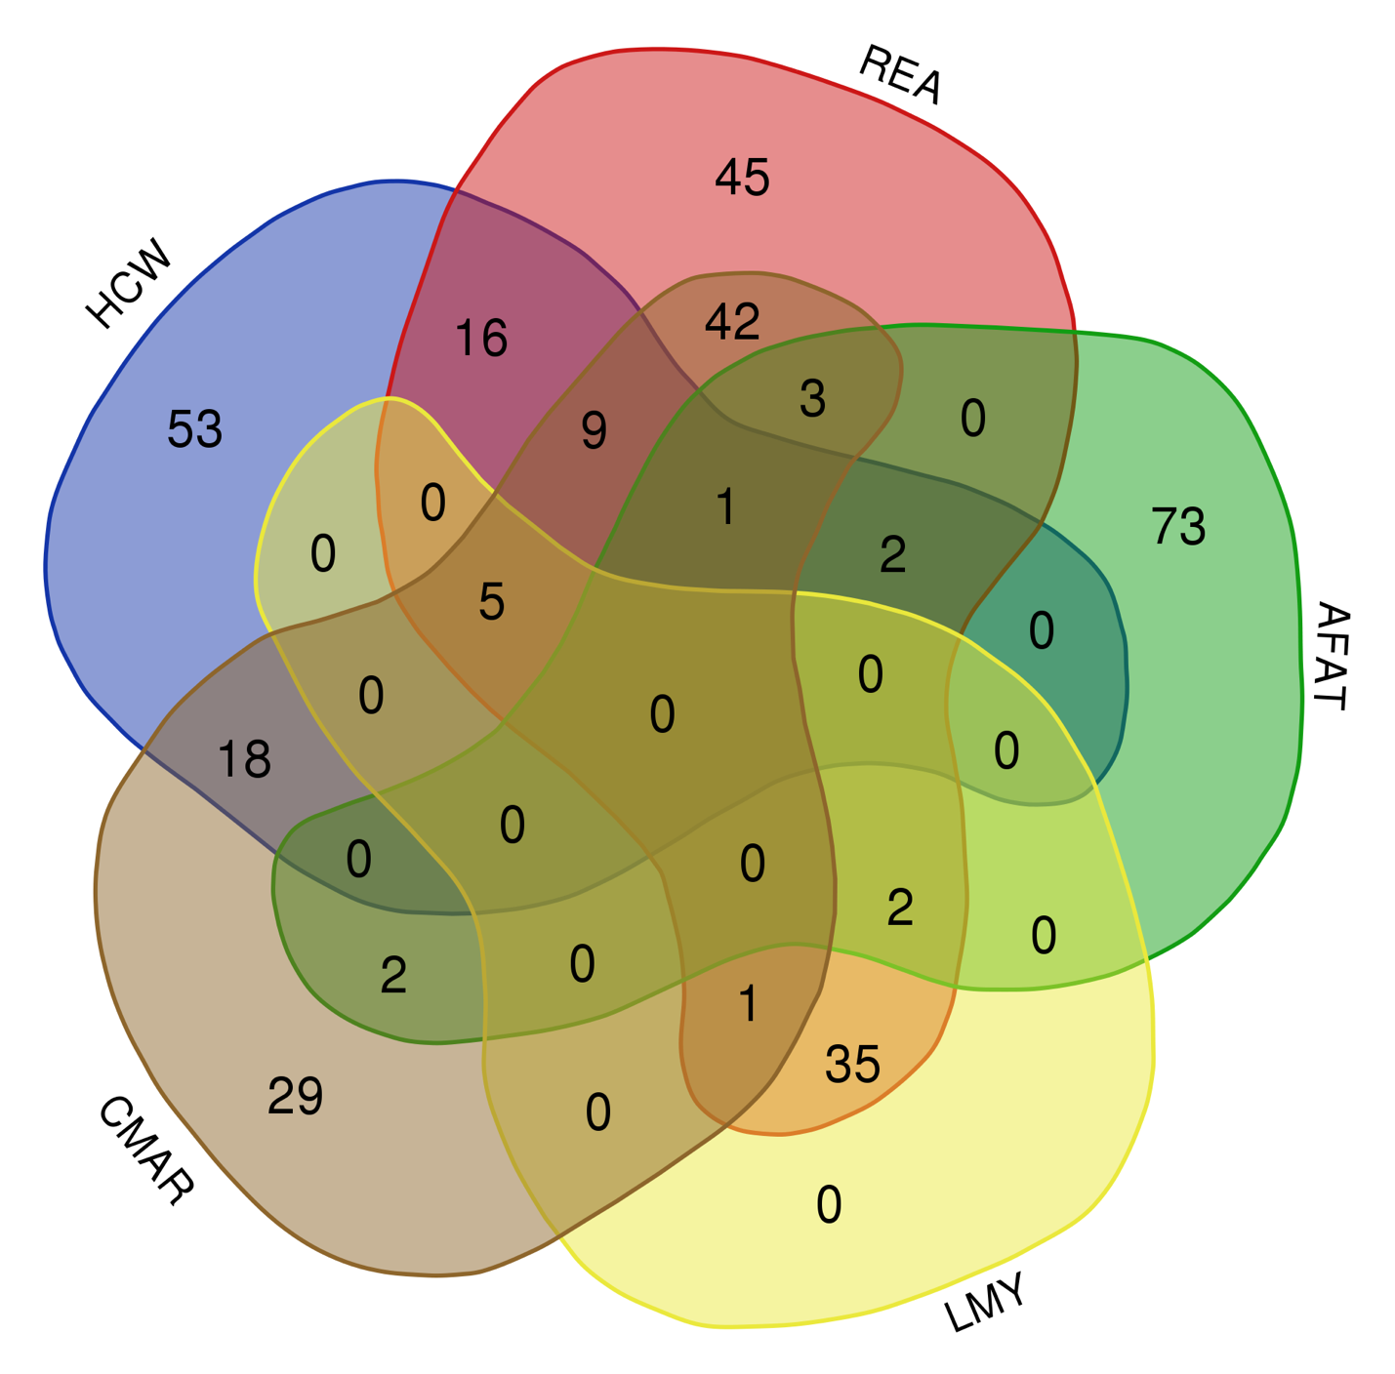

Figure S1 Uniquely common candidate genes for carcass merit traits in a beef cattle multibreed population

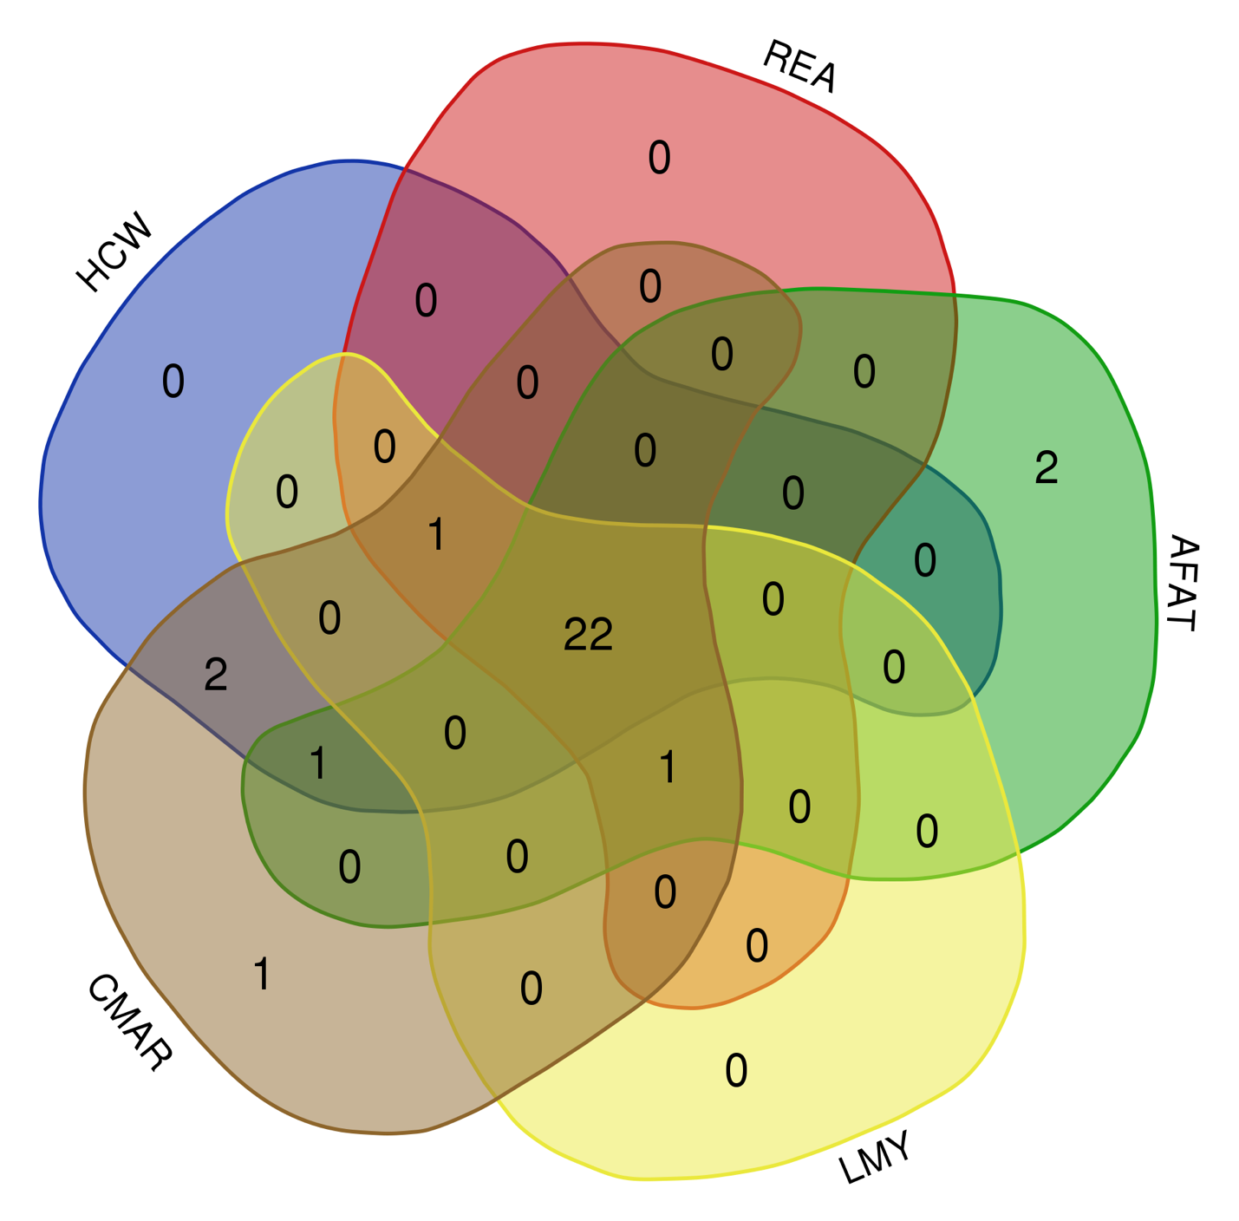
Figure S2 Uniquely common biological functions for carcass merit traits in a beef cattle multibreed population

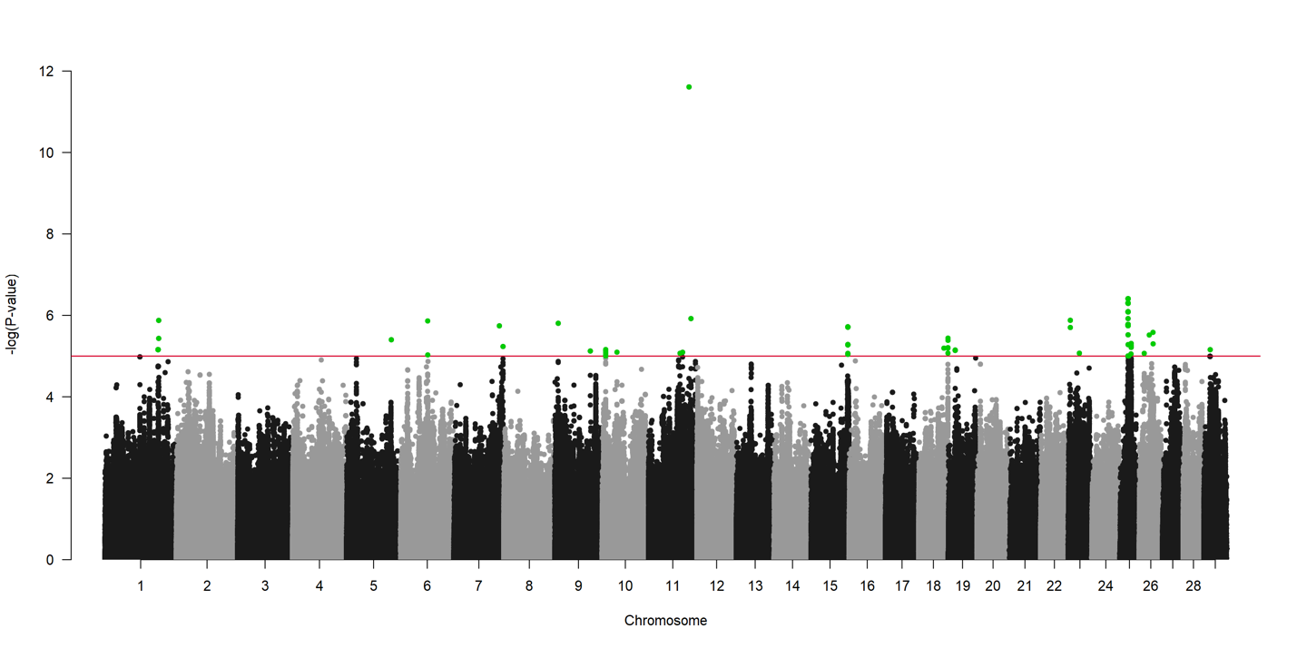
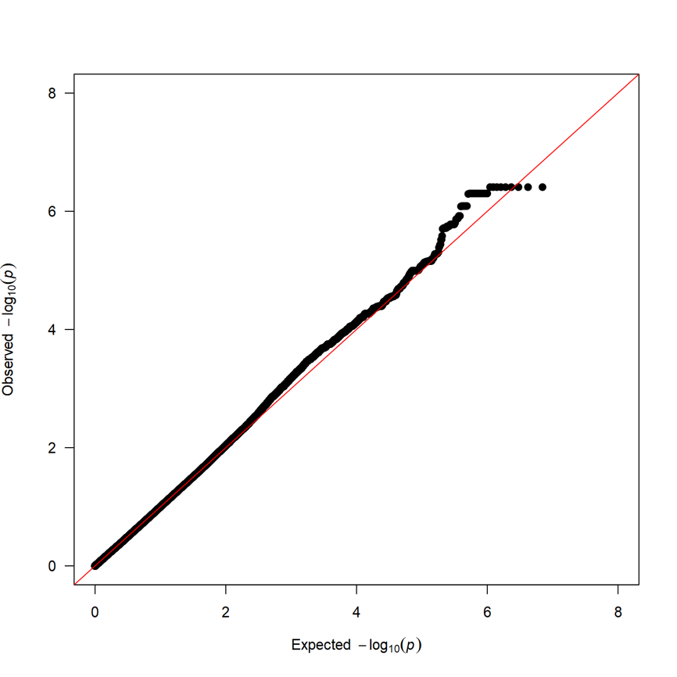
Figure S3 Manhattan plot and QQ plot for acetic acid

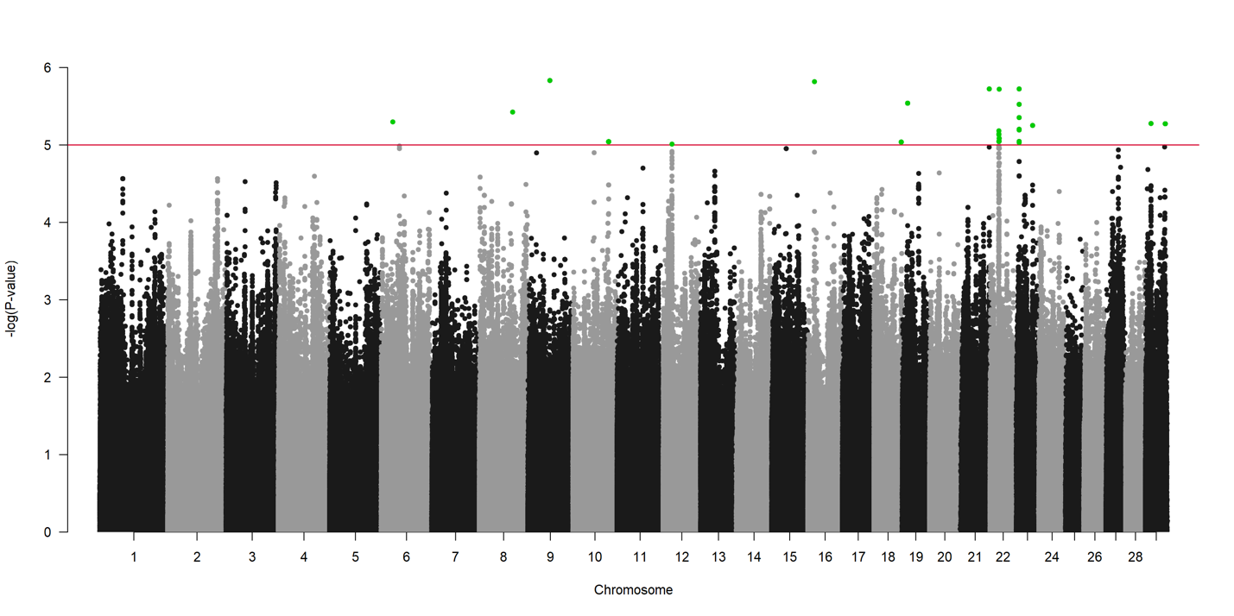
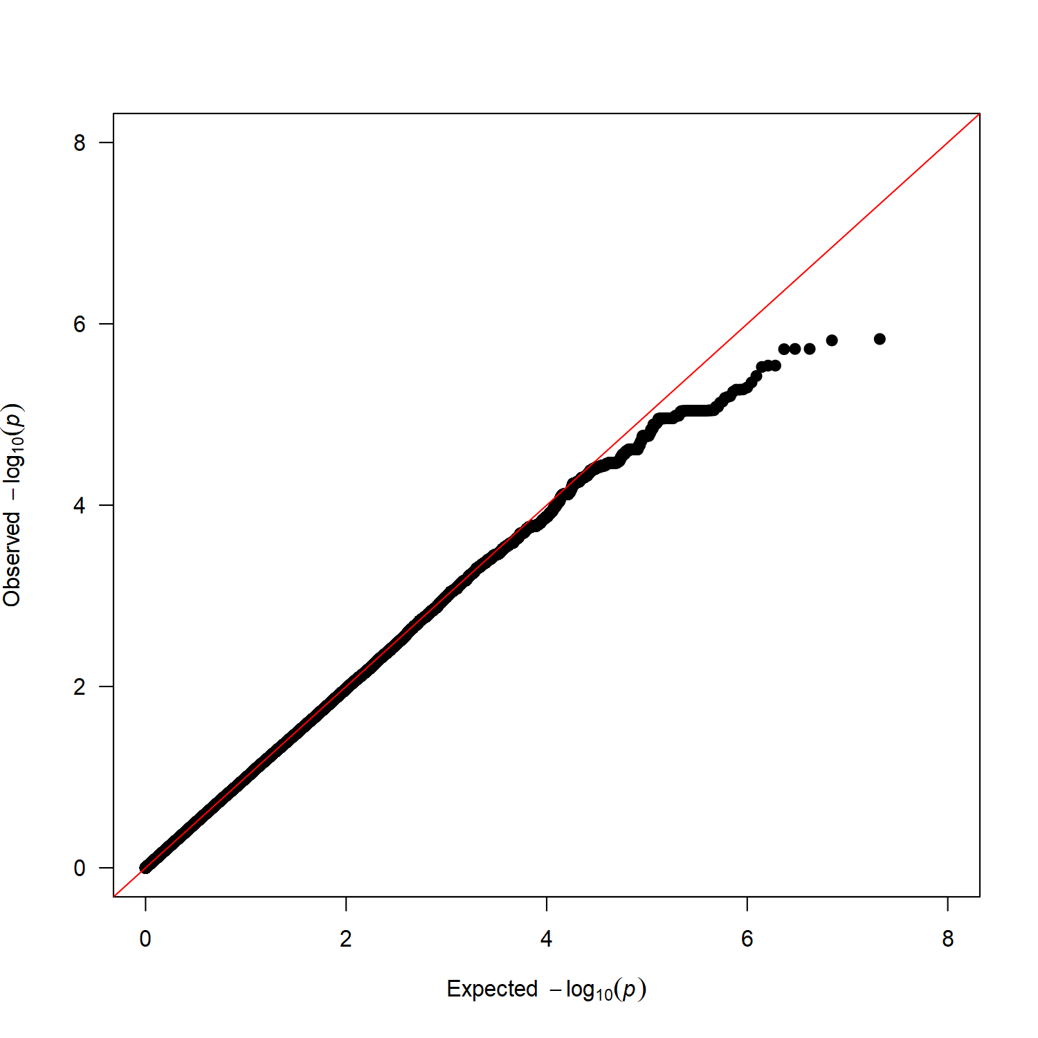
Figure S4 Manhattan plot and QQ plot for citric acid

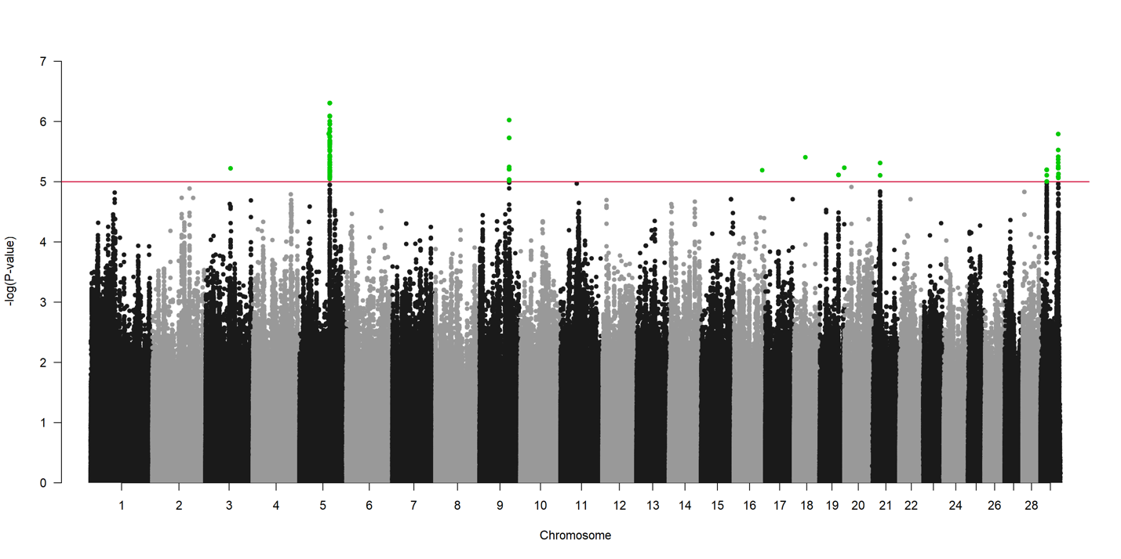
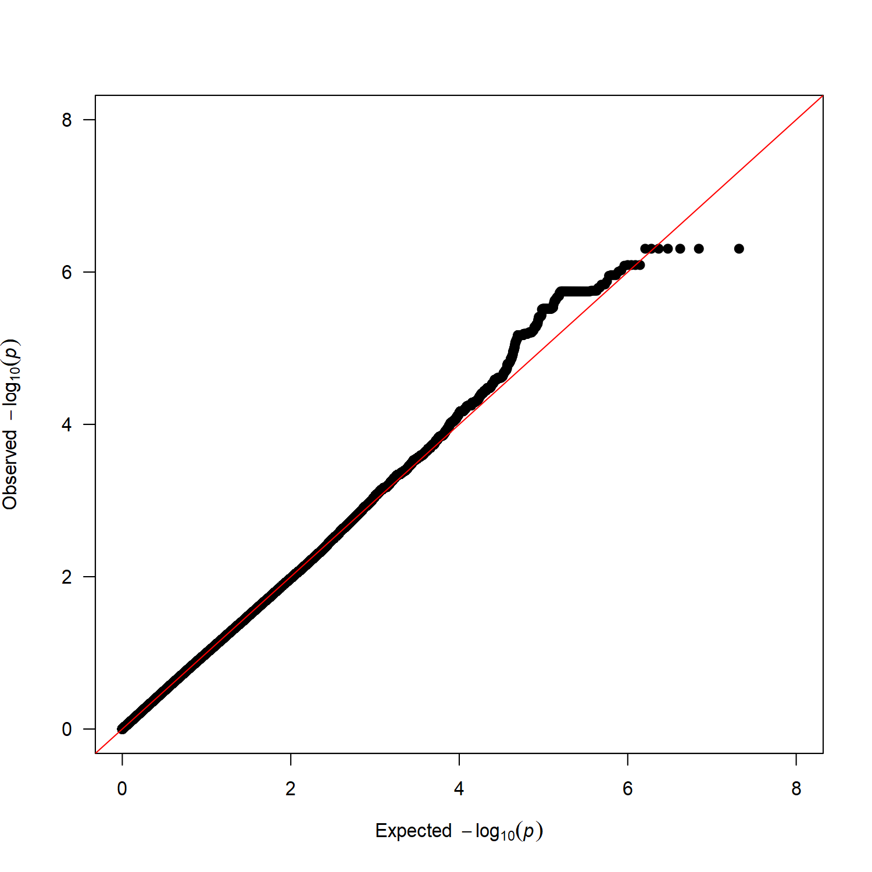
Figure S5 Manhattan plot and QQ plot for choline
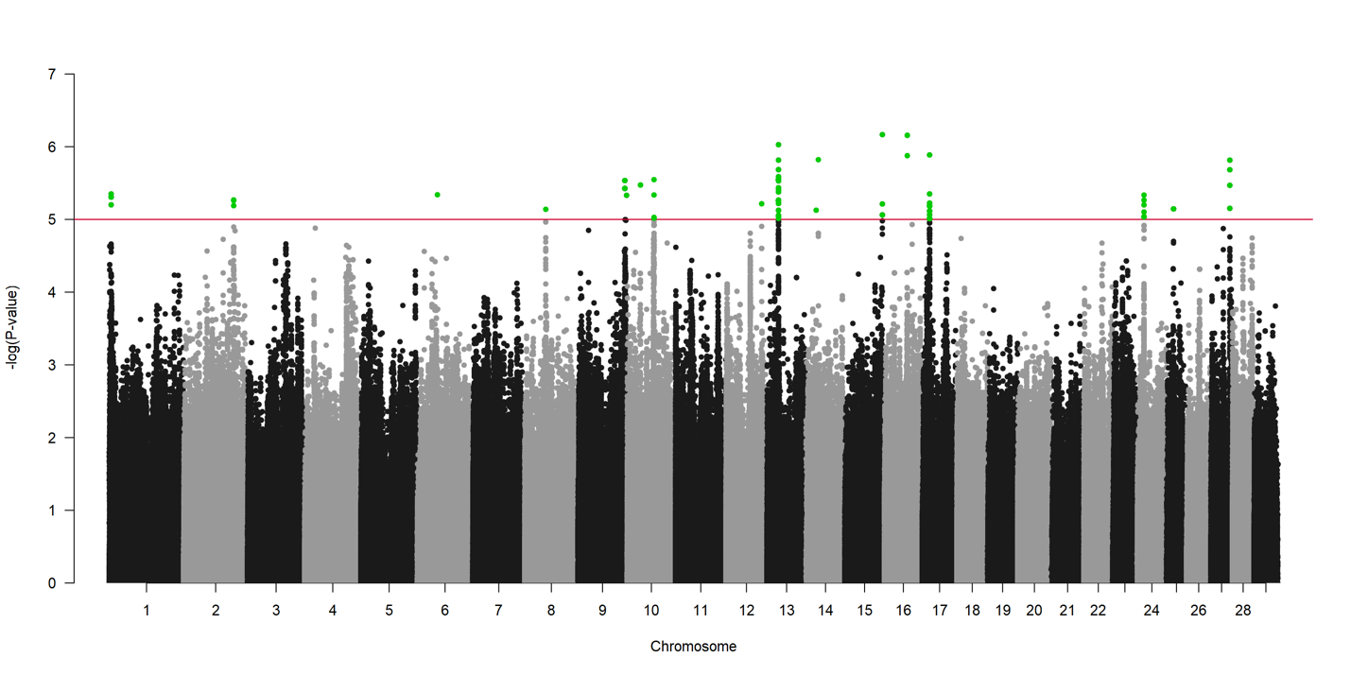
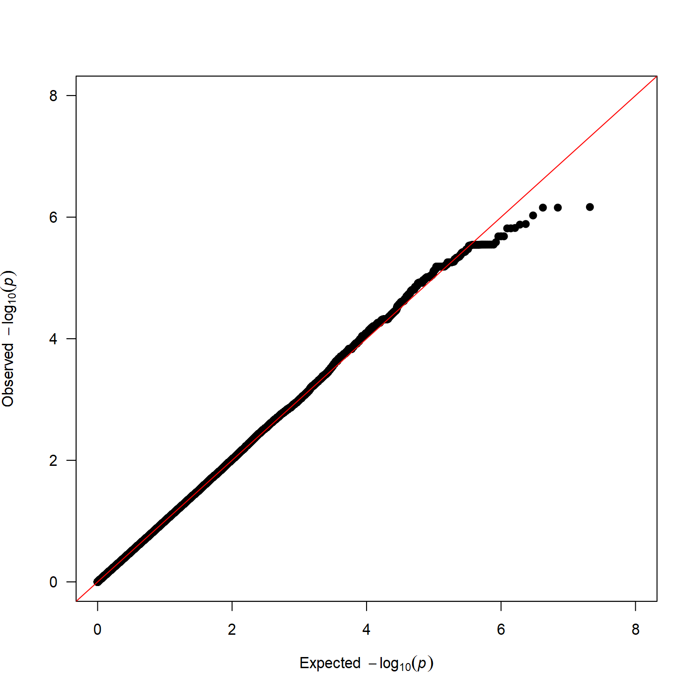

Figure S6 Manhattan plot and QQ plot for D-glucose
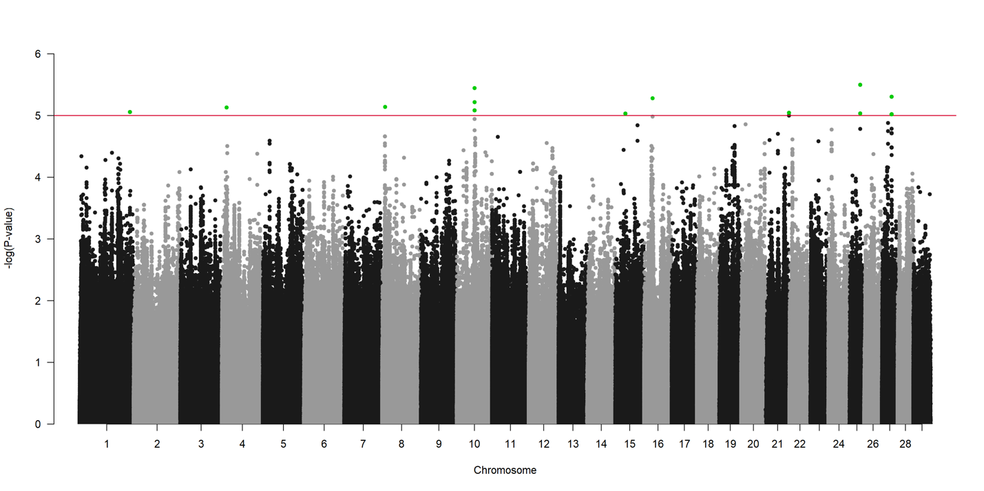

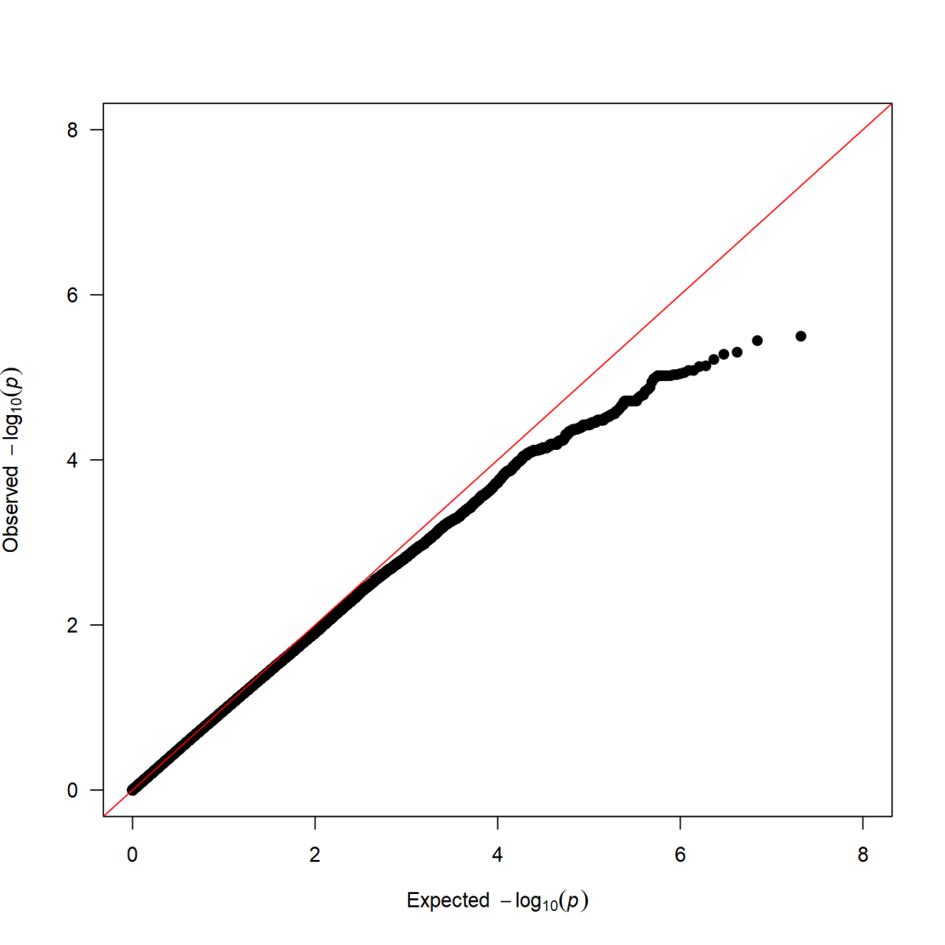
Figure S7 Manhattan plot and QQ plot for glycine

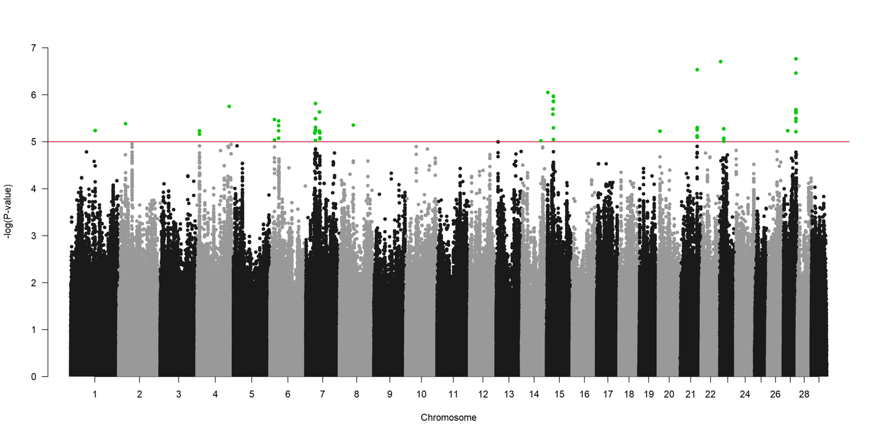
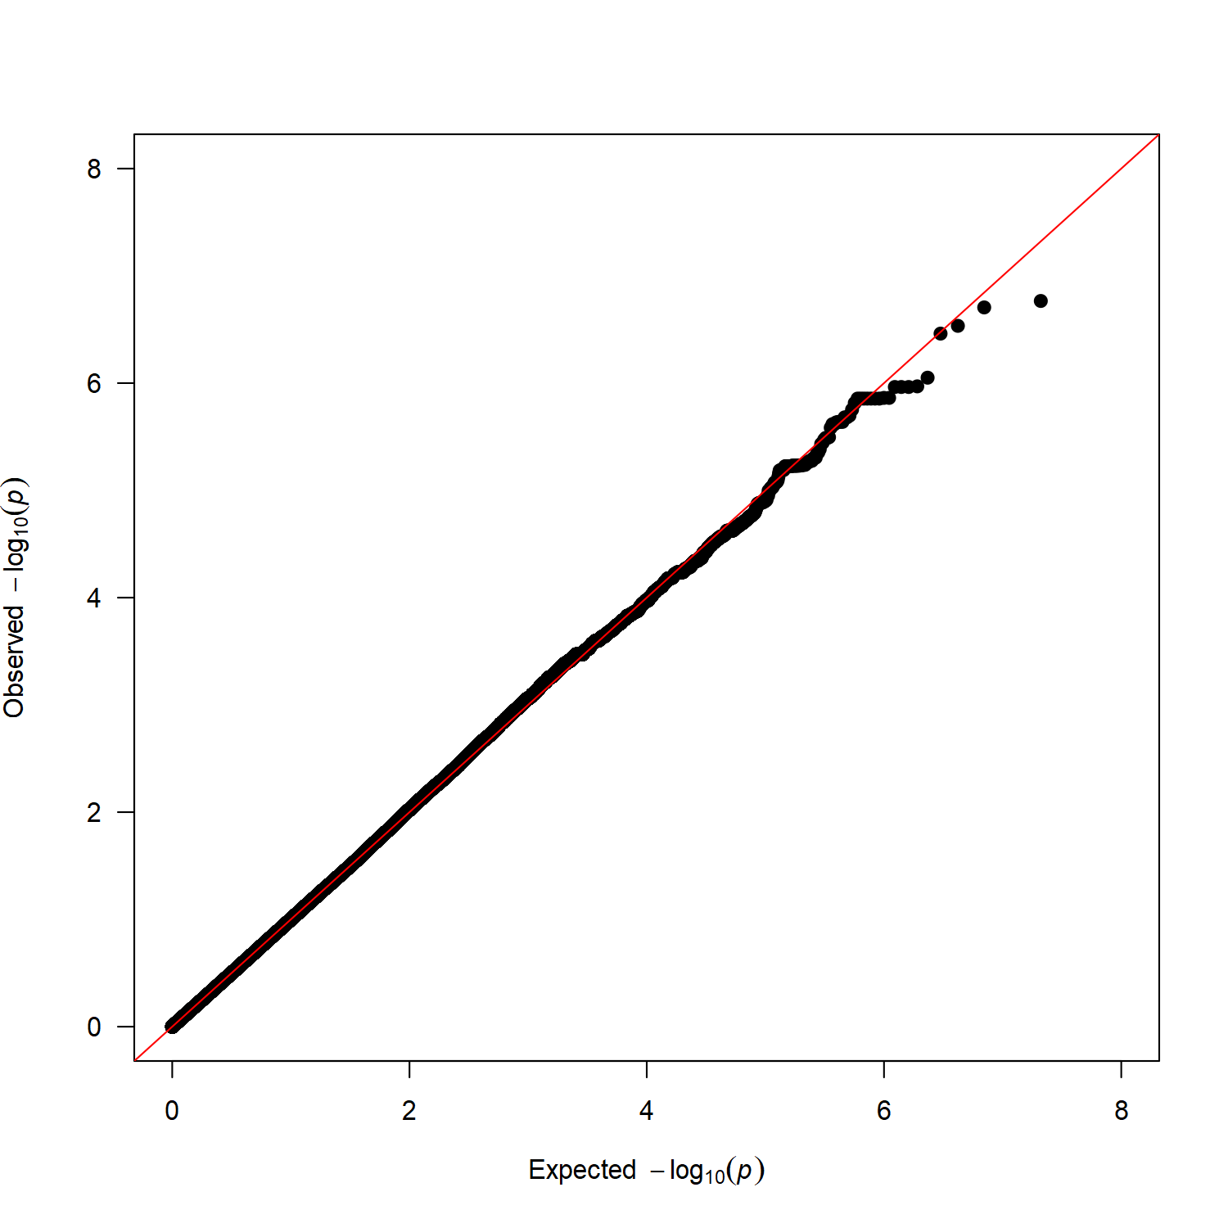
Figure S8 Manhattan plot and QQ plot for glycerol

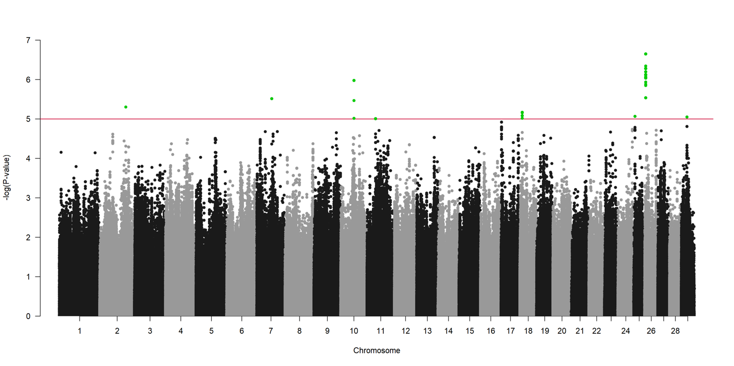

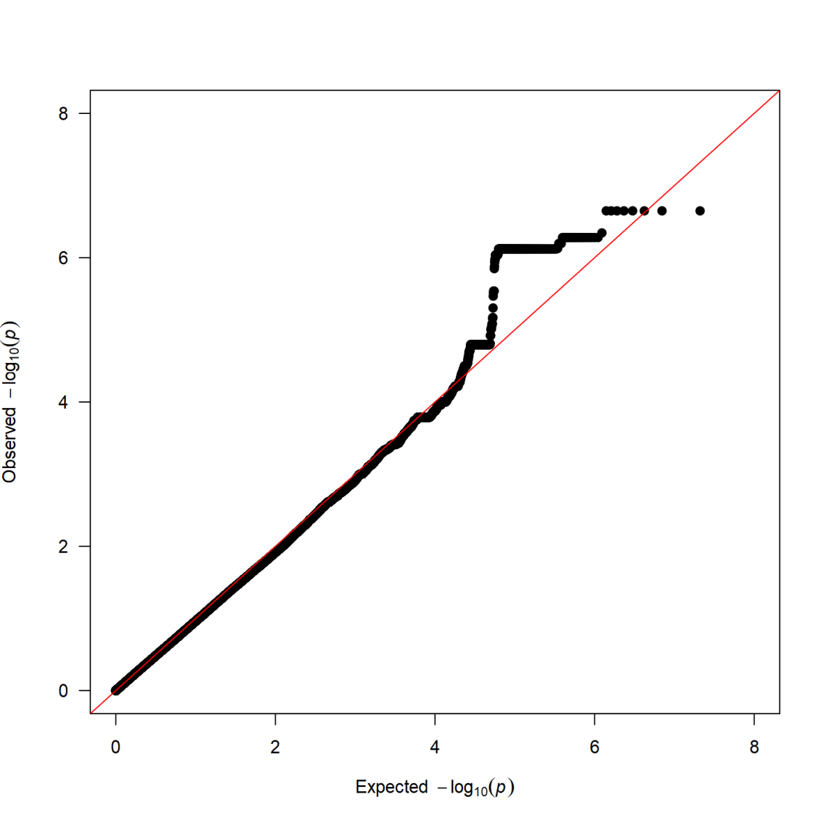
Figure S9 Manhattan plot and QQ plot for fumaric acid

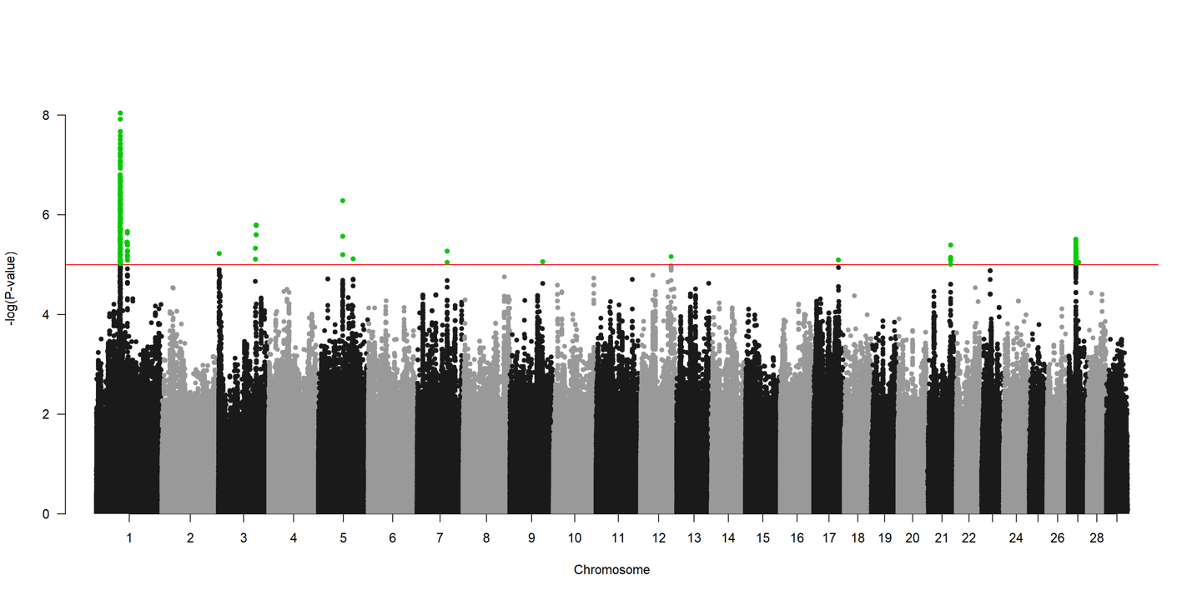
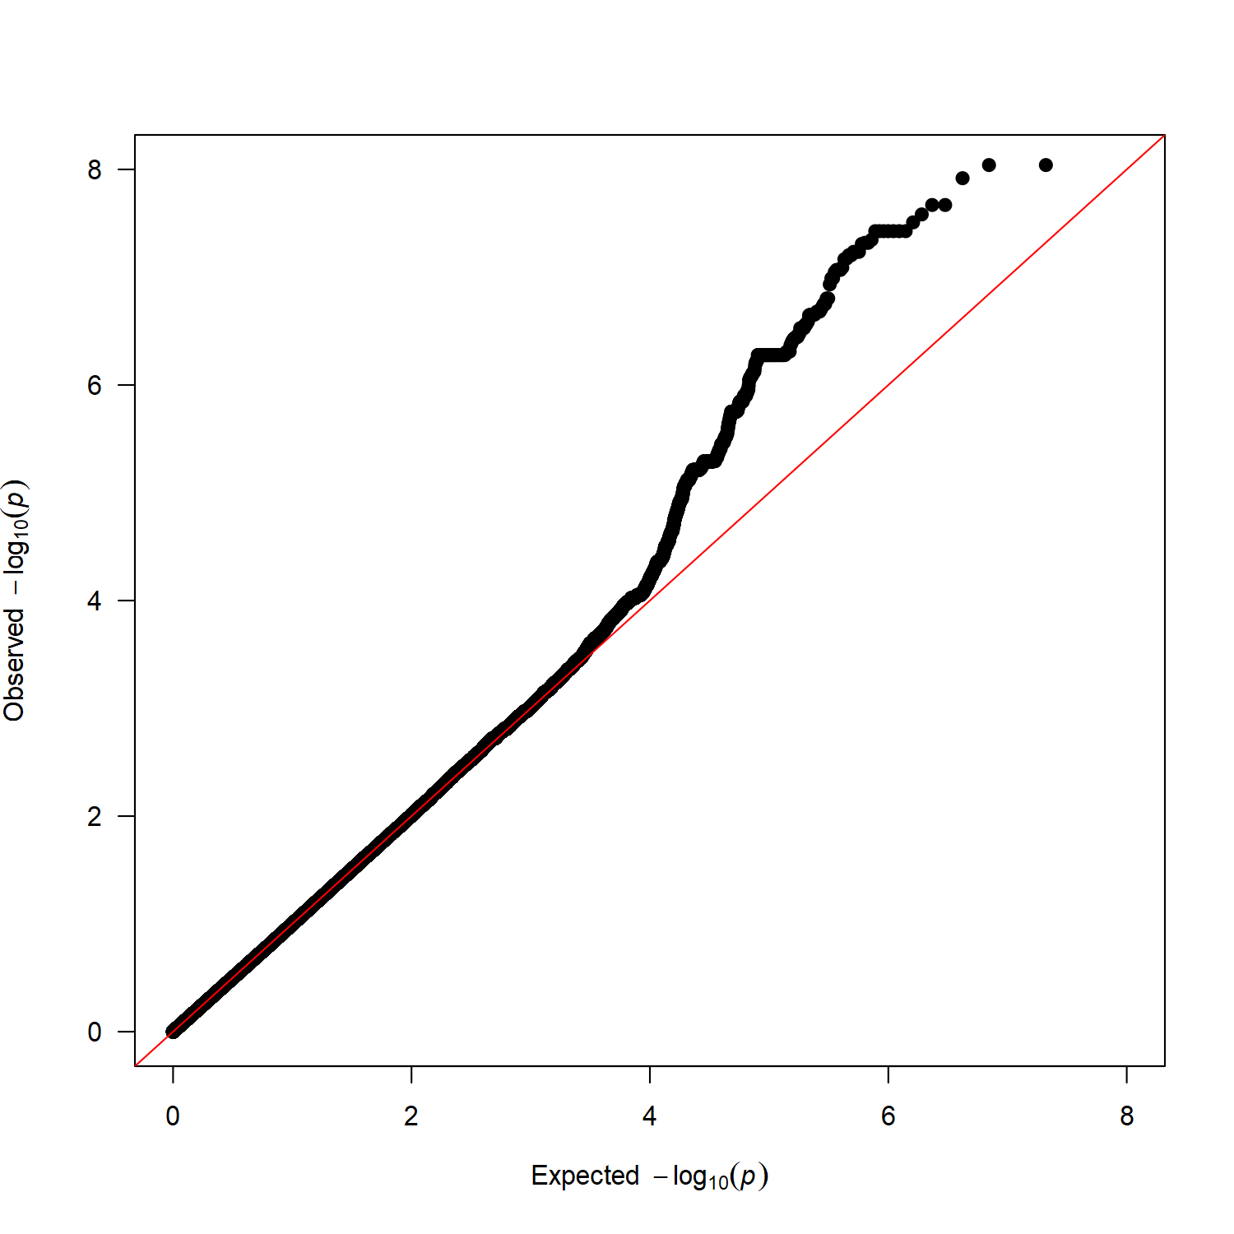
Figure S10 Manhattan plot and QQ plot for lysine

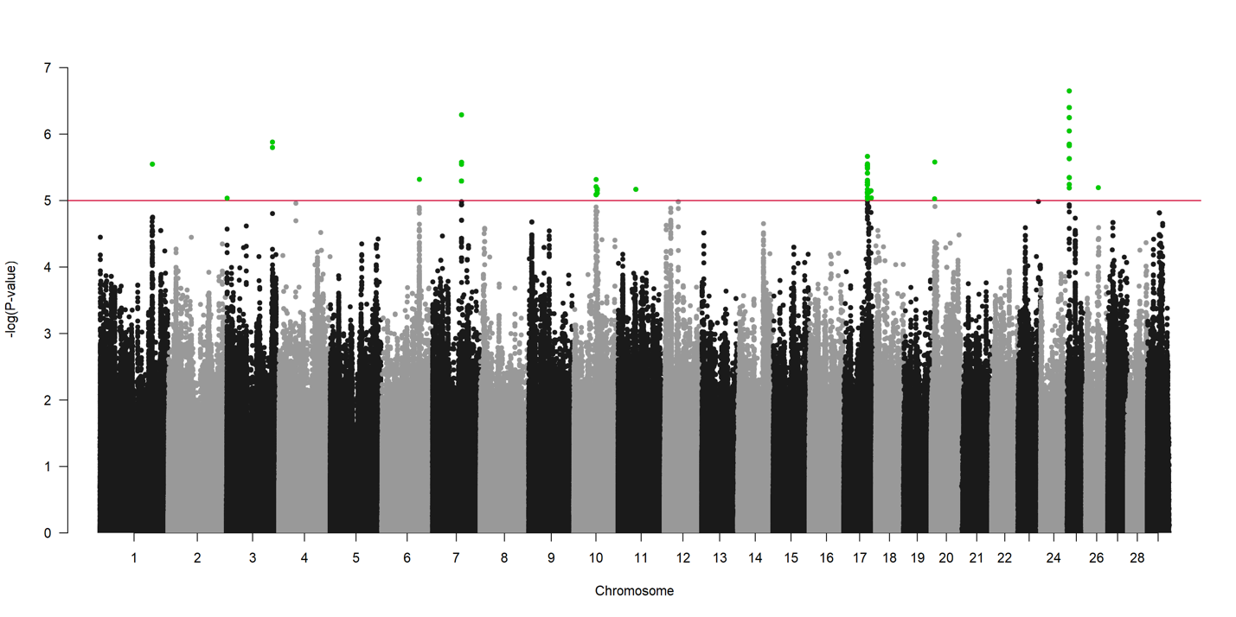
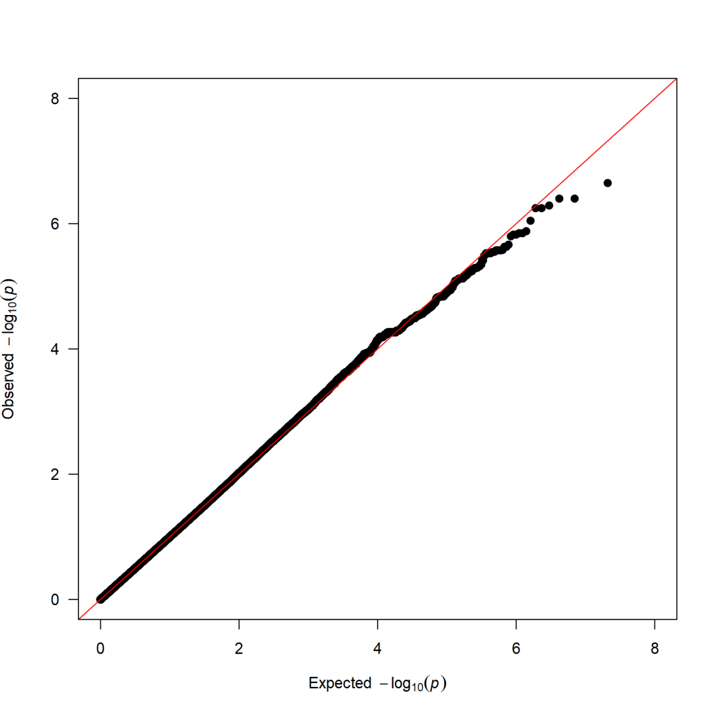
Figure S11 Manhattan plot and QQ plot for L-lactic acid

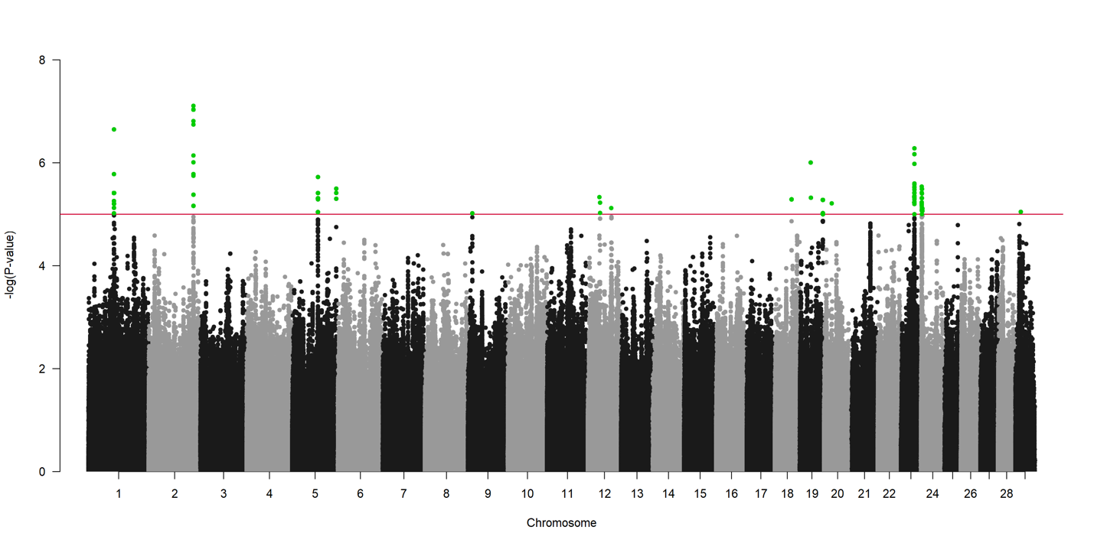
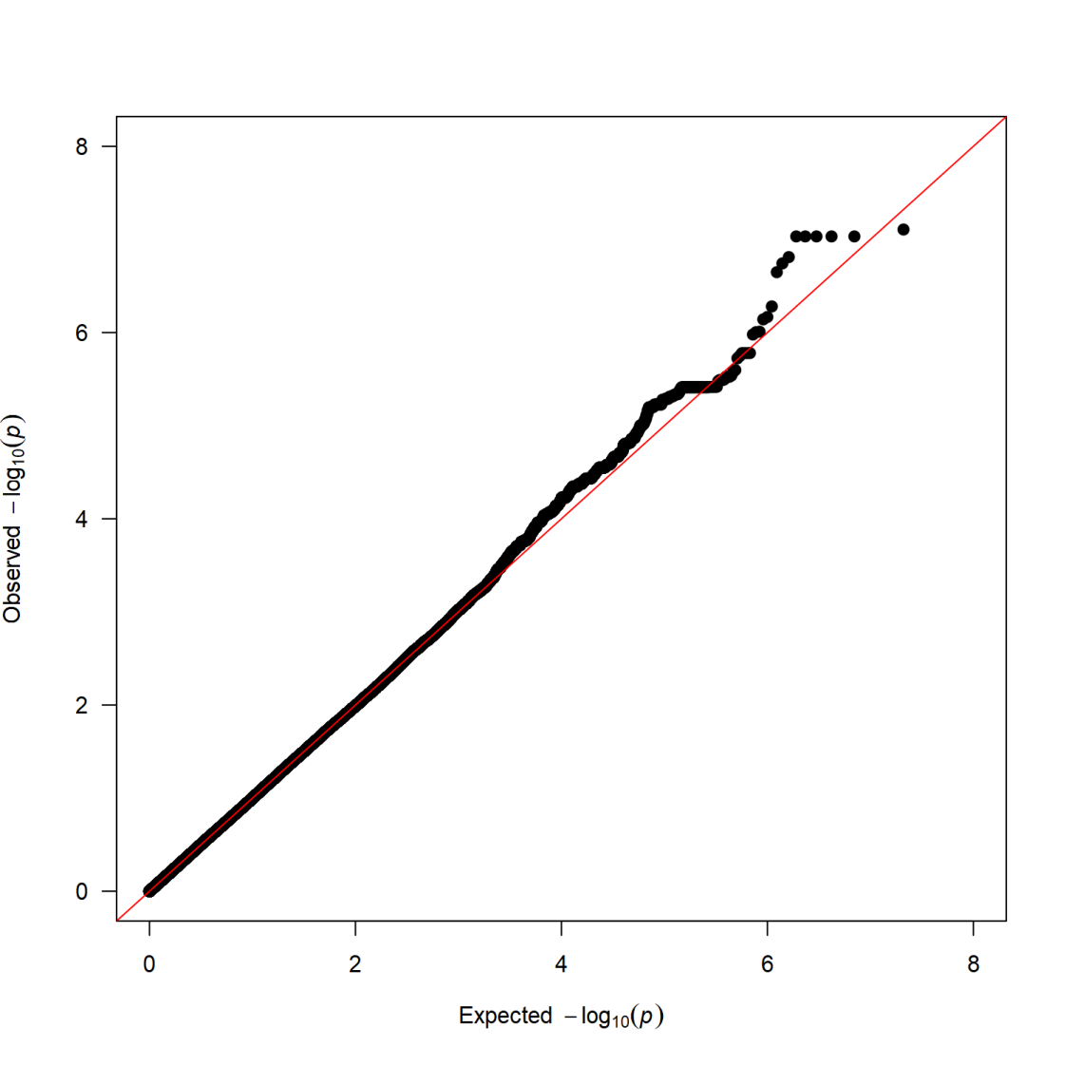
Figure S12 Manhattan plot and QQ plot for pyruvic acid

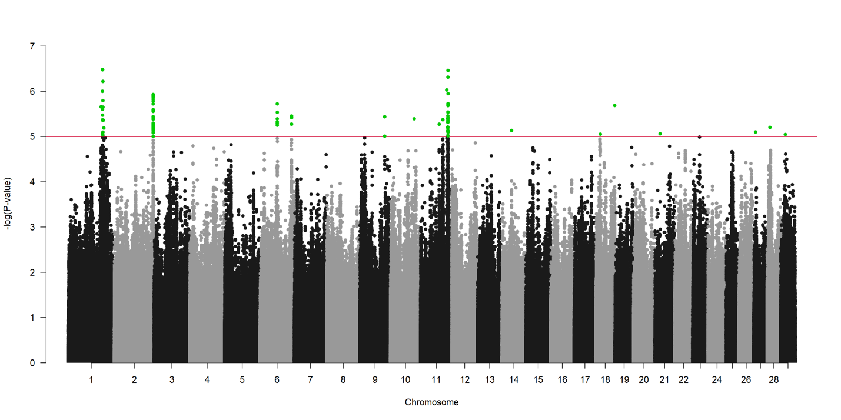
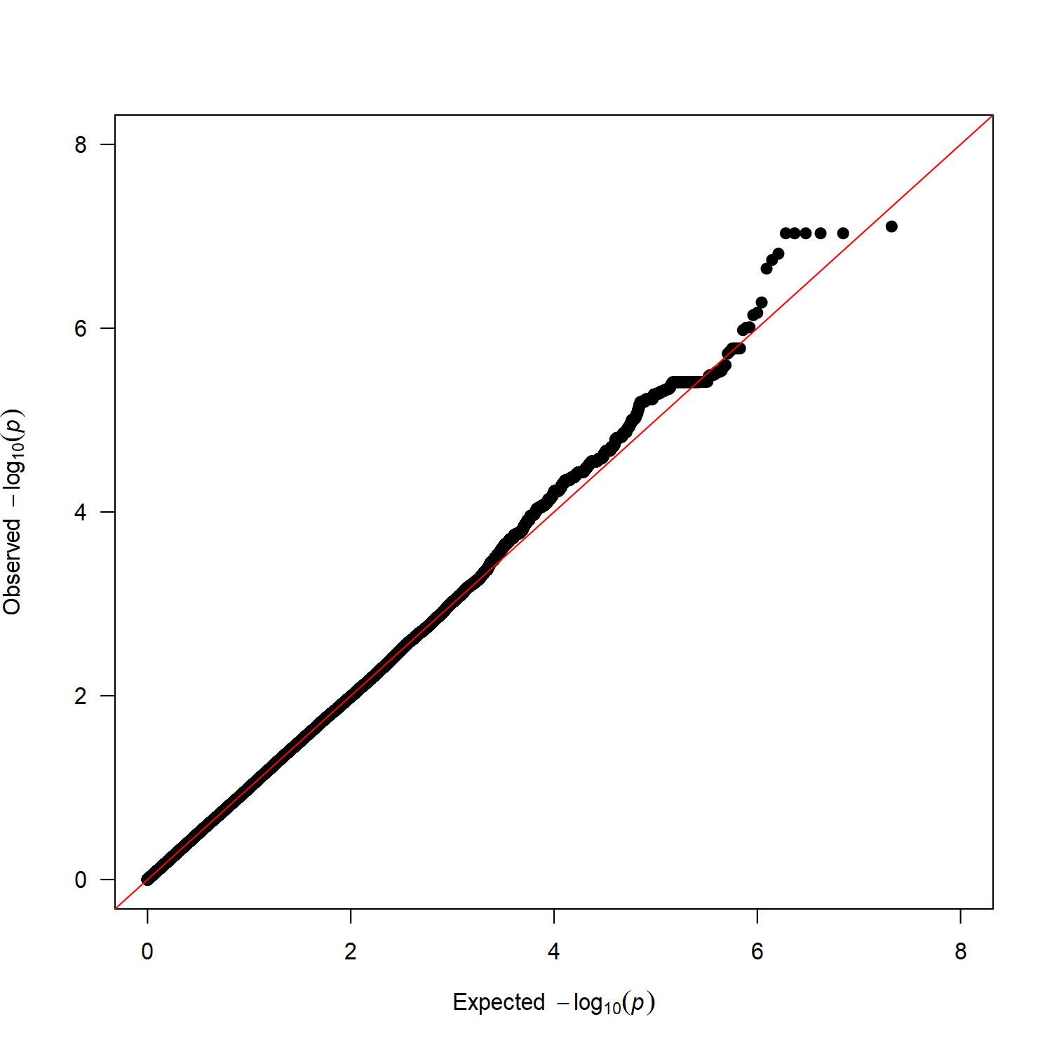
Figure S13 Manhattan plot and QQ plot for succinic acid

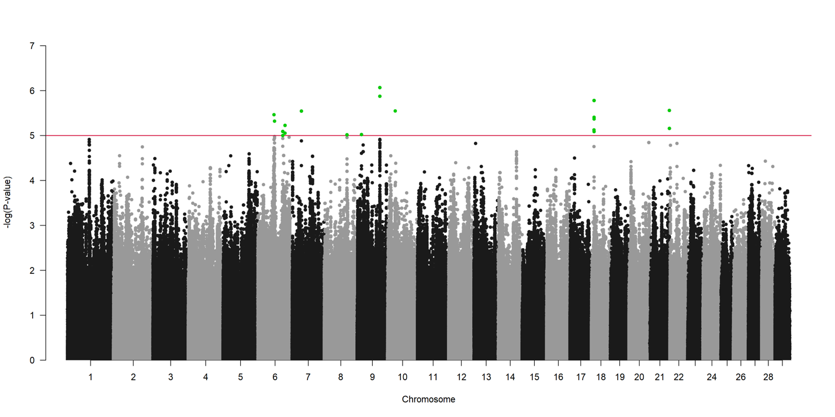
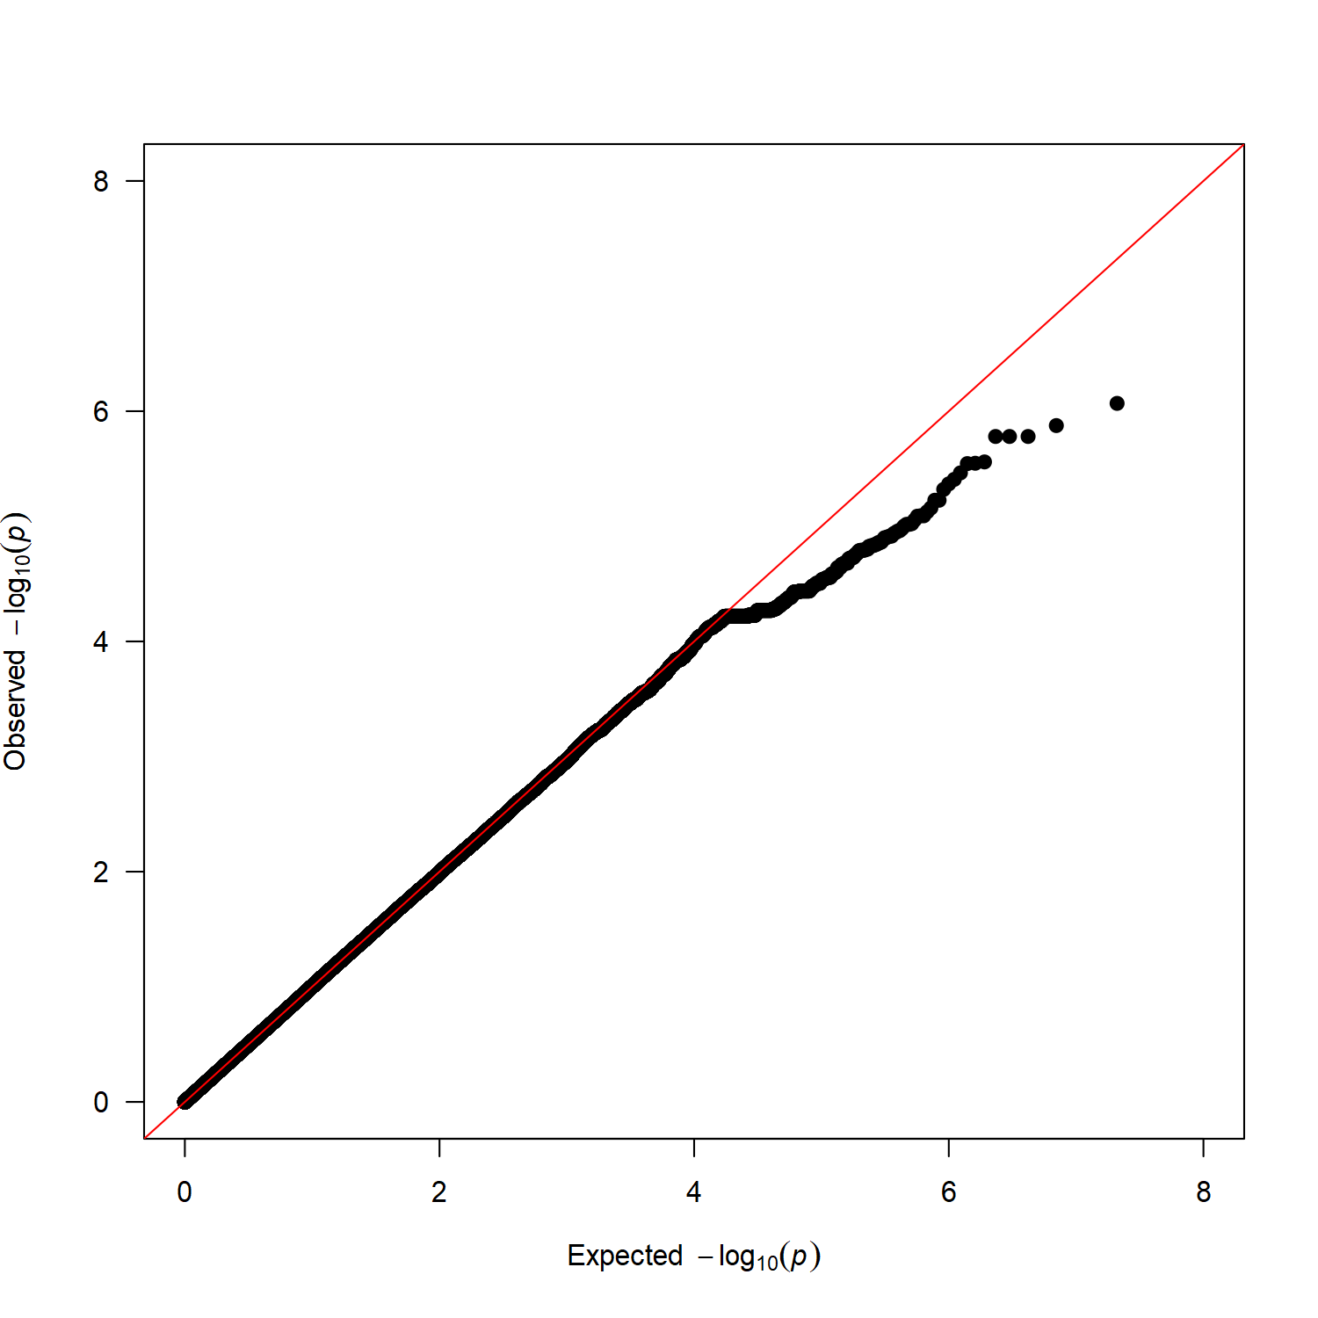
Figure S14 Manhattan plot and QQ plot for 3-hydroxybutyric acid

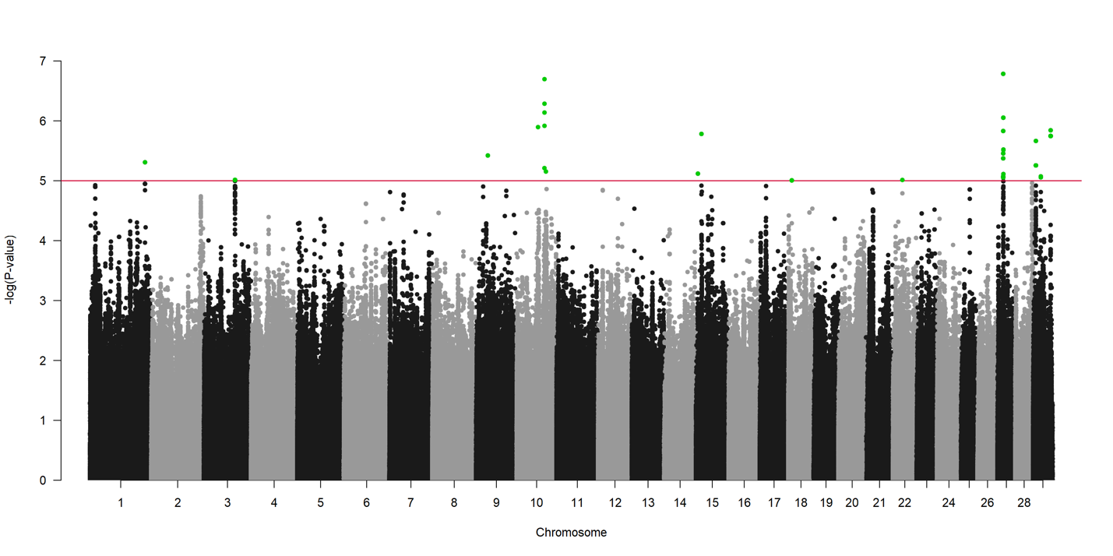
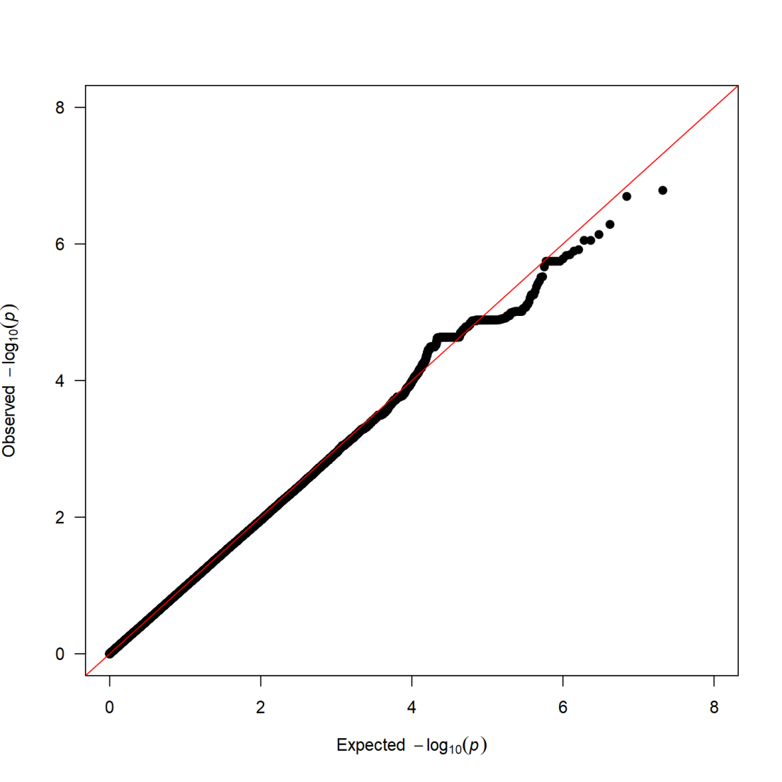
Figure S15 Manhattan plot and QQ plot for creatinine

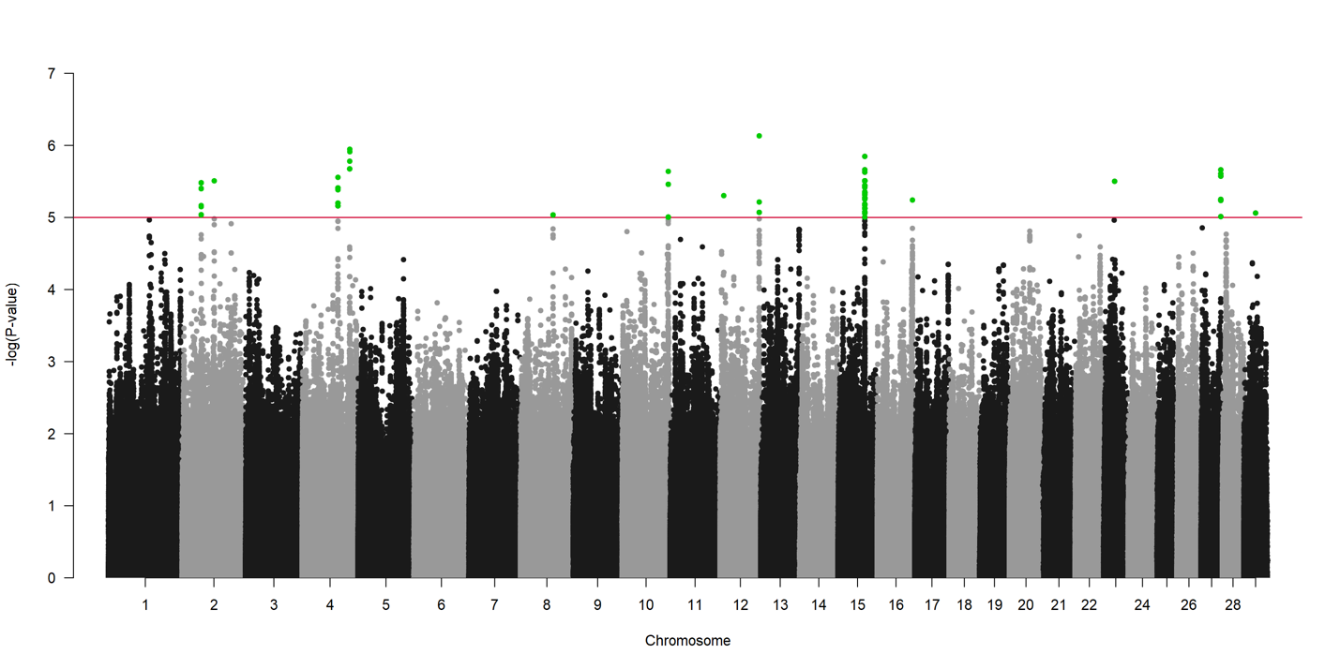

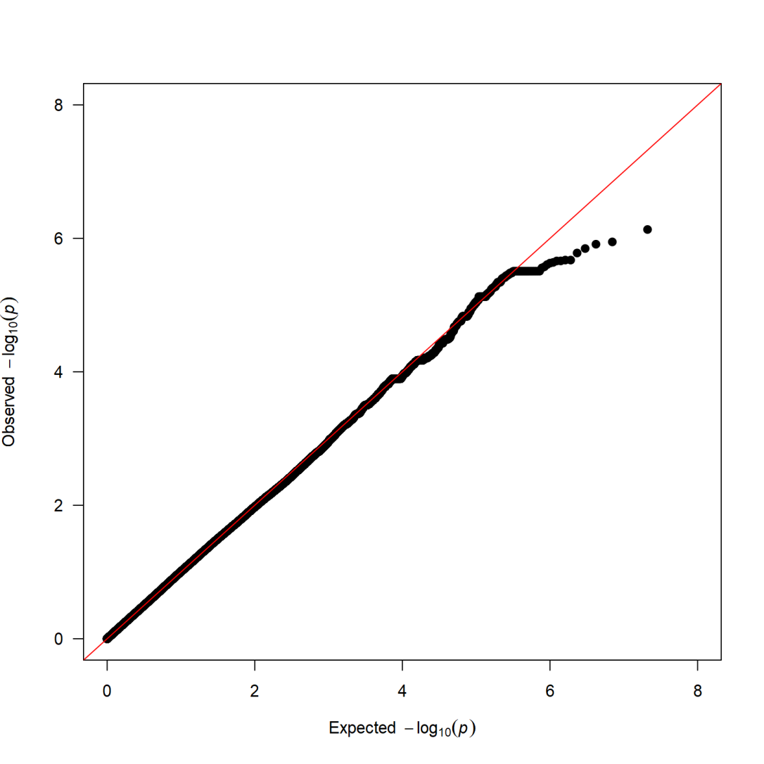
Figure S16 Manhattan plot and QQ plot for L-glutamine

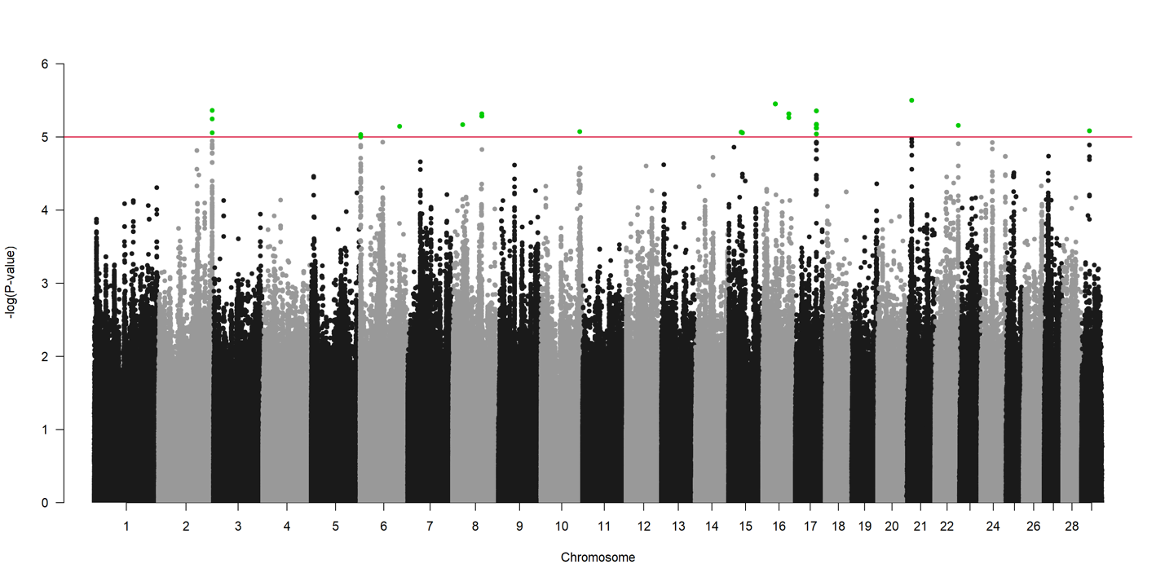

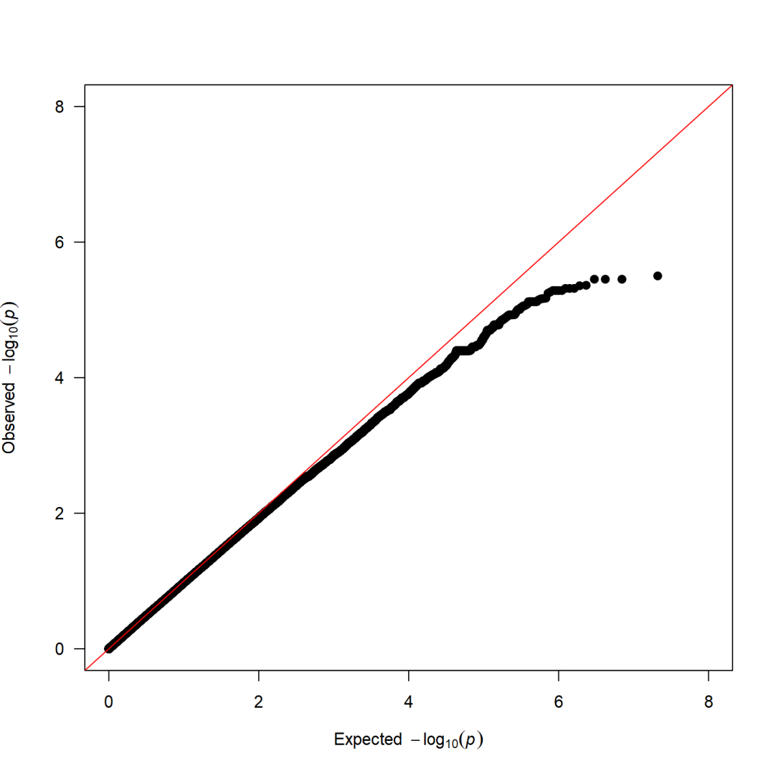
Figure S17 Manhattan plot and QQ plot for methnoal

