Supplementary Information

Oxidative coupling of methane—Comparisons of MnTiO₃-Na₂WO₄ and MnO_{x}-TiO₂-Na₂WO₄ catalysts on different silica supports
Worapinit Tiyatha^{1,2}, Thanaphat Chukeaw^{1,2}, Sarannuch Sringam^{1,2}, Thongthai Witoon^{1,2,3}, Metta Chareonpanich^{1,2,3}, Günther Rupprechter⁴, Anusorn Seubsai^{1,2,3}*
¹ Department of Chemical Engineering, Faculty of Engineering, Kasetsart University, Bangkok 10900, Thailand
² Center of Excellence on Petrochemical and Materials Technology, Kasetsart University, Bangkok 10900, Thailand
³ Research Network of NANOTEC–KU on NanoCatalysts and NanoMaterials for Sustainable Energy and Environment, Kasetsart University, Bangkok 10900, Thailand
⁴ Institute of Materials Chemistry, TU Wien, 1060 Vienna, Austria
*Corresponding author: fengasn@ku.ac.th

Supplementary Figure S1 Activity in OCM reaction: a) MnTiO₃-NW/CS, b) MnTiO₃-NW/SG, and c) Mn-Ti-NW/SG catalysts. Testing conditions: 50 mg catalyst, gas feed of CH₄:O₂:N₂ = 3:1:4, reactor temperature = 700 °C, atmospheric pressure, total gas flow rate = 50 mL min⁻¹ (GHSV = 30,588 h⁻¹).

Supplementary Table S1 Characteristic XRD values (2θ) crystalline phases found in different catalysts.
Catalyst | Crystalline phase | 2θ (degree) | ICDD No.
NW/CS | Sodium tungsten oxide (Na₂WO₄) | 16.806, 27.612, 32.499, 48.828, 52.004, 57.015 | 01-074-2369
 | α-cristobalite (SiO₂) | 21.947, 28.401, 31.375, 36.056 | 01-071-0785
 | α-tridymite (SiO₂) | 23.440, 24.443, 29.625, 30.064, 35.853 | 01-086-0681
5MnTiO₃-NW/CS | Sodium tungsten oxide (Na₂WO₄) | 16.806, 27.612, 32.499, 48.828, 52.004, 57.015 | 01-074-2369
 | α-cristobalite (SiO₂) | 21.947, 28.401, 31.375, 36.056 | 01-071-0785
 | Manganese oxide (Mn₂O₃) | 21.101, 32.930, 38.171, 55.110 | 01-071-0635
 | Manganese oxide (Mn₃O₄) | 31.138, 32.533, 36.191, 38.101, 44.600 | 00-001-1127
 | Rutile (TiO₂) | 27.436, 36.080, 41.240, 54.321, 56.759 | 01-075-1753
 | Manganese titanium oxide (MnTiO₃) | 41.385, 48.104, 52.262, 55.368 | 00-002-0846
 | α-tridymite (SiO₂) | 23.440, 24.443, 29.625, 30.064, 35.853 | 01-086-0681
20MnTiO₃-NW/CS | Sodium tungsten oxide (Na₂WO₄) | 16.806, 27.612, 32.499, 48.828, 52.004, 57.015 | 01-074-2369
 | α-cristobalite (SiO₂) | 21.947, 28.401, 31.375, 36.056 | 01-071-0785
 | Manganese oxide (Mn₂O₃) | 21.101, 32.930, 38.171, 55.110 | 01-071-0635
 | Manganese oxide (Mn₃O₄) | 31.138, 32.533, 36.191, 38.101, 44.600 | 00-001-1127
 | Rutile (TiO₂) | 27.436, 36.080, 41.240, 54.321, 56.759 | 01-075-1753
 | Manganese titanium oxide (MnTiO₃) | 41.385, 48.104, 52.262, 55.368 | 00-002-0846
 | α-tridymite (SiO₂) | 23.440, 24.443, 29.625, 30.064, 35.853 | 01-086-0681
NW/SG | Sodium tungsten oxide (Na₂WO₄) | 16.806, 27.612, 32.499, 48.828, 52.004, 57.015 | 01-074-2369
 | α-cristobalite (SiO₂) | 21.947, 28.401, 31.375, 36.056 | 01-071-0785
 | α-tridymite (SiO₂) | 23.440, 24.443, 29.625, 30.064, 35.853 | 01-086-0681
10MnTiO₃-NW/SG | Sodium tungsten oxide (Na₂WO₄) | 16.806, 27.612, 32.499, 48.828, 52.004, 57.015 | 01-074-2369
 | α-cristobalite (SiO₂) | 21.947, 28.401, 31.375, 36.056 | 01-071-0785
 | Manganese oxide (Mn₂O₃) | 21.101, 32.930, 38.171, 55.110 | 01-071-0635
 | Manganese oxide (Mn₃O₄) | 31.138, 32.533, 36.191, 38.101, 44.600 | 00-001-1127
 | Rutile (TiO₂) | 27.436, 36.080, 41.240, 54.321, 56.759 | 01-075-1753
 | Manganese titanium oxide (MnTiO₃) | 41.385, 48.104, 52.262, 55.368 | 00-002-0846
 | Quartz (SiO₂) | 20.861, 26.642, 50.145 | 01-075-0443
Supplementary Table S1 Characteristic XRD values (2θ) crystalline phases found in different catalysts. (Continued)
Catalyst | Crystalline phase | 2θ (degree) | ICDD No.
10MnTiO3-NW/SG | α-tridymite (SiO₂) | 23.440, 24.443, 29.625, 30.064, 35.853 | 01-086-0681
20MnTiO₃-NW/SG | Sodium tungsten oxide (Na₂WO₄) | 16.806, 27.612, 32.499, 48.828, 52.004, 57.015 | 01-074-2369
 | α-cristobalite (SiO₂) | 21.947, 28.401, 31.375, 36.056 | 01-071-0785
 | Manganese oxide (Mn₂O₃) | 21.101, 32.930, 38.171, 55.110 | 01-071-0635
 | Manganese oxide (Mn₃O₄) | 31.138, 32.533, 36.191, 38.101, 44.600 | 00-001-1127
 | Rutile (TiO₂) | 27.436, 36.080, 41.240, 54.321, 56.759 | 01-075-1753
 | Manganese titanium oxide (MnTiO₃) | 41.385, 48.104, 52.262, 55.368 | 00-002-0846
 | Quartz (SiO₂) | 20.861, 26.642, 50.145 | 01-075-0443
 | α-tridymite (SiO₂) | 23.440, 24.443, 29.625, 30.064, 35.853 | 01-086-0681
5Mn-Ti-NW/SG | Sodium tungsten oxide (Na₂WO₄) | 16.806, 27.612, 32.499, 48.828, 52.004, 57.015 | 01-074-2369
 | α-cristobalite (SiO₂) | 21.947, 28.401, 31.375, 36.056 | 01-071-0785
 | Manganese oxide (Mn₂O₃) | 21.101, 32.930, 38.171, 55.110 | 01-071-0635
 | Manganese oxide (Mn₃O₄) | 31.138, 32.533, 36.191, 38.101, 44.600 | 00-001-1127
 | Rutile (TiO₂) | 27.436, 36.080, 41.240, 54.321, 56.759 | 01-075-1753
 | α-tridymite (SiO₂) | 23.440, 24.443, 29.625, 30.064, 35.853 | 01-086-0681
20Mn-Ti-NW/SG | Sodium tungsten oxide (Na₂WO₄) | 16.806, 27.612, 32.499, 48.828, 52.004, 57.015 | 01-074-2369
 | α-cristobalite (SiO₂) | 21.947, 28.401, 31.375, 36.056 | 01-071-0785
 | Manganese oxide (Mn₂O₃) | 21.101, 32.930, 38.171, 55.110 | 01-071-0635
 | Manganese oxide (Mn₃O₄) | 31.138, 32.533, 36.191, 38.101, 44.600 | 00-001-1127
 | Rutile (TiO₂) | 27.436, 36.080, 41.240, 54.321, 56.759 | 01-075-1753
 | α-tridymite (SiO₂) | 23.440, 24.443, 29.625, 30.064, 35.853 | 01-086-0681
Used MnTiO₃-NW/CS | Sodium tungsten oxide (Na₂WO₄) | 16.806, 27.612, 32.499, 48.828, 52.004, 57.015 | 01-074-2369
 | α-cristobalite (SiO₂) | 21.947, 28.401, 31.375, 36.056 | 01-071-0785
 | Manganese oxide (Mn₂O₃) | 21.101, 32.930, 38.171, 55.110 | 01-071-0635
 | Manganese oxide (Mn₃O₄) | 31.138, 32.533, 36.191, 38.101, 44.600 | 00-001-1127
 | Rutile (TiO₂) | 27.436, 36.080, 41.240, 54.321, 56.759 | 01-075-1753
 | Manganese titanium oxide (MnTiO₃) | 41.385, 48.104, 52.262, 55.368 | 00-002-0846
 | Quartz (SiO₂) | 20.861, 26.642, 50.145 | 01-075-0443
 | α-tridymite (SiO₂) | 23.440, 24.443, 29.625, 30.064, 35.853 | 01-086-0681
Supplementary Table S1 Characteristic XRD values (2θ) crystalline phases found in different catalysts. (Continued)
Catalyst | Crystalline phase | 2θ (degree) | ICDD No.
Used MnTiO₃-NW/SG | Sodium tungsten oxide (Na₂WO₄) | 16.806, 27.612, 32.499, 48.828, 52.004, 57.015 | 01-074-2369
 | α-cristobalite (SiO₂) | 21.947, 28.401, 31.375, 36.056 | 01-071-0785
 | Manganese oxide (Mn₂O₃) | 21.101, 32.930, 38.171, 55.110 | 01-071-0635
 | Manganese oxide (Mn₃O₄) | 31.138, 32.533, 36.191, 38.101, 44.600 | 00-001-1127
 | Rutile (TiO₂) | 27.436, 36.080, 41.240, 54.321, 56.759 | 01-075-1753
 | Manganese titanium oxide (MnTiO₃) | 41.385, 48.104, 52.262, 55.368 | 00-002-0846
 | Quartz (SiO₂) | 20.861, 26.642, 50.145 | 01-075-0443
 | α-tridymite (SiO₂) | 23.440, 24.443, 29.625, 30.064, 35.853 | 01-086-0681
Used Mn-Ti-NW/SG | Sodium tungsten oxide (Na₂WO₄) | 16.806, 27.612, 32.499, 48.828, 52.004, 57.015 | 01-074-2369
 | α-cristobalite (SiO₂) | 21.947, 28.401, 31.375, 36.056 | 01-071-0785
 | Manganese oxide (Mn₂O₃) | 21.101, 32.930, 38.171, 55.110 | 01-071-0635
 | Manganese oxide (Mn₃O₄) | 31.138, 32.533, 36.191, 38.101, 44.600 | 00-001-1127
 | Rutile (TiO₂) | 27.436, 36.080, 41.240, 54.321, 56.759 | 01-075-1753
 | α-tridymite (SiO₂) | 23.440, 24.443, 29.625, 30.064, 35.853 | 01-086-0681

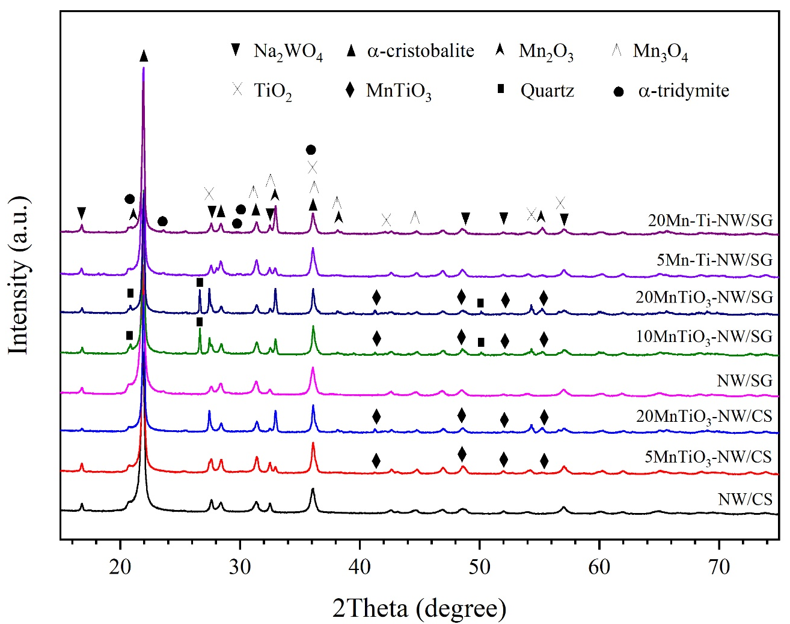
Supplementary Figure S2 XRD patterns of catalysts.

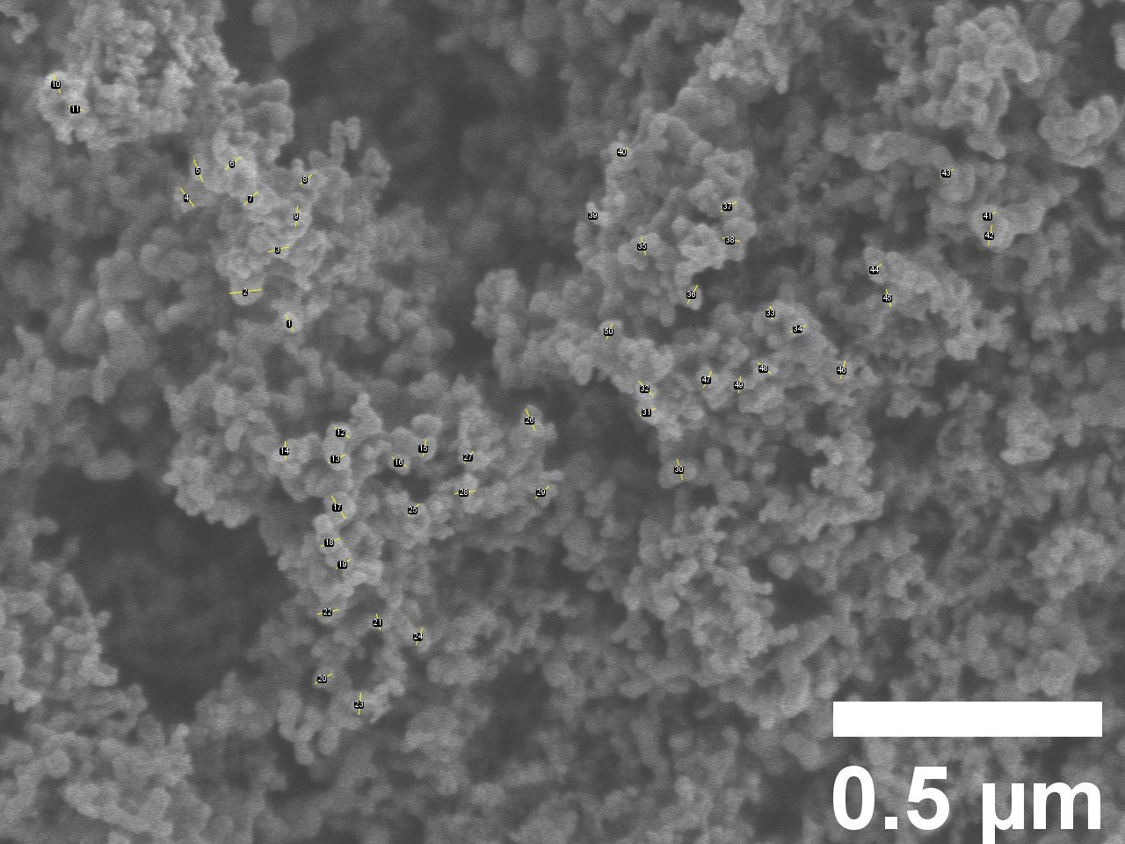
Supplementary Figure S3 The average particle size of CS.
Supplementary Table S2 The average particle size of CS.
No. | Length (μm) | No. | Length (μm) | No. | Length (μm) | No. | Length (μm) | No. | Length (μm)
1 | 0.032 | 11 | 0.027 | 21 | 0.030 | 31 | 0.031 | 41 | 0.028
2 | 0.060 | 12 | 0.033 | 22 | 0.040 | 32 | 0.037 | 42 | 0.037
3 | 0.039 | 13 | 0.035 | 23 | 0.040 | 33 | 0.023 | 43 | 0.027
4 | 0.041 | 14 | 0.033 | 24 | 0.033 | 34 | 0.028 | 44 | 0.029
5 | 0.044 | 15 | 0.030 | 25 | 0.029 | 35 | 0.032 | 45 | 0.032
6 | 0.036 | 16 | 0.031 | 26 | 0.043 | 36 | 0.038 | 46 | 0.034
7 | 0.033 | 17 | 0.048 | 27 | 0.027 | 37 | 0.033 | 47 | 0.033
8 | 0.028 | 18 | 0.038 | 28 | 0.038 | 38 | 0.032 | 48 | 0.030
9 | 0.038 | 19 | 0.031 | 29 | 0.033 | 39 | 0.015 | 49 | 0.030
10 | 0.035 | 20 | 0.036 | 30 | 0.039 | 40 | 0.025 | 50 | 0.030
 |  |  |  |  |  |  |  | Avg. | 0.034

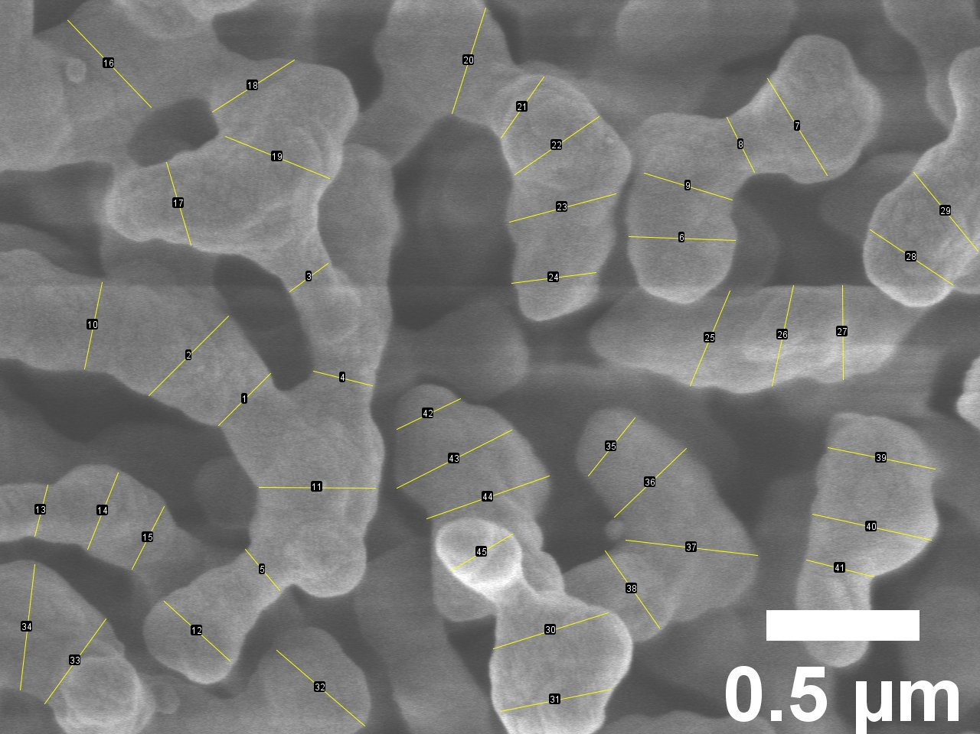
Supplementary Figure S4 The average particle size of NW/CS.

Supplementary Table S3 The average particle size of NW/CS.
No. | Length (μm) | No. | Length (μm) | No. | Length (μm) | No. | Length (μm) | No. | Length (μm)
1 | 0.240 | 11 | 0.380 | 21 | 0.244 | 31 | 0.370 | 41 | 0.227
2 | 0.368 | 12 | 0.290 | 22 | 0.334 | 32 | 0.379 | 42 | 0.230
3 | 0.156 | 13 | 0.173 | 23 | 0.360 | 33 | 0.341 | 43 | 0.420
4 | 0.198 | 14 | 0.269 | 24 | 0.279 | 34 | 0.413 | 44 | 0.424
5 | 0.176 | 15 | 0.230 | 25 | 0.337 | 35 | 0.244 | 45 | 0.234
6 | 0.348 | 16 | 0.394 | 26 | 0.335 | 36 | 0.325 | Avg. | 0.312
7 | 0.373 | 17 | 0.283 | 27 | 0.308 | 37 | 0.433
8 | 0.201 | 18 | 0.317 | 28 | 0.325 | 38 | 0.309
9 | 0.301 | 19 | 0.367 | 29 | 0.332 | 39 | 0.357
10 | 0.289 | 20 | 0.362 | 30 | 0.393 | 40 | 0.397

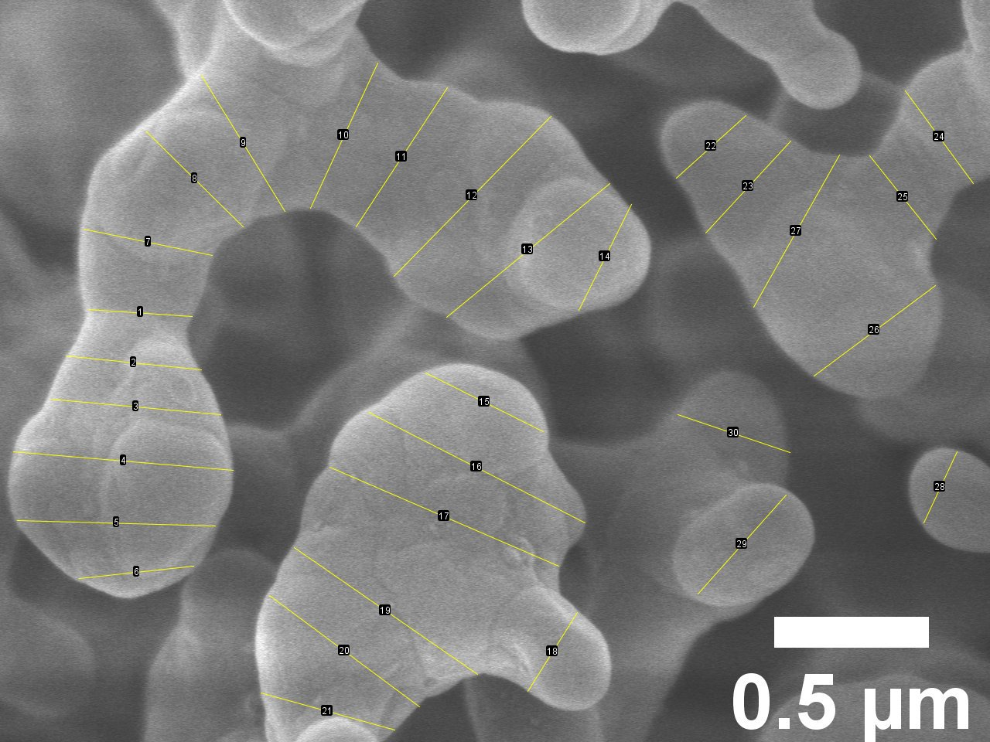
Supplementary Figure S5 The average particle size of 5MnTiO₃-NW/CS.

Supplementary Table S4 The average particle size of 5MnTiO₃-NW/CS.
No. | Length (μm) | No. | Length (μm) | No. | Length (μm)
1 | 0.336 | 11 | 0.538 | 21 | 0.449
2 | 0.440 | 12 | 0.725 | 22 | 0.303
3 | 0.550 | 13 | 0.682 | 23 | 0.405
4 | 0.713 | 14 | 0.383 | 24 | 0.372
5 | 0.640 | 15 | 0.425 | 25 | 0.345
6 | 0.372 | 16 | 0.787 | 26 | 0.490
7 | 0.424 | 17 | 0.806 | 27 | 0.566
8 | 0.442 | 18 | 0.301 | 28 | 0.254
9 | 0.516 | 19 | 0.721 | 29 | 0.429
10 | 0.518 | 20 | 0.604 | 30 | 0.383
 |  |  |  | Avg. | 0.497

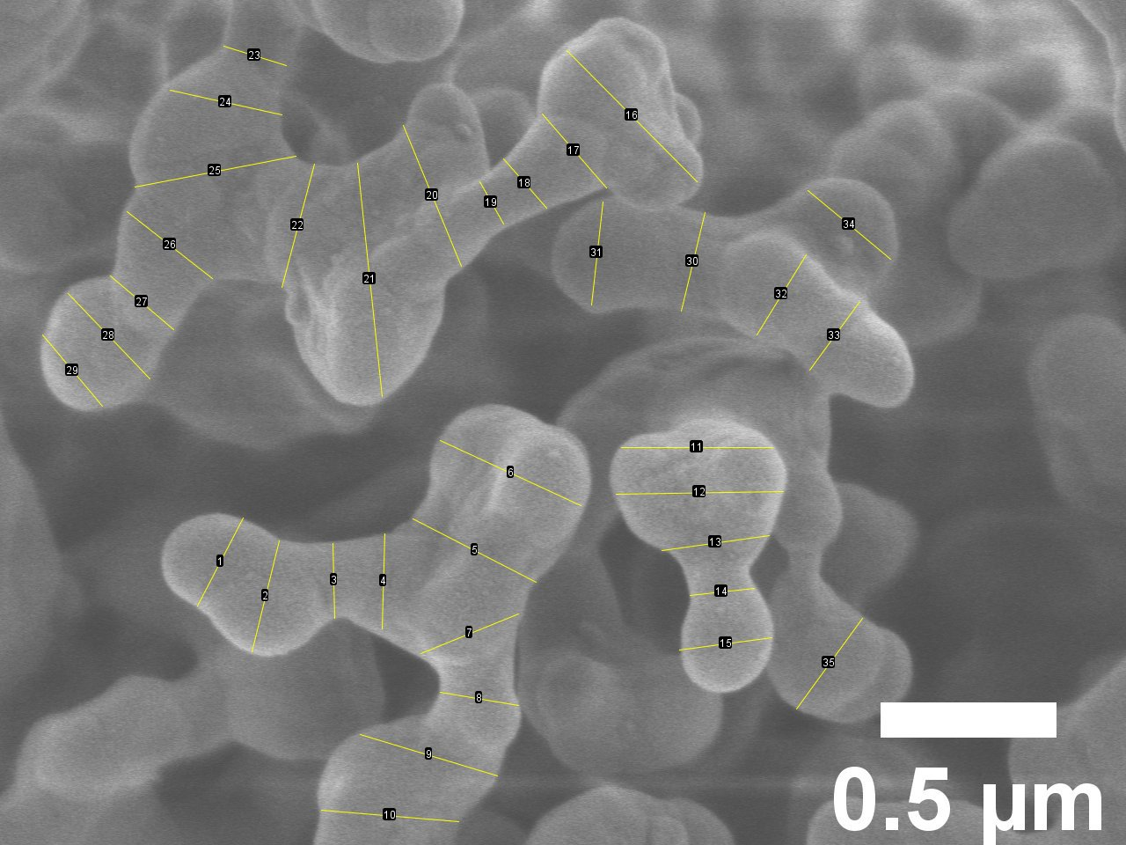
Supplementary Figure S6 The average particle size of 20MnTiO₃-NW/CS.

Supplementary Table S5 The average particle size of 20MnTiO₃-NW/CS.
No. | Length (μm) | No. | Length (μm) | No. | Length (μm) | No. | Length (μm)
1 | 0.281 | 11 | 0.430 | 21 | 0.666 | 31 | 0.294
2 | 0.324 | 12 | 0.475 | 22 | 0.362 | 32 | 0.267
3 | 0.212 | 13 | 0.308 | 23 | 0.186 | 33 | 0.242
4 | 0.270 | 14 | 0.184 | 24 | 0.325 | 34 | 0.305
5 | 0.394 | 15 | 0.266 | 25 | 0.466 | 35 | 0.318
6 | 0.441 | 16 | 0.526 | 26 | 0.310 | Avg. | 0.324
7 | 0.299 | 17 | 0.278 | 27 | 0.236
8 | 0.226 | 18 | 0.186 | 28 | 0.336
9 | 0.408 | 19 | 0.138 | 29 | 0.266
10 | 0.391 | 20 | 0.433 | 30 | 0.288

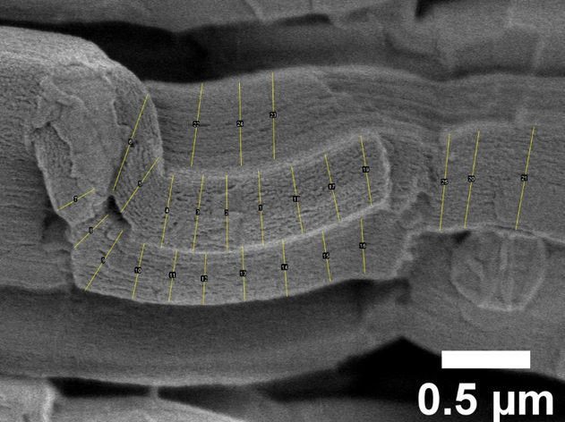
Supplementary Figure S7 The average particle size of SG.

Supplementary Table S6 The average particle size of SG.
No. | Length (μm) | No. | Length (μm) | No. | Length (μm) | No. | Length (μm) | No. | Length (μm)
1 | 0.426 | 6 | 0.579 | 11 | 0.296 | 16 | 0.311 | 21 | 0.591
2 | 0.430 | 7 | 0.245 | 12 | 0.288 | 17 | 0.383 | 22 | 0.477
3 | 0.434 | 8 | 0.262 | 13 | 0.310 | 18 | 0.385 | 23 | 0.493
4 | 0.416 | 9 | 0.401 | 14 | 0.323 | 19 | 0.395 | 24 | 0.470
5 | 0.379 | 10 | 0.317 | 15 | 0.284 | 20 | 0.551 | 25 | 0.553
 |  |  |  |  |  |  |  | Avg. | 0.400

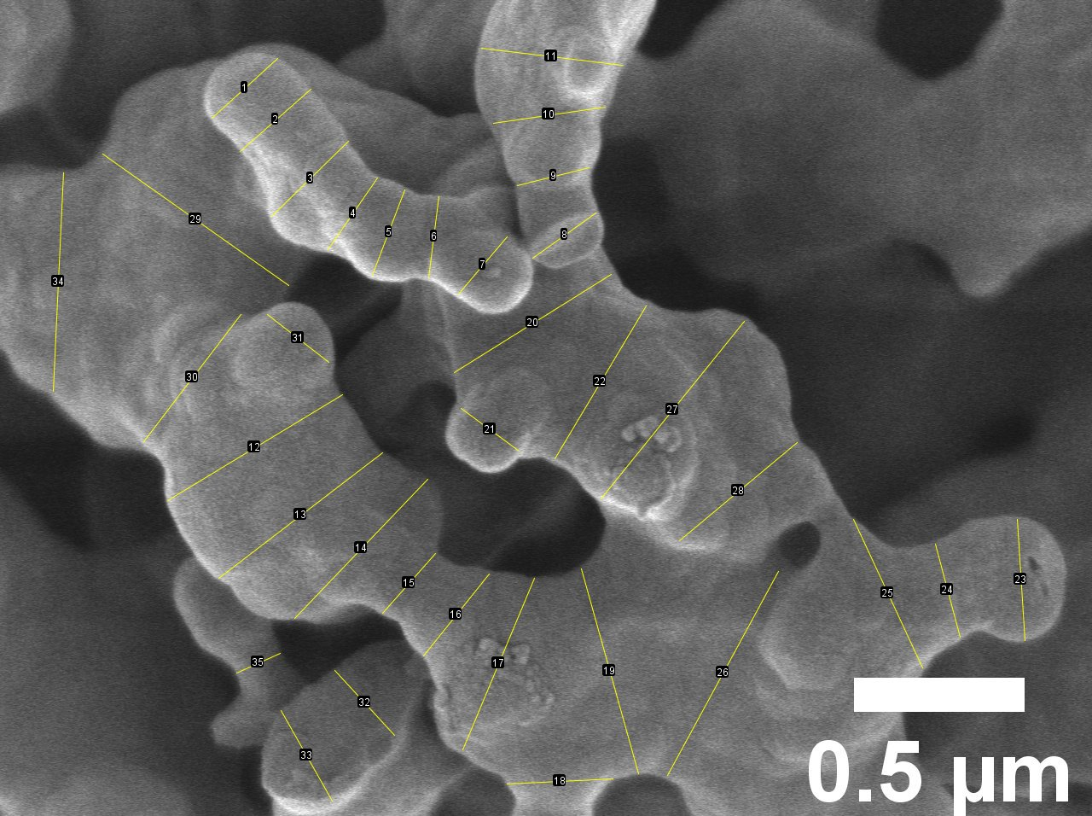
Supplementary Figure S8 The average particle size of NW/SG.

Supplementary Table S7 The average particle size of NW/SG.
No. | Length (μm) | No. | Length (μm) | No. | Length (μm) | No. | Length (μm)
1 | 0.260 | 11 | 0.416 | 21 | 0.211 | 31 | 0.228
2 | 0.276 | 12 | 0.599 | 22 | 0.521 | 32 | 0.258
3 | 0.315 | 13 | 0.605 | 23 | 0.356 | 33 | 0.305
4 | 0.255 | 14 | 0.564 | 24 | 0.282 | 34 | 0.641
5 | 0.267 | 15 | 0.234 | 25 | 0.480 | 35 | 0.140
6 | 0.239 | 16 | 0.308 | 26 | 0.680 | Avg. | 0.392
7 | 0.220 | 17 | 0.545 | 27 | 0.668
8 | 0.228 | 18 | 0.310 | 28 | 0.449
9 | 0.216 | 19 | 0.623 | 29 | 0.667
10 | 0.331 | 20 | 0.542 | 30 | 0.469

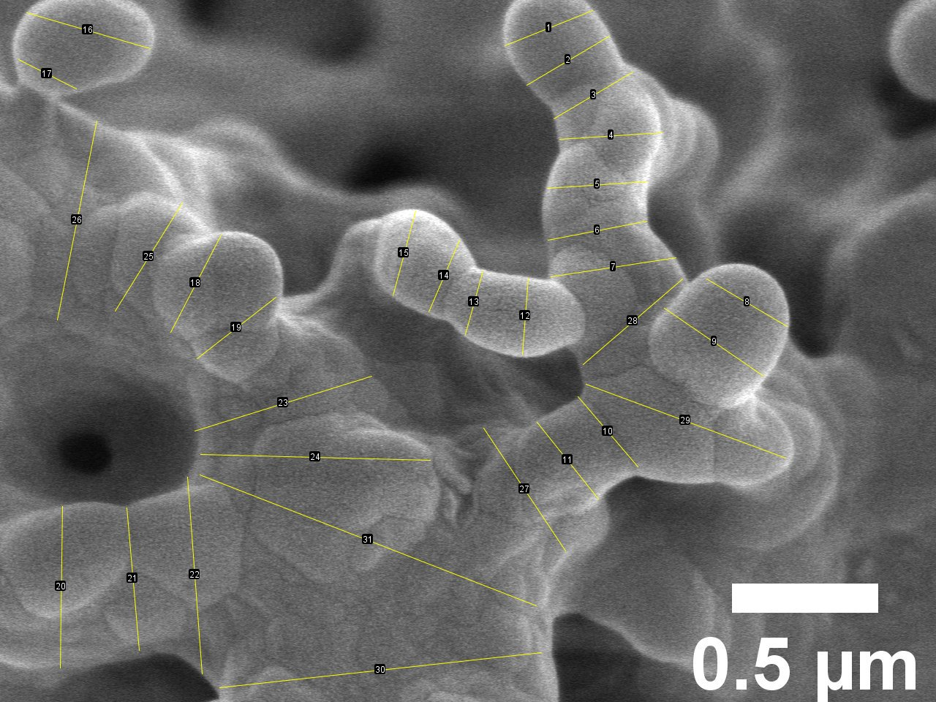
Supplementary Figure S9 The average particle size of 10MnTiO₃-NW/SG.

Supplementary Table S8 The average particle size of 10MnTiO₃-NW/SG.
No. | Length (μm) | No. | Length (μm) | No. | Length (μm) | No. | Length (μm)
1 | 0.323 | 11 | 0.336 | 21 | 0.489 | 31 | 1.234
2 | 0.328 | 12 | 0.261 | 22 | 0.674 | Avg. | 0.469
3 | 0.314 | 13 | 0.226 | 23 | 0.633
4 | 0.351 | 14 | 0.267 | 24 | 0.785
5 | 0.341 | 15 | 0.300 | 25 | 0.436
6 | 0.344 | 16 | 0.440 | 26 | 0.693
7 | 0.432 | 17 | 0.221 | 27 | 0.505
8 | 0.319 | 18 | 0.375 | 28 | 0.449
9 | 0.412 | 19 | 0.342 | 29 | 0.728
10 | 0.316 | 20 | 0.553 | 30 | 1.107

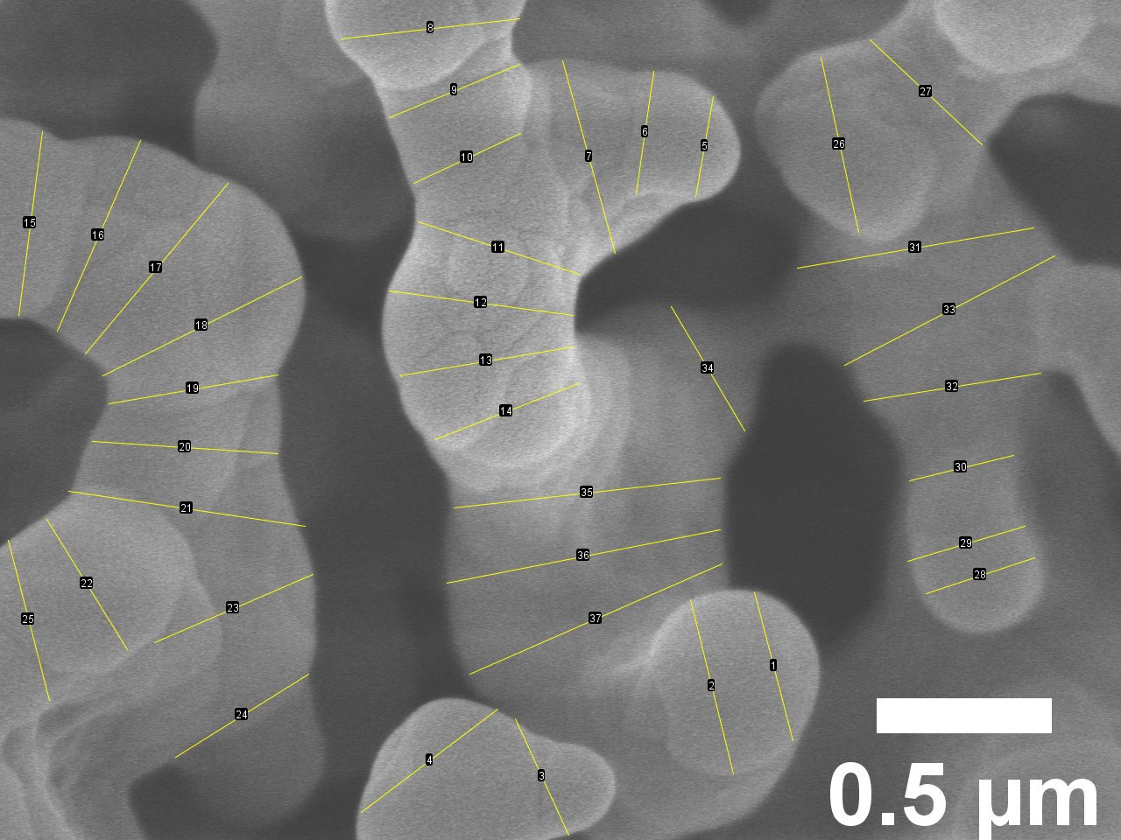
Supplementary Figure S10 The average particle size of 20MnTiO₃-NW/SG.

Supplementary Table S9 The average particle size of 20MnTiO₃-NW/SG.
No. | Length (μm) | No. | Length (μm) | No. | Length (μm) | No. | Length (μm)
1 | 0.439 | 11 | 0.484 | 21 | 0.682 | 31 | 0.685
2 | 0.512 | 12 | 0.530 | 22 | 0.438 | 32 | 0.511
3 | 0.366 | 13 | 0.502 | 23 | 0.493 | 33 | 0.677
4 | 0.489 | 14 | 0.440 | 24 | 0.448 | 34 | 0.412
5 | 0.289 | 15 | 0.529 | 25 | 0.472 | 35 | 0.765
6 | 0.354 | 16 | 0.595 | 26 | 0.511 | 36 | 0.795
7 | 0.570 | 17 | 0.635 | 27 | 0.439 | 37 | 0.786
8 | 0.513 | 18 | 0.634 | 28 | 0.327 | Avg. | 0.506
9 | 0.403 | 19 | 0.490 | 29 | 0.350
10 | 0.337 | 20 | 0.531 | 30 | 0.306

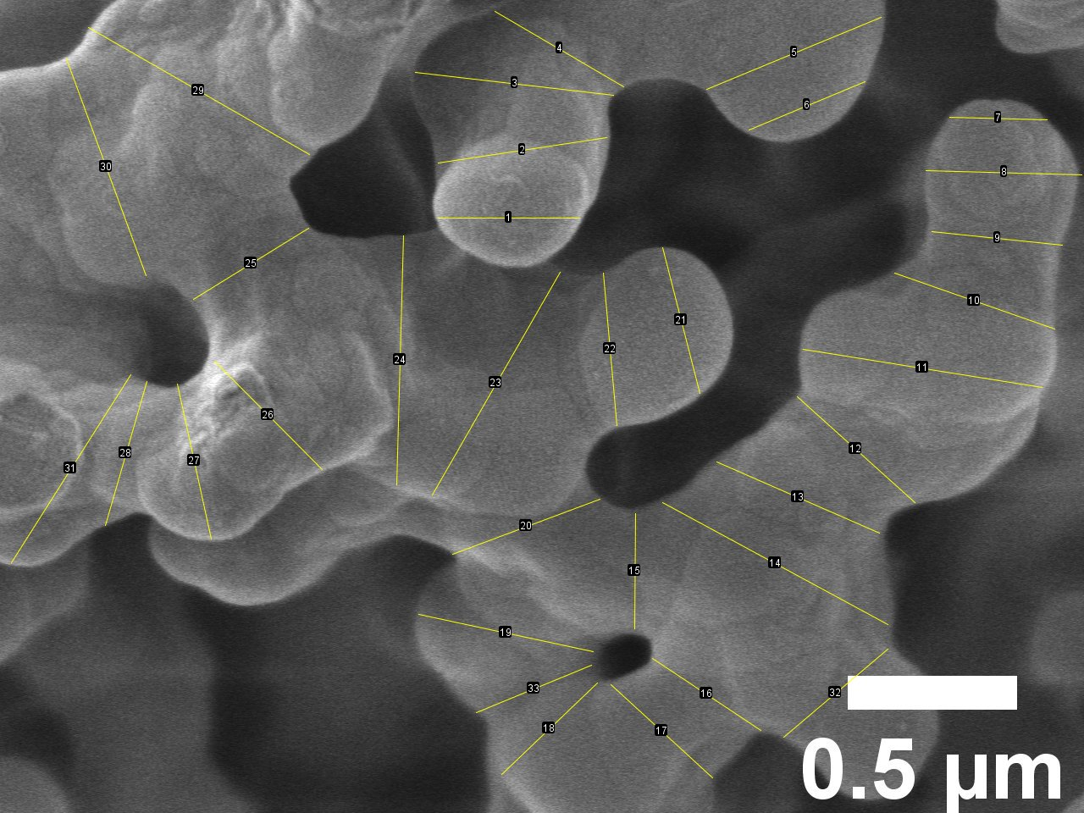
Supplementary Figure S11 The average particle size of 5Mn-Ti-NW/SG.

Supplementary Table S10 The average particle size of 5Mn-Ti-NW/SG.
No. | Length (μm) | No. | Length (μm) | No. | Length (μm) | No. | Length (μm)
1 | 0.418 | 11 | 0.714 | 21 | 0.444 | 31 | 0.657
2 | 0.503 | 12 | 0.467 | 22 | 0.452 | 32 | 0.403
3 | 0.589 | 13 | 0.524 | 23 | 0.758 | 33 | 0.368
4 | 0.440 | 14 | 0.756 | 24 | 0.735 | Avg. | 0.500
5 | 0.557 | 15 | 0.340 | 25 | 0.400
6 | 0.371 | 16 | 0.384 | 26 | 0.451
7 | 0.288 | 17 | 0.407 | 27 | 0.468
8 | 0.461 | 18 | 0.391 | 28 | 0.442
9 | 0.387 | 19 | 0.527 | 29 | 0.753
10 | 0.500 | 20 | 0.464 | 30 | 0.682

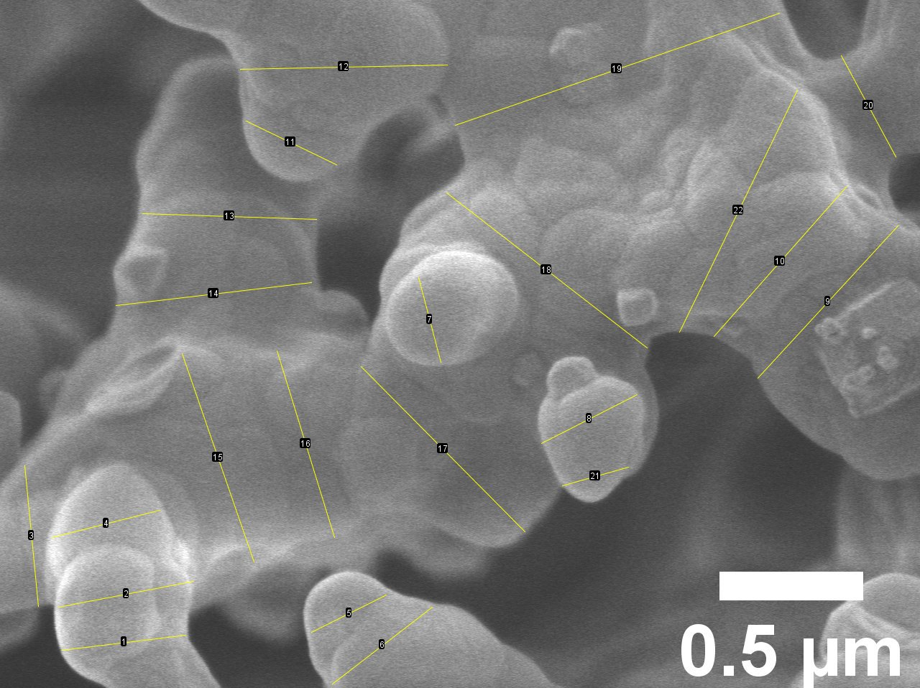
Supplementary Figure S12 The average particle size of 20Mn-Ti-NW/SG.

Supplementary Table S11 The average particle size of 20Mn-Ti-NW/SG.
No. | Length (μm) | No. | Length (μm) | No. | Length (μm)
1 | 0.433 | 9 | 0.720 | 17 | 0.810
2 | 0.479 | 10 | 0.694 | 18 | 0.882
3 | 0.492 | 11 | 0.349 | 19 | 1.193
4 | 0.387 | 12 | 0.720 | 20 | 0.401
5 | 0.291 | 13 | 0.605 | 21 | 0.239
6 | 0.439 | 14 | 0.685 | 22 | 0.937
7 | 0.305 | 15 | 0.767 | Avg. | 0.585
8 | 0.374 | 16 | 0.679

Supplementary Figure S13 Plots of N₂-physisorption at standard temperature and pressure (STP): a) CS and SG, b) MnTiO₃-NW/CS, c) MnTiO₃-NW/SG, and d) Mn-Ti-NW/SG catalysts. Each inset shows the corresponding pore size distribution plot.

Supplementary Table S12 FE-SEM and EDX images of catalysts.
Catalyst | SEM | EDX and weight percent elemental
Catalyst | SEM | Mn | Ti | Na | W | Si
NW/CS | 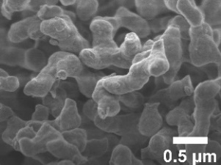 |  |  | 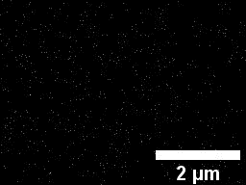  0.30% | 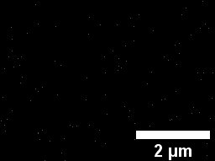  2.80% | 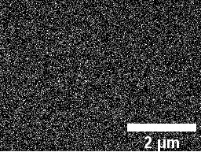  39.34%
5MnTiO₃-NW/CS | 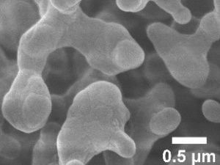 | 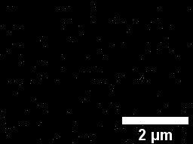  0.01% | 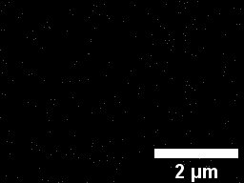  0.01% | 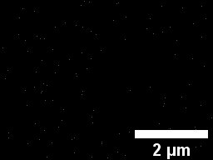  0.10% | 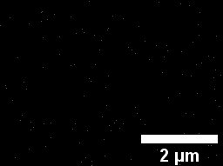  2.15% | 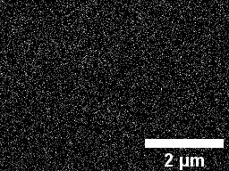  45.46%
20MnTiO₃-NW/CS | 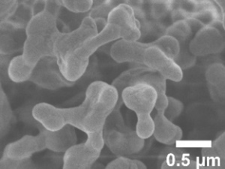 | 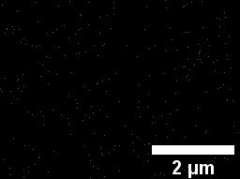  0.34% | 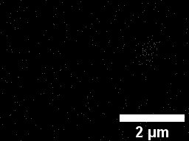  0.28% | 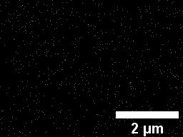  0.14% | 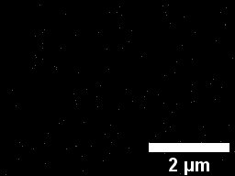  3.11% | 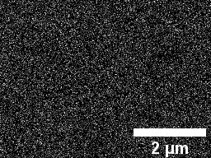  27.81%
NW/SG | 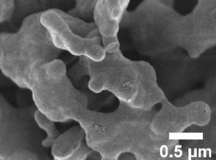 |  |  | 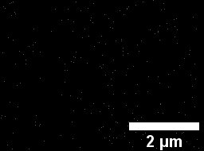  0.01% | 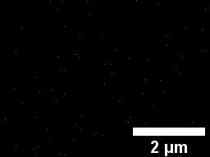  2.17% | 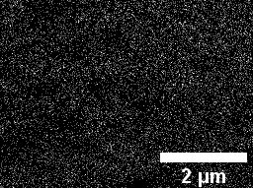  27.81%

Supplementary Table S12 FE-SEM and EDX images of catalysts. (Continued)

Catalyst | SEM | EDX and weight percent elemental
Catalyst | SEM | Mn | Ti | Na | W | Si
10MnTiO₃-NW/SG | 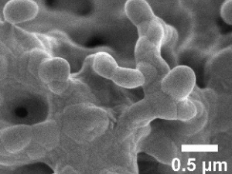 | 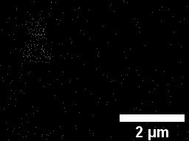  1.59% | 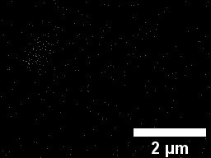  0.52% | 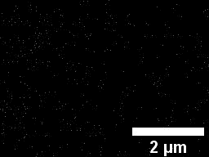  0.02% | 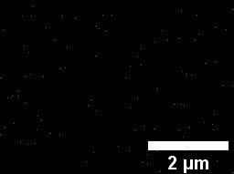  1.89% | 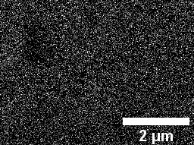  39.72%
20MnTiO₃-NW/SG | 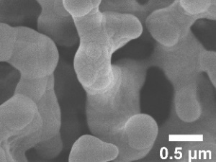 | 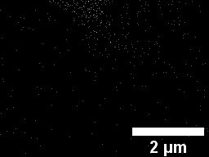  1.56% | 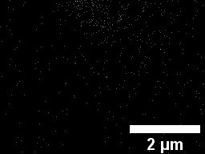  0.93% | 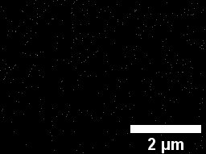  0.15% | 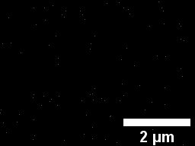  0.01% | 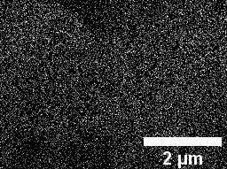  25.84%
5Mn-Ti-NW/SG | 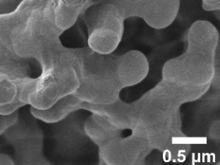 | 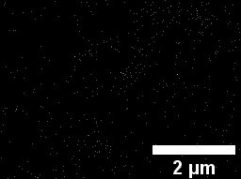  1.23% | 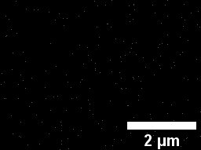  0.01% | 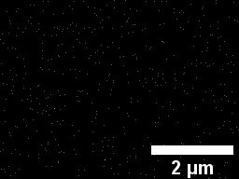  0.01% | 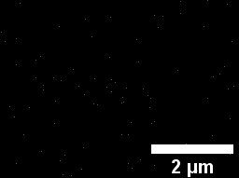  1.22% | 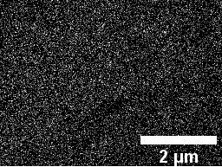  19.79%
20Mn-Ti-NW/SG | 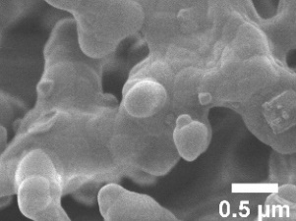 | 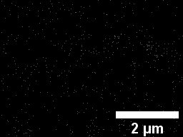  2.81% | 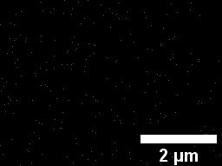  0.01% | 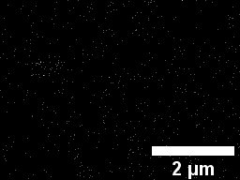  0.53% | 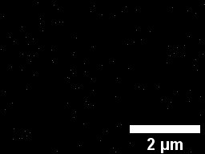  2.81% | 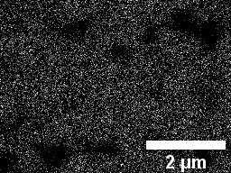  28.15%
Supplementary Table S12 FE-SEM and EDX images of catalysts. (Continued)

Catalyst | SEM | EDX and weight percent elemental
Catalyst | SEM | Mn | Ti | Na | W | Si
Used MnTiO₃-NW/CS | 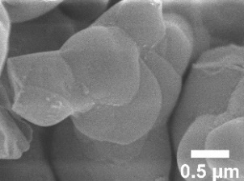 | 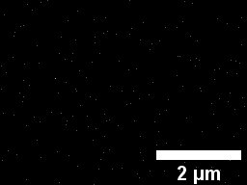  0.15% | 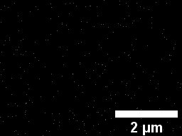  0.16% | 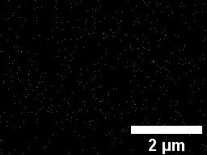  0.23% | 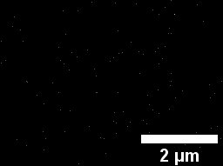  1.66% | 35.15%
Used MnTiO₃-NW/SG | 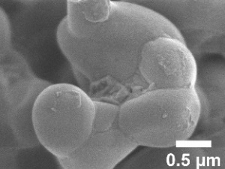 | 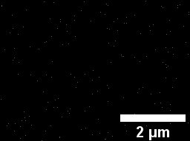  0.01% | 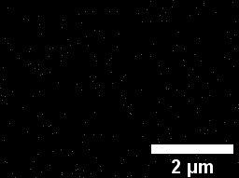  0.01% | 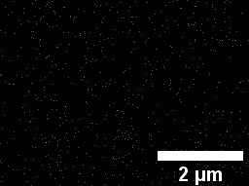  0.30% | 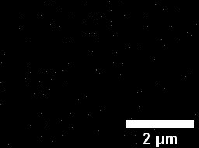  1.44% | 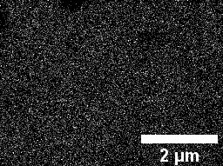  24.64%
Used Mn-Ti-NW/SG | 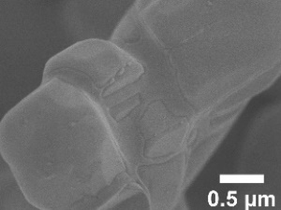 | 4.26% | 0.01% | 0.30% | 1.96% | 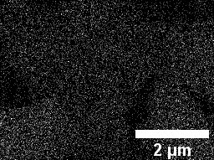  24.44%

Supplementary Figure S14 FTIR spectra of CS, Na/CS, NW/CS, and MnTiO₃-NW/CS.

Supplementary Table S13 Observed XPS binding energies of Na 1s, W 4f, Si 2p, Ti 2p, and Mn 2p.
Catalyst | Binding energy (eV)
Catalyst | Na 1s | W 4f |  | Si 2p | Mn 2p |  | Ti 2p
Catalyst | Na 1s | 4f_{5/2} | 4f_{7/2} | Si 2p | 2p_{1/2} | 2p_{3/2} | 2p_{1/2} | 2p_{3/2}
NW/CS | 1071.3 | 37.6 | 35.4 | 103.5 | - | - | - | -
MnTiO₃-NW/CS | 1071.3 | 37.6 | 35.4 | 103.4 | 655.4,  654.1,  652.8 | 643.9,  642.4,  641.3 | 464.74 | 459.1
NW/SG | 1071.6 | 37.8 | 35.7 | 103.7 | - | - | - | -
MnTiO₃-NW/SG | 1071.6 | 37.8 | 35.7 | 103.1 | 655.7,  654.1,  652.8 | 644.9,  642.1,  641.4 | 464.8 | 459.2
Mn-Ti-NW/SG | 1071.3 | 37.6 | 35.5 | 103.4 | 655.1,  654.0,  652.8 | 643.3,  642.4,  641.4 | 464.0 | 458.5

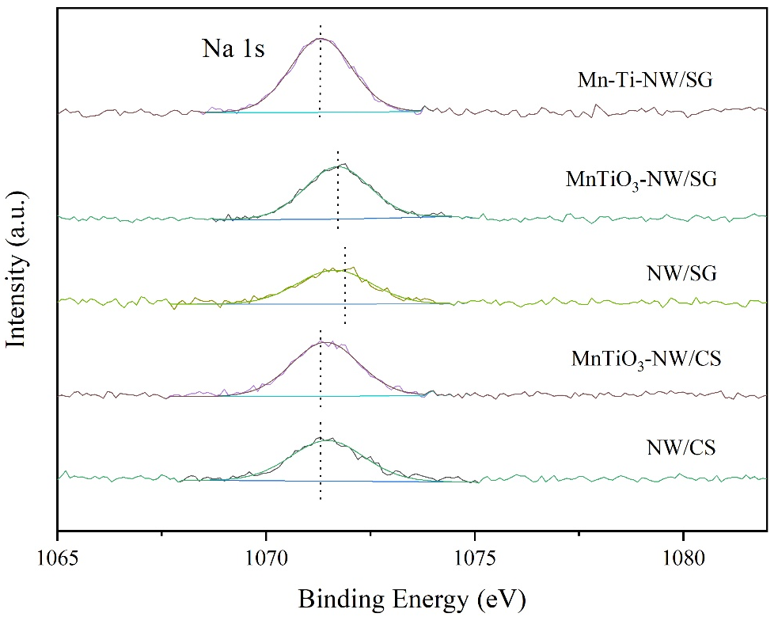
Supplementary Figure S15 XPS Na 1s spectra of catalysts.

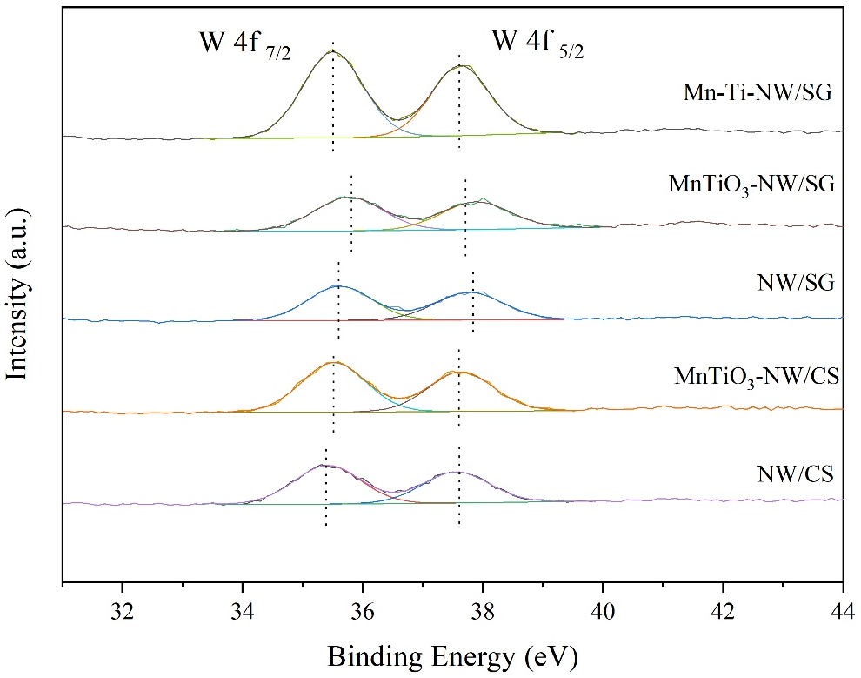
Supplementary Figure S16 XPS W 4f spectra of catalysts.

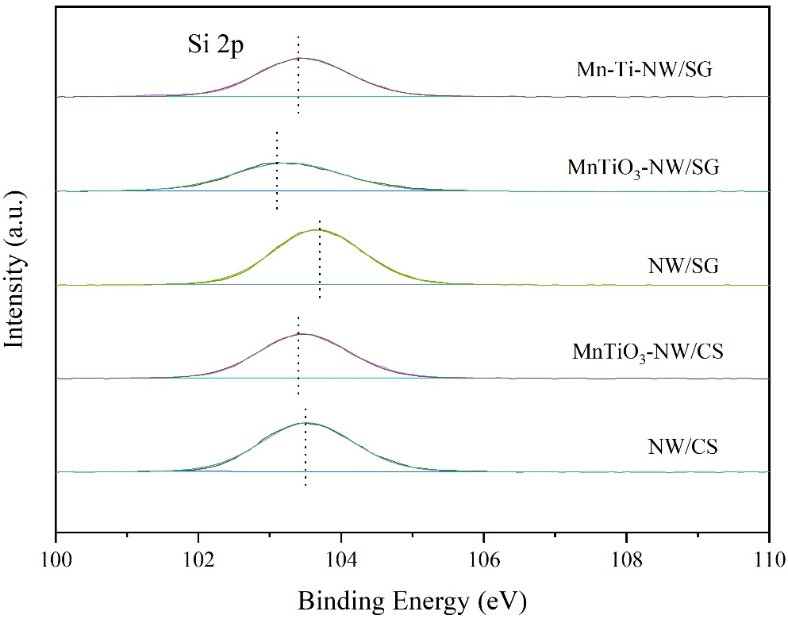
Supplementary Figure S17 XPS Si 2p spectra of catalysts.

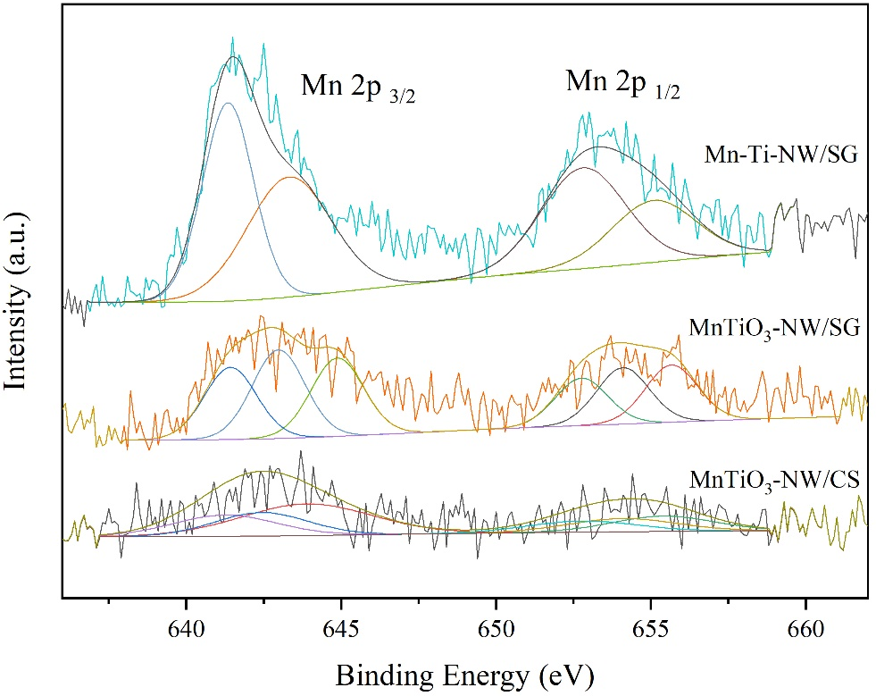
Supplementary Figure S18 XPS Mn 2p spectra of catalysts.

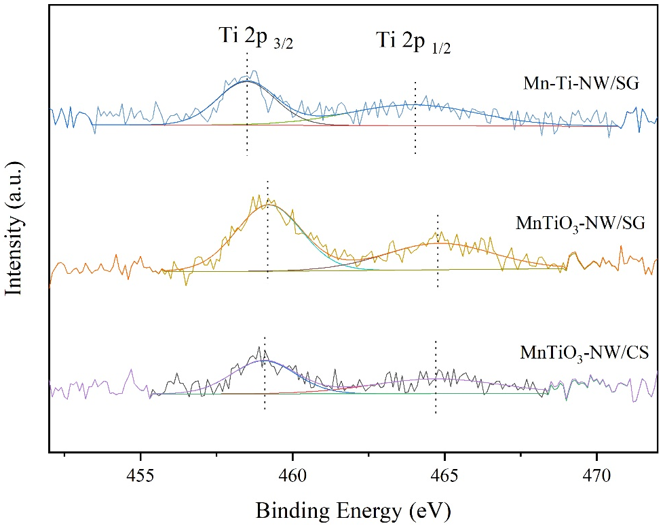
Supplementary Figure S19 XPS Ti 2p spectra of the catalysts.

Supplementary Figure S20 Catalytic performance of Mn-Ti-NW/CS.

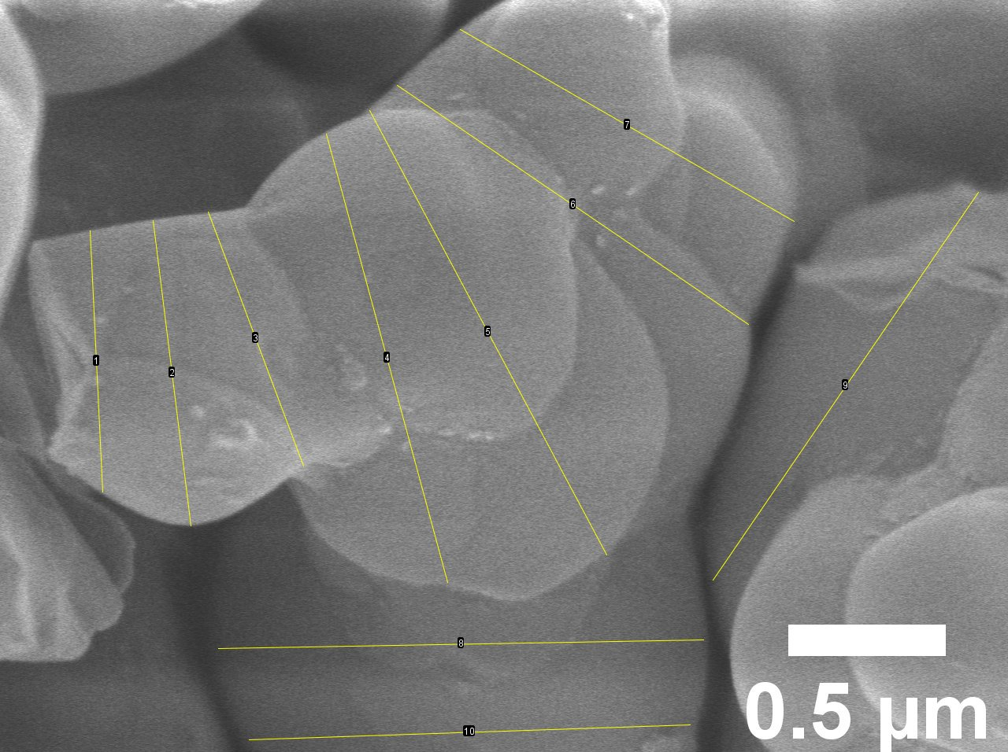
Supplementary Figure S21 The average particle size of Used MnTiO₃-NW/CS.

Supplementary Table S14 The average particle size of Used MnTiO₃-NW/CS.
No. | Length (μm)
1 | 0.831
2 | 0.977
3 | 0.862
4 | 1.476
5 | 1.600
6 | 1.349
7 | 1.223
8 | 1.540
9 | 1.493
10 | 1.401
Avg. | 1.275

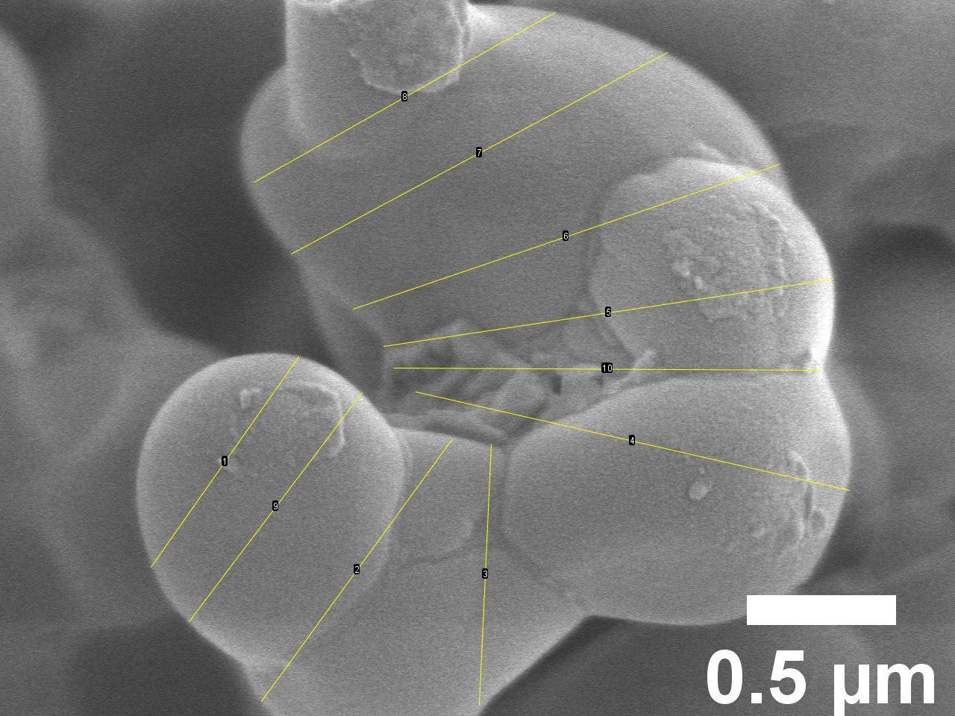
Supplementary Figure S22 The average particle size of Used MnTiO₃-NW/SG.

Supplementary Table S15 The average particle size of Used MnTiO₃-NW/SG.
No. | Length (μm)
1 | 0.861
2 | 1.088
3 | 0.871
4 | 1.490
5 | 1.522
6 | 1.508
7 | 1.429
8 | 1.160
9 | 0.962
10 | 1.430
Avg. | 1.232

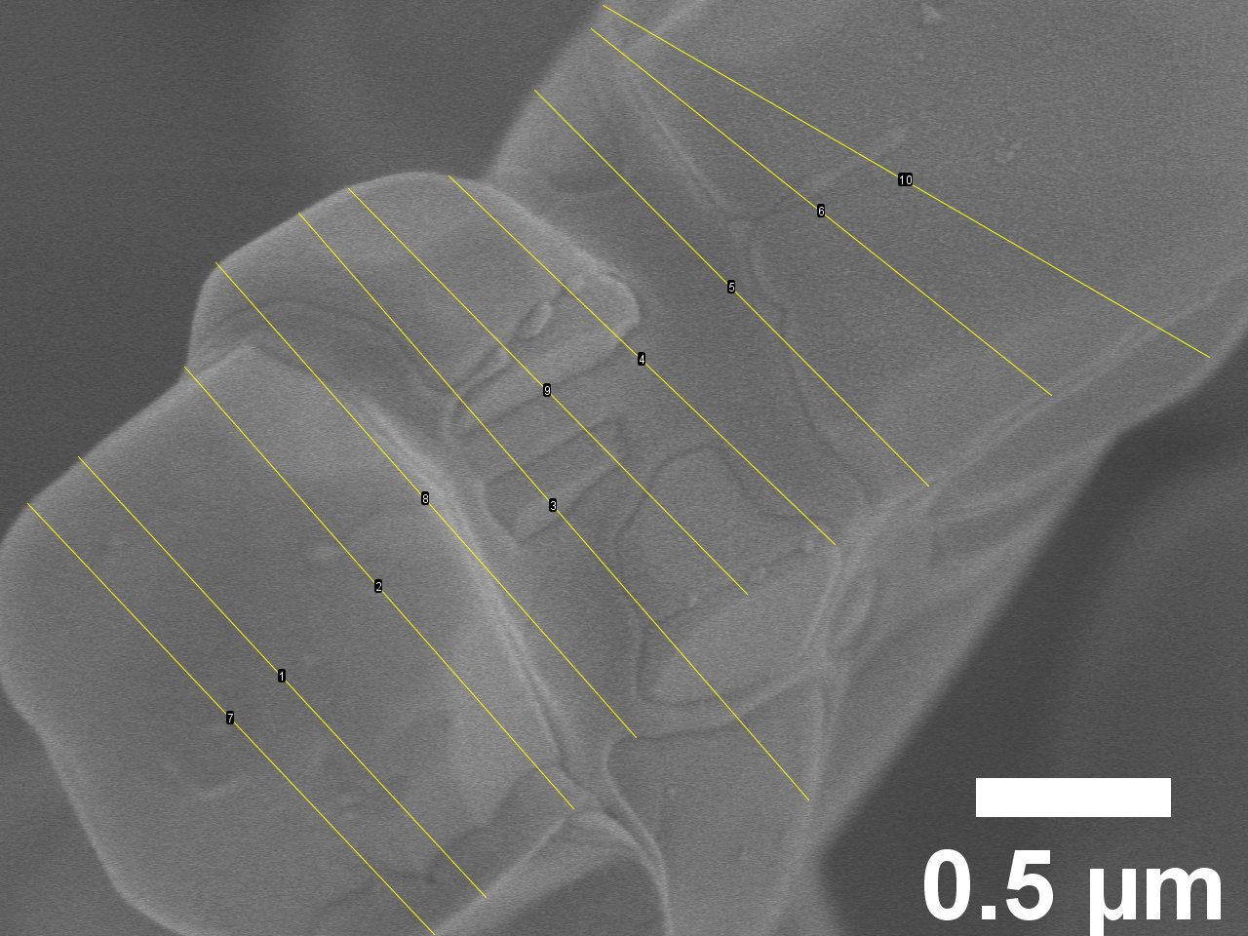
Supplementary Figure S23 The average particle size of Used Mn-Ti-NW/SG.

Supplementary Table S16 The average particle size of Used Mn-Ti-NW/SG.
No. | Length (μm)
1 | 1.541
2 | 1.509
3 | 1.994
4 | 1.369
5 | 1.432
6 | 1.509
7 | 1.519
8 | 1.626
9 | 1.458
10 | 1.798
Avg. | 1.575

The mechanisms of OCM reaction, methane oxidation, and dehydrogenation are shown in equations (S1)–(S14).
.
$\text{2CH}\text{4}\text{ + }\text{0}\text{.}\text{5O}\text{2} →\text{ C}\text{2}\text{H}\text{6}\text{ + }\text{H}\text{2}\text{O}$ (S1)
$\text{C}\text{2}\text{H}\text{6}\text{ + }\text{0}\text{.}\text{5O}\text{2} →\text{ C}\text{2}\text{H}\text{4}\text{ + }\text{H}\text{2}\text{O}$ (S2)
$\text{CH}\text{4}\text{ + }\text{O}\text{2} →\text{ CO}\text{2}\text{ + }\text{2H}\text{2}\text{O}$ (S3)
$\text{CH}\text{4}\text{ + }\text{O}\text{2} →\text{ CO}\text{2}\text{ + }\text{2H}\text{2}\text{O}\text{ + }\text{H}\text{2}$ (S4)
$\text{CO}\text{ + }\text{0}\text{.}\text{5O}\text{2} →\text{ CO}\text{2}$ (S5)
$\text{C}\text{2}\text{H}\text{4}\text{ + }\text{2O}\text{2} →\text{ 2CO}\text{ + }\text{2H}\text{2}\text{O}$ (S6)
$\text{C}\text{2}\text{H}\text{6} →\text{ C}\text{2}\text{H}\text{4}\text{ + }\text{H}\text{2}$ (S7)
$\text{C}\text{2}\text{H}\text{4}\text{ + }\text{2H}\text{2}\text{O} →\text{ 2CO}\text{ + }\text{4H}\text{2}$ (S8)
$\text{CO}\text{ + }\text{H}\text{2}\text{O} → \text{CO}\text{2}\text{+ }\text{H}\text{2}$ (S9)
$\text{CO}\text{2}\text{ + }\text{H}\text{2} →\text{ CO}\text{+ }\text{H}\text{2}\text{O}$ (S10)
${\text{C}}_{\text{3}}{\text{H}}_{\text{6}} \text{+} {\text{4.5O}}_{\text{2}} \text{→} {\text{3CO}}_{\text{2}} \text{+} {\text{3H}}_{\text{2}}\text{O}$ (S11)
${\text{C}}_{\text{3}}{\text{H}}_{\text{6}} \text{+} {\text{H}}_{\text{2}} \text{→} {\text{C}}_{\text{3}}{\text{H}}_{\text{8}}$ (S12)
${\text{C}}_{\text{3}}{\text{H}}_{\text{8}} \text{+} \text{0.5}{\text{O}}_{\text{2}} \text{→} {\text{C}}_{\text{3}}{\text{H}}_{\text{6}} \text{+} {\text{H}}_{\text{2}}\text{O}$ (S13)
${\text{C}}_{\text{3}}{\text{H}}_{\text{8}} \text{+}{ \text{5O}}_{\text{2}} \text{→}{ \text{3CO}}_{\text{2}} \text{+}{ \text{4H}}_{\text{2}}\text{O}$ (S14)

[Reference: B. Beck et al. / Catalysis Today 228 (2014) 212–218]

Supplementary Table S17 A survey of catalysts reported in literature.
No. | Catalyst | Reaction temperature (˚C) | C₂₊ yield  (%) |  | C₂₊ selectivity  (%) |  | CH₄ conversion  (%) |  | Ref.
1 | Na₂WO₄/SiO₂ | 800 | 9.1 |  | 74.3 |  | 12.3 |  | ¹
2 | Mn-Na₂WO₄/SiO₂ | 800 | 23.9 |  | 64.9 |  | 36.8 |  | ¹
3 | Mn/Na₂WO₄/SiO₂ | 850 | 26.4 |  | 80.0 |  | 33.0 |  | ²
4 | Na₂WO₄/SiO₂ | 850 | 22.9 |  | 52.0 |  | 44.0 |  | ²
5 | Na₂WO₄/SiO₂ | 775 | 7.0 |  | 63.0 |  | 11.0 |  | ³
6 | V/Na₂WO₄/SiO₂ | 775 | 1.2 |  | 12.0 |  | 10.0 |  | ³
7 | Cr/Na₂WO₄/SiO₂ | 775 | 2.4 |  | 24.0 |  | 10.0 |  | ³
8 | Mn/Na₂WO₄/SiO₂ | 775 | 16.0 |  | 80.0 |  | 20.0 |  | ³
9 | Fe/Na₂WO₄/SiO₂ | 775 | 9.0 |  | 60.0 |  | 15.0 |  | ³
10 | CO/Na₂WO₄/SiO₂ | 775 | 11.0 |  | 68.0 |  | 16.0 |  | ³
11 | Zn/Na₂WO₄/SiO₂ | 775 | 6.0 |  | 63.0 |  | 9.0 |  | ³
12 | Mn-Na₂WO₄/SiO₂ | 850 | 17.0 |  | 75.0 |  | 22.0 |  | ⁴
13 | Na₂WO₄/Mn/SiO₂ | 850 | 17.2 |  | 54.0 |  | 32.0 |  | ⁵
14 | W-Mn/SiO₂ | 820 | 20.7 |  | 68.4 |  | 30.3 |  | ⁶
15 | W-Li/SiO₂ | 800 | 6.0 |  | 52.0 |  | 10.0 |  | ⁷
16 | Mn-Li/SiO₂ | 800 | 6.0 |  | 40.0 |  | 15.0 |  | ⁷
17 | Mn-W/SiO₂ | 800 | 6.0 |  | 40.0 |  | 15.0 |  | ⁷
18 | Mn-0.1Li-W/SiO₂ | 800 | 11.0 |  | 58.0 |  | 18.0 |  | ⁷
19 | Mn-0.25Li-W/SiO₂ | 800 | 15.0 |  | 78.0 |  | 18.0 |  | ⁷
20 | W-Li-W/SiO₂ | 800 | 15.0 |  | 79.0 |  | 19.0 |  | ⁷
21 | Na₂WO₄/Mn/SiO₂ | 800 | 11.2 |  | 27.4 |  | 41.0 |  | ⁸
22 | La/Na₂WO₄/Mn/SiO₂ | 800 | 10.6 |  | 25.4 |  | 41.7 |  | ⁸
23 | Na-W-Mn/SiO₂ | 850 | 29.0 |  | 69.0 |  | 42.0 |  | ⁹
24 | Na₂WO₄/SiO₂ | 800 | 15.0 |  | 74.0 |  | 20.0 |  | ¹⁰
25 | W/SiO₂ | 800 | 6.0 |  | 54.0 |  | 11.0 |  | ¹⁰
26 | Mn/SiO₂ | 800 | 9.0 |  | 43.0 |  | 19.0 |  | ¹⁰
27 | W-Na-Mn/SiO₂ | 775 | 18.3 |  | 39.6 |  | 46.1 |  | ¹¹
28 | Mo-Na-Mn/SiO₂ | 775 | 12.5 |  | 37.2 |  | 33.6 |  | ¹¹
29 | Nb-Na-Mn/SiO₂ | 775 | 13.0 |  | 33.2 |  | 39.3 |  | ¹¹
30 | V-Na-Mn/SiO₂ | 775 | 2.7 |  | 8.0 |  | 33.5 |  | ¹¹
31 | Cr-Na-Mn/SiO₂ | 775 | 4.6 |  | 11.5 |  | 40.1 |  | ¹¹
32 | Ce-Mn/Na₂WO₄/SiO₂ | 840 | 21.1 |  | 62.4 |  | 33.9 |  | ¹²
33 | Na-W-Mn/SiO₂ | 800 | 19.1 |  | 63.2 |  | 30.2 |  | ¹³
34 | Mn-Na₂WO₄/SiO₂ | 825 | 19.1 |  | 72.2 |  | 26.5 |  | ¹⁴
35 | Mn/SiO₂ | 800 | 0.6 |  | 14.4 |  | 5.7 |  | ¹⁵
36 | Na₂WO₄/SiO₂ | 800 | 2.9 |  | 69.0 |  | 4.8 |  | ¹⁵
37 | Mn-Na₂WO₄/SiO₂ | 800 | 18.5 |  | 73.3 |  | 28.5 |  | ¹⁵
38 | NaCl-Mn-Na₂WO₄/SiO₂ | 750 | 34.6 |  | 62.9 |  | 55.0 |  | ¹⁶
39 | (NaCl+KCl)-Mn-Na₂WO₄/SiO₂ | 750 | 31.6 |  | 70.0 |  | 45.1 |  | ¹⁶
Supplementary Table S17 A survey of catalysts reported in literature. (Continued)
No. | Catalyst | Reaction temperature (˚C) | C₂₊ yield  (%) |  | C₂₊ selectivity  (%) |  | CH₄ conversion  (%) |  | Ref.
40 | KCl-Mn-Na₂WO₄/SiO₂ | 750 | 27.0 |  | 75.3 |  | 35.9 |  | ¹⁶
41 | CsCl-Mn-Na₂WO₄/SiO₂ | 750 | 22.6 |  | 74.9 |  | 30.1 |  | ¹⁶
42 | LiCl-Mn-Na₂WO₄/SiO₂ | 750 | 11.3 |  | 80.2 |  | 14.1 |  | ¹⁶
43 | Mn-Na₂WO₄/SiO₂ | 750 | 5.2 |  | 63.4 |  | 8.2 |  | ¹⁶
44 | Mn_{x}O_{y}-Na₂WO₄/D11-10 | 750 | 3.6 |  | 52.9 |  | 6.7 |  | ¹⁷
45 | Mn_{x}O_{y}-Na₂WO₄/SiO₂ (grade 923) | 750 | 1.3 |  | 63.6 |  | 2.0 |  | ¹⁷
46 | Mn_{x}O_{y}-Na₂WO₄/SiO₂ (fumed) | 750 | 4.5 |  | 61.3 |  | 7.4 |  | ¹⁷
47 | Mn_{x}O_{y}-Na₂WO₄/Aerosil TT 600 | 750 | 4.5 |  | 60.7 |  | 7.3 |  | ¹⁷
48 | Mn_{x}O_{y}-Na₂WO₄/Aeroperl R 806/30 | 750 | 4.9 |  | 68.9 |  | 7.1 |  | ¹⁷
49 | Mn_{x}O_{y}-Na₂WO₄/Aerosil OX 50 | 750 | 3.5 |  | 55.4 |  | 6.4 |  | ¹⁷
50 | Mn_{x}O_{y}-Na₂WO₄/Aerosil 380 | 750 | 4.2 |  | 62.6 |  | 6.6 |  | ¹⁷
51 | Mn_{x}O_{y}-Na₂WO₄/Aerosil 300 | 750 | 3.3 |  | 57.4 |  | 5.9 |  | ¹⁷
52 | Mn_{x}O_{y}-Na₂WO₄/Sipernat D10 | 750 | 3.5 |  | 80.3 |  | 4.4 |  | ¹⁷
53 | Mn_{x}O_{y}-Na₂WO₄/Sipernat 310 | 750 | 5.4 |  | 75.8 |  | 7.0 |  | ¹⁷
54 | Mn_{x}O_{y}-Na₂WO₄/SBA-15 | 750 | 10.4 |  | 73.4 |  | 14.1 |  | ¹⁷
55 | Na₂WO₄/Mn/SiO₂ | 800 | 2.5 |  | 67.6 |  | 3.2 |  | ¹⁸
56 | Na₂WO₄-Mn/SiO₂ | 800 | 19.6 |  | 66.4 |  | 29.5 |  | ¹⁸
57 | TiO₂-Mn₂O₃-Na₂WO₄/SiO₂ | 700 | 14.0 |  | 70.0 |  | 20.0 |  | ¹⁹
58 | TiO₂-Mn₂O₃-Na₂WO₄/SiO₂ | 720 | 19.7 |  | 76.0 |  | 26.0 |  | ²⁰
59 | Mn₂O₃-TiO₂-Na₂WO₄/SiO₂ | 650 | 13.6 |  | 62.0 |  | 22.0 |  | ²⁰
60 | Na₂WO₄/Mn/SiO₂ (silica gel) | 775 | 16.9 |  | 50.8 |  | 33.4 |  | ²¹
61 | Na₂WO₄/Mn/SiO₂ (silica gel) | 800 | 17.1 |  | 51.0 |  | 33.5 |  | ²¹
62 | Na₂WO₄/Mn/SiO₂ (fumed silica) | 800 | 16.5 |  | 52.7 |  | 33.3 |  | ²¹
63 | Mn/Na₂WO₄/SiO₂ | 725 | 16.0 |  | 79.8 |  | 20.2 |  | ²²
64 | Mn-Na-W/SiO₂ | 750 | 16.0 |  | 64.0 |  | 25.0 |  | ²³
65 | Al-Na₂WO₄/SiO₂ | 800 | 3.2 |  | 37.0 |  | 7.69 |  | ²⁴
66 | Li-Na₂WO₄/SiO₂ | 800 | 4.6 |  | 47.8 |  | 9.56 |  | ²⁴
67 | La-Na₂WO₄/SiO₂ | 800 | 6.1 |  | 49.5 |  | 11.9 |  | ²⁴
68 | Cu-Na₂WO₄/SiO₂ | 800 | 7.5 |  | 22.3 |  | 33.8 |  | ²⁴
69 | Cr-Na₂WO₄/SiO₂ | 800 | 9.8 |  | 29.9 |  | 27.7 |  | ²⁴
70 | Na₂-WO₄/SiO₂ | 800 | 10.9 |  | 24.0 |  | 33.5 |  | ²⁴
71 | Mg-Na₂WO₄/SiO₂ | 800 | 12.5 |  | 53.2 |  | 21.6 |  | ²⁴
72 | Ni-Na₂WO₄/SiO₂ | 800 | 13.7 |  | 36.1 |  | 35.4 |  | ²⁴
73 | Ce-Na₂WO₄/SiO₂ | 800 | 15.4 |  | 32.9 |  | 42.1 |  | ²⁴
74 | Zn-Na₂WO₄/SiO₂ | 800 | 17.8 |  | 65.9 |  | 25.5 |  | ²⁴
75 | Co-Na₂WO₄/SiO₂ | 800 | 18.4 |  | 10.2 |  | 41.8 |  | ²⁴
76 | Mn-Na₂WO₄/SiO₂ | 800 | 19.5 |  | 41.1 |  | 45.4 |  | ²⁴
Supplementary Table S17 A survey of catalysts reported in literature. (Continued)
No. | Catalyst | Reaction temperature (˚C) | C₂₊ yield  (%) |  | C₂₊ selectivity  (%) |  | CH₄ conversion  (%) |  | Ref.
77 | Mn-W/SiO₂ | 800 | 11.0 |  | 48.0 |  | 24.0 |  | ²⁴
78 | Ce-W/SiO₂ | 800 | 7.0 |  | 35.0 |  | 20.0 |  | ²⁴
79 | Mn-Na/SiO₂ | 800 | 14.0 |  | 44.0 |  | 31.0 |  | ²⁴
80 | Na₂WO₄-Mn/SiO₂ | 800 | 20.0 |  | 67.0 |  | 30.0 |  | ²⁴
81 | Na₂WO₄-Ce/SiO₂ | 800 | 20.0 |  | 74.0 |  | 27.0 |  | ²⁴
82 | TiO₂-Mn₂O₃‐Na₂WO₄/SiO₂ | 700 | 16.7 |  | 73.0 |  | 23.0 |  | ²⁵
83 | Na₂WO₄-TiO₂/SiO₂ | 700 | 4.9 |  | 71.7 |  | 6.8 |  | ²⁶
84 | MnO_{x}-Na₂WO₄/SiO₂ | 770 | 12.4 |  | 70.4 |  | 17.6 |  | ²⁷
85 | Nb-MnO_{x}-Na₂WO₄/SiO₂ | 770 | 15.2 |  | 68.2 |  | 22.3 |  | ²⁷
86 | Ti-MnO_{x}-Na₂WO₄/SiO₂ | 770 | 11.2 |  | 70.4 |  | 15.9 |  | ²⁷
87 | Sn-MnO_{x}-Na₂WO₄/SiO₂ | 770 | 7.5 |  | 69.5 |  | 10.8 |  | ²⁷
88 | Ce-MnO_{x}-Na₂WO₄/SiO₂ | 770 | 12.7 |  | 66.7 |  | 19.0 |  | ²⁷
89 | Fe-MnO_{x}-Na₂WO₄/SiO₂ | 770 | 15.8 |  | 65.5 |  | 24.1 |  | ²⁷
90 | Ge-MnO_{x}-Na₂WO₄/SiO₂ | 770 | 16.4 |  | 70.7 |  | 23.2 |  | ²⁷
91 | Mn₂O₃-Na₂WO₄/SiC | 800 | 20.5 |  | 54.5 |  | 37.5 |  | ²⁸
92 | Mn₂O₃-Na₂WO₄/SiO₂ | 700 | 23.5 |  | 60.5 |  | 39.7 |  | ²⁹
93 | Na₂WO₄-Ti-Mn/SiO₂ | 700 | 22.1 |  | 62.3 |  | 35.4 |  | ³⁰
94 | Na₂WO₄-TiO₂-MnO_{x}-Sr_{0.25}/SiO₂ | 750 | 22.9 |  | 62.5 |  | 36.6 |  | ³¹

Supplementary Table S18 Comparisons of OCM performance of catalysts having different initial specific surface area. Testing conditions: 50 mg catalyst, gas feed of CH₄:O₂:N₂ = 3:1:4, reactor temperature = 700 °C, atmospheric pressure, total feed gas flow rate = 50 mL min⁻¹ (GHSV = 30,588 h⁻¹).
Catalyst | Specific surface area of fumed SiO₂ (m² g⁻¹) | BET surface area of catalyst (m² g⁻¹) | C₂₊ selectivity (%) | CH₄ conversion (%) | C₂₊ yield (%)
5MnTiO₃-NW/CS | 85–115 | 3.20 | 58.1 | 35.5 | 20.6
5MnTiO₃-NW/CS* | 350–420 | 2.86 | 57.0 | 34.3 | 19.6

Supplementary Table S19 Catalytic performance of 20Mn-Ti-NW/SG catalysts over 24 h. Testing conditions: 50 mg catalyst, gas feed of CH₄:O₂:N₂ = 3:1:4, reactor temperature = 700 °C, atmospheric pressure, total feed gas flow rate = 50 mL min⁻¹ (GHSV = 30,588 h⁻¹).
Time (h) | C₂₊ selectivity (%) | CH₄ conversion (%) | C₂₊ yield (%) | r_{C2+} * | CH₄ balance (%)**
1 | 62.2 | 33.7 | 21.0 | 0.24 | 5.9
2 | 61.7 | 35.6 | 22.0 | 0.25 | 1.7
3 | 58.9 | 38.1 | 22.4 | 0.26 | 6.7
4 | 60.8 | 36.6 | 22.3 | 0.25 | 4.0
5 | 63.1 | 34.8 | 22.0 | 0.25 | 0.2
6 | 62.2 | 35.2 | 21.9 | 0.25 | 1.2
7 | 62.8 | 34.8 | 21.9 | 0.25 | 1.7
8 | 62.5 | 35.1 | 22.0 | 0.25 | 1.2
9 | 62.5 | 34.8 | 21.8 | 0.25 | 1.5
10 | 62.5 | 34.9 | 21.8 | 0.25 | 1.2
11 | 63.0 | 34.7 | 21.9 | 0.25 | 1.1
12 | 62.6 | 35.1 | 22.0 | 0.25 | 0.4
13 | 62.0 | 35.2 | 21.8 | 0.25 | 0.4
14 | 62.0 | 34.8 | 21.6 | 0.25 | 0.6
15 | 62.0 | 34.7 | 21.5 | 0.25 | 0.5
16 | 62.1 | 34.4 | 21.4 | 0.24 | 0.4
17 | 62.0 | 33.9 | 21.0 | 0.24 | 0.1
18 | 62.0 | 33.6 | 20.9 | 0.24 | 0.0
19 | 61.9 | 33.7 | 20.8 | 0.24 | 0.6
20 | 61.8 | 32.7 | 20.2 | 0.23 | 0.8
21 | 61.7 | 33.1 | 20.4 | 0.23 | 0.9
22 | 61.4 | 32.6 | 20.0 | 0.23 | 0.0
23 | 61.5 | 32.6 | 20.0 | 0.23 | 0.6
24 | 61.3 | 32.7 | 20.1 | 0.23 | 1.4

* unit of r_{C2+} = moles of C₂₊/[(total moles of MnTiO₃ or (Mn+Ti) and Na₂WO₄)×h]
** CH₄ balance (%) = {${\text{n}}_{{\text{CH}}_{\text{4}} in}$ –$[\text{2}\left({\text{n}}_{{\text{C}}_{\text{2}}{\text{H}}_{\text{4}}}\text{+ }{\text{n}}_{{\text{C}}_{\text{2}}{\text{H}}_{\text{6}}}\right)\text{+3}\left({\text{n}}_{{\text{C}}_{\text{3}}{\text{H}}_{\text{6}}}\text{+ }{\text{n}}_{{\text{C}}_{\text{3}}{\text{H}}_{\text{8}}}\right)\text{+4}\left({\text{n}}_{{\text{C}}_{\text{4}}{\text{H}}_{\text{10}}}\right)\text{+ }{\text{n}}_{\text{CO}}\text{+ }{\text{n}}_{{\text{CO}}_{\text{2}}}+{\text{n}}_{{\text{CH}}_{\text{4}}out}]$}×100/${\text{n}}_{{\text{CH}}_{\text{4}} in}$

References
- Jiang, Z. C., Yu, C. J., Fang, X. P., Li, S. B. & Wang, H. L. Oxide/support interaction and surface reconstruction in the sodium tungstate (Na₂WO₄)/silica system. J. Phys. Chem. A 97, 12870-12875 (1993).
- Palermo, A., Vazquez, J. P. H., Tikhov, M. S. & Lambert, R. M. Critical influence of the amorphous silica-to-cristobalite phase transition on the performance of Mn/Na₂WO₄/SiO₂ catalysts for the oxidative coupling of methane. J. Catal. 177, 259-266 (1998).
- Malekzadeh, A. et al. Correlation of electrical properties and performance of OCM MO_{x}/Na₂WO₄/SiO₂ catalysts. Catal. Commun. 2, 241-247 (2001).
- Ji, S. F. et al. The relationship between the structure and the performance of Na-W-Mn/SiO₂ catalysts for the oxidative coupling of methane. Appl. Catal. A Gen. 225, 271-284 (2002).
- Ji, S. et al. Surface WO4 tetrahedron: The essence of the oxidative coupling of methane over M-W-Mn/SiO₂ catalysts. J. Catal. 220, 47-56 (2003).
- Wang, J. et al. Comparative study on oxidation of methane to ethane and ethylene over Na₂WO₄-Mn/SiO₂ catalysts prepared by different methods. J. Mol. Catal. A Chem. 245, 272-277 (2006).
- Malekzadeh, A., Khodadadi, A., Dalai, A. K. & Abedini, M. Oxidative coupling of methane over lithium doped (Mn+W)/SiO₂ catalysts. J. Nat. Gas Chem. 16, 121-129 (2007).
- Wu, J., Zhang, H., Qin, S. & Hu, C. La-promoted Na₂WO₄/Mn/SiO₂ catalysts for the oxidative conversion of methane simultaneously to ethylene and carbon monoxide. Appl. Catal. A Gen. 323, 126-134 (2007).
- Chua, Y. T., Mohamed, A. R. & Bhatia, S. Oxidative coupling of methane for the production of ethylene over sodium-tungsten-manganese-supported-silica catalyst (Na-W-Mn/SiO₂). Appl. Catal. A Gen. 343, 142-148 (2008).
- Gholipour, Z., Malekzadeh, A., Hatami, R., Mortazavi, Y. & Khodadadi, A. Oxidative coupling of methane over (Na₂WO₄+Mn or Ce)/SiO₂ catalysts: In situ measurement of electrical conductivity. J. Nat. Gas Chem. 19, 35-42 (2010).
- Mahmoodi, S., Ehsani, M. R. & Ghoreishi, S. M. Effect of promoter in the oxidative coupling of methane over synthesized Mn/SiO₂ nanocatalysts via incipient wetness impregnation. J. Ind. Eng. Chem. 16, 923-928 (2010).
- Shahri, S. M. K. & Pour, A. N. Ce-promoted Mn/Na₂WO₄/SiO₂ catalyst for oxidative coupling of methane at atmospheric pressure. J. Nat. Gas Chem. 19, 47-53 (2010).
- Lee, J. Y. et al. Scaled-up production of C₂ hydrocarbons by the oxidative coupling of methane over pelletized Na₂WO₄/Mn/SiO₂ catalysts: Observing hot spots for the selective process. Fuel 106, 851-857 (2013).
- Godini, H. R. et al. Sol–gel method for synthesis of Mn–Na₂WO₄/SiO₂ catalyst for methane oxidative coupling. Catal. Today 236, 12-22 (2014).
- Elkins, T. W. & Hagelin-Weaver, H. E. Characterization of Mn-Na₂WO₄/SiO₂ and Mn-Na₂WO₄/MgO catalysts for the oxidative coupling of methane. Appl. Catal. A Gen. 497, 96-106 (2015).
- Hiyoshi, N. & Ikeda, T. Oxidative coupling of methane over alkali chloride-Mn-Na₂WO₄/SiO₂ catalysts: Promoting effect of molten alkali chloride. Fuel Process. Technol. 133, 29-34 (2015).
- Yildiz, M. et al. Silica material variation for the Mn_{x}O_{y}-Na₂WO₄/SiO₂. Appl. Catal. A Gen. 525, 168-179 (2016).
- Fleischer, V., Steuer, R., Parishan, S. & Schomäcker, R. Investigation of the surface reaction network of the oxidative coupling of methane over Na₂WO₄/Mn/SiO₂ catalyst by temperature programmed and dynamic experiments. J. Catal. 341, 91-103 (2016).
- Wang, P., Zhao, G., Liu, Y. & Lu, Y. TiO2-doped Mn₂O₃-Na₂WO₄/SiO₂ catalyst for oxidative coupling of methane: Solution combustion synthesis and MnTiO₃-dependent low-temperature activity improvement. Appl. Catal. A Gen. 544, 77-83 (2017).
- Wang, P., Zhao, G., Wang, Y. & Lu, Y. MnTiO₃-driven low-temperature oxidative coupling of methane over TiO₂-doped Mn₂O₃-Na₂WO₄/SiO₂ catalyst. Sci. Adv. 3, e1603180; doi:10.1126/sciadv.1603180 (2017).
- Yunarti, R. T. et al. Oxidative coupling of methane using Mg/Ti-doped SiO₂-supported Na₂WO₄/Mn catalysts. ACS Sustain. Chem. Eng. 5, 3667-3674 (2017).
- Uzunoglu, C., Leba, A. & Yildirim, R. Oxidative coupling of methane over Mn-Na₂WO₄ catalyst supported by monolithic SiO₂. Appl. Catal. A Gen. 547, 22-29 (2017).
- Hayek, N. S., Lucas, N. S., Damouny, C. W. & Gazit, O. M. Critical surface parameters for the oxidative coupling of methane over the Mn-Na-W/SiO₂ catalyst. ACS Appl. Mater. Interfaces 9, 40404-40411 (2017).
- Gu, S. et al. Effects of metal or metal oxide additives on oxidative coupling of methane using Na₂WO₄/SiO₂ catalysts: Reducibility of metal additives to manipulate the catalytic activity. Appl. Catal. A Gen. 562, 114-119 (2018).
- Wang, P., Zhang, X., Zhao, G., Liu, Y. & Lu, Y. Oxidative coupling of methane: MO_{x}-modified (M=Ti, Mg, Ga, Zr) Mn₂O₃-Na₂WO₄/SiO₂ catalysts and effect of MO_{x} modification. Chinese J. Catal. 39, 1395-1402 (2018).
- Seubsai, A., Tiencharoenwong, P., Kidamorn, P. & Niamnuy, C. Synthesis of light hydrocarbons via oxidative coupling of methane over silica-supported Na₂WO₄-TiO₂ catalyst. Eng. J. 23, 169-182 (2019).
- Hayek, N. S., Khlief, G. J., Horani, F. & Gazit, O. M. Effect of reaction conditions on the oxidative coupling of methane over doped MnO_{x}-Na₂WO₄/SiO₂ catalyst. J. Catal. 376, 25-31 (2019).
- Kim, J., Park, L.-H., Ha, J.-M. & Park, E. D. Oxidative coupling of methane over Mn₂O₃-Na₂WO₄/SiC catalysts. Catalysts 9; doi:10.3390/catal9040363 (2019).
- Chukeaw, T., Sringam, S., Chareonpanich, M. & Seubsai, A. Screening of single and binary catalysts for oxidative coupling of methane to value-added chemicals. Mol. Catal. 470, 40-47 (2019).
- Sringam, S., Kidamorn, P., Chukeaw, T., Chareonpanich, M. & Seubsai, A. Investigation of metal oxide additives onto Na₂WO₄-Ti/SiO₂ catalysts for oxidative coupling of methane to value-added chemicals. Catal. Today 358, 263-269 (2020).
- Kidamorn, P. et al. Synthesis of value-added chemicals via oxidative coupling of methanes over Na₂WO₄-TiO₂-MnO_{x}/SiO₂ catalysts with alkali or alkali earth oxide additives. ACS Omega 5, 13612-13620 (2020).

