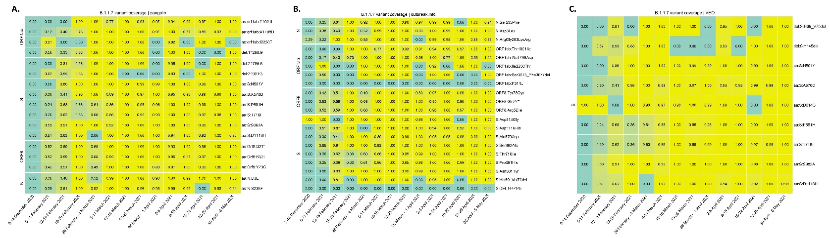
Supplementary Figure 1: Detected mutations of the Alpha variant (B.1.1.7) using data provided by A. outbreak.info, B. pangolin and C. VEO

