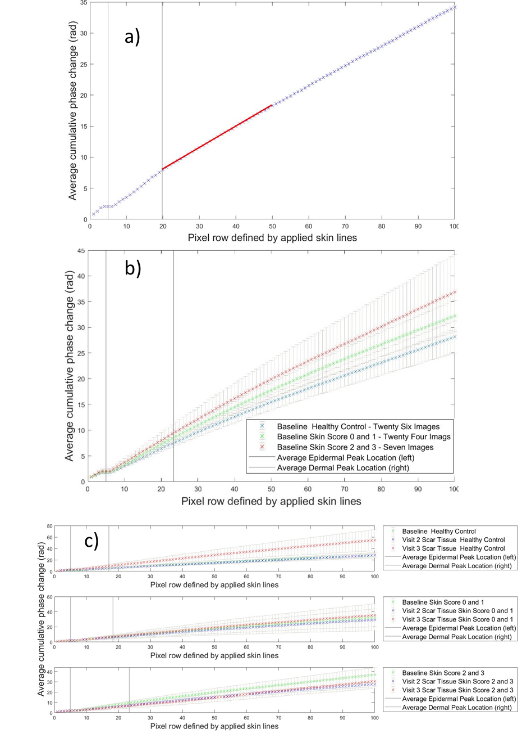
Supplemental figure: Plots from a) Figure 2g, b) Figure 4a and c) Figure 5 with standard errors (in grey) for cumulative measures in depth. In the main figures graphs are shown without errors for clarity of data observation.

