SUPPLEMENTARY MATERIAL
Untargeted sequencing of circulating microRNAs in a healthy and diseased older population
Lukas Streese¹, Philippe Demougin², Paula Iborra³, Alexander Kanitz³, Arne Deiseroth¹, Julia M. Kröpfl¹, Arno Schmidt-Trucksäss¹, Mihaela Zavolan³, Henner Hanssen¹*
¹Department of Sport, Exercise and Health, Medical Faculty, University of Basel, Basel, Switzerland.
²Transfaculty Research Platform Molecular and Cognitive Neurosciences, Life Sciences Training Facility, Biozentrum, University of Basel, Basel, Switzerland.
³Computational and Systems Biology, Biozentrum, University of Basel, Basel, Switzerland.

Short title: Untargeted sequencing of circulating miRNAs

*Address for correspondence:
Prof. Henner Hanssen, FESC
Professor of Preventive Sports Medicine
Department of Sport, Exercise and Health, University of Basel
Birsstrasse 320 B , 4052 Basel
Tel. 041 (0)61 377 8746|Fax 041 (0)61 207 4748
email: henner.hanssen@unibas.ch

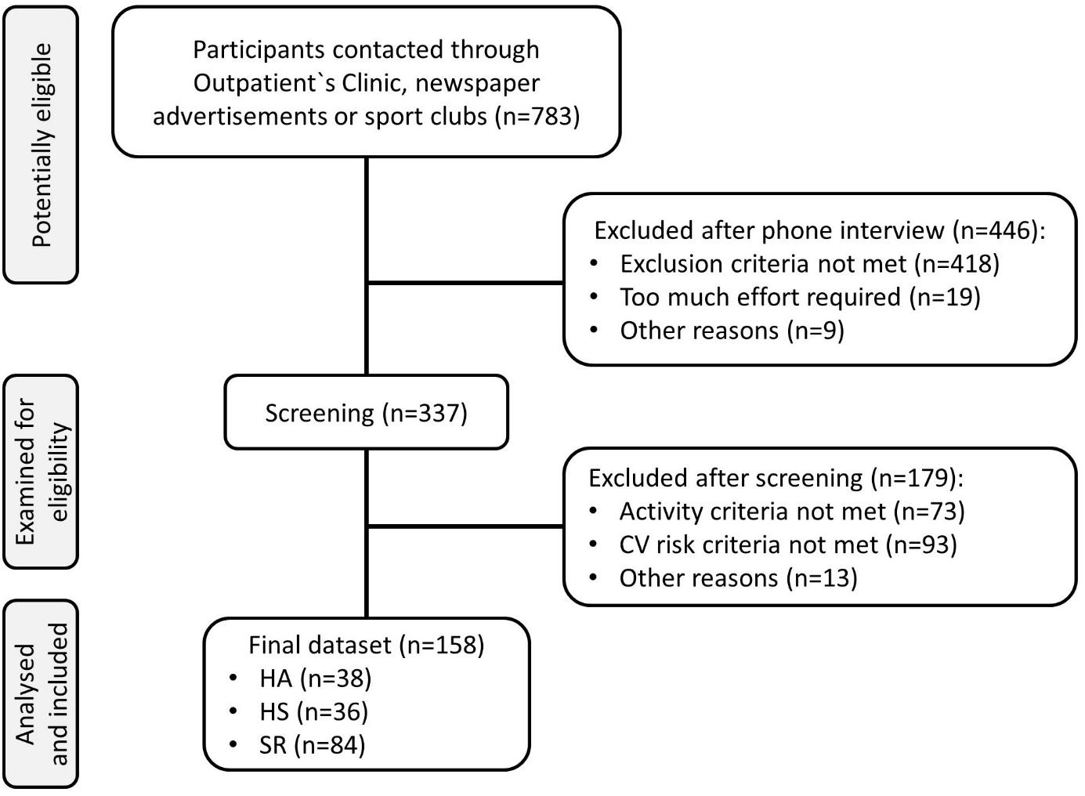
Figure S1. Flow-chart
CV, cardiovascular; HA, healthy active, HS, healthy sedentary, SR, sedentary patients with increased cardiovascular risk.

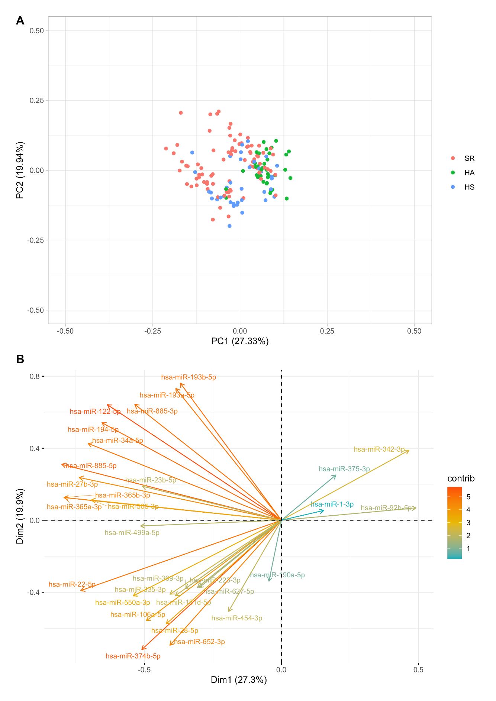
Figure S2. Principal component analysis of the differentially expressed miRNAs only.
(A) Projection of the data on the ﬁrst two principal components, which explain 27% and ~20% of the variance. (B) PCA loadings of all 30 deferentially expressed miRNAs with its contribution to the explained variance in the data (as indicated on the colour scale).

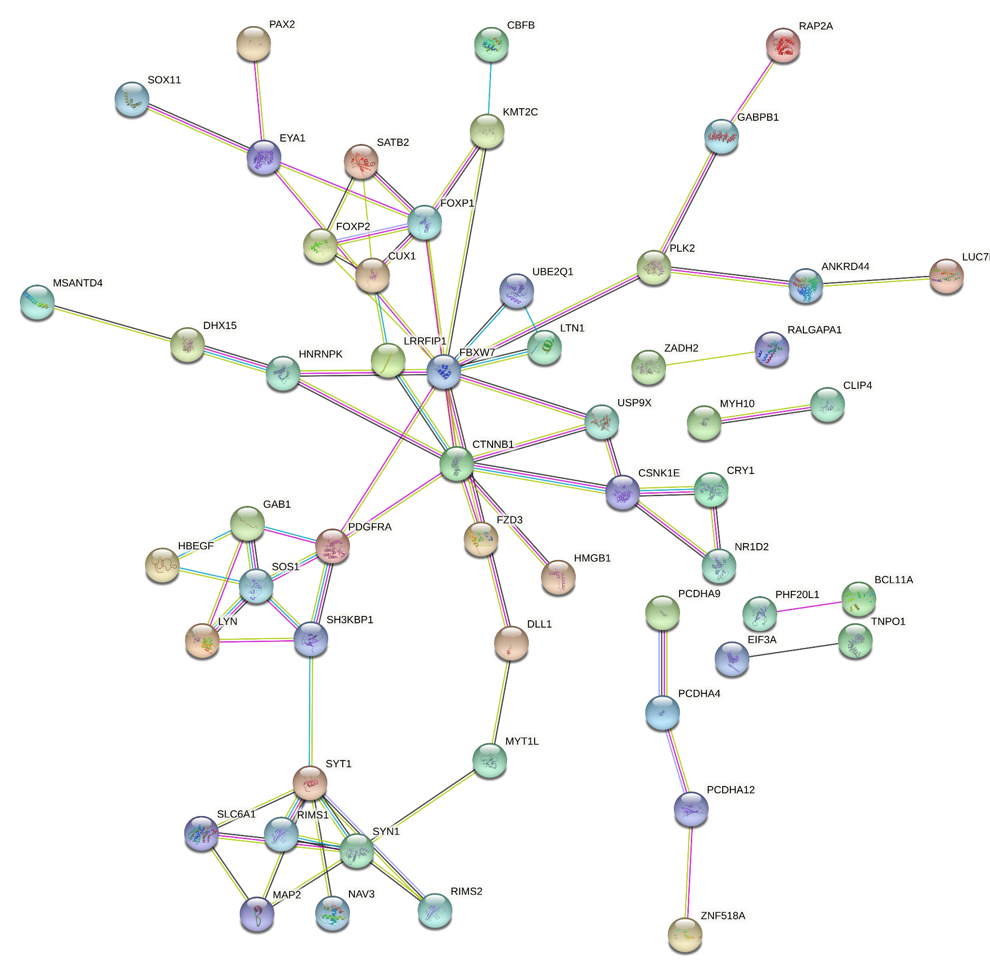
Figure S3. STRING network of top ten target genes associated with cardiovascular disease
Top ten target genes of miRNAs highlighted in Figure 3 (left block) were included in this STRING network. Color saturation of the edges represents the confidence score of the functional association. Red lines, indicates the presence of fusion evidence; green lines, neighborhood evidence; blue lines, cooccurrence evidence; purple lines, experimental evidence; yellow lines, text-mining evidence; light blue lines, database evidence; black lines, co-expression evidence.

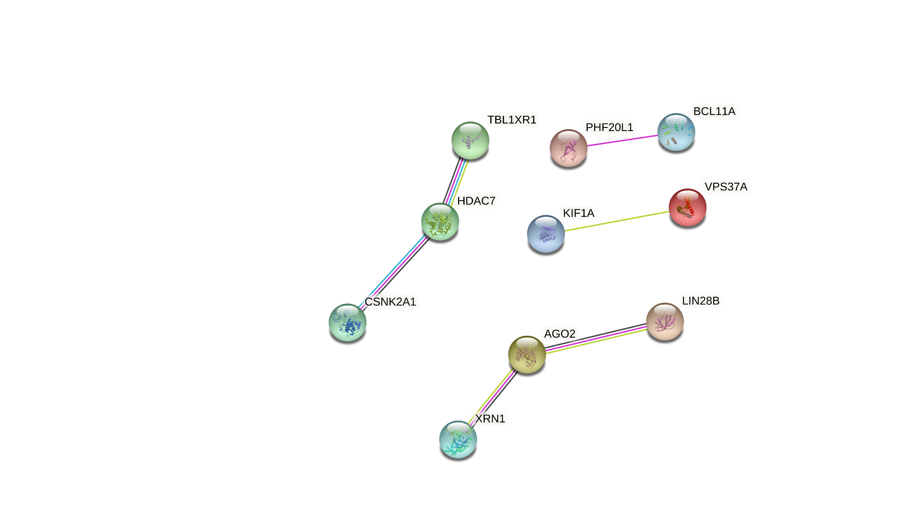
Figure S4. STRING network of top ten target genes associated with a healthy lifestyle
Top ten target genes of miRNAs highlighted in Figure 3 (right block) were included in this STRING network. Color saturation of the edges represents the confidence score of a functional association. Red lines, indicates the presence of fusion evidence; blue lines, cooccurrence evidence; purple lines, experimental evidence; yellow lines, text-mining evidence; light blue lines, database evidence.

Table S1. Risk factors.
Risk factor | Definition | SR  n (%)
Obesity | body mass index ≥30 kg/m² | 71 (85)
Hypertension | ≥140 mmHg systolic or ≥90 mmHg diastolic BP during 24h monitoring or  treatment with antihypertensive medications | 18 (21)  38 (45)
Diabetes | fasting glucose ≥5.6 mmol/l or  antidiabetic medications | 24 (29)  10 (12)
Smoking | current smoking status | 28 (33)
Low HDL | <1.0 mmol/l (male); <1.2 mmol/l (female) | 28 (33)
Hypertriglyceridemia | triglyceride >1.7 mmol/l | 24 (29)
High LDL | >4.9 mmol/l or  cholesterol lowering drugs | 2 (2)  15 (18)
SR, sedentary patients with increased cardiovascular risk; BP, blood pressure; HDL, high-density lipoprotein;
LDL, low-density lipoprotein.
Table S2. Summary of target genes triggered by ≥ three miRNAs described in Figure 3.
Target gene | Gene name | miRNAs
FAM126B | family with sequence similarity 126 member B | miR-342-3p, miR-885-3p, miR-34a-5p, miR-505-3p, miR-27b-3p
MSL2 | male-specific lethal 2 homolog (Drosophila) | miR-34a-5p, miR-27b-3p, miR-885-5p, miR-23b-5
CREBRF | CREB3 regulatory factor | miR-34a-5p, miR-505-3p, miR-27b-3p
KITLG | KIT ligand | miR-34a-5p, miR-505-3p, miR-27b-3p, miR-194-5
MSANTD3 | Myb/SANT-like DNA-binding domain containing 3 | miR-92b-5p, miR-342-3p, miR-23b-5p
LIN28B | lin-28 homolog B | miR-885-3p, miR-27b-3p, miR-194-5
CADM1 | cell adhesion molecule 1 | miR-505-3p, miR-27b-3p, miR-194-5
SORCS1 | sortilin-related VPS10 domain containing receptor 1 | miR-193b-5p, miR-122-5p, miR-885-5p
CHD1 | chromodomain helicase DNA binding protein 1 | miR-885-3p, miR-34a-5p, miR-194-5
ZBTB34 | zinc finger and BTB domain containing 34 | miR-193b-5p, miR-27b-3p, miR-885-5p
FLRT3 | fibronectin leucine rich transmembrane protein 3 | miR-885-3p, miR-505-3p, miR-27b-3p
MEIS2 | meis homeobox 2 | miR-505-3p, miR-27b-3p, miR-194-5
SOX6 | SRY-box transcription factor 6 | miR-342-3p, miR-505-3p, miR-194-5
GALNT7 | polypeptide N-acetylgalactosaminyltransferase 7 | miR-885-3p, miR-34a-5p, miR-27b-3p
MTMR4 | myotubularin related protein 4 | miR-27b-3p, miR-885-5p, miR-23b-5
FOXP1 | forkhead box P1 | miR-193b-5p, miR-122-5p, miR-34a-5p, miR-885-5p
FOXP2 | forkhead box P2 | miR-193b-5p, miR-122-5p, miR-34a-5p, miR-27b-3p
FBXO33 | F-box protein 33 | miR-193b-5p, miR-27b-3p, miR-885-5p
TMEM185B | transmembrane protein 185B | miR-193b-5p, miR-885-5p, miR-23b-5
LCOR | ligand dependent nuclear receptor corepressor | miR-193b-5p, miR-27b-3p, miR-23b-5
DIXDC1 | DIX domain containing 1 | miR-34a-5p, miR-885-5p, miR-23b-5
PDE7A | phosphodiesterase 7A | miR-193b-5p, miR-122-5p, miR-34a-5p, miR-23b-5
CDK14 | cyclin-dependent kinase 14 | miR-193b-5p, miR-27b-3p, miR-885-5p
PLAG1 | pleiomorphic adenoma gene 1 | miR-122-5p, miR-34a-5p, miR-27b-3p
SATB1 | SATB homeobox 1 | miR-193b-5p, miR-122-5p, miR-34a-5p
NPAS3 | neuronal PAS domain protein 3 | miR-122-5p, miR-27b-3p, miR-885-5p

