Supporting Information for

Molecular phylogenetic and morphometric analysis of population structure and demography of endangered threadfin fish Eleutheronema from Indo-Pacific waters

Jie Xiao¹, Shaoliang Lyu¹, Teuku H. Iqbal², Sukree Hajisamae², Karl W.K. Tsim³,
Wen-Xiong Wang^{1,4}*

¹School of Energy and Environment and State Key Laboratory of Marine Pollution, City University of Hong Kong, Kowloon, Hong Kong, China
²Faculty of Science and Technology, Prince of Songkla University, Pattani 94000, Thailand.
³Division of Life Science, Hong Kong University of Science and Technology, Clear Water Bay, Kowloon, Hong Kong, China
⁴Research Centre for the Oceans and Human Health, City University of Hong Kong Shenzhen Research Institute, Shenzhen 518057, China

*Corresponding author, Email: wx.wang@cityu.edu.hk

Figure S1. Phylogenetic tree constructed using 164 CO1 (a) and 164 16s rRNA (b) sequences of Eleutheronema tetradactylum and Eleutheronema rhadinum based on maximum likelihood (ML) methods
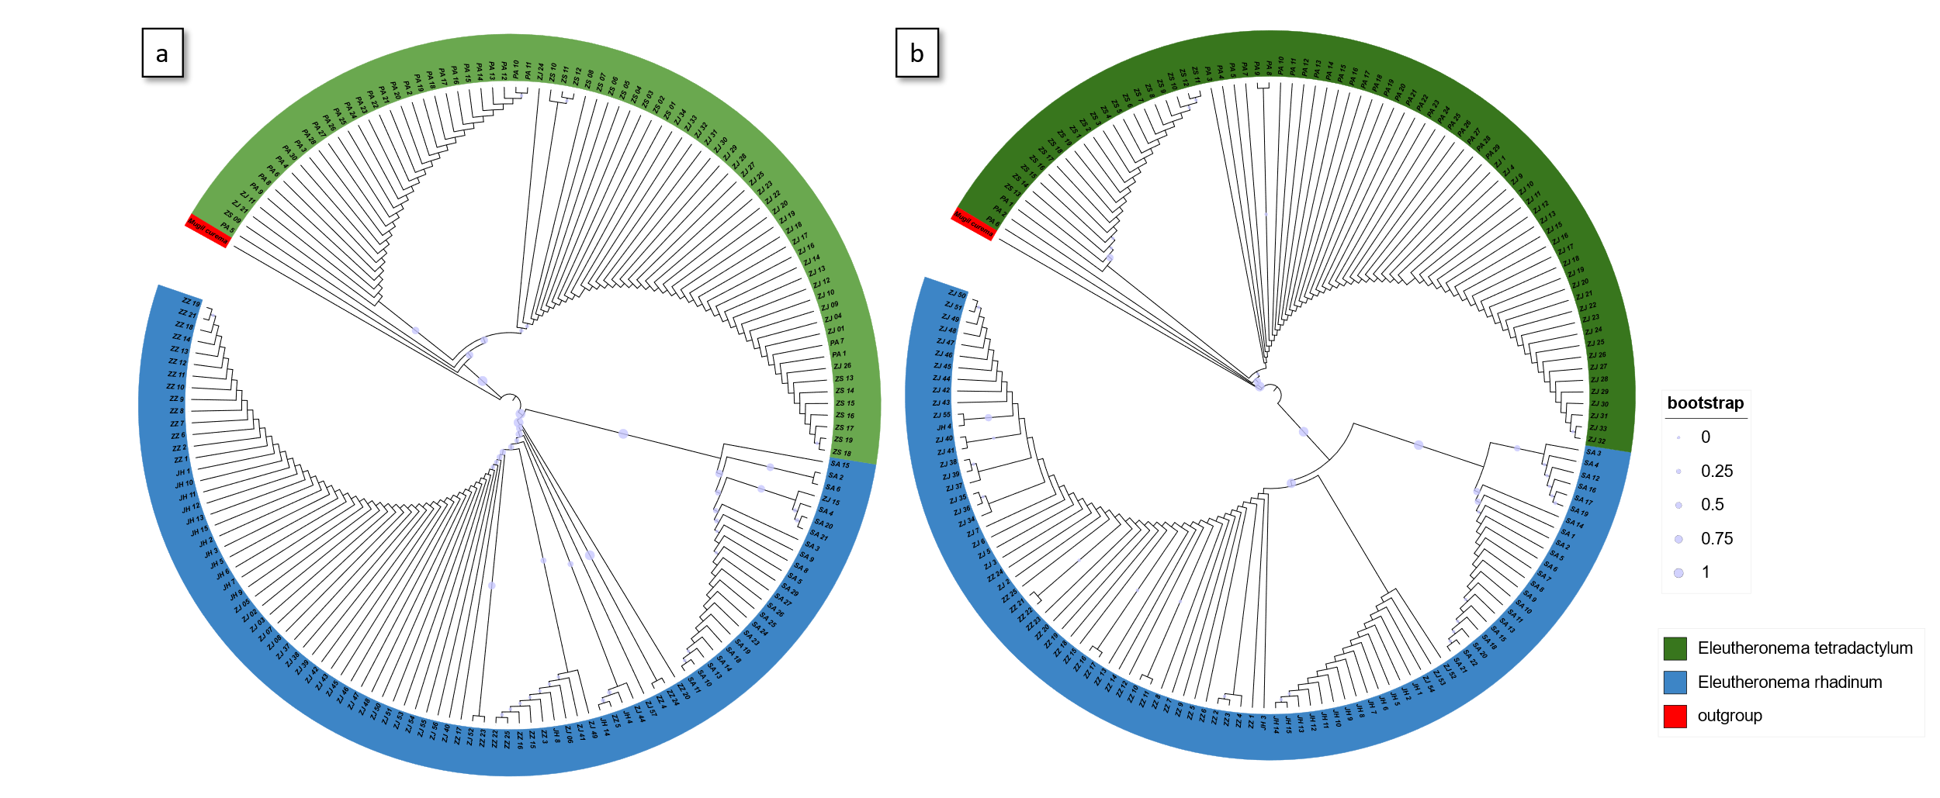
Fig S2. Landmarks coordinates transformation. 1, mouth tip. 2, operculum top. 3, the first dorsal fin front. 4, the first dorsal fin back. 5, the second dorsal fin front. 6, the second dorsal fin back. 7, caudal top. 8, caudal bottom. 9, anal fin back. 10, anal fin front. 11, pectoral fin.

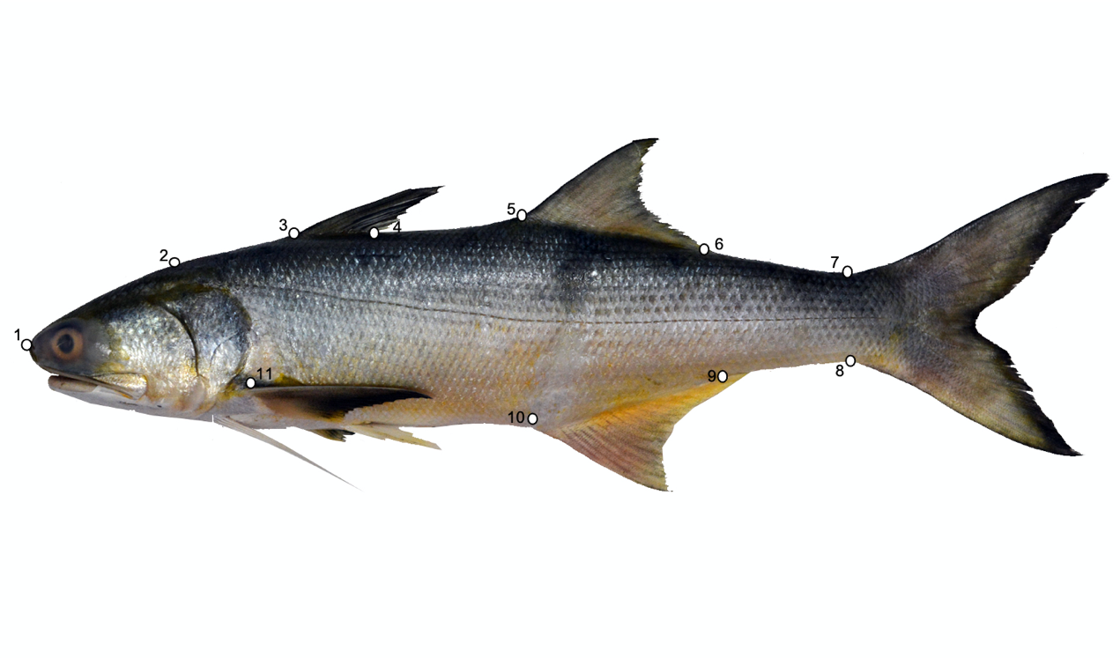

Figure S3. The mismatch distribution analysis (MDA) estimated based on the CO1 haplotypes of (a) Eleutheronema tetradactylum and (b) Eleutheronema rhadinum
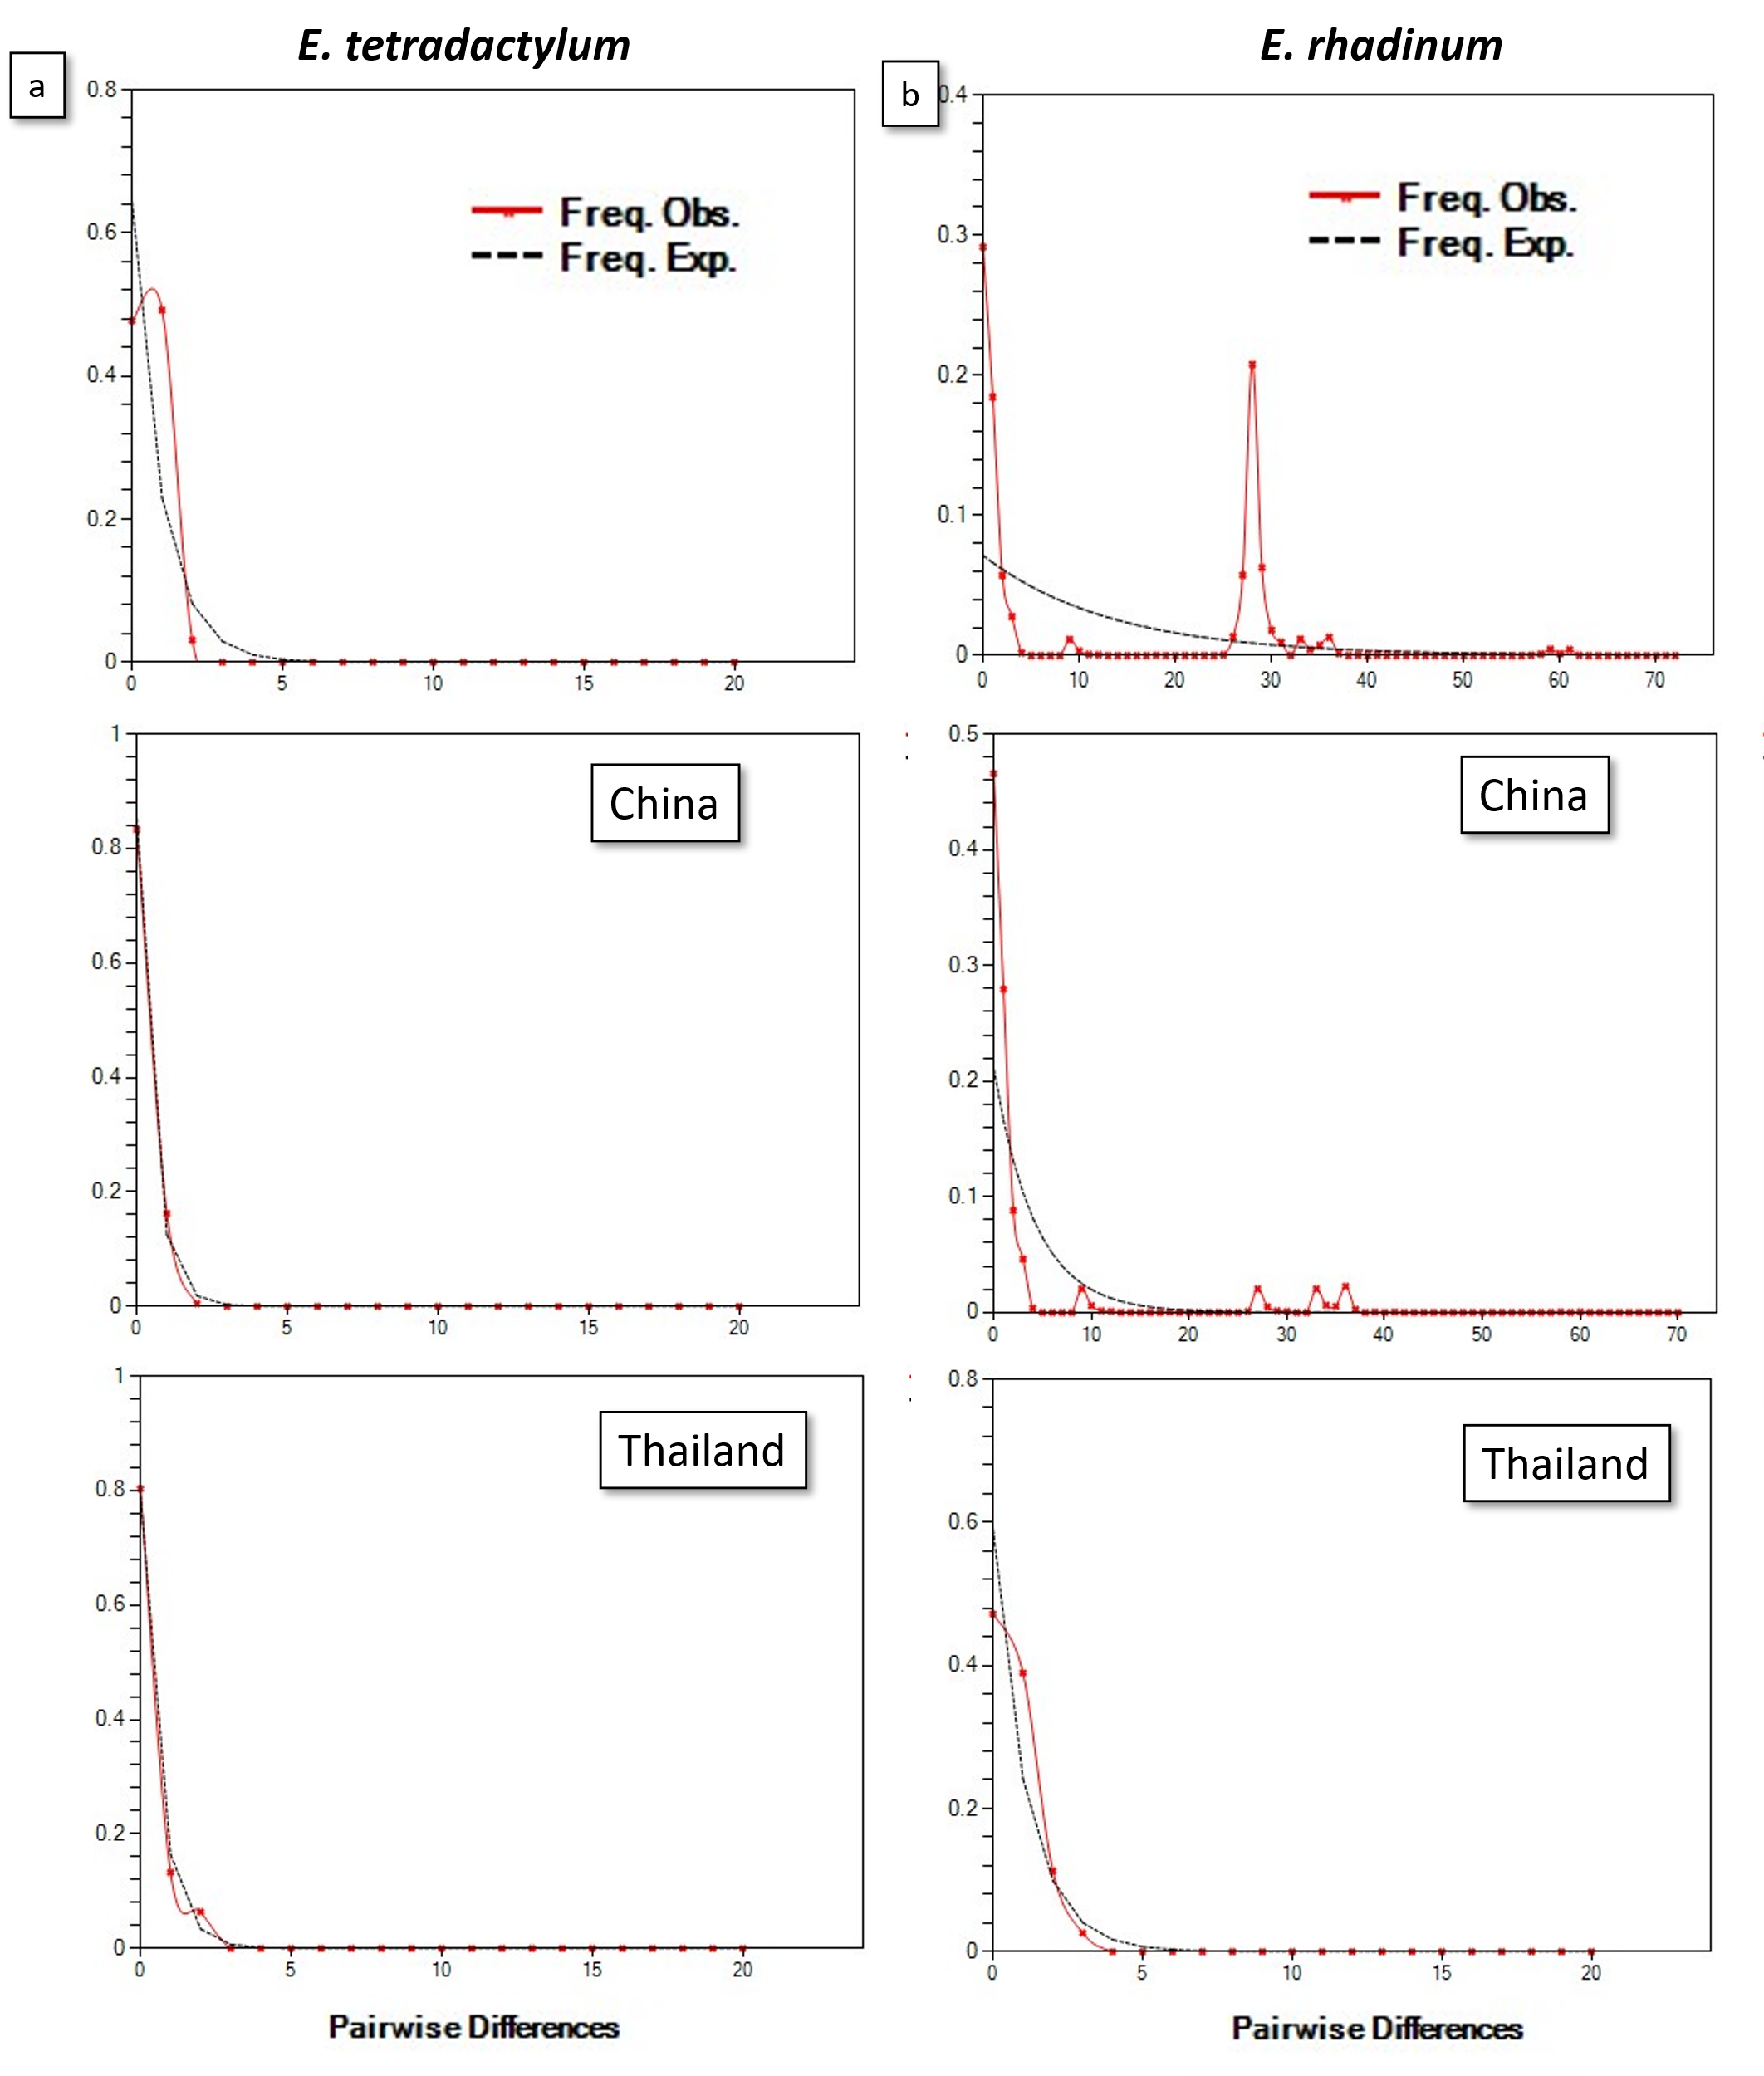
Table S1. Population information and geographical characteristics of E. tetradactylum and E. rhadinum.
Population | N | Location | Latitude | Longitude | Year
Zhanjiang (ZJ) | 54 | China | 20.70 | 110.55 | 2020/10-11
Jianghong (JH) | 15 | China | 21.05 | 109.45 | 2020/11-12
Zhangzhou (ZZ) | 25 | China | 24.25 | 118.08 | 2021/3-4
Zhongshan (ZS) | 19 | China | 22.51 | 113.39 | 2021/6
Pattani Bay (PA) | 29 | Thailand | 6.544 | 101.17 | 2020/11
Satun (SA) | 22 | Thailand | 6.291 | 100.04 | 2020/12

Table S2. CO1 sequences of E. tetradactylum and E. rhadinum used in this study.
Species | Location | Accession number | Reference
E. tetradactylum | Malaysia | MG816119-28 | (Atikah et al. 2020)
 | India | EF609512-13, MG923346-50 | (Lakra et al. 2011)
E. rhadinum | Malaysia | MG816129-38 | (Atikah et al. 2020)
 | Vietnam | MK777485 | (Thu et al. 2019)

Table S3. Pairwise Fst values for CO1 sequences in E. tetradactylum and E. rhadinum.
 | Location | Zhongshan | Zhanjiang
E. tetradactylum | Zhongshan
 | Zhanjiang | 0.01740
 | Pattani bay | 0.81344 | 0.73738
 |  | Zhanjiang | Satun | Jianghong
 | Zhanjiang
E. rhadinum | Satun | 0.93668
 | Jianghong | -0.01308 | 0.97721
 | Zhangzhou | 0.01430 | 0.88497 | 0.02019

Table S4. Haplotypes of CO1 sequences identified in E. tetradactylum and E. rhadinum populations.
 | E. rhadinum |  |  |  |  |  | E. tetradactylum
 | Malaysia | SA | ZJ | Vietnam | JH | ZZ | India | Malaysia | ZS | PA | ZJ
Hap_1 | 1 | 0 | 0 | 0 | 0 | 0 | 0 | 0 | 0 | 0 | 0
Hap_2 | 1 | 0 | 0 | 0 | 0 | 0 | 0 | 0 | 0 | 0 | 0
Hap_3 | 1 | 0 | 0 | 0 | 0 | 0 | 0 | 0 | 0 | 0 | 0
Hap_4 | 1 | 0 | 0 | 0 | 0 | 0 | 0 | 0 | 0 | 0 | 0
Hap_5 | 1 | 0 | 0 | 0 | 0 | 0 | 0 | 0 | 0 | 0 | 0
Hap_6 | 1 | 0 | 0 | 0 | 0 | 0 | 0 | 0 | 0 | 0 | 0
Hap_7 | 1 | 2 | 0 | 0 | 0 | 0 | 0 | 0 | 0 | 0 | 0
Hap_8 | 1 | 0 | 0 | 0 | 0 | 0 | 0 | 0 | 0 | 0 | 0
Hap_9 | 1 | 3 | 1 | 0 | 0 | 0 | 0 | 0 | 0 | 0 | 0
Hap_10 | 1 | 15 | 0 | 0 | 0 | 0 | 0 | 0 | 0 | 0 | 0
Hap_11 | 0 | 0 | 0 | 1 | 0 | 0 | 0 | 0 | 0 | 0 | 0
Hap_12 | 0 | 0 | 1 | 0 | 0 | 0 | 0 | 0 | 0 | 0 | 0
Hap_13 | 0 | 0 | 19 | 0 | 12 | 14 | 0 | 0 | 0 | 0 | 0
Hap_14 | 0 | 0 | 1 | 0 | 0 | 1 | 0 | 0 | 0 | 0 | 0
Hap_15 | 0 | 0 | 3 | 0 | 1 | 5 | 0 | 0 | 0 | 0 | 0
Hap_16 | 0 | 0 | 1 | 0 | 0 | 0 | 0 | 0 | 0 | 0 | 0
Hap_17 | 0 | 0 | 1 | 0 | 0 | 0 | 0 | 0 | 0 | 0 | 0
Hap_18 | 0 | 1 | 0 | 0 | 0 | 0 | 0 | 0 | 0 | 0 | 0
Hap_19 | 0 | 1 | 0 | 0 | 0 | 0 | 0 | 0 | 0 | 0 | 0
Hap_20 | 0 | 0 | 0 | 0 | 2 | 1 | 0 | 0 | 0 | 0 | 0
Hap_21 | 0 | 0 | 0 | 0 | 0 | 1 | 0 | 0 | 0 | 0 | 0
Hap_22 | 0 | 0 | 0 | 0 | 0 | 1 | 0 | 0 | 0 | 0 | 0
Hap_23 | 0 | 0 | 0 | 0 | 0 | 1 | 0 | 0 | 0 | 0 | 0
Hap_24 | 0 | 0 | 0 | 0 | 0 | 1 | 0 | 0 | 0 | 0 | 0
Hap_27 | 0 | 0 | 0 | 0 | 0 | 0 | 5 | 3 | 18 | 2 | 23
Hap_28 | 0 | 0 | 0 | 0 | 0 | 0 | 1 | 0 | 0 | 0 | 0
Hap_29 | 0 | 0 | 0 | 0 | 0 | 0 | 1 | 0 | 0 | 0 | 0
Hap_30 | 0 | 0 | 0 | 0 | 0 | 0 | 0 | 1 | 0 | 0 | 0
Hap_31 | 0 | 0 | 0 | 0 | 0 | 0 | 0 | 1 | 0 | 0 | 0
Hap_32 | 0 | 0 | 0 | 0 | 0 | 0 | 0 | 1 | 0 | 0 | 0
Hap_33 | 0 | 0 | 0 | 0 | 0 | 0 | 0 | 1 | 0 | 0 | 0
Hap_34 | 0 | 0 | 0 | 0 | 0 | 0 | 0 | 1 | 0 | 0 | 0
Hap_35 | 0 | 0 | 0 | 0 | 0 | 0 | 0 | 1 | 0 | 0 | 0
Hap_36 | 0 | 0 | 0 | 0 | 0 | 0 | 0 | 1 | 0 | 26 | 2
Hap_37 | 0 | 0 | 0 | 0 | 0 | 0 | 0 | 0 | 1 | 0 | 0
Hap_38 | 0 | 0 | 0 | 0 | 0 | 0 | 0 | 0 | 0 | 0 | 1
Hap_39 | 0 | 0 | 0 | 0 | 0 | 0 | 0 | 0 | 0 | 0 | 1
Hap_40 | 0 | 0 | 0 | 0 | 0 | 0 | 0 | 0 | 0 | 1 | 0
Hap_25 and Hap_26 represent the haplotype of outgroup, Megalobrama amblycephala and Scophthalmus maximus

Table S5-1. Phenotypic variation within and among the populations of Eleutheronema tetradactylum concerning morphometric variables, unit: cm.
 | Sites
 | Zhanjiang, n= 28 |  | Pattani Bay, n= 30
L_{T} | 45.54 ± 4.09 | (37.83-51.97) | 36.98 ± 2.16 | (31.29-41.14)
L_{S} | 37.38 ± 3.43 | (31.31 -42.59) | 30.2 ± 1.79 | (25.04-33.85)
L_{H} | 9.48 ± 0.89 | (7.85-11.07) | 8.04 ± 1.7 | (6.10-9.23)
D_{B} | 9.23 ± 0.87 | (7.90-11.04) | 7.35 ± 0.5 | (5.92-8.30)
D_{E} | 1.59 ± 0.20 | (1.24-1.96) | 1.45 ± 0.16 | (1.07-1.72)
D_{CP} | 3.99 ± 0.37 | (3.30-4.47) | 3.19 ± 0.27 | (2.61-3.80)
L_{CP} | 5.87 ± 0.64 | (4.74-6.95) | 4.54 ± 0.32 | (3.96-5.25)
L_{CF} | 9.83 ± 0.90 | (8.26-11.15) | 7.87 ± 0.78 | (6.24-9.77)
H_{CF} | 11.13 ± 1.62 | (7.40-13.94) | 7.08 ± 0.94 | (4.89-9.71)

L_{T}: total Length; L_{S}: standard Length; L_{H}: head Length; D_{B}: body depth; D_{E}: eye diameter; D_{CP}: depth of caudal peduncle; L_{CP}: Length of caudal peduncle; L_{CF}: Length of caudal fin; H_{CF}: height of caudal fin.

Table S5-2. Phenotypic variation within and among the populations of Eleutheronema rhadinum concerning morphometric variables, unit: cm.
 | Sites
 | Zhanjiang, n= 28 |  | Jianghong, n= 16 |  | Satun, n=28 |  | Zhangzhou, n=25
L_{T} | 32.02 ±3.97 | (27.43-49.24) | 55.20 ±3.23 | (49.66-59.87) | 49.71±5.47 | (31.96-62.03) | 24.41±4.21 | (19.10-31.93)
L_{S} | 25.45 ±3.09 | (21.66 -38.80) | 44.55 ±2.82 | (40.29-49.52) | 40.02±4.29 | (25.59-49.21) | 19.10±3.25 | (14.95-25.12)
L_{H} | 6.19 ± 0.83 | (5.13-9.60) | 10.39 ± 0.72 | (9.11-11.60) | 9.24±1.11 | (6.45-13.19) | 5.12±0.82 | (3.96-6.48)
D_{B} | 6.48 ± 0.78 | (5.77-9.79) | 10.71 ± 0.82 | (9.62-12.19) | 9.83±1.16 | (5.83-12.49) | 4.65±0.79 | (3.52-6.11)
D_{E} | 1.20 ±0.12 | (0.96-1.57) | 1.57 ± 0.23 | (1.24-2.08) | 1.77±0.18 | (1.19-2.06) | 0.98±0.13 | (0.73-1.27)
D_{CP} | 2.77 ± 0.33 | (2.36-4.16) | 4.13 ± 0.29 | (3.59-4.69) | 3.89±0.39 | (2.46-4.81) | 2.08±0.34 | (1.52-2.66)
L_{CP} | 4.32 ±0.66 | (3.46-7.03) | 7.39 ± 0.65 | (6.53-8.56) | 6.98±1.05 | (3.59-7.87) | 3.29±0.65 | (2.39-4.45)
L_{CF} | 7.47 ± 0.81 | (6.24-10.56) | 12.53 ± 0.81 | (11.29-13.91) | 11.64±1.53 | (7.30-14.88) | 5.99±1.04 | (4.46-7.72)
H_{CF} | 7.09 ± 1.37 | (4.91-10.53) | 11.70 ± 1.26 | (9.25-13.60) | 11.29±2.05 | (6.12- 16.47) | 6.34±1.17 | (4.53-8.86)

L_{T}: total Length; L_{S}: standard Length; L_{H}: head Length; D_{B}: body depth; D_{E}: eye diameter; D_{CP}: depth of caudal peduncle; L_{CP}: Length of caudal peduncle; L_{CF}: Length of caudal fin; H_{CF}: height of caudal fin.
Table S6. Six morphological traits of E. tetradactylum and E. rhadinum.
Species | Location | L_{H}/L_{S} | D_{E}/L_{H} | D_{CP}/L_{CP} | D_{B}/L_{S} | L_{CP}/L_{S} | L_{CF}/L_{CP}
E. tetradactylum | ZJ | 0.254 | 0.168 | 0.685 | 0.247 | 0.157 | 1.68
E. tetradactylum | PA | 0.266 | 0.181 | 0.709 | 0.243 | 0.149 | 1.75
E. rhadinum | ZJ | 0.243 | 0.197 | 0.647 | 0.255 | 0.169 | 1.742
E. rhadinum | SA | 0.227 | 0.193 | 0.548 | 0.247 | 0.177 | 1.652
E. rhadinum | JH | 0.234 | 0.152 | 0.561 | 0.241 | 0.166 | 1.703
E. rhadinum | ZZ | 0.269 | 0.194 | 0.640 | 0.244 | 0.172 | 1.837

L_{H}/L_{S}: head length/standard length; D_{E}/L_{H}: eye diameter/head length; D_{CP}/L_{CP}: depth of caudal peduncle/length of caudal peduncle; D_{B}/L_{S}: body depth/standard length; L_{CP}/L_{S}: length of caudal peduncle/standard length; and L_{CF}/L_{CP}: length of caudal fin/length of caudal peduncle

Table S7. Principal component analysis (PCA) of morphometric variables E. tetradactylum and E. rhadinum.
morphometric variables | E. tetradactylum |  |  | E. rhadinum
morphometric variables | PC1 | PC2 | PC3 | PC1 | PC2 | PC3
L_{H}/L_{S} | 0.07305 | -0.81379 | 0.16073 | 0.38248 | -0.14556 | 0.69152
D_{E}/L_{H} | 0.24707 | 0.32531 | -0.65381 | -0.00309 | 0.67347 | 0.39044
D_{CP}/L_{CP} | 0.55906 | 0.05402 | 0.14679 | 0.56505 | 0.21598 | -0.03541
D_{B}/L_{S} | 0.04688 | 0.46772 | 0.72021 | 0.1037 | 0.66014 | -0.36945
L_{CP}/L_{S} | -0.57972 | 0.09558 | 0.01395 | -0.49438 | 0.19529 | 0.47763
L_{CF}/L_{CP} | 0.53179 | -0.03319 | 0.07908 | 0.52844 | -0.06849 | 0.05898
Percentage of Variance | 42.50% | 19.71% | 19.06% | 42.19% | 23.53% | 15.32%
Cumulative | 42.50% | 62.21% | 81.27% | 42.19% | 65.72% | 81.05%

L_{H}/L_{S}: head length/standard length; D_{E}/L_{H}: eye diameter/head length; D_{CP}/L_{CP}: depth of caudal peduncle/length of caudal peduncle; D_{B}/L_{S}: body depth/standard length; L_{CP}/L_{S}: length of caudal peduncle/standard length; and L_{CF}/L_{CP}: length of caudal fin/ length of caudal peduncle

Table S8-1. Mahalanobis and Procrustes distances among populations of E. tetradactylum and E. rhadinum.

Population | Mahalanobis distances |  |  |  |  | Procrustes distances
Population | ERJH | ERSA | ERZJ | ERZZ | ETPA | ERJH | ERSA | ERZJ | ERZZ | ETPA
ERSA | 2.6777 |  |  |  |  | 0.0276
ERZJ | 5.5718 | 5.25 |  |  |  | 0.041 | 0.0336
ERZZ | 5.7186 | 5.4544 | 4.8768 |  |  | 0.0477 | 0.0458 | 0.0413
ETPA | 7.2411 | 6.2745 | 5.7297 | 6.3985 |  | 0.0696 | 0.055 | 0.0437 | 0.0631
ETZJ | 4.3004 | 3.6127 | 3.2838 | 4.1637 | 5.0451 | 0.0356 | 0.0316 | 0.0244 | 0.0358 | 0.0509

Table S8-2. P-values from permutation tests (10000 permutation rounds) for Mahalanobis and Procrustes distances among populations of E. tetradactylum and E. rhadinum.
Population | P-values for Mahalanobis distances |  |  |  |  | P-values for Procrustes distances
Population | ERJH | ERSA | ERZJ | ERZZ | ETPA | ERJH | ERSA | ERZJ | ERZZ | ETPA
ERSA | <.0001 |  |  |  |  | <.0001
ERZJ | <.0001 | <.0001 |  |  |  | <.0001 | <.0001
ERZZ | <.0001 | <.0001 | <.0001 |  |  | <.0001 | <.0001 | <.0001
ETPA | <.0001 | <.0001 | <.0001 | <.0001 |  | <.0001 | <.0001 | <.0001 | <.0001
ETZJ | <.0001 | <.0001 | <.0001 | <.0001 | <.0001 | <.0001 | <.0001 | <.0001 | <.0001 | <.0001

