Supplementary Figures

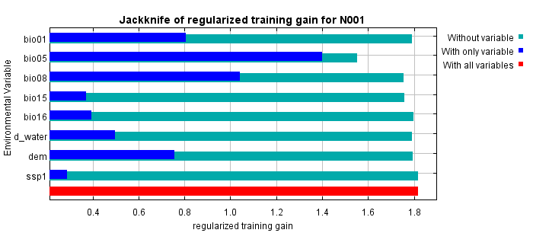
Fig. S1. Jackknife test results showing the relative contributions of variables to the current distribution. bio01, annual mean temperature; bio05, maximum temperature of warmest month; bio08, mean temperature of wettest quarter; bio15, precipitation seasonality; bio16, precipitation of wettest quarter; d_water; distance from water; dem, altitude; ssp1, land cover change.

Fig. S2. Survey of nutria (M. coypus) in different places of South Korea. a, dens; b, feces; c, camera trapping; d, live trap setting; e; direct observation in the Nakdong River, Jinju; f, direct observation in a wetland.

