Historical reconstruction of the population dynamics of southern right whales in the southwestern Atlantic Ocean

Romero, M.A., M.A. Coscarella, G.D. Adams, J.C. Pedraza, R. González and E.A. Crespo

Supplementary material

Table S1. Observed catch series (number of individuals) used in this study. $C_{y}$: annual catch values.

Year | $$C_{y,min}$$ | $$C_{y,max}$$ | Year | $$C_{y,min}$$ | $$C_{y,max}$$
1678 | 20 | 30 | 1849 | 2 | 28
1679 | 20 | 30 | 1850 | 6 | 34
1680 | 20 | 30 | 1851 | 1 | 1
1681 | 20 | 30 | 1852 | 1 | 1
1682 | 20 | 30 | 1853 | 0 | 2
1683 | 20 | 30 | 1854 | 0 | 0
1684 | 20 | 30 | 1855 | 0 | 2
1685 | 20 | 30 | 1856 | 1 | 44
1686 | 20 | 30 | 1857 | 6 | 8
1687 | 20 | 30 | 1858 | 7 | 19
1688 | 20 | 30 | 1859 | 5 | 6
1689 | 20 | 30 | 1860 | 8 | 14
1690 | 20 | 30 | 1861 | 0 | 10
1691 | 20 | 30 | 1862 | 5 | 16
1692 | 20 | 30 | 1863 | 15 | 34
1693 | 20 | 30 | 1864 | 7 | 22
1694 | 20 | 30 | 1865 | 0 | 23
1695 | 20 | 30 | 1866 | 5 | 17
1696 | 20 | 30 | 1867 | 0 | 3
1697 | 20 | 30 | 1868 | 0 | 24
1698 | 20 | 30 | 1869 | 0 | 45
1699 | 20 | 30 | 1870 | 0 | 19
1700 | 20 | 30 | 1871 | 0 | 16
1701 | 20 | 30 | 1872 | 0 | 25
1702 | 20 | 30 | 1873 | 0 | 7
1703 | 20 | 30 | 1874 | 0 | 27
1704 | 20 | 30 | 1875 | 0 | 10
1705 | 20 | 30 | 1876 | 0 | 5
1706 | 20 | 30 | 1877 | 0 | 4
1707 | 20 | 30 | 1878 | 2 | 17
1708 | 20 | 30 | 1879 | 5 | 21
1709 | 20 | 30 | 1880 | 0 | 27
1710 | 20 | 30 | 1881 | 0 | 12
1711 | 20 | 30 | 1882 | 0 | 21
1712 | 20 | 30 | 1883 | 0 | 36
1713 | 20 | 30 | 1884 | 0 | 15
1714 | 20 | 30 | 1885 | 0 | 7
1715 | 20 | 30 | 1886 | 0 | 12
1716 | 20 | 30 | 1887 | 1 | 28
1717 | 20 | 30 | 1888 | 4 | 23
1718 | 20 | 30 | 1889 | 3 | 40
1719 | 20 | 30 | 1890 | 0 | 13
1720 | 20 | 30 | 1891 | 0 | 18
1721 | 20 | 30 | 1892 | 0 | 2
1722 | 20 | 30 | 1893 | 0 | 73
1723 | 20 | 30 | 1894 | 0 | 41
1724 | 20 | 30 | 1895 | 0 | 8
1725 | 20 | 30 | 1896 | 0 | 0
1726 | 20 | 30 | 1897 | 0 | 2
1727 | 20 | 30 | 1898 | 0 | 0
1728 | 20 | 30 | 1899 | 0 | 32
1729 | 20 | 30 | 1900 | 0 | 0
1730 | 20 | 30 | 1901 | 0 | 0
1731 | 20 | 30 | 1902 | 0 | 0
1732 | 20 | 30 | 1903 | 0 | 0
1733 | 20 | 30 | 1904 | 0 | 0
1734 | 20 | 30 | 1905 | 0 | 0
1735 | 20 | 30 | 1906 | 0 | 0
1736 | 20 | 30 | 1907 | 93 | 93
1737 | 20 | 30 | 1908 | 65 | 65
1738 | 20 | 30 | 1909 | 56 | 56
1739 | 20 | 30 | 1910 | 117 | 117
1740 | 20 | 30 | 1911 | 95 | 95
1741 | 20 | 30 | 1912 | 26 | 26
1742 | 20 | 30 | 1913 | 67 | 67
1743 | 20 | 30 | 1914 | 21 | 21
1744 | 20 | 30 | 1915 | 19 | 19
1745 | 20 | 30 | 1916 | 15 | 15
1746 | 20 | 30 | 1917 | 54 | 54
1747 | 20 | 30 | 1918 | 14 | 14
1748 | 104 | 196 | 1919 | 15 | 15
1749 | 104 | 196 | 1920 | 13 | 13
1750 | 104 | 196 | 1921 | 10 | 10
1751 | 20 | 30 | 1922 | 1 | 1
1752 | 20 | 30 | 1923 | 12 | 12
1753 | 20 | 30 | 1924 | 12 | 12
1754 | 20 | 30 | 1925 | 1 | 1
1755 | 20 | 30 | 1926 | 1 | 1
1756 | 20 | 30 | 1927 | 3 | 3
1757 | 20 | 30 | 1928 | 3 | 3
1758 | 20 | 30 | 1929 | 1 | 1
1759 | 20 | 30 | 1930 | 1 | 1
1760 | 20 | 30 | 1931 | 2 | 2
1761 | 20 | 1750 | 1932 | 1 | 1
1762 | 20 | 1750 | 1933 | 1 | 1
1763 | 20 | 1750 | 1934 | 9 | 9
1764 | 20 | 1750 | 1935 | 0 | 0
1765 | 20 | 1750 | 1936 | 0 | 0
1766 | 20 | 1750 | 1937 | 0 | 0
1767 | 20 | 1750 | 1938 | 0 | 0
1768 | 20 | 1750 | 1939 | 1 | 1
1769 | 20 | 1750 | 1940 | 1 | 1
1770 | 20 | 1750 | 1941 | 0 | 0
1771 | 0 | 1750 | 1942 | 0 | 0
1772 | 1002 | 1002 | 1943 | 0 | 0
1773 | 1003 | 1003 | 1944 | 0 | 0
1774 | 1006 | 1006 | 1945 | 0 | 0
1775 | 1016 | 1016 | 1946 | 1 | 1
1776 | 1326 | 1326 | 1947 | 0 | 0
1777 | 994 | 994 | 1948 | 0 | 0
1778 | 970 | 970 | 1949 | 0 | 0
1779 | 880 | 880 | 1950 | 0 | 0
1780 | 772 | 772 | 1951 | 0 | 0
1781 | 700 | 700 | 1952 | 0 | 0
1782 | 645 | 645 | 1953 | 5 | 5
1783 | 635 | 635 | 1954 | 0 | 0
1784 | 670 | 670 | 1955 | 1 | 1
1785 | 907 | 907 | 1956 | 0 | 0
1786 | 857 | 857 | 1957 | 10 | 10
1787 | 1175 | 1175 | 1958 | 0 | 0
1788 | 1175 | 1175 | 1959 | 0 | 0
1789 | 854 | 854 | 1960 | 1 | 1
1790 | 720 | 720 | 1961 | 1335 | 1335
1791 | 791 | 791 | 1962 | 509 | 509
1792 | 780 | 780 | 1963 | 37 | 37
1793 | 760 | 760 | 1964 | 0 | 0
1794 | 610 | 610 | 1965 | 0 | 0
1795 | 780 | 780 | 1966 | 47 | 47
1796 | 548 | 548 | 1967 | 0 | 0
1797 | 518 | 518 | 1968 | 0 | 0
1798 | 396 | 396 | 1969 | 0 | 0
1799 | 376 | 376 | 1970 | 0 | 0
1800 | 650 | 650 | 1971 | 0 | 0
1801 | 673 | 673 | 1972 | 0 | 0
1802 | 601 | 601 | 1973 | 1 | 1
1803 | 727 | 727 | 1974 | 0 | 0
1804 | 581 | 581 | 1975 | 0 | 0
1805 | 577 | 577 | 1976 | 0 | 0
1806 | 553 | 553 | 1977 | 0 | 0
1807 | 474 | 474 | 1978 | 0 | 0
1808 | 667 | 667 | 1979 | 0 | 0
1809 | 543 | 543 | 1980 | 0 | 0
1810 | 400 | 400 | 1981 | 0 | 0
1811 | 184 | 184 | 1982 | 0 | 0
1812 | 40 | 40 | 1983 | 0 | 0
1813 | 34 | 34 | 1984 | 0 | 0
1814 | 0 | 673 | 1985 | 0 | 0
1815 | 0 | 647 | 1986 | 0 | 0
1816 | 0 | 1027 | 1987 | 0 | 0
1817 | 71 | 918 | 1988 | 0 | 0
1818 | 113 | 1154 | 1989 | 0 | 0
1819 | 201 | 1436 | 1990 | 0 | 0
1820 | 233 | 1454 | 1991 | 0 | 0
1821 | 171 | 1216 | 1992 | 0 | 0
1822 | 133 | 774 | 1993 | 0 | 0
1823 | 148 | 864 | 1994 | 0 | 0
1824 | 136 | 835 | 1995 | 0 | 0
1825 | 244 | 762 | 1996 | 0 | 0
1826 | 163 | 754 | 1997 | 0 | 0
1827 | 173 | 805 | 1998 | 0 | 0
1828 | 122 | 788 | 1999 | 0 | 0
1829 | 172 | 663 | 2000 | 0 | 0
1830 | 187 | 854 | 2001 | 0 | 0
1831 | 195 | 274 | 2002 | 0 | 0
1832 | 203 | 233 | 2003 | 0 | 0
1833 | 229 | 309 | 2004 | 0 | 0
1834 | 199 | 243 | 2005 | 0 | 0
1835 | 78 | 443 | 2006 | 0 | 0
1836 | 107 | 232 | 2007 | 0 | 0
1837 | 13 | 378 | 2008 | 0 | 0
1838 | 21 | 258 | 2009 | 0 | 0
1839 | 1 | 60 | 2010 | 0 | 0
1840 | 2 | 146 | 2011 | 0 | 0
1841 | 2 | 83 | 2012 | 0 | 0
1842 | 0 | 29 | 2013 | 0 | 0
1843 | 2 | 21 | 2014 | 0 | 0
1844 | 1 | 1 | 2015 | 0 | 0
1845 | 4 | 79 | 2016 | 0 | 0
1846 | 3 | 6 | 2017 | 0 | 0
1847 | 0 | 67 | 2018 | 0 | 0
1848 | 5 | 45 | 2019 | 0 | 0

Table S2. Observed total number of whales from the aerial-survey across the monitoring area south of Península Valdés to the limit of the main concentration area, totalling a coastal strip 620 km in length.

Flight | Year | Month | Observed whales | Julian day
1 | 1999 | 5 | 5 | 139
2 | 1999 | 7 | 117 | 183
3 | 1999 | 8 | 460 | 229
4 | 1999 | 9 | 549 | 272
5 | 1999 | 11 | 172 | 314
6 | 1999 | 12 | 10 | 349
9 | 2000 | 5 | 43 | 149
10 | 2000 | 7 | 323 | 194
11 | 2000 | 9 | 558 | 271
12 | 2000 | 11 | 296 | 319
19 | 2005 | 6 | 84 | 159
20 | 2005 | 7 | 591 | 200
21 | 2005 | 9 | 733 | 251
22 | 2005 | 10 | 217 | 298
23 | 2005 | 12 | 3 | 351
25 | 2006 | 3 | 1 | 87
26 | 2006 | 5 | 4 | 130
27 | 2006 | 7 | 657 | 212
28 | 2006 | 9 | 786 | 250
29 | 2006 | 10 | 484 | 296
32 | 2007 | 5 | 57 | 143
33 | 2007 | 6 | 393 | 177
34 | 2007 | 8 | 1006 | 234
36 | 2007 | 10 | 957 | 275
37 | 2007 | 11 | 108 | 328
39 | 2008 | 4 | 16 | 120
40 | 2008 | 7 | 606 | 183
42 | 2008 | 9 | 621 | 251
43 | 2008 | 9 | 502 | 267
44 | 2008 | 11 | 173 | 315
46 | 2009 | 5 | 5 | 126
47 | 2009 | 6 | 335 | 176
48 | 2009 | 9 | 705 | 253
49 | 2010 | 4 | 6 | 117
50 | 2010 | 10 | 662 | 274
51 | 2011 | 5 | 14 | 133
52 | 2011 | 8 | 1262 | 228
53 | 2011 | 10 | 284 | 278
54 | 2012 | 5 | 58 | 144
55 | 2012 | 8 | 802 | 215
56 | 2013 | 5 | 50 | 138
57 | 2013 | 7 | 1143 | 207
58 | 2013 | 9 | 909 | 249
59 | 2013 | 11 | 161 | 317
60 | 2014 | 4 | 1 | 113
61 | 2014 | 6 | 253 | 170
62 | 2014 | 10 | 468 | 281
63 | 2015 | 4 | 3 | 113
64 | 2015 | 6 | 112 | 159
65 | 2015 | 9 | 557 | 257
66 | 2015 | 10 | 278 | 275
67 | 2015 | 11 | 102 | 322
68 | 2016 | 8 | 725 | 222
69 | 2016 | 9 | 439 | 265
70 | 2016 | 10 | 112 | 301
71 | 2017 | 7 | 542 | 188
72 | 2017 | 9 | 838 | 247
73 | 2017 | 10 | 246 | 294
74 | 2018 | 5 | 39 | 143
75 | 2018 | 8 | 1079 | 213
76 | 2018 | 8 | 1605 | 243
77 | 2019 | 7 | 301 | 189
78 | 2019 | 8 | 1077 | 237
79 | 2019 | 10 | 362 | 275

Table S3. Estimated abundance ($A_{y}$: accumulated number of right whales) and log-scale variance-covariance matrix from the two stage regression model. Regression parameters were estimated as follows intercept $a=-13.26 (0.66 SE)$, julian day $c=0.16 (0.0060 SE)$, and Julian day^2 $d=-0.00034 (0.000013 SE)$. Year specific regression parameters ($b_{y}$) are given below.
 |  |  |  | $$Σ$$
Year | $$b_{y}$$ | $$A_{y}$$ |  | 1999 | 2000 | 2005 | 2006 | 2007 | 2008 | 2009 | 2010 | 2011 | 2012 | 2013 | 2014 | 2015 | 2016 | 2017 | 2018 | 2019
1999 | 0 | 956 |  | 0.0261 | 0.0015 | 0.0016 | 0.0007 | 0.0014 | 0.0013 | 0.0009 | 0.0019 | 0.0008 | 0.0008 | 0.0012 | 0.0015 | 0.0015 | 0.0004 | 0.0002 | 0.0001 | 0.0004
2000 | 0.666 (0.239) | 1,868 |  | 0.0015 | 0.0339 | 0.0011 | 0.0007 | 0.0013 | 0.0011 | 0.0011 | 0.0017 | 0.0006 | 0.0008 | 0.0009 | 0.0017 | 0.0014 | 0.0001 | 0.0001 | 0.0004 | 0.0000
2005 | 0.219 (0.229) | 1,193 |  | 0.0016 | 0.0011 | 0.0294 | 0.0007 | 0.0011 | 0.0011 | 0.0005 | 0.0015 | 0.0007 | 0.0006 | 0.0012 | 0.0013 | 0.0014 | 0.0002 | 0.0001 | 0.0003 | 0.0000
2006 | 0.428 (0.243) | 1,473 |  | 0.0007 | 0.0007 | 0.0007 | 0.0346 | 0.0009 | 0.0007 | 0.0010 | 0.0011 | 0.0005 | 0.0008 | 0.0007 | 0.0012 | 0.0009 | 0.0001 | 0.0002 | 0.0006 | 0.0002
2007 | 0.85 (0.225) | 2,237 |  | 0.0014 | 0.0013 | 0.0011 | 0.0009 | 0.0272 | 0.0010 | 0.0009 | 0.0015 | 0.0007 | 0.0011 | 0.0012 | 0.0015 | 0.0014 | 0.0002 | 0.0003 | 0.0004 | 0.0000
2008 | 0.714 (0.229) | 1,953 |  | 0.0013 | 0.0011 | 0.0011 | 0.0007 | 0.0010 | 0.0289 | 0.0008 | 0.0012 | 0.0006 | 0.0005 | 0.0009 | 0.0010 | 0.0012 | 0.0002 | 0.0003 | 0.0002 | 0.0001
2009 | 0.437 (0.275) | 1,499 |  | 0.0009 | 0.0011 | 0.0005 | 0.0010 | 0.0009 | 0.0008 | 0.0515 | 0.0013 | 0.0010 | 0.0024 | 0.0009 | 0.0018 | 0.0009 | 0.0004 | 0.0003 | 0.0013 | 0.0006
2010 | 0.528 (0.337) | 1,676 |  | 0.0019 | 0.0017 | 0.0015 | 0.0011 | 0.0015 | 0.0012 | 0.0013 | 0.0910 | 0.0010 | 0.0020 | 0.0016 | 0.0016 | 0.0017 | 0.0002 | 0.0003 | 0.0009 | 0.0003
2011 | 0.364 (0.269) | 1,387 |  | 0.0008 | 0.0006 | 0.0007 | 0.0005 | 0.0007 | 0.0006 | 0.0010 | 0.0010 | 0.0477 | 0.0010 | 0.0006 | 0.0009 | 0.0008 | 0.0001 | 0.0003 | 0.0004 | 0.0001
2012 | 0.684 (0.308) | 1,936 |  | 0.0008 | 0.0008 | 0.0006 | 0.0008 | 0.0011 | 0.0005 | 0.0024 | 0.0020 | 0.0010 | 0.0700 | 0.0013 | 0.0019 | 0.0009 | 0.0008 | 0.0001 | 0.0017 | 0.0003
2013 | 0.847 (0.24) | 2,238 |  | 0.0012 | 0.0009 | 0.0012 | 0.0007 | 0.0012 | 0.0009 | 0.0009 | 0.0016 | 0.0006 | 0.0013 | 0.0340 | 0.0012 | 0.0012 | 0.0001 | 0.0001 | 0.0003 | 0.0001
2014 | 0.495 (0.283) | 1,592 |  | 0.0015 | 0.0017 | 0.0013 | 0.0012 | 0.0015 | 0.0010 | 0.0018 | 0.0016 | 0.0009 | 0.0019 | 0.0012 | 0.0571 | 0.0014 | 0.0000 | 0.0003 | 0.0009 | 0.0001
2015 | 0.253 (0.235) | 1,234 |  | 0.0015 | 0.0014 | 0.0014 | 0.0009 | 0.0014 | 0.0012 | 0.0009 | 0.0017 | 0.0008 | 0.0009 | 0.0012 | 0.0014 | 0.0321 | 0.0004 | 0.0005 | 0.0002 | 0.0003
2016 | -0.009 (0.261) | 954 |  | 0.0004 | 0.0001 | 0.0002 | 0.0001 | 0.0002 | 0.0002 | 0.0004 | 0.0002 | 0.0001 | 0.0008 | 0.0001 | 0.0000 | 0.0004 | 0.0432 | 0.0001 | 0.0005 | 0.0001
2017 | 0.49 (0.261) | 1,570 |  | 0.0002 | 0.0001 | 0.0001 | 0.0002 | 0.0003 | 0.0003 | 0.0003 | 0.0003 | 0.0003 | 0.0001 | 0.0001 | 0.0003 | 0.0005 | 0.0001 | 0.0422 | 0.0000 | 0.0000
2018 | 0.824 (0.265) | 2,201 |  | 0.0001 | 0.0004 | 0.0003 | 0.0006 | 0.0004 | 0.0002 | 0.0013 | 0.0009 | 0.0004 | 0.0017 | 0.0003 | 0.0009 | 0.0002 | 0.0005 | 0.0000 | 0.0445 | 0.0004
2019 | 0.293 (0.263) | 1,291 |  | 0.0004 | 0.0000 | 0.0000 | 0.0002 | 0.0000 | 0.0001 | 0.0006 | 0.0003 | 0.0001 | 0.0003 | 0.0001 | 0.0001 | 0.0003 | 0.0001 | 0.0000 | 0.0004 | 0.0422

Table S4. Estimable parameters and prior specifications for considered in the sensitivity analyses (Scens 1-14).
Sensitivity | $$R_{max}$$ | $$σ^{2}$$ | $$Pmsy$$ | SLR | Catch | $$N_{recent}$$ | Q | N-haplotypes
Base | $$runif(0, 0.11)$$ | $$runif\left(1, 10\right)*0.0000651$$ | unif(0.5, 0.8) | Include | $$unif(Low, High)$$ | 2019 U[100, 10,000] | Analytical | 24
1 | $$rlnom(-2.67, 0.5)$$ | $$runif\left(1, 10\right)*0.0000651$$ | unif(0.5, 0.8) | Include | $$unif(Low, High)$$ | 2019 U[100, 10,000] | Analytical | 24
2 | $$rlnom(-2.67, 0.3)$$ | $$runif\left(1, 10\right)*0.0000651$$ | unif(0.5, 0.8) | Include | $$unif(Low, High)$$ | 2019 U[100, 10,000] | Analytical | 24
3 | $$rlnom\left(-2.67, 0.5\right)$$  $$T(0.02,0.11)$$ | $$runif\left(1, 10\right)*0.0000651$$ | unif(0.5, 0.8) | Include | $$unif(Low, High)$$ | 2019 U[100, 10,000] | Analytical | 24
4 | $$runif(0, 0.11)$$ | $$runif\left(1, 100\right)*0.0000651$$ | unif(0.5, 0.8) | Include | $$unif(Low, High)$$ | 2019 U[100, 10,000] | Analytical | 24
5 | $$runif(0, 0.11)$$ | $$runif\left(1, 2\right)*0.0000651$$ | unif(0.5, 0.8) | Include | $$unif(Low, High)$$ | 2019 U[100, 10,000] | Analytical | 24
6 | $$runif(0, 0.11)$$ | $$runif\left(1, 10\right)*0.0000651$$ | unif(0.5, 0.8) | Include | $$unif(Low, High)$$ | 2004 U[100, 10,000] | Analytical | 24
7 | $$runif(0, 0.11)$$ | $$runif\left(1, 10\right)*0.0000651$$ | unif(0.5, 0.8) | Exclude | $$unif(Low, High)$$ | 2019 U[100, 10,000] | Analytical | 24
8 | $$runif(0, 0.11)$$ | $$runif\left(1, 10\right)*0.0000651$$ | unif(0.5, 0.8) | Include | $$low$$ | 2019 U[100, 10,000] | Analytical | 24
9 | $$runif(0, 0.11)$$ | $$runif\left(1, 10\right)*0.0000651$$ | unif(0.5, 0.8) | Include | $$high$$ | 2019 U[100, 10,000] | Analytical | 24
10 | $$runif(0, 0.11)$$ | $$runif\left(1, 10\right)*0.0000651$$ | unif(0.5, 0.8) | Include | $$unif(Low, High)$$ | 2019 U[100, 10,000] | Analytical | 0
11 | $$runif(0, 0.11)$$ | $$runif\left(1, 10\right)*0.0000651$$ | unif(0.5, 0.8) | Include | $$unif(Low, High)$$ | 2019 U[100, 10,000] | Analytical | 25
12 | $$runif(0, 0.11)$$ | $$runif\left(1, 10\right)*0.0000651$$ | unif(0.5, 0.8) | Include | $$unif(Low, High)$$ | 2019 U[100, 10,000] | Analytical | 37
13 | $$runif(0, 0.11)$$ | $$runif\left(1, 10\right)*0.0000651$$ | unif(0.5, 0.8) | Include | $$unif(Low, High)$$ | 2019 U[100, 10,000] | Analytical + additional obs error | 24
14 | $$runif(0, 0.11)$$ | $$runif\left(1, 10\right)*0.0000651$$ | unif(0.5, 0.8) | Include | $$unif(Low, High)$$ | 2019 U[100, 10,000] | Analytical + power function | 24

Table S5. Posterior mean, standard deviations and 50% and 95% Bayesian credible intervals (CI) for the key biological parameters estimated by the individual state-space assessment models of the southern right whale Eubalaena australis. $P_{Min}$ refers to the minimum estimated abundance relative to $K$. $\hat{q}$ refers to the distribution of analytical catchability across posterior draws while $q$ refers to the posterior distribution of catchability.

S5.0 Model average
 | Mean | Median | 2.5% | 25% | 75% | 97.5%
$$R_{max}$$ | 0.014 | 0.012 | 0.001 | 0.006 | 0.02 | 0.034
$$K$$ | 60,682 | 58,212 | 33,329 | 48,271 | 70,580 | 100,920
$$z$$ | 4.245 | 3.408 | 1.066 | 1.903 | 6.052 | 10.56
$$P_{MSY}$$ | 0.648 | 0.647 | 0.506 | 0.571 | 0.724 | 0.793
$$σ$$ | 0.0189 | 0.0197 | 0.0091 | 0.0155 | 0.0229 | 0.0253
$$N_{Min}$$ | 1,958 | 1,829 | 355 | 969 | 2,919 | 3,969
$$N_{2019}$$ | 4,667 | 4,634 | 3,857 | 4,333 | 4,964 | 5,668
$$N_{2021}$$ | 4,796 | 4,742 | 3,853 | 4,400 | 5,143 | 6,013
$$N_{2030}$$ | 5,466 | 5,299 | 3,886 | 4,698 | 6,079 | 7,931
$$P_{Min}$$ | 0.032 | 0.03 | 0.008 | 0.019 | 0.042 | 0.067
$$P_{2019}$$ | 0.084 | 0.08 | 0.042 | 0.064 | 0.1 | 0.152
$$P_{2021}$$ | 0.087 | 0.082 | 0.042 | 0.064 | 0.103 | 0.16
$$P_{2030}$$ | 0.1 | 0.091 | 0.043 | 0.069 | 0.122 | 0.205
$$\hat{q}$$ | 0.383 | 0.362 | 0.207 | 0.345 | 0.38 | 0.717
$$q$$ | 0.401 | 0.359 | 0.158 | 0.276 | 0.472 | 0.809
$$β$$ | -0.001 | 0 | -0.081 | 0 | 0 | 0.067
$$τ^{2}$$ | 0.046 | 0 | 0 | 0 | 0 | 0.529

S5.1 Base Case
 | Mean | Median | 2.5% | 25% | 75% | 97.5%
$$R_{max}$$ | 0.011 | 0.01 | 0.001 | 0.006 | 0.016 | 0.028
$$K$$ | 65,222 | 62,661 | 40,628 | 53,071 | 74,703 | 103,269
$$z$$ | 4.276 | 3.474 | 1.072 | 1.957 | 6.095 | 10.491
$$P_{MSY}$$ | 0.65 | 0.65 | 0.507 | 0.575 | 0.725 | 0.792
$$σ$$ | 0.0187 | 0.0195 | 0.0091 | 0.0151 | 0.0228 | 0.0252
$$N_{Min}$$ | 2,185 | 2,167 | 517 | 1,288 | 3,049 | 3,991
$$N_{2019}$$ | 4,593 | 4,567 | 3,819 | 4,289 | 4,868 | 5,521
$$N_{2021}$$ | 4,702 | 4,664 | 3,830 | 4,351 | 5,016 | 5,801
$$N_{2030}$$ | 5,242 | 5,120 | 3,871 | 4,602 | 5,749 | 7,259
$$P_{Min}$$ | 0.033 | 0.032 | 0.011 | 0.022 | 0.042 | 0.062
$$P_{2019}$$ | 0.075 | 0.073 | 0.041 | 0.059 | 0.088 | 0.125
$$P_{2021}$$ | 0.077 | 0.074 | 0.041 | 0.06 | 0.091 | 0.131
$$P_{2030}$$ | 0.087 | 0.082 | 0.042 | 0.064 | 0.104 | 0.163
$$\hat{q}$$ | 0.362 | 0.362 | 0.319 | 0.346 | 0.377 | 0.409
$$q$$ | 0.379 | 0.358 | 0.185 | 0.28 | 0.462 | 0.668
$$β$$ | 0 | 0 | 0 | 0 | 0 | 0
$$τ^{2}$$ | 0 | 0 | 0 | 0 | 0 | 0

S5.2 Scen 1
 | Mean | Median | 2.5% | 25% | 75% | 97.5%
$$R_{max}$$ | 0.024 | 0.023 | 0.013 | 0.019 | 0.028 | 0.037
$$K$$ | 51,372 | 50,155 | 34,875 | 43,593 | 57,933 | 74,232
$$z$$ | 4.176 | 3.338 | 1.058 | 1.836 | 5.975 | 10.539
$$P_{MSY}$$ | 0.646 | 0.644 | 0.506 | 0.567 | 0.722 | 0.793
$$σ$$ | 0.0195 | 0.0206 | 0.0094 | 0.0164 | 0.0234 | 0.0253
$$N_{Min}$$ | 838 | 753 | 270 | 539 | 1,046 | 1,894
$$N_{2019}$$ | 4,982 | 4,961 | 4,140 | 4,669 | 5,276 | 5,933
$$N_{2021}$$ | 5,224 | 5,199 | 4,242 | 4,860 | 5,559 | 6,353
$$N_{2030}$$ | 6,469 | 6,379 | 4,795 | 5,777 | 7,074 | 8,630
$$P_{Min}$$ | 0.016 | 0.015 | 0.007 | 0.011 | 0.019 | 0.031
$$P_{2019}$$ | 0.101 | 0.099 | 0.062 | 0.084 | 0.116 | 0.154
$$P_{2021}$$ | 0.106 | 0.103 | 0.064 | 0.087 | 0.122 | 0.165
$$P_{2030}$$ | 0.132 | 0.127 | 0.073 | 0.104 | 0.155 | 0.223
$$\hat{q}$$ | 0.362 | 0.361 | 0.319 | 0.346 | 0.377 | 0.41
$$q$$ | 0.379 | 0.356 | 0.179 | 0.279 | 0.462 | 0.675
$$β$$ | 0 | 0 | 0 | 0 | 0 | 0
$$τ^{2}$$ | 0 | 0 | 0 | 0 | 0 | 0

S5.3 Scen 2
 | Mean | Median | 2.5% | 25% | 75% | 97.5%
$$R_{max}$$ | 0.032 | 0.032 | 0.022 | 0.028 | 0.036 | 0.045
$$K$$ | 45,518 | 44,255 | 31,869 | 39,076 | 51,150 | 65,183
$$z$$ | 3.939 | 3.028 | 1.041 | 1.655 | 5.607 | 10.398
$$P_{MSY}$$ | 0.636 | 0.631 | 0.504 | 0.554 | 0.714 | 0.791
$$σ$$ | 0.0204 | 0.0215 | 0.0103 | 0.018 | 0.0238 | 0.0253
$$N_{Min}$$ | 474 | 445 | 182 | 334 | 580 | 934
$$N_{2019}$$ | 5,253 | 5,227 | 4,397 | 4,927 | 5,559 | 6,245
$$N_{2021}$$ | 5,597 | 5,565 | 4,596 | 5,213 | 5,952 | 6,774
$$N_{2030}$$ | 7,453 | 7,370 | 5,599 | 6,699 | 8,106 | 9,834
$$P_{Min}$$ | 0.01 | 0.01 | 0.005 | 0.008 | 0.012 | 0.018
$$P_{2019}$$ | 0.12 | 0.118 | 0.075 | 0.101 | 0.136 | 0.178
$$P_{2021}$$ | 0.128 | 0.125 | 0.078 | 0.107 | 0.146 | 0.193
$$P_{2030}$$ | 0.171 | 0.165 | 0.097 | 0.137 | 0.199 | 0.277
$$\hat{q}$$ | 0.362 | 0.361 | 0.318 | 0.346 | 0.377 | 0.408
$$q$$ | 0.379 | 0.356 | 0.174 | 0.278 | 0.462 | 0.687
$$β$$ | 0 | 0 | 0 | 0 | 0 | 0
$$τ^{2}$$ | 0 | 0 | 0 | 0 | 0 | 0

S5.4 Scen 3
 | Mean | Median | 2.5% | 25% | 75% | 97.5%
$$R_{max}$$ | 0.027 | 0.026 | 0.02 | 0.023 | 0.029 | 0.038
$$K$$ | 48,961 | 47,787 | 34,149 | 42,003 | 54,824 | 69,502
$$z$$ | 4.097 | 3.26 | 1.056 | 1.78 | 5.832 | 10.467
$$P_{MSY}$$ | 0.643 | 0.641 | 0.505 | 0.563 | 0.719 | 0.792
$$σ$$ | 0.0197 | 0.0208 | 0.0096 | 0.0168 | 0.0235 | 0.0253
$$N_{Min}$$ | 645 | 628 | 254 | 474 | 796 | 1,125
$$N_{2019}$$ | 5,080 | 5,063 | 4,252 | 4,772 | 5,368 | 6,001
$$N_{2021}$$ | 5,353 | 5,329 | 4,418 | 4,995 | 5,674 | 6,427
$$N_{2030}$$ | 6,781 | 6,679 | 5,220 | 6,138 | 7,322 | 8,877
$$P_{Min}$$ | 0.013 | 0.013 | 0.006 | 0.01 | 0.015 | 0.021
$$P_{2019}$$ | 0.108 | 0.105 | 0.069 | 0.091 | 0.122 | 0.159
$$P_{2021}$$ | 0.114 | 0.111 | 0.071 | 0.095 | 0.129 | 0.17
$$P_{2030}$$ | 0.144 | 0.139 | 0.086 | 0.117 | 0.165 | 0.233
$$\hat{q}$$ | 0.362 | 0.361 | 0.319 | 0.346 | 0.377 | 0.408
$$q$$ | 0.378 | 0.356 | 0.178 | 0.278 | 0.462 | 0.679
$$β$$ | 0 | 0 | 0 | 0 | 0 | 0
$$τ^{2}$$ | 0 | 0 | 0 | 0 | 0 | 0

S5.5 Scen 4
 | Mean | Median | 2.5% | 25% | 75% | 97.5%
$$R_{max}$$ | 0.018 | 0.016 | 0.001 | 0.008 | 0.026 | 0.048
$$K$$ | 68,352 | 58,217 | 31,205 | 45,791 | 77,736 | 165,051
$$z$$ | 4.361 | 3.538 | 1.059 | 1.928 | 6.442 | 10.46
$$P_{MSY}$$ | 0.651 | 0.652 | 0.506 | 0.573 | 0.732 | 0.792
$$σ$$ | 0.0619 | 0.0657 | 0.0243 | 0.0532 | 0.0744 | 0.08
$$N_{Min}$$ | 1,279 | 1,056 | 163 | 510 | 1,868 | 3,320
$$N_{2019}$$ | 4,251 | 4,215 | 3,134 | 3,809 | 4,647 | 5,576
$$N_{2021}$$ | 4,449 | 4,389 | 3,061 | 3,925 | 4,911 | 6,168
$$N_{2030}$$ | 5,391 | 5,139 | 2,938 | 4,247 | 6,191 | 9,700
$$P_{Min}$$ | 0.02 | 0.016 | 0.004 | 0.01 | 0.026 | 0.056
$$P_{2019}$$ | 0.076 | 0.072 | 0.024 | 0.053 | 0.094 | 0.148
$$P_{2021}$$ | 0.08 | 0.075 | 0.024 | 0.054 | 0.101 | 0.164
$$P_{2030}$$ | 0.099 | 0.087 | 0.024 | 0.058 | 0.123 | 0.257
$$\hat{q}$$ | 0.381 | 0.379 | 0.318 | 0.357 | 0.404 | 0.452
$$q$$ | 0.395 | 0.373 | 0.197 | 0.296 | 0.474 | 0.702
$$β$$ | 0 | 0 | 0 | 0 | 0 | 0
$$τ^{2}$$ | 0 | 0 | 0 | 0 | 0 | 0

S5.6 Scen 5
 | Mean | Median | 2.5% | 25% | 75% | 97.5%
$$R_{max}$$ | 0.011 | 0.01 | 0.001 | 0.005 | 0.015 | 0.025
$$K$$ | 65,401 | 63,721 | 42,267 | 54,251 | 74,884 | 98,081
$$z$$ | 4.285 | 3.481 | 1.074 | 1.957 | 6.148 | 10.487
$$P_{MSY}$$ | 0.65 | 0.65 | 0.507 | 0.575 | 0.726 | 0.792
$$σ$$ | 0.0098 | 0.0099 | 0.0082 | 0.009 | 0.0107 | 0.0113
$$N_{Min}$$ | 2,380 | 2,407 | 599 | 1,450 | 3,288 | 4,135
$$N_{2019}$$ | 4,654 | 4,625 | 3,958 | 4,374 | 4,906 | 5,502
$$N_{2021}$$ | 4,756 | 4,717 | 3,978 | 4,433 | 5,038 | 5,746
$$N_{2030}$$ | 5,257 | 5,146 | 4,058 | 4,680 | 5,711 | 7,097
$$P_{Min}$$ | 0.036 | 0.036 | 0.013 | 0.025 | 0.045 | 0.062
$$P_{2019}$$ | 0.075 | 0.073 | 0.044 | 0.06 | 0.088 | 0.122
$$P_{2021}$$ | 0.077 | 0.074 | 0.044 | 0.061 | 0.09 | 0.127
$$P_{2030}$$ | 0.086 | 0.081 | 0.044 | 0.065 | 0.102 | 0.157
$$\hat{q}$$ | 0.359 | 0.359 | 0.32 | 0.345 | 0.373 | 0.402
$$q$$ | 0.376 | 0.356 | 0.183 | 0.277 | 0.46 | 0.663
$$β$$ | 0 | 0 | 0 | 0 | 0 | 0
$$τ^{2}$$ | 0 | 0 | 0 | 0 | 0 | 0

S5.7 Scen 6
 | Mean | Median | 2.5% | 25% | 75% | 97.5%
$$R_{max}$$ | 0.011 | 0.01 | 0.001 | 0.005 | 0.015 | 0.027
$$K$$ | 66,158 | 63,547 | 40,680 | 53,688 | 75,704 | 107,014
$$z$$ | 4.247 | 3.443 | 1.073 | 1.925 | 6.043 | 10.526
$$P_{MSY}$$ | 0.649 | 0.648 | 0.507 | 0.573 | 0.724 | 0.793
$$σ$$ | 0.0188 | 0.0196 | 0.0092 | 0.0153 | 0.0229 | 0.0253
$$N_{Min}$$ | 2,251 | 2,257 | 533 | 1,347 | 3,120 | 4,039
$$N_{2019}$$ | 3,997 | 3,985 | 3,399 | 3,781 | 4,204 | 4,642
$$N_{2021}$$ | 4,677 | 4,644 | 3,807 | 4,333 | 4,988 | 5,764
$$N_{2030}$$ | 5,194 | 5,083 | 3,819 | 4,576 | 5,698 | 7,209
$$P_{Min}$$ | 0.034 | 0.033 | 0.011 | 0.023 | 0.043 | 0.063
$$P_{2019}$$ | 0.064 | 0.063 | 0.038 | 0.053 | 0.074 | 0.097
$$P_{2021}$$ | 0.076 | 0.073 | 0.04 | 0.059 | 0.089 | 0.129
$$P_{2030}$$ | 0.085 | 0.08 | 0.04 | 0.062 | 0.102 | 0.161
$$\hat{q}$$ | 0.362 | 0.361 | 0.32 | 0.346 | 0.377 | 0.409
$$q$$ | 0.379 | 0.358 | 0.185 | 0.28 | 0.461 | 0.667
$$β$$ | 0 | 0 | 0 | 0 | 0 | 0
$$τ^{2}$$ | 0 | 0 | 0 | 0 | 0 | 0

S5.8 Scen 7
 | Mean | Median | 2.5% | 25% | 75% | 97.5%
$$R_{max}$$ | 0.012 | 0.011 | 0.001 | 0.006 | 0.016 | 0.028
$$K$$ | 44,325 | 42,598 | 26,104 | 35,130 | 51,283 | 73,576
$$z$$ | 4.22 | 3.418 | 1.07 | 1.923 | 6.009 | 10.487
$$P_{MSY}$$ | 0.648 | 0.647 | 0.507 | 0.572 | 0.723 | 0.792
$$σ$$ | 0.0188 | 0.0196 | 0.0091 | 0.0152 | 0.0229 | 0.0253
$$N_{Min}$$ | 2,092 | 2,004 | 447 | 1,165 | 2,992 | 3,991
$$N_{2019}$$ | 4,595 | 4,564 | 3,823 | 4,291 | 4,868 | 5,523
$$N_{2021}$$ | 4,705 | 4,665 | 3,823 | 4,356 | 5,010 | 5,810
$$N_{2030}$$ | 5,249 | 5,138 | 3,858 | 4,614 | 5,755 | 7,296
$$P_{Min}$$ | 0.046 | 0.044 | 0.015 | 0.03 | 0.06 | 0.092
$$P_{2019}$$ | 0.112 | 0.108 | 0.057 | 0.086 | 0.133 | 0.193
$$P_{2021}$$ | 0.115 | 0.11 | 0.058 | 0.088 | 0.137 | 0.202
$$P_{2030}$$ | 0.13 | 0.121 | 0.059 | 0.093 | 0.157 | 0.251
$$\hat{q}$$ | 0.362 | 0.362 | 0.32 | 0.347 | 0.377 | 0.41
$$q$$ | 0.379 | 0.358 | 0.185 | 0.28 | 0.462 | 0.669
$$β$$ | 0 | 0 | 0 | 0 | 0 | 0
$$τ^{2}$$ | 0 | 0 | 0 | 0 | 0 | 0

S5.9 Scen 8
 | Mean | Median | 2.5% | 25% | 75% | 97.5%
$$R_{max}$$ | 0.012 | 0.011 | 0.001 | 0.006 | 0.016 | 0.028
$$K$$ | 48,695 | 47,251 | 35,532 | 42,559 | 53,021 | 70,792
$$z$$ | 4.231 | 3.4 | 1.067 | 1.917 | 6.047 | 10.555
$$P_{MSY}$$ | 0.648 | 0.647 | 0.506 | 0.572 | 0.724 | 0.793
$$σ$$ | 0.0188 | 0.0196 | 0.0092 | 0.0153 | 0.0229 | 0.0252
$$N_{Min}$$ | 1,908 | 1,729 | 285 | 905 | 2,905 | 3,998
$$N_{2019}$$ | 4,595 | 4,575 | 3,821 | 4,297 | 4,869 | 5,504
$$N_{2021}$$ | 4,706 | 4,672 | 3,832 | 4,356 | 5,021 | 5,766
$$N_{2030}$$ | 5,250 | 5,139 | 3,867 | 4,616 | 5,762 | 7,262
$$P_{Min}$$ | 0.038 | 0.036 | 0.007 | 0.021 | 0.053 | 0.076
$$P_{2019}$$ | 0.098 | 0.096 | 0.06 | 0.083 | 0.111 | 0.145
$$P_{2021}$$ | 0.1 | 0.098 | 0.06 | 0.084 | 0.115 | 0.153
$$P_{2030}$$ | 0.113 | 0.108 | 0.06 | 0.089 | 0.132 | 0.194
$$\hat{q}$$ | 0.362 | 0.362 | 0.32 | 0.347 | 0.377 | 0.409
$$q$$ | 0.379 | 0.359 | 0.185 | 0.28 | 0.462 | 0.668
$$β$$ | 0 | 0 | 0 | 0 | 0 | 0
$$τ^{2}$$ | 0 | 0 | 0 | 0 | 0 | 0

S5.10 Scen 9
 | Mean | Median | 2.5% | 25% | 75% | 97.5%
$$R_{max}$$ | 0.011 | 0.011 | 0.001 | 0.006 | 0.016 | 0.027
$$K$$ | 82,367 | 80,169 | 54,382 | 70,069 | 91,694 | 124,377
$$z$$ | 4.249 | 3.461 | 1.074 | 1.939 | 6.064 | 10.467
$$P_{MSY}$$ | 0.649 | 0.649 | 0.507 | 0.574 | 0.724 | 0.792
$$σ$$ | 0.0188 | 0.0196 | 0.0091 | 0.0153 | 0.0229 | 0.0252
$$N_{Min}$$ | 2,346 | 2,346 | 750 | 1,555 | 3,101 | 4,005
$$N_{2019}$$ | 4,595 | 4,566 | 3,816 | 4,294 | 4,866 | 5,518
$$N_{2021}$$ | 4,706 | 4,665 | 3,835 | 4,352 | 5,020 | 5,803
$$N_{2030}$$ | 5,251 | 5,132 | 3,853 | 4,613 | 5,759 | 7,287
$$P_{Min}$$ | 0.028 | 0.028 | 0.012 | 0.021 | 0.034 | 0.045
$$P_{2019}$$ | 0.059 | 0.057 | 0.034 | 0.048 | 0.068 | 0.094
$$P_{2021}$$ | 0.06 | 0.058 | 0.034 | 0.048 | 0.07 | 0.099
$$P_{2030}$$ | 0.068 | 0.064 | 0.034 | 0.051 | 0.081 | 0.125
$$\hat{q}$$ | 0.362 | 0.361 | 0.319 | 0.347 | 0.377 | 0.409
$$q$$ | 0.379 | 0.358 | 0.185 | 0.28 | 0.462 | 0.668
$$β$$ | 0 | 0 | 0 | 0 | 0 | 0
$$τ^{2}$$ | 0 | 0 | 0 | 0 | 0 | 0

S5.11 Scen 10
 | Mean | Median | 2.5% | 25% | 75% | 97.5%
$$R_{max}$$ | 0.011 | 0.01 | 0.001 | 0.006 | 0.016 | 0.028
$$K$$ | 65,449 | 63,149 | 40,708 | 53,472 | 74,640 | 103,802
$$z$$ | 4.251 | 3.45 | 1.071 | 1.923 | 6.091 | 10.524
$$P_{MSY}$$ | 0.649 | 0.649 | 0.507 | 0.573 | 0.725 | 0.793
$$σ$$ | 0.0188 | 0.0196 | 0.0091 | 0.0152 | 0.0229 | 0.0253
$$N_{Min}$$ | 2,198 | 2,185 | 524 | 1,294 | 3,070 | 4,029
$$N_{2019}$$ | 4,589 | 4,563 | 3,813 | 4,286 | 4,863 | 5,510
$$N_{2021}$$ | 4,698 | 4,662 | 3,818 | 4,344 | 5,014 | 5,774
$$N_{2030}$$ | 5,235 | 5,119 | 3,836 | 4,609 | 5,737 | 7,260
$$P_{Min}$$ | 0.033 | 0.032 | 0.011 | 0.022 | 0.042 | 0.062
$$P_{2019}$$ | 0.075 | 0.072 | 0.041 | 0.059 | 0.088 | 0.125
$$P_{2021}$$ | 0.077 | 0.074 | 0.041 | 0.06 | 0.09 | 0.131
$$P_{2030}$$ | 0.087 | 0.081 | 0.042 | 0.064 | 0.103 | 0.163
$$\hat{q}$$ | 0.363 | 0.362 | 0.32 | 0.346 | 0.378 | 0.41
$$q$$ | 0.379 | 0.359 | 0.185 | 0.28 | 0.462 | 0.669
$$β$$ | 0 | 0 | 0 | 0 | 0 | 0
$$τ^{2}$$ | 0 | 0 | 0 | 0 | 0 | 0

S5.12 Scen 11
 | Mean | Median | 2.5% | 25% | 75% | 97.5%
$$R_{max}$$ | 0.011 | 0.01 | 0.001 | 0.006 | 0.016 | 0.028
$$K$$ | 65,380 | 63,131 | 40,420 | 53,235 | 74,846 | 103,595
$$z$$ | 4.257 | 3.464 | 1.068 | 1.956 | 6.072 | 10.473
$$P_{MSY}$$ | 0.649 | 0.649 | 0.506 | 0.575 | 0.725 | 0.792
$$σ$$ | 0.0188 | 0.0195 | 0.0091 | 0.0153 | 0.0228 | 0.0253
$$N_{Min}$$ | 2,186 | 2,151 | 509 | 1,300 | 3,040 | 3,996
$$N_{2019}$$ | 4,594 | 4,571 | 3,824 | 4,297 | 4,867 | 5,488
$$N_{2021}$$ | 4,704 | 4,669 | 3,829 | 4,356 | 5,018 | 5,760
$$N_{2030}$$ | 5,241 | 5,125 | 3,850 | 4,619 | 5,760 | 7,214
$$P_{Min}$$ | 0.033 | 0.032 | 0.011 | 0.022 | 0.042 | 0.062
$$P_{2019}$$ | 0.075 | 0.072 | 0.041 | 0.059 | 0.088 | 0.125
$$P_{2021}$$ | 0.077 | 0.074 | 0.041 | 0.06 | 0.091 | 0.131
$$P_{2030}$$ | 0.087 | 0.081 | 0.042 | 0.064 | 0.104 | 0.163
$$\hat{q}$$ | 0.362 | 0.362 | 0.32 | 0.347 | 0.377 | 0.409
$$q$$ | 0.379 | 0.358 | 0.185 | 0.28 | 0.462 | 0.668
$$β$$ | 0 | 0 | 0 | 0 | 0 | 0
$$τ^{2}$$ | 0 | 0 | 0 | 0 | 0 | 0

S5.13 Scen 12
 | Mean | Median | 2.5% | 25% | 75% | 97.5%
$$R_{max}$$ | 0.012 | 0.011 | 0.001 | 0.006 | 0.016 | 0.028
$$K$$ | 65,365 | 62,894 | 40,794 | 52,886 | 74,926 | 104,918
$$z$$ | 4.208 | 3.377 | 1.07 | 1.914 | 5.979 | 10.487
$$P_{MSY}$$ | 0.648 | 0.646 | 0.507 | 0.572 | 0.723 | 0.792
$$σ$$ | 0.0188 | 0.0195 | 0.0091 | 0.0152 | 0.0228 | 0.0253
$$N_{Min}$$ | 2,169 | 2,128 | 502 | 1,267 | 3,051 | 3,999
$$N_{2019}$$ | 4,595 | 4,568 | 3,821 | 4,289 | 4,867 | 5,504
$$N_{2021}$$ | 4,707 | 4,672 | 3,833 | 4,357 | 5,017 | 5,774
$$N_{2030}$$ | 5,250 | 5,125 | 3,861 | 4,621 | 5,767 | 7,267
$$P_{Min}$$ | 0.033 | 0.032 | 0.011 | 0.022 | 0.042 | 0.062
$$P_{2019}$$ | 0.075 | 0.073 | 0.04 | 0.059 | 0.089 | 0.124
$$P_{2021}$$ | 0.077 | 0.074 | 0.041 | 0.06 | 0.091 | 0.131
$$P_{2030}$$ | 0.087 | 0.082 | 0.041 | 0.064 | 0.104 | 0.163
$$\hat{q}$$ | 0.362 | 0.362 | 0.32 | 0.347 | 0.378 | 0.409
$$q$$ | 0.379 | 0.359 | 0.185 | 0.28 | 0.462 | 0.668
$$β$$ | 0 | 0 | 0 | 0 | 0 | 0
$$τ^{2}$$ | 0 | 0 | 0 | 0 | 0 | 0

S5.14 Scen 13
 | Mean | Median | 2.5% | 25% | 75% | 97.5%
$$R_{max}$$ | 0.011 | 0.01 | 0.001 | 0.006 | 0.016 | 0.027
$$K$$ | 65,219 | 62,711 | 40,336 | 53,069 | 74,676 | 104,121
$$z$$ | 4.281 | 3.462 | 1.075 | 1.944 | 6.119 | 10.492
$$P_{MSY}$$ | 0.65 | 0.649 | 0.507 | 0.574 | 0.726 | 0.792
$$σ$$ | 0.0187 | 0.0195 | 0.0091 | 0.0152 | 0.0228 | 0.0252
$$N_{Min}$$ | 2,193 | 2,166 | 505 | 1,290 | 3,071 | 4,015
$$N_{2019}$$ | 4,591 | 4,565 | 3,822 | 4,289 | 4,866 | 5,499
$$N_{2021}$$ | 4,700 | 4,662 | 3,836 | 4,353 | 5,008 | 5,776
$$N_{2030}$$ | 5,237 | 5,115 | 3,864 | 4,601 | 5,740 | 7,274
$$P_{Min}$$ | 0.033 | 0.032 | 0.011 | 0.022 | 0.042 | 0.063
$$P_{2019}$$ | 0.075 | 0.073 | 0.041 | 0.059 | 0.089 | 0.125
$$P_{2021}$$ | 0.077 | 0.074 | 0.041 | 0.06 | 0.091 | 0.133
$$P_{2030}$$ | 0.087 | 0.082 | 0.041 | 0.064 | 0.104 | 0.165
$$\hat{q}$$ | 0.363 | 0.362 | 0.32 | 0.347 | 0.377 | 0.409
$$q$$ | 0.379 | 0.359 | 0.185 | 0.28 | 0.462 | 0.668
$$β$$ | 0 | 0 | 0 | 0 | 0 | 0
$$τ^{2}$$ | 0.462 | 0.448 | 0.274 | 0.378 | 0.529 | 0.734

S5.15 Scen 14
 | Mean | Median | 2.5% | 25% | 75% | 97.5%
$$R_{max}$$ | 0.011 | 0.01 | 0.001 | 0.006 | 0.016 | 0.028
$$K$$ | 65,265 | 62,694 | 40,554 | 52,985 | 74,762 | 105,519
$$z$$ | 4.258 | 3.459 | 1.078 | 1.907 | 6.068 | 10.611
$$P_{MSY}$$ | 0.649 | 0.649 | 0.507 | 0.571 | 0.724 | 0.794
$$σ$$ | 0.0188 | 0.0196 | 0.0091 | 0.0153 | 0.0228 | 0.0252
$$N_{Min}$$ | 2,179 | 2,165 | 503 | 1,267 | 3,053 | 4,003
$$N_{2019}$$ | 4,594 | 4,563 | 3,828 | 4,293 | 4,868 | 5,529
$$N_{2021}$$ | 4,703 | 4,657 | 3,832 | 4,348 | 5,014 | 5,805
$$N_{2030}$$ | 5,248 | 5,121 | 3,874 | 4,608 | 5,756 | 7,374
$$P_{Min}$$ | 0.033 | 0.032 | 0.011 | 0.022 | 0.042 | 0.062
$$P_{2019}$$ | 0.075 | 0.073 | 0.04 | 0.059 | 0.089 | 0.125
$$P_{2021}$$ | 0.077 | 0.074 | 0.041 | 0.06 | 0.091 | 0.132
$$P_{2030}$$ | 0.087 | 0.082 | 0.041 | 0.064 | 0.104 | 0.166
$$\hat{q}$$ | 0.551 | 0.387 | 0.073 | 0.216 | 0.678 | 2.016
$$q$$ | 0.576 | 0.381 | 0.064 | 0.206 | 0.704 | 2.276
$$β$$ | -0.007 | -0.008 | -0.207 | -0.075 | 0.061 | 0.192
$$τ^{2}$$ | 0 | 0 | 0 | 0 | 0 | 0

Table S6. Bayes factor comparison of scenarios. Blank indicates the model was not included in model averaging.
Model | BayesFactor
B | 0.1085
S-1 | 0.0687
S-2 | 0.0323
S-3 | 0.0518
S-4
S-5
S-6 | 0.108
S-7 | 0.1083
S-8
S-9
S-10 | 0.1041
S-11 | 0.1055
S-12 | 0.1045
S-13 | 0.1017
S-14 | 0.1066

Figure S1. Trend of the observed (black dots) and estimated (grey dots) accumulated numbers of the southern right whale Eubalaena australis and associated 95% confidence interval (black bars) and 95% posterior predictive intervals (grey bars). The solid blue line represents the median estimated model-averaged trajectory of the population abundance ($N_{y}$) multiplied by posterior catchability (q), while the shaded areas correspond to the 50% and 95% credible intervals.

S1.1 Base Case
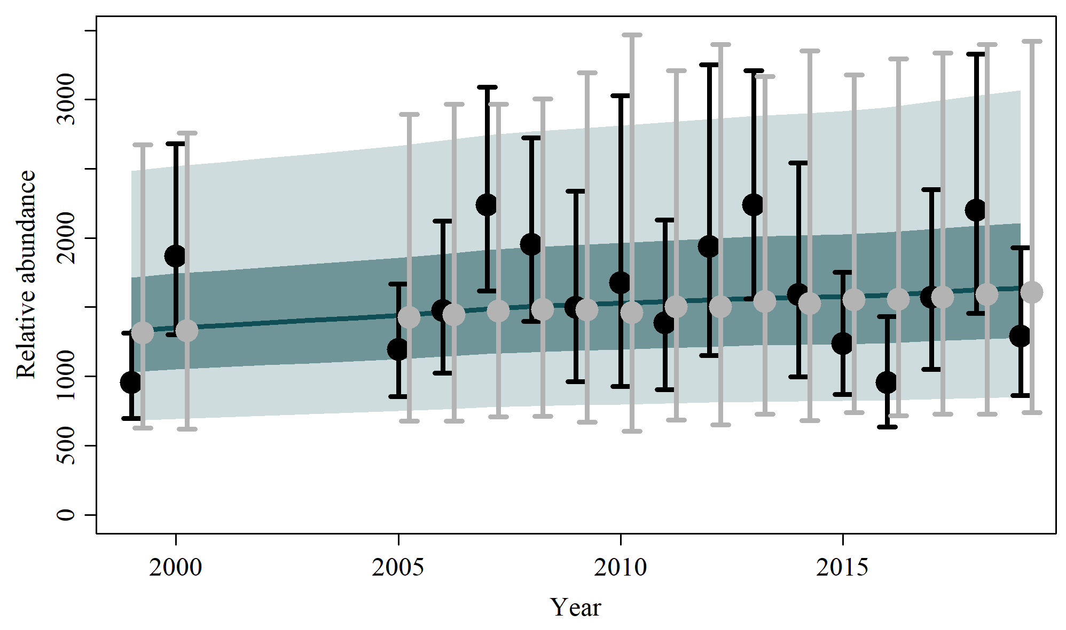

S1.2 Scen 1
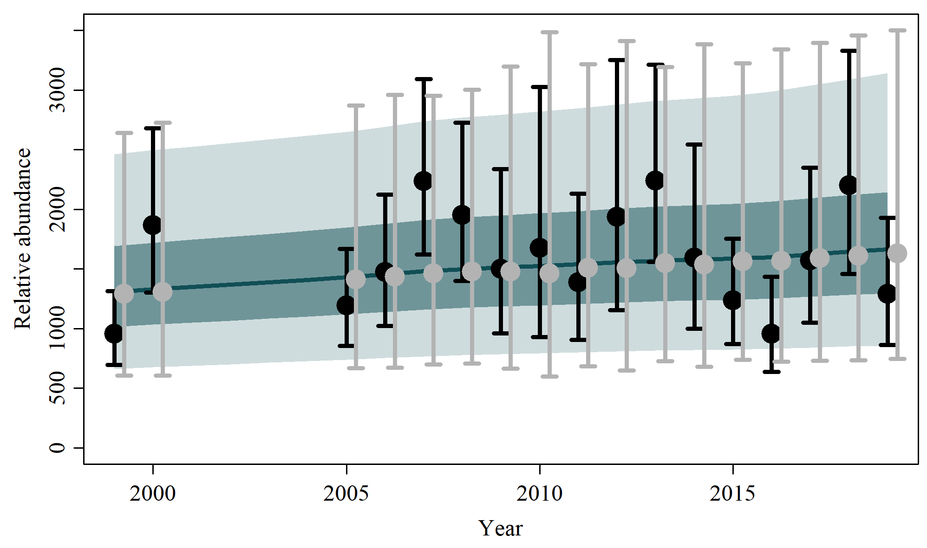

S1.3 Scen 2
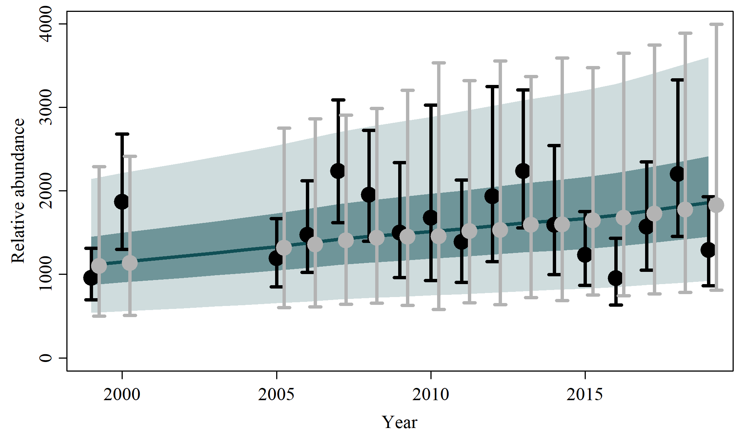

S1.4 Scen 3
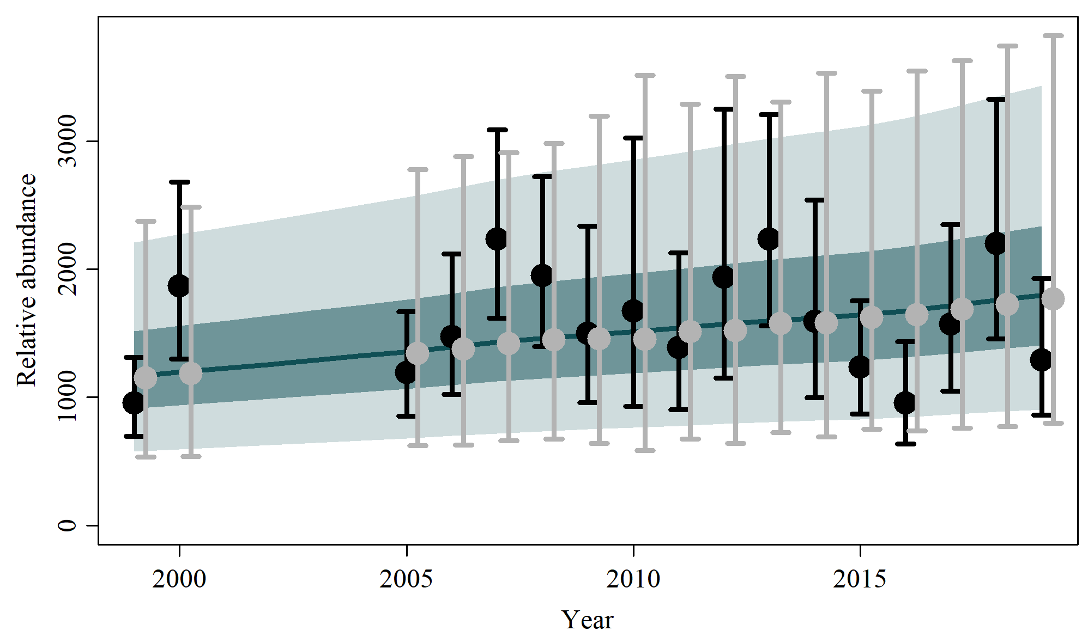

S1.5 Scen 4
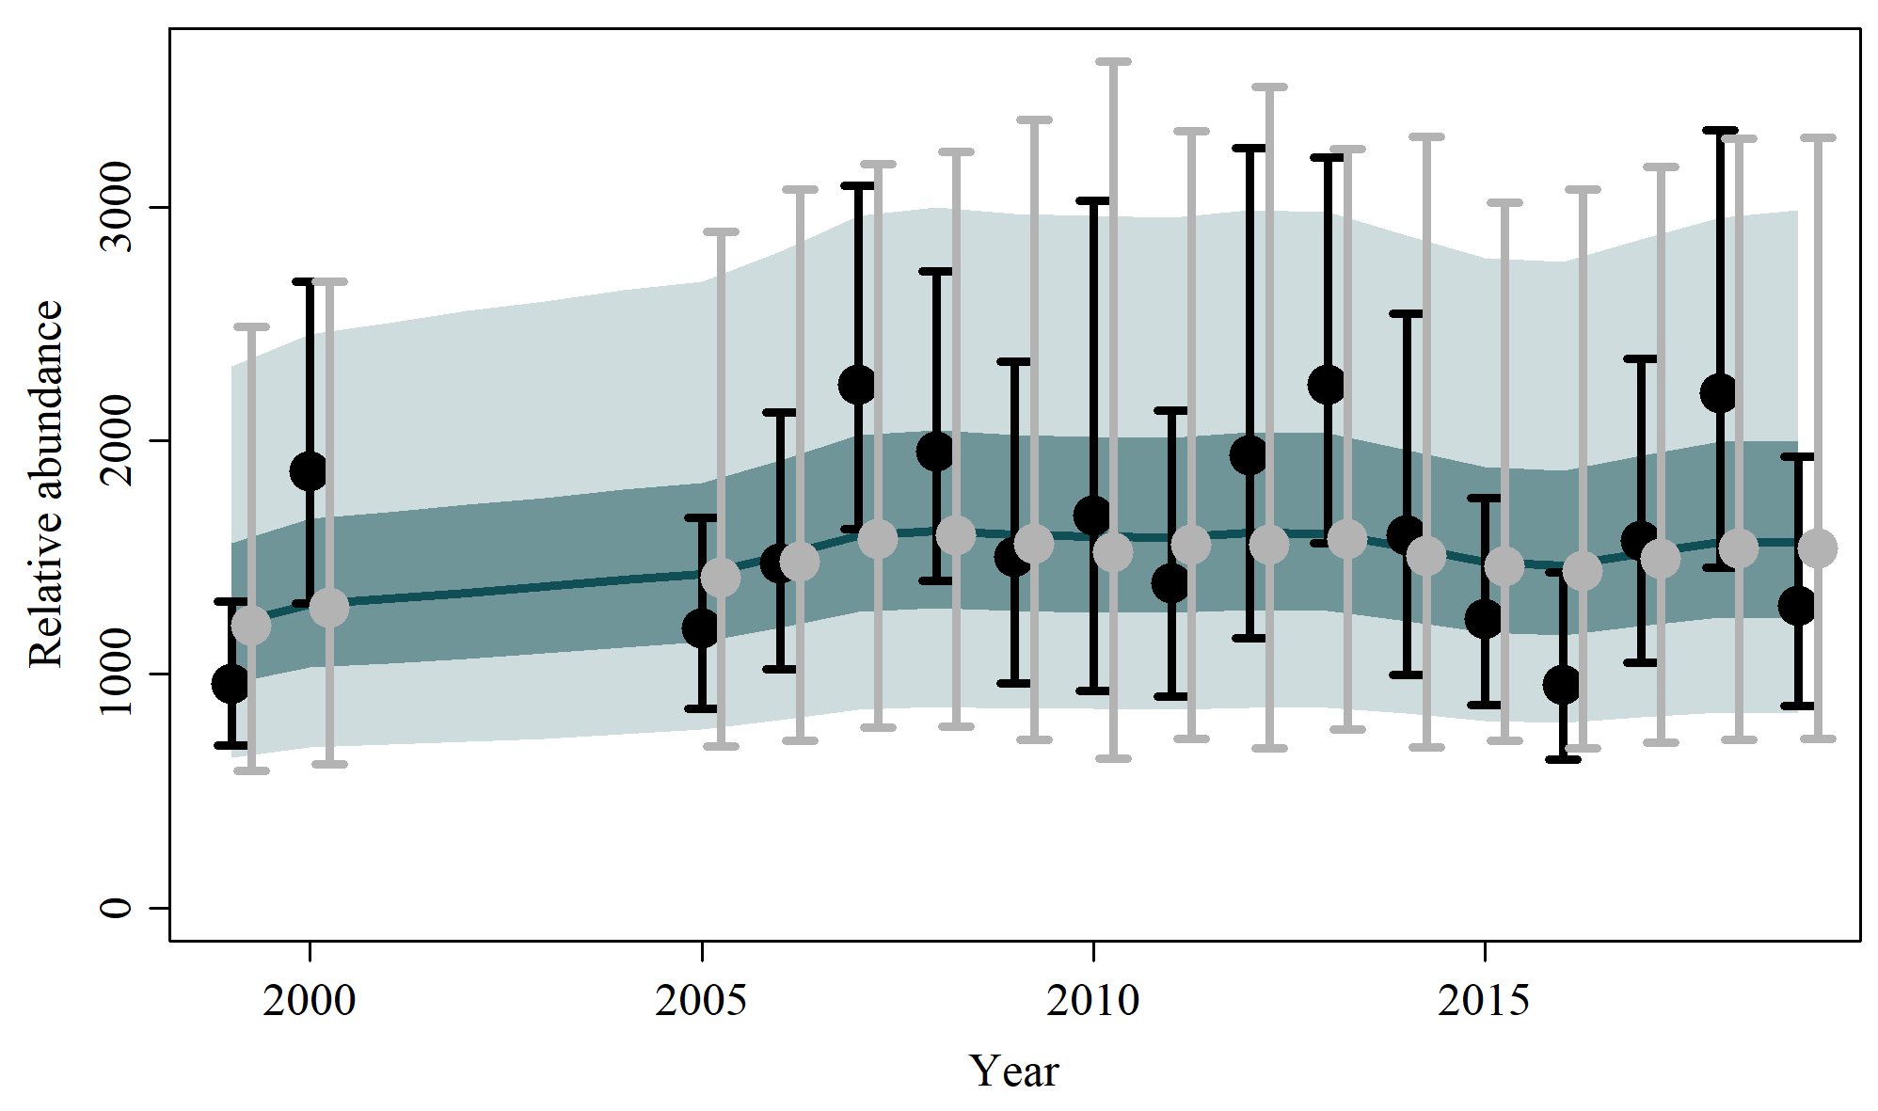

S1.6 Scen 5
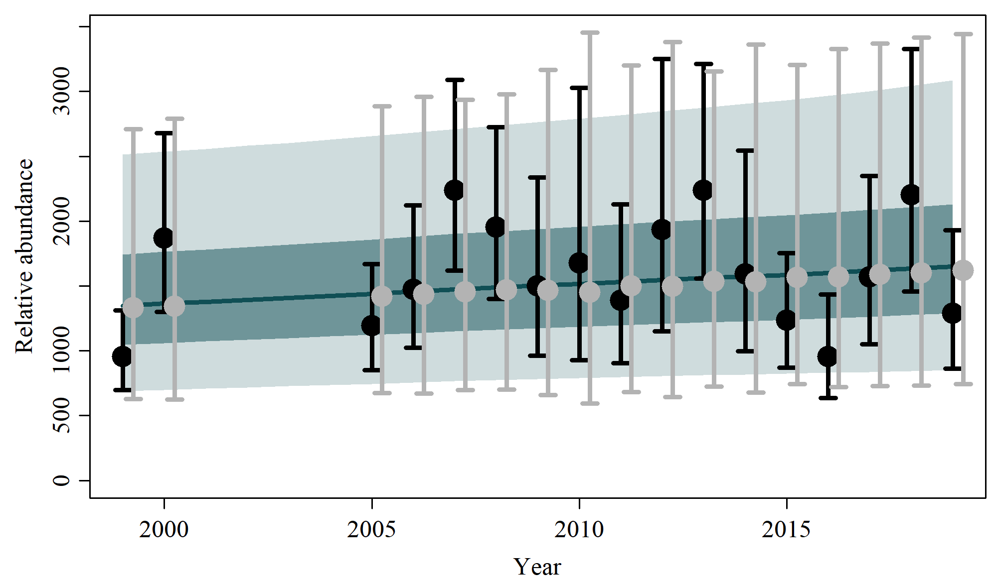

S1.7 Scen 6
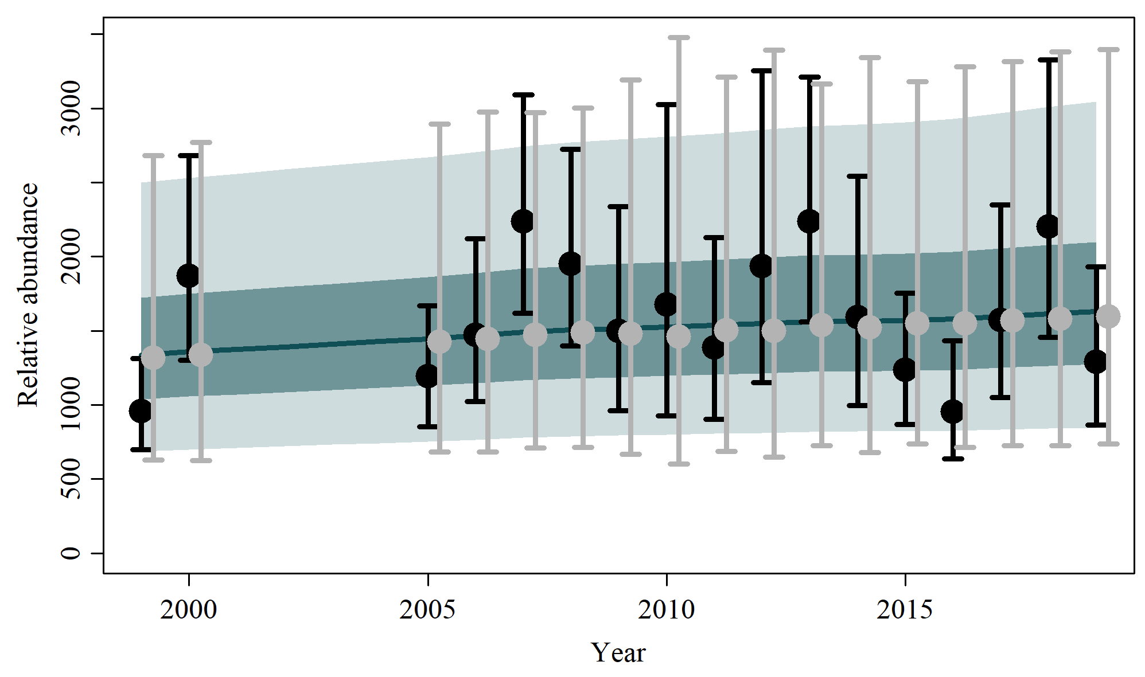

S1.8 Scen 7
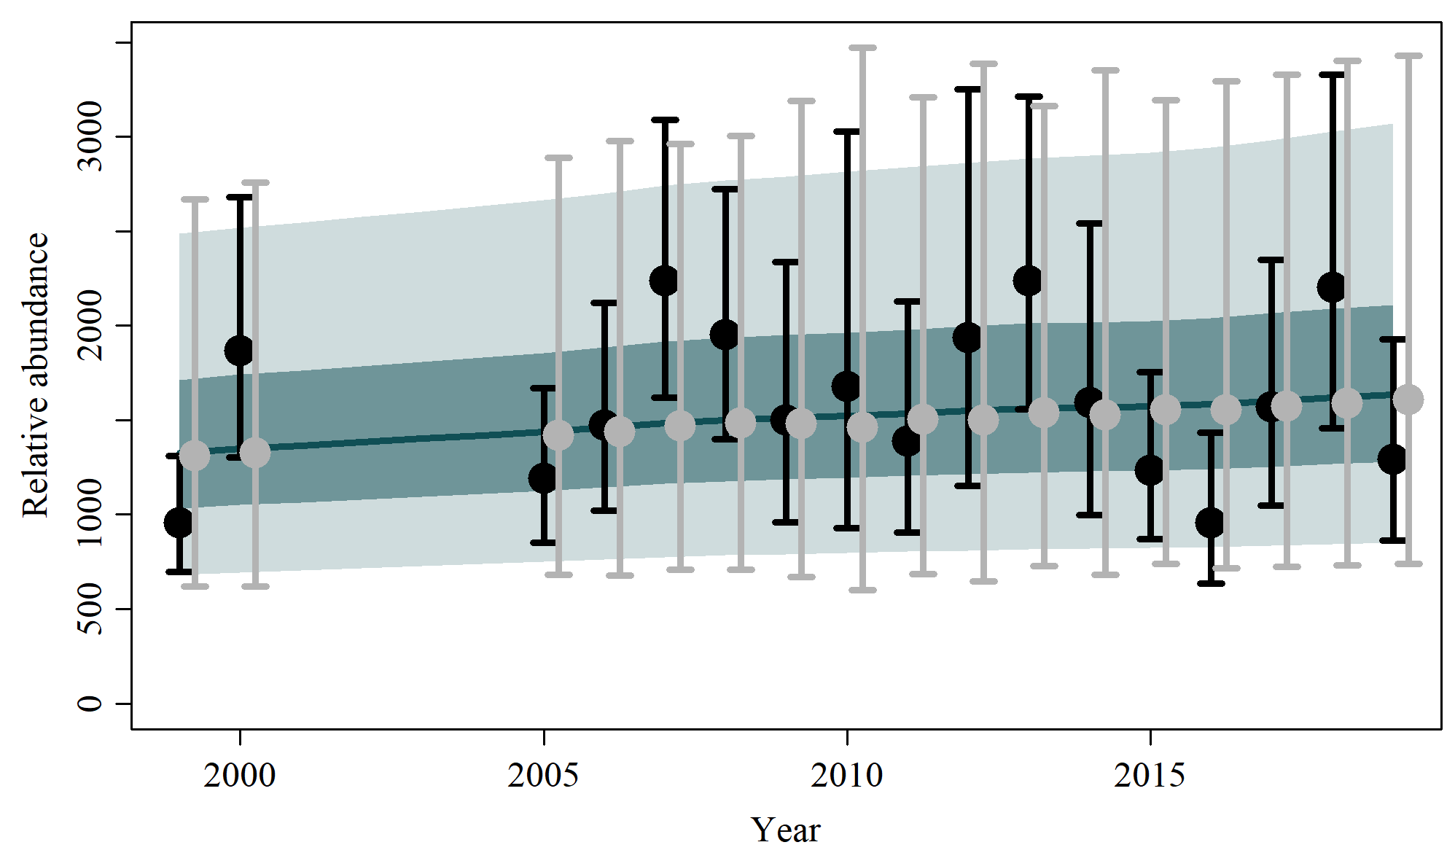

S1.9 Scen 8
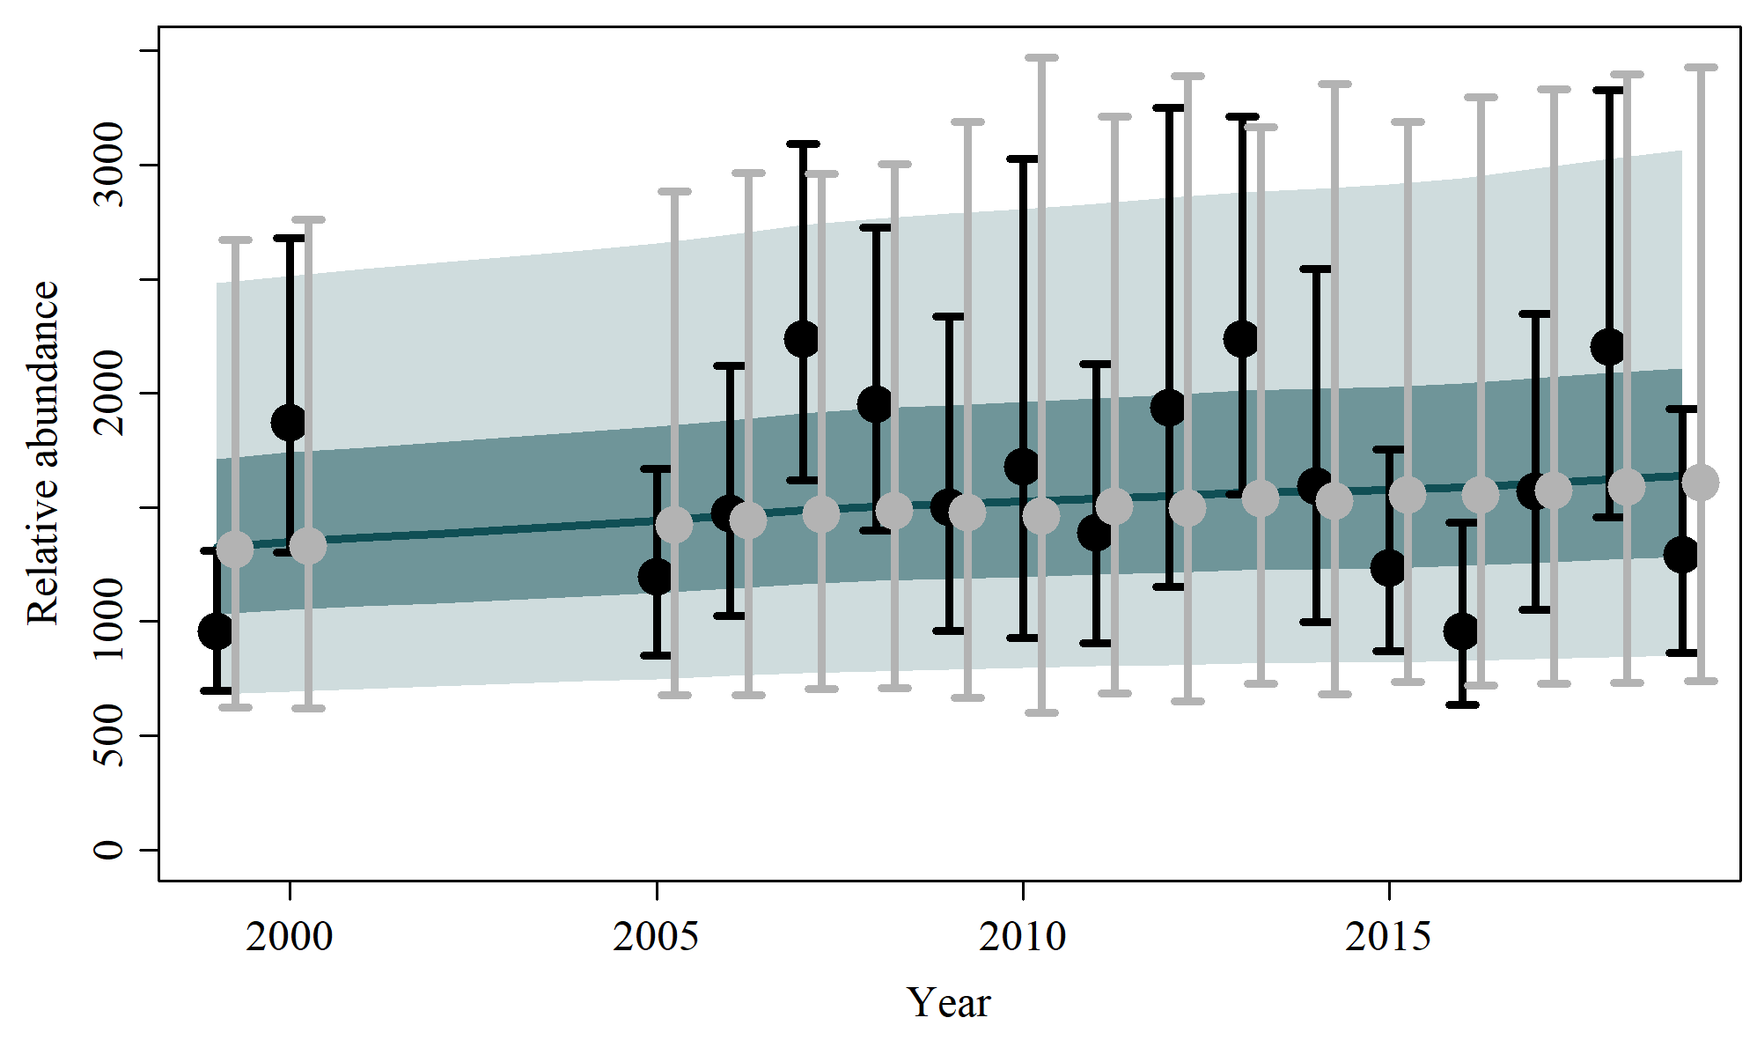

S1.10 Scen 9
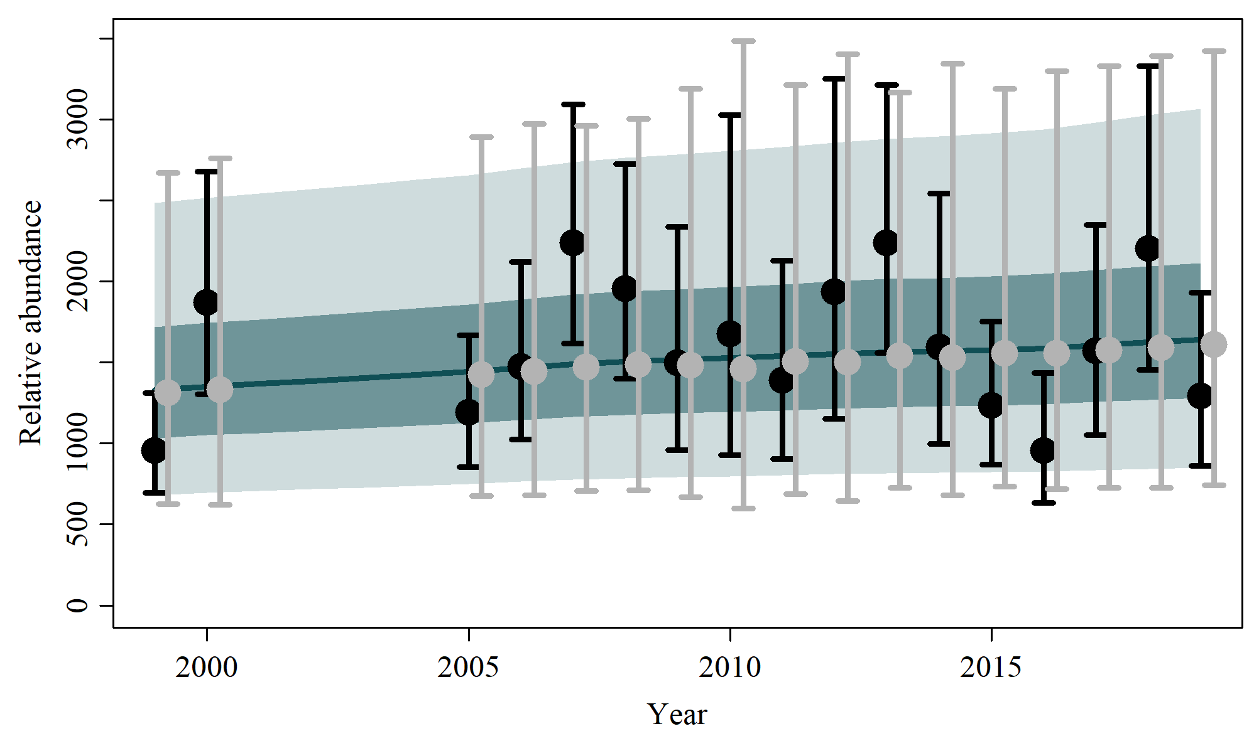

S1.11 Scen 10
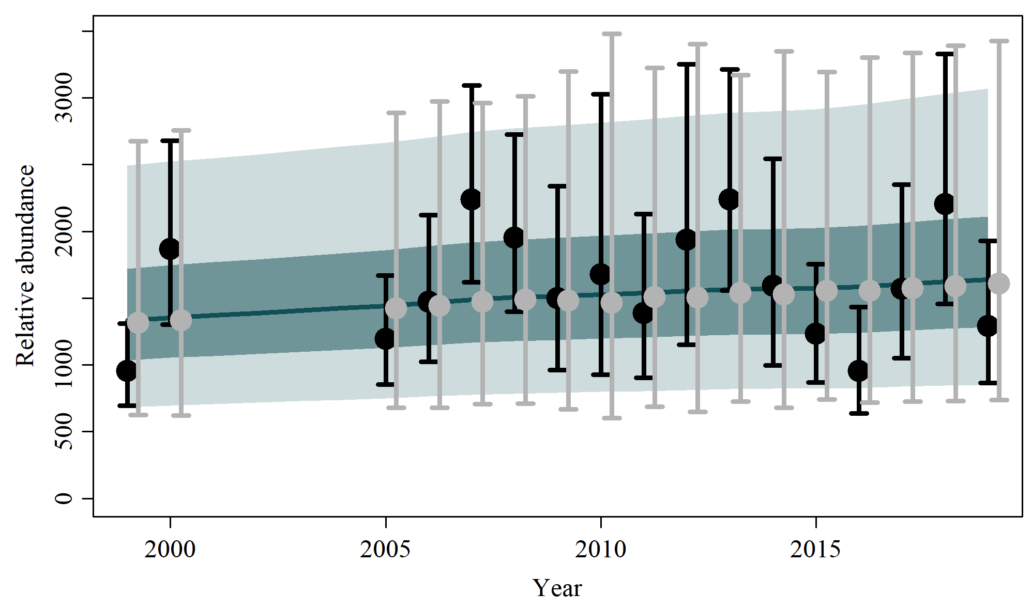

S1.12 Scen 11
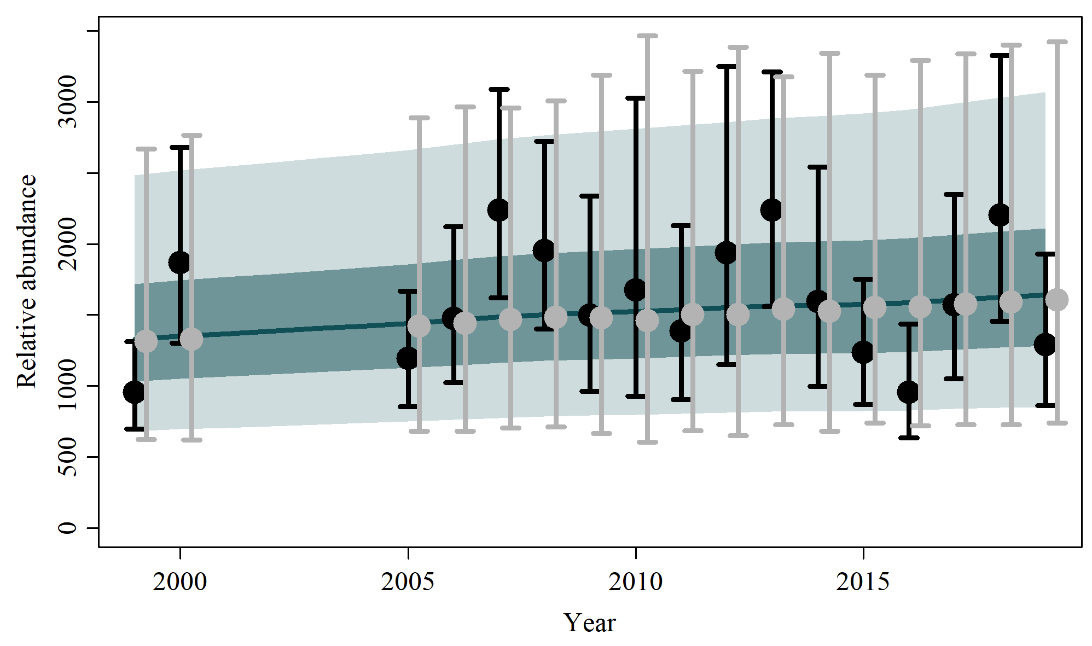

S1.13 Scen 12
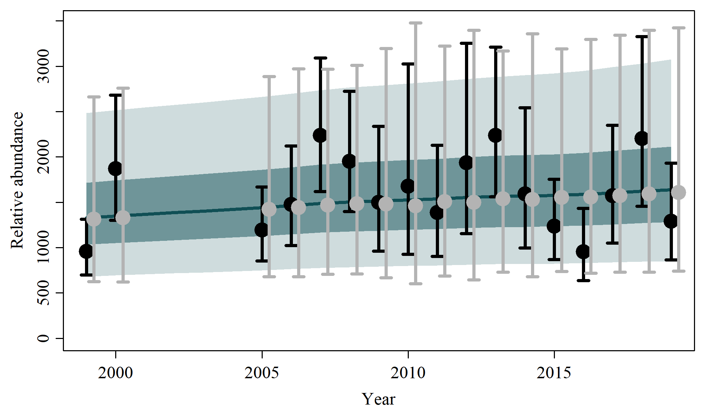

S1.14 Scen 13
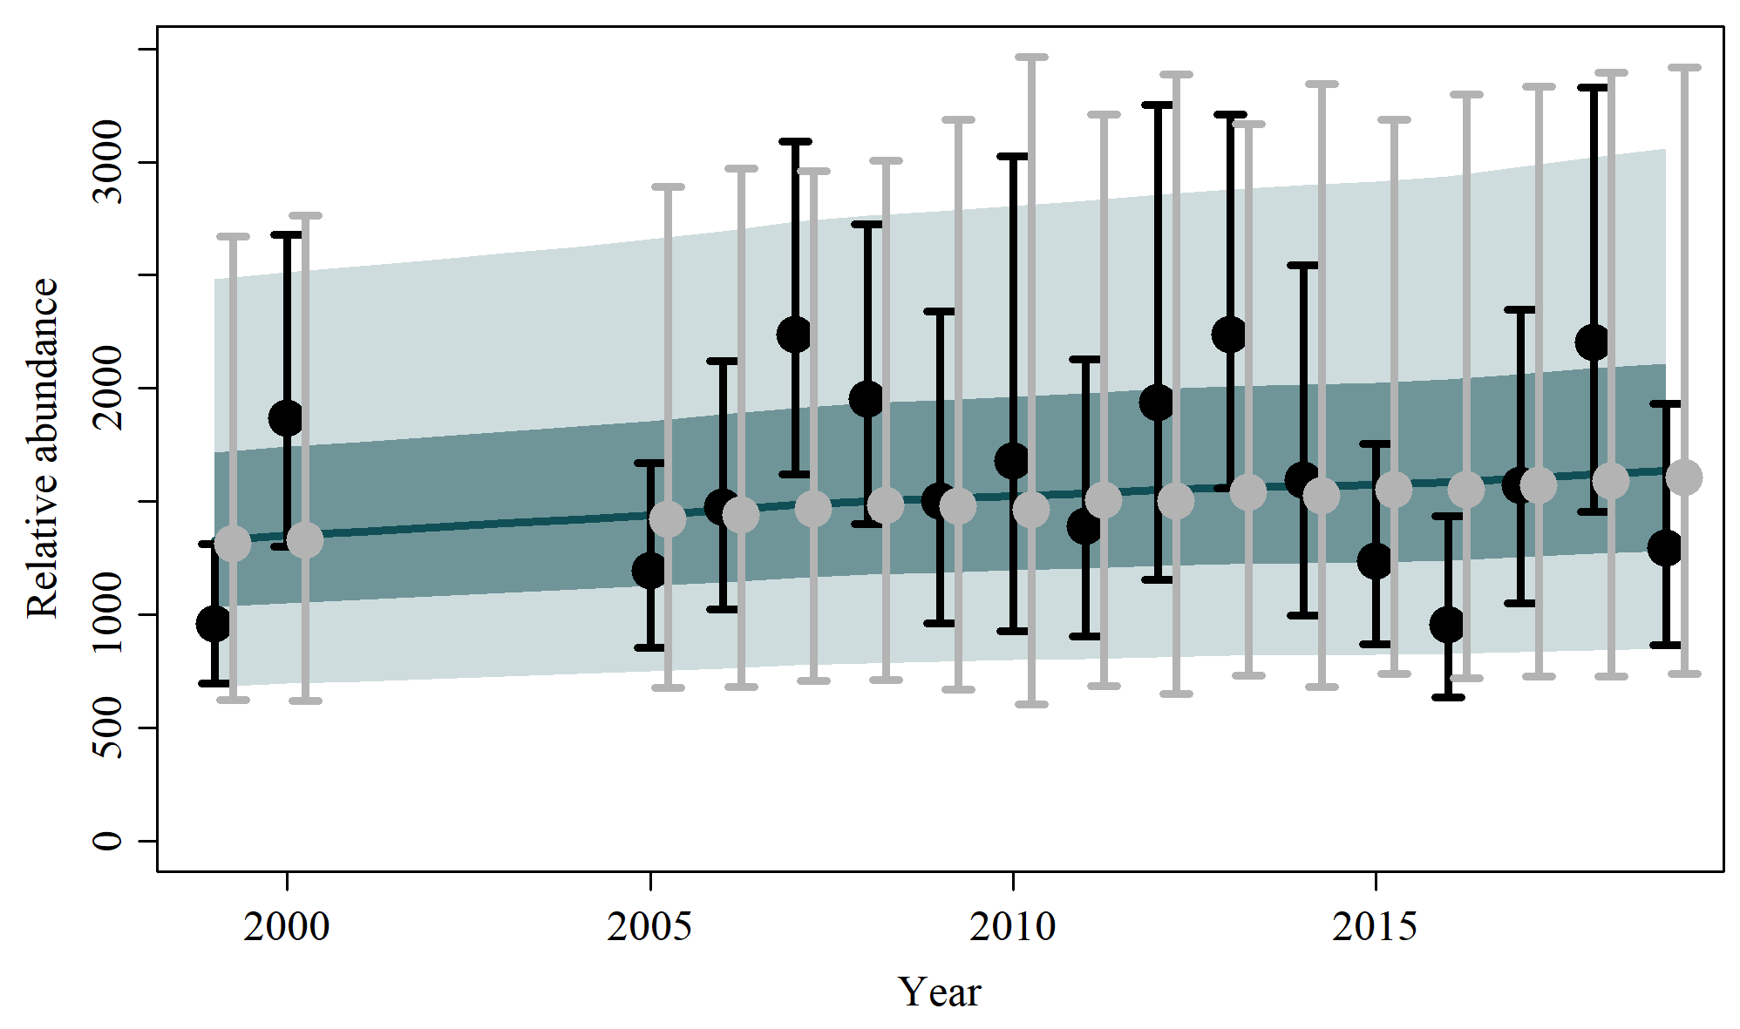

S1.15 Scen 14
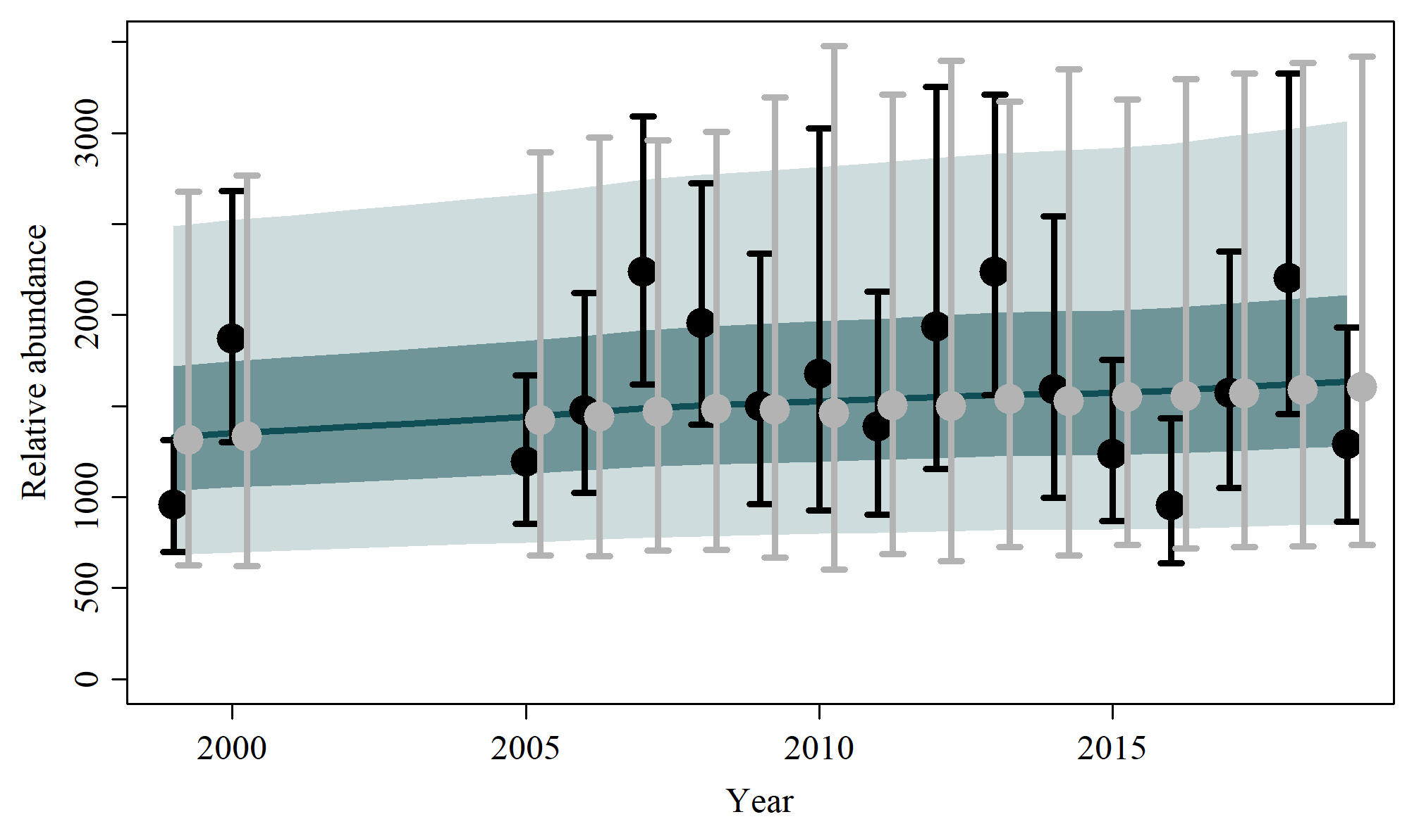

Figure S2. Posterior probability (thick line) and post-model pre-data (thin line) distributions of the key biological parameters for the base case and sensitivity scenarios of the assessment of southern right whale (SRW) Eubalaena australis. The posterior probability distribution of the base case is illustrated in the dashed grey line.

S2.1 Base Case
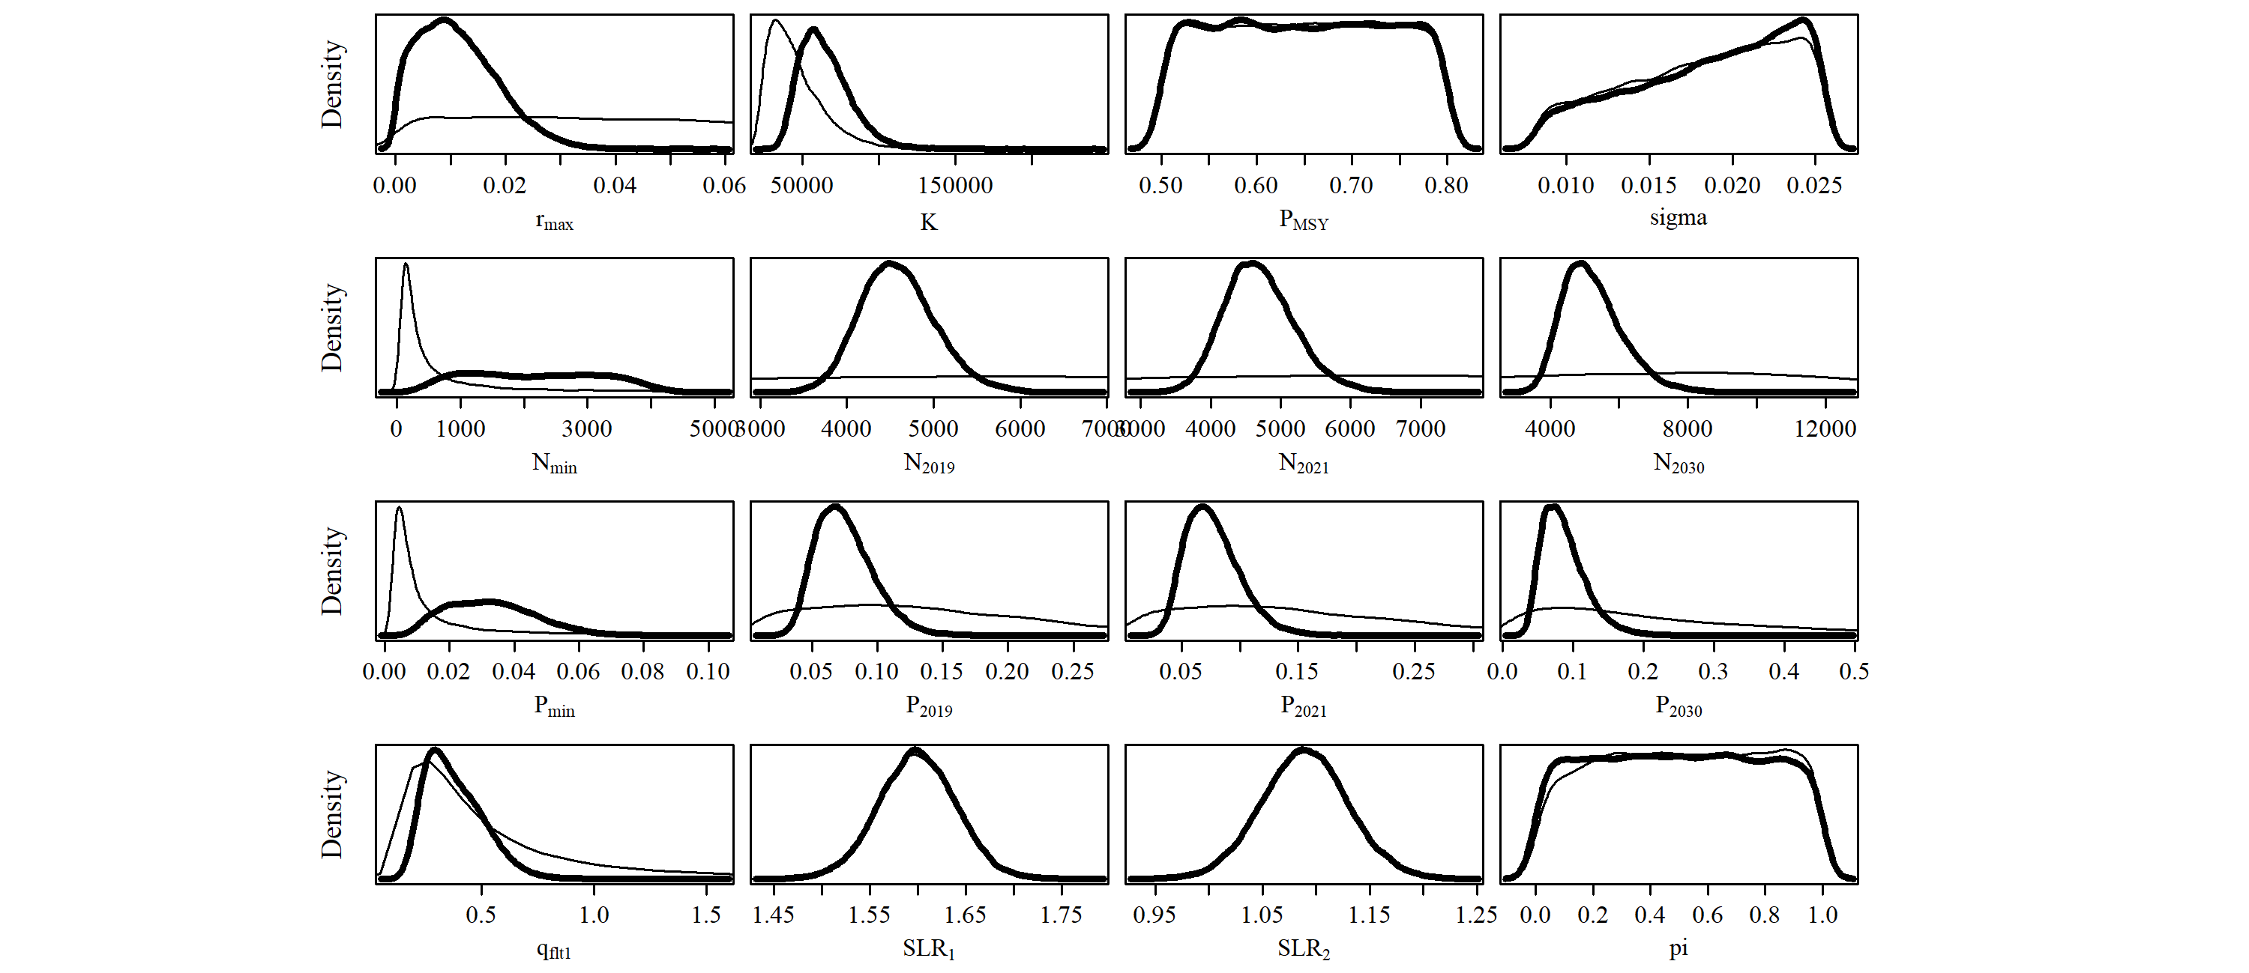

S2.2 Scen 1
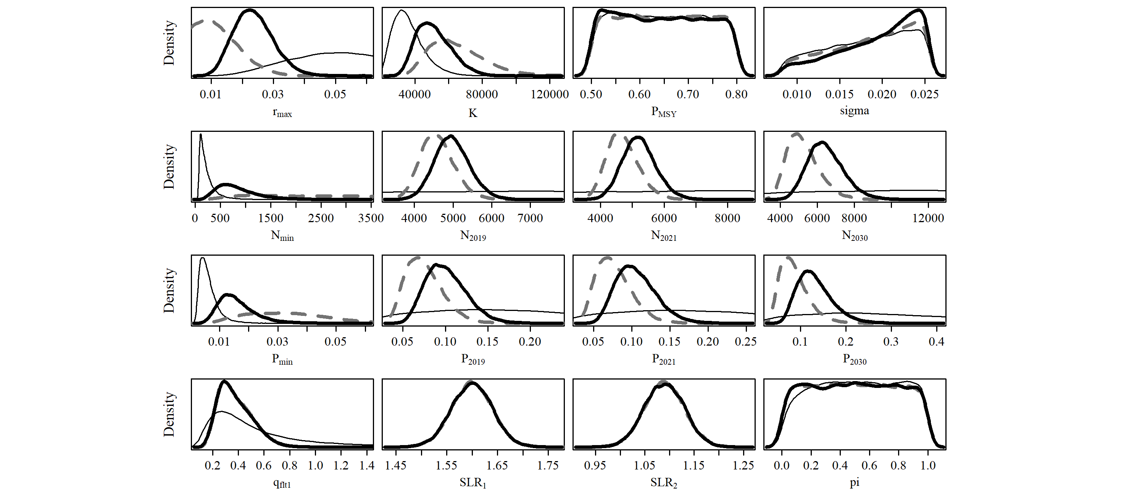

S2.3 Scen 2
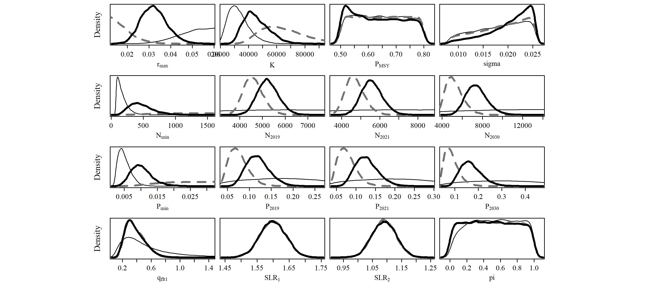
S2.4 Scen 3
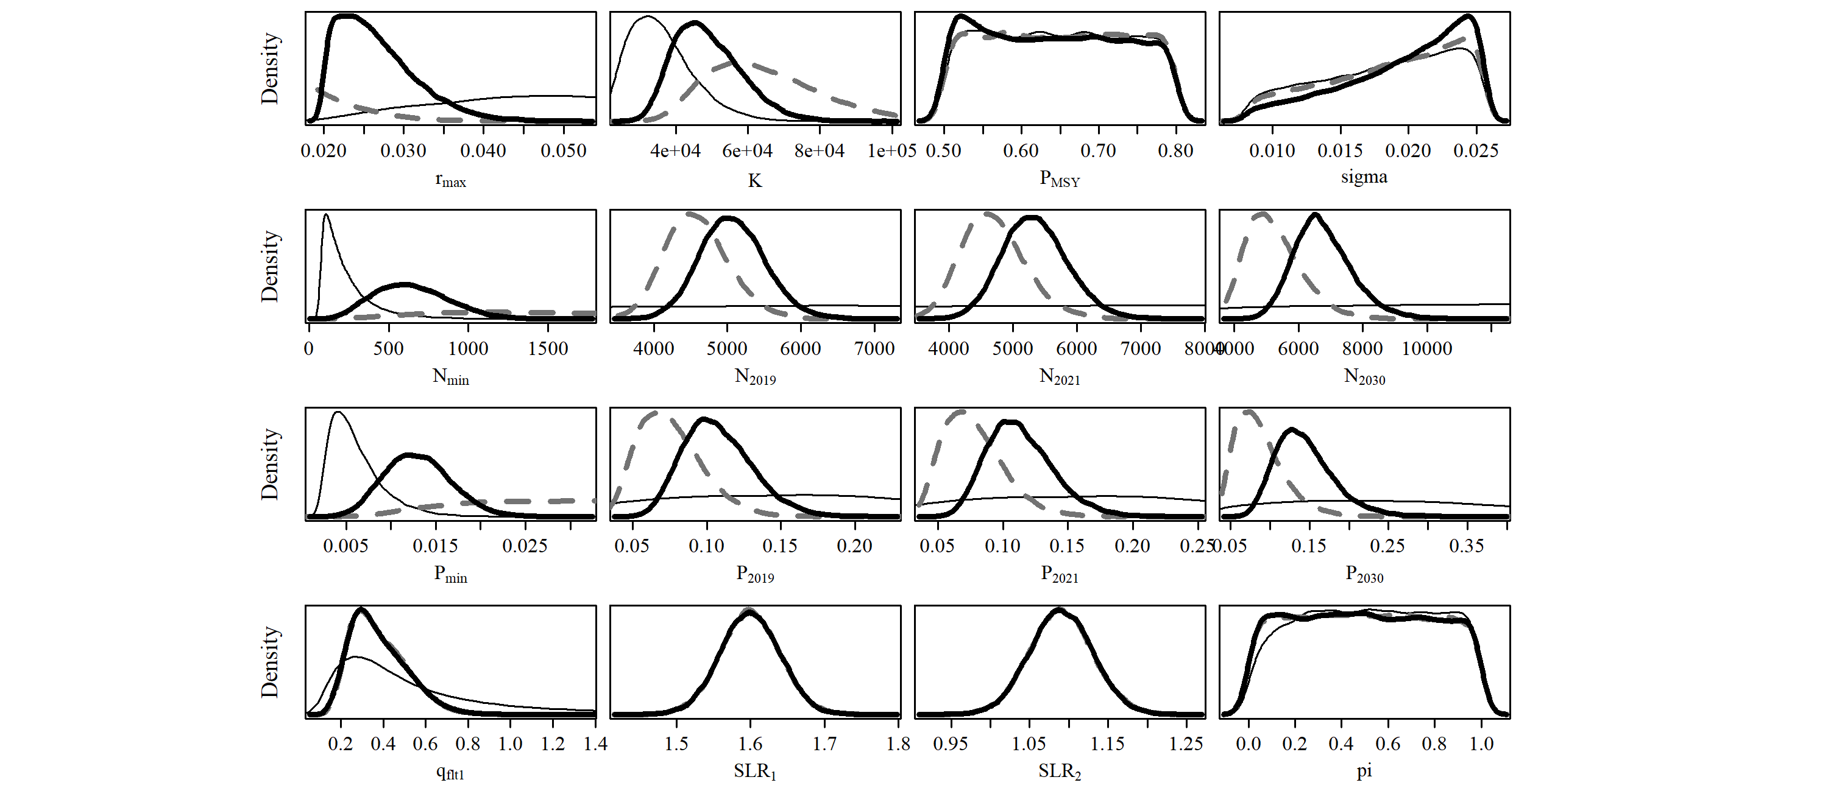
S2.5 Scen 4
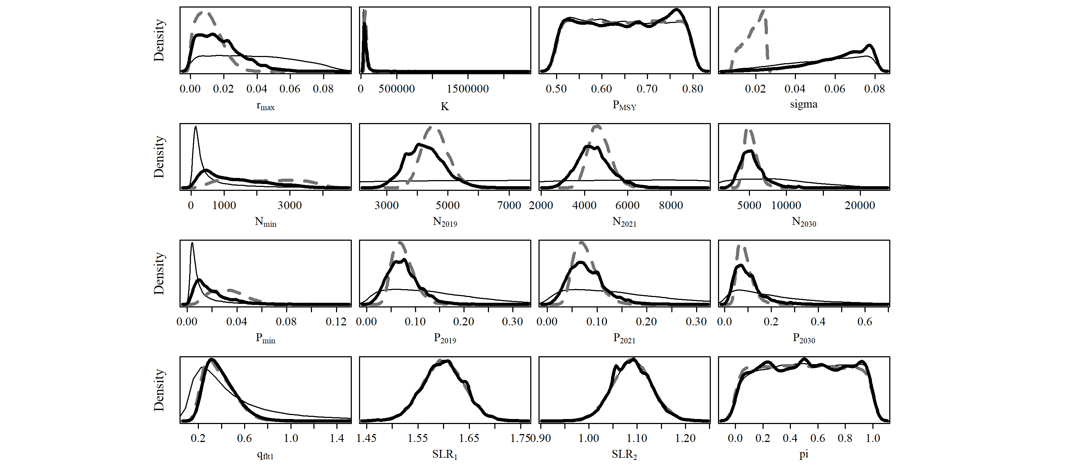
S2.6 Scen 5
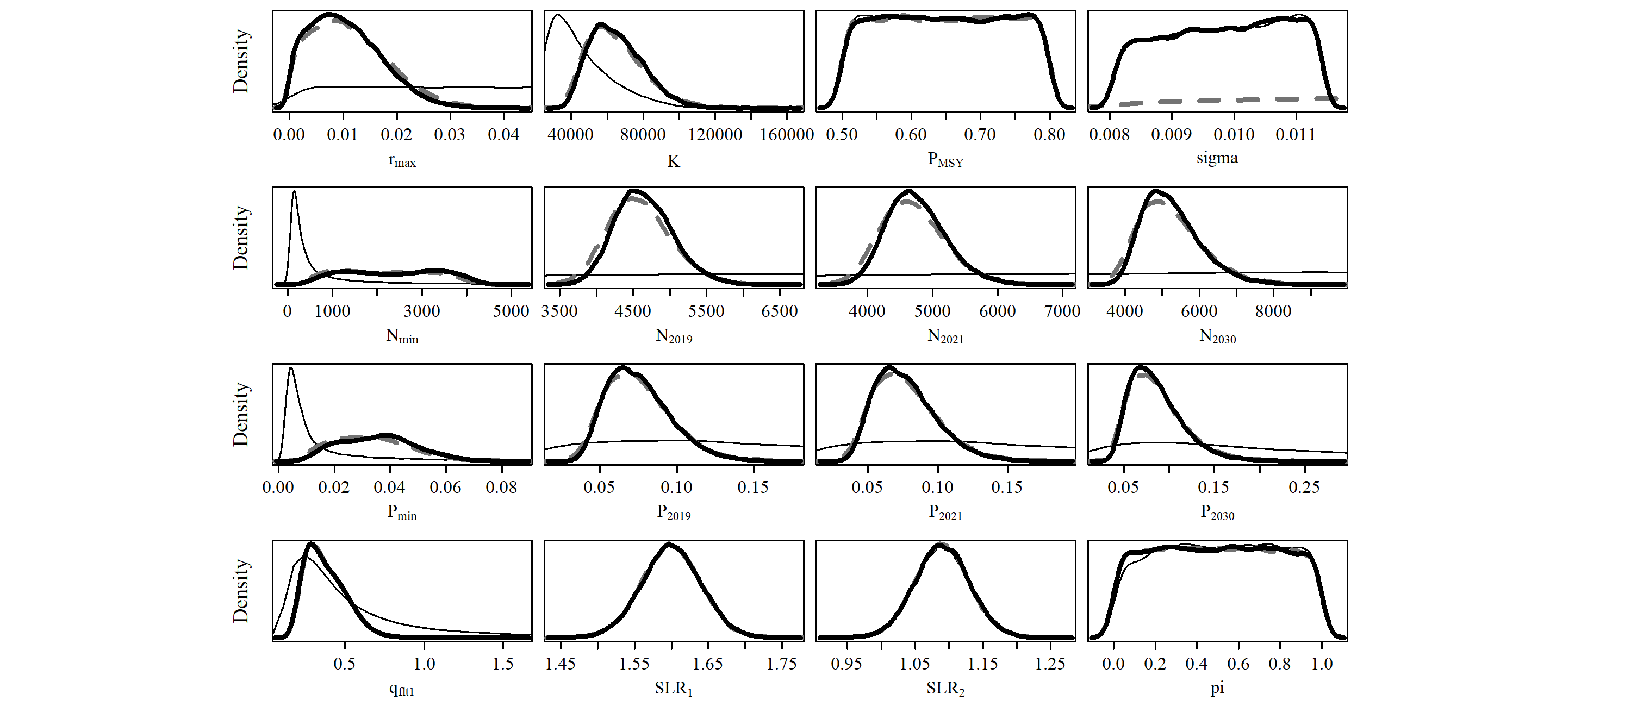
S2.7 Scen 6 (Note: target year is not included)
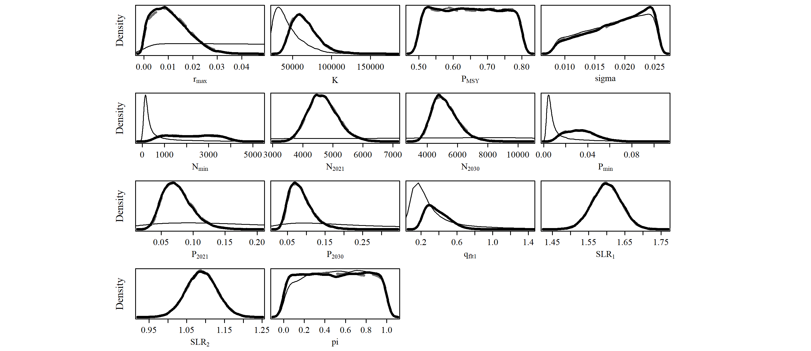
S2.8 Scen 7
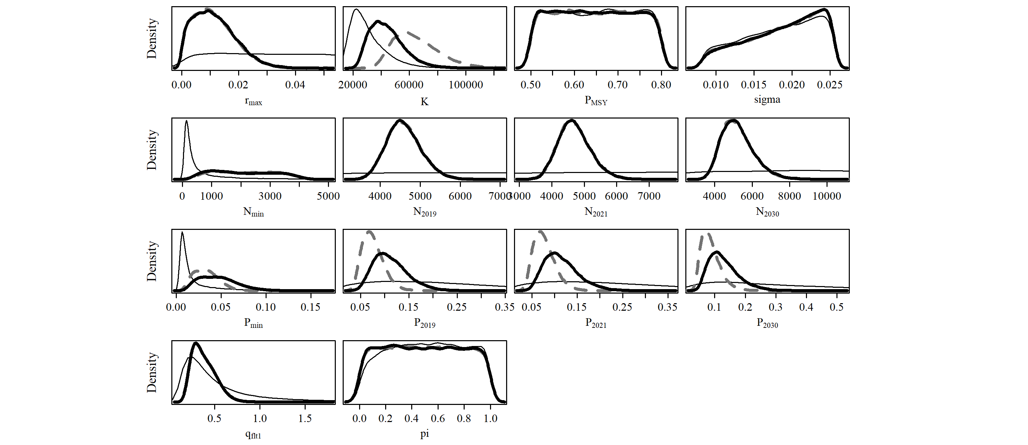

S2.9 Scen 8
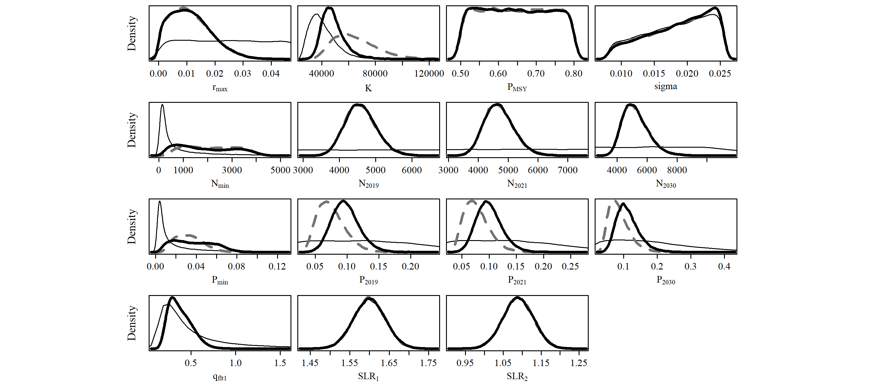
S2.10 Scen 9
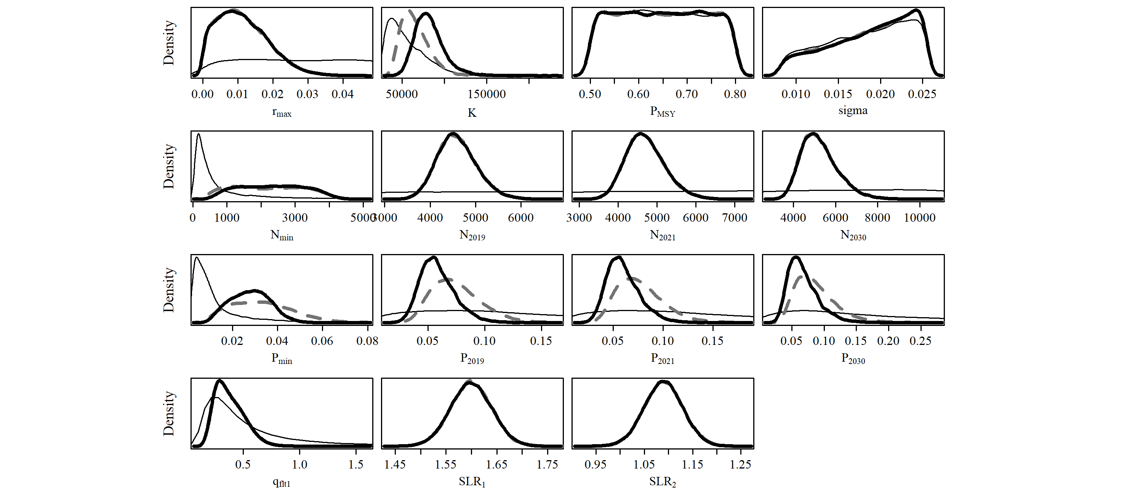
S2.11 Scen 10
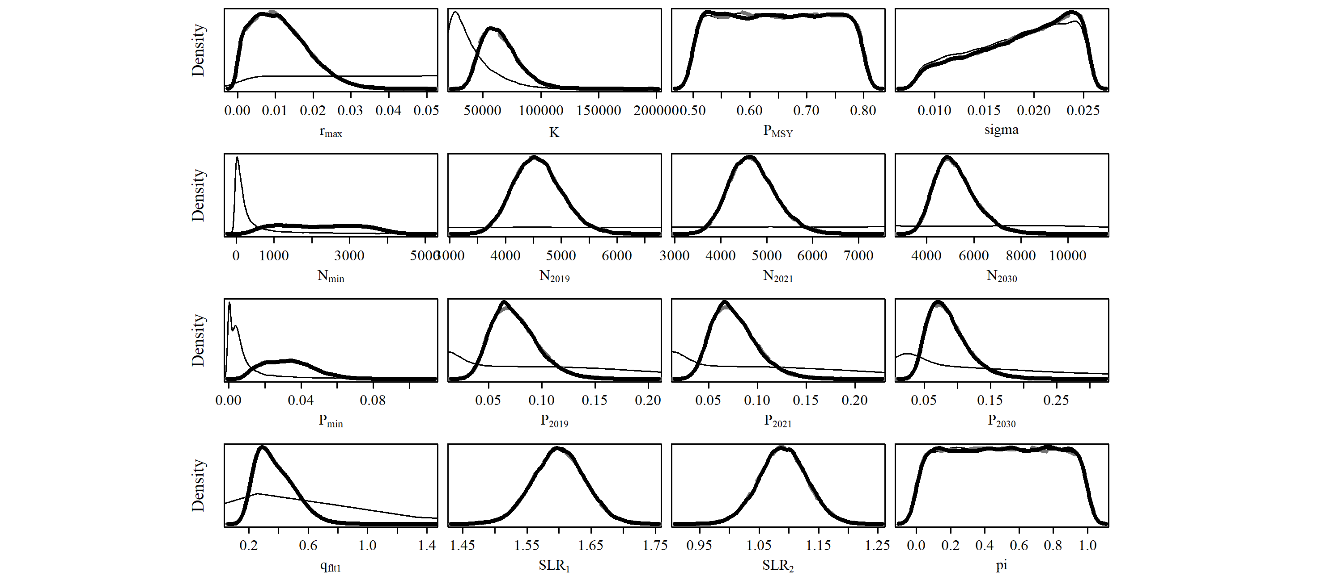

S2.12 Scen 11
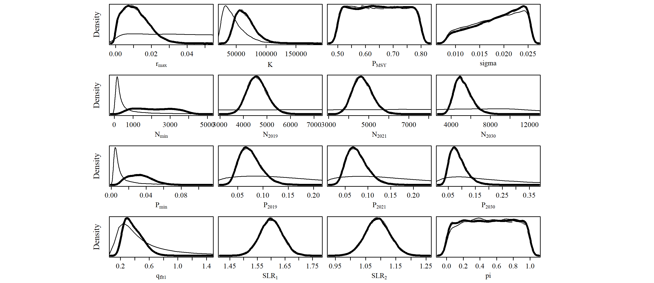
S2.13 Scen 12
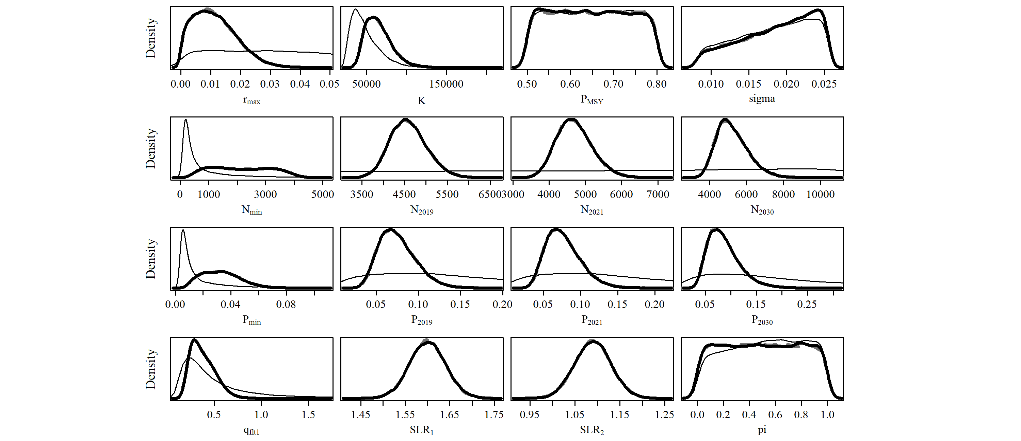
S2.14 Scen 13
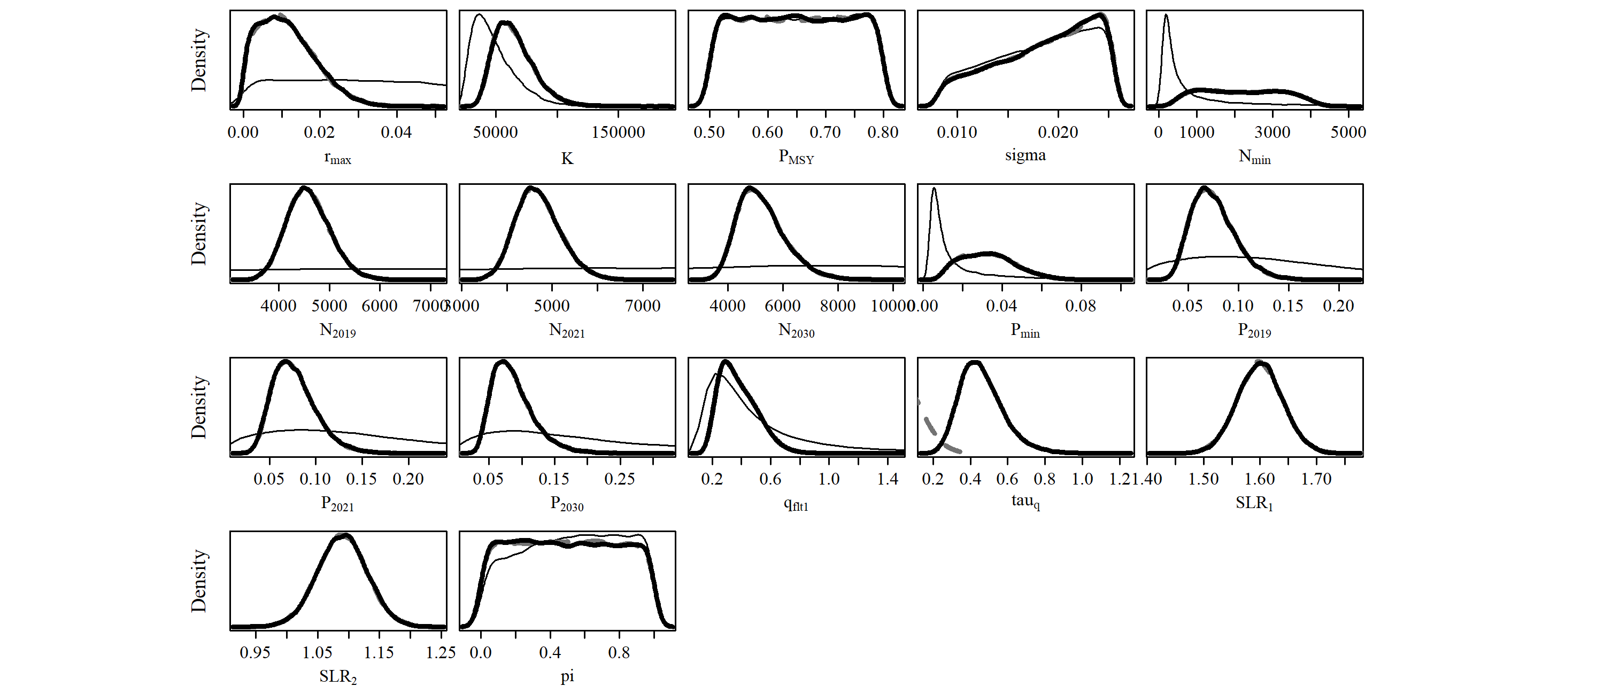
S2.15 Scen 14
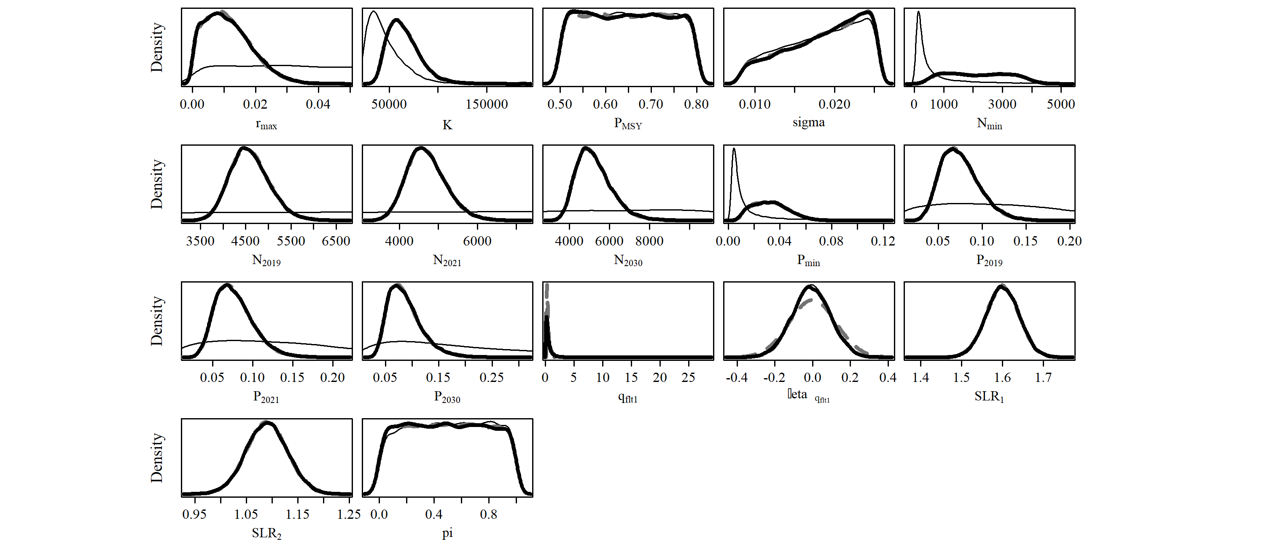

Figure S3. Population trajectories (blue lines) and time series of estimated catches (red lines) of southern right whale (SRW) Eubalaena australis. The solid blue line represents the median estimated model-averaged trajectory of the population abundance ($N_{y}$), while the shaded areas correspond to the 50% and 95% credible intervals. The dashed line represents the median estimated base case trajectory of the abundance. The solid red line represents the average number of whaling catches as estimated by the catch parameter ($π$), while the red shaded areas correspond to the 50% and 95% credible intervals. The grey and black dots represent the estimated and observed, respectively, absolute abundance in 2010.

S3.1 Base Case
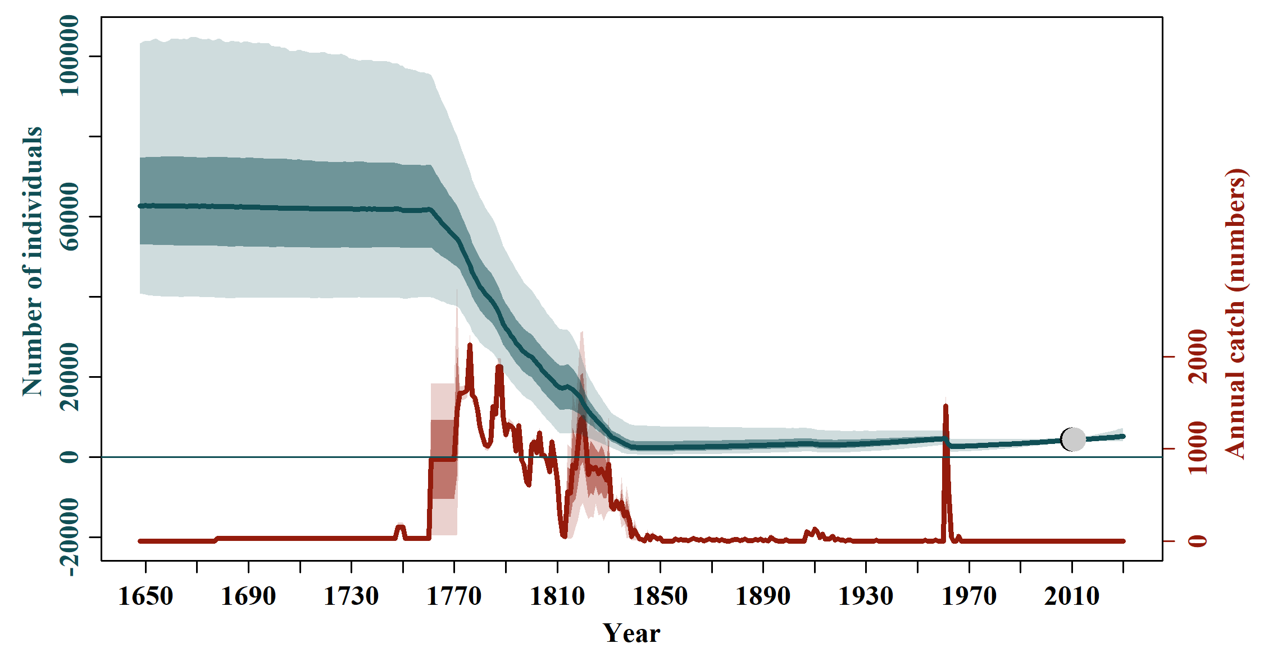

S3.2 Scen 1
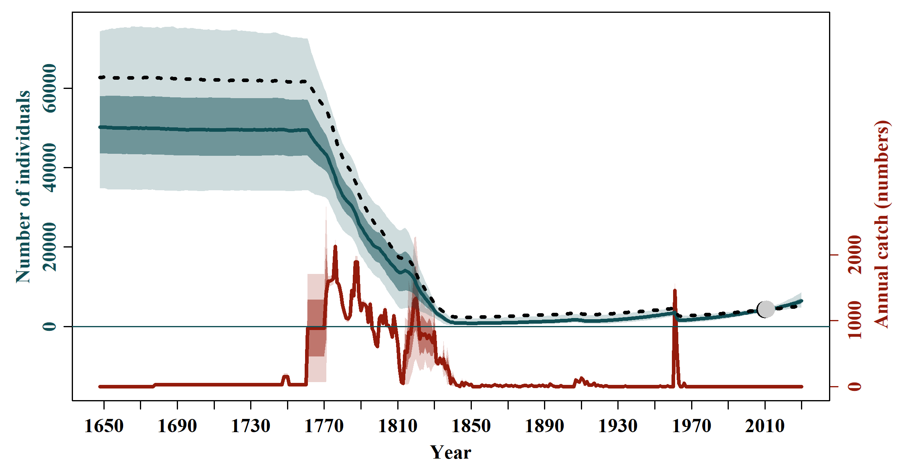

S3.3 Scen 2
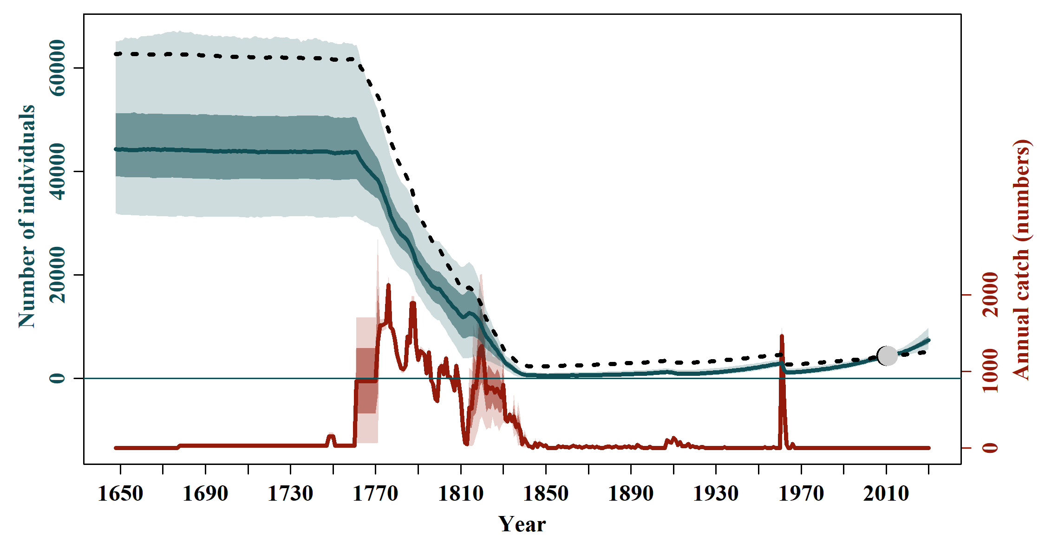

S3.4 Scen 3
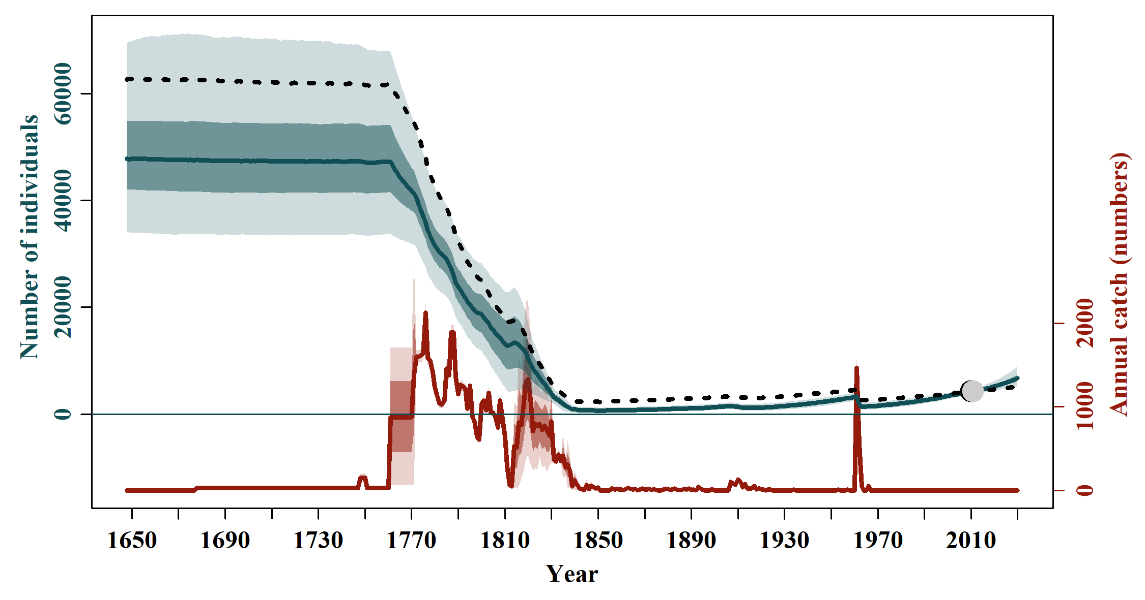

S3.5 Scen 4
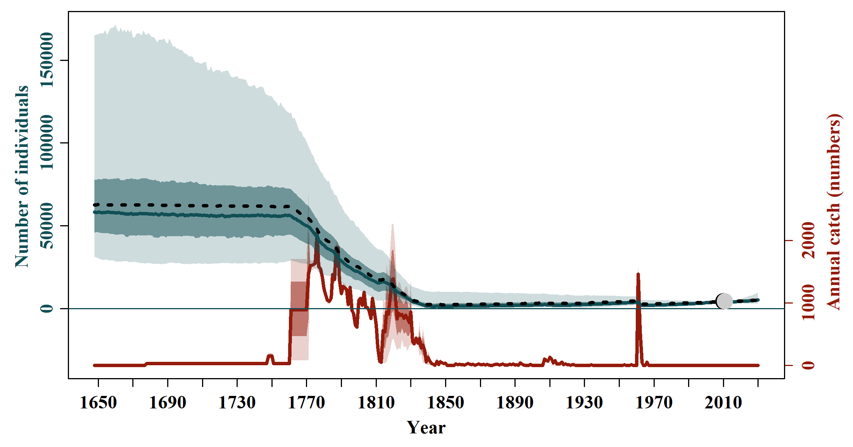

S3.6 Scen 5
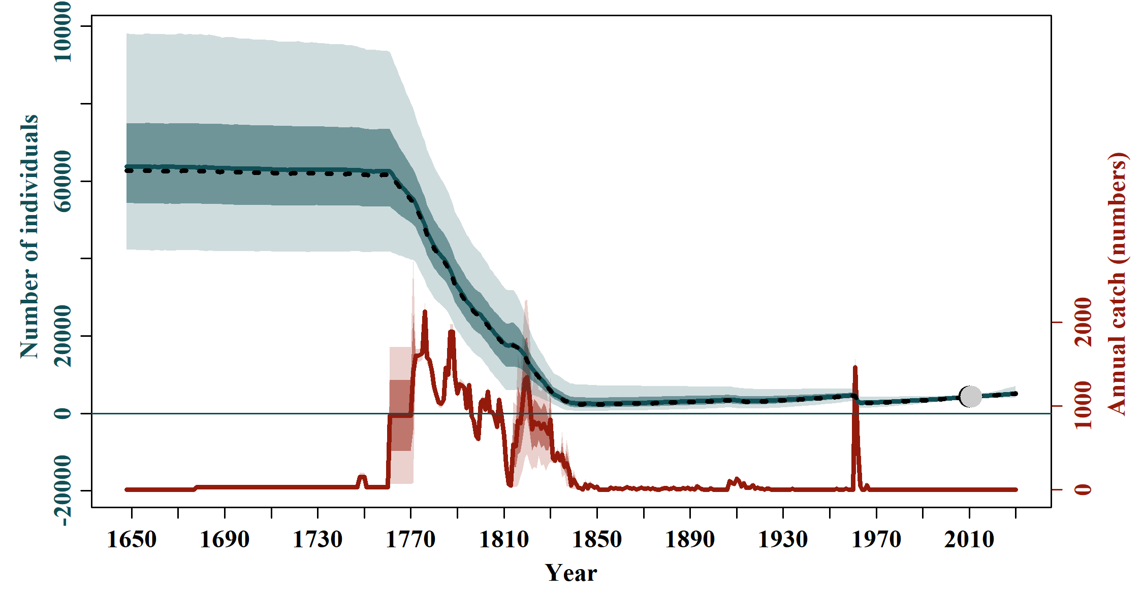

S3.7 Scen 6
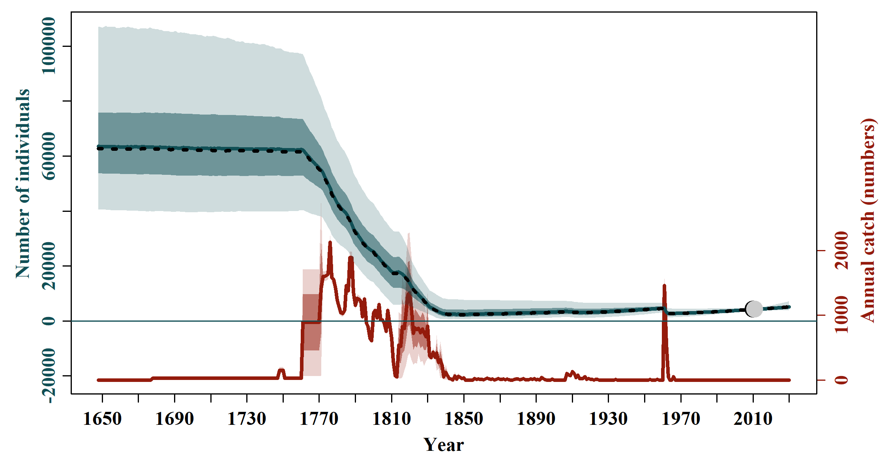

S3.8 Scen 7
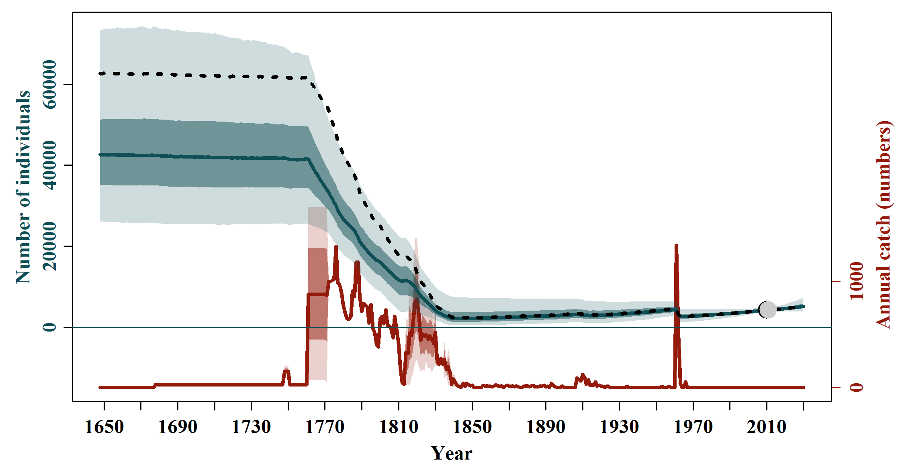

S3.9 Scen 8
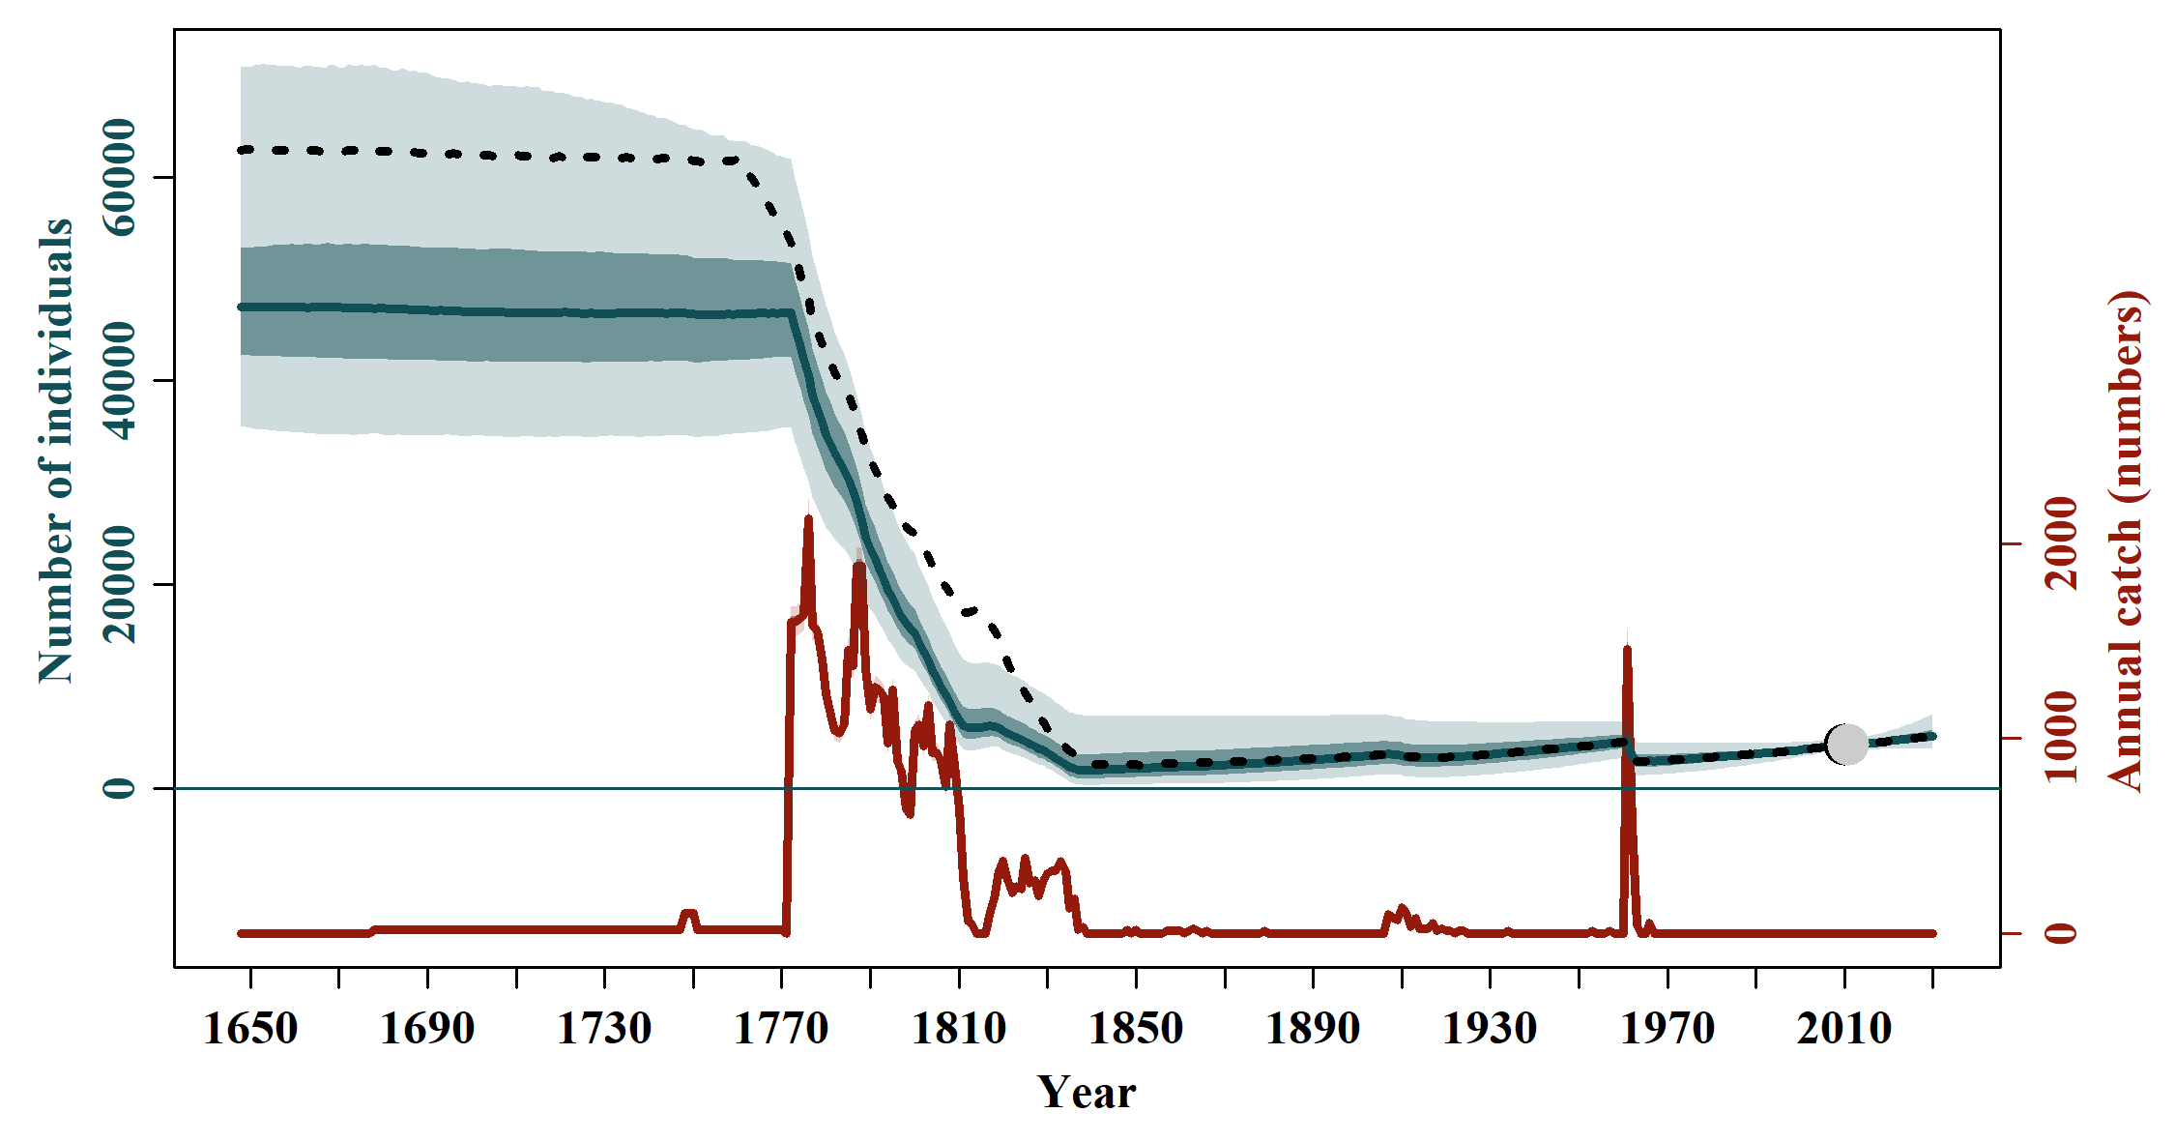

S3.10 Scen 9
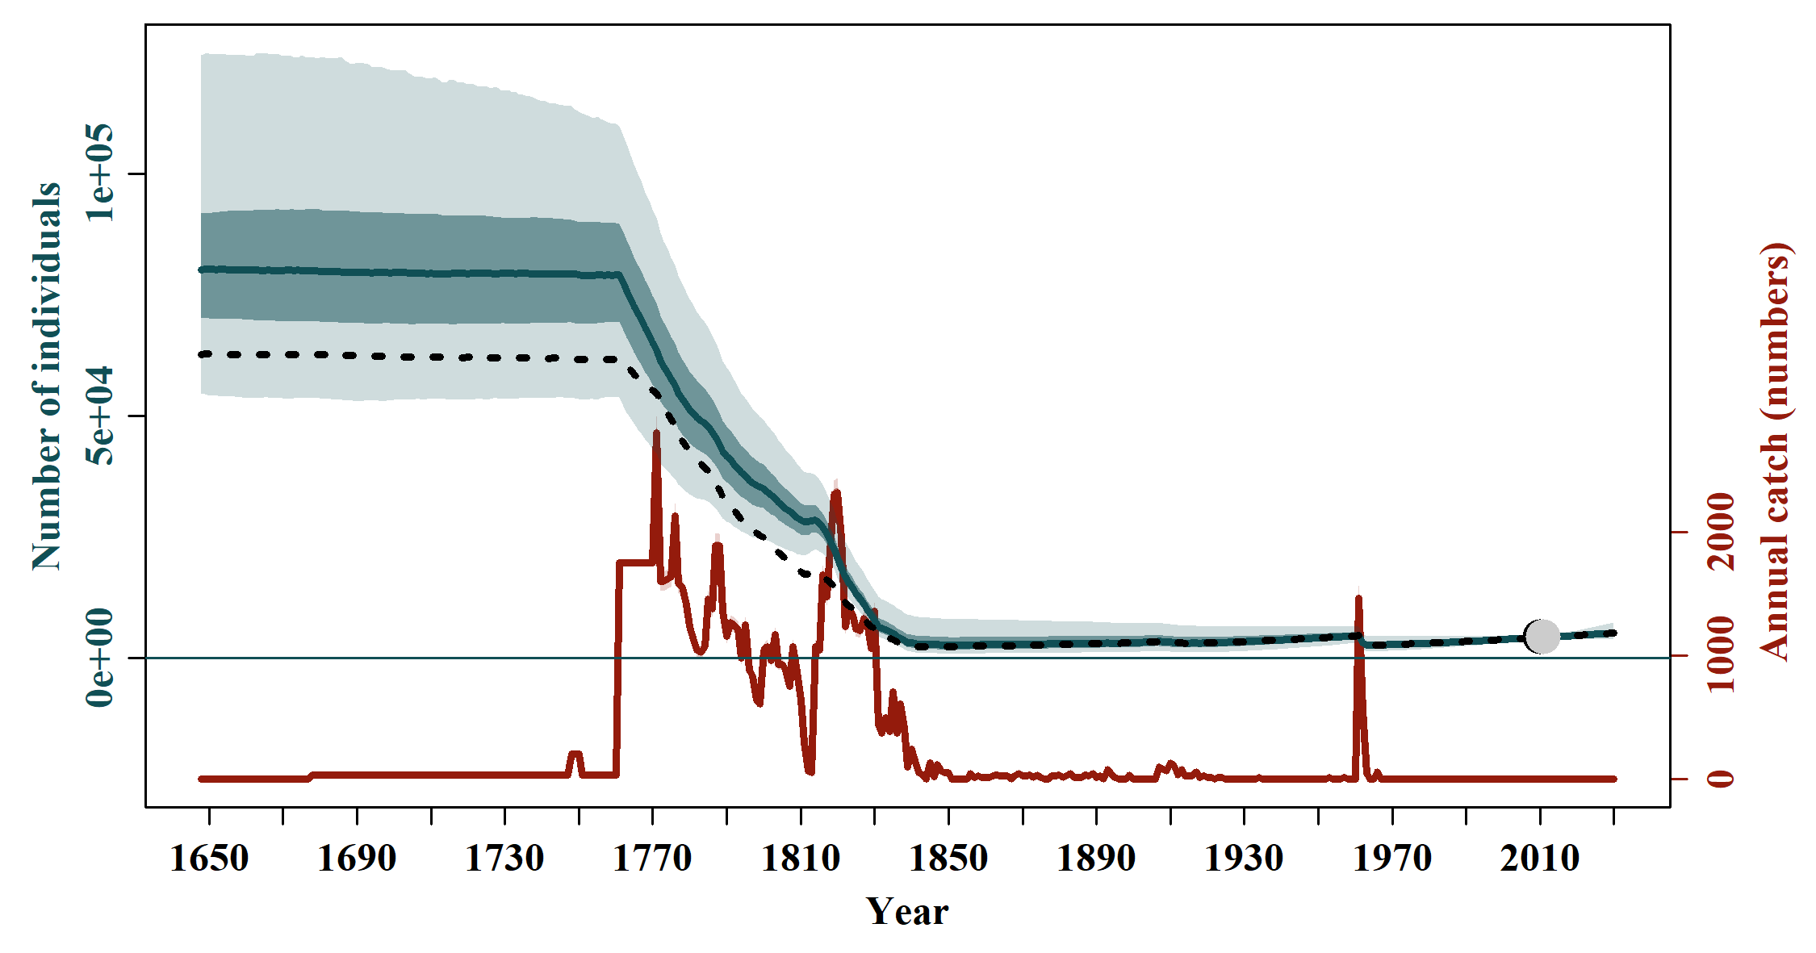

S3.11 Scen 10
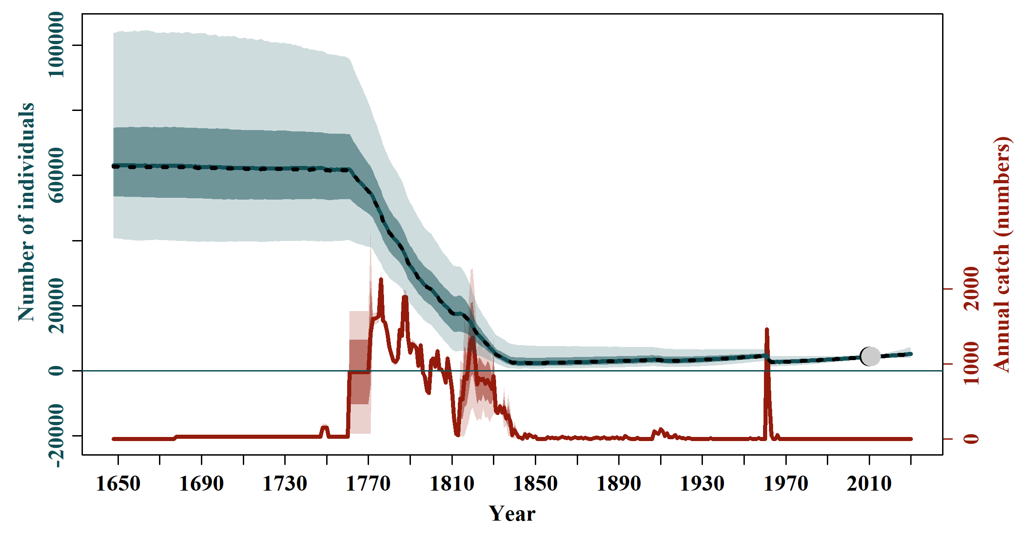

S3.12 Scen 11
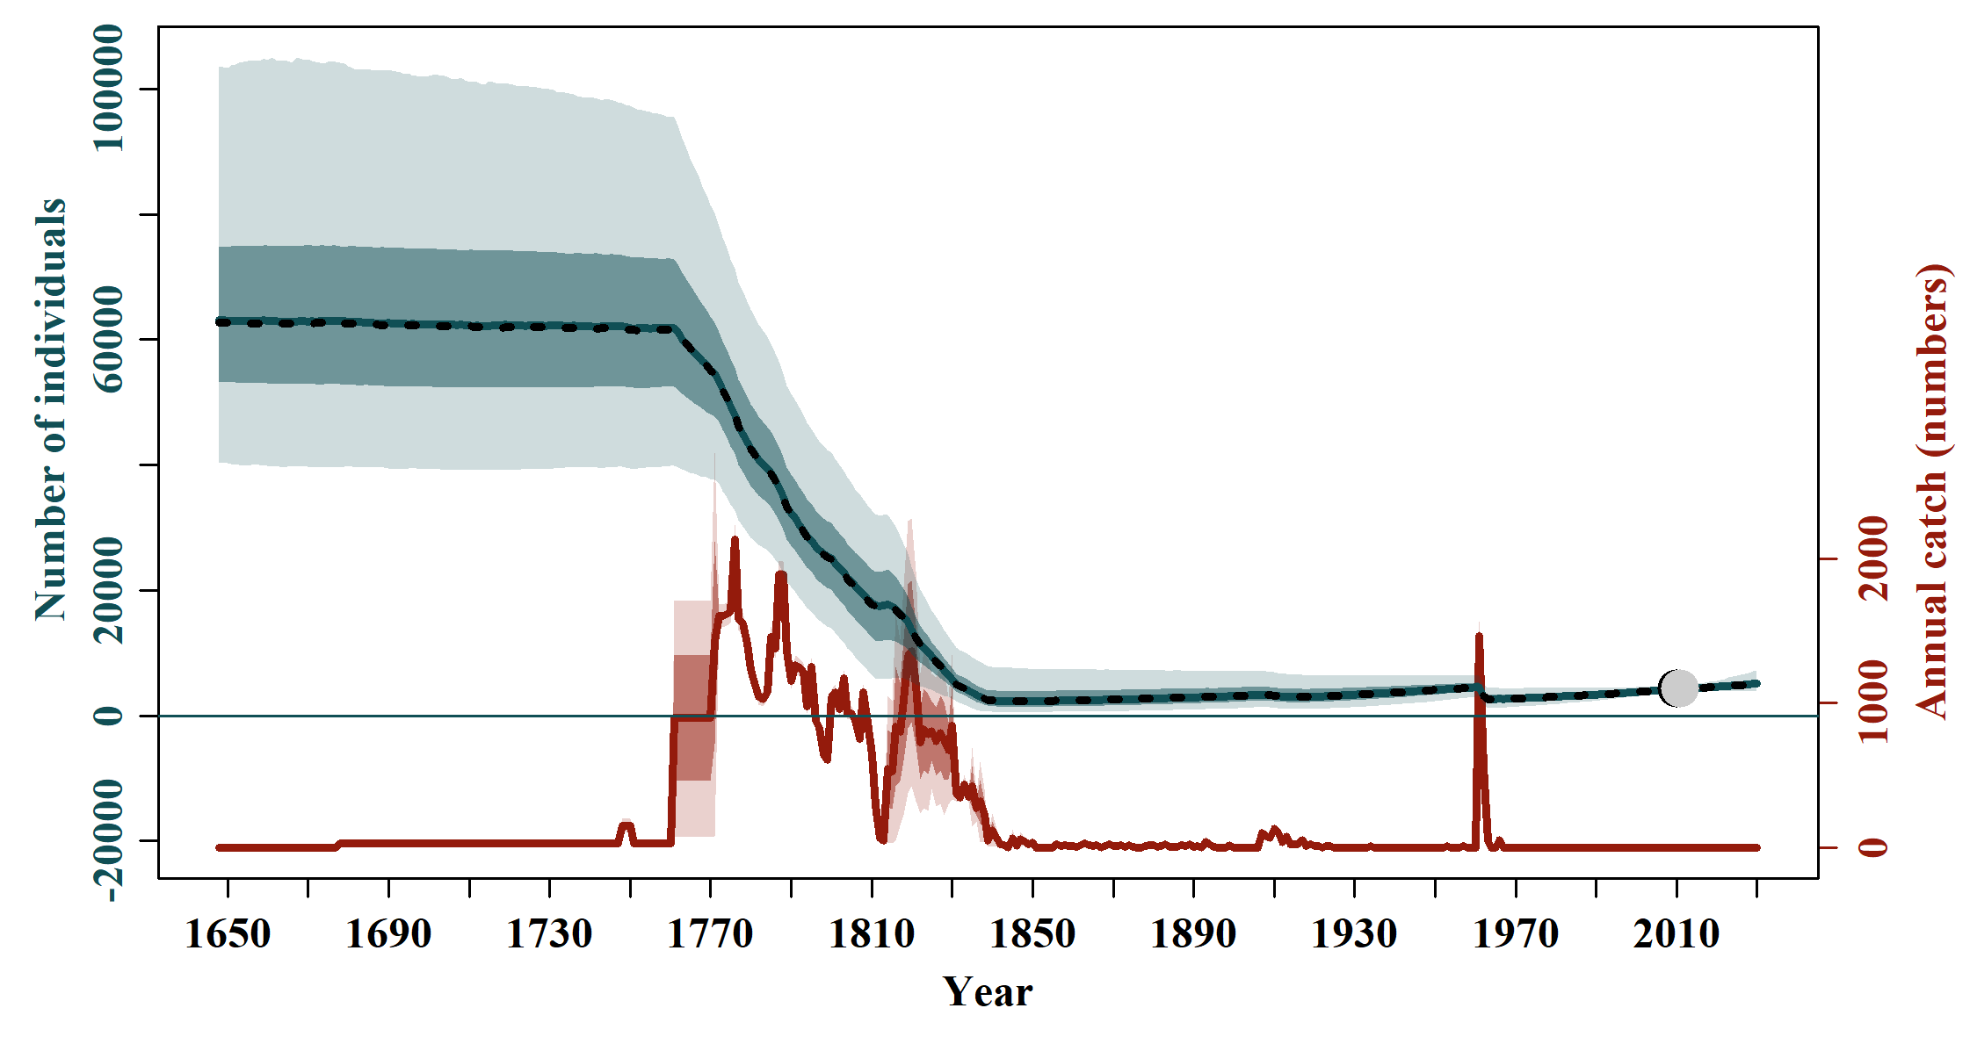

S3.13 Scen 12
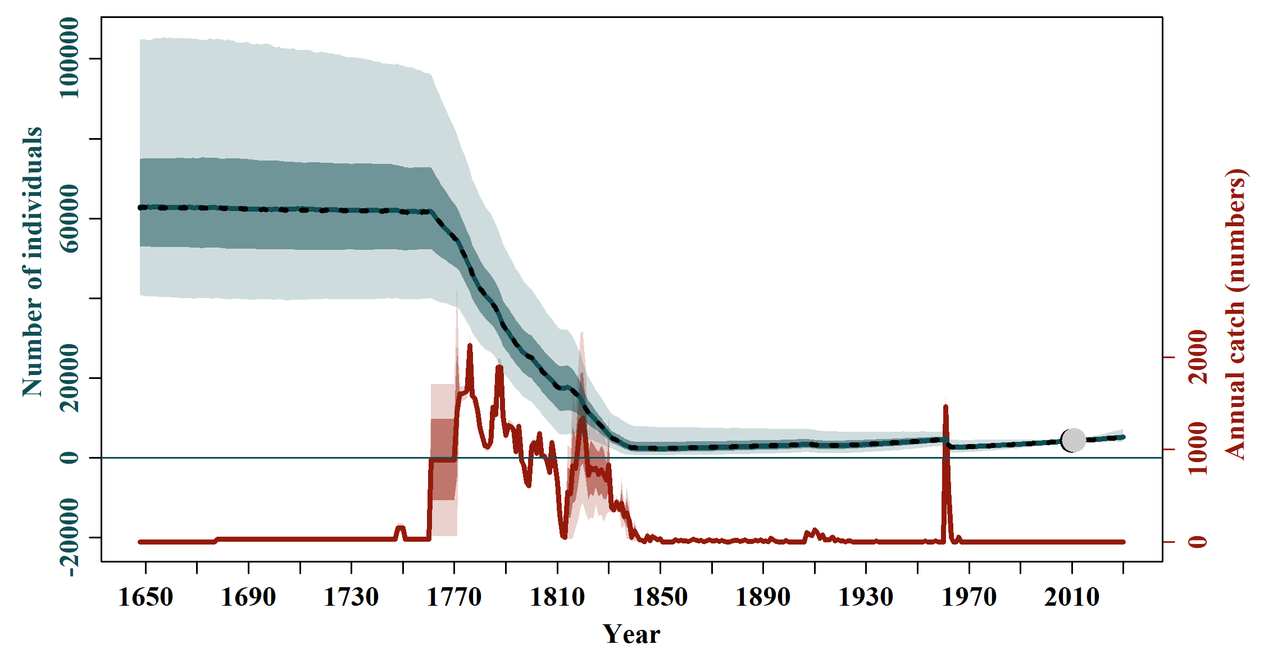

S3.14 Scen 13
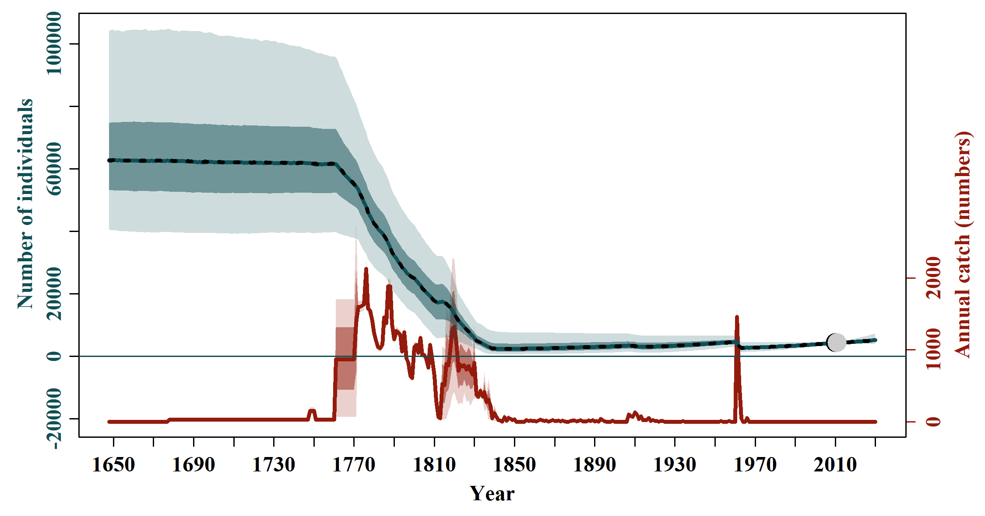

S3.15 Scen 14
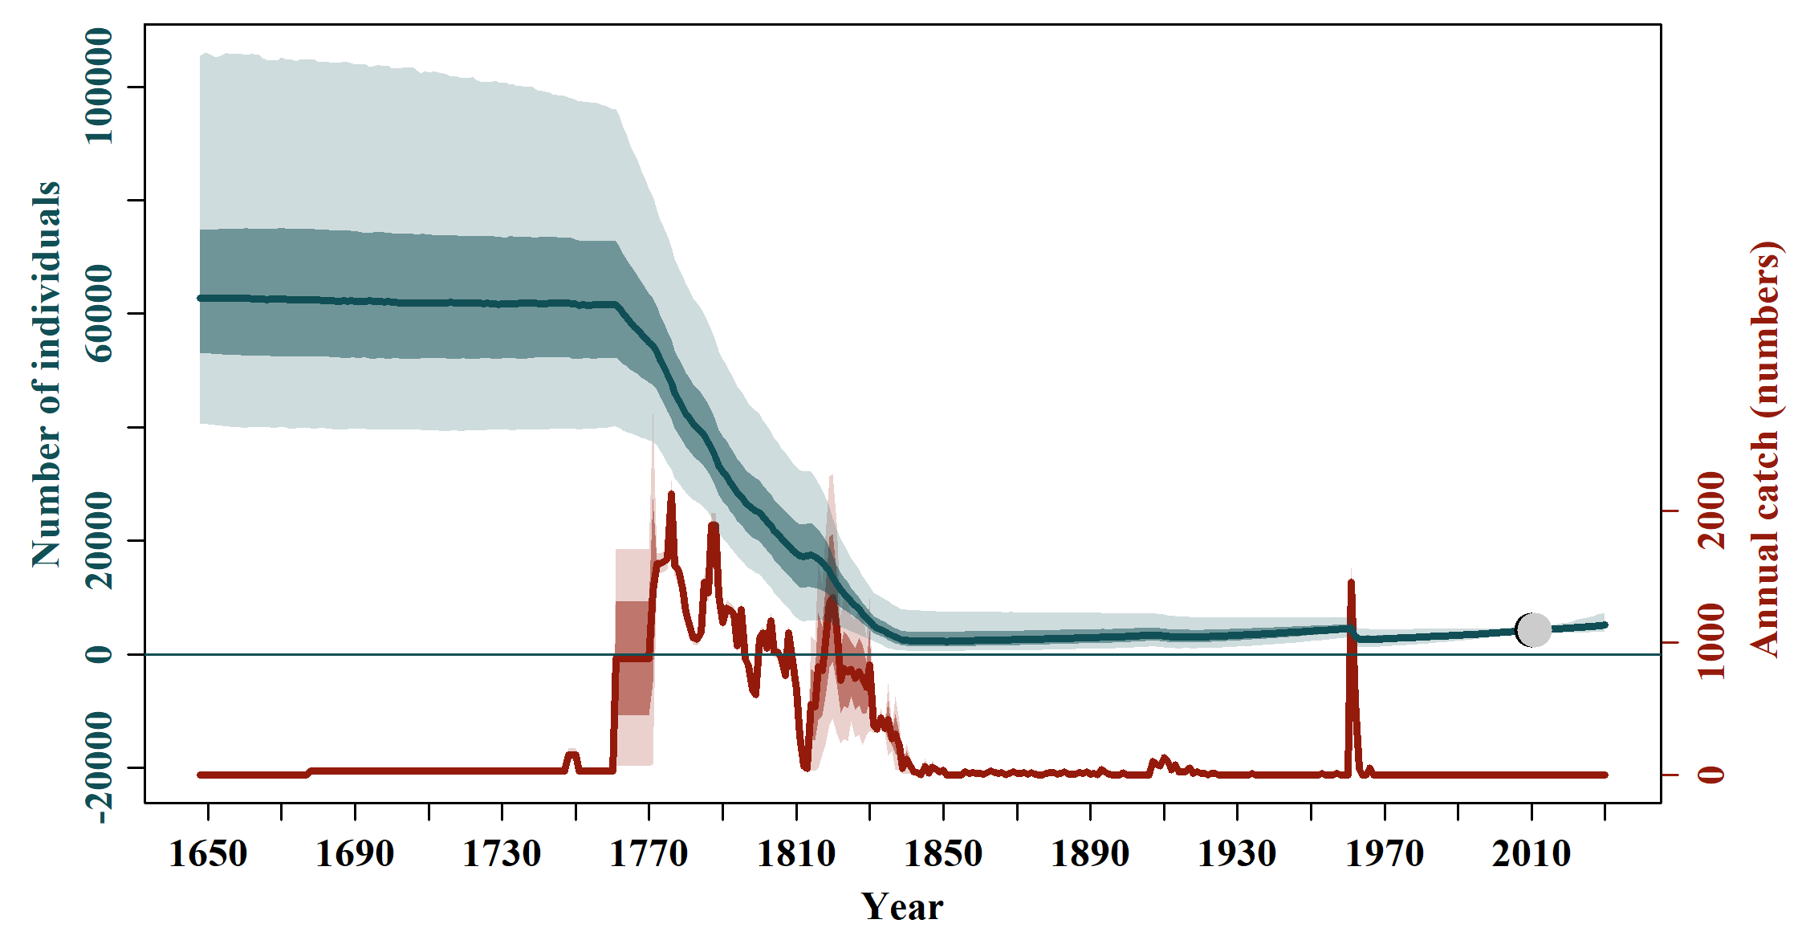

Figure S4. Fits of the observed (black dots) and estimated (grey dots) absolute abundance of southern right whale Eubalaena australis and associated 95% confidence interval (black bars) and 95% posterior predictive intervals (grey bars). The blue line is the median abundance trajectory and the shaded areas correspond to the 50% and 95% credible intervals.
S4.0 Model average  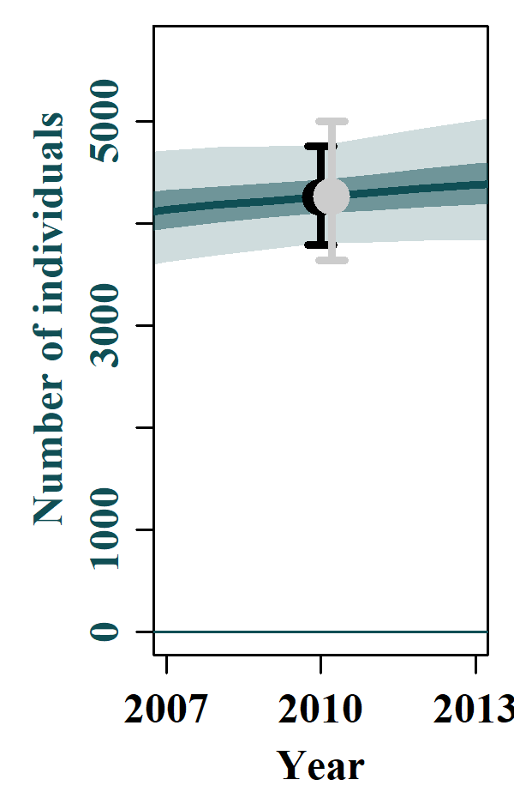 | S4.1 Base case  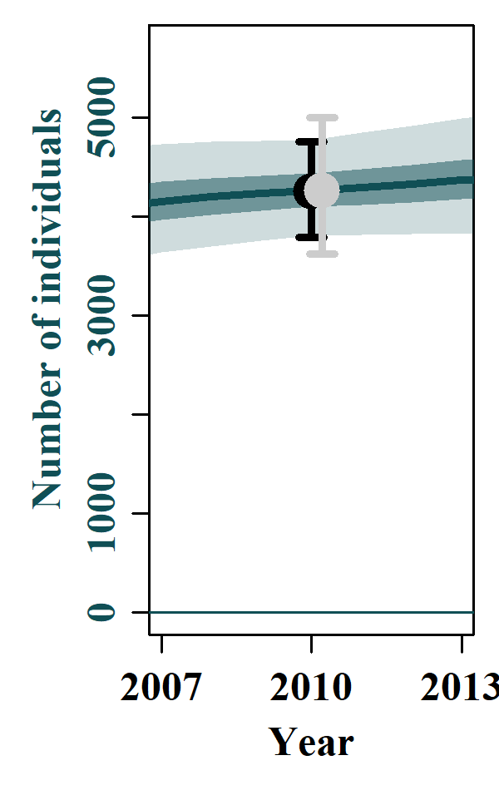 | S4.2 Scen 1  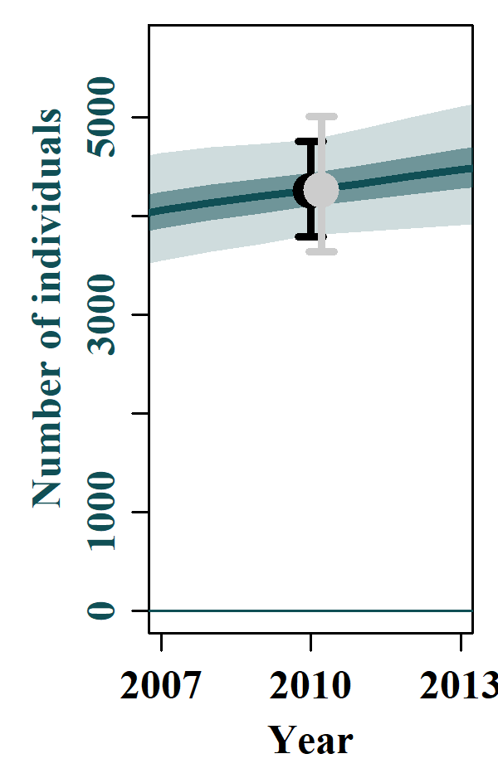 | S4.3 Scen 2  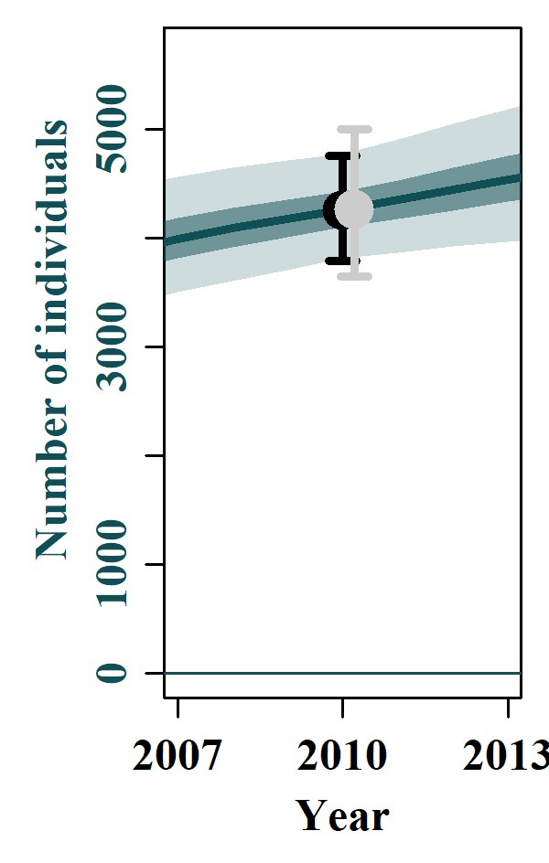
S4.4 Scen 3  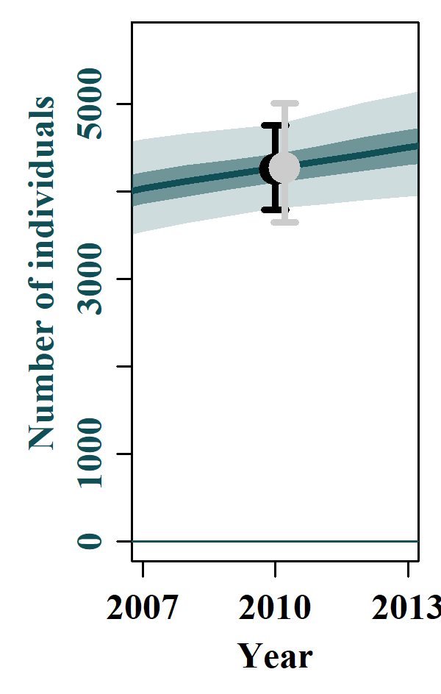 | S4.5 Scen 4  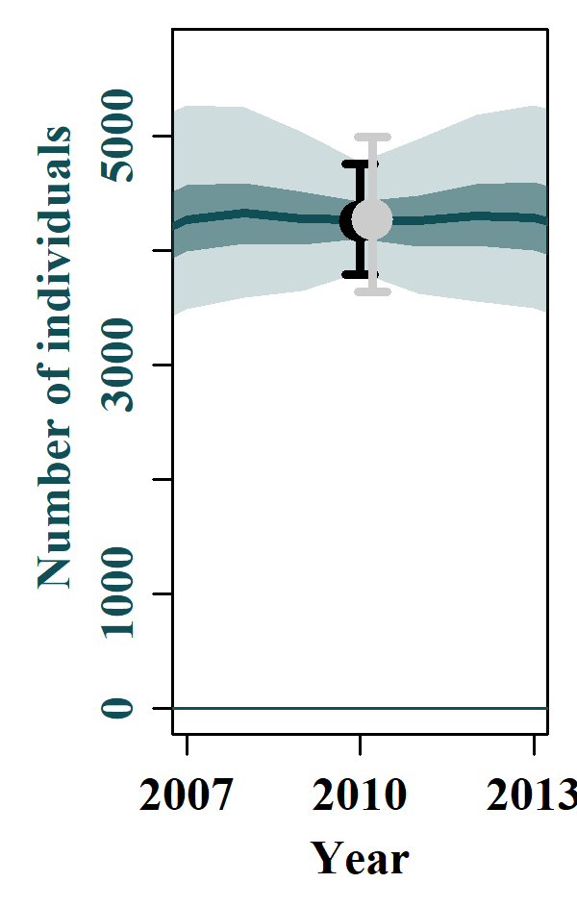 | S4.6 Scen 5  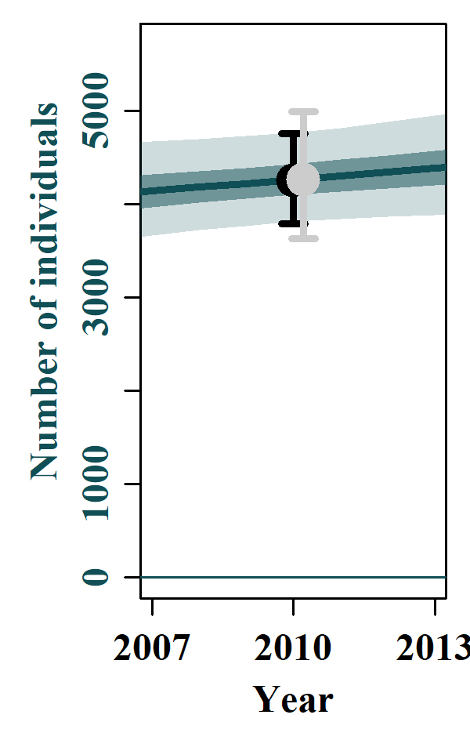 | S4.7 Scen 6  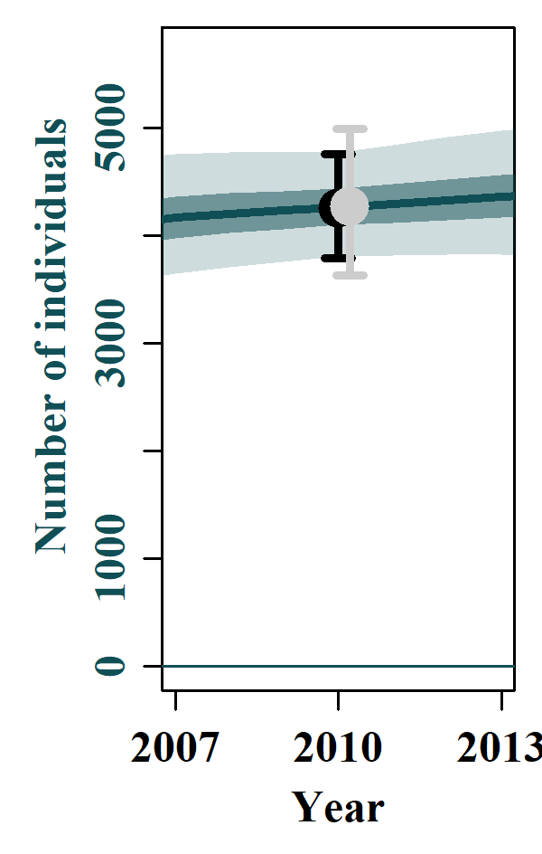
S4.8 Scen 7  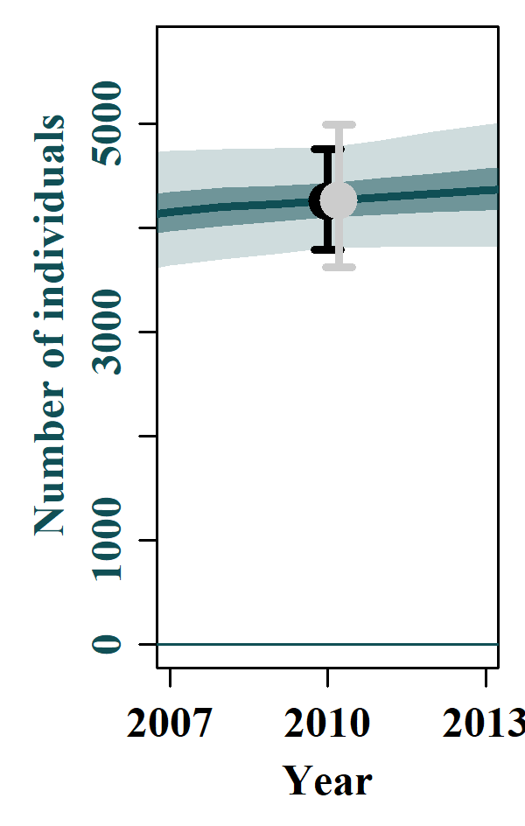 | S4.9 Scen 8  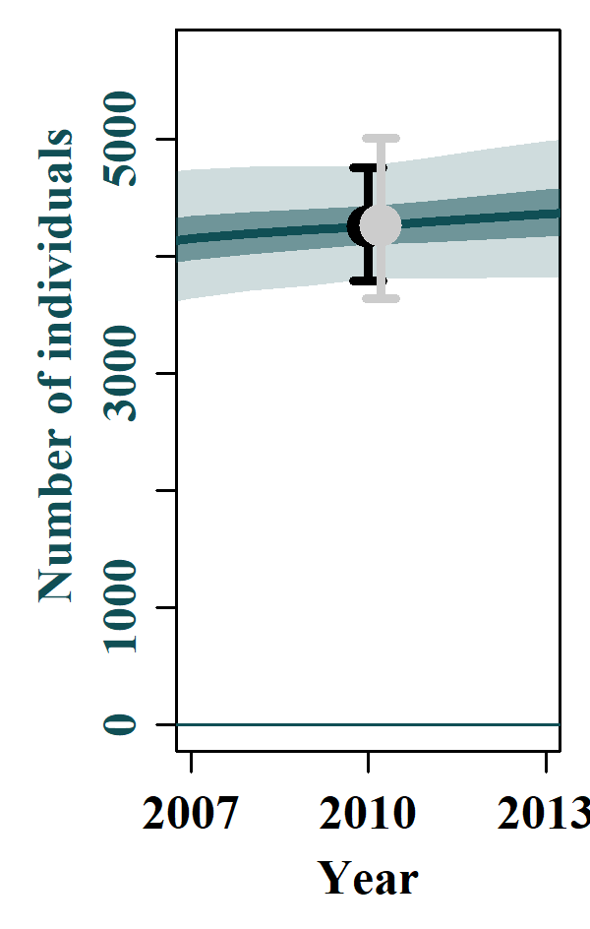 | S4.10 Scen 9  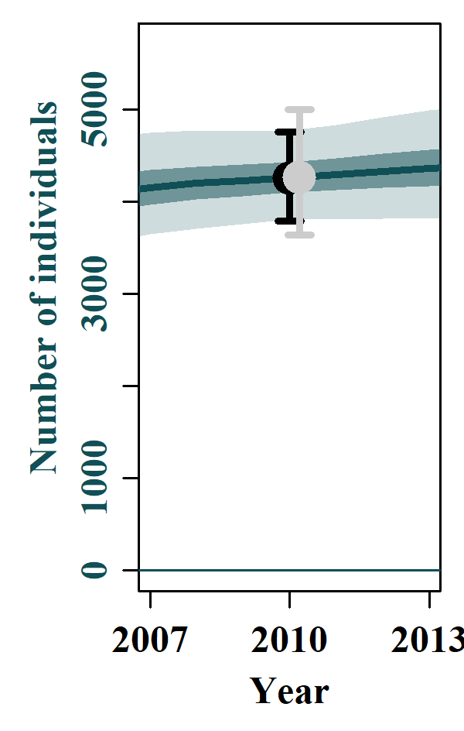 | S4.11 Scen 10  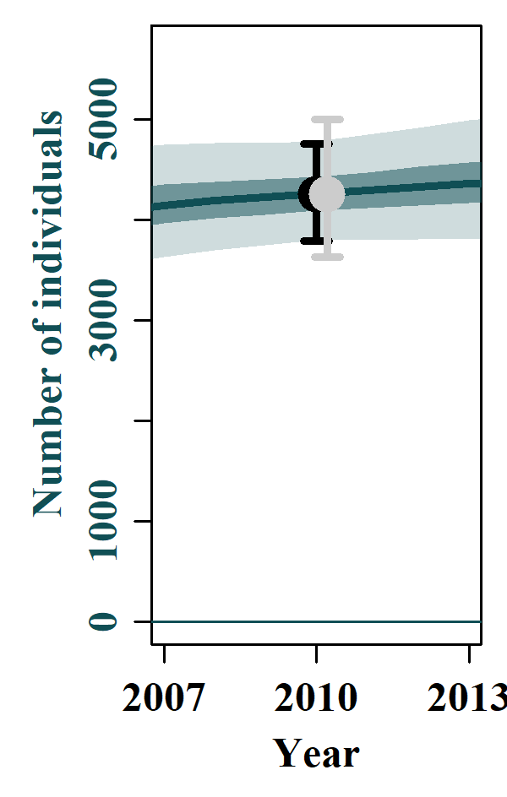
S4.12 Scen 11  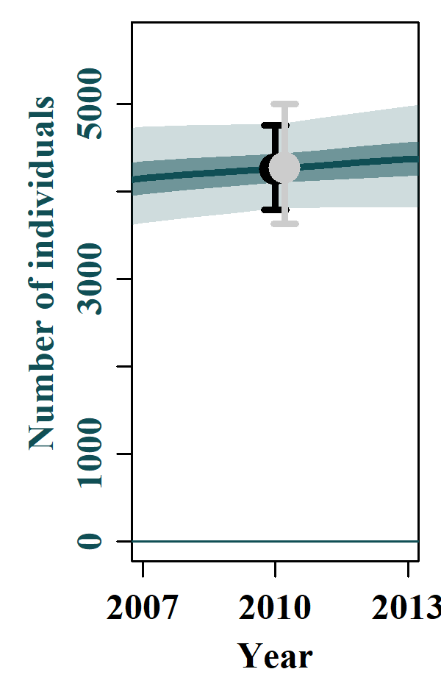 | S4.13 Scen 12  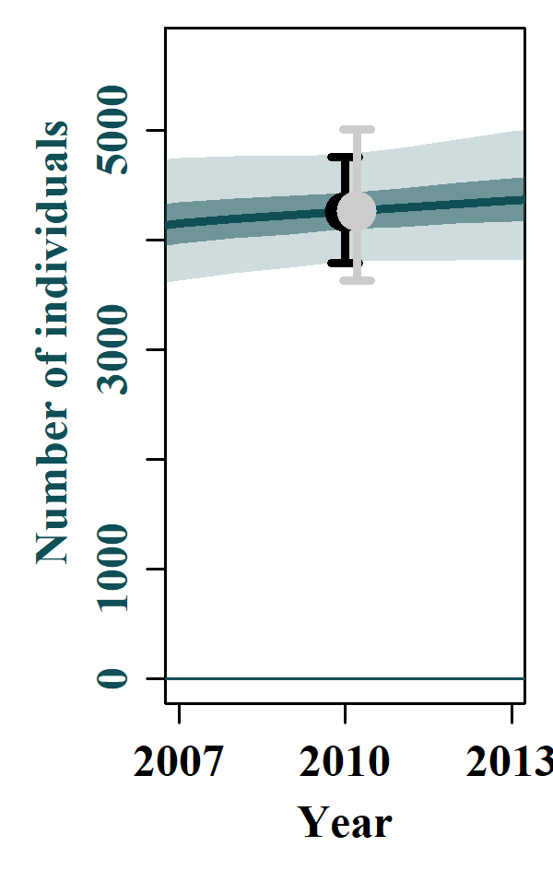 | S4.14 Scen 13  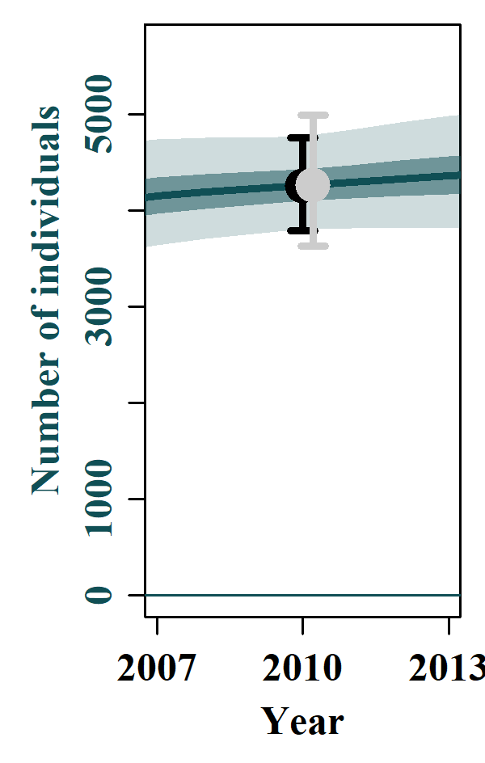 | S4.15 Scen 14  