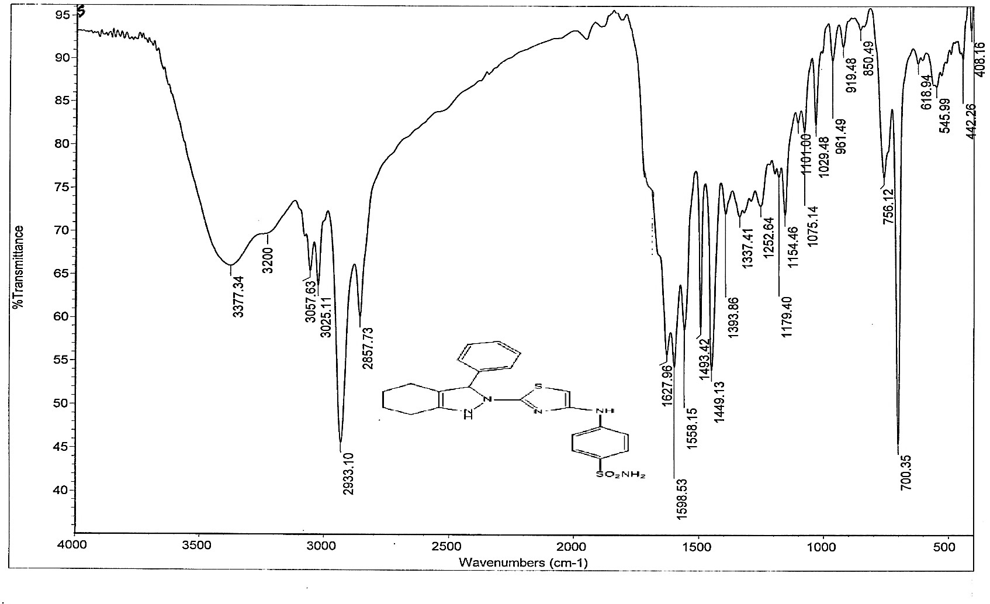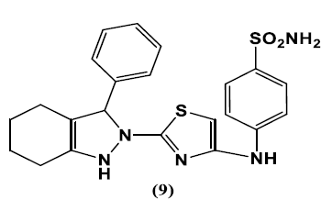

Fig. (S1 a). IR spectrum of compound 2

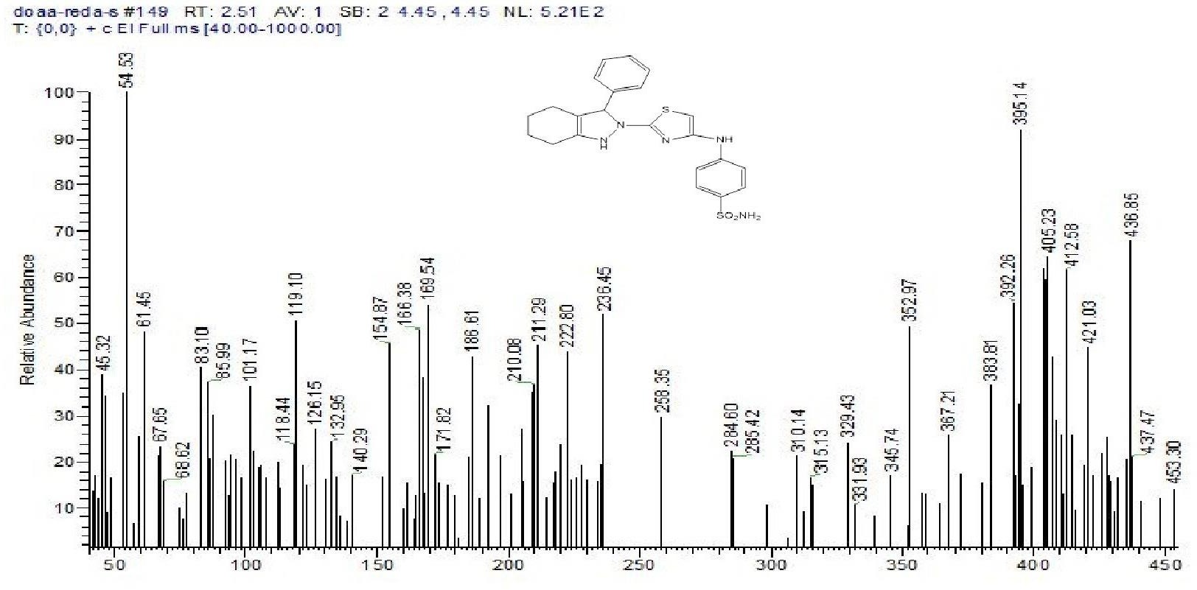

Fig. (S1 b).Mass spectroscopy of compound 2

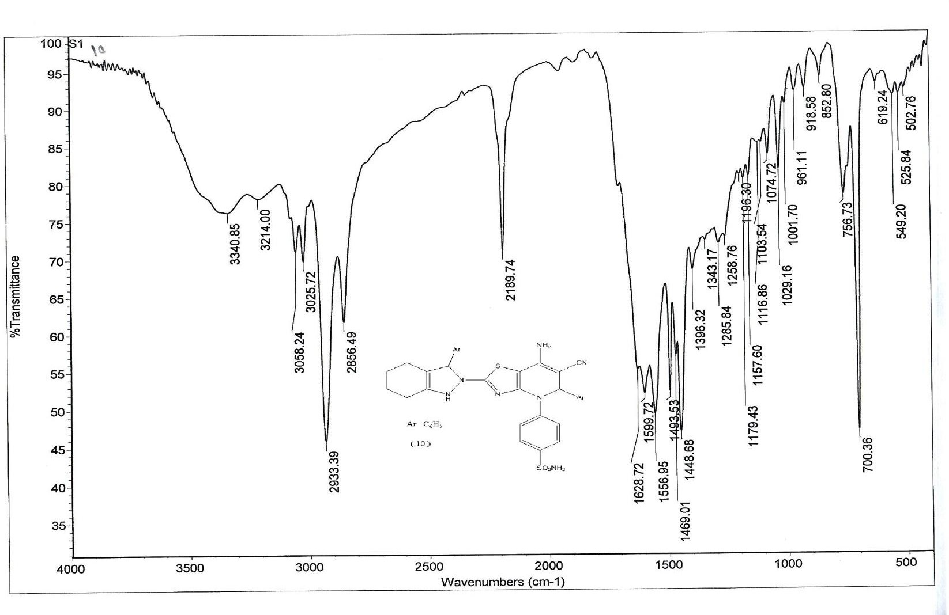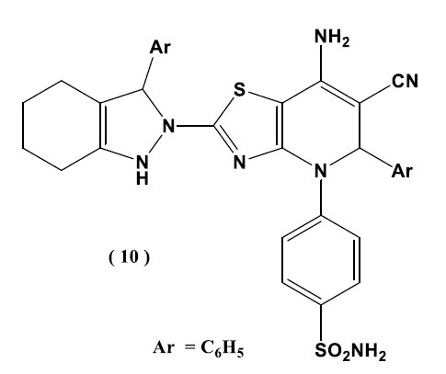

3

Fig. (S2 a).IR spectrum of compound 3

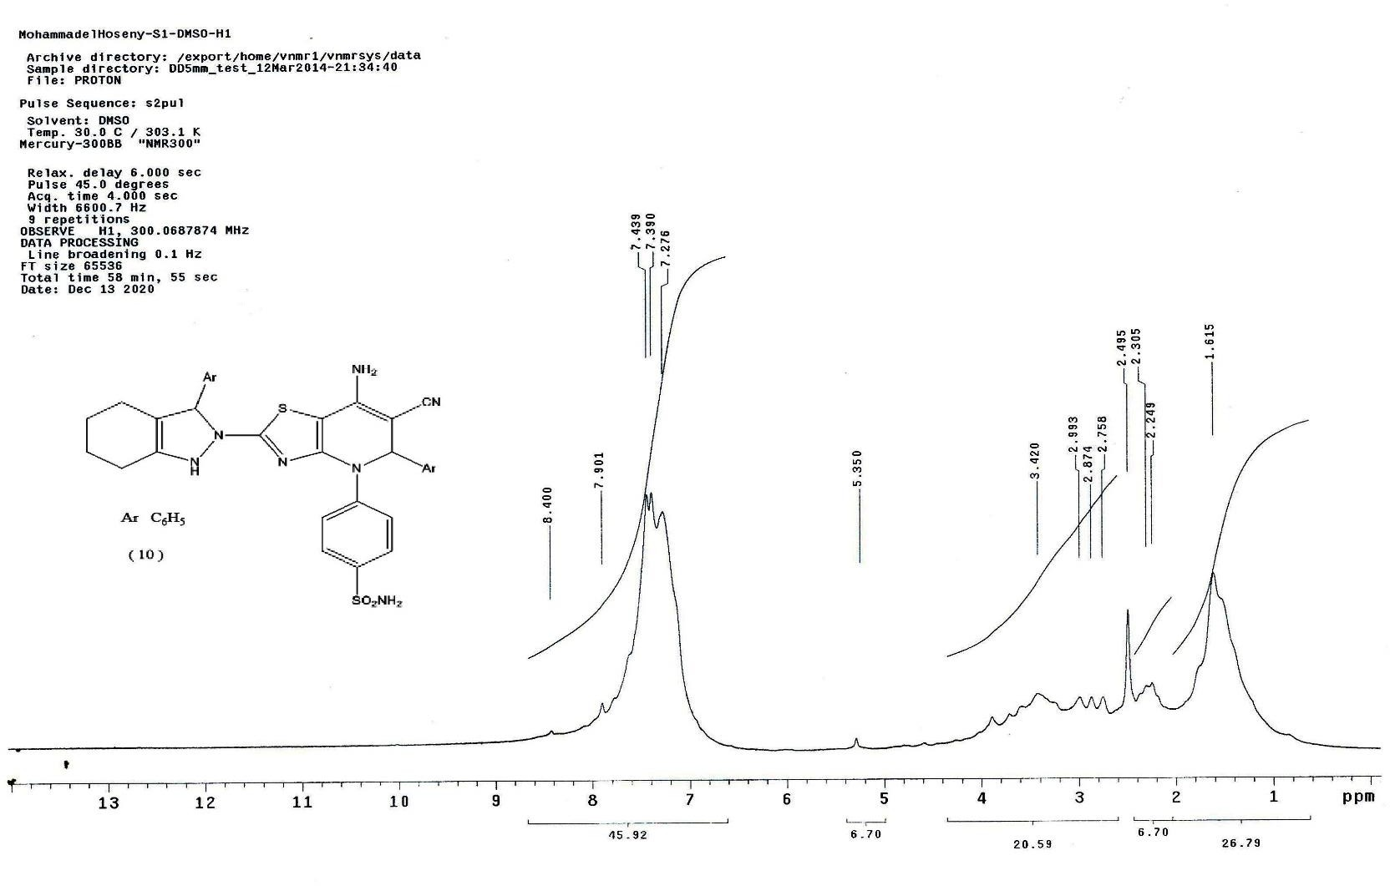

3

Fig. (S2 b). 1H-NMR spectrum of compound 3

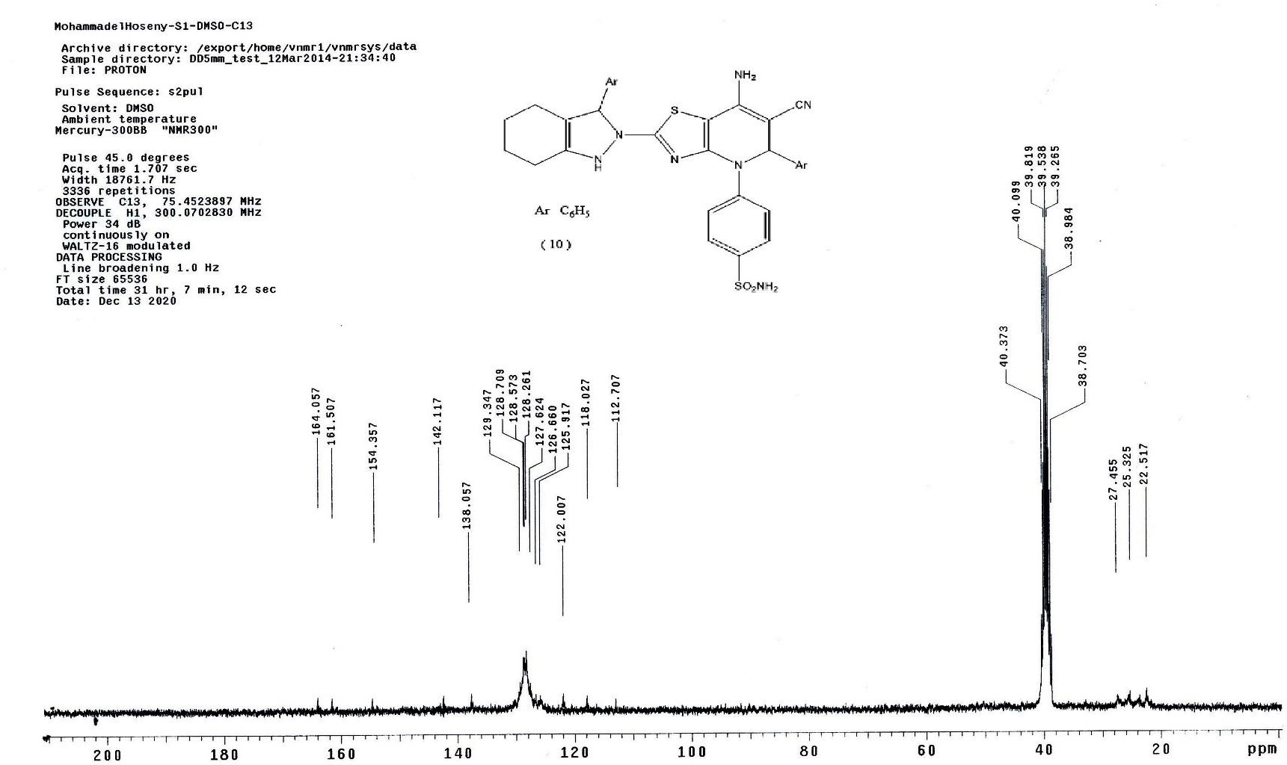

3

Fig. (S2 c). 13C-NMR spectrum of compound 3

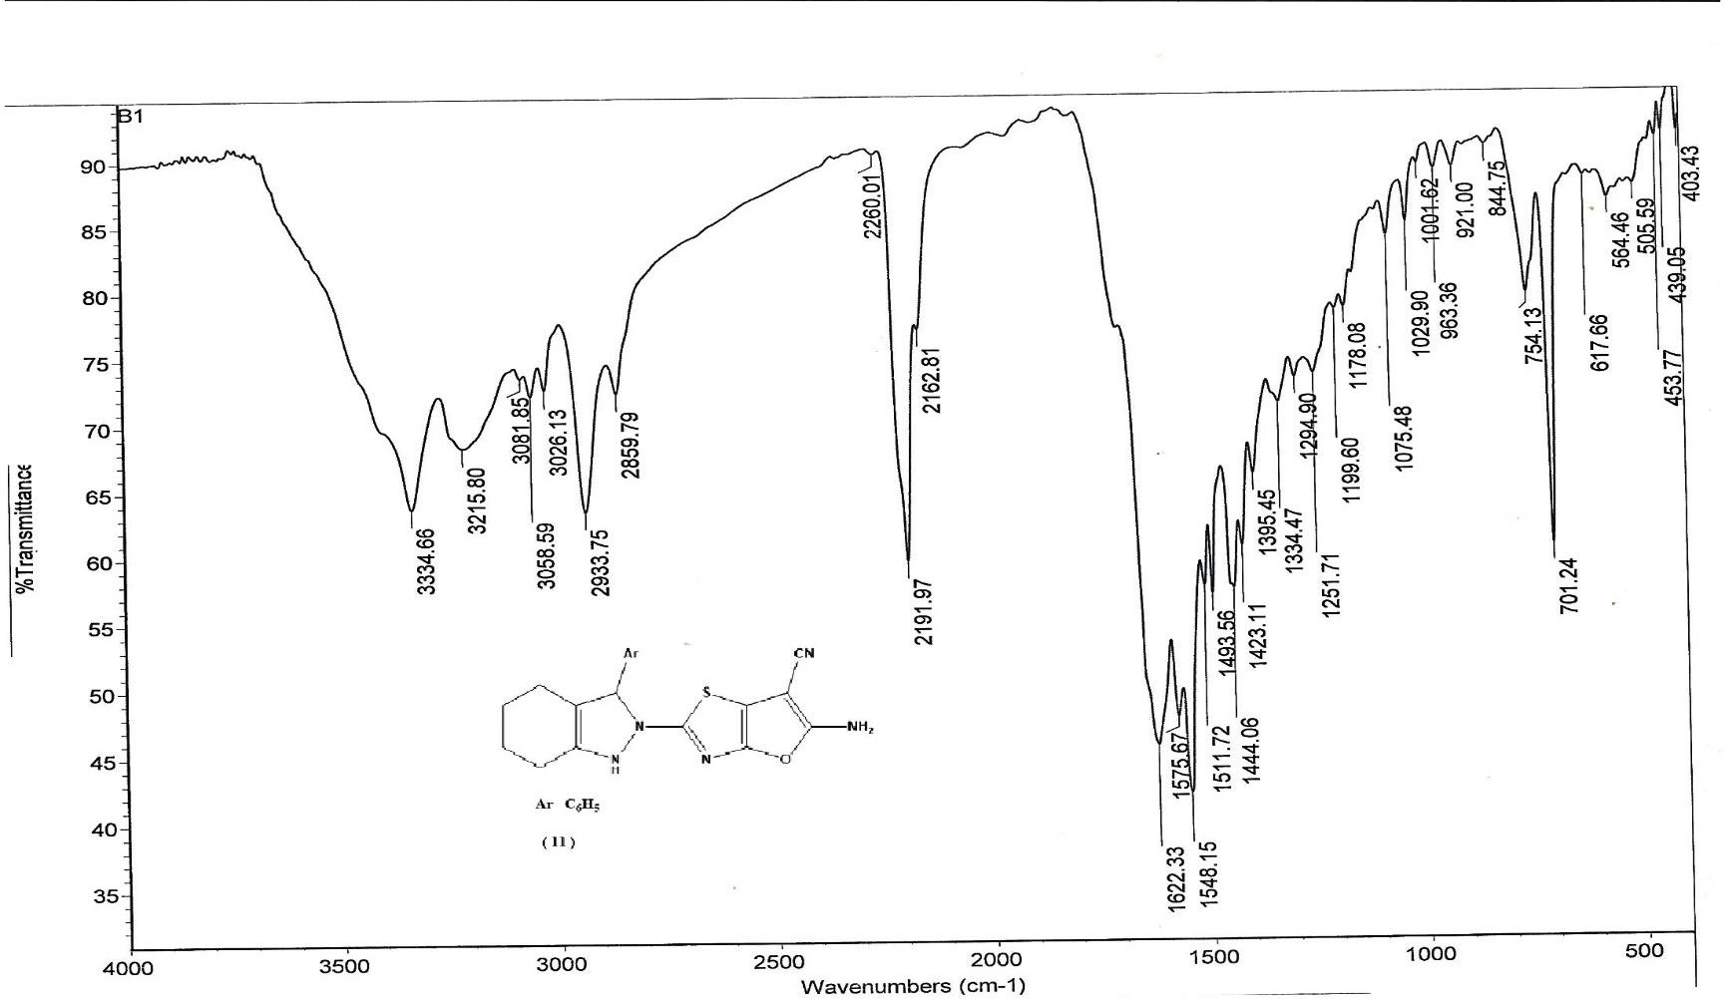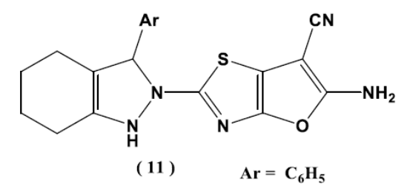

4

Fig. (S3 a). IR spectrum of compound 4

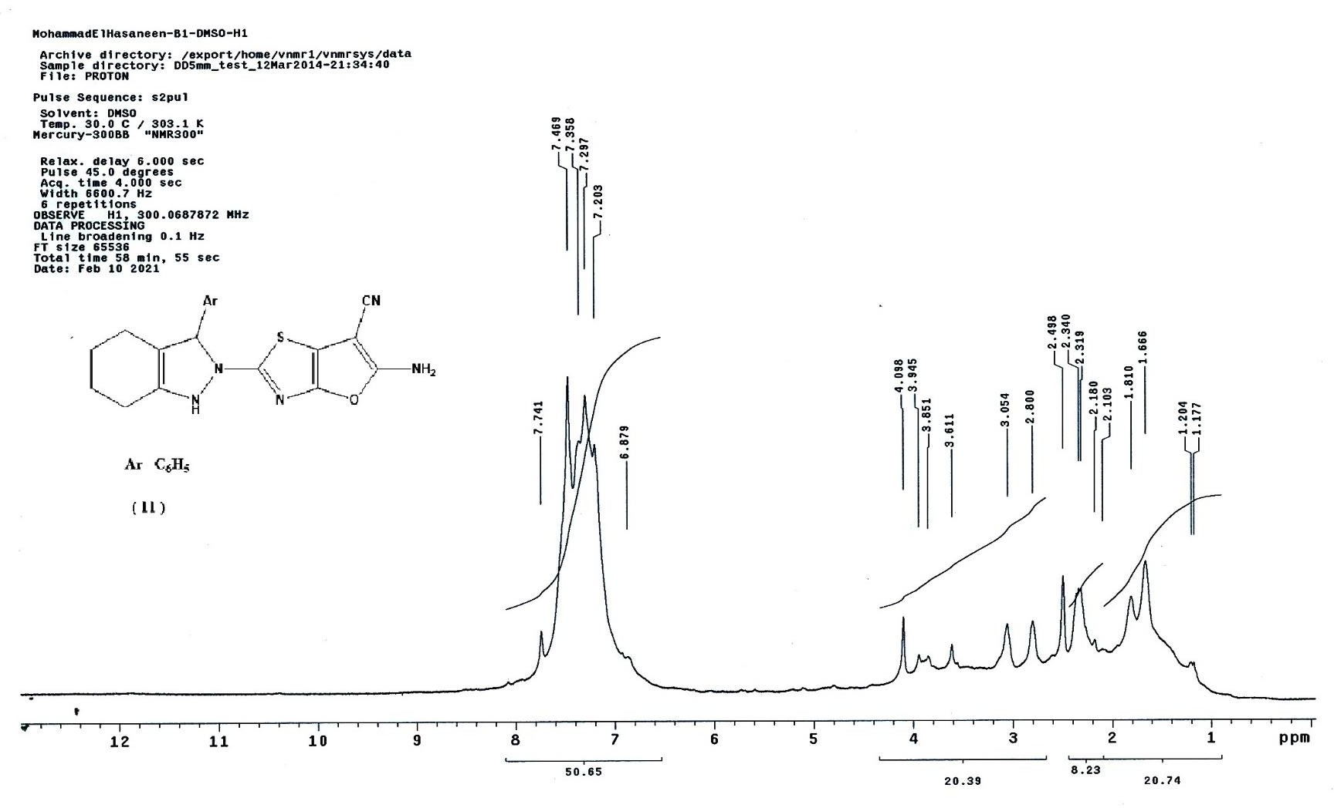

4

Fig. (S3 b). 1H-NMR spectrum of compound 4

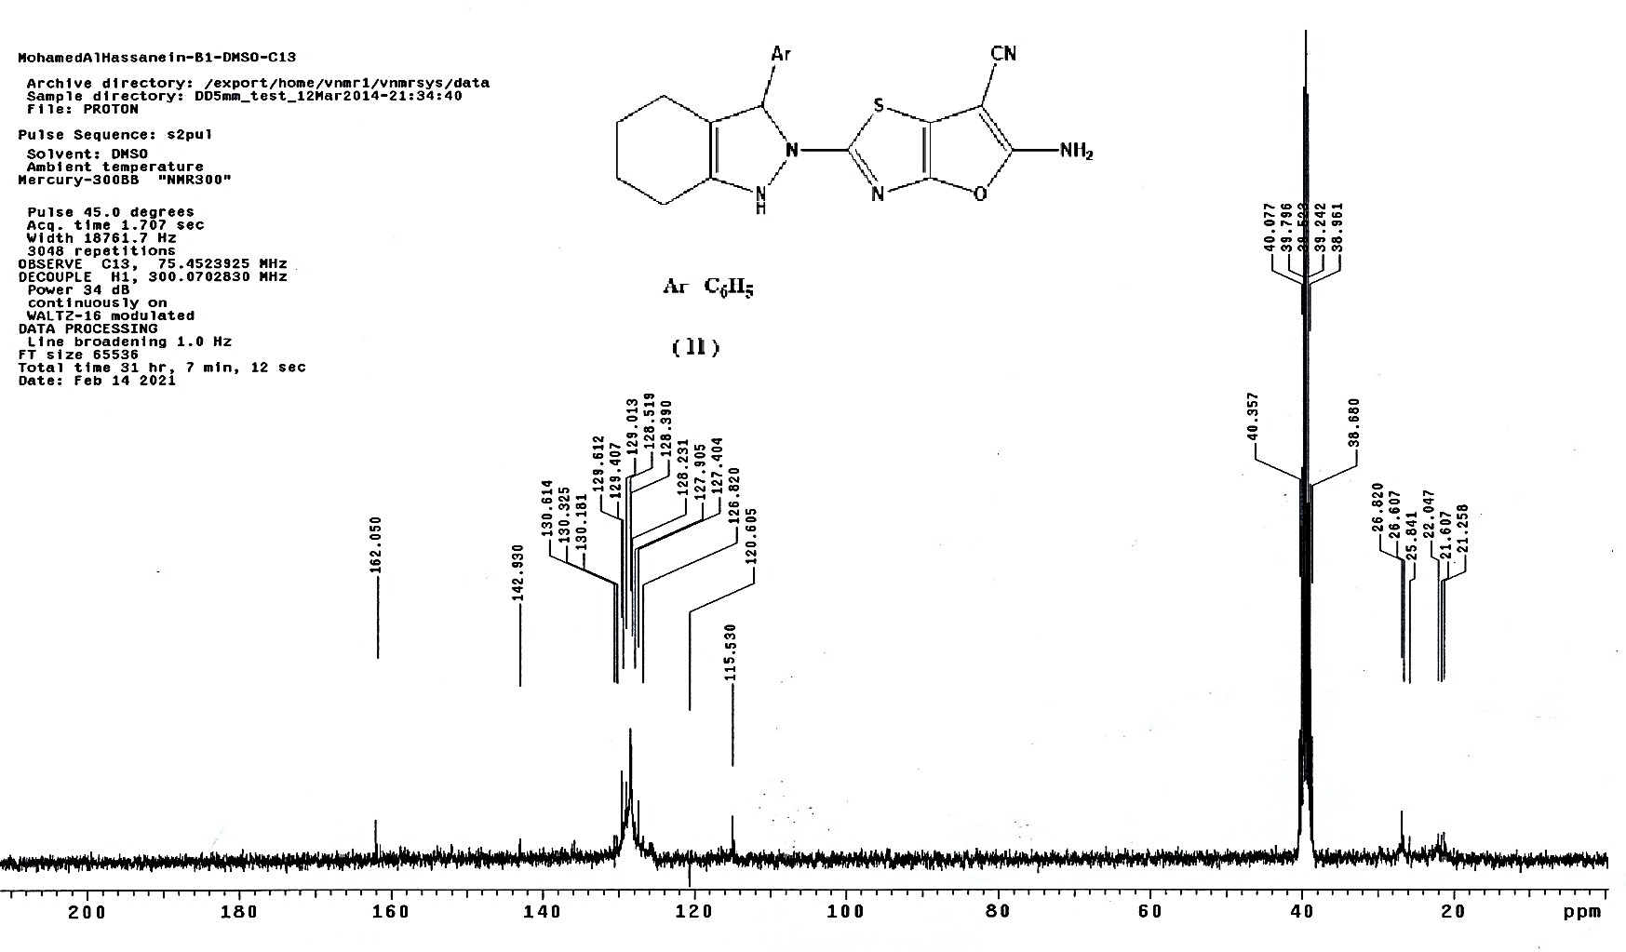

4

Fig. (S3c).13C-NMR spectrum of compound 4

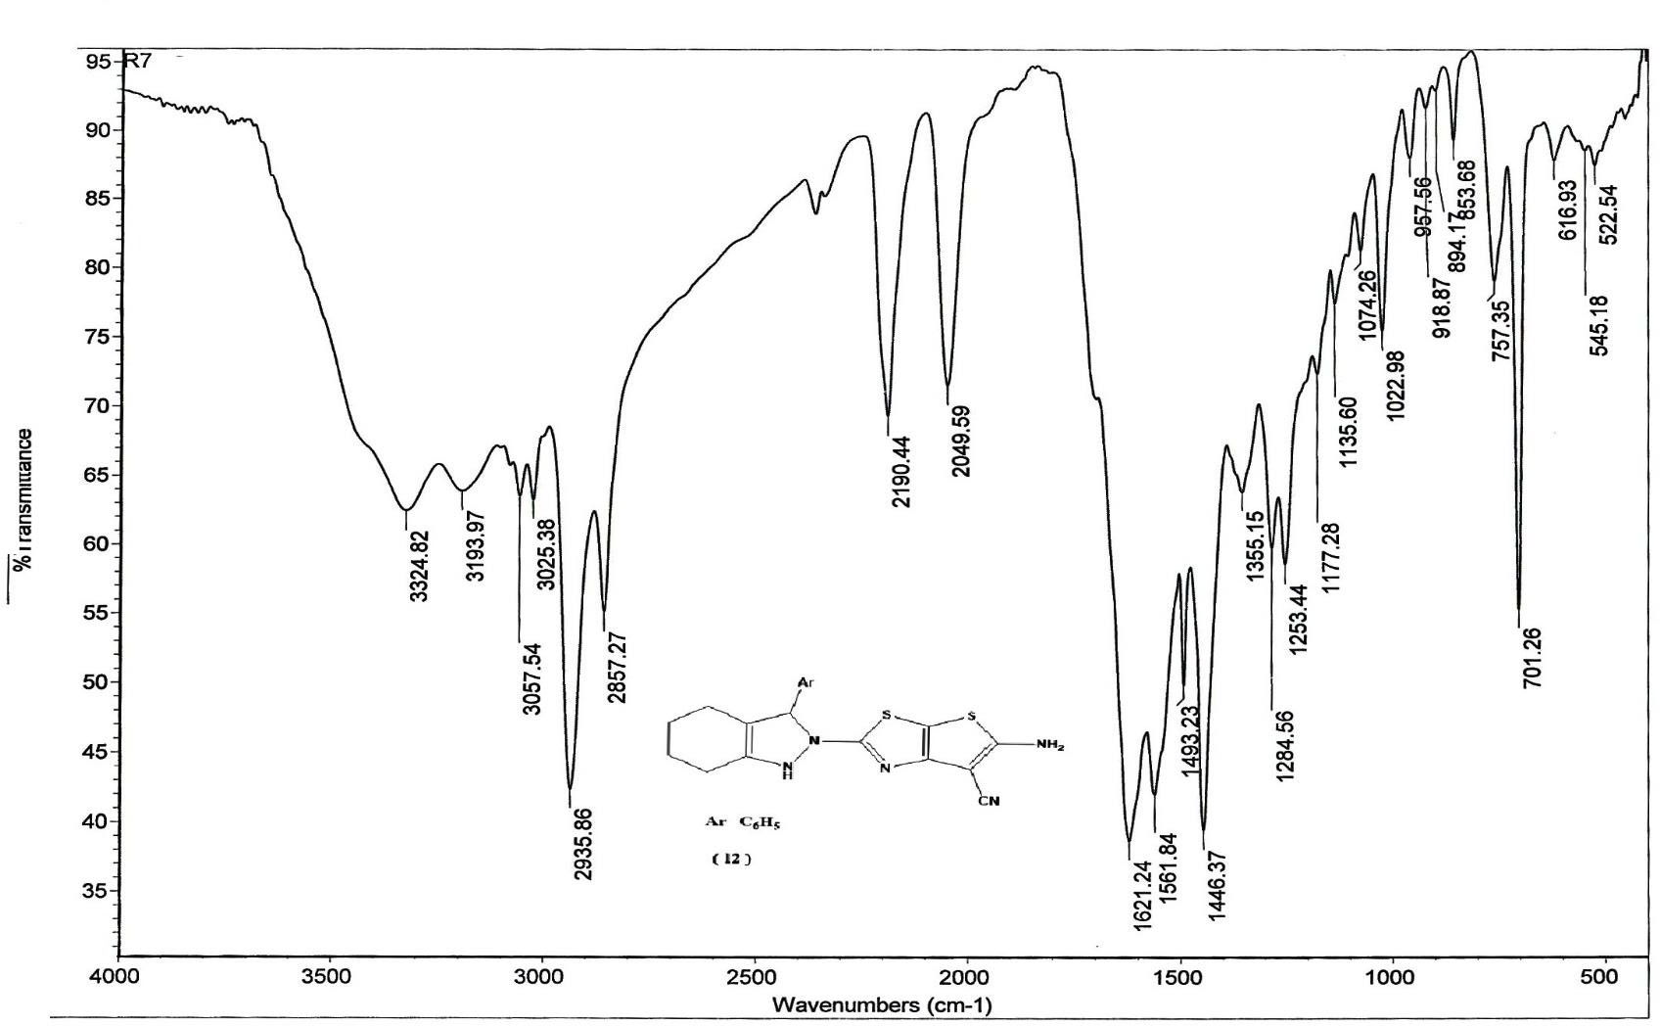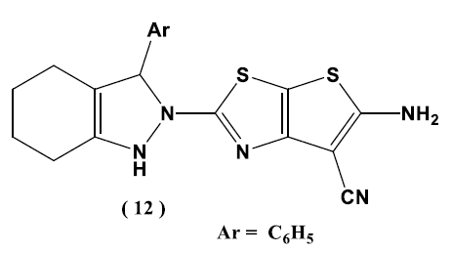

5

Fig. (S4 a). IR spectrum of compound 5

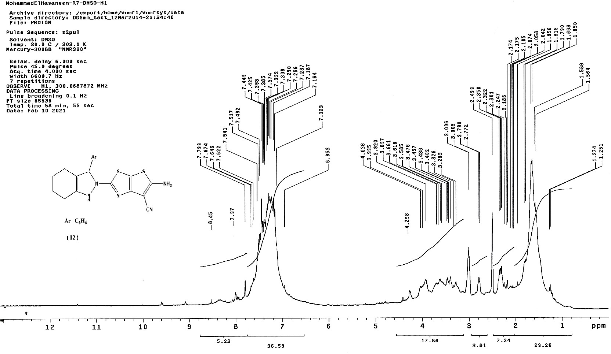

5

Fig. (S4 b). 1H-NMR spectrum of compound 5

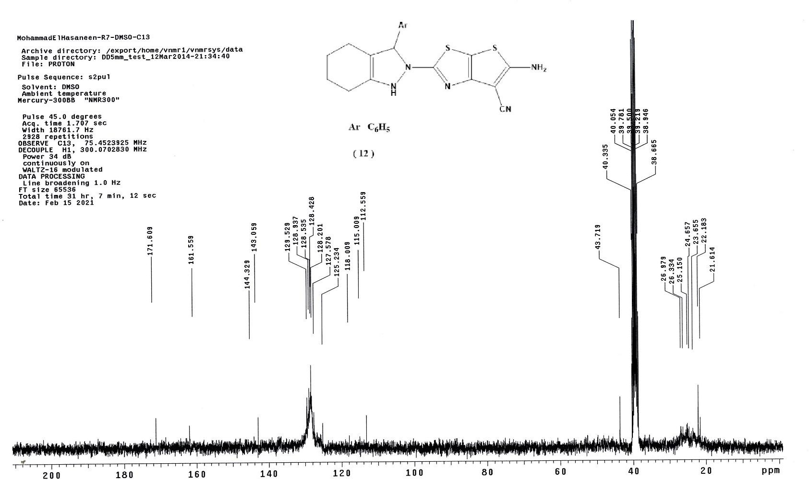

5

Fig. (S4 c). 13C-NMR spectrum of compound 5

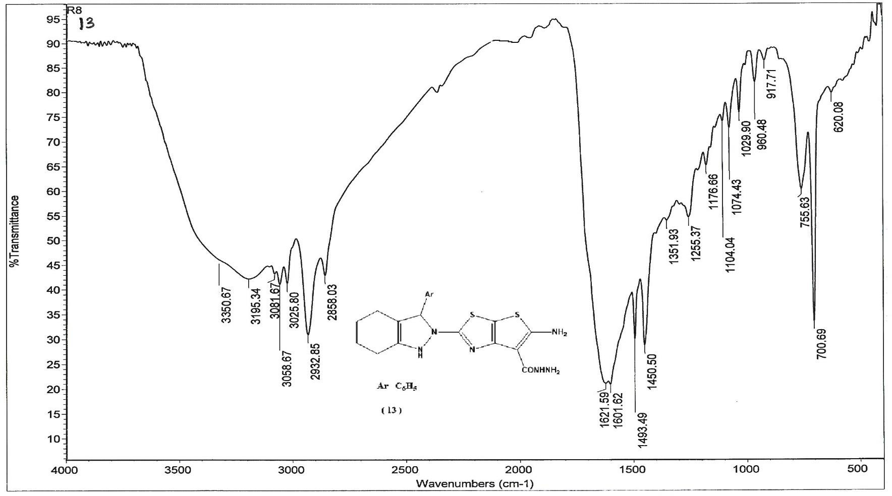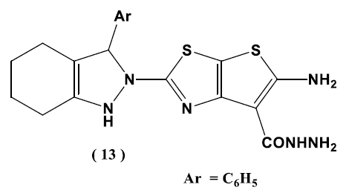

6

Fig. (S5 a).IR spectrum of compound 6

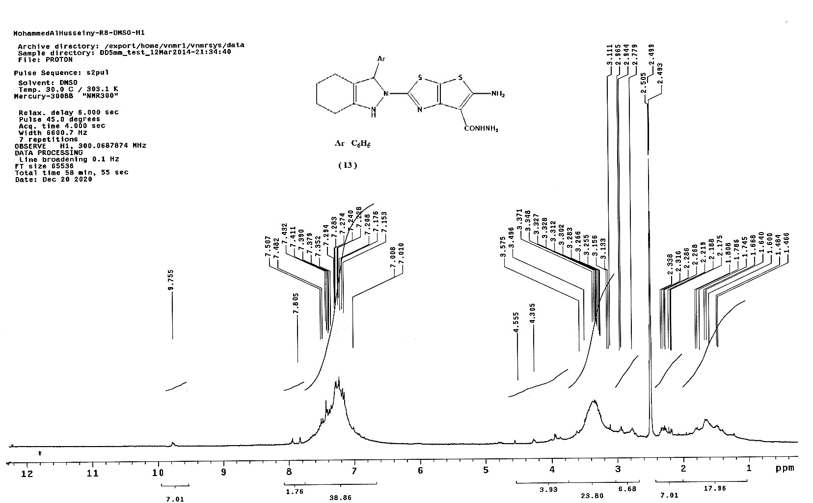

6

Fig. (S5 b). 1H-NMR spectrum of compound 6

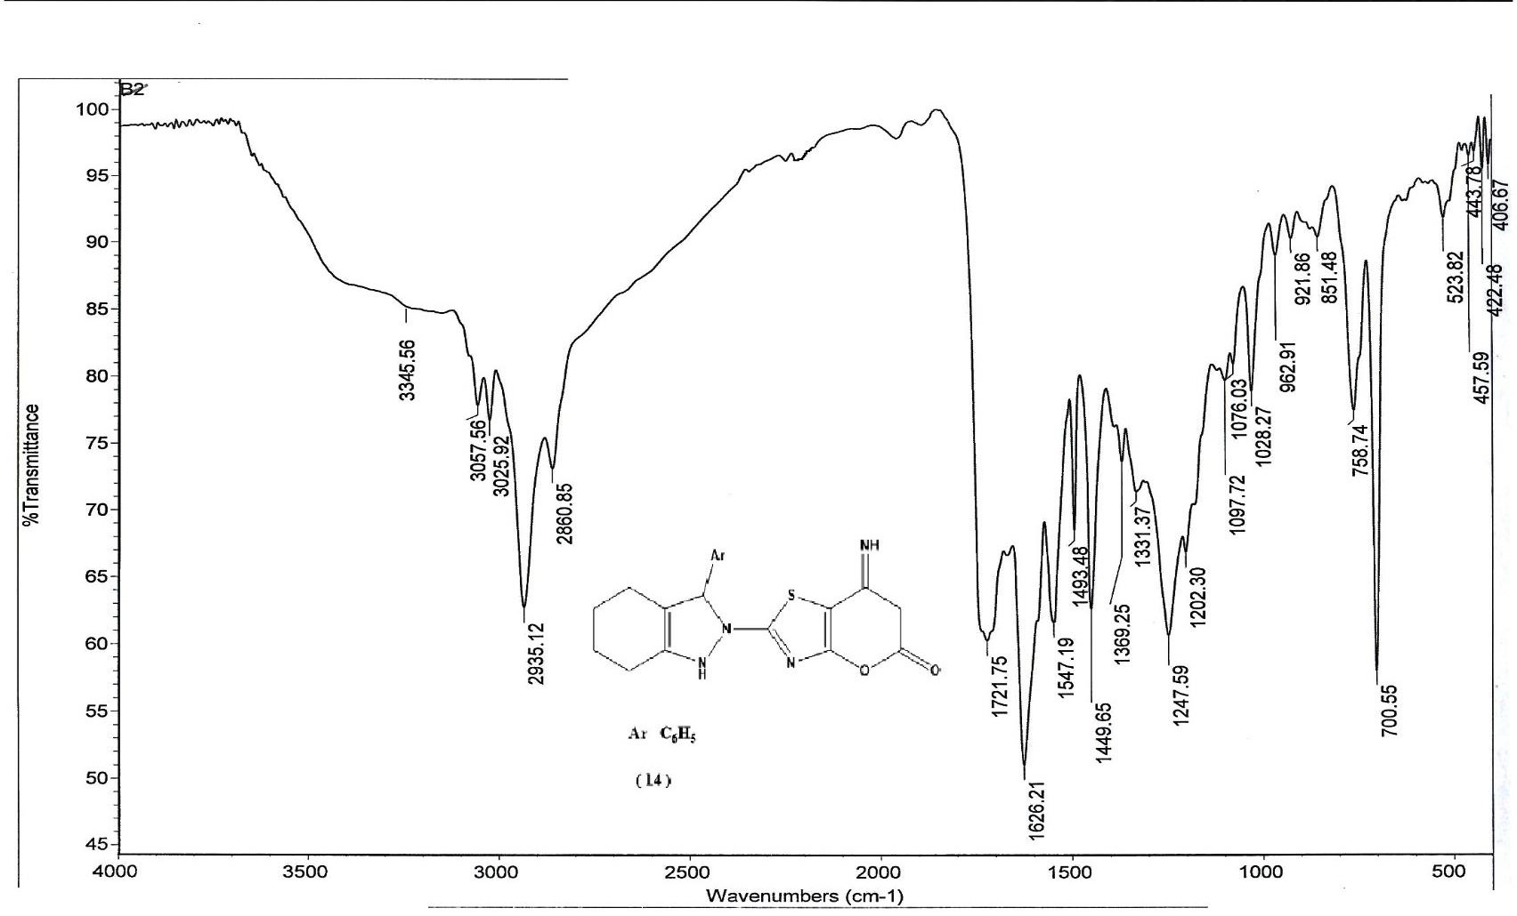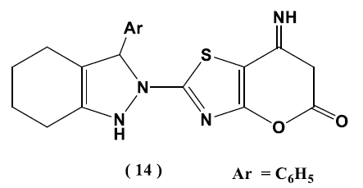

7

Fig. (S6 a). IR spectrum of compound 7

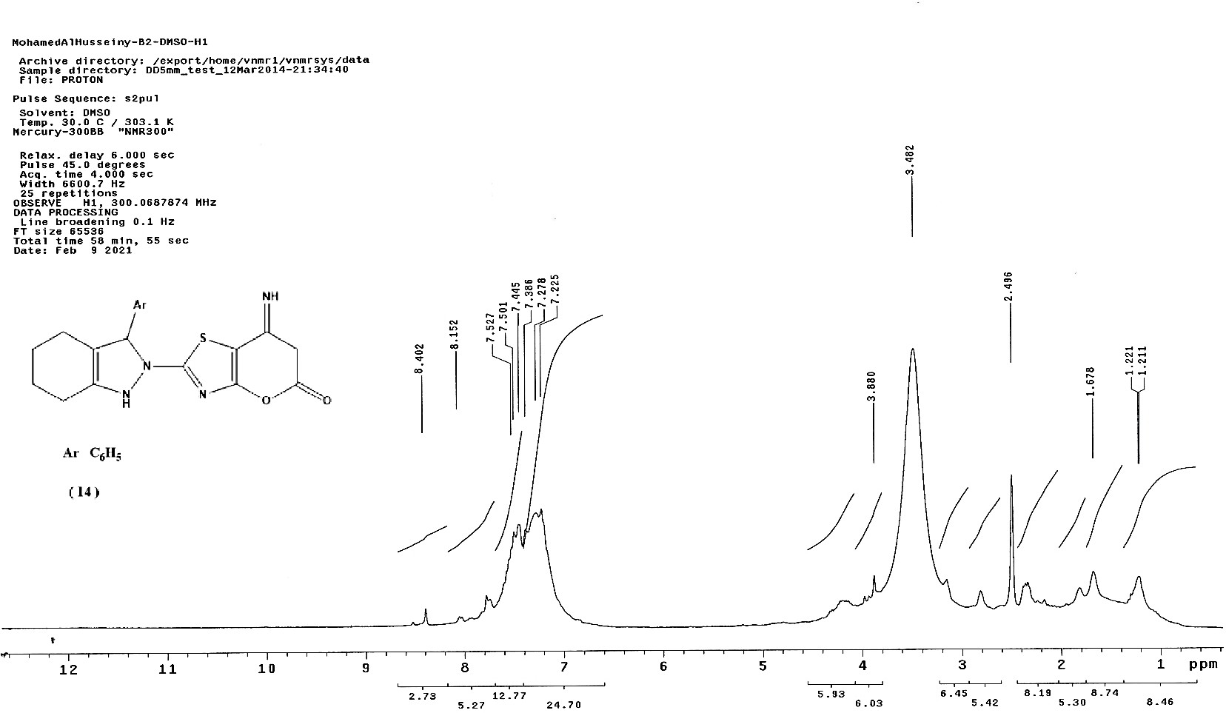

7

Fig. (S6b). 1H-NMR spectrum of compound 7

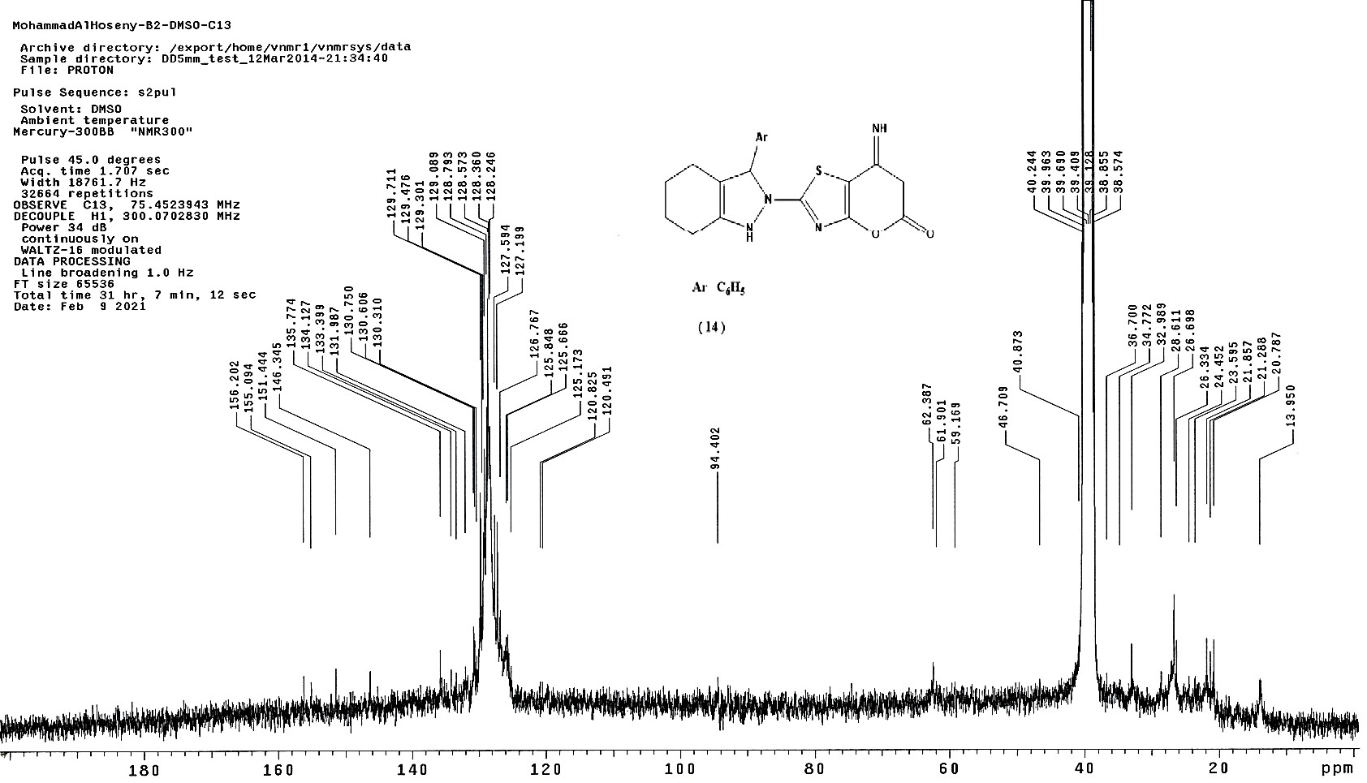

7

Fig. (S6 c).13C-NMR spectrum of compound 7

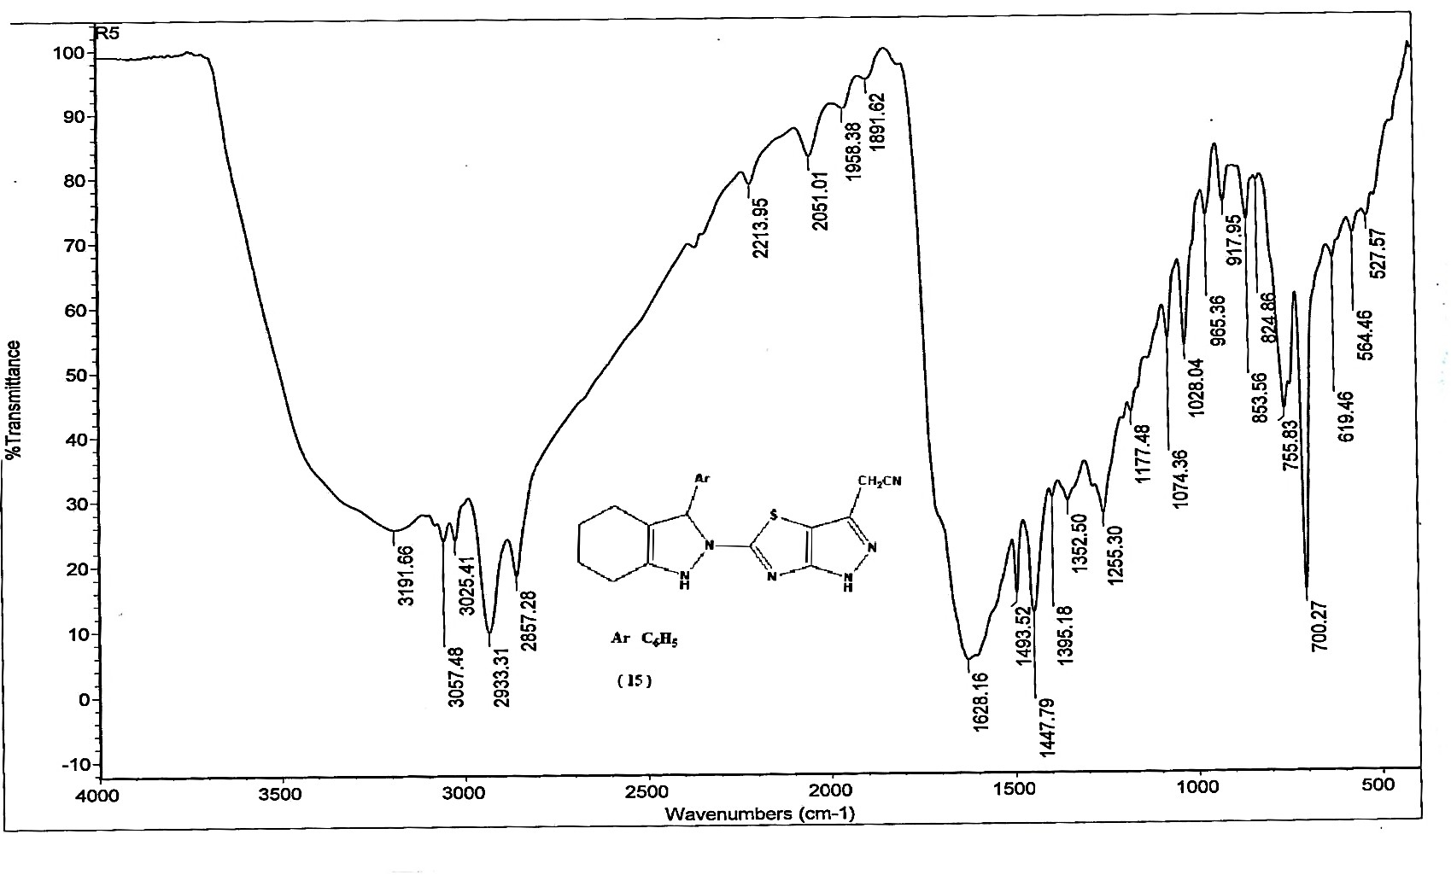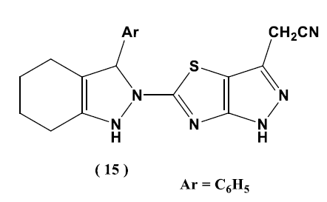

8

Fig. (S7 a). IR spectrum of compound 8

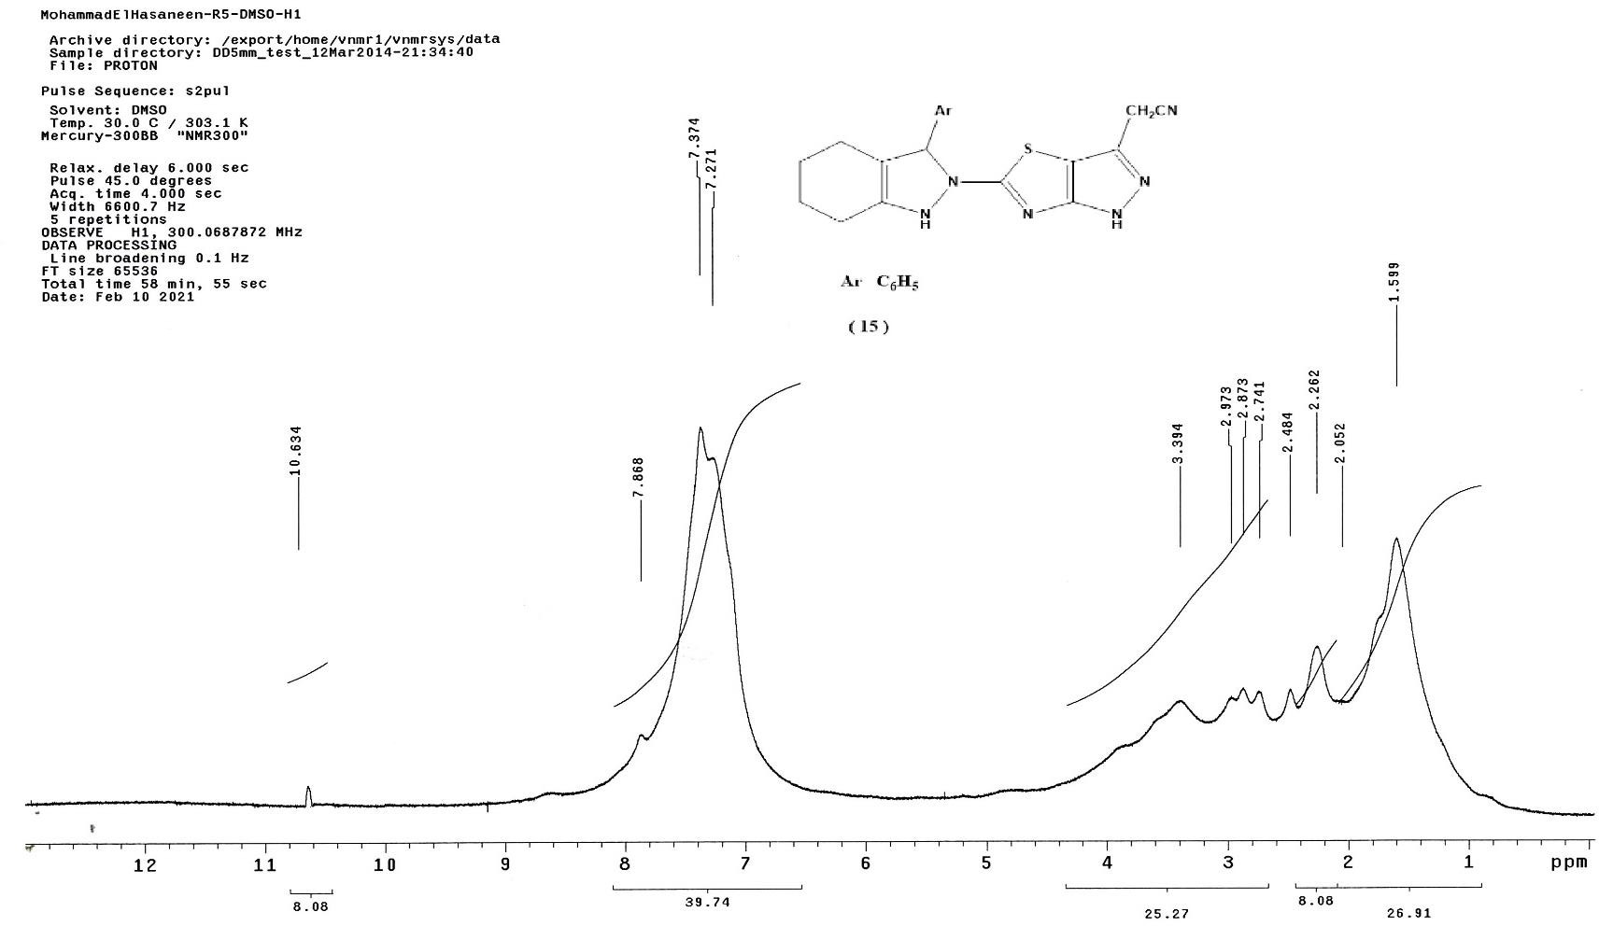

8

Fig. (S7 b). 1H-NMR spectrum of compound 8

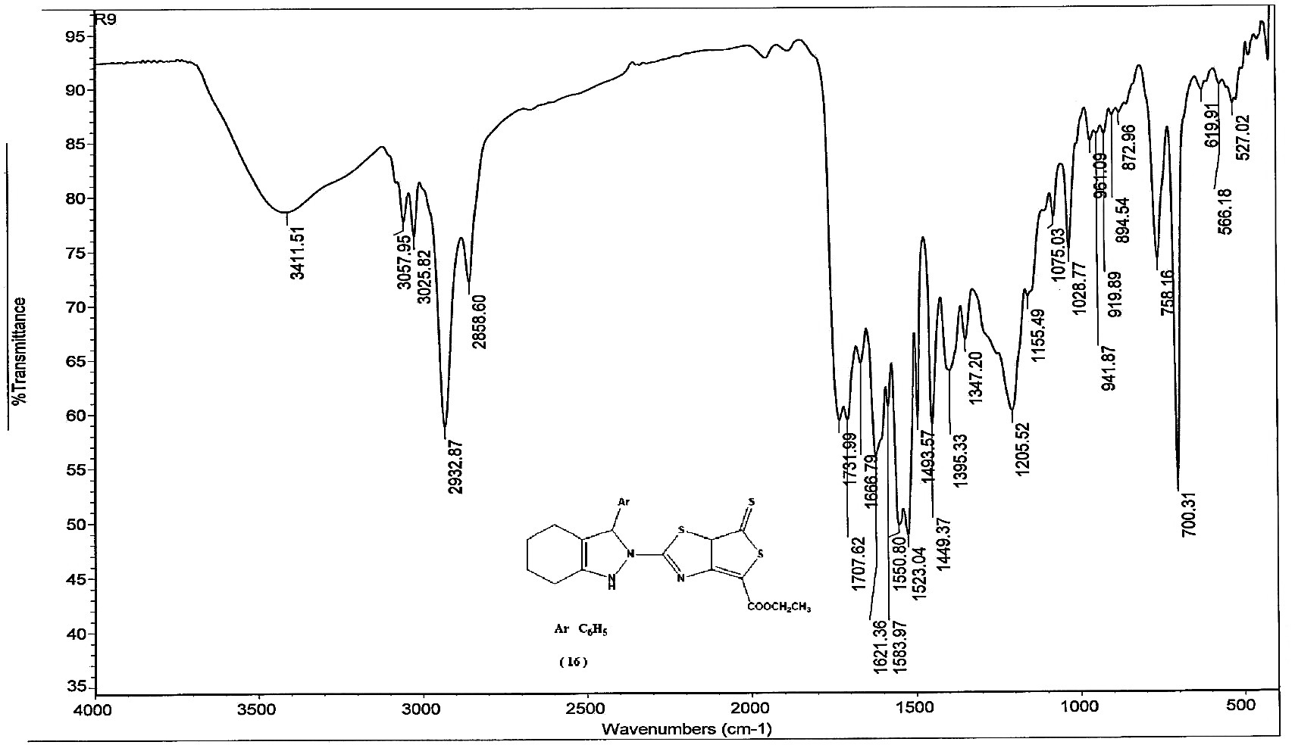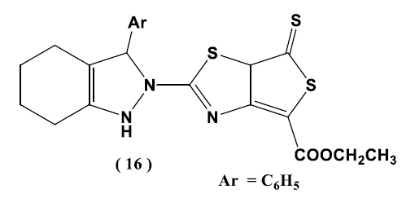

9

Fig. (S8 a).IR spectrum of compound 9

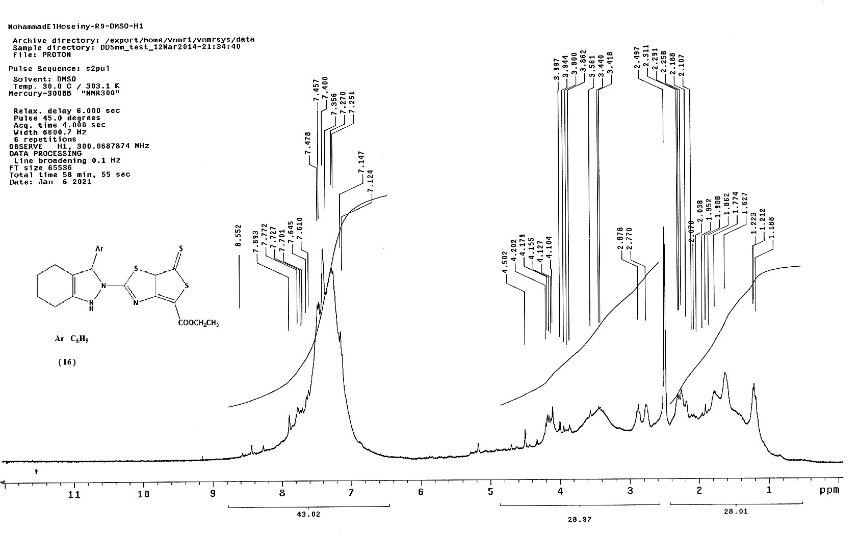

9

Fig. (S8 b). 1H-NMR spectrum of compound 9

