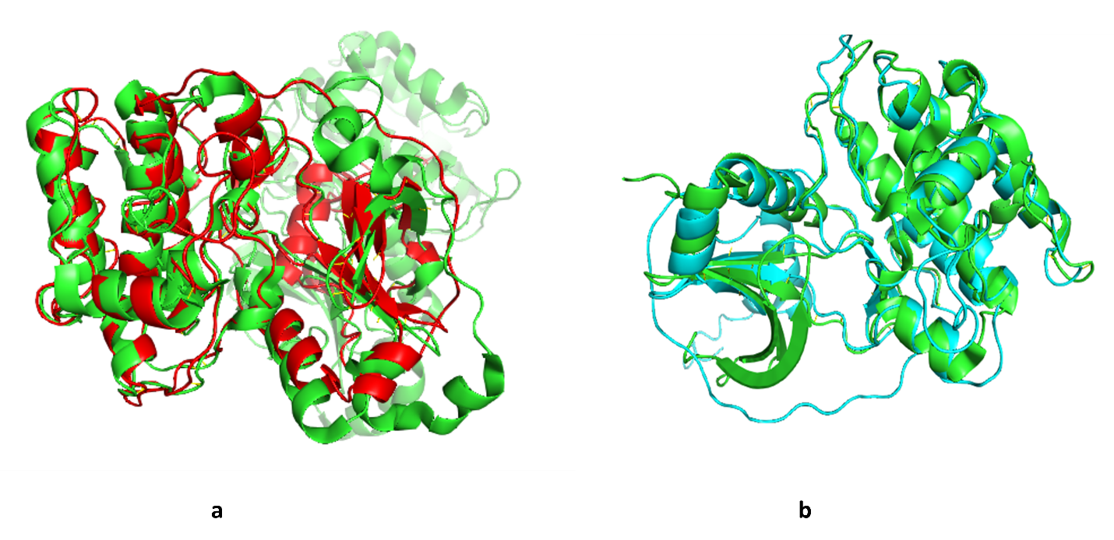
Figure 1: (a) Alignment of Predicted structure of PKCɩ (i-TASSER, Kinase domain) with crystal structure of kinase domain of PKCɩ (38AX:ID from protein data base). (b) Alignment of Predicted structure of PKCɩ (i-TASSER, C1 &Kinase domain) with crystal structure of C1 & kinase domain of PKC-theta (1XJD:ID from protein data base).

