ADDITIONAL FILES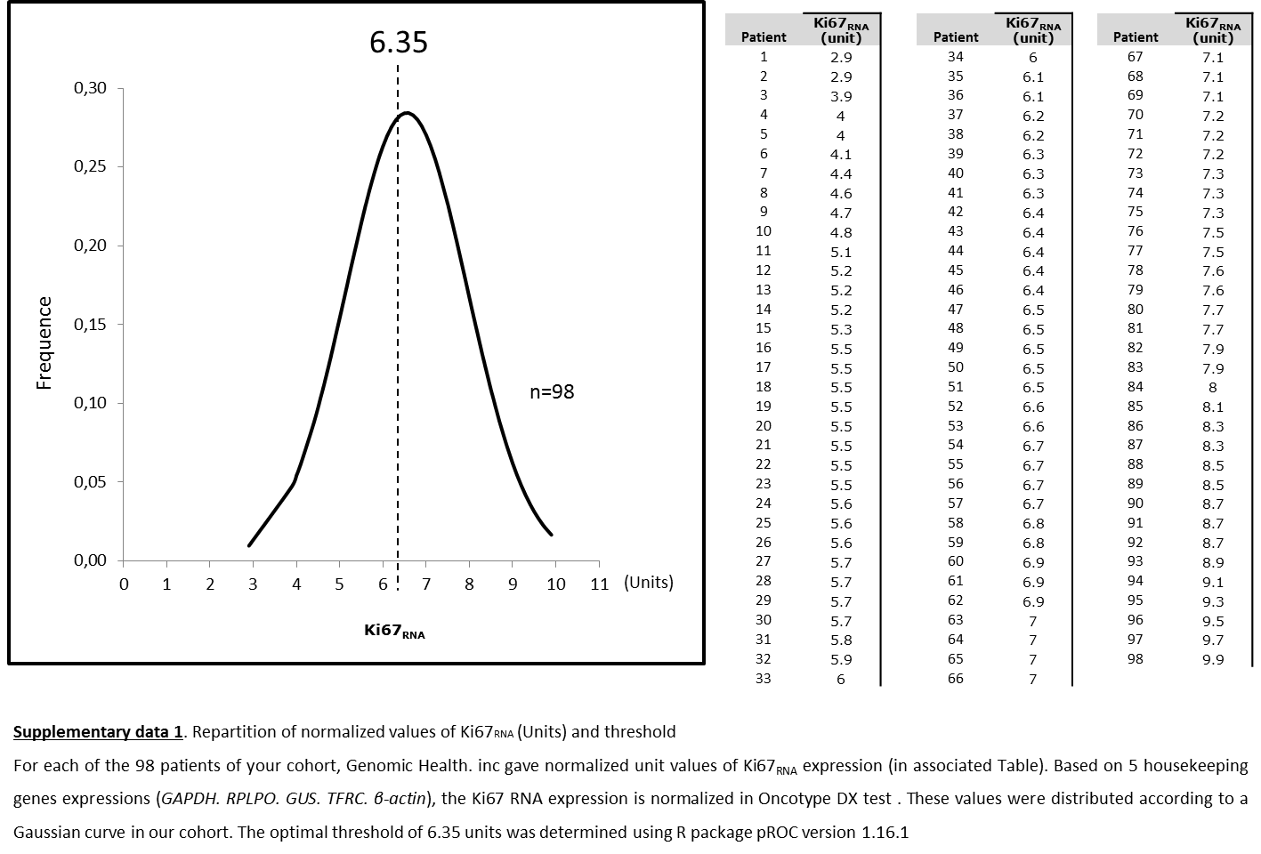

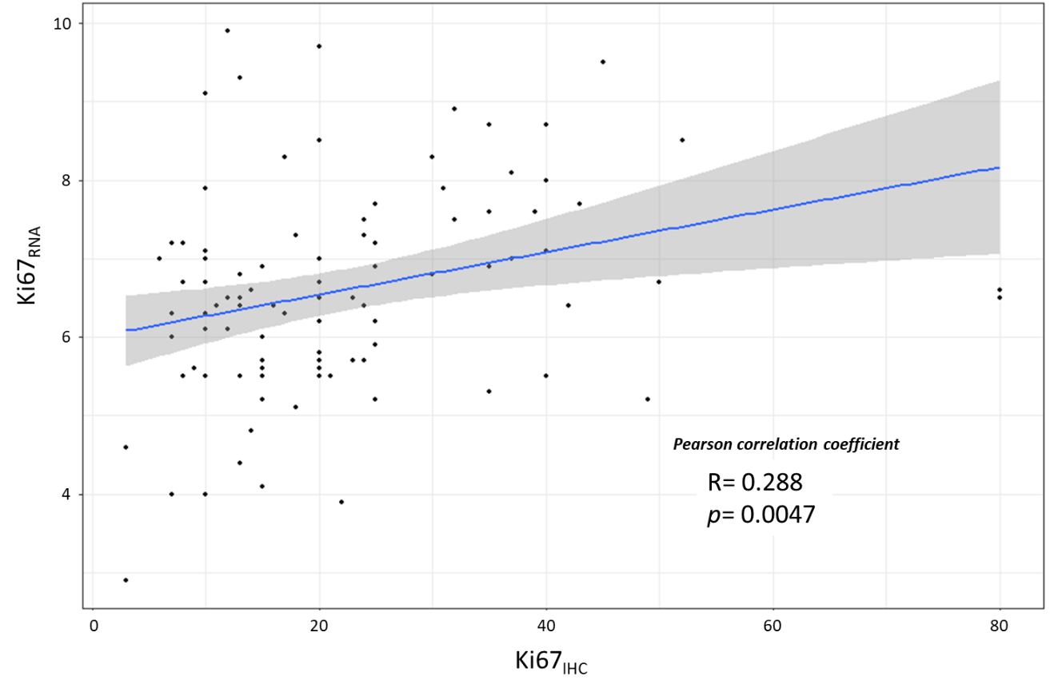
Supplementary data 2. Correlation between Ki67_{RNA} and Ki67_{IHC}

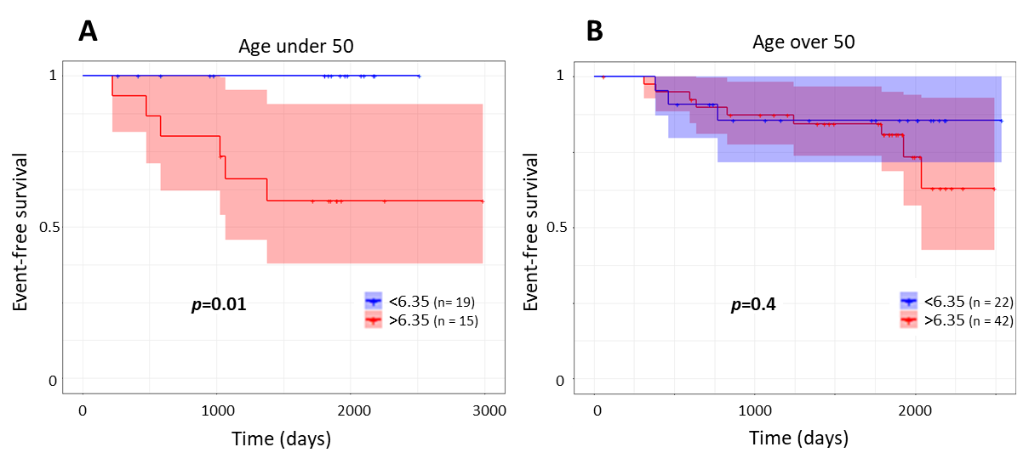
Supplementary data 3. EFS according to age subgroups and their respective Ki67_{RNA} status
Statistical analyses were obtained by a Cox univariate test.

