Hydrophobic adsorbent prepared from spent methanol-to-propylene catalyst for directional adsorption of high COD oily wastewater
Xiaojing Yong^{a, b@}, Hui Su^{b}, Nana Zhao^{b}, Zhengwei Jin^{b}, Min Yao^{a@}, Yulong Ma^{a@}
a. Key Laboratory of High-efficiency Utilization of Coal and Green Chemical Engineering, College of Chemistry and Chemical Engineering, Ningxia University, Yinchuan 750021, China
b. Institute of Coal Chemical Industry Technology, Ningxia Coal Industry Co., Ltd. of national energy group, Yinchuan 750411, China

@ Corresponding authors at: State Key Laboratory of High-efficiency Utilization of Coal and Green Chemical Engineering, College of Chemistry and Chemical Engineering, Ningxia University, Ningxia Yinchuan 750021, PR China
E-mail address: 377748087@qq.com (XJ. Yong), ndglym@163.com (M. Yao), yulongma796@sohu.com (Y.L. Ma)

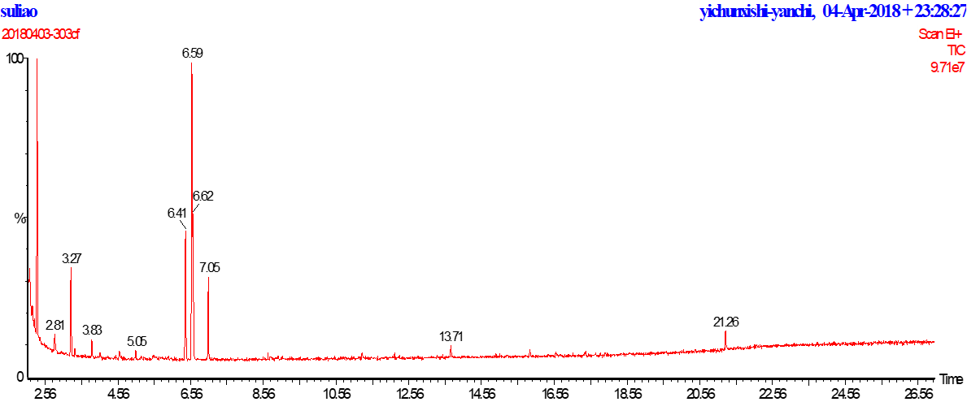
Fig. S1 Retention time of the waste water on LC-MS

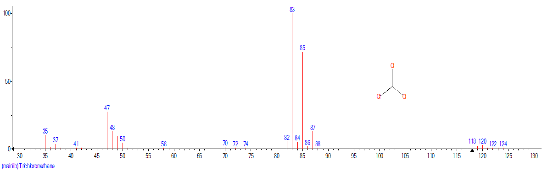
Fig. S2 LC/MS of Trichloromethane

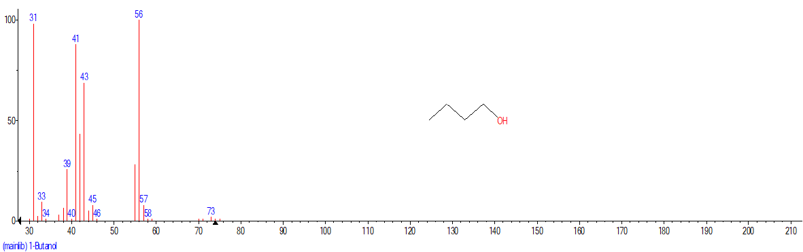
Fig. S3 LC/MS of 1-Butanol
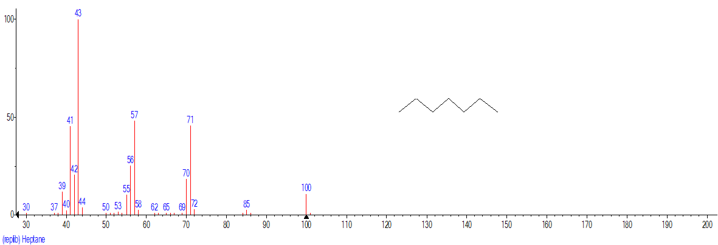
Fig. S4 LC/MS of heptane

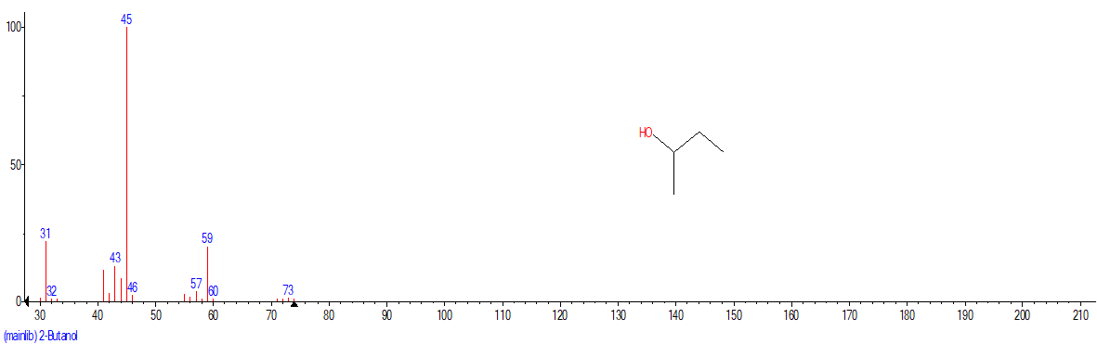
Fig. S5 LC/MS of 2-butanol

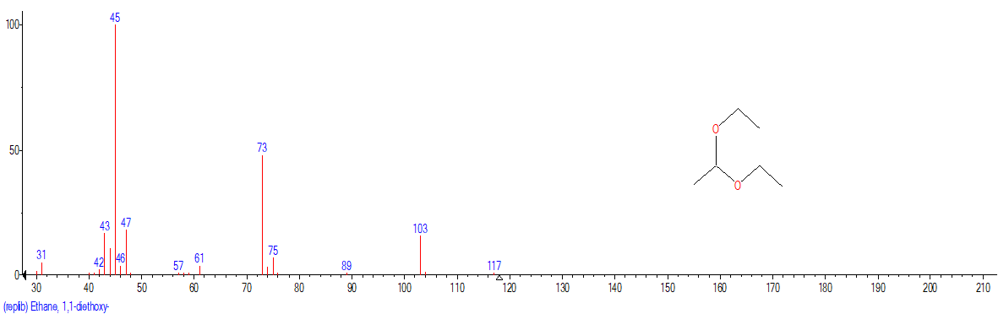
Fig. S6 LC/MS of 1,1-diethoxy-ethane

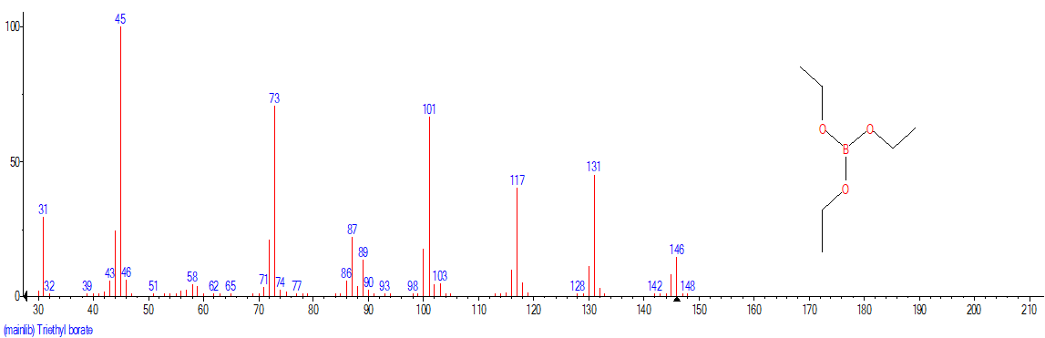
Fig. S7 LC/MS of triethyl borate

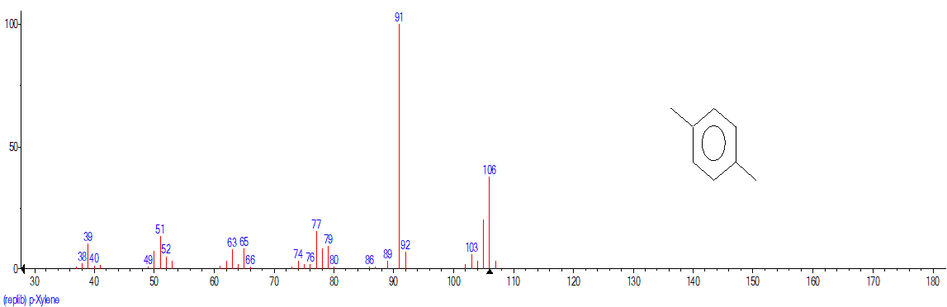
Fig. S8 LC/MS of p-xylene

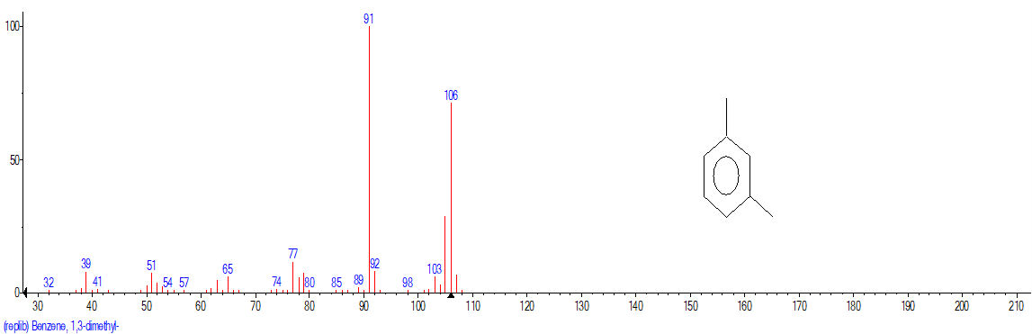
Fig. S9 LC/MS of 1,3-dimethyl-benzene

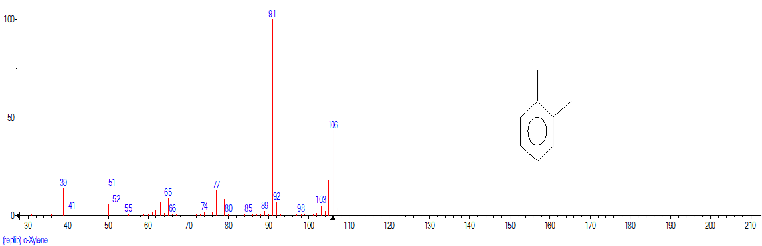
Fig. S10 LC/MS of o-xylene

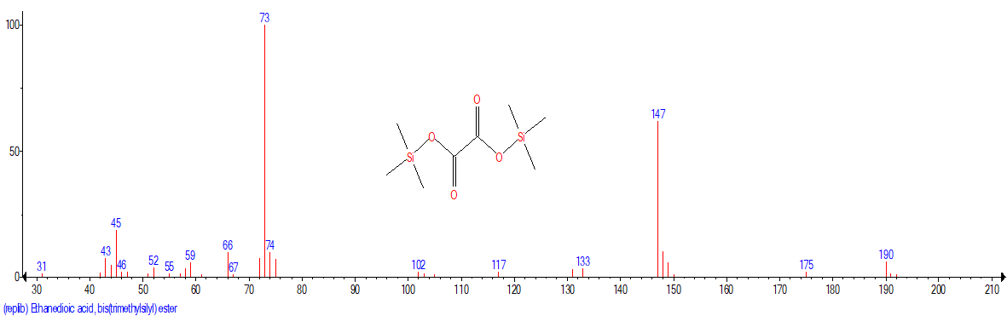
Fig. S11 LC/MS of ethanedioic acid, bis(trimethylsilyl) ester

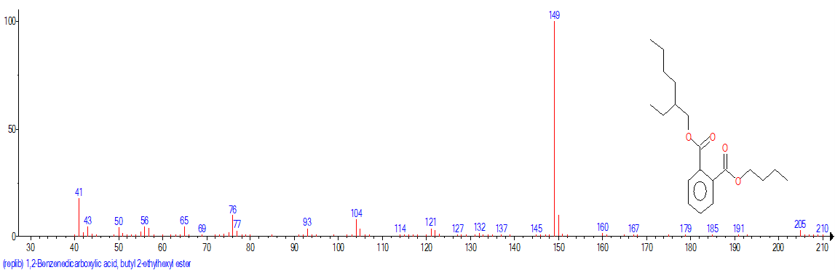
Fig. S12 LC/MS of 1,2-Benzenedicarboxylic acid, butyl 2-ethylhexyl ester

Fig. S13 Distribution of N₂ adsorption/desorption isotherm (a) and pore size of adsorbent products (b)

