Supplementary Material

Supplementary Figures
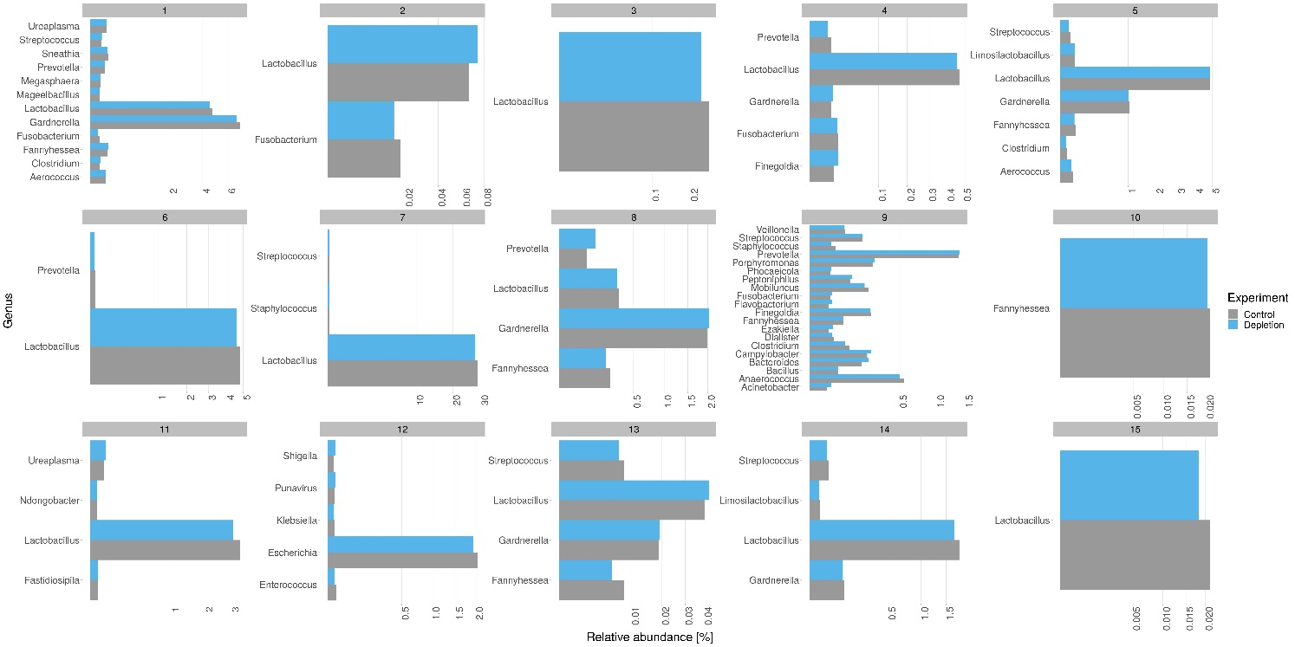
Figure S1: Comparison of the relative abundance of bacterial genera for all vaginal samples (control in grey, depletion in blue).

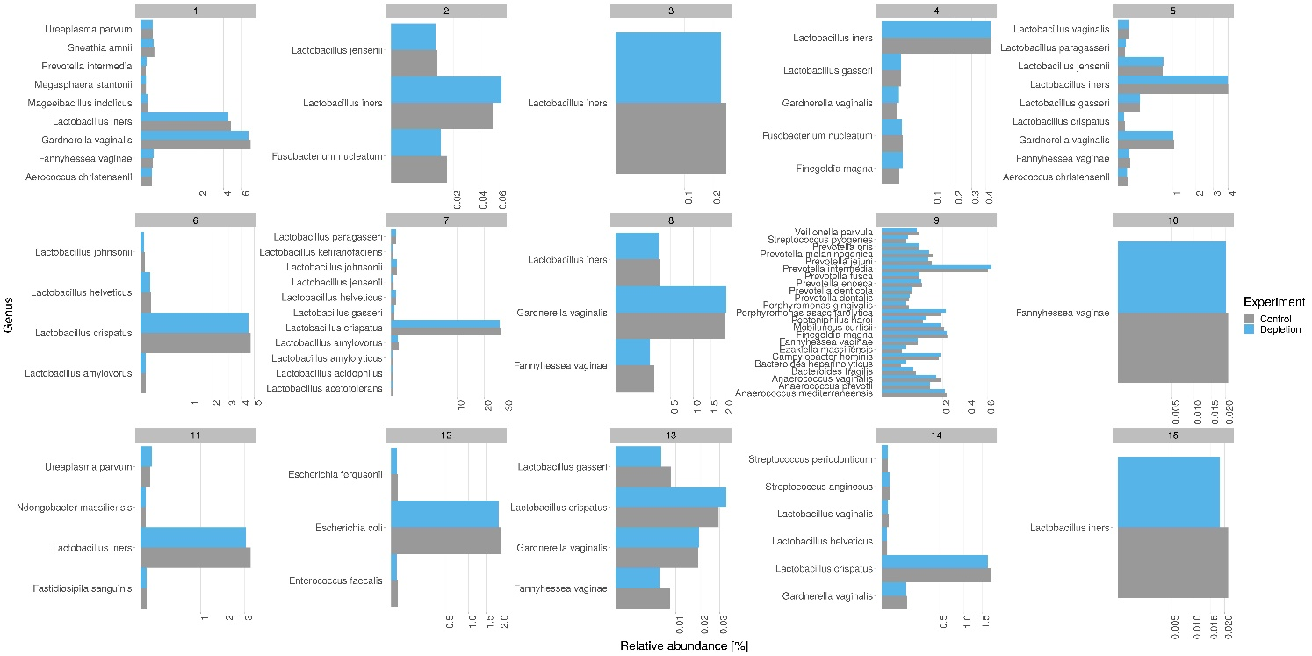
Figure S2: Comparison of the relative abundance of bacterial species for all vaginal samples (control in grey, depletion in blue).

