Supplementary data

Fig. S1. Molecular masses of synthetic peptides (LfcinB6, KR-12-a4 and Lf-KR) were determined by electrospray ionization-mass spectrometry (ESI-MS).

Fig. S2. Analytical RP-HPLC profiles of synthetic peptides (LfcinB6, KR-12-a4 and Lf-KR). Peptides were eluted for 60 min with a flow rate of 1.0 mL/min by analytical RP-HPLC on a C₁₈ column (5 mm; 4.6 mm × 250 mm; Vydac) using a gradient of buffer B (0.05% TFA in CH₃CN/H₂O 90:10 v/v) in buffer A (0.05 %TFA in H₂O).

Fig. S3. Effects of LfcinB6, KR-12-a5, Lf-KR, and LL‐37 on the mRNA levels of iNOS (a)
and TNF-α (b) in LPS-stimulated RAW264.7 cells.

Fig. S1

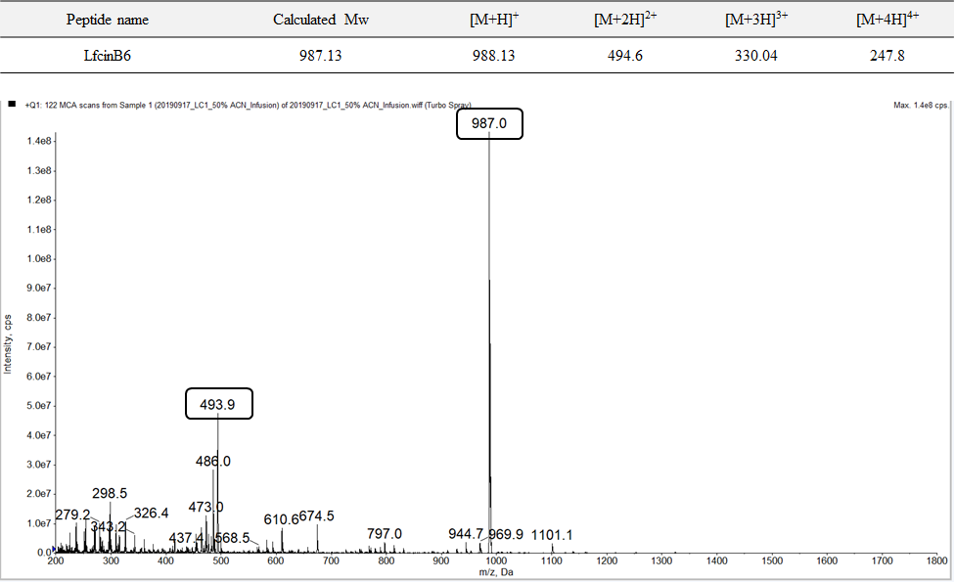
Fig. S1

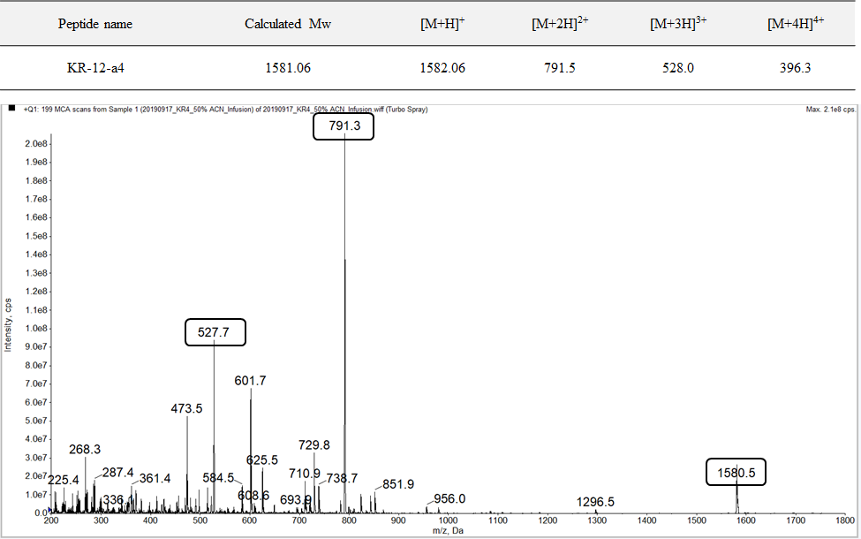
Fig. S1

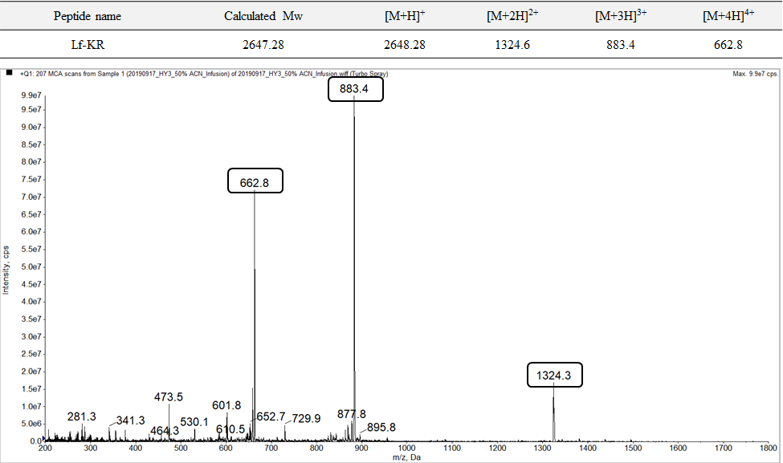
Fig. S2
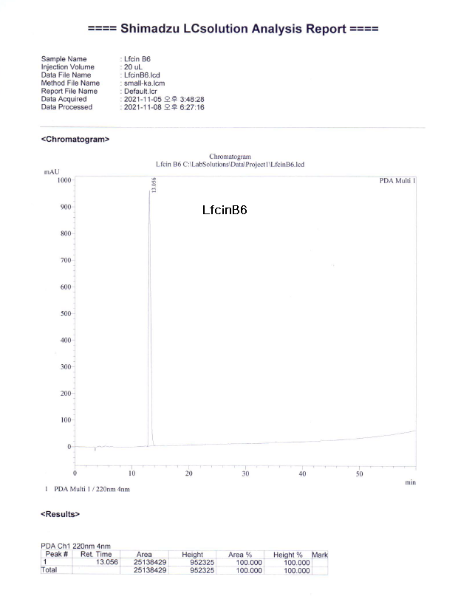

Fig. S2
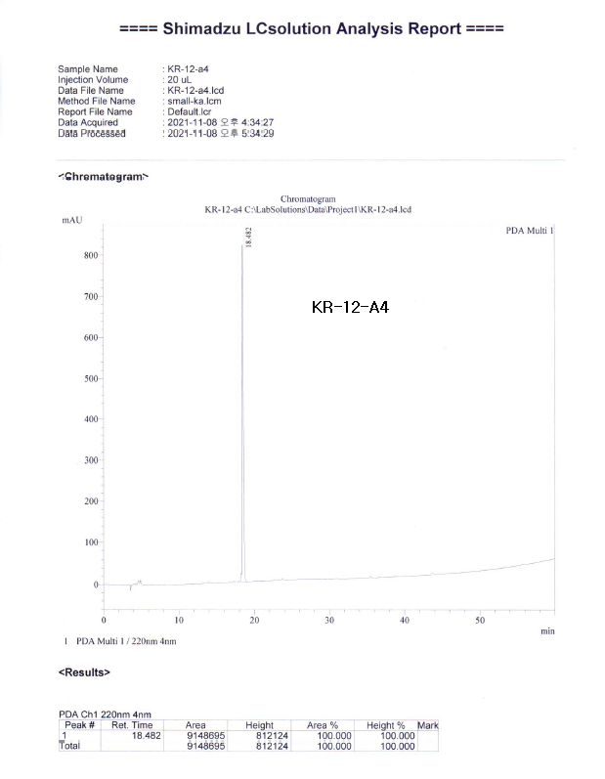
Fig. S2
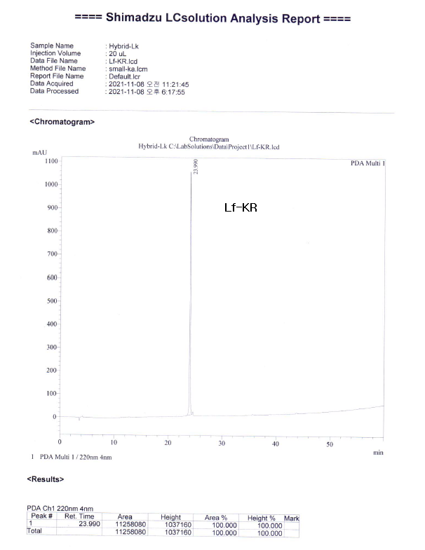

Fig. S3-a

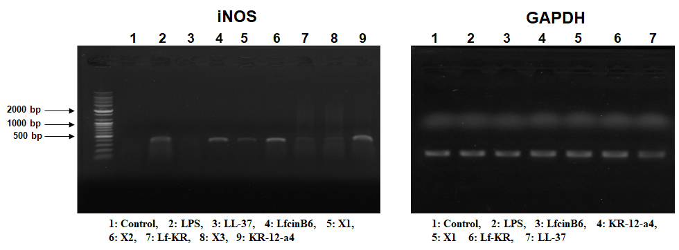

Fig. S3-b

