Supplementary Table 1. Comparison of short-term recurrence rates (<6 and <12 months) among female patients with early-stage IDC receiving different treatments
Treatment | <6 months | <12 months | p-value
BCT | 0.05% | 0.07% | <0.001
MAS | 0.12% | 0.14% | <0.001
MAS+RT | 0.10% | 0.14% | <0.001
IDC, invasive ductal carcinoma; BCT, breast conservative treatment; MAS, mastectomy; RT, radiotherapy.
Supplementary Table 2. Comparison of long-term recurrence rates among female patients with early-stage IDC receiving different treatments
Treatment | <1 year | <3 years | <5 years | <10 years | <15 years | p-value
BCT | 0.07% | 0.12% | 0.43% | 2.01% | 4.15% | <0.001
MAS | 0.14% | 0.20% | 0.24% | 0.55% | 0.81% | <0.001
MAS+RT | 0.14% | 0.24% | 0.43% | 0.68% | 0.97% | <0.001
IDC, invasive ductal carcinoma; BCT, breast conservative treatment; MAS, mastectomy; RT, radiotherapy.
Supplementary Table 3. Follow-up rates and numbers of subjects at risk at each follow-up time-points
Treatment | N | Number at risk (follow-up rates)
Treatment | N | <6 months | <1 year | <3 years | <5 years | <10 years | <15 years
BCT | 132,510 | 127,435 | 121,220 | 97,930 | 75,976 | 31,832 | 4,257
BCT | 132,510 | (96.2%) | (91.5%) | (73.9%) | (57.3%) | (24.0%) | (3.2%)
MAS | 46,580 | 44,863 | 42,975 | 35,029 | 27,248 | 11,355 | 1,413
MAS | 46,580 | (96.3%) | (92.3%) | (75.2%) | (58.5%) | (24.4%) | (3.0%)
MAS+RT | 5,874 | 5,693 | 5,425 | 4,303 | 3,196 | 1,237 | 187
MAS+RT | 5,874 | (96.9%) | (92.4%) | (73.3%) | (54.4%) | (21.1%) | (3.2%)
BCT, breast conservative treatment; MAS, mastectomy; RT, radiotherapy.

Supplementary Table 4. The 1-yr, 3-yr, 5-yr cumulative recurrence rates and 95% confidence intervals of the three treatment groups
Treatment | <1 year | <3 year | <5 year
BCT | 0.07% (0.06%−0.09%) | 0.20% (0.18%−0.23%) | 0.43% (0.39%−0.47%)
MAS | 0.14% (0.11%−0.18%) | 0.20% (0.16%−0.25%) | 0.24% (0.20%−0.29%)
MAS+RT | 0.14% (0.07%−0.28%) | 0.24% (0.14%−0.41%) | 0.43% (0.27%−0.67%)
BCT, breast conservative treatment; MAS, mastectomy; RT, radiotherapy

Supplementary Figure 1. Comparison of short-term recurrence rates among female patients with invasive ductal carcinoma receiving different treatments. BCT, breast conservative treatment; MAS, mastectomy; RT, radiotherapy
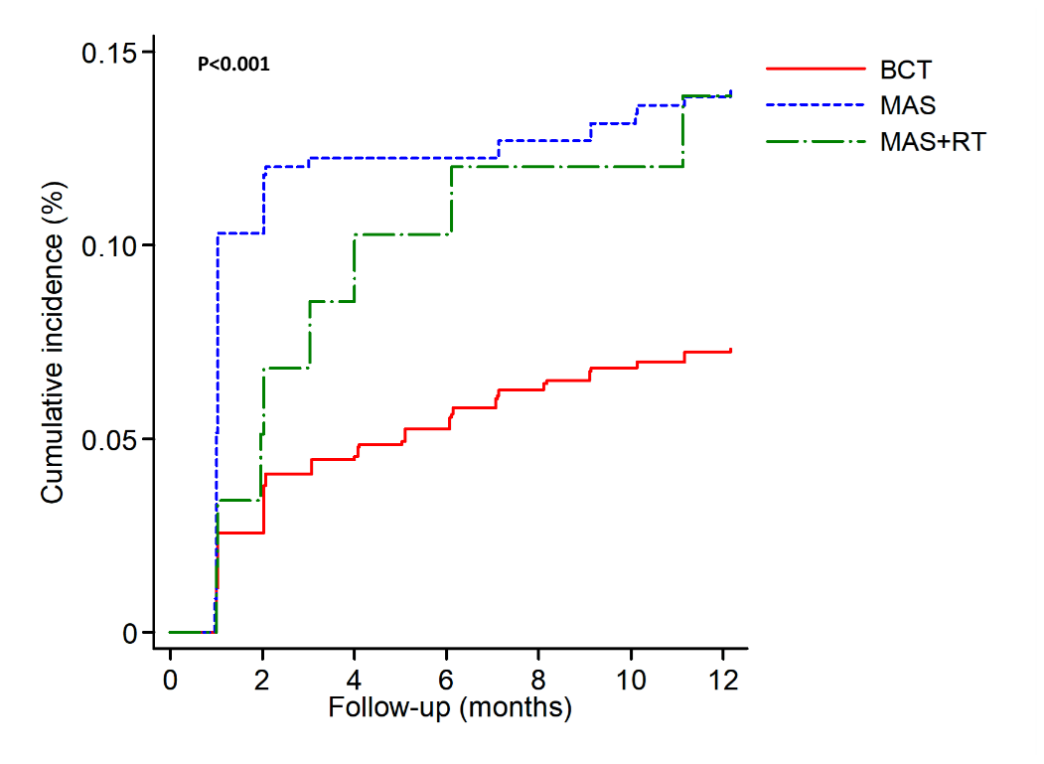
Supplementary Figure 2. Comparison of long-term recurrence rates among female patients with invasive ductal carcinoma receiving different treatments. BCT, breast conservative treatment; MAS, mastectomy; RT, radiotherapy
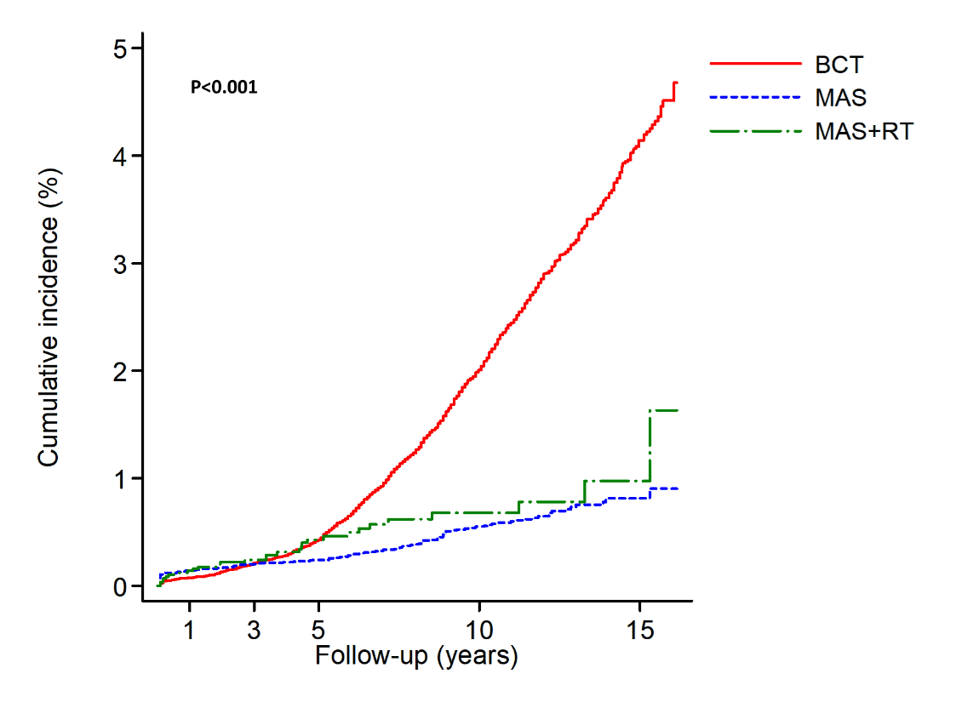

Supplementary Figure 3. Log minus Log Plot for checking the proportionality assumption of Cox proportional hazard model

(1) short-term recurrence | (2) long-term recurrence
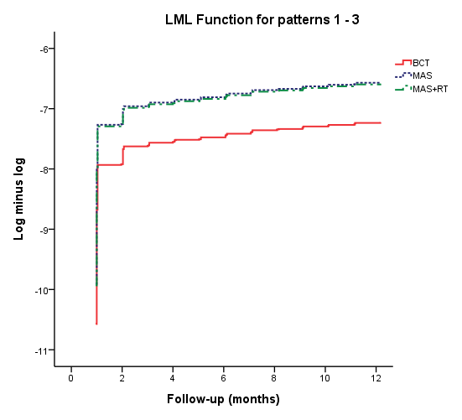 | 