Cell cycle arrest is an important mechanism of action of compound Kushen injection in the prevention of colorectal cancer
Jie Sun^{1,+}, Mei Li^{1,+}, Tingru Lin^{1,2+}, Di Wang¹, Jingyi Chen², Yu Zhang², Qing Mu¹, Huiting Su¹, Na Wu¹, Aiyu Liu¹, Yimeng Yu¹, Yulan Liu², Shaojie Wang³, Xin Yu⁴, Jingzhu Guo^{5,*}, Weidong Yu^{1,*}
·Authors’ affiliations:
¹Department of Central Laboratory & Institute of Clinical Molecular Biology, Peking University People’s Hospital, Beijing, China
²Department of Gastroenterology, Peking University People’s Hospital, Beijing, China
³Department of Traditional Chinese Medicine, Peking University People’s Hospital, Beijing, China
⁴Department of hepatobiliary Surgery, Peking University People’s Hospital, Beijing, China,
⁵Department of Pediatric, Peking University People’s Hospital, Beijing, China
*Corresponding authors:
Jingzhu Guo, guojingzhu@pkuph.edu.cn
Weidong Yu, weidongyu@bjmu.edu.cn
+Jie Sun, Mei Li and Tingru Lin contributed equally to this study

Supplementary Table S1 A list of target genes and corresponding compounds in the treatment of colorectal cancer with CKI.

PubChem CID | Compound | Herb | Target | Uniprot ID
12442899 | Sophoranol | Kushen | IRF1 | P10914
509245 | sophoraflavanone B | Kushen | IL10 | P22301
259846 | lupeol | Kushen | MDM2 | Q00987
259846 | lupeol | Kushen | MTOR | P42345
115012 | soyasapogenol B | Kushen | MDM2 | Q00987
115012 | soyasapogenol B | Kushen | MTOR | P42345
115012 | soyasapogenol B | Kushen | ANP32A | P39687
3082765 | dehydromiltirone | Kushen | MDM2 | Q00987
3082765 | dehydromiltirone | Kushen | ANP32A | P39687
3082765 | dehydromiltirone | Kushen | EGF | P01133
3082765 | dehydromiltirone | Kushen | MTOR | P42345
102073915 | kusulactone | Kushen | MDM2 | Q00987
102073915 | kusulactone | Kushen | MTOR | P42345
102073915 | kusulactone | Kushen | ANP32A | P39687
91572 | Phaseolin | Kushen | MDM2 | Q00987
91572 | Phaseolin | Kushen | MTOR | P42345
91572 | Phaseolin | Kushen | EGF | P01133
91572 | Phaseolin | Kushen | ANP32A | P39687
91510 | maackiain | Kushen | ERBB2 | P04626
10854625 | kushenol S | Kushen | ERBB2 | P04626
5319307 | matsukaze lactone | Kushen | ERBB2 | P04626
5281611 | Resokaempferol | Kushen | HOXB13 | Q92826
5281611 | Resokaempferol | Kushen | MAP2K2 | P36507
42607818 | sophoranochromene | Kushen | HOXB13 | Q92826
91466 | matrine | Kushen | UNG | P13051
91466 | matrine | Kushen | PTPRJ | Q12913
10659287 | (-)-14β-hydroxymatrine | Kushen | UNG | P13051
10659287 | (-)-14β-hydroxymatrine | Kushen | PTPRJ | Q12913
114850 | Oxymatrine | Kushen | UNG | P13051
114850 | Oxymatrine | Kushen | PTPRJ | Q12913
165549 | sophoridine | Kushen | UNG | P13051
165549 | sophoridine | Kushen | PTPRJ | Q12913
5271984 | isomatrine | Kushen | UNG | P13051
5271984 | isomatrine | Kushen | PTPRJ | Q12913
115269 | sophocarpine | Kushen | UNG | P13051
115269 | sophocarpine | Kushen | PTPRJ | Q12913
24721085 | Oxysophocarpine | Kushen | UNG | P13051
24721085 | Oxysophocarpine | Kushen | PTPRJ | Q12913
126455735 | (-)-leontalbinine N-oxide | Kushen | UNG | P13051
126455735 | (-)-leontalbinine N-oxide | Kushen | PTPRJ | Q12913
169014 | sophoramine | Kushen | UNG | P13051
169014 | sophoramine | Kushen | PTPRJ | Q12913
3041752 | lehmannine | Kushen | UNG | P13051
3041752 | lehmannine | Kushen | PTPRJ | Q12913
10742453 | kushenol P | Kushen | UNG | P13051
10742453 | kushenol P | Kushen | MPO | P05164
10835998 | kushenol R | Kushen | UNG | P13051
10598514 | kushenol T | Kushen | UNG | P13051
44563198 | kurarinol | Kushen | UNG | P13051
72936 | (-)-sophoraflavanone G | Kushen | UNG | P13051
10599228 | kushenol X | Kushen | UNG | P13051
381851 | kushenol N | Kushen | UNG | P13051
133561937 | 2'-methoxykurarinone | Kushen | UNG | P13051
5275227 | leachianone G | Kushen | UNG | P13051
20056309 | sophoraflavoside Ⅰ | Kushen | UNG | P13051
68406 | Octacosanol | Kushen | UNG | P13051
14104288 | 3,7,4'-Trihydroxy-5-methoxy-8-prenylflavanone | Kushen | UNG | P13051
15953774 | 2-(2,4-Dihydroxy-5-prenylphenyl)-5,6-methylenedioxybenzofuran | Kushen | UNG | P13051
129716399 | 8-Isopentenyl-kaempferol | Kushen | UNG | P13051
44584550 | koumidine | Kushen | UNG | P13051
101297615 | normacusine b | Kushen | UNG | P13051
442822 | sophoraisoflavanone a | Kushen | UNG | P13051
15385683 | (+)-14α-hydroxymatrine | Kushen | UNG | P13051
15385683 | (+)-14α-hydroxymatrine | Kushen | PTPRJ | Q12913
14379237 | 5,6-dehydrolupanine | Kushen | MTOR | P42345
14379237 | 5,6-dehydrolupanine | Kushen | EGF | P01133
14379237 | 5,6-dehydrolupanine | Kushen | ANP32A | P39687
6326060 | sophojaponicin | Kushen | MTOR | P42345
6326060 | sophojaponicin | Kushen | DAB2 | P98082
44257277 | genistein-7-O-rutinoside | Kushen | TP53 | P04637
5492234 | lanceolarin | Kushen | TP53 | P04637
623329 | (-)-12-ethylsophoramine | Kushen | EGF | P01133
623329 | (-)-12-ethylsophoramine | Kushen | ANP32A | P39687
623329 | (-)-12-ethylsophoramine | Kushen | PTPRJ | Q12913
3085182 | Manmanine | Kushen | EGF | P01133
3085182 | Manmanine | Kushen | ANP32A | P39687
14353465 | 4'-hydroxyisolonchocarpin | Kushen | EGF | P01133
162147 | Aloperine | Kushen | EGF | P01133
162147 | Aloperine | Kushen | ANP32A | P39687
7014 | sparteine | Kushen | EGF | P01133
7014 | sparteine | Kushen | ANP32A | P39687
71317062 | Genistein-7-O-glucoside | Kushen | TYMS | P04818
71317062 | Genistein-7-O-glucoside | Kushen | MAP2K2 | P36507
10496772 | kushecarpin C | Kushen | PTPRJ | Q12913
73145 | β-Amyrin | Kushen | ANP32A | P39687
442827 | trifolirhizin | Kushen | AURKA | O14965
442827 | trifolirhizin | Kushen | DHFR | P00374
442827 | trifolirhizin | Kushen | CHEK1 | O14757
442827 | trifolirhizin | Kushen | IGF1 | P05019
44257441 | (-)-Maackiain-3-O-glucoside | Kushen | DAB2 | P98082
14841223 | Trifolirhizin 6'-O-malonate | Kushen | DAB2 | P98082
10982109 | Specionin | Kushen | BIRC5 | O15392
21721878 | kushenol L | Kushen | PLA2G2A | P14555
21721878 | kushenol L | Kushen | TP73 | O15350
21721878 | kushenol L | Kushen | AXIN1 | O15169
6440079 | Hexadecyl-ferulate | Kushen | PLA2G2A | P14555
15385684 | (+)-9α-hydroxymatrine | Kushen | ALK | Q9UM73
15385684 | (+)-9α-hydroxymatrine | Kushen | CCND1 | P24385
10495761 | kushecarpin A | Kushen | TP73 | O15350
14274649 | 5,9-dihydroxymatrine | Kushen | CTNNB1 | P35222
10382239 | isostrychnine | Kushen | AR | P10275
5319322 | medicagol | Kushen | TOP1 | P11387
101667015 | epilamprolobine N-oxide | Kushen | TOP1 | P11387
9576780 | macrozamin | Baituling | ERBB4 | Q15303
3220 | Emodin | Baituling | ERBB4 | Q15303
119422 | Hesperetin 7-O-rutinoside | Baituling | DICER1 | Q9UPY3
10168 | 1,8-Dihydroxy-3-carboxyanthraquinone | Baituling | DLC1 | Q96QB1
346868 | anthemisol | Baituling | CDKN2A | Q8N726
24836924 | amylum | Baituling | MMP1 | P03956
316844 | isoastilbin | Baituling | DNMT1 | P26358
101937309 | isoengelitin | Baituling | DNMT1 | P26358
101937309 | isoengelitin | Baituling | UNG | P13051
73642 | Resveratrol-3-O-β-D-glucopyranoside | Baituling | DNMT1 | P26358
12408 | Octacosane | Baituling | MDM2 | Q00987
69244670 | 3,3',5,5'-tetrahydroxy-4-methoxystilbene | Baituling | ERBB2 | P04626
128735 | Isobaimuxinol | Baituling | ERBB2 | P04626
128735 | Isobaimuxinol | Baituling | PTPRJ | Q12913
114829 | Liquiritigenin | Baituling | HOXB13 | Q92826
119258 | astilbin | Baituling | HOXB13 | Q92826
119422 | Hesperetin 7-O-rutinoside | Baituling | TP53 | P04637
91439 | smilagenin | Baituling | PTPRJ | Q12913
99474 | diosgenin | Baituling | PTPRJ | Q12913

Supplementary Table S2 Key target protein and degree value of CKI for colorectal cancer

Target name | Degree | Target name | Degree
TP53 | 27 | MTOR | 15
CCND1 | 24 | IGF1 | 14
CDKN2A | 20 | CHEK1 | 13
CTNNB1 | 19 | AR | 13
ERBB2 | 19 | TYMS | 12
MDM2 | 18 | AURKA | 12
EGF | 18 | DNMT1 | 12
Supplementary Table S3 CKI herb-compounds-candidate targets network parameters

Network parameters | Values
Numbers of nodes | 118
Network density | 0.030
Network diameter | 8
Network heterogeneity | 1.880
Average number of neighbors | 3.458
Characteristic path length | 3.259
Shortest paths  Network centralization | 13806(100%)  0.526

Supplementary Table S4 The KEGG pathway predicted by RNA-seq validation and network pharmacology

No. | CKI Target pathways | Prediction | RNA-Seq validation
 |  | CRC (33) | SW620(32) | SW480(23)
1 | cell cycle | √ (19) | √ (1) | √ (2)
2 | Acute myeloid leukemia | √ (30) | √ (16)
3 | *Chronic myeloid leukemia | √ (15) | √ (3)
4 | *Colorectal cancer | √ (12) | √ (4)
5 | *Endometrial cancer | √ (5) | √ (20)
6 | *ErbB signaling pathway | √ (17)) | √ (29)
7 | *FoxO signaling pathway | √ (14) | √ (7)
8 | *Glioma | √ (4) | √ (17)
9 | HTLV-1 infection | √ (27) | √ (8)
10 | *Melanoma | √ (8) | √ (15)
11 | *Non-small cell lung cancer | √ (6) | √ (28)
12 | *p53 signaling pathway | √ (7) | √ (6)
13 | *Pancreatic cancer | √ (13) | √ (18)
14 | *pathway in cancer | √ (3) | √ (22)
15 | *Proteoglycans in cancer | √ (9) | √ (2)
16 | *Prostate cancer | √ (1) | √ (23)
17 | *Viral carcinogenesis | √ (23) | √ (9)
18 | Basal transcription factors |  | √ (32) | √ (7)
19 | Homologous recombination |  | √ (12) | √ (10)
20 | mRNA surveillance pathway |  | √ (25) | √ (5)
21 | Nucleotide excision repair |  | √ (26) | √ (8)
22 | splicsome |  | √ (14) | √ (1)
23 | Adherens junction | √ (33)
24 | Basal cell carcinoma | √ (28)
25 | Bladder cancer | √ (2)
26 | Central carbon metabolism in cancer | √ (20)
27 | Focal adhesion | √ (24)
28 | Happo signaling pathways | √ (22)
29 | Hepatitis B | √ (29)
30 | HIF1 signaling pathway | √ (18)
31 | microRNAs in cancer | √ (10)
32 | PI3K-Akt signaling pathways | √ (21)
33 | Prolactin signaling pathway | √ (32)
34 | Signaling pathways regulating pluripotency of stem cells | √ (26)
35 | Thyroid cancer | √ (16)
36 | Thyroid hormone signaling pathway | √ (11)
37 | transcriptional misregulation in cancer | √ (31)
38 | Wnt signaling pathways | √ (25)
39 | Axon guicance |  | √ (21)
40 | Epstein-Barr virus infection |  | √ (30)
41 | Estrogen signaling pathway |  | √ (5)
42 | Insulin signaling pathway |  | √ (27)
43 | Lysine degradation |  | √ (31)
44 | Mismatch repair |  | √ (13)
45 | Propanoate metablism |  | √ (11)
46 | Renal cell carcinoma |  | √ (19)
47 | small cell lung cancer |  | √ (10)
48 | Ubiquitin mediated proteolysis |  | √ (24)
49 | Amino sugar and nucleotide sugar metabolism |  |  | √ (16)
50 | ABC transporters |  |  | √ (15)
51 | DNA replication |  |  | √ (12)
52 | Fanconi anemia pathway |  |  | √ (11)
53 | Galactose metabolism |  |  | √ (22)
54 | Herpes simplex infection |  |  | √ (17)
55 | Influenza A |  |  | √ (20)
56 | Leishmaniasis |  |  | √ (23)
57 | Ovarian sterodogenesis |  |  | √ (18)
58 | pertussis |  |  | √ (14)
59 | Pyrimidine metabolism |  |  | √ (9)
60 | Ribosome biogenesis in eukaryotes |  |  | √ (6)
61 | RIG-like receptor signaling pathway |  |  | √ (13)
62 | RNA transport |  |  | √ (3)
63 | Toll-like receptor signaling pathway |  |  | √ (19)
64 | Tuberculosis |  |  | √ (21)
65 | Valine, leucine and isoleucine degradation |  |  | √ (4)
(number) represents the sequence number of signal pathways with statistical significance

Supplementary Table S5 The mainly KEGG pathway predicted of CKI anti-cancer by network pharmacology
No. | CKI targeted signal pathways | Pan-C | CRC | GC | EsC | LC
 |  | ref. 16 | Our data | ref.20 | ref.17 | ref.19
1 | Bladder cancer | √ (19) | √ (2) | √ (56) | √ (28) | √ (4)
2 | HIF1 signaling pathway | √ (17) | √ (18) | √ (15) | √ (21) | √ (20)
3 | PI3K-Akt signaling pathways | √ (1) | √ (21) | √ (6) | √ (1) | √ (17)
4 | *Prostate cancer | √ (6) | √ (1) | √ (2) | √ (5) | √ (6)
5 | *Colorectal cancer | √ (15) | √ (12) | √ (17) | √ (24)
6 | *Chronic myeloid leukemia |  | √ (15) | √ (13) | √ (20) | √ (3)
7 | *Endometrial cancer |  | √ (5) | √ (11) | √ (26) | √ (8)
8 | *ErbB signaling pathway |  | √ (17) | √ (10) | √ (8) | √ (22)
9 | Focal adhesion |  | √ (24) | √ (60) | √ (22) | √ (16)
10 | *FoxO signaling pathway |  | √ (14) | √ (5) | √ (2) | √ (19)
11 | *Glioma |  | √ (4) | √ (4) | √ (4) | √ (7)
12 | *Melanoma |  | √ (8) | √ (9) | √ (18) | √ (5)
13 | *Non-small cell lung cancer |  | √ (6) | √ (7) | √ (7) | √ (1)
14 | *Pancreatic cancer |  | √ (13) | √ (8) | √ (19) | √ (9)
15 | Hepatitis B | √ (7) | √ (29) | √ (1) |  | √ (13)
16 | *p53 signaling pathway | √ (18) | √ (7) | √ (57) |  | √ (18)
17 | *pathway in cancer |  | √ (3) | √ (3) |  | √ (11)
18 | *Proteoglycans in cancer | √ (2) | √ (9) |  | √ (6) | √ (10)
19 | Thyroid hormone signaling pathway | √ (9) | √ (11) | √ (50)
20 | microRNAs in cancer | √ (3) | √ (10) |  | √ (3)
21 | *Viral carcinogenesis |  | √ (23) | √ (58) | √ (23)
Pan-C: Pan-Cancer; CRC: Colorectal Cancer; GC: Gastric Cancer; EsC: Esophageal Cancer; LC: Lung Cancer; (number) represents the sequence number of signal pathways with statistical significance

Supplementary Table S6 Sequences of primers for RT-qPCR analyses

Primer Name | Primer Sequence (5’-3’)
𝛽-actin Forward primer | 5’-CATGTACGTTGCTATCCAGGC-3’
𝛽-actin Reverse primer | 5’-CTCCTTAATGTCACGCACGAT-3’
P53 Forward primer | 5’-CAAGCAATGGATGATTTGATGCT-3’
P53 Reverse primer | 5’-TGGGTCTTCAGTGAACCATTGT-3’
P21 Forward primer | 5’-TGTCCGTCAGAACCCATGC-3’
P21 Reverse primer | 5’-AAAGTCGAAGTTCCATCGCTC-3’
CCND1 Forward primer | 5’-GCTGCGAAGTGGAAACCATC-3’
CCND1 Reverse primer | 5’-CCTCCTTCTGCACACATTTGAA-3’
CDKN2A Forward primer | 5’-GATCCAGGTGGGTAGAAGGTC-3’
CDKN2A Reverse primer | 5’-CCCCTGCAAACTTCGTCCT-3’
CHEK1 Forward primer | 5’-AATTGCCATGGGACCAACC-3’
CHEK1 Reverse primer | 5’-CTAGAGGAGCAGAATCGATT-3’
MDM2 Forward primer | 5’-GAATCATCGGACTCAGGTACATC-3’
MDM2 Reverse primer | 5’-TCTGTCTCACTAATTGCTCTCCT-3’

Supplementary Table S7 Antibodies or dyes used in this study

Name | Article number | Corporation name | Country | Dilution ratio
𝛽-actin | SAB2100037 | Sigma-Aldrich | USA | 1:3000 (WB)
P53 | 21891-1-AP | Proteintech Group | USA | 1:1000 (WB)  1:400 (IHC)
P21 | #2947 | Cell Signaling Technology | USA | 1:1000 (WB)
Ki67 | Ab15580 | Abcam | UK | 1:200 (IHC)
p-AKT | #4060 | Cell Signaling Technology | USA | 1:200 (IHC)
p-mTOR  p-CHEK1 | #5536  #2348 | Cell Signaling Technology  Cell Signaling Technology | USA  USA | 1:200 (IHC)  1:100 (IHC)
HRP-labeled Rabbit Anti-Goat IgG | ZB-2306 | Zhongshan Golden-bridge Biotechnology | China | 1:1000 (WB)
 | GK600710 | Gene Tech | China | 1X (IHC)

Figure S1

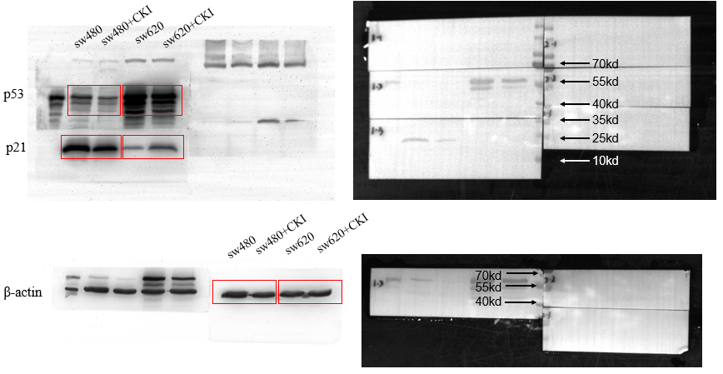
Figure S1. Full length western blot of Figure 8c, 8d
Figure S2
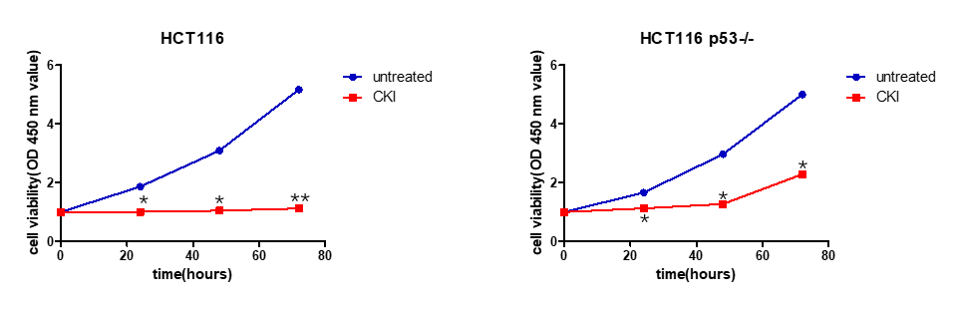
Figure S2. Compound Kushen injection inhibits p53 wt and p53 null colorectal cancer cell lines proliferation in vitro. HCT116 and HCT116 p53-/- cell viability was measured under different treatment conditions using CCK-8. Each data point represents the mean ± SD from three independent experiments. *p < 0.05, **p < 0.01, compared with control.
Figure S3
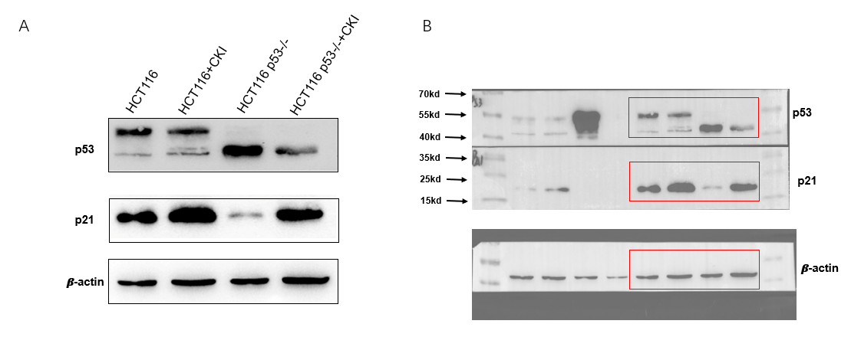
Figure S3. Compound Kushen injection alters the expression of p21 in p53 wt and p53 null colorectal cancer cell lines. A. Western blot analysis of p53 and p21 in HCT116 and HCT116 p53-/- cells. B. Full length western blot of p53 and p21 in HCT116 and HCT116 p53-/- cells.
Figure S4
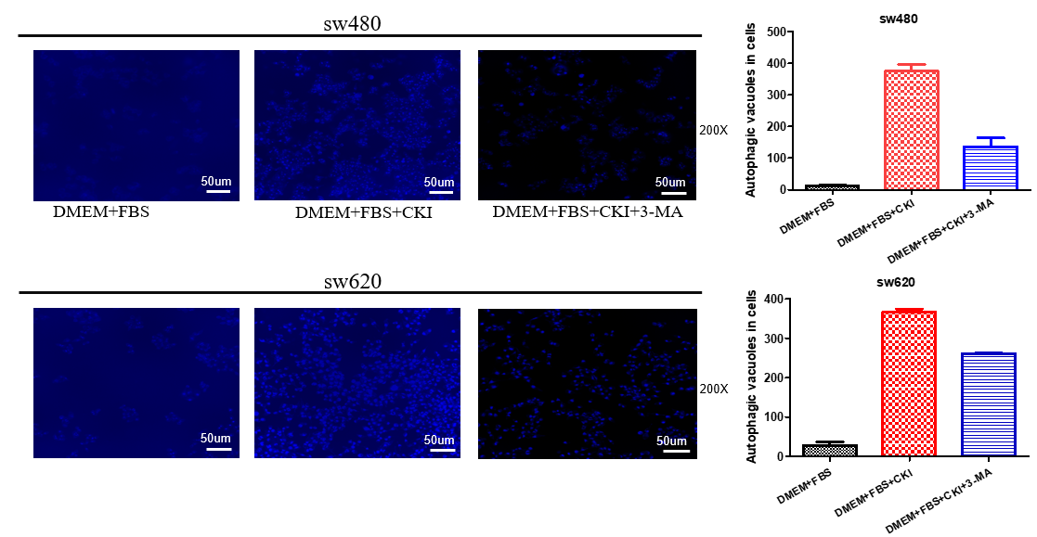
Figure S4. Compound Kushen injection induces autophagy of SW480 and SW620 CRC cells and the cell death inhibited by the inhibitor 3-MA in vitro. SW480 and SW620 cells were incubated in regular DMEM as a negative control. After incubated for 24h, control cells, CKI-treated cells and 3-MA-treated cells were incubated with a working solution of Autophagy Blue for 30 min at 37°C in a 5% CO₂ incubator and then washed four times with wash buffer. Cells were imaged under a fluorescence microscope with a DAPI channel. Autophagy is indicated by the bright blue dot staining of autophagic vacuoles. Each data point represents the mean ± SD from three independent experiments.

Figure S5
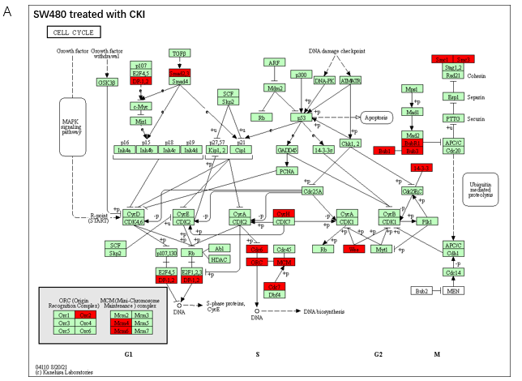
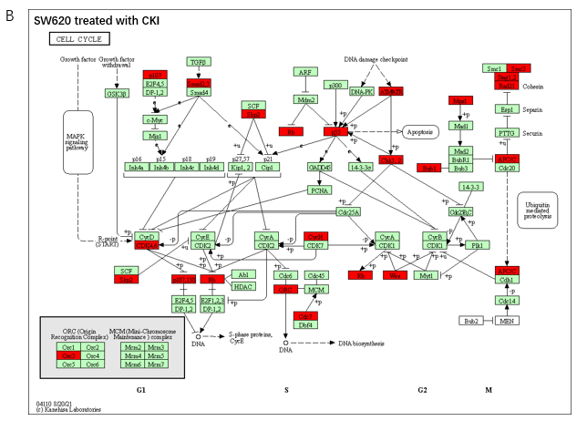
Figure S5. The cell cycle pathway map showed the distribution of differentially regulated genes of RNA-Seq. A. The regulation of CKI in the SW480 cells. B. The regulation of CKI in the SW620 cells. Red colors represent the targets of CKI on the cell cycle pathway.
Figure S6

A
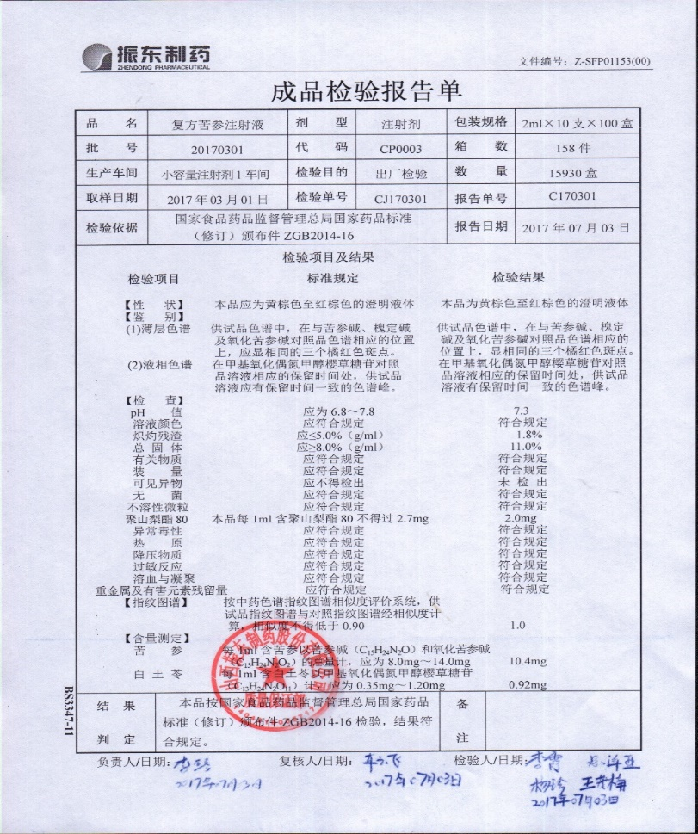
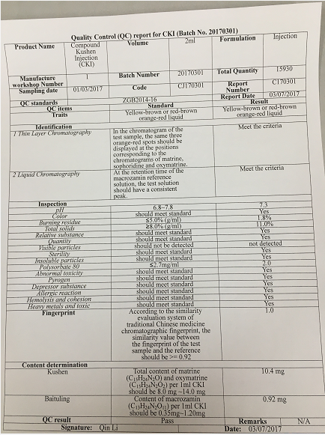
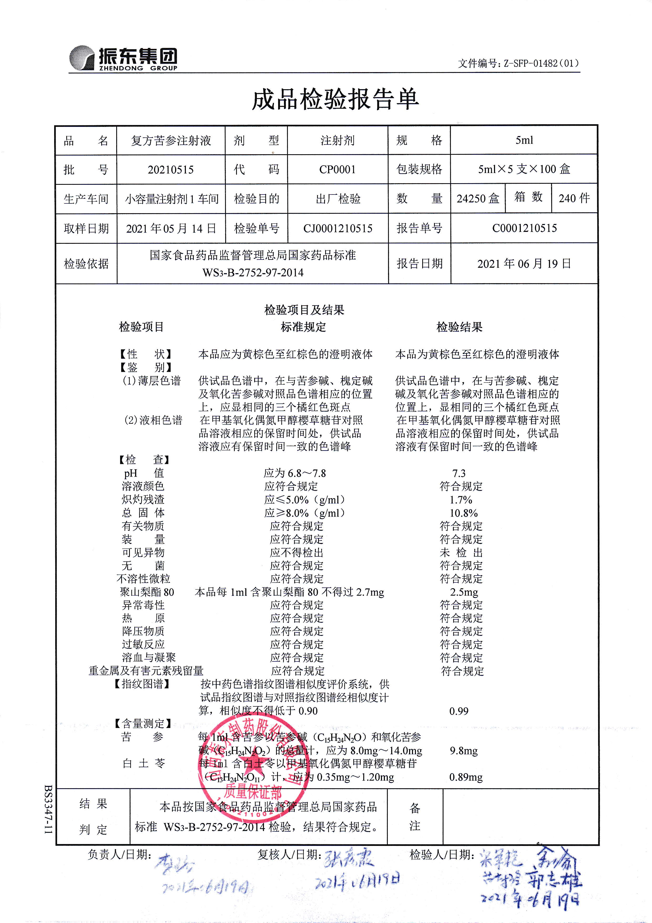
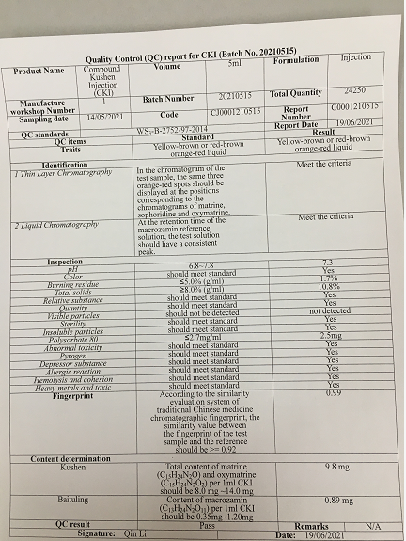
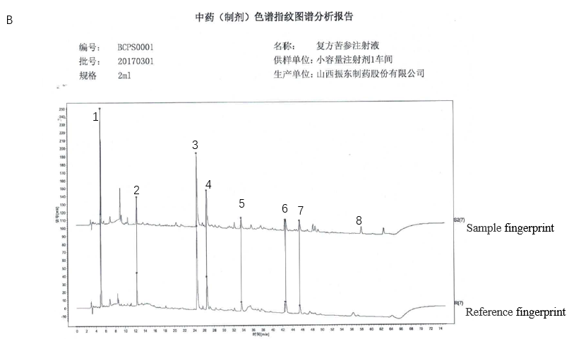
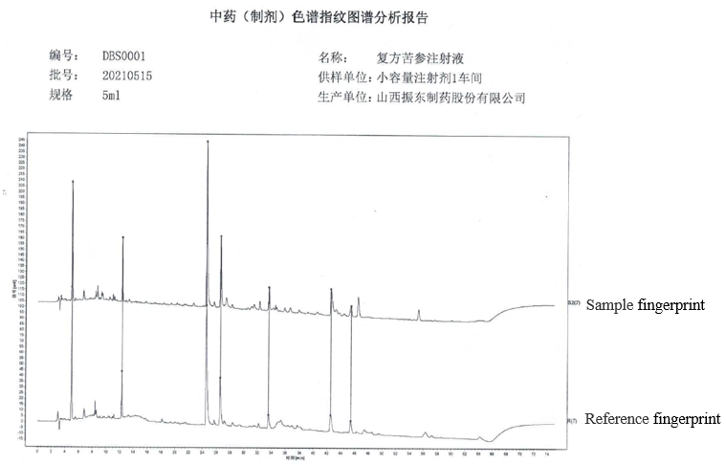
Figure S6. Quality control report and fingerprint of CKI. A. Quality control report for Batch No. 20170301 and 20210515. B. Representative fingerprint of CKI for Batch No. 20170301 and 20210515. Peak 1 is Piscidic acid, Peak 2 is Macrozamin, Peak 3 is Oxymatrine, Peak 4 is Oxysophocarpine, Peak 5 is N-methylthyramine, Peak 6 is Matrine, and Peak 7 is Sophocarping.

