Breed dependent regulatory mechanisms of beneficial and non-beneficial fatty acid profiles in subcutaneous adipose tissue in cattle with divergent feed efficiency

Mi Zhou^{a,#}, Zhi Zhu^{b#}, Hui-Zeng Sun^{c}, Ke Zhao^{d}, Mike E.R. Dugan^{e}, Heather Bruceª, Carolyn Fitzsimmons^{a,e}, Changxi Li^{a,e}, and Le Luo Guanª

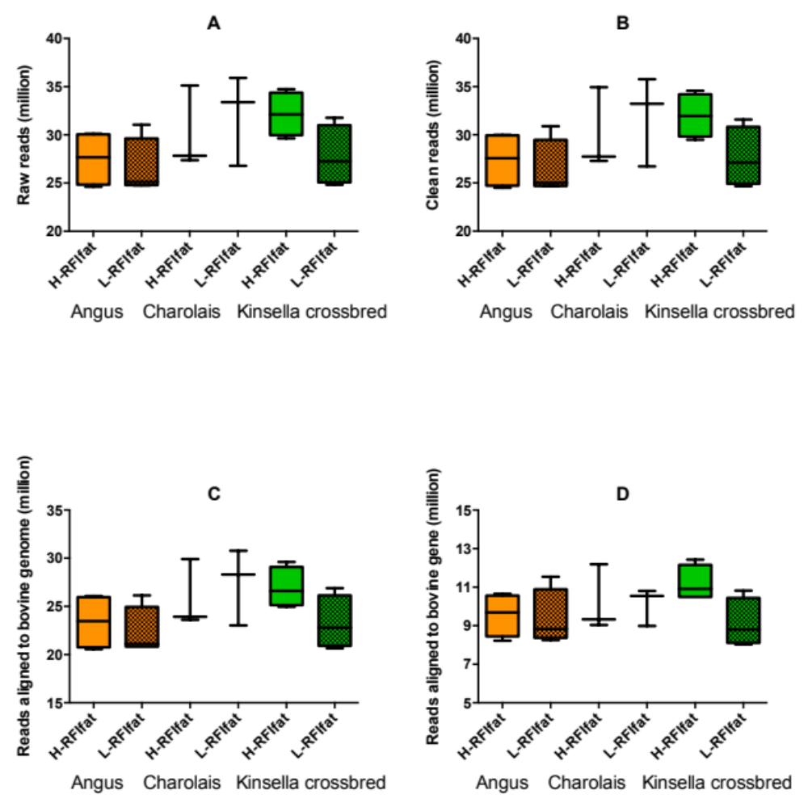

Supplementary Figure S1. RNA-sequencing results. (A) Number of raw reads obtained from libraries. (B) Number of clean reads after quality control with quality score ≥ 20 and leangth ≥ 75. (C) Number of reads aligned to the reference bovine genome. (D) Number of reads aligned to bovine gene.

