Breed dependent regulatory mechanisms of beneficial and non-beneficial fatty acid profiles in subcutaneous adipose tissue in cattle with divergent feed efficiency

Mi Zhou^{a,#}, Zhi Zhu^{b#}, Hui-Zeng Sun^{c}, Ke Zhao^{d}, Mike E.R. Dugan^{e}, Heather Bruceª, Carolyn Fitzsimmons^{a,e}, Changxi Li^{a,e}, and Le Luo Guanª

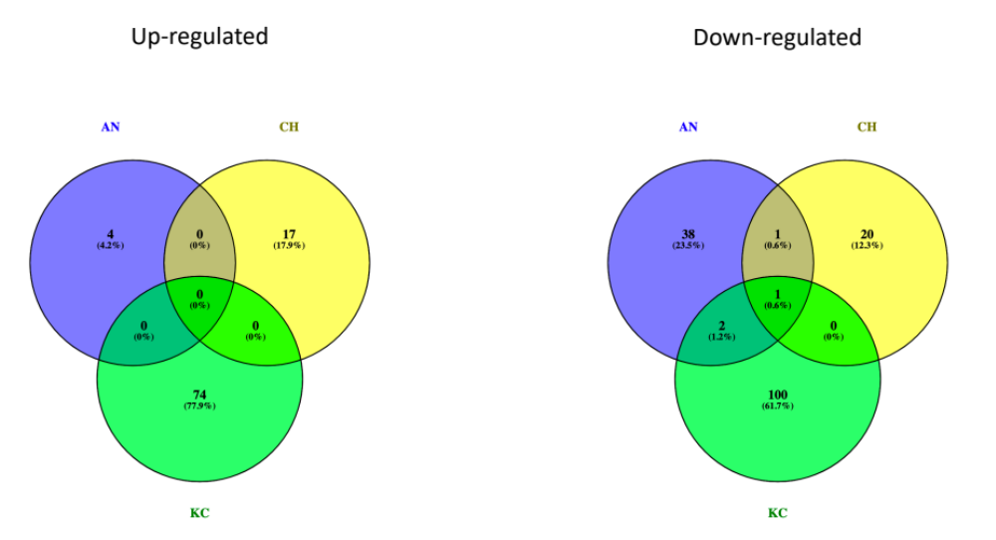

Supplementary Figure S2. Distribution of the identified differential expressed genes among the three breeds. Up-regulated and Down-regulated referred to the differential expressed genes between H-RFI and L-RFI animals.

