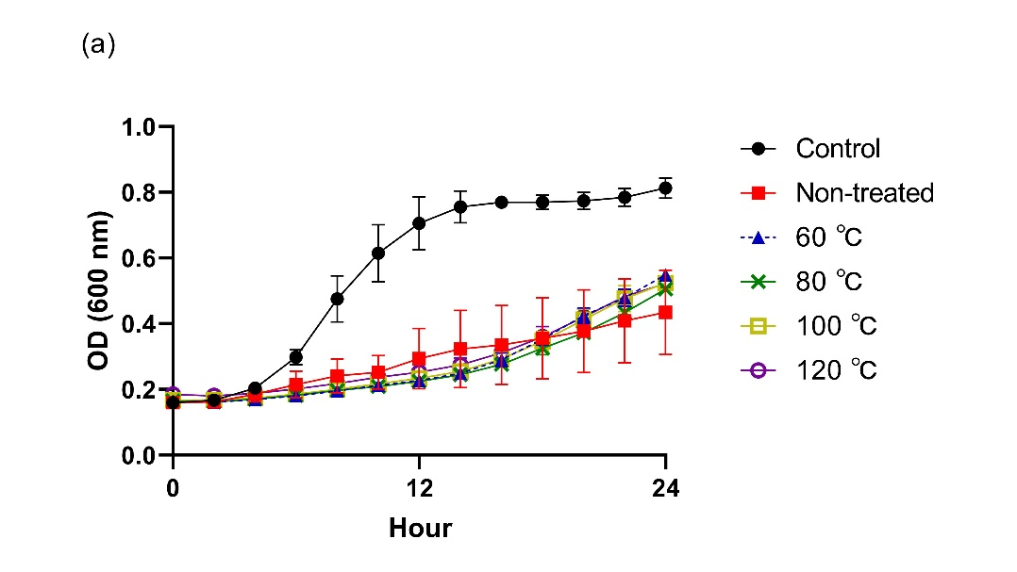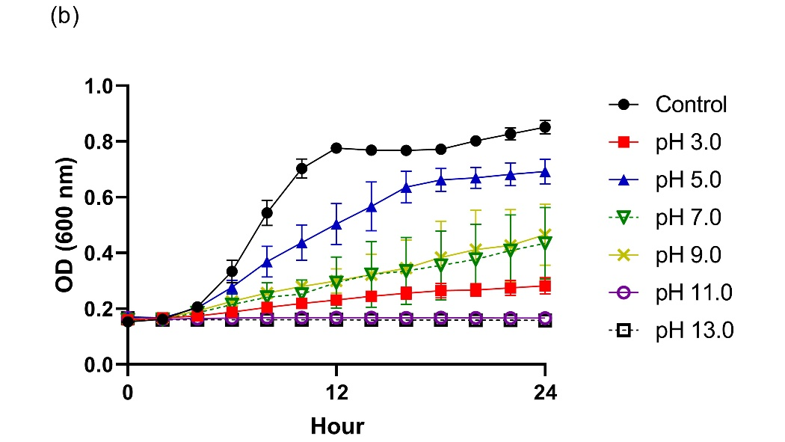
Supplementary Fig. 1 Growth curves of Gardnerella vaginalis suspensions incubated for 24 h with 5% (v/v) Lactobacillus paracasei CH88 cell-free supernatant treated at different temperatures for 30 min (a) and different pH (b). Data points are means ± standard errors of the means (n=3; error bars). Some error bars lie within the data points. OD, optical density.

