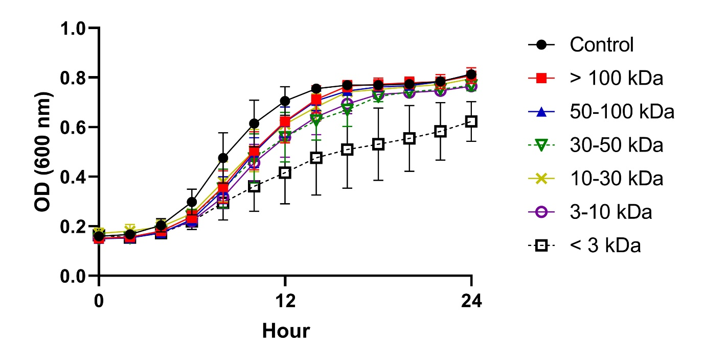 Supplementary Fig. 2 Growth curves of Gardnerella vaginalis suspensions incubated for 24 h with 5% (v/v) Lactobacillus paracasei CH88 cell-free supernatant fractions with different molecular weights. Data points are means ± standard errors of the means (n=3; error bars). Some error bars lie within the data points. OD, optical density.

