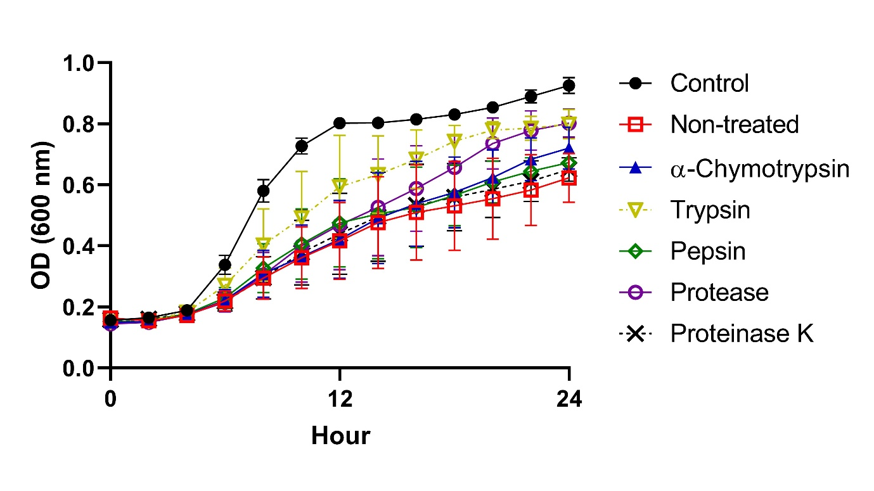 Supplementary Fig 3. Growth curves of Gardnerella vaginalis suspensions incubated for 24 h with 5% (v/v) fraction below 3 kDa from Lactobacillus paracasei CH88 cell-free supernatant treated with different proteolytic enzymes. Data points are means ± standard errors of the means (n=3; error bars). Some error bars lie within the data points. OD, optical density.

