SUPPLEMENTAL MATERIALS

Supplementary Table 1
Background demographics of patients with BMI > 25 and ≤ 25 in DPP4i (+) and (-) groups

 | DPP4i (+) |  |  |  |  | DPP4i (-)
 | BMI>25 | BMI≤25 | P |  |  | BMI>25 | BMI≤25 | P
 | n=138 | n=186 |  |  |  | n=230 | n=331 | P
Baseline characteristics
Age, years | 64.8 ± 10.0 | 70.5 ± 9.2 | <0.0001 |  |  | 65.1 ± 10.5 | 69.9 ± 9.5 | <0.0001
Male, n (%) | 117 (84.8) | 152 (81.7) | 0.47 |  |  | 186 (80.9) | 278 (84.0) | 0.34
Hypertension, n (%) | 112 (81.2) | 135 (72.6) | 0.07 |  |  | 192 (83.5) | 255 (77.0) | 0.06
Dyslipidemia, n (%) | 117 (84.8) | 137 (73.7) | 0.02 |  |  | 192 (83.5) | 245 (74.0) | 0.008
Current smoker, n (%) | 35 (25.4) | 37 (19.9) | 0.24 |  |  | 51 (22.2) | 84 (25.4) | 0.76
Chronic kidney disease, n (%) | 44 (31.9) | 53 (28.5) | 0.51 |  |  | 67 (29.1) | 108 (32.6) | 0.77
Hemodialysis, n (%) | 9 (6.5) | 14 (7.5) | 0.73 |  |  | 20 (8.7) | 32 (9.7) | 0.15
ACS, n (%) | 30 (21.7) | 32 (17.2) | 0.3 |  |  | 66 (28.7) | 86 (26.0) | 0.48
LVEF, % | 60.3 ± 12.9 | 60.2 ± 12.7 | 0.97 |  |  | 62.0 ± 11.4 | 59.9 ± 13.4 | 0.12
Diabetes duration, years | 15 (9, 22) | 13 (8, 20) | 0.93 |  |  | 12 (4, 20) | 17 (6, 26) | 0.0004
Lesion characteristics
Number of diseased vessels | 1.9 ± 0.8 | 1.9 ± 0.8 | 0.84 |  |  | 1.9 ± 0.8 | 2.1 ± 0.8 | 0.13
Diseased Vessel
RCA, n (%) | 49 (35.5) | 42 (22.6) | 0.01 |  |  | 69 (30.0) | 108 (32.6) | 0.51
LAD, n (%) | 68 (49.3) | 108 (58.1) | 0.12 |  |  | 119 (51.7) | 154 (46.5) | 0.22
LCX, n (%) | 22 (15.9) | 41 (22.0) | 0.17 |  |  | 41 (17.8) | 65 (19.6) | 0.59
Laboratory findings
TC, mg/dL | 161.7 ± 33.1 | 160.4 ± 33.3 | 0.74 |  |  | 174.8 ± 43.4 | 166.2 ± 38.7 | 0.01
LDL-C, mg/dL (Friedewald) | 93.3 ± 26.5 | 92.2 ± 27.8 | 0.72 |  |  | 100.9 ± 32.8 | 95.8 ± 30.2 | 0.06
HDL-C, mg/dL | 40.2 ± 9.9 | 44.3 ± 13.9 | 0.003 |  |  | 41.9 ± 11.9 | 45.1 ± 14.8 | 0.006
TG, mg/dL | 127 (102, 173) | 107 (79, 145) | 0.0004 |  |  | 134 (97, 187) | 107 (81, 149) | <0.0001
FBG, mg/dL | 134.2 ± 54.1 | 131.9 ± 52.5 | 0.71 |  |  | 138.1 ± 56.1 | 134.7 ± 59.0 | 0.48
HbA1c-NG, % | 7.1 ± 0.9 | 7.1 ± 1.0 | 0.94 |  |  | 7.4 ± 1.3 | 7.2 ± 1.0 | 0.008
hs-CRP, mg/L | 0.09 (0.04, 0.33) | 0.08 (0.03, 0.29) | 0.29 |  |  | 0.12 (0.04, 0.37) | 0.08 (0.03, 0.21) | 0.02
Hemoglobin, g/dL | 13.7 ± 1.8 | 13.1 ± 1.8 | 0.001 |  |  | 13.6 ± 1.9 | 13.0 ± 2.0 | 0.006
eGFR, ml/min/1.73m² | 71.0 ± 27.3 | 71.3 ± 31.5 | 0.94 |  |  | 69.2 ± 28.1 | 67.0 ± 27.5 | 0.36
1,5-AG, μg/mL | 9.1 (3.5, 15.3) | 8.4 (4.4, 14.0) |  | 0.73 |  | 9.2 (4.5, 15.3) | 8.1 (4, 14.1) | 0.18
BNP, pg/ml | 34.7 (14.8, 99.8) | 48.3 (25.1, 123.5) | 0.07 |  |  | 43.3 (17.6, 118.1) | 65.8 (28.7, 165.7) | 0.001
Medications
Sulfonylurea, n (%) | 46 (33.3) | 53 (28.5) | 0.35 |  |  | 54 (23.5) | 81 (24.5) | 0.79
Metformin, n (%) | 45 (32.6) | 32 (17.2) | 0.001 |  |  | 43 (18.7) | 50 (15.1) | 0.26
Thiazolidinedione, n (%) | 16 (11.6) | 14 (7.5) | 0.21 |  |  | 35 (15.2) | 29 (8.8) | 0.02
SGLT-2 inhibitor, n (%) | 11 (8.0) | 1 (0.5) | 0.0005 |  |  | 2 (0.9) | 3 (0.9) | 0.96
GLP-1 receptor agonist, n (%) | 0 (0) | 1 (0.5) | 0.39 |  |  | 4 (1.7) | 1 (0.3) | 0.07
α-Glucosidase inhibitor, n (%) | 24 (17.4) | 38 (20.4) | 0.49 |  |  | 44 (19.1) | 84 (25.4) | 0.08
Glinide, n (%) | 11 (8.0) | 27 (14.5) | 0.07 |  |  | 8 (3.5) | 26 (7.9) | 0.03
Insulin, n (%) | 16 (11.6) | 32 (17.2) | 0.16 |  |  | 69 (30.0) | 106 (32.0) | 0.61
ACE-I/ ARB, n (%) | 87 (63.0) | 85 (45.7) | 0.002 |  |  | 132 (57.4) | 181 (54.7) | 0.53
β-Blocker, n (%) | 70 (50.7) | 79 (42.5) | 0.14 |  |  | 121 (52.6) | 135 (40.8) | 0.006
Statin, n (%) | 110 (79.7) | 132 (71.0) | 0.07 |  |  | 142 (62.0) | 214 (64.7) | 0.52
Ezetimibe, n (%) | 14 (10.1) | 12 (6.5) | 0.23 |  |  | 11 (4.8) | 14 (4.2) | 0.75
Fibrate, n (%) | 8 (5.8) | 3 (1.6) | 0.04 |  |  | 15 (6.5) | 8 (2.4) | 0.02

Supplementary Table 2
Univariate Cox proportional hazard analyses for predictors of CV-death following PCI

 | HR | 95% CI | p-value
Age (1 year older) | 1.06 | 1.03–1.10 | <0.0001
Male | 1.71 | 0.83–4.12 | 0.184
BMI¹ (1 kg/m² higher) | 0.87 | 0.80–0.94 | 0.001
Hypertension | 1.01 | 0.54–2.04 | 0.986
Dyslipidemia | 1.30 | 0.69–2.73 | 0.45
Acute coronary syndrome | 1.08 | 0.59–1.88 | 0.795
Multivessel disease | 1.20 | 0.69–2.16 | 0.54
Chronic kidney disease | 2.61 | 1.56–4.36 | 0.0002
LVEF² (1% higher) | 0.96 | 0.94–0.98 | 0.0004
Former smoker | 1.70 | 1.02–2.86 | 0.04
Beta-blockers | 1.17 | 0.70–1.95 | 0.55
ACEIs³/ARBs⁴ | 1.16 | 0.69–1.99 | 0.57
Statins | 0.78 | 0.47–1.34 | 0.36
Ezetimibe | 0.65 | 0.11–2.08 | 0.55
Hemoglobin (1 g/dL higher) | 0.67 | 0.57–0.79 | <0.0001
Triglycerides (1 mg/dL higher) | 0.99 | 0.986–0.996 | 0.001
LDL-C⁵ (1 mg/dL higher) | 0.99 | 0.979–0.999 | 0.04
HDL-C⁶ (1 mg/dL higher) | 1.01 | 0.987–1.02 | 0.45
HbA1c-NG⁷ (1 % higher) | 0.73 | 0.54–0.96 | 0.036
1,5-AG⁸ (1 μg/mL higher) | 0.90 | 0.84–0.97 | 0.006
IRI⁹ (1 μU/mL higher) | 1.00 | 0.98–1.02 | 0.67
Fasting blood glucose (1 mg/dL higher) | 1.00 | 0.997–1.005 | 0.38
Log BNP¹⁰ (1 higher) | 4.57 | 2.95–7.04 | <0.0001
eGFR¹¹ (10 mL/min/1.73m² higher) | 0.77 | 0.71–0.84 | <0.0001
hs-CRP¹² (0.1 mg/dL higher) | 1.02 | 1.01–1.03 | <0.0001
IGF-1¹³ (1 ng/mL higher) | 0.99 | 0.979–0.997 | 0.009
IGFBP-3¹⁴ (1 ng/mL higher) | 1.00 | 1.001–1.003 | 0.001
IGF-1/IGFBP-3 (quartile higher) | 0.47 | 0.34–0.64 | <0.0001
Sulfonylurea | 0.60 | 0.30–1.10 | 0.12
Metformin | 0.46 | 0.178–0.996 | 0.049
Thiazolidinedione | 1.17 | 0.54–2.27 | 0.66
α-Glucosidase inhibitor | 1.13 | 0.62–1.97 | 0.67
Glinide | 0.59 | 0.14–1.58 | 0.37
Insulin | 2.46 | 1.45–4.12 | 0.0007
DPP4i¹⁵ | 0.39 | 0.17–0.78 | 0.01
1 body mass index, 2 left ventricular ejection fraction, 3 angiotensin converting enzyme inhibitors, 4 angiotensin Ⅱ receptor blockers, 5 low-density lipoprotein, 6 high-density lipoprotein, 7 glycated hemoglobin, 8 1,5-anhydroglucitol, 9 immunoreactive insulin, 10 B-type natriuretic peptide, 11 estimated glomerular filtration rate, 12 high-sensitivity C-reactive protein, 13 insulin-like growth factor-1, 14 insulin-like growth factor binding protein-3, 15 dipeptidyl peptidase-4 inhibitors.

Supplementary Table 3
Univariate Cox proportional hazard analyses for predictors of 3P-MACE following PCI

 | HR | 95% CI | p-value
Age (1 year older) | 1.04 | 1.02–1.06 | 0.001
Male | 1.47 | 0.83–2.84 | 0.19
BMI¹ (1 kg/m² higher) | 0.93 | 0.87–0.99 | 0.03
Hypertension | 1.17 | 0.69–2.11 | 0.58
Dyslipidemia | 1.22 | 0.73–2.16 | 0.47
Acute coronary syndrome | 1.23 | 0.76–1.91 | 0.39
Multivessel disease | 1.33 | 0.84–2.17 | 0.23
Chronic kidney disease | 2.34 | 1.54–3.55 | <0.0001
LVEF² (1% higher) | 0.97 | 0.96–0.99 | 0.005
Former smoker | 1.45 | 0.96–2.21 | 0.08
Beta-blockers | 1.02 | 0.67–1.54 | 0.93
ACEIs³/ARBs⁴ | 1.10 | 0.73–1.70 | 0.65
Statins | 0.67 | 0.44–1.03 | 0.06
Ezetimibe | 0.63 | 0.15–1.67 | 0.39
Hemoglobin (1 g/dL higher) | 0.69 | 0.61–0.79 | <0.0001
Triglycerides (1 mg/dL higher) | 0.99 | 0.992–0.999 | 0.04
LDL-C⁵ (1 mg/dL higher) | 0.99 | 0.988–1.002 | 0.29
HDL-C⁶ (1 mg/dL higher) | 1.00 | 0.984–1.02 | 0.92
HbA1c-NG⁷ (1 % higher) | 1.05 | 0.86–1.25 | 0.60
1,5-AG⁸ (1 μg/mL higher) | 0.93 | 0.88–0.98 | 0.01
IRI⁹ (1 μU/mL higher) | 1.01 | 0.99–1.02 | 0.25
Fasting blood glucose (1 mg/dL higher) | 1.00 | 0.999–1.005 | 0.06
Log BNP¹⁰ (1 higher) | 3.69 | 2.59–5.23 | <0.0001
eGFR¹¹ (10 mL/min/1.73m² higher) | 0.98 | 0.97–0.99 | <0.0001
hs-CRP¹² (0.1 mg/dL higher) | 1.02 | 1.01–1.03 | <0.0001
IGF-1¹³ (1 ng/mL higher) | 0.99 | 0.985–0.999 | 0.04
IGFBP-3¹⁴ (1 ng/mL higher) | 1.00 | 1.001–1.003 | <0.0001
IGF-1/IGFBP-3 (quartile higher) | 0.55 | 0.43–0.68 | <0.0001
Sulfonylurea | 0.64 | 0.37–1.04 | 0.07
Metformin | 0.69 | 0.37–1.20 | 0.20
Thiazolidinedione | 0.92 | 0.46–1.66 | 0.80
α-Glucosidase inhibitor | 1.01 | 0.61–1.61 | 0.97
Glinide | 0.97 | 0.41–1.94 | 0.93
Insulin | 2.35 | 1.52–3.58 | 0.0002
DPP4i¹⁵ | 0.43 | 0.23–0.74 | 0.002
1 body mass index, 2 left ventricular ejection fraction, 3 angiotensin converting enzyme inhibitors, 4 angiotensin Ⅱ receptor blockers, 5 low-density lipoprotein, 6 high-density lipoprotein, 7 glycated hemoglobin, 8 1,5-anhydroglucitol, 9 immunoreactive insulin, 10 B-type natriuretic peptide, 11 estimated glomerular filtration rate, 12 high-sensitivity C-reactive protein, 13 insulin-like growth factor-1, 14 insulin-like growth factor binding protein-3, 15 dipeptidyl peptidase-4 inhibitors.

Supplementary Table 4
Multivariate cox proportional hazard analyses using 4 models assessed the hazard ratios of DPP4i for CV-death and 3P-MACE

Model 1: Hazard ratios for dipeptidyl peptidase-4 inhibitors (DPP4i) were adjusted by age and sex

For CV-death
 | HR | 95% CI | p-value
Age (1 year older) | 1.07 | 1.04–1.10 | <0.0001
Male | 2.04 | 0.99–4.94 | 0.054
DPP4i | 0.38 | 0.16–0.75 | 0.005

For 3P-MACE
 | HR | 95% CI | p-value
Age (1 year older) | 1.04 | 1.02–1.07 | 0.0004
Male | 1.67 | 0.94–3.23 | 0.08
DPP4i | 0.42 | 0.23–0.73 | 0.001

Model 2: Hazard ratios for dipeptidyl peptidase-4 inhibitors (DPP4i) were adjusted by age, sex, body mass index (BMI), chronic kidney disease (CKD), BNP (B-type natriuretic peptide) and insulin use

For CV-death
 | HR | 95% CI | p-value
Age (1 year older) | 1.06 | 1.03–1.09 | 0.0003
Male | 3.88 | 1.66–11.35 | 0.0009
BMI (1 kg/m² higher) | 0.93 | 0.85–1.02 | 0.14
Chronic kidney disease | 0.98 | 0.53–1.81 | 0.95
Log BNP (1 higher) | 5.02 | 2.96–8.52 | <0.0001
Insulin | 2.26 | 1.24–4.05 | 0.009
DPP4i | 0.39 | 0.16–0.82 | 0.01

For 3P-MACE
 | HR | 95% CI | p-value
Age (1 year older) | 1.03 | 1.00–1.06 | 0.01
Male | 2.45 | 1.31–5.13 | 0.004
BMI (1 kg/m² higher) | 0.99 | 0.93–1.06 | 0.81
Chronic kidney disease | 1.17 | 0.71–1.91 | 0.54
Log BNP (1 higher) | 3.61 | 2.40–5.44 | <0.0001
Insulin | 1.92 | 1.19–3.06 | 0.009
DPP4i | 0.47 | 0.25–0.84 | 0.01

Model 3: Hazard ratios for dipeptidyl peptidase-4 inhibitors (DPP4i) were adjusted by age, sex, acute coronary syndrome (ACS), left ventricular ejection fraction (LVEF), statins and hemoglobin

For CV-death
 | HR | 95% CI | p-value
Age (1 year older) | 1.05 | 1.01–1.09 | 0.01
Male | 4.28 | 1.50–18.05 | 0.004
ACS | 0.74 | 0.29–1.73 | 0.50
LVEF | 1.00 | 0.98–1.01 | 0.46
statins | 0.82 | 0.42–1.70 | 0.59
Hemoglobin (1 g/dL higher) | 0.66 | 0.55–0.78 | <0.0001
DPP4i | 0.44 | 0.19–0.95 | 0.04

For 3P-MACE
 | HR | 95% CI | p-value
Age (1 year older) | 1.03 | 1.00–1.06 | 0.04
Male | 3.35 | 1.44–9.75 | 0.003
ACS | 0.98 | 0.46–1.94 | 0.95
LVEF | 1.00 | 0.99–1.01 | 0.91
statins | 0.79 | 0.44–1.43 | 0.42
Hemoglobin (1 g/dL higher) | 0.67 | 0.58–0.77 | <0.0001
DPP4i | 0.55 | 0.29–1.01 | 0.052

Model 4: Adjusted by anti-diabetic medications

For CV-death
 | HR | 95% CI | p-value
Metformin | 0.50 | 0.19–1.10 | 0.12
Sulfonylurea | 0.72 | 0.35–1.39 | 0.33
Alpha-glucosidase inhibitors | 1.23 | 0.66–2.18 | 0.50
Thiazolidinedione | 1.40 | 0.63–2.76 | 0.38
Glinide | 0.64 | 0.15–1.78 | 0.43
Insulin | 2.11 | 1.21–3.62 | 0.009
DPP4i | 0.48 | 0.21–0.99 | 0.046

For 3P-MACE
 | HR | 95% CI | p-value
Metformin | 0.75 | 0.39–1.32 | 0.33
Sulfonylurea | 0.79 | 0.44–1.35 | 0.40
Alpha-glucosidase inhibitors | 1.06 | 0.63–1.71 | 0.82
Thiazolidinedione | 1.03 | 0.51–1.87 | 0.94
Glinide | 1.08 | 0.44–2.22 | 0.86
Insulin | 2.05 | 1.30–3.18 | 0.002
DPP4i | 0.51 | 0.27–0.88 | 0.02

Supplementary Table 5
Multivariate Cox proportional hazard analyses using Model 2 assessed the hazard ratios of IGF-1/IGFBP-3 ratio for CV-death and 3P-MACE

Model 2: Hazard ratios for dipeptidyl peptidase-4 inhibitors (DPP4i) were adjusted by age, sex, body mass index (BMI), chronic kidney disease (CKD), BNP (B-type natriuretic peptide) and insulin use

For CV-death
 | HR | 95% CI | p-value
Age (1 year older) | 1.05 | 1.01–1.09 | 0.01
Male | 4.62 | 1.77–15.83 | 0.0009
BMI (1 kg/m² higher) | 0.96 | 0.87–1.06 | 0.47
Chronic kidney disease | 0.83 | 0.39–1.75 | 0.63
Log BNP (1 higher) | 3.32 | 1.83–6.07 | <0.0001
Insulin | 2.83 | 1.38–5.69 | 0.005
IGF-1/IGFBP-3 (quartile increase) | 0.58 | 0.40–0.80 | 0.002

For 3P-MACE
 | HR | 95% CI | p-value
Age (1 year older) | 1.01 | 0.99–1.05 | 0.31
Male | 2.99 | 1.46–6.96 | 0.002
BMI (1 kg/m² higher) | 0.99 | 0.92–1.07 | 0.89
Chronic kidney disease | 1.03 | 0.56–1.86 | 0.93
Log BNP (1 higher) | 2.70 | 1.69–4.30 | <0.0001
Insulin | 2.31 | 1.31–4.01 | 0.004
IGF-1/IGFBP-3 (quartile increase) | 0.59 | 0.45–0.77 | 0.0001

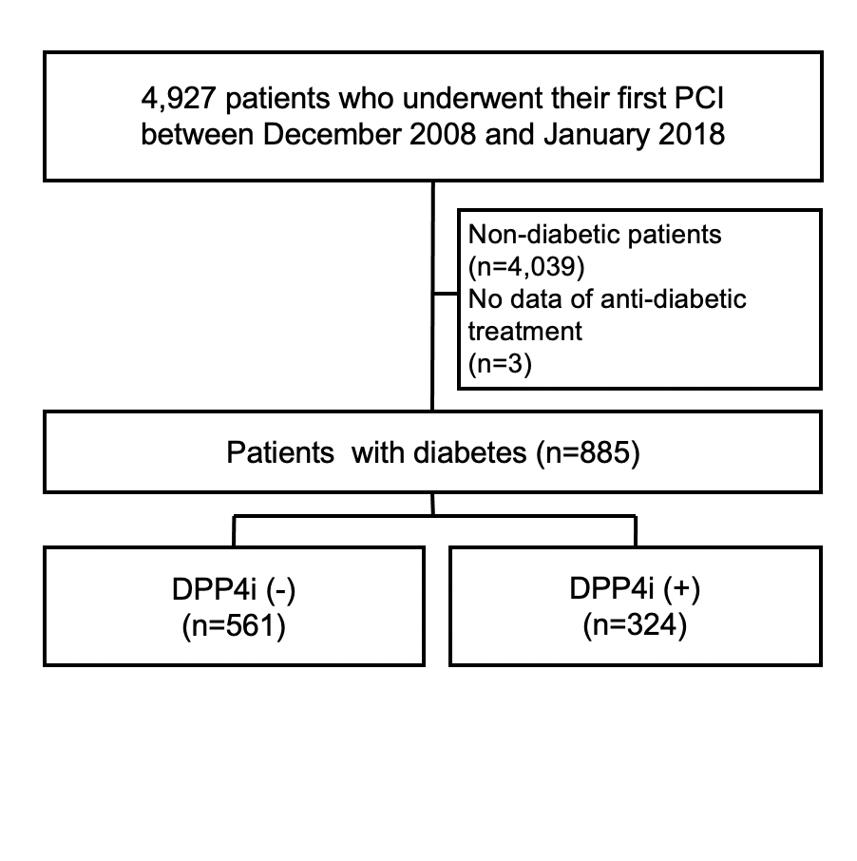
Supplementary Figure 1

Supplementary Figure 1: Consort diagram

Supplementary Figure 2
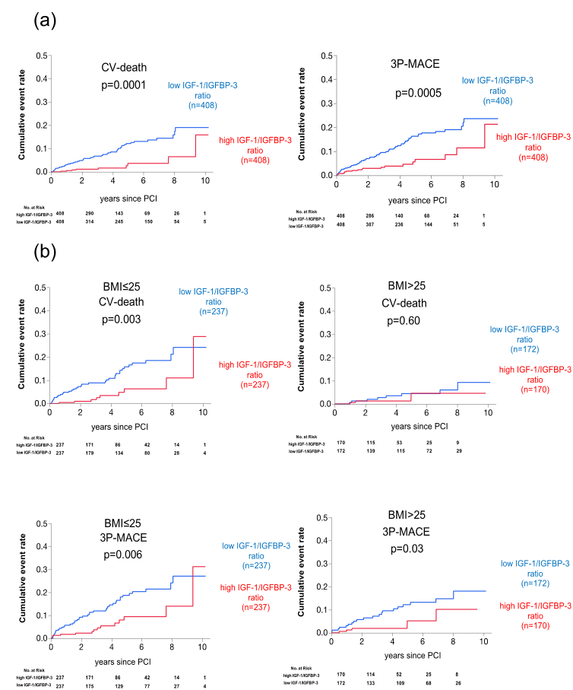

Supplementary Figure 2: Cumulative incidence of adverse outcomes following PCI in two groups divided by the median of IGF-1/IGFBP-3 ratio
(a) Cumulative incidences of cardiovascular (CV)-death and the composite of CV-death, non-fatal myocardial infarction and ischemic stroke (3P-MACE) in the high and low IGF-1/IGFBP-3 ratio groups. (b) Cumulative incidences of CV-death and 3P-MACE in the high and low IGF-1/IGFBP-3 ratio groups in patients with and without low BMI (≤ and > median BMI, 25).

