Supplementary information

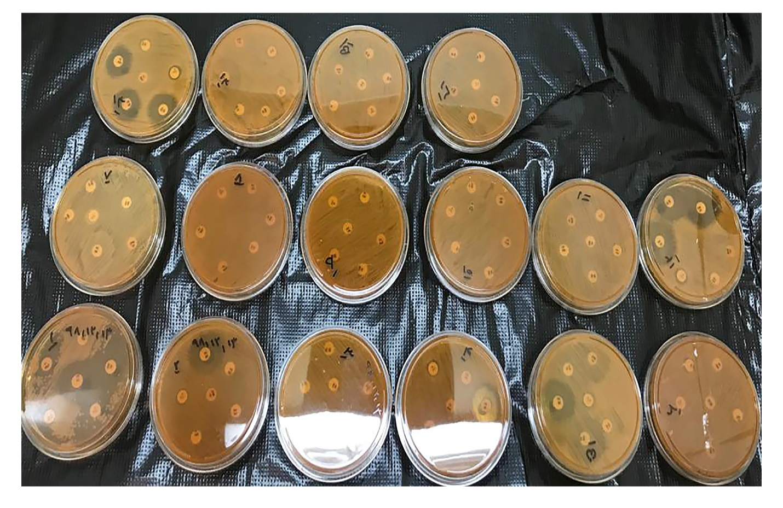
Figure S1. Disk diffusion results from some isolates versus selective antibiotics. According to the results, each of the isolates showed a percentage of resistance to different antibiotics.

